**Rollno : 230701211**

**EXPERIMENT 5: System calls programming**

**Aim:** To experiment system calls using fork(), execlp() and pid() functions.

**Program:**

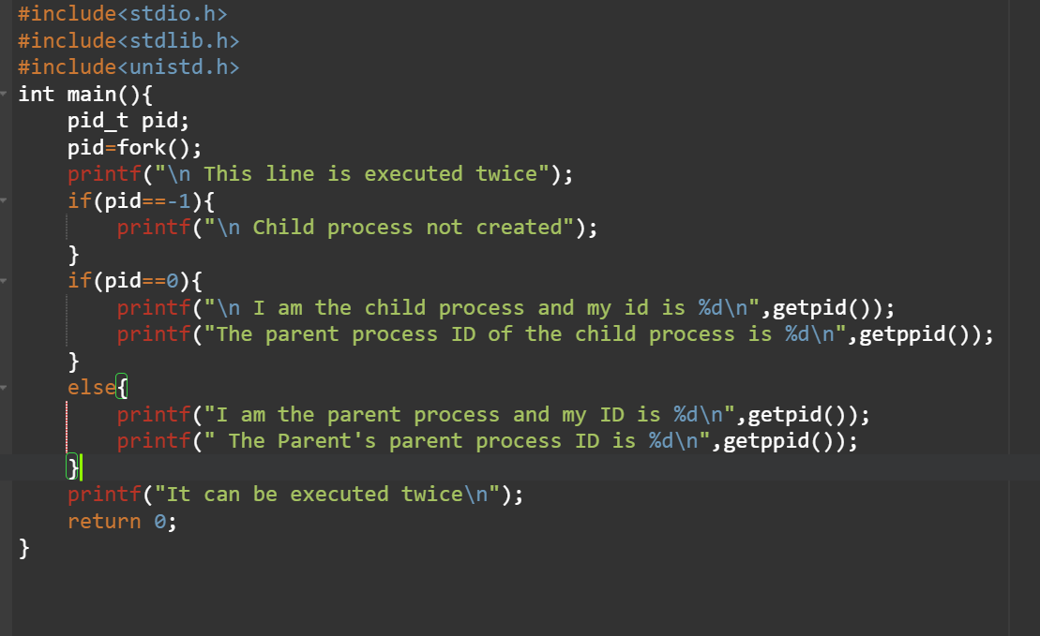

**Output:**

