**Experiment 8**

**Create storyboards to represent the user flow for a mobile app (e.g., food delivery app) using Balsamiq**

**AIM:**

The aim is to create storyboards representing the user flow for a mobile app, such as a food delivery app, using Balsamiq.

**PROCEDURE:**

I am going to design a Fitness tracking App.

**Step 1: Define the User Flow**

**1. Identify Key Screens**

The screens of the fitness tracking app.

1. Welcome/Login Screen

Login/Sign-up options

Social login (Google/Apple)

1. Home/Dashboard Screen

Overview of today’s steps, calories, workouts

1. Workout Tracker Screen

Select workout type (running, yoga, etc.)

Start/Stop workout tracking

1. Progress/History Screen

View weekly/monthly progress

Graphs for steps, calories, etc.

1. Profile Screen

Edit user profile

Set fitness goals and preferences

**2. Map the User Journey**

A typical user flow would look like this:

1.Welcome/Login Screen

User logs in or signs up

2. Home Screen

User sees a summary of their daily activity

Chooses to start a workout or view progress

3.Workout Tracker Screen

User selects a workout and starts tracking

Ends workout and data is saved

4.Progress Screen

User views progress for motivation

Analyzes trends over time

5.Profile Screen

User sets or updates fitness goals

**Step 2: Create Storyboards Using Balsamiq**

1. **Install Balsamiq**:

Download and install Balsamiq from the https://balsamiq.com/ website.

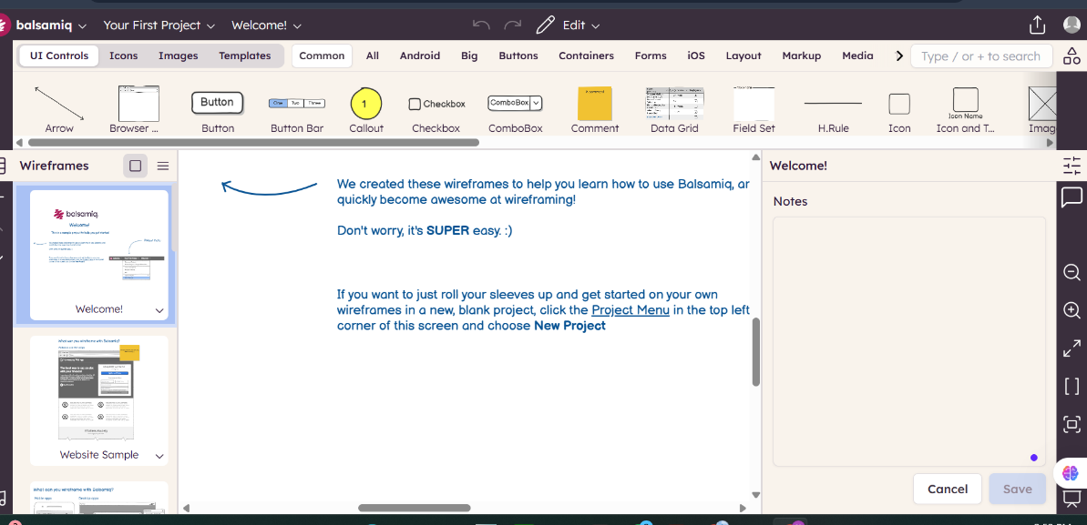

2. **Create a New Project**:

Open Balsamiq and create a new project.

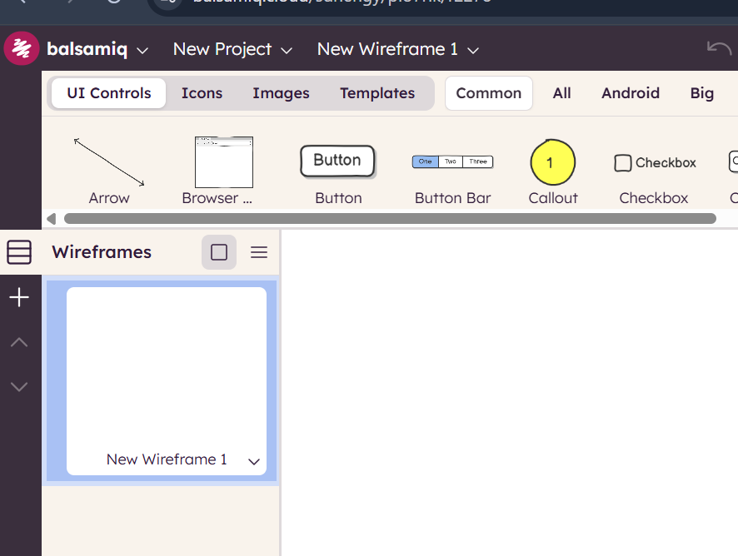

3. **Add Wireframe Screens**:

Use the “+” button to add new wireframe screens for each key screen in your app.

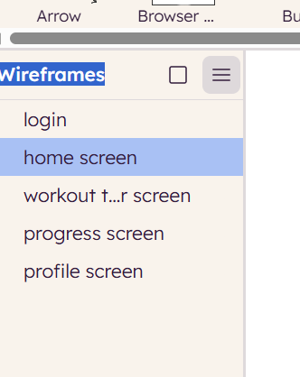

4. **Design Each Screen**:

Use Balsamiq's components to design the UI for each screen.

Include basic elements like buttons, text fields, and images.

1) Log in Screen

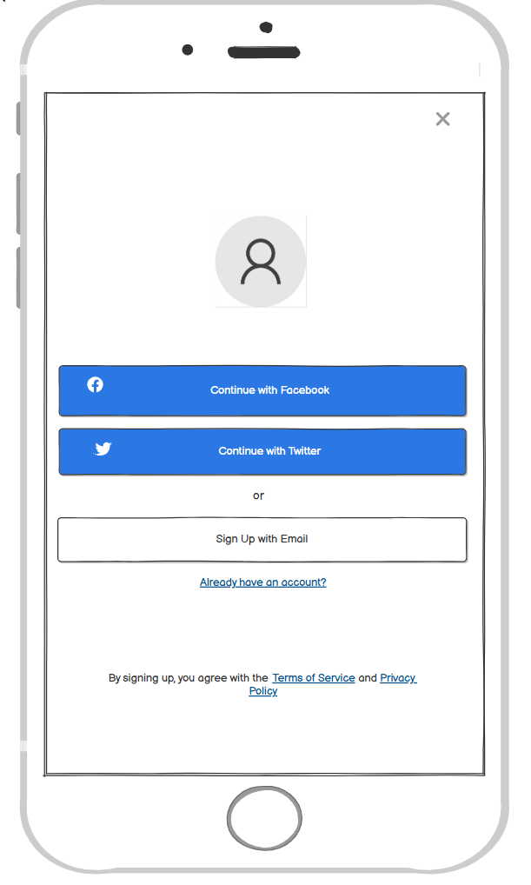

2)Home screen

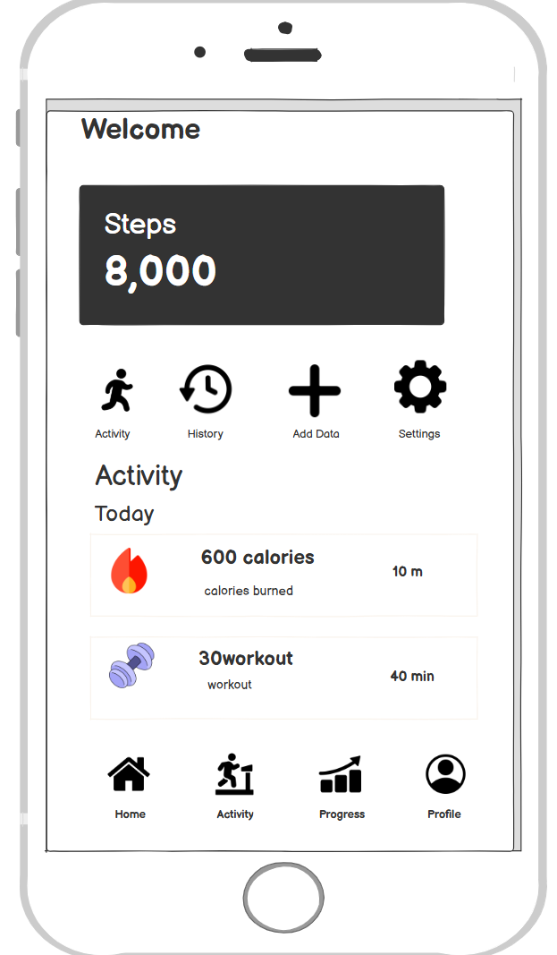

3)Workout Tracker screen

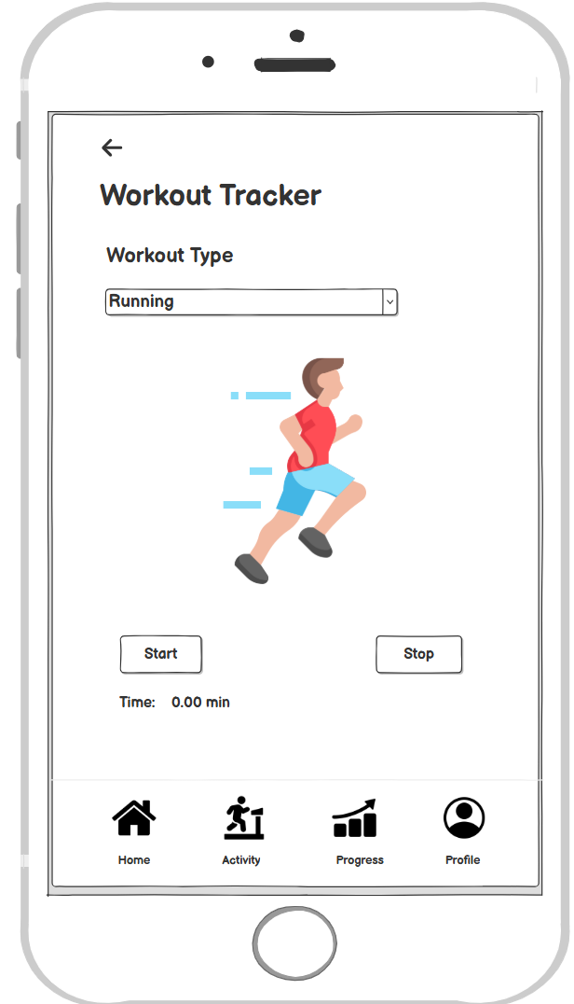

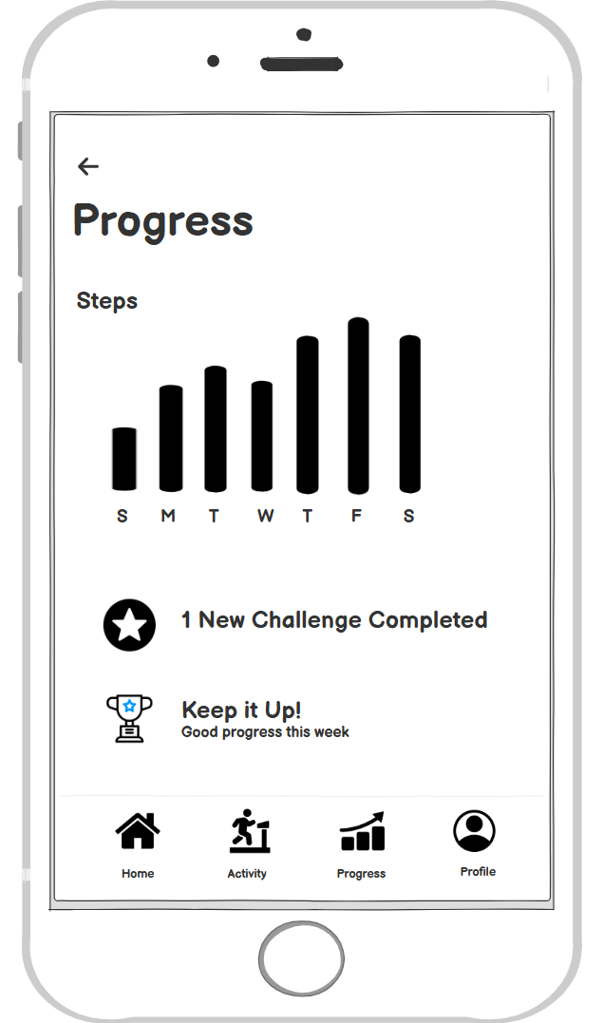4) Progress screen

5)Profile screen

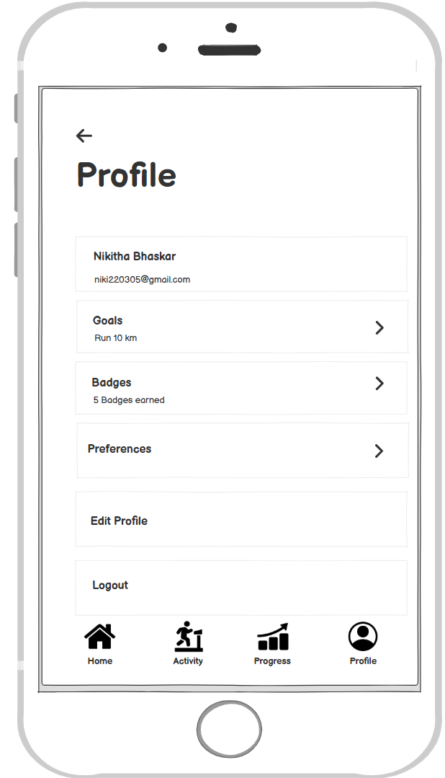

**5. Organize the Flow:**

Arrange the screens in the order users will navigate through them.

Connect the screens with arrows to represent user actions.

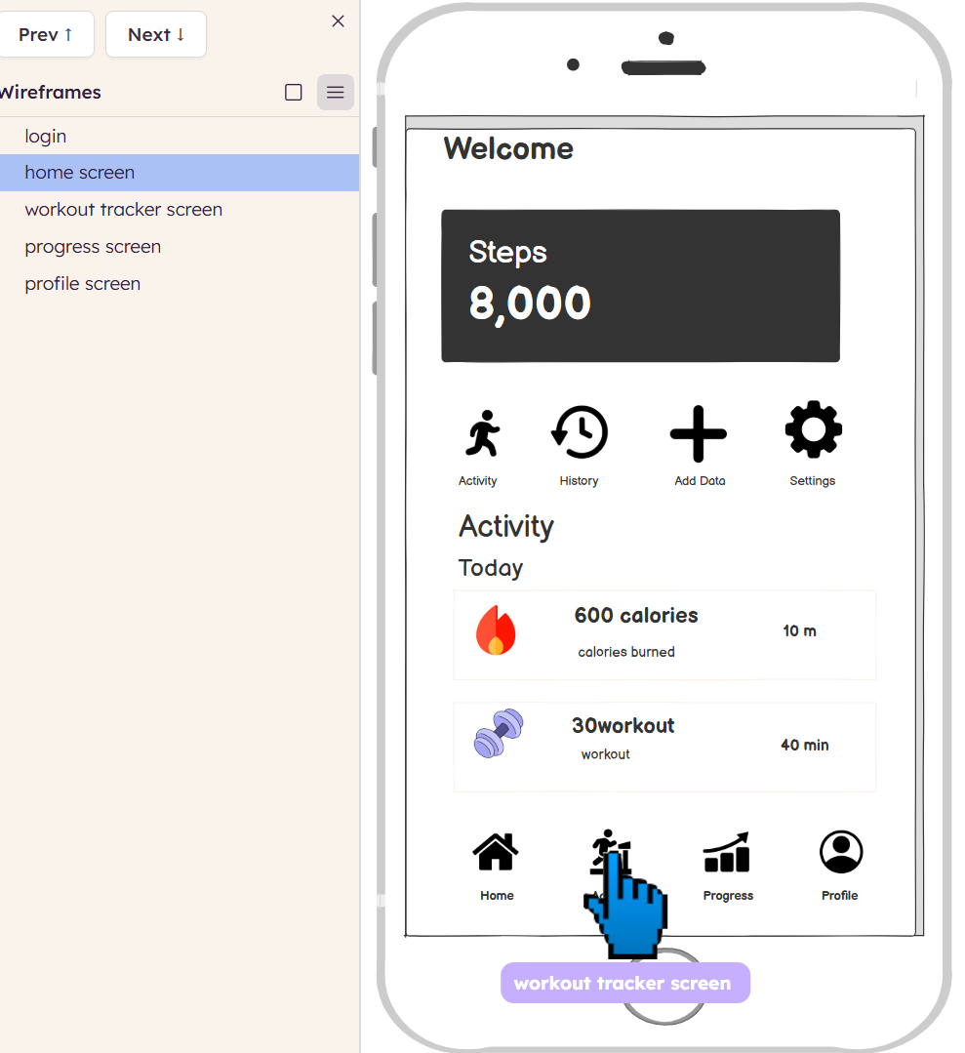

This is the presentation link of the fitness tracker screen.

<https://balsamiq.cloud/sdnengy/plo7rik>