OPSIS
An Accessibility-First Examination and Coding-Assessment Platform for Blind and Visually Impaired Users
A PROJECT REPORT
Submitted by
RISHAN RUSKIN  PRAJAIN RAJ R  PRADEEP SINGH B  NAVEEN KUMAR I | 230701265  230701232  230701229  230701205
In partial fulfillment for the award of the degree
of
BACHELOR OF ENGINEERING
IN
COMPUTER SCIENCE AND ENGINEERING
 | 
DEPARTMENT OF COMPUTER SCIENCE AND ENGINEERING
RAJALAKSHMI ENGINEERING COLLEGE, CHENNAI
(An Autonomous Institution, Affiliated to Anna University, Chennai)
ANNA UNIVERSITY: CHENNAI 600 025
Academic Year [2026 – 2027]
ANNA UNIVERSITY, CHENNAI
BONAFIDE CERTIFICATE
This is to certify that this project report titled “OPSIS: An Accessibility-First Examination and Coding-Assessment Platform for Blind and Visually Impaired Users” is the bonafide work of RISHAN RUSKIN (230701265), PRAJAIN RAJ R(230701232), PRADEEP SINGH B
(230701229), NAVEEN KUMAR I(230701205), who carried out the project work under my supervision, for the requirements of the degree of Bachelor of Engineering in Computer Science and Engineering.

SIGNATURE  Dr.J.Manoranjini  HEAD OF THE DEPARTMENT  Department of Computer Science and Engineering  Rajalakshmi Engineering College,  Chennai - 602105 | SIGNATURE  Dr.J.Manoranjini  SUPERVISOR  Department of Computer Science and Engineering  Rajalakshmi Engineering College,  Chennai - 602105
Submitted for the project viva-voce examination held on
Internal Examiner | External Examiner
DECLARATION
I hereby declare that the project entitled “OPSIS: An Accessibility-First Examination and Coding-Assessment Platform for Blind and Visually Impaired Users” submitted for the degree of Bachelor of Engineering in Computer Science and Engineering is my original work and that the project has not formed the basis for the award of any degree, associateship, fellowship or any other similar title. All work reported in this document reflects the actual state of the implementation as of the date of submission, including features that are complete, partially complete, or planned for future development, as distinguished explicitly throughout the report.
Place:
Date:
RISHAN RUSKIN
PRAJAIN RAJ R
PRADEEP SINGH B
NAVEEN KUMAR I

ABSTRACT
OPSIS is an integrated full-stack web-based examination platform created specifically to serve blind and visually impaired students. The platform uses React and TypeScript front-end, Node.js/Express back-end, and PostgreSQL database accessed through Drizzle ORM. Unlike existing examination systems where accessibility is seen as an additional optional feature that can be achieved through screen reader compatibility, OPSIS is made as an accessible platform from scratch, with accessibility serving as one of the main requirements for each and every part of the system: authentication, question rendering, timing mechanism, code-based assessment, and reviewing results.
The OPSIS platform allows four question types: multiple choice, true/false, short answer, and programming. The latter is evaluated by the actual code-execution engine that runs the provided code of student (JavaScript, TypeScript, or Python) against test cases defined by the instructor within the limited resources Node.js virtual machine environment or Python subprocess. There is no simulation or randomization involved. Programming questions are created using the built-in Monaco Editor – the same editor that is used in Visual Studio Code, but configured for accessibility.
An important novelty brought by the platform is OPSIS Assist, an in-app accessibility layer combining the support for keyboard navigation, non-visual page reading cursor and voice command recognition hands-free. Everything is connected to one centralized speech-synthesis narrator and voice-command matching engine. OPSIS Assist is explicitly described both in the application and in this report as the in-app reading and command layer for OPSIS content. It complements existing screen readers like NVDA, JAWS, VoiceOver, and Orca that are still fully supported through semantic HTML, ARIA roles and live regions.
In this report, the overall architecture of the system, database schema and all implemented modules (authentication and authorization, examination and question management, accessible exam interface, code-execution engine, accessibility preferences system, voice-interaction subsystem, manual grading, admin console and evidence-based analytics dashboard) are described. In addition, the accessibility features integrated in the system, the automated tests for the codebase, security measures (bcrypt password hashing, session-backed server-side authorization checked on every request, sandboxed and resource-limited code execution, request validation by Zod), and limitations of the project are enumerated. In particular, the current limitations include the presence of several sections of the administrative console that currently render only dummy data; the only workflow scoring problem found during the review; and the existence of some duplication in the accessibility settings system. This way it is ensured that completed functionality, partially completed functionality and the functionality scheduled for future work are not considered to be equal. The document concludes with discussion of practical implications of the project and realistic plan for further work.
Keywords: web accessibility, WCAG 2.1/2.2, assistive technology, screen readers, voice user interfaces, speech synthesis, speech recognition, sandboxed code execution, online examination systems, React, TypeScript, Express, PostgreSQL, Drizzle ORM, Monaco Editor.
ACKNOWLEDGEMENT
Initially we thank the Almighty for being with us through every walk of our life and showering
his blessings through the endeavor to put forth this report. Our sincere thanks to our
Chairman
Mr. S.MEGANATHAN, B.E, F.I.E., our Vice Chairman Mr. ABHAY SHANKAR
MEGANATHAN, B.E., M.S., and our respected Chairperson Dr. (Mrs.) THANGAM
MEGANATHAN, Ph.D., for providing us with the requisite infrastructure and sincere
endeavoring in educating us in their premier institution.
Our sincere thanks to Dr. S.N. MURUGESAN, M.E., Ph.D., our beloved Principal for his kind
support and facilities provided to complete our work in time. We express our sincere thanks
to Dr. J. Manoranjini,, Ph.D., Professor and Head of the Department of Computer Science and
Engineering for his guidance and encouragement throughout the project work. We convey our
sincere and deepest gratitude to our internal guide,
Dr. J. Manoranjini,, Ph.D., Associate Professor, Department of Computer Science and
Engineering for her valuable guidance throughout the course of the project. We thank our
Project Coordinator, Dr. S. Madhusudhan, Assistant Professor, Department of Computer
Science and Engineering for his useful tips during our review to build our project.

RISHAN RUSKIN(230701265)
PRAJAIN RAJ R(230701232)
PRADEEP SINGH B(230701229)
NAVEEN KUMAR I(230701205)

TABLE OF CONTENTS
CHAPTER NO. | TITLE | PAGE NO.
— | ABSTRACT | iv
— | ACKNOWLEDGEMENT | v
— | LIST OF TABLES | xi
— | LIST OF FIGURES | xii
— | LIST OF ABBREVIATIONS | xiii
1 | INTRODUCTION | 1
1.1 | GENERAL | 1
1.2 | OBJECTIVES | 1
1.3 | EXISTING SYSTEM | 2
1.4 | PROPOSED SYSTEM | 3
1.5 | SCOPE | 3
1.5.1 | In Scope (Implemented) | 3
1.5.2 | Out of Scope (Current Version) | 4
2 | BACKGROUND AND PROBLEM STATEMENT | 5
2.1 | BACKGROUND AND MOTIVATION | 5
2.2 | PROBLEM STATEMENT | 5
3 | SYSTEM ANALYSIS AND DESIGN | 7
3.1 | REQUIREMENTS ANALYSIS | 7
3.1.1 | Functional Requirements | 7
3.1.2 | Non-Functional Requirements | 8
3.2 | SYSTEM ARCHITECTURE | 9
3.2.1 | High-Level Architecture | 10
3.2.2 | Frontend Architecture | 10
3.2.3 | Backend Architecture | 11
3.2.4 | Database Architecture | 11
3.3 | TECHNOLOGY STACK | 11
3.3.1 | Frontend | 12
3.3.2 | Backend | 13
3.3.3 | Data & Infrastructure | 13
3.3.4 | Development Tools | 14
3.4 | SYSTEM DESIGN | 15
3.4.1 | End-to-End User Workflow | 15
3.4.2 | Component / Data-Flow Architecture | 16
3.5 | DATABASE DESIGN | 17
3.5.1 | Entity–Relationship Overview | 17
3.5.2 | Table Reference | 17
3.5.3 | CRUD Operations | 20
3.6 | OVERALL DATA FLOW | 21
3.6.1 | Categories of data and where they live | 22
3.6.2 | What this view makes explicit | 23
4 | PROJECT DESCRIPTION | 24
4.1 | MODULE DESCRIPTION | 24
4.2 | THE ACCESSIBLE EXAMINATION SYSTEM | 25
4.2.1 | End-to-End Examination Workflow | 25
4.2.2 | What "accessible" means across the whole workflow, not just within one screen | 26
4.2.3 | Known cross-cutting limitations of the workflow | 27
4.3 | ACCESSIBILITY DESIGN | 27
4.3.1 | Design philosophy: screen-reader-first, not screen-reader-retrofitted | 27
4.3.2 | The accessibility-settings model | 27
4.3.3 | Accessibility Interaction Flow | 28
4.3.4 | Concrete ARIA and semantic-HTML techniques observed in the codebase | 28
4.3.5 | Illustrative mapping to WCAG 2.1/2.2 success criteria | 29
4.3.6 | Known limitations of the accessibility design | 30
4.4 | VOICE INTERACTION | 30
4.4.1 | Design principle: deterministic, not conversational | 30
4.4.2 | Voice Command Processing Flow | 31
4.4.3 | Complete voice-command inventory | 31
4.4.4 | Why voice is never a second implementation | 32
4.4.5 | Known limitations | 32
4.5 | AUTHENTICATION AND USER MANAGEMENT | 33
4.5.1 | User Authentication Flow | 33
4.5.2 | Role model | 33
4.5.3 | Authorisation is re-checked, not cached, at every layer | 34
4.5.4 | Known limitations | 34
5 | IMPLEMENTATION AND DISCUSSION | 35
5.1 | DETAILED IMPLEMENTATION | 35
5.1.1 | Module 1 — Authentication and User Management | 35
5.1.2 | Module 2 — Exam and Question Management | 37
5.1.3 | Module 3 — Accessible Examination Interface (ExamTaking) | 39
5.1.4 | Module 4 — Coding Question Engine (Monaco Editor + Sandboxed Execution) | 42
5.1.5 | Module 5 — Accessibility Profile and Settings | 47
5.1.6 | Module 6 — OPSIS Assist (Unified Accessibility Controller) | 49
5.1.7 | Module 7 — Grading (Automatic and Manual) | 53
5.1.8 | Module 8 — Administrative Console (Admin Portal) | 55
5.1.9 | Module 9 — Analytics Dashboard | 59
5.1.10 | Module 10 — Automated Test Suite | 61
5.2 | HOW THE MODULES INTEGRATE | 64
5.3 | TESTING AND VALIDATION | 66
5.3.1 | Methodology and an explicit statement of what this section does and does not claim | 66
5.3.2 | Server-side security and integrity tests (test:security) | 67
5.3.3 | Sandboxed code-execution tests (part of test:security — codeRunner.test.ts) | 69
5.3.4 | Voice-subsystem tests (test:voice) | 70
5.3.5 | Browser end-to-end test (test:assist-browser — opsis-assist.e2e.mjs) | 71
5.3.6 | Summary | 72
5.4 | DEVELOPMENT CHALLENGES AND SOLUTIONS | 73
5.4.1 | Phase 1 — Security and Grading Integrity | 73
5.4.2 | Phase 4 — Instructor-Side Fixes | 75
5.4.3 | Phase 6 (Original and Revised) — OPSIS Assist | 77
5.5 | SECURITY CONSIDERATIONS | 79
5.5.1 | Controls implemented and verified | 79
5.5.2 | Controls not found in the code reviewed | 80
5.5.3 | Security posture summary | 81
6 | RESULT | 82
6.1 | RESULTS | 82
6.1.1 | What kind of results this section reports | 82
6.1.2 | Functional results — what the platform demonstrably does | 82
6.1.3 | Automated-test results, precisely stated | 82
6.1.4 | Areas found to be incomplete or illustrative, stated as results in their own right | 83
6.1.5 | Interpreting these results | 83
6.2 | CURRENT IMPLEMENTATION STATUS | 83
6.2.1 | Completed | 83
6.2.2 | Partially Completed | 84
6.2.3 | Planned / Not Implemented | 85
6.3 | LIMITATIONS | 85
6.3.1 | Illustrative rather than live data | 86
6.3.2 | Identified defects | 86
6.3.3 | Documentation/code discrepancies | 86
6.3.4 | Accessibility and testing gaps | 87
6.3.5 | Architectural and scope boundaries | 87
6.3.6 | Security gaps | 88
6.3.7 | Why this section exists | 88
6.4 | OUTPUT SCREENSHOTS | 88
6.4.1 | Dashboard on First Launch — Microphone Permission | 88
6.4.2 | Dashboard with Voice Recognition Active | 89
6.4.3 | Exam Selection | 90
6.4.4 | Pre-Exam Instructions and Start Confirmation | 91
6.4.5 | Question Screen During the Exam | 92
6.4.6 | Submit or Exit Confirmation | 93
6.4.7 | Exam Completion Summary | 94
7 | CONCLUSION AND FUTURE WORK | 95
7.1 | CONCLUSION | 95
7.2 | FUTURE SCOPE | 95
7.2.1 | Near-term — closing identified gaps | 96
7.2.2 | Per-student accommodations (explicitly scoped in the project's own Phase 5 specification) | 96
7.2.3 | Platform maturity | 96
7.2.4 | Security hardening | 97
7.2.5 | Evaluation | 97
7.2.6 | Explicitly out of scope, by the project's own design decision | 97
— | PUBLICATION STATUS
— | REFERENCES | 98
LIST OF TABLES
TABLE NO. | TABLE NAME | PAGE NO.
3.1 | Functional requirements | 7
3.2 | Non-functional requirements | 8
3.3 | Frontend technology stack | 12
3.4 | Backend technology stack | 13
3.5 | Data and infrastructure technology stack | 13
3.6 | Development tools | 14
3.7 | Table reference — users | 17
3.8 | Table reference — exams | 18
3.9 | Table reference — questions | 18
3.10 | Table reference — exam_attempts | 19
3.11 | Table reference — code_submissions | 20
3.12 | Table reference — user_settings | 20
3.13 | Categories of data and where they live | 22
4.1 | Modules of OPSIS | 24
4.2 | Illustrative mapping to WCAG 2.1/2.2 success criteria | 29
4.3 | Complete voice-command inventory | 31
4.4 | Role model — capabilities by role | 34
5.1 | Languages selectable vs. executable in the coding engine | 43
5.2 | Admin Portal — real vs. illustrative sections | 56
5.3 | Automated test scripts | 62
5.4 | Server-side security and integrity tests | 67
5.5 | Sandboxed code-execution tests | 69
5.6 | Voice-subsystem tests | 70
5.7 | Browser end-to-end test | 71
5.8 | Security controls implemented and verified | 79
6.1 | Completed items | 83
6.2 | Partially completed items | 84
LIST OF FIGURES
FIGURE NO. | FIGURE NAME | PAGE NO.
3.1 | High-level architecture of OPSIS | 10
3.2 | Component / data-flow architecture | 16
3.3 | Entity–relationship overview | 17
3.4 | Overall data flow | 21
4.1 | Accessibility interaction flow | 28
4.2 | Voice command processing flow | 31
4.3 | User authentication flow | 33
5.1 | Examination lifecycle across the modules | 66
6.1 | Dashboard on first launch with the browser's microphone-permission prompt | 88
6.2 | Student dashboard with voice recognition active | 89
6.3 | Exam selection screen listing the available subject papers | 90
6.4 | Pre-exam instructions and start confirmation for the English paper | 91
6.5 | Question screen showing a multiple-choice question with keyed options | 92
6.6 | Submit-or-exit confirmation dialog during an exam | 93
6.7 | Exam completion summary after submission | 94
LIST OF ABBREVIATIONS
ABBREVIATION | EXPANSION
ADA | Americans with Disabilities Act
API | Application Programming Interface
ARIA | Accessible Rich Internet Applications
CPU | Central Processing Unit
CRUD | Create, Read, Update, Delete
CSRF | Cross-Site Request Forgery
CSS | Cascading Style Sheets
DOM | Document Object Model
E2E | End-to-End
FR | Functional Requirement
HTML | HyperText Markup Language
HTTP | HyperText Transfer Protocol
ICT | Information and Communication Technology
IDE | Integrated Development Environment
JAWS | Job Access With Speech (screen reader)
JS | JavaScript
JSON | JavaScript Object Notation
LLM | Large Language Model
LMS | Learning Management System
MCQ | Multiple Choice Question
NFR | Non-Functional Requirement
NVDA | NonVisual Desktop Access (screen reader)
ORM | Object-Relational Mapping
POUR | Perceivable, Operable, Understandable, Robust
REST | Representational State Transfer
SQL | Structured Query Language
TS | TypeScript
TTS | Text-to-Speech
UI | User Interface
UUID | Universally Unique Identifier
VM | Virtual Machine
W3C | World Wide Web Consortium
WCAG | Web Content Accessibility Guidelines
XSS | Cross-Site Scripting

CHAPTER 1
INTRODUCTION

1.1 GENERAL
Independent and fair examination is one of the key factors in inclusion and accessible education. Whereas sighted examinees see in a digital examination platform just another convenience tool, blind or visually impaired examinees need the platform to actually make the examination possible to perform independently. Most widely used learning management systems and tools for assessment were conceived as applications for a sighted user who operates them using a mouse, with any accessibility support being a secondary feature that was added later on top of the existing design, if at all present. Thus, as widely reported by the accessibility experts and users of assistive technologies, the system can have screen reader support but fail completely in actual exam conditions because of unlabeled controls, keyboard traps, silent state changes, inaccessible timer and code editor, which assumes mouse input and presence of a monitor.
OPSIS addresses this problem by creating a full-stack exam platform dedicated to blind and visually impaired examinees. It has been developed as a Computer Science and Engineering final year project. The system provides means to author the exam by an instructor, to take the exam as a student under a proctoring timer, automatically and manually grade the exam and to review its results. Most importantly, it takes non-visual usability as one of the principal constraints of its design rather than an additional mode that is applied to the visually oriented product.
Term OPSIS is used as a product identity in the source code, configuration files and user-visible copy. In addition to that, there is also an in-application accessibility subsystem, branded as "OPSIS Assist," detailed in Section 4.4. This report describes what has been implemented: each of the modules with its inner workings, technologies used, automated tests, as well as, following academic integrity requirement for an evidence-based presentation of the result, what has not been implemented yet, illustrative data and future work.

1.2 OBJECTIVES
1. Build an examination platform that is designed from the start with screen-reader first and keyboard first as the primary interaction paradigms, rather than designing from a visual perspective and then trying to add accessibility afterward.
2. Render four different question types common to a Computer Science course – multiple choice, true/false, short answer, and coding – through a single, accessible question rendering pipeline.
3. Execute real, sandboxed, constrained code execution for programming questions in JavaScript, TypeScript, and Python, with deterministic, test-case based grading.
4. Develop a system-wide accessibility preferences system (Accessibility Center) that allows the student to configure their visual, auditory, navigational, and cognitive load accessibility needs, persisting on a per-user basis.
5. Build an accessibility layer for in-application voice and reading cursor support (OPSIS Assist) that is deterministic (explicit phrase matching with a confidence gate, not natural language inference), auditable, and safe for a proctored, time-sensitive environment specifically with regard to preventing destructive actions (submitting the exam) with a single voice command.
6. Protect the server-side logic with authentication and authorization with roles, salted password hashes, and by checking every state-changing API route for the user’s current role stored in the session store.
7. Give instructors access to tools that allow them to create examinations and questions (coding questions included with test-cases), manual graders for free text short-answer questions, and class-level and question-level performance metrics.
8. Develop an automated test suite covering authentication/authorization, grading integrity, code execution integrity and sandboxing, password safety, voice command matching integrity, and browser-based testing of the full OPSIS Assist keyboard/voice/narration lifecycle.
9. Honestly document what components of the system have been implemented with live data, what are partially implemented, and what are just placeholders or future work, especially in the administrative console.

1.3 EXISTING SYSTEM
Current institutional examination software can generally be classified into three main groups, each having its own accessibility restrictions which motivated the development of this project:
- Learning Management Systems (LMSs) quizzes (quizzes/assignments as a part of LMS packages) usually offer standard question types with basic screen reader support, but do not provide facilities to deal with programming or code execution and accessibility levels differ dramatically among various modules/themes;
- Exam-delivering and proctoring platforms are often geared towards cheating prevention (webcam proctoring, lockdown browsers, etc.), rather than towards accessibility. Lockdown/kiosk browsers are known to interfere with screen reading software and some of them even actively prevent using screen readers for exam security purposes;
- Competitive-programming platforms and similar coding assessment platforms (used for technical/exam assessment and interviews) provide students with powerful IDE environment inside of the browser. Yet, after conducting general accessibility checks in this category, we discovered that such platforms usually don't customize their embedded IDEs to be accessible with a screen reader and provide no alternative way of performing code review without a monitor/mouse combination.
In all the above cases, existing practical workarounds require manual assistance: an individual room, a reader/scribe or paper exam which moves the student outside of the same platform, timing and format as other students. None of the methods scales well and none allows students to operate independently during the exam.

1.4 PROPOSED SYSTEM
OPSIS proposes one unified examination platform wherein the accessibility option is not an alternative toggle for particular users but the default operating environment of the UI for all users. In more detail, the system consists of:
- Support of each possible question type created by the instructor – multiple-choice, true or false, short answer, and coding questions – through one accessible rendering question component. Thus, the system aggregates all accessibility-related effort into one component instead of spreading it among different types of questions.
- Running of the submitted code within a true sandboxed Node.js virtual machine or restricted permissions of a Python subprocess using instructor-defined test cases. This way, simulation or random passing and failing of the tests are avoided, and accessible feedback ("2 of 4 tests passed") actually represents a program execution.
- OPSIS Assist – a centrally controlled accessibility assistant that supports a non-visual reading cursor, constant command recognition, and a unified speech-synthesis narrator along with full keyboard support and third-party screen reader compatibility. OPSIS Assist was developed specifically for the collaboration with NVDA/JAWS/VoiceOver/Orca and not in competition with those tools.
- Persistence of user-specific accessibility options on the server-side (font size, contrast, dyslexia font style, speech rate/pitch/volume, voice mode, reduced motion, and so forth) so that the student's configuration follows them through different sessions and even devices rather than being limited to one browser window.
- Separation of the instructor administration interface and the student examination interface with the session-based role enforcement on all relevant API routes (student / instructor / admin). authorisation (student / instructor / admin) on every relevant API route, not merely client-side route-guarding.

1.5 SCOPE

1.5.1 In Scope (Implemented)
- Student and instructor authentication (username/password) with access controls based on roles (student, instructor, admin).
- Question creation functionality for all question types including the authoring of coding question test cases.
- The exam taking system: navigating between questions, flagging questions, timer based submission, autosave, and keyboard/voice controls.
- Monaco editor and execution engine for Javascript, TypeScript, and Python code.
- Grading system for all question types except short answer question that requires a manual grading workflow.
- Accessibility preferences system (Accessibility Center and Settings page) and the OPSIS Assist system.
- Evidence-based analytics system with a real data-aggregation API and administrative system to manage users and exams, and partially the institution.
- An automated test system (Node.js unit/integration tests and Puppeteer based browser tests).

1.5.2 Out of Scope (Current Version)
- Sandboxed execution of Java, C++, C, Go, and Rust — these languages can be selected using the language list in the general-purpose CodeEditor component, although they are not connected to the execution API, which is only compatible with JavaScript, TypeScript, and Python (refer to Section 5.1.4 and 6.3 for exact specifications).
- Real-time proctoring, plagiarism checks, and browser lockdowns for exams.
- Native mobile applications (the platform is a responsive web application only).
- Offline exam completion or offline-first data synchronization.
- A natural language AI assistant — the phrase-matcher used in the voice control feature of the codebase is specifically deterministic, and the project’s own development specification for the voice system does not include an LLM-powered conversation layer for this version (refer to Section 5.4).

CHAPTER 2
BACKGROUND AND PROBLEM STATEMENT

2.1 BACKGROUND AND MOTIVATION
The Web Content Accessibility Guidelines (WCAG) have become the international standard for accessibility in web content, expressed through four core pillars: perceivable, operable, understandable, and robust ("POUR"). WCAG guidelines are not the only standard of accessibility, alongside it, regional standards like Section 508 (USA), EN 301 549 (European Union), ADA, and similar standards create regulatory motivation for implementing accessibility into educational software. However, examination and assessment software still remain vulnerable to accessibility concerns: timed interface, state indicators that change dynamically (timer, auto-save indicator, question navigator), rich text editor, and, increasingly often, code editor for assessment of programming skills create interaction models that present considerable accessibility issues and, most of the time, are not subject to any accessibility analysis before implementation.
The problem of OPSIS was identified on the basis of the gap between the existing state of affairs and the necessity of accessible examinations in Computer Science education. Existing accessible examination tools generally allow for the usage of basic types of questions (multiple choice, short answer) but do not provide accessibility to the actual coding and execution environment, which constitutes the basis of Computer Science assessment system. For a blind Computer Science student a traditional written multiple-choice examination may present no problems of accessibility but when the same student takes a programming examination in the form of coding in black box browser-based integrated development environment (IDE), the student will face a tool that may be considered inaccessible.
Thus, the problem addressed by OPSIS is the lack of the accessible programming examination tool, which allows for conducting all possible question types, including programming one, executed against actual test cases. The exam itself should be accessible in terms of operability without sight with keyboard, screen reader, and voice commands using Monaco code editor (the open-source version of Visual Studio Code editor) as coding environment.

2.2 PROBLEM STATEMENT
Three interrelated barriers arise before blind and visually impaired students who are sitting regular digital exams, especially those including some programming or coding parts:
- Lack of accessible interface: regular digital exam interfaces usually use visual indicators (color-coded status, icon-only controls, sighted-only progress indicators) without any alternative indicators and often contain keyboard traps and interactive elements without proper labeling that make it impossible to operate the exam without using a sighted assistant.
- Lack of accessible code editing and execution: regular general-purpose code editor embedded in browser-based assessment system isn’t optimized for the use with screen readers and the whole pipeline from editing code to getting the result of execution is completely inaccessible providing no explanations of why it passed or failed.
- Dependence on human proctors or manual accommodations: without any accessible code editor and execution environment, educational institution relies only on the manual assistance (reader, extended and separate sessions) which is inconvenient, inconsistent from sitting to sitting, reduces student’s independence and, in some cases, exposes the answers to unauthorized parties.
OPSIS formulates this problem as an engineering problem and sets the goal of developing an exam platform where all core actions (authenticating, navigating through the exam, answering multiple-choice/true/false/short answer/coding questions, executing and receiving feedback on code execution, managing time and seeing the results) can be performed by a blind or visually impaired student with standard assistive devices (screen reader and keyboard) and/or internal voice layer of the platform.

CHAPTER 3
SYSTEM ANALYSIS AND DESIGN

3.1 REQUIREMENTS ANALYSIS

3.1.1 Functional Requirements
Table 3.1: Functional requirements
ID | Requirement | Status
FR-1 | A user shall be able to register and log in with a username and password. | Implemented
FR-2 | The system shall assign each user a role (student, instructor, or admin) and enforce role-based access to routes and API endpoints. | Implemented
FR-3 | An instructor shall be able to create, edit, and manage exams and questions of type multiple choice, true/false, short answer, and coding. | Implemented
FR-4 | A student shall be able to start a timed exam attempt, navigate between questions, flag questions for review, and submit the exam. | Implemented
FR-5 | Student answers shall be automatically saved (autosaved) during the attempt without requiring an explicit save action. | Implemented
FR-6 | For coding questions, the system shall execute submitted code against instructor-defined test cases and report pass/fail results per test case. | Implemented (JavaScript, TypeScript, Python)
FR-7 | Objective question types (multiple choice, true/false, coding) shall be graded automatically; short-answer questions shall be queued for manual instructor grading. | Implemented
FR-8 | A student shall be able to view their results, including score, percentage, pass/fail status, and a per-question breakdown. | Implemented
FR-9 | A user shall be able to configure accessibility preferences (font, contrast, speech, navigation, voice) and have them persist across sessions. | Implemented
FR-10 | The system shall provide a voice command interface allowing hands-free navigation of an exam, answer selection, and code-test execution. | Implemented (OPSIS Assist)
FR-11 | Final exam submission via voice shall require a two-stage stage-then-confirm command sequence and shall never execute from a single utterance. | Implemented
FR-12 | An instructor shall be able to view aggregate analytics (usage, score distribution, per-exam performance, most-difficult questions) computed from real attempt data. | Implemented
FR-13 | An administrator shall be able to manage user accounts, including changing roles and removing accounts. | Implemented
FR-14 | An administrator shall be able to view institution-wide statistics, manage departments, faculty, and students, and generate reports. | Partially implemented — see Section 6.2

3.1.2 Non-Functional Requirements
Table 3.2: Non-functional requirements
ID | Requirement | How addressed
NFR-1 | Accessibility | WCAG 2.1/2.2 AA-oriented design: semantic HTML, ARIA labels/landmarks/live regions, full keyboard operability, screen-reader compatibility (NVDA/JAWS/VoiceOver/Orca), and the OPSIS Assist voice/reading-cursor layer.
NFR-2 | Security | bcrypt password hashing (cost factor 12), server-side session store with per-request role revalidation, Zod schema validation on all mutating routes, sandboxed/resource-limited code execution.
NFR-3 | Reliability | Autosaved answers, auto-submission on timer expiry, graceful degradation when voice/speech APIs are unavailable in the browser.
NFR-4 | Performance | Deterministic, locally-matched voice commands (no network round-trip for command recognition); code execution is time- and memory-bounded per submission (default 3s / 128MB, configurable per question).
NFR-5 | Usability | Consistent keyboard shortcut scheme (Alt+N/P/F/R/H for exam navigation; F5/F9/Ctrl+S for the code editor; Ctrl+Shift+Space for OPSIS Assist), in-app help dialogs, and a live settings preview panel.
NFR-6 | Portability | Built as a responsive web application using standard web APIs (Web Speech API, SpeechSynthesis) with graceful feature-detection fallbacks; deployable via Replit's autoscale target or any Node.js-compatible host.
NFR-7 | Maintainability | TypeScript across the full stack, a shared Zod/Drizzle schema module (shared/schema.ts) consumed by both client and server, and an automated test suite exercising security-critical and accessibility-critical logic.
NFR-8 | Auditability / Honesty of data | The analytics dashboard explicitly reports which metrics are unavailable (an unavailableMetrics field returned by the API) rather than fabricating them — see Sections 5.1.9 and 6.3.

3.2 SYSTEM ARCHITECTURE
The OPSIS system has a standard three-layer web architecture, namely a React single page application, an Express REST API with a stateless per request and server-side sessions and a PostgreSQL database which can be accessed using Drizzle ORM; along with a fourth layer that is specific to this particular application, the accessibility and voice interaction layer which resides within the client side layer but is still considered a subsystem in its own right.

3.2.1 High-Level Architecture
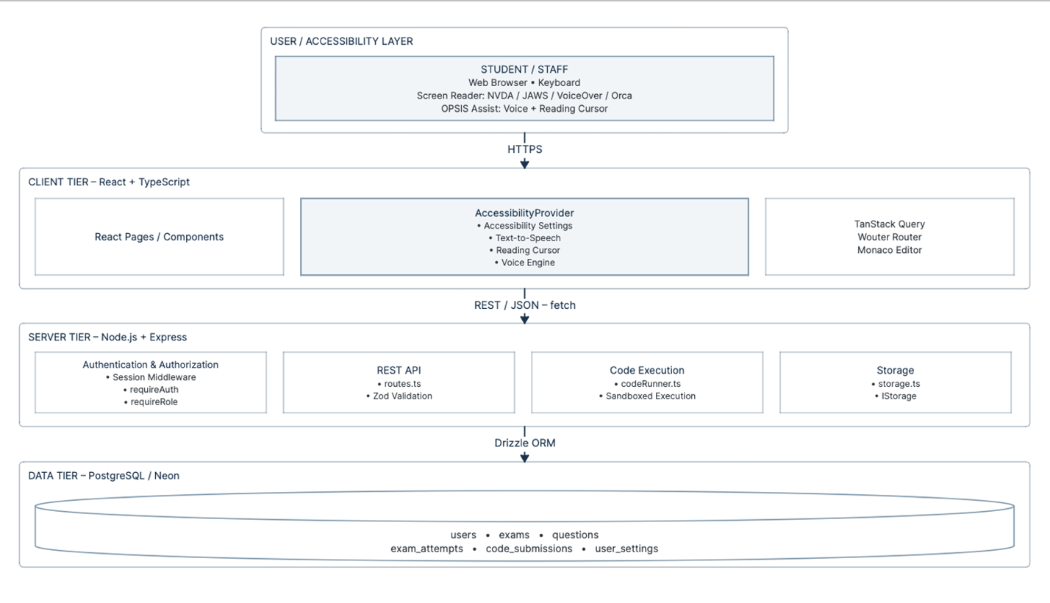
Figure 3.1: High-level architecture of OPSIS

3.2.2 Frontend Architecture
The client is a single-page application using React 18 and TypeScript, built with Vite. Wouter, a minimalistic client-side router, is responsible for routing; a top-level Router component maps paths to page components (Dashboard, ExamTaking, Results, Settings, Help, AccessibilityCenter, ExamManagement, GradeAnswers, AdminPortal, AnalyticsDashboard). State of the server (exams, questions, attempts, settings, analytics) is maintained with TanStack Query, which handles caching, automatic refetching and mutations; local state of UI (visibility of dialogs, drafts of forms, current question index) with React's own useState/useReducer. Forms are made with React Hook Form and validated with Zod schemas; some schemas are shared with the server. Component library relies on Radix UI primitives styled with Tailwind CSS following the shadcn/ui convention; Radix UI primitives were chosen because they have well-built-in ARIA and keyboard interaction features for composite widgets such as dialogs, tabs and radio groups.
The most important architectural aspect of the frontend codebase is AccessibilityProvider (client/src/components/AccessibilityProvider.tsx), a React context provider attached once at the top level of the application. It maintains: the complete accessibility-settings object (more than 40 individual settings fields); the text-to-speech narrator; OPSIS Assist voice recognition session; the "reading cursor" scanner of the DOM; a single keyboard listener for the entire application, used to drive OPSIS Assist and exposing a registerShortcut/registerVoiceScope API for individual pages (ExamTaking, CodeEditor, Results) to contribute their scoped shortcuts and voice commands without having to install a second keyboard listener themselves. The single-owner principle was an architectural fix implemented midway through development, documented in Section 5.4.

3.2.3 Backend Architecture
The backend consists of a Node.js app written in TypeScript and running as native ES modules, using the Express framework for HTTP routing (server/index.ts, server/routes.ts). For authentication, the project uses express-session with an in-memory session store (memorystore) and bcryptjs for password hashing. Two guards at the level of Express are utilised: requireAuth (server/auth.ts), which is mounted on the entire /api namespace after the login/register/me routes and ensures fetching the current user from the storage on every request to make sure that a role change or deletion of the account take effect immediately rather than waiting until the next login; and requireRole(...roles) used to protect specific routes (all /api/admin/* routes, exam/question write routes) from being accessed by anyone other than instructor/admin. Request bodies are validated against Zod schemas (both hand-written route-level schemas and the common insert-schemas which are generated automatically from the Drizzle table definitions using drizzle-zod) before passing to the storage layer, therefore any errors and unexpected fields will lead to a 400 response rather than being silently ignored.
The business logic of the application is implemented in several small modules: routes.ts (HTTP handlers and request/response processing, including sanitization of answers/test-cases to make sure that hidden test cases and correct answers aren't sent to the students which shouldn't see them), storage.ts (an storage-agnostic IStorage interface along with its concrete implementation MemStorage which is used in both development and the current default runtime), codeRunner.ts (the code execution engine described in detail in Section 5.1.4) and auth.ts (sessions typing along with two guards mentioned above). The IStorage interface is designed intentionally to be storage-agnostic – the MemStorage implementation exports the same asynchronous methods as its PostgreSQL-based equivalent would – so the substitution of one implementation with another is possible behind the existing interface; see the current state of it in Section 6.2.

3.2.4 Database Architecture
Persisted data will be modeled using Drizzle ORM using the PostgreSQL database schema that was defined once in shared/schema.ts and used both on the server side for typing storage/queries and client side for TypeScript typing of API responses. Drizzle-Zod generates "insert schemas" from table definitions at runtime to validate them, ensuring that there is no divergence between the validation schema of a request and the row created by it. Connectivity in production will leverage Neon’s PostgreSQL Serverless solution (using @neondatabase/serverless and the WebSocket driver) which was configured for the autoscale deployment target in the Replit setup of this project.

3.3 TECHNOLOGY STACK
The table below is an enumeration of all of the frameworks, libraries, and platforms that are truly included within the project's package.json / configuration files, organized by layer. None of the entries in the table below are merely aspirational; they have all been utilized by some code in this review.

3.3.1 Frontend
Table 3.3: Frontend technology stack
Technology | Role
React 18 + TypeScript | Component-based UI framework and static typing across the client codebase.
Vite | Development server and production bundler; provides hot module replacement during development.
Wouter | Lightweight client-side routing (path-to-component mapping for all pages).
TanStack Query (React Query) v5 | Server-state fetching, caching, and mutation management for all REST API interaction.
React Hook Form + @hookform/resolvers | Form state management with schema-driven validation.
Zod + zod-validation-error | Runtime schema validation shared between client forms and server request bodies.
Radix UI primitives | Accessible, unstyled component primitives (dialog, tabs, select, switch, slider, radio group, toast, etc.).
shadcn/ui pattern + Tailwind CSS | Utility-first styling and a consistent, themeable component layer built on Radix.
@monaco-editor/react (Monaco Editor) | The embedded code editor for programming questions — the same engine used by Visual Studio Code.
Framer Motion | Declarative animation for page/question transitions (respecting the reduced-motion accessibility setting).
Recharts | Charting library used by the Analytics Dashboard and the Admin Portal's illustrative charts.
lucide-react | Icon set used throughout the interface, consistently marked aria-hidden where decorative.
Web Speech API (SpeechRecognition / webkitSpeechRecognition) and SpeechSynthesis | Native browser APIs underlying OPSIS Assist's speech-to-text and text-to-speech, wrapped by the project's own voice/ module rather than called directly from components.

3.3.2 Backend
Table 3.4: Backend technology stack
Technology | Role
Node.js + Express | HTTP server and REST routing.
TypeScript (ES modules) | Static typing and modern module syntax across the server codebase.
express-session + memorystore | Server-side session management (cookie-based, httpOnly, sameSite=lax, 8-hour rolling expiry).
bcryptjs | Salted password hashing (cost factor 12) for stored credentials.
Zod + drizzle-zod | Request-body validation and auto-derived insert schemas from the Drizzle table definitions.
Drizzle ORM + drizzle-kit | Type-safe SQL query building and schema-migration tooling.
@neondatabase/serverless + ws | Serverless PostgreSQL driver (Neon) using a WebSocket connection, for production database access.
esbuild | Production bundling of the Express server for deployment.
Node.js vm module (built-in) | Sandboxed execution context used to run submitted JavaScript/TypeScript against test cases.
esbuild "transform" API | Transpiles submitted TypeScript to executable JavaScript before sandboxed execution.
python3 (subprocess via child_process.execFile) + AST pre-validation | Restricted subprocess execution of submitted Python code, with an AST walk that rejects imports, class definitions, and dunder/global access before execution.
node:child_process, ulimit (via bash -c) | Process-level CPU-time, virtual-memory, and file-size limits applied to every code-execution subprocess.

3.3.3 Data & Infrastructure
Table 3.5: Data and infrastructure technology stack
Technology | Role
PostgreSQL (via Neon serverless) | Relational database engine for production persistence.
In-memory storage (MemStorage) | The IStorage implementation currently used at runtime (development and the current default), holding all entities in JavaScript Maps with seeded sample data; see Section 6.2.
Replit (development platform) | The cloud IDE/runtime the project was built and iterated in; also its default deployment target (autoscale).
Docker + docker-compose (present in a sibling variant of the project) | Containerised build/run configuration explored for deployment portability.
GitHub Actions (present in a sibling variant of the project) | CI workflow configuration for automated checks on push.

3.3.4 Development Tools
Table 3.6: Development tools
Tool | Role in development
Replit workspace | Primary development environment: in-browser editor, integrated shell, package management, and the built-in "Start application" workflow (npm run dev on port 5000).
Replit AI Agent (specification-driven iterative development) | A significant portion of OPSIS was built through detailed, written engineering specifications given to an AI coding agent inside Replit — see Section 5.4, which reproduces the actual specification documents used for the security/grading-integrity pass and the OPSIS Assist voice-system rewrite. These documents were retained in the project's attached_assets/ directory as a record of the development process.
TypeScript compiler (tsc) | Static type checking (npm run check) across the whole codebase.
Node.js built-in test runner (node --test) | Runs the project's unit and integration tests for the voice engine (test:voice) and server security/grading logic (test:security).
Puppeteer-core + a bundled Chromium build | Headless-browser end-to-end testing of the OPSIS Assist keyboard/voice lifecycle (test:assist-browser).
Drizzle Kit | Generates and applies SQL migrations from the shared schema (npm run db:push).
Browser developer tools (manual) | Used for manual verification of ARIA semantics, keyboard tab order, and console-error-free operation during development.

3.4 SYSTEM DESIGN

3.4.1 End-to-End User Workflow
The below trace illustrates the sequence of activities that occur from the time when the student starts up OPSIS till he gets his answer — the actual realization of the generic workflow asked for in this report.

1. User opens OPSIS in a browser (with or without a screen reader running).
2. App.tsx calls GET /api/auth/me; if no session cookie is present or valid,
the accessible AuthForm (sign in / register) is rendered.
3. User authenticates (POST /api/auth/login or /api/auth/register).
→ bcrypt.compare() verifies the password; a new session is regenerated
and req.session.user is populated with {id, username, role}.
4. On success, AccessibilityProvider mounts for the authenticated user:
- loads saved settings from localStorage immediately (instant, offline-safe)
- then fetches GET /api/settings/:userId and merges server-stored
preferences (font size, contrast, speech, voice mode, ...) over the local copy
5. User lands on Dashboard (student) or AdminPortal (instructor/admin).
6. User interacts via keyboard (Tab / Alt-shortcuts), a third-party screen
reader, and/or OPSIS Assist (Ctrl+Shift+Space to toggle the continuous
reading-cursor + voice layer described in Section 4.4).
7. User starts an exam → POST /api/attempts creates an ExamAttempt row and
starts the client-side timer from exam.duration.
8. ExamTaking renders the current question via QuestionRenderer, which
dispatches to the correct sub-renderer for the question type.
9. Every answer change updates local state and is queued for autosave;
two seconds after the last change, PUT /api/attempts/:id persists
{ answers } to the attempt row.
10. For a coding question, "Run" (F5, the Run button, or the voice command
"run tests") calls POST /api/code/execute; the server runs the code
in codeRunner.ts, stores a CodeSubmission row, and returns per-test
results (with hidden-test details stripped) — the UI announces the
outcome via the accessibility live region and, if enabled, speech.
11. On submission, the user stages ("submit exam" / the Submit button),
confirms ("confirm submit" / the Confirm button), and the client sends
PUT /api/attempts/:id with completedAt set; the server computes the
final score via gradeAttempt() (Section 5.1.7) and marks the attempt
graded unless a short-answer question requires manual review.
12. The client is redirected to /results/:attemptId, where Results.tsx
fetches the attempt and exam, and presents score, percentage,
pass/fail, and a per-question breakdown — readable in full via the
"read results" voice command or Alt+R-equivalent speech trigger.

3.4.2 Component / Data-Flow Architecture
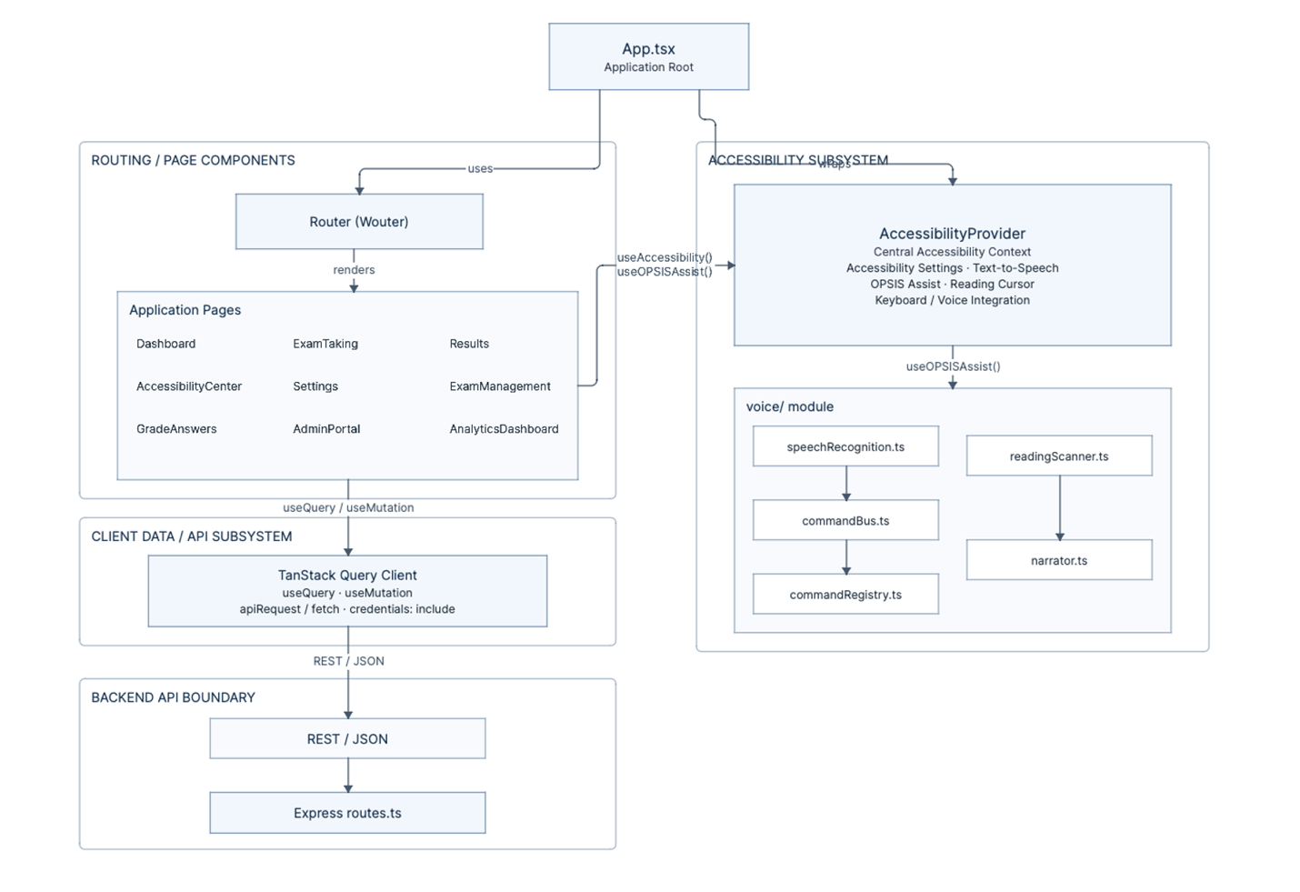
Figure 3.2: Component / data-flow architecture

3.5 DATABASE DESIGN
The schema is only declared once in shared/schema.ts using the PostgreSQL table builder provided by Drizzle ORM. Each primary key is a server-generated UUID (gen_random_uuid()). There are six tables in total that represent our entire domain. The insert validation for each of the tables is automatically generated using drizzle-zod's createInsertSchema(), ensuring consistency between the two sets of constraints.

3.5.1 Entity–Relationship Overview
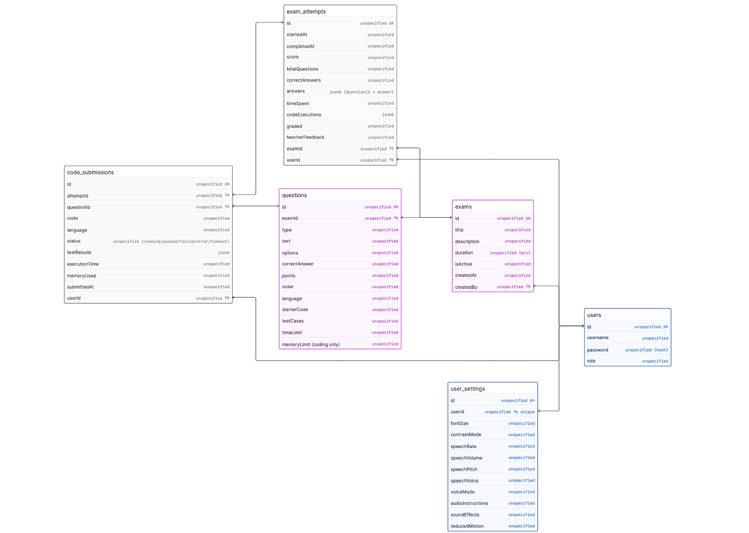
Figure 3.3: Entity–relationship overview

3.5.2 Table Reference
users
Table 3.7: Table reference — users
Field | Type | Notes
id | varchar (UUID) | Primary key, server-generated.
username | text | Unique; used for both students (e.g. a roll number such as "S001") and staff.
password | text | bcrypt hash — never the plaintext password (see Section 4.5 and 5.5).
role | text | 'student' | 'instructor' | 'admin', default 'student'.

exams
Table 3.8: Table reference — exams
Field | Type | Notes
id | varchar (UUID) | Primary key.
title / description | text | Exam metadata; description is optional.
duration | integer | Exam length in minutes; drives the client-side countdown timer.
createdBy | varchar (FK → users.id) | The authoring instructor; used for ownership checks (canManageExam).
isActive | boolean | Whether students can currently see/attempt the exam (default true).
createdAt | timestamp | Server-set on creation.

questions
Table 3.9: Table reference — questions
Field | Type | Notes
id / examId | varchar (UUID) | Primary key; foreign key to the owning exam.
type | text | 'multiple_choice' | 'short_answer' | 'true_false' | 'coding'.
text | text | The question prompt.
options | jsonb | Array of {id, text} for multiple-choice options; null otherwise.
correctAnswer | text | Canonical answer for auto-graded types; stripped from API responses to students unless they own/manage the exam.
points / order | integer | Scoring weight and display order within the exam.
language | text | Coding-question only — 'javascript' | 'python' | 'java' | 'cpp' | 'c' | 'typescript' | 'go' | 'rust' (only the first three are executable server-side; see Section 5.1.4).
starterCode | text | Coding-question only — the initial template shown in the editor.
testCases | jsonb | Coding-question only — array of {id, input, expectedOutput, description?, isHidden?}.
timeLimit / memoryLimit | integer | Coding-question only — per-question execution ceiling (seconds / MB), enforced by codeRunner.ts.

exam_attempts
Table 3.10: Table reference — exam_attempts
Field | Type | Notes
id / examId / userId | varchar (UUID) | Primary key and foreign keys to the exam and the student.
startedAt / completedAt | timestamp | completedAt is null while the attempt is in progress.
score / correctAnswers / totalQuestions | integer | totalQuestions is actually the sum of question points (see Section 6.3 for this naming nuance); score and correctAnswers are computed server-side by gradeAttempt().
answers | jsonb | Map of questionId → the student's current answer (or, for coding questions, their latest code).
timeSpent | integer | Minutes elapsed, recorded at submission.
codeExecutions | jsonb | Reserved field for execution-history tracking on the attempt itself (in the current implementation, per-execution detail is authoritative in the separate code_submissions table).
graded / teacherFeedback | boolean / text | graded is true once every short-answer question (if any) has been manually scored; teacherFeedback holds the instructor's consolidated written feedback.

code_submissions
Table 3.11: Table reference — code_submissions
Field | Type | Notes
id / attemptId / questionId / userId | varchar (UUID) | Primary key and foreign keys tying a submission to its attempt, question, and author.
code / language | text | The exact code submitted and the language it was executed as.
status | text | 'running' | 'passed' | 'failed' | 'error' | 'timeout'.
testResults | jsonb | Per-test-case pass/fail, actual vs. expected output, timing, and error text.
executionTime / memoryUsed | integer | Milliseconds and KB, as reported by the execution engine.
submittedAt | timestamp | Server-set at execution time.

user_settings
Table 3.12: Table reference — user_settings
Field | Type | Notes
id / userId | varchar (UUID) | Primary key; userId is unique (one settings row per user).
fontSize / contrastMode | integer / text | Server-persisted subset of the full client-side accessibility-settings object (see Section 4.3.2 for the complete client-side settings model, which is broader than this table).
speechRate / speechVolume / speechPitch / speechVoice | integer / integer / integer / text | Text-to-speech tuning, persisted server-side so preferences follow the user across devices.
voiceMode | text | 'off' | 'push-to-talk' | 'assist'.
audioInstructions / soundEffects / reducedMotion | boolean | Core accessibility toggles persisted server-side; the remaining ~30 client-side preference fields are currently persisted only in the browser's localStorage — see Section 6.3.

3.5.3 CRUD Operations
All tables are accessed via the IStorage API with all the necessary CRUD operations depending on the nature of each table (for instance, questions support CRUD but exam_attempts and code_submissions have only create/read/update because you can never delete an attempt in order to keep track of all exam sessions). All writes are done via Zod validated schemas for inserts and partial updates and all reads involving question information are done through the sanitizeQuestion() function where the correctAnswer and any hidden test cases are stripped unless the reader is the owner of the exam.

3.6 OVERALL DATA FLOW
In each section 3.2 15 16, and 18, a high-level data-flow diagram has been made with one concern in focus (architecture, module integration, the examination lifecycle, voice processing). Here you have the only view of the entire system these details fit into the fully expanded set of data the platform handles, and the single set of tiers it passes through.
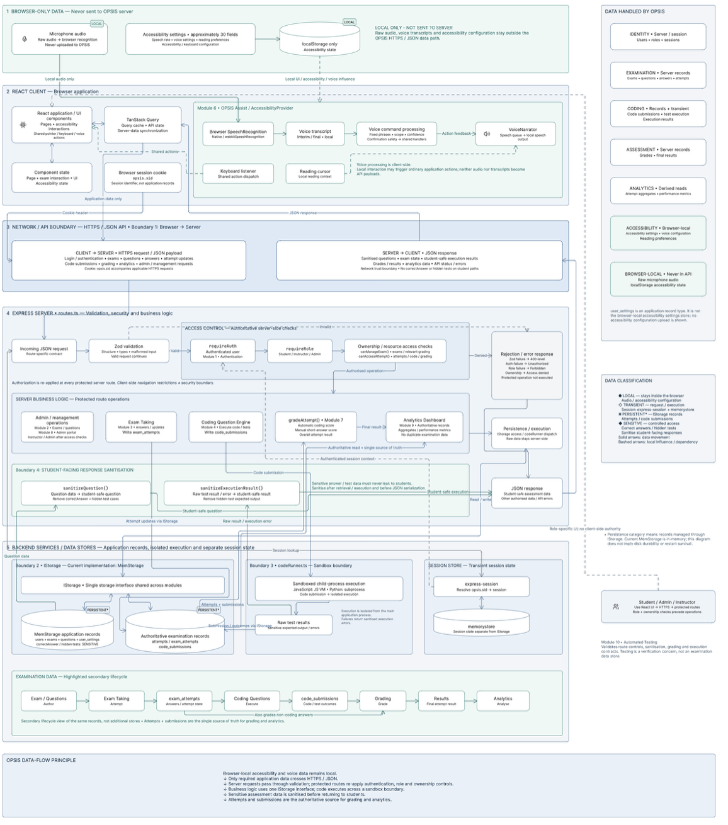
Figure 3.4: Overall data flow

3.6.1 Categories of data and where they live
Table 3.13: Categories of data and where they live
Data category | Where it originates | Where it is persisted | Crosses the network?
Credentials | Login/registration form | bcrypt hash in the users table | Yes — password sent once over HTTPS at login/registration only, never stored or echoed back in plaintext.
Exam/question content | Instructor authoring (Module 2) | exams / questions tables | Yes, sanitised per-viewer by sanitizeQuestion().
A student's answers and code | Exam Taking / Coding Question Engine (Modules 3–4) | exam_attempts.answers, code_submissions | Yes — autosaved continuously, not only at submission.
Execution results | codeRunner.ts (Module 4) | code_submissions.testResults | Yes, with hidden-test detail stripped for the executing student.
Scores and feedback | gradeAttempt() (Module 7) | exam_attempts.score/correctAnswers/teacherFeedback | Yes — delivered to Results.tsx and the Analytics endpoint alike.
Core accessibility settings (~10 fields) | AccessibilityProvider (Module 5) | user_settings table | Yes, debounced PUT to /api/settings/:userId.
Remaining accessibility settings (~30 fields) | AccessibilityProvider (Module 5) | Browser localStorage only | No — this subset never reaches the server (Section 5.1.5/6.3).
Microphone audio | BrowserSpeechEngine (Module 6) | Not persisted anywhere | No — processed by the browser's own SpeechRecognition implementation; OPSIS never receives raw audio.
Aggregate analytics figures | Computed on demand by GET /api/analytics/overview (Module 9) | Not separately persisted — recomputed from exam_attempts/code_submissions on each request | Yes, in the response to an authorised instructor/admin request only.

3.6.2 What this view makes explicit
- There are two different types of data that are explicitly never transmitted to the server. These are raw microphone audio and approximately 75% of the accessibility-settings model, and so that is why in Section 5.1.5 and Section 5.1.6 device/browser-level limits are described (no cross-device settings sync for this portion; no server-side voice-accuracy telemetry) as a knock-on effect of this data flow decision, rather than as something to be fixed with isolated bug reports.
- Each and all of the data types that do traverse the network is processed by the very same validation/authorisation/sanitisation layer in routes. Ts (Section 5.2) no matter what module it's part of. This fundaments the consistent security stance described in Section 5.5.

CHAPTER 4
PROJECT DESCRIPTION

4.1 MODULE DESCRIPTION
The components of OPSIS are listed below.All the above modules have been detailed separately in Section 5.1.This table gives an overall idea of all the modules mentioned in this document.
Table 4.1: Modules of OPSIS
# | Module | Summary | Status
1 | Authentication & User Management | Registration, login/logout, session-based role authorisation. | Complete
2 | Exam & Question Management | Instructor authoring of exams and all four question types. | Complete
3 | Accessible Examination Interface | Timed, keyboard/voice/screen-reader-operable question navigation, flagging, autosave, submission. | Complete
4 | Coding Question Engine | Monaco editor + sandboxed JS/TS/Python execution against test cases. | Complete for JS/TS/Python; UI lists 5 additional non-executable languages
5 | Accessibility Profile / Settings | Persisted, per-user visual, audio, navigation, and cognitive-load preferences. | Complete, with a documented settings-page duplication — Section 6.3
6 | OPSIS Assist (Voice & Reading Cursor) | Unified keyboard listener, non-visual reading cursor, continuous voice commands, centralised narrator. | Implemented; last recorded end-to-end test run failed — Section 5.1.6/5.3
7 | Grading (Automatic + Manual) | Server-side auto-grading of objective/coding questions; instructor UI for short-answer grading. | Complete, with one scoring-workflow defect documented in Section 5.1.7/6.3
8 | Administrative Console (Admin Portal) | Role management (real), plus student/faculty/department/reporting sections. | Partially complete — role management and a subset of views are live; several sections use illustrative data (Section 6.3)
9 | Analytics Dashboard | Evidence-based usage, score-distribution, and question-difficulty analytics. | Complete
10 | Automated Test Suite | Unit/integration tests (security, grading, code execution, voice matching) and a Puppeteer E2E test. | Complete — see Section 5.3 for the last recorded run status

4.2 THE ACCESSIBLE EXAMINATION SYSTEM
The latter four sections 5.1.2, 5.1.3, 5.1.4, 5.1.7 each also describe the internals of one module in isolation. The purpose of describing it from the other direction in this section the continuous path a student journeys along from the time an exam is set to the time a result is received was because an accessibility promise that applies to one module and fails at the transfer to the next would be completely hidden if each module were read independently.

4.2.1 End-to-End Examination Workflow

1. INSTRUCTOR AUTHORS EXAM (Module 2)
Creates exam metadata + questions (MCQ/true-false/short-answer/coding);
server re-validates completeness (validateQuestion()) before accepting.

2. STUDENT STARTS ATTEMPT (Module 3)
POST /api/attempts creates an exam_attempts row; timer seeded from
exam.duration; AccessibilityProvider/OPSIS Assist already active
from the moment the page mounts — no separate "accessible mode" to
switch on.

3. STUDENT ANSWERS QUESTIONS (Modules 3 + 4)
Every navigation/answer/flag action passes through
dispatchExamAction(), identically for mouse, keyboard, and voice.
Coding questions additionally round-trip through
POST /api/code/execute (Module 4) for each "Run Tests".
Answers autosave (debounced PUT) throughout; nothing is held only
in memory until submission.

4. STUDENT SUBMITS (Module 3, two-stage safety)
stageSubmit → confirmation dialog (answered/unanswered/flagged
summary) → confirmSubmit → PUT with completedAt set.

5. SERVER GRADES (Module 7)
gradeAttempt() scores MCQ/true-false/coding immediately;
short-answer, if present, leaves graded:false pending an
instructor.

6. [If short-answer present] INSTRUCTOR GRADES (Module 7)
GradeAnswers.tsx → instructor assigns points/feedback →
gradeAttempt() recomputes the total → graded:true.

7. STUDENT VIEWS RESULT (Results.tsx)
Score, per-question breakdown, and any instructor feedback,
voice/keyboard-navigable identically to the exam interface itself.

4.2.2 What "accessible" means across the whole workflow, not just within one screen
- Continuity of interaction model: the registration of the same set of keyboard shortcuts, and the scoping mechanism for the voice-commands (Module 6), is the same on the exam page, when in the editor of a code question, on the results page there is never a place in the journey when a student has to learn another, page-specific interaction.
- Continuity of state truth; the visual navigator sidebar, the mobile dot-navigator and all speech announcement of exam state(answered/flagged/redid etc.) all come from the same source React state(Module 3) rather than separate visual and non-visual states that could conflict.
- Continuity of safety assurances: the two-step submit protocol and the destructive-action flag in the voice command register (6) occurs at precisely the one step in the entire process where submission is irrevocable, and there is no Like that required double check, thereby constraining the additional inconvenience to coequal the true danger.
- Continuity of academic integrity: since both code executing (Module 4) and marking (Module 7) occur on the server against the stored records (accessible to all students), a student's scripting tool (voice input, read cursor) is limited to producing the same 'inputs' a mouse/keyboard user could; it hasn't been granted a 'free' way to produce better marks.

4.2.3 Known cross-cutting limitations of the workflow
- Moreaccessibility optionsare available on extendedTimeouts/timeoutWarningsbut they're not connected to the timer for submitting (Section 5.1.3/6.3). An accommodation set up in Module 5 displays this option but doesn't actually alter how Module 3 works.
- The "Download Results" action in Results. Tsx is a stub (alert not a true export) so the last step of this workflow currently ends on-screen only, with no offline copy available see Section 6.3.

4.3 ACCESSIBILITY DESIGN
This section distils the specific accessibility methods common to all the modules discussed in Section 5.1 into one description of the platform's design philosophy, and makes explicit what has, and has not, been formally validated.

4.3.1 Design philosophy: screen-reader-first, not screen-reader-retrofitted
The general motif from start to finish is that non-visual access is designed as the primary access method, with visual UI overlays added on afterward, unlike the other way around. In specific; the current question, whether a response has been given, and how much time has passed is stored once in React state and referenced by visual UI, ARIA live-region text, and spoken narration (Section 4.2.2); composite widgets are created from Radix UI primitives because they come prepackaged with ARIA roles/states and keyboard interaction behaviors baked in, without the need for additional custom code; and the reading cursor and keyboard shortcut management is centralized within one controller (Module 6) to ensure that non-visual navigation is a core feature, not a paged add-on.

4.3.2 The accessibility-settings model
AccessibilityProvider's AccessibilitySettings object (Module 5) allows a user to customize this design to their own requirements: over 40 fields across vision (font size, contrast mode, colour-blind palettes, cursor size), reading (reading mask, reading guide line, spacing), audio/speech (rate volume pitch, voice selection, audio instructions, sound effects), navigation (voice mode, keyboard-only affordances), and cognitive load (reduced motion, simplified layout) a substantively more comprehensive set of controls than the approximately ten fields currently persisted server-side (Section 5.1.5's user_settings table).

4.3.3 Accessibility Interaction Flow
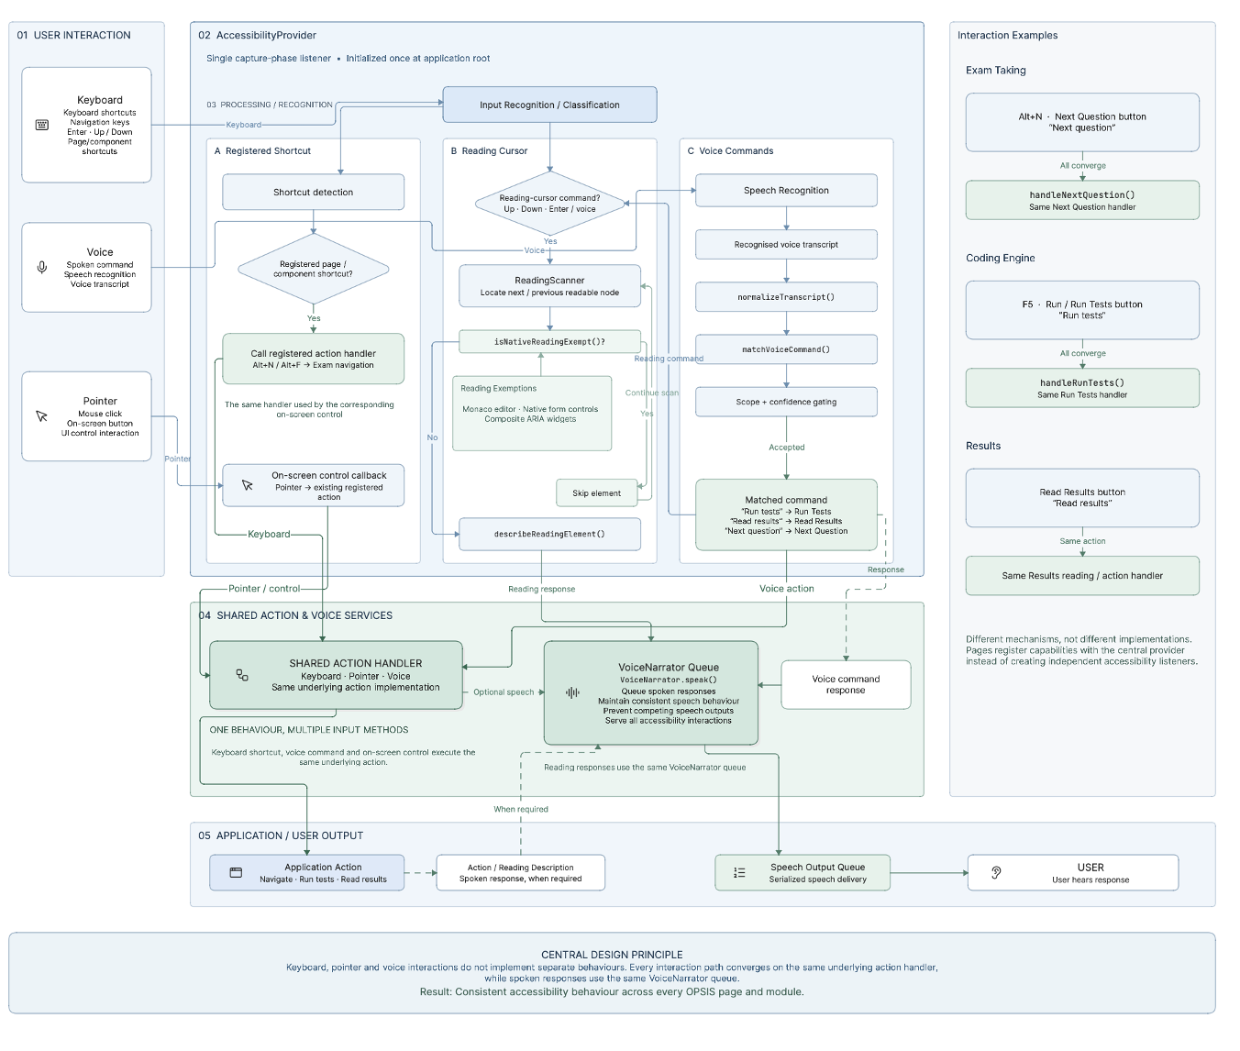
Figure 4.1: Accessibility interaction flow

4.3.4 Concrete ARIA and semantic-HTML techniques observed in the codebase
- Landmark regions and skip links: role="application"/"banner"/"navigation"/"contentinfo" on major areas of the exam page (Section 5.1.3), plus skip-links to get past repeat content a focus-target bug for a skip-link was discovered and fixed during development (Section 5.4).
- Live regions: announceToScreenReader writes to an ARIA live region instead of visual change alone (answer recorded, exam created, settings changed, network status).
- Labelled and grouped form controls: React Hook Form datafields are given labels; the coding-question authoring form (Module 2) gives its language/starter-code/test-case datafields a with an appropriate.
- Error detection: validation errors at the field level have role="alert" so are announced as they're computed (Module 2); mod failure errors show as more understandable toast text than generic mod failure message.
- aria-label on state aware controls: the per-question buttons within the exam navigator for the exam test controls provide a full aria-label stating the state of the button in words (e.g. "Question 4 current flagged, answered") instead of just some colour/icon differentiation(Module 3).
- Deliberate aria-live="off" on the per-second text of the countdown timer so that a screen reader does not re-announce it each tick, with an explicit, on-demand read timer affordance (Module 3) this is an example of a design action attempting to prevent naïve, verbose accessibility implementation.

4.3.5 Illustrative mapping to WCAG 2.1/2.2 success criteria
The application's own UI (the InternationalKeyboardHelp and AccessibilityCenter components) displays this conformance badges (checkmarks), under the words Documentation and Application in the ToolsMenu window: WCAG 2.1 AA / WCAG 2.2 AA / Section 508 / EN 301 549 / ADA / DDA / AODA. This report considers those badges to be the project's own publicly stated goal, rather than certified conformance, as no formal, tool-supported accessibility audit (for instance: an automated axe-core scan or a manual screen-reader conformance baseline comparison against the full WCAG success-criteria list) has been performed on the product as evidenced by the work included in this report. These table is an illustrative mapping, for this report alone, between particular features that were implemented and the WCAG criteria they most directly relate to; it records design intent supported by real code, rather than certified conformance.
Table 4.2: Illustrative mapping to WCAG 2.1/2.2 success criteria
WCAG Success Criterion | OPSIS feature addressing it
1.1.1 Non-text Content | Icons are consistently marked aria-hidden where decorative (Section 3.3.1); no user-facing icon is the sole conveyor of information without an accompanying label.
1.4.3 / 1.4.6 Contrast (Minimum / Enhanced) | Contrast-mode setting in the accessibility profile (Module 5), togglable independently of theme.
2.1.1 Keyboard | Every documented interaction — exam navigation, coding, settings, admin Role Management — is operable via the keyboard shortcuts and reading cursor OPSIS Assist provides (Module 6).
2.2.1 Timing Adjustable | Partially addressed: the exam timer exists and warns audibly at fixed thresholds, but the extended-time accommodation setting is not yet wired to it (Section 5.1.3/6.3) — an identified gap, not a met criterion.
2.4.3 Focus Order | Radix UI primitives' built-in focus management for dialogs/menus; a skip-link focus-target defect was found and fixed during development (Section 5.4).
2.4.7 Focus Visible | Inherited from the underlying Tailwind/Radix component styling used throughout (Section 3.3.1) — not independently audited for this report.
3.3.1 / 3.3.3 Error Identification / Suggestion | role="alert" field errors with specific, readable messages in the exam-authoring and settings forms (Sections 5.1.2, 5.1.5).
4.1.3 Status Messages | announceToScreenReader() live-region announcements used consistently for state changes across modules (Section 4.3.4).

4.3.6 Known limitations of the accessibility design
- No formal accessibility audit (automated or manual) has been done; these mapping is our own analysis of implemented features against relevant sections this report does not constitute a certification.
- The visual/non-visual continuity identified in Section17.1 has been confirmed for the modules tested using the automated test suite and by reviewing the code directly (Section14), but not for the example Admin Portal parts (Section14.8) which were not within scope for our accessibility review.
- This settings related to being colour-blind-friendly, palette, and cursor-size are in the settings model (Section 4.3.2), but to save one of over 40 such fields on the client side there is currently no needs to be stored persistent on the server (Section 5.1.5).

4.4 VOICE INTERACTION
Here, I put together the whole voice-command function of OPSIS Assist (what was presented as Module 6, Section 5.1.6) into one complete reference: the complete set of commands, the fixed algorithm behind the command system, and the process an utterance goes through (from microphone to action).

4.4.1 Design principle: deterministic, not conversational
In OPSIS, voice command playback events are matched and dispatched by a fixed-phrase confidence-gated pattern match system(VoiceCommandBus and the VOICE_COMMANDS registry, commandRegistry. Ts) there is no generative-AI or natural language understanding component to interpret arbitrary utterances, a scope choice, which is explicitly specified in the project's own requirements documents (Section 1.5.2, Section 5.4). Predictability is prioritized over conversational flexibility: a user can memorize and build a muscle memory for a fixed predetermined vocabulary(fallbacks are documented in docstrings and in full below and in InternationalKeyboardHelp. Tsx / Help. Tsx), and expect consistent, reliable "behavior" every time it's used, unlike a probabilistic interpretation that might yield something different on multiple identical attempts at the same phrase- a goal explicitly maintained for a system used in timed, high-stakes tests.

4.4.2 Voice Command Processing Flow
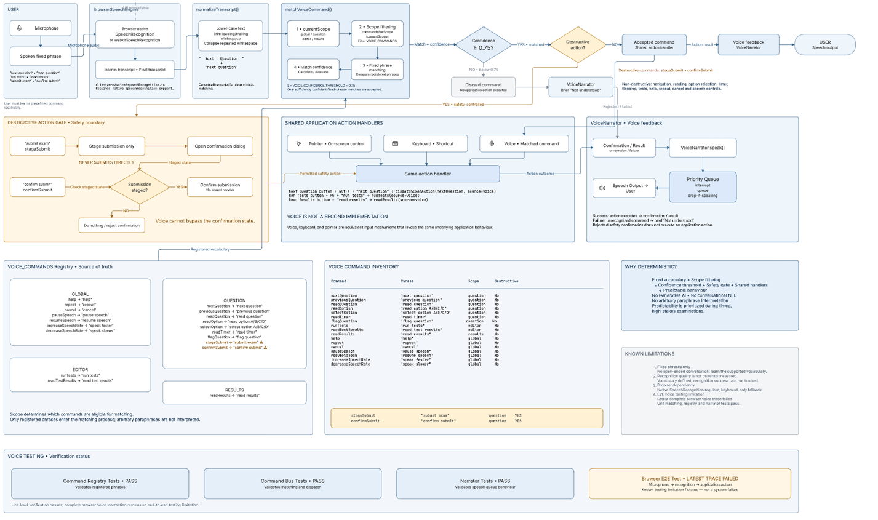
Figure 4.2: Voice command processing flow

4.4.3 Complete voice-command inventory
Table 4.3: Complete voice-command inventory
Command | Representative phrase(s) | Scope | Destructive?
nextQuestion | "next question" | question | No
previousQuestion | "previous question" | question | No
readQuestion | "read question" | question | No
readOption | "read option A" (also B/C/D, or true/false) | question | No
selectOption | "select option A" (also B/C/D, or true/false) | question | No
readTimer | "read timer" | question | No
flagQuestion | "flag question" | question | No
runTests | "run tests" | editor | No
readTestResults | "read test results" | editor | No
readResults | "read results" | results | No
help | "help" | global | No
repeat | "repeat" | global | No
cancel | "cancel" | global | No
pauseSpeech | "pause speech" | global | No
resumeSpeech | "resume speech" | global | No
increaseSpeechRate | "speak faster" | global | No
decreaseSpeechRate | "speak slower" | global | No
stageSubmit | "submit exam" | question | Yes — stages only, opens confirmation dialog
confirmSubmit | "confirm submit" | question | Yes — only acts if a submission is already staged

4.4.4 Why voice is never a second implementation
Each row in what I just said table ultimately produces the same function being called by the corresponding button or shortcut key (section 5.1.3's dispatchExamAction(action, source) is the most obvious one, where source is just used to identify whether this is also spoken). This is the core reason why the three input methods - pointer, keyboard, and voice - are truly equivalent.

4.4.5 Known limitations
- No open or conversation style voice interface issues for spoken commands must use (or learn) these collection of fixed phrase utterances, there is no meaning-preserving, but differently-worded exception here.
- Voice-recognition success rate is not tracked/recorded (Section 5.1.9) this section is listing what the system is supposed to recognize, not how much is actually recognizes.
- Recognition will only work if the browser supports the native SpeechRecognition API, and will fall back to keyboard-only if the API is not available (Section 5.1.6).
- The last browser end-to-end test run of the complete voice flow failed for the final recorded trace of the (Section 5.1.6/5.3), but the command-matching tests at unit level (commandBus/commandRegistry/narrator) pass regardless.

4.5 AUTHENTICATION AND USER MANAGEMENT
The inner workings of the authentication module are described in module 1 (Section 5.1.1); this section encapsulates the identity and authorisation model underlying and referenced by all subsequent modules in Section 5.1 into one account, with flow diagram.

4.5.1 User Authentication Flow
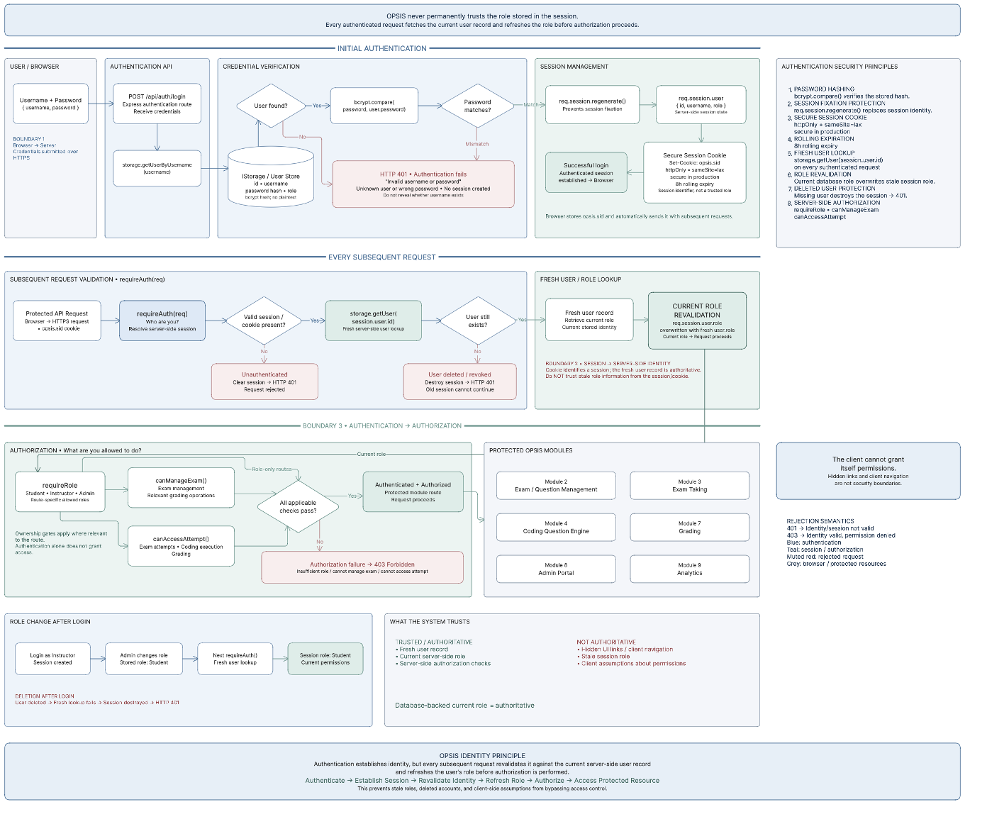
Figure 4.3: User authentication flow

4.5.2 Role model
The only three possible requirements for a given user account in OPSIS are student, instructor, or admin (all stored as a single string on the users table. There are no other roles or permissions tables present). All new accounts are created "student" by default, as a user cannot select instructor or admin roles while registering. An instructor or admin account is created by one of two mechanisms: an existing admin user "promotes" an account to instructor or admin by the Admin Portal's Role Management (Section 5.1.8, PUT /api/admin/users/:id/role). Or an initial admin account in a production environment is created using the BOOTSTRAP_ADMIN_USERNAME/BOOTSTRAP_ADMIN_PASSWORD environment variable mechanism (Section 5.1.1).
Table 4.4: Role model — capabilities by role
Capability | Student | Instructor | Admin
Take an exam / view own results | Yes | N/A (not the intended use) | N/A
Author/edit/delete exams and questions | No | Own exams only (canManageExam()) | Any exam
Grade short-answer responses | No | Own exams' attempts only | Any attempt
View Analytics Dashboard | No | Own exams' data only | All active exams' data
Access Admin Portal / Role Management | No | No | Yes
Change another user's role / delete a user | No | No | Yes

4.5.3 Authorisation is re-checked, not cached, at every layer
The platform's authorisation model is built of three separate mechanisms, each enforced by the server on every relevant request rather than presuming from a value stored in the client: requireAuth (Section 4.5.1) verifies and re-verifies identity/role; requireRole(...roles) restricts entire groups of routes to particular roles (e.g. instructor/admin-only exam-authoring routes, admin-only Role Management routes); and resource level ownership functions canManageExam and canAccessAttempt also ensure that the logged-in user is not simply in a suitable role but in fact owns (or is an admin of) the particular exam or attempt in question; Section 5.2 shows how these three checks are propagated throughout all other modules' routes.

4.5.4 Known limitations
- There was no flow to reset/forget password, there was no multi-factor authentication enabled on logins, and there was no account lock out or limited number of allowed attempts to log in (see 23 for reasons).
- No institutional SSO/identity-provider integration local username/password only.
- Rollover occurs on the revalidating user's next request (Section 4.5.1), not immediately if they're currently issuing a request at the time of rollover a unavoidable and slight timing factor of re-validating per-request instead of pushing a real-time revocation signal.

CHAPTER 5
IMPLEMENTATION AND DISCUSSION

5.1 DETAILED IMPLEMENTATION
In this section, each individual module is described using a consistent format, which consists of purpose, the problem solved by the module, design/implementation strategy, internal and external workflows, accessibility issues, input/processing/output, error handling, security, testing, status of the project, and its limitations before going to Section 5.2 which talks about integration.

5.1.1 Module 1 — Authentication and User Management
Purpose and problem addressed
.User requirement
It needs to be possible for a student or faculty member to be able to register and log in using just a keyboard and/or screen reader, be provided with an immediate verbal announcement of any validation or credentials error, and maintain persistent session and roles throughout (and even after a role change by the administrator), unless there is an actual expiration of the session.
Design approach and technologies used
The process of authentication is purposely simple — username and password only, no identity provider involved whatsoever — and it is achieved by using the library called express-session (the cookie name is opsis.sid, httpOnly, sameSite=lax, secure, 8 hours of expiration period, which is a rolling one), as well as bcryptjs for password hashing (cost factor is 12). There is a client-side AuthForm, which is made from React Hook Form and a Zod schema (loginSchema and registerSchema), which means that the client-side calculates validation errors before sending a request, while it is re-validated by the server (credentialsSchema, registrationSchema).
Internal workflow
- Registration: POST /api/auth/register verifies the payload, searches for an existing user using storage.getUserByUsername(), creates a user with fixed role "student" (instructor or admin account cannot be registered by itself — see Section 4.5), creates a default user_settings row for the newly created account, regenerates the session (req.session.regenerate) to protect from session fixation, and returns the user object.
- Login: POST /api/auth/login finds the user using username, compares the given password with the bcrypt hash stored with bcrypt.compare() function, and if the comparison succeeds — regenerates the session and saves {id, username, role} in req.session.user.
- Session check: GET /api/auth/me is called on each page load, and if the session is not set, it returns {user: null} (this renders the AuthForm), otherwise calls requireAuth middleware, thus the "who am I?" check and all the other protected routes have the same code.
- Revalidating the role on each request: requireAuth doesn't blindly trust the role stored in the session cookie. On each authenticated request it queries for the user again using storage.getUser(id) and updates req.session.user.role to the current role, so any role change made by an admin (PUT /api/admin/users/:id/role) or account deletion affects the session immediately. This functionality is automated tested (Section 5.3).
- Logout: POST /api/auth/logout destroys the session on server side and clears the cookie.
User workflow (accessibility-annotated)
The user uses the tab key to navigate to the Sign In / Register segmented control (role="tablist" and aria-selected attribute in all tabs), then uses the tab key again to select the username and password fields (each with a corresponding <Label> element), and presses enter. The failure in validation (e.g. password less than 8 characters long) is displayed below the field; any failure of login/registration is displayed using a destructive toast notification with a message. ("Invalid username or password" or "Username already exists or invalid data").
Input / Processing / Output
Input: username (truncated, 1-100 characters) and password (8-200 characters) during registration; username and password (both required, no upper length limit re-imposed) during login. Processing: Zod validation → (during registration) uniqueness test → bcrypt hashing/verification → session creation. Output: JSON {user: {id, username, role}} if successful; JSON {message} and corresponding HTTP status (400 for validation errors, 401 for wrong username/password pair, 409 for duplicate username) if unsuccessful.
Error handling
All paths encapsulate their code within a try/catch; a validation exception thrown by Zod is considered distinct from a server error and is returned as a 400 status rather than 500 status so that the client can display the proper response instead of a vague error condition. The AuthForm component on the client-side renders these exceptions as toasts and renders field-specific exceptions near the fields themselves.
Security considerations
Passwords will NEVER be stored in clear text — the password is hashed using createUser(), which utilizes bcrypt, and the defense of password.startsWith("$2") will avoid re-hashing an already hashed password should it pass through internal code more than once. The session cookie is also marked as httpOnly, making it inaccessible by client side JavaScript and preventing XSS-driven session hijacking.
Testing performed
auth.test.ts (automated Node.js test runner) tests that the user’s authorized role is reread from storage with each requireAuth call, as well as testing that if the role changes during a session, the new role is read the next time. passwordSecurity.test.ts tests that the createUser() function does not store a plain-text password, and that the bcrypt.compare() method successfully accepts the correct password but rejects the incorrect password. productionBootstrap.test.ts tests that in a production environment, no demo accounts (the seeded “instructor” and “S001” accounts used for development) will be created unless bootstrap-admin environment variables are set.
Current status
Done. Registration, login, logout, sessions and per request revalidation of roles are all done and have been automatically tested.
Known limitations
- Lack of password reset process.
- Lack of multi-factor authentication.
- Lack of account lockout or rate limiting after multiple failed login attempts (refer to Section 5.5).
- Instructor/Admin accounts cannot be self-registered because registration will always generate "Student" role – creating an instructor account is currently possible only with an existing admin account promoting an account through Admin Portal's role management or production bootstrap-admin environment variable upon initial deployment.
Possible future improvements
- Institutional Single Sign-On (SSO/SAML/OAuth) Integration to be used inside an institutional identity solution.
- Password policy and breached passwords validation capabilities.
- Multi-factor authentication support for instructor/admin accounts.

5.1.2 Module 2 — Exam and Question Management
Purpose and problem addressed
The instructor needs a system that can produce not just basic questions but programming questions – the exact thing that this project aimed to achieve (Section 2.2). The system should be able to provide the instructor with everything necessary in order to create a programming question, including: the starting code shown to the learner; the programming language that it should run in; and several test cases (with some visible to the learner, some invisible).
User requirement
The teacher should be able to design the test, include any of the four kinds of questions on that test, edit and delete questions, and more importantly when designing programming-based questions, the teacher should be able to set an unlimited number of test cases with control over visibility, execution time, and memory limit for each case, providing instant feedback about the mistakes.
Design approach and technologies used
In the ExamManagement.tsx file, there is a dual-pane authoring interface where the left pane shows the instructor’s exams (client-side filtered using exam.createdBy === currentUser.id), and the right side pane shows the questions in the chosen exam. The exam form and question forms are both React Hook Form elements that are validated using the Zod schemas defined in the page; the question schema has a .superRefine() to validate based on the conditions, where a coding question must have the language set, starterCode is not empty, timeLimit/memoryLimit are positive values, and it should have at least one test case where the expectedOutput is non-empty, while for a non-coding question, the correct answer must be non-empty.
Internal workflow
- Exam creation and updating: POST /api/exams (only instructors and admins, via requireRole) or PUT /api/exams/:id (ownership checked via canManageExam, allowing either the exam's owner or any admin).
- Question creation, update, and deletion: POST /api/exams/:examId/questions, PUT /api/questions/:id, DELETE /api/questions/:id – all perform server-side ownership check of the exam and in case of updates, run validateQuestion(), performing the same rules for coding questions as the Zod schema on the client side, so a request constructed outside the UI cannot circumvent them.
- The client side performs normalization of the payload before sending (questionPayload()) – in case of coding question, the options and correctAnswer get nulled, and in case of a non-coding question, the language, starter code, test cases and time and memory limits get nulled.
User workflow (accessibility-annotated)
The teacher switches among the exam items, clicks “New Exam” to bring up the Radix Dialog where they can enter the title/description/duration information and save it. Choosing an exam loads the questions in that exam; clicking on "Add Question" brings up a secondary dialog that gets populated with different inputs depending on the type of Question they select. If they select Coding, a fieldset (with appropriate legend) contains the language dropdown, the textarea for starter code and the test case rows which get added dynamically. The error messages on the coding fields have role="alert" so the screen reader reads it out as soon as the message pops up.
Input / Processing / Output
Input: exam metadata (title, description, duration), question metadata (type, text, points, order) plus specific-to-type properties (multiple choice: options + correct answer, true/false & short answer: correct answer, coding: language + starter code + test cases + time limit + memory limit). Processing: Zod validation at the client and server side, ownership checks, ordinal assignment (order = questions.length + 1, if question is newly added). Output: the exam/question that was updated/created, which is used to update the TanStack Query cache.
Error handling
All mutations report their results through announceToScreenReader – “Exam created successfully”, “Question added successfully”, “Question deleted successfully” – so the user with a screen reader is told directly about the result without having to manually search for any changes. Failed mutation brings up the message from the server (for example, “Coding questions need to have starter code and at least one test”) in a destructive toast.
Security considerations
Both create and update/delete paths will be restricted by requireRole("instructor", "admin"), and then, in particular for the specified exam/question, by canManageExam() - the instructor cannot modify and delete other instructor’s exam even if he/she guesses the exam’s ID; the admin manages all exams.
Testing performed
Not yet in its own automated test file; has been manually tested during development and is implicitly tested by gradingIntegrity.test.ts which uses the same storage system that this module uses to create exams/questions programmatically.
Current status
Complete for all four question types, with server-side ownership verification and completion of coding questions.
Known limitations
- Deletion of questions uses the native confirm() box rather than the accessible Dialog element in the application, a slight mismatch in the interaction model (see Section 6.3).
- There is no bulk import of questions (such as through CSV or QTI format), only manual creation via the form.
- There is no option to attach images to a question (pertinent to the discussion about future alt-text requirements in the Future Scope section).
Possible future improvements
- Bulk import/export of questions.
- A specific, accessible dialogue box that would take place of the native confirm().
- Ability to support images/diagrams questions which have an obligatory text description by instructors, spoken via audio description option.

5.1.3 Module 3 — Accessible Examination Interface (ExamTaking)
Purpose and problem addressed
Here is the module wherein the student spends the vast bulk of his/her time and where the consequences of the lack of accessibility are the worst; for a student who cannot independently tell how much time has left, if his/her answers were saved, and how to undo an accidental marking of the answer as flagged or the accidental submission, is not only hindered but possibly disadvantaged in comparison with his/her peers. ExamTaking.tsx (client/src/pages/ExamTaking.tsx) operates on the principle that every element of state shown visually on the screen — timer, autosave flag, networking status, answered/flagged status of every question — should have its visual counterpart.
User requirement
The visually impaired student needs to have the capacity to: begin the examination; hear or see the current question, as well as the alternatives in case of multiple-choice questions/true/false questions; pick the answer, change the answer, or mark it; switch from one question to another in any sequence; be aware at any point in time about how many questions have been attempted/unattempted/marked and how much time is left; analyze coding test output; and finally submit the examination in a double-click confirmation manner without using a mouse.
Design approach and technologies used
This page revolves around a few React state variables — currentQuestionIndex, answers (questionId-to-answer mapping), flaggedQuestions (Set), timeRemaining/totalTime — and is controlled through a number of common action functions (nextQuestion, previousQuestion, flagQuestion, goToQuestion, handleAnswerChange, confirmSubmit). The Framer Motion library handles animations for question transitions and sidebar transitions, but all animated affordances are mindful of the system’s reduced motion setting. TanStack Query mutations take care of creating an attempt (POST /api/attempts), autosaving an attempt (PUT /api/attempts/:id, debounce 2 seconds from last change) and submitting an attempt.
Internal workflow — the shared action-dispatch pattern
One simple method, dispatchExamAction(action, source), is the only way of invoking any of the five examination actions (nextQuestion, previousQuestion, flagQuestion, stageSubmit, confirmSubmit). This method will be called in exactly the same way irrespective of whether the action is performed using the mouse, using a key combination, or speaking it out. The value of the source parameter can be either "button," "keyboard," or "voice." This reflects the fact that there is a direct result of using the command-bus paradigm in the design of this project (Section 5.4): voice input is not an alternative way to perform the "next question" action but the same method with additional vocal output (shouldSpeak = source === "voice").
Timer implementation and announcements
The countdown works as a decremented timeRemaining value (in seconds), generated through setInterval on the onset of an attempt (creationAttemptMutation.onSuccess triggers the timeRemaining with exam.duration * 60). Right at the moment when there are 300 seconds and 60 seconds left, the notification, “5 minutes left in the exam” and “1 minute left. Please submit your answers” is issued. The notifications are issued through both the ARIA live region (announceToScreenReader) and an interrupt-level spoken announcement in case speech is turned on. With this, the message will be heard regardless of whether another announcement is already in progress or not. Once the countdown reaches zero, automatic submission is activated through submitExamMutation.mutate(), which avoids the penalty of a client side timer expiring without submission.
Question navigation and the navigator sidebar
An alternative left-hand “Navigator” panel (role="navigation", including role="grid" made up of buttons per question) displays the status of each question in one place: current (colored), answered (green dot), flagged (amber dot), or unanswered (neutral). The aria-label of each button provides the complete status in text form (for example, “Question 4, current, flagged, answered”), thus providing the exact same information available visually through color and placement as equally as possible to users who rely on screen readers. Below this panel, there is a visual count of “answered vs. remaining,” which is also available to assistive technologies through the same DOM text.
Autosave, network status, and state resilience
Updates to answers are persisted in local state right away to avoid UI blocking until completion of the round trip over the network. The changes are then sent to the server two seconds after the last change using a debounced action. There is a status message visible and announced by screen readers showing states: idle, saving, saved, and error. There is an additional message for online and offline events of the browser saying "Network connection lost. Answers are saved locally." and "Network connection restored." This lets the student know that the answers are safely stored locally in case of disconnection.
Preventing accidental submission
Submission follows a two-step process, intentionally designed, for all input modes. The first step is Initiate—the click on the Submit button, press on the corresponding keyboard button, or say “submit exam.” This action does nothing but stages submission. Confirmation dialog appears, showing a summary of answered, unanswered, and flagged questions and, if there are any unanswered questions, gives an explicit amber warning of the number of unanswered questions. Confirmation—choosing “Confirm Submit” or saying “confirm submit,” when the dialog is displayed—is the action that triggers dispatchExamAction("confirmSubmit," …). Without having anything to confirm, i.e., without having anything staged before, this call is a no-op ("No submission is waiting for confirmation. Say submit exam first."). The two-step approach is explicitly required by the voice system specification of the project (Section 5.4) and is equally applied to all input modes—a misinterpreted voice command will not submit anything.
Accessibility during examinations — consolidated
- Semantic structure: The page root has role="application" and aria-label; the header, navigation, main content, and footer have the roles of banner, navigation, none (main content) and contentinfo, respectively.
- Keyboard shortcuts: Next, Previous, Flag/Unflag, Read Question, and Help are registered through the OPSIS Assist controller's scoped-shortcut API (Section 4.4), rather than with a separate listener.
- Voice commands (scope "question"): "Next question," "Previous question," "Read question," "Read/Select option A" (or B/C/D or True/False), "Read timer," "Flag question," "Run tests/read test results" (goes to the active coding question editor if any), "Help," "Repeat," "Cancel," "Pause/Resume Speech," "Speak faster/slower," "Submit exam" → "Confirm submit."
- Accessibility of timer: In order to reduce verbosity for screen reader users, the live countdown text intentionally has aria-live="off" attribute, yet is completely accessible when demanded through the controls that accompany Alt+R key and "read timer" voice command and announce remaining time in minutes and seconds using natural language.
- Announcements about answer change: Every answer choice makes an announcement "Answer recorded." via a screen-reader live region in addition to the visible "Answered" badge. Voice-driven choices additionally announce the chosen option explicitly (e.g., "Option B selected").
- Handling of exam state across modalities: The flagged, answered, and current states of each question are calculated just once and shown identically across all modalities – including the sighted navigator, the mobile dot navigator, their aria-labels, and the pre-submission summary dialog box. There is a single source of truth that drives all these representations and avoids different visual and non-visual implementations that may diverge.
Input / Processing / Output
Inputs include keyboard events, voice transcript events (from the Assist controller), and pointer events, all of which invoke dispatchExamAction functions. Process includes updating the local state and then debounced PUT request to store answers; a countdown timer; on submission, a PUT request with completedAt field filled in to trigger server-side grading (Section 5.1.7). Outputs include an updated question and navigator UI, voice and live-region announcements, and on submission, a redirection to the results page.
Error handling
In case of a failed auto save, the status indicator is updated to “error” (visibly and audibly), but the locally saved response of the student is not deleted and is retried again when the next debounce happens or when the student submits. In case there is no exam id present or the exam has zero questions, an error page is presented to the user.
Security considerations
Each mutate-attempt call is assessed anew on the server side through canAccessAttempt() (Section 4.5). A student may access or manipulate only his/her attempt, and any manipulation of an already finished attempt is not allowed (409 Conflict), even with the client manipulation designed to cause such mutation.
Testing performed
The Puppeteer E2E Test (tests/browser/opsis-assist.e2e.mjs, discussed in Section 5.3) automates the interaction with this particular webpage using a full keyboard-only process (answer, flag, navigate, submit, confirm) with Assist turned off, followed by repeating the exact process with Assist turned on, where a voice transcript ("run tests," "next question") replaces the microphone input. It claims that the state of the user interface in both cases is identical.
Current status
Done. All items in this sub-section refer to codes that have already been executed.
Known limitations
- Extended-time/timeout warning accessibility configurations are part of the settings schema, but there is no way to implement them to change exam.duration for each individual student, as mentioned in Section 6.3.
- Extra time provision per individual student is not possible at the data model level, as it is part of the future work documentation (Section 5.4, Phase 5).
Possible future improvements
- Time allowances on per-student basis paid for by the instructor, which will be obtained from a new data field and not a universal examination time allowance.
- A finer set of sound cues within the last 60 seconds of the countdown timer (such as a sound every 15 seconds), which is a well-specified future component of the project itself.

5.1.4 Module 4 — Coding Question Engine (Monaco Editor + Sandboxed Execution)
Purpose and problem addressed
This module embodies the primary technological feature distinguishing the project: a genuinely functional programming-question interface that can be used by students who depend exclusively on screen readers or a keyboard because it utilizes the real execution on the server side of the student’s code using instructor-generated test cases—instead of just simulated or fake pass/fail test results. It directly responds to the problem pinpointed in Section 2.2 (lack of accessible code authoring and evaluation tool). Its accuracy is key to academic integrity, as a student’s score on a programming question must represent real-life behavior of his/her code.
User requirement
The student must be able to read/write his program by using just the keyboard (and also with voice commands if available), choose a suitable programming language, run his program on the question’s provided sample test cases as many times as he wants before submitting his work, and get a feedback from each test case showing what worked well and what didn’t and why it didn’t work. The feedback should include a detailed explanation of every test case that did not produce the correct output, encountered a runtime exception, or timed out.
Design approach and technologies used
The editor being used here is @monaco-editor/react (found at client/src/components/CodeEditor.tsx) and is using the same editing mechanism as Visual Studio Code. This editor is surrounded by a thin layer specific to OPSIS, which provides keyboard shortcuts, resizable fonts, and support for voice commands besides all the keyboard accessibility support provided by Monaco. CodingQuestionRenderer.tsx combines the CodeEditor along with the user interface specific to the question, including: the prompt itself, the language chooser, the list of sample test cases not marked hidden, the time and space limits specified, a "Run Tests" button, and a log of student executions for the relevant question in the current attempt. The execution of code is never done in the client browser but rather each run is sent through a POST request to POST /api/code/execute, where server-side processing is handled by codeRunner.ts. As such, students have no way of affecting grading by tampering with client-side JavaScript.
Language support boundary
The language selection offered by the editor offers eight languages; but only three can be used on server-side execution. This particular point has been made clearly in the report since it is not made clear through the user interface. Any misinterpretation of this particular boundary may create wrong impressions about the grading abilities of OPSIS.
Table 5.1: Languages selectable vs. executable in the coding engine
Language | Selectable in the Editor (LANGUAGE_CONFIGS) | Executable via POST /api/code/execute (EXECUTABLE_LANGUAGES)
JavaScript | Yes | Yes — Node.js vm module
TypeScript | Yes | Yes — transpiled to JavaScript via esbuild's transform API, then run in the same vm sandbox
Python | Yes | Yes — restricted python3 subprocess with an AST pre-validation pass
Java | Yes | No — selectable for syntax highlighting/editing only; a run attempt is rejected by the server
C++ | Yes | No
C | Yes | No
Go | Yes | No
Rust | Yes | No

Internal workflow — client
- The editor uses local scope for defining keyboard shortcuts: F5 runs the code against all test cases, F9 restores the editor with question's starterCode, Ctrl+= and Ctrl+- change font size of the editor, and Ctrl+S captures the event, announcing the fact that the exam is autosaved by the system, and there is no need for using the native browser save function (there is no such command as "save code" separately from autosave).
- CodeEditor subscribes to the shared OPSIS Assist controller through useOPSISAssist("editor", ...) (section 4.4) and has an onVoiceActionsReady callback, which gives parent components (CodingQuestionRenderer / ExamTaking) access to two actions runTests and readTestResults. That's why voice commands "run tests" and "read test results" (section 5.1.3) trigger the exact same functions as F5 shortcut and the on-screen "Run Tests" button.
- Once "Run Tests" button is selected, the client sends the current code of the editor, selected programming language and questionId/attemptId to the server, showing the loading state (which is announced with the live region saying "Running your code against N test cases").
Internal workflow — server (codeRunner.ts)
- The executeCode() function controls the execution of each run for the user-submitted code, irrespective of its language. Firstly, it imposes size restrictions on MAX_CODE_BYTES (64 KB), MAX_INPUT_BYTES (8 KB) per test case, MAX_OUTPUT_BYTES (64 KB) — the program's output, and limits the requested timeout to 250 ms — 5000 ms range, in order to prevent both malformed requests and instructors' timeLimit from causing indefinite or resource-consuming execution. Then, it dispatches the execution based on language to one of two isolated execution paths.
- JavaScript/TypeScript — runJavaScriptTest(): the TypeScript source code gets transpiled to JavaScript via the esbuild's transform() API; then the JavaScript gets executed inside of an isolated Node.js vm environment (an isolated global scope per each execution, not the global scope of the server's process), run as a child process with ulimit limits on CPU time (-t), virtual memory (-v) and file size (-f), invoked using Node's experimental-permission flag to impose additional filesystem/network restrictions within the sandbox. The testRunner.test.ts test (Section 5.3) explicitly ensures that a VM escape attempt gets blocked automatically.
- Python — runPythonTest(): the submitted code gets analyzed in terms of Abstract Syntax Tree and rejected in case it contains the following constructs: Import/ImportFrom, ClassDef, Global/Nonlocal, access to dunder attributes (like __class__, __globals__) and usage of the specified list of dangerous builtins (open, exec, eval, compile, __import__ and other similar functions). Only those pieces of code that pass the static analysis get passed to the restricted subprocess python3 -I -S (isolated mode with no site packages) with the specified ulimit parameters and an injected minimal __opsis_safe_builtins builtins replacement list. A test confirms that the import-based escape attempt will get rejected before execution even starts.
- For each test case, the engine compares the program's output to the expected output (both normalized by trailing whitespace) and logs a true pass/fail result. The codeRunner.test.ts includes a specific regression test which asserts that the program with wrong output should be considered failed (and not passed) since this is the only way how the fabricated/mocked result of execution could be hidden.
User workflow (accessibility-annotated)
The student uses the editor area (the built-in accessibility feature of Monaco provides a text-area alternative for users who rely on a screen reader, and also offers standard line-by-line keyboard navigation support), writes or modifies the code, and then hits F5 or voices "run tests". During the execution phase a live-region message will confirm that the tests have been initiated, after which upon completion the results will be read out loud in sequence, according to each specific test case: "Test 1: passed", "Test 2: failed. Expected value: 42. Received value: 41", etc., and at the same time shown visually in the form of a pass/fail list, along with the expected vs. received outputs, the time taken to execute, and the amount of memory used.
Input / Processing / Output
Inputs: the currently edited text, the currently selected language, and the questionId/attemptId of the target. Process: size and timeout check on the server, execution in a language-specific sandbox against each test case available for the question, both visible and hidden ones, comparison of the outputs, and storage of the code_submissions entry. Output to the client: sanitized results – sanitizeExecutionResult() (server/routes.ts) removes the expectedOutput as well as the very existence of any hidden test case from the answer that is returned to the student, giving only an aggregate pass/fail count for hidden tests.
Error handling
The exception that occurred in the code written by the student (such as a TypeError not caught and handled) will be caught and logged as a separate "error" status (as opposed to silently assuming "failure" with no explanation) along with the actual error message in the code. In the case where a test case runs longer than its time limit, the status "timeout" will be set as opposed to hanging the request indefinitely; see codeRunner.test.ts for a test case that makes sure a submission that enters an infinite loop is killed with a timeout status.
Security considerations
- The execution process is totally sandboxed at both the semantics of the language level (language AST pre-validated for Python and minimal vm context created along with the Node.js permissioning system for JavaScript/TypeScript) and the OS/process level (CPU/Memory/File size limits imposed on each execution process subprocess), and both of these levels are tested separately using automation and not just claimed here in the report.
- POST /api/code/execute checks if the user has access to the specific attempt (canAccessAttempt() function, Section 4.5) and if the target question is really a coding type question before doing anything, therefore the execution endpoint can not be used as a generic way to run code on arbitrary inputs.
- Hidden test cases and corresponding output are never sent in any of the responses received by the executing student.
Testing performed
The module is tested through codeRunner.test.ts via seven cases, which include: a successful JavaScript submission, a successful TypeScript submission (which verifies the transpile process), a JavaScript submission resulting in incorrect output (verifying that the engine recognizes a real failure rather than a fake success), a JavaScript submission which exceeds the time limit, a successful Python submission, a JavaScript submission which tries to escape from the VM sandbox (and gets blocked), and a Python submission which tries to import a disallowed package (and gets blocked).
Current status
Complete and functional for JavaScript, TypeScript, and Python — and that is explicitly said and meant because even the project’s replit.md file, which describes this subsystem, uses the term “mock” or simulation of code execution, which is not entirely correct in the current state of the project. The codeRunner.ts file and automated tests for this code, which were analyzed for this report, provide actual sandbox execution and actual determination of passing or failing of the test cases. The fact that project documentation and actual code differ in some way is noted here for the sake of providing an accurate report.
Known limitations
- JavaScript, TypeScript, and Python are the only supported executable languages, with Java, C++, C, Go, and Rust only supporting the language selection without code execution.
- There is no tolerance or unordered-output testing for each test case, as the output comparison consists of an exact string match only.
- The system does not contain a code execution results cache that stores previous results of identical unchanged code.
Possible future improvements
- Execution support for the remaining five listed languages using a containerized execution environment (Docker-like) instead of the current subprocess/ulimit technique that is language runtime-dependent.
- Customizable methods for output comparison to enable floating point tolerance and flexible ordering for instructors writing numerical or set-based test cases.

5.1.5 Module 5 — Accessibility Profile and Settings
Purpose and problem addressed
There is no one-size-fits-all accessibility setup that will work for every user – a low-vision user needs to have high contrast and bigger fonts only, a blind user requires constant speech output without any dependence on the visual state, and a user sensitive to cognitive load needs to have fewer animations and simpler navigation without requiring the other two. The module makes it possible for every user to have an explicitly set up and individually adjustable accessibility setup instead of having one fixed “accessibility mode”.
User requirement
Each setting that impacts accessibility needs to be located and changed in one single location; the impact of changing a particular setting should be clear; the setting should persist across sessions; and it should also be possible for users to reset all settings to default values.
Design approach and technologies used
These settings live in one single authoritative location: AccessibilitySettings from the AccessibilityProvider (client/src/components/AccessibilityProvider.tsx), which is a React Context provider that is only initialized once, close to the root of the application. This object consists of over 40 distinct fields, divided into groups for vision (font size, contrast mode, colour blind friendly palettes, cursor size), reading (reading mask, reading guide line, line-height/letter spacing), audio and speech (speech rate/speech volume/speech pitch/voice, audio instructions, sound effects), navigation (voice mode, keyboard mode, skip links) and reduced cognitive load (reduced motion, simplified layout). These settings are updated right away into browser localStorage under opsis-accessibility-settings (ensuring that the profile will survive a reload of the page without relying on any network access) and, in case of the core set of the fields, uploaded to the server using PUT /api/settings/:userId.
Settings interfaces
- AccessibilityCenter.tsx (route /accessibility) – the dedicated settings page, featuring a five-tab interface (Vision, Reading, Audio & Speech, Navigation, Cognitive), all controls being directly bound to useAccessibility() (context hook providing the AccessibilityProvider's state and setter functions), with a real-time Preview showing the changes in the font size, contrast and motion as they are applied, export/import of the entire settings state in JSON format, and a mention of the WCAG 2.2 AA compliance.
- QuickAccessibilityPanel.tsx – an additional panel that always floats on top of any other content and contains four one-click presets (High Visibility, Motion Sensitive, Audio Focus, Reading Mode), each switching a set of fields at once, along with the grouped visual, audio, motion and navigation controls and a link to the full AccessibilityCenter.
- Settings.tsx (route /settings) – a more generic account preferences page that shows the accessibility settings alongside with other account settings, accessing the same AccessibilityProvider context.
- useAccessibilitySettings.ts – another custom hook that fetches/mutations the /api/settings through TanStack Query API, independent from the AccessibilityProvider's state and storage strategy (it relies solely on the HTTP API and not on the localStorage); used only in a few cases and serves as the alternative way to access the very same server data described further under Known limitations section.
Internal workflow
On authentication, AccessibilityProvider initializes itself from localStorage first (to ensure that the UI doesn’t briefly appear unstyled before settings are loaded) and then from the persisted subset on the server via GET /api/settings/:userId, always using the more recently updated one of the two whenever there’s disagreement. Every setter (setFontSize, setContrastMode, etc.) updates the React state, persists the entire settings object to localStorage immediately, and – for the subset stored on the server only – fires a debounced PUT request to /api/settings/:userId. There is a first-time-only popup (“Are you currently using a screen reader?”) which allows setting up a sensible initial settings profile without having to go through all the settings screens.
User workflow (accessibility-annotated)
Every control in AccessibilityCenter is a standard, fully keyboard-operable Radix primitive (switch, slider, radio group, select) with an explicit, programmatically-associated label — none of the 40-plus settings are exposed only through a visual-only affordance such as an unlabelled icon toggle. Changing a setting speaks a short confirmation ("Font size increased", "High contrast enabled") through the same narrator used elsewhere in the application, so the settings page is fully usable by the same screen-reader-dependent user the rest of the platform is designed for.
Input / Processing / Output
Input: a user's control interaction (toggle, slider drag/arrow-key adjustment, select choice) on any settings surface. Processing: context state update, localStorage write, and — for the server-persisted subset — a debounced PUT to /api/settings/:userId validated against the userSettings Zod insert schema. Output: an immediate, live-applied visual/audio change across the entire application (every component reads settings from the same context, so a change made on the Settings page is reflected instantly in, for example, the exam interface without a reload) plus a spoken/live-region confirmation.
Error handling
A failed server sync leaves the localStorage-held value in effect (the user's change is never silently discarded on the client) and is retried on the next debounce cycle; Export/Import validates the imported JSON's shape before applying it and surfaces a specific error message for a malformed file rather than applying a partially-valid object.
Security considerations
PUT /api/settings/:userId requires the authenticated user to be updating their own settings row (or an admin, per requireAuth's ownership pattern used throughout the API), so one user cannot alter another user's accessibility profile.
Testing performed
Not Provided — no dedicated automated test file for this module was found in the reviewed test suite; its behaviour was validated through the manual and Puppeteer-driven exercise of dependent pages (e.g. ExamTaking's Assist-on flow, Section 5.3) rather than through unit tests of AccessibilityProvider or AccessibilityCenter directly.
Current status
Complete for the core settings surface and its live application across the platform, with the specific duplication described below.
Known limitations
- Only JavaScript, TypeScript, and Python can be run; Java, C++, C, Go, and Rust can only be selected by editors but not have server-side execution.
- The output comparison is an exact string match; no tolerance on float numbers, unordered outputs, or partial marks inside one test case are available.
- There is no code execution result caching – re-executing the same unmodified code means full execution again, not the previous result from cache.
Possible future improvements
- Combine the access to settings hooks into one single hook so that AccessibilityCenter, Settings.tsx, and any other future settings interface can access the settings via the same access code.
- Persist the entire settings object on the server side so that an entire profile of a user (and not just the current core part) will travel along with them.
- Tackle the issue of stale closure for the method handleReset(), which may be fixed by reading current settings from a ref or functional state updater.

5.1.6 Module 6 — OPSIS Assist (Unified Accessibility Controller)
Purpose and problem addressed
At first, the interaction using keyboard and voice input in OPSIS was implemented separately page by page, resulting in precisely the failure mode that accessible software should never allow: multiple global keydown listeners, each listening to the same set of keys, and voice input being yet another implementation of the same set of actions that can be performed with the mouse/keyboard, not an equivalent way of performing them (the history is outlined with the original specification in Section 5.4). OPSIS Assist is the solution — the single application-specific controller implementing all actions that can be performed via shortcuts, voice commands, screen-reading (the "reading cursor") and speaking.
User requirement
A user needs to be able to control the whole system — navigate the site, read text, respond to questions, execute the code, and complete the exam — through the use of the keyboard alone, or through voice commands, provided the user decides to activate this feature, with one switchable button that will activate or deactivate voice input, and with the clear statement of what OPSIS Assist does and does not do ("OPSSIS Assist does not replace NVDA, JAWS, VoiceOver or any other screen reader" - Section 5.3)..
Design approach and technologies used
OPSIS Assist is completely contained within AccessibilityProvider.tsx in the form of four components that work together as part of one provider: one single listener for the document keydown event during capture phase; a reading cursor that uses a MutationObserver on a selected READING_SELECTOR (class ReadingScanner located in client/src/voice/readingScanner.ts); real-time speech recognition (class BrowserSpeechEngine in client/src/voice/speechRecognition.ts using the native SpeechRecognition/webkitSpeechRecognition API); and a centralized queue for speech output (class VoiceNarrator in client/src/voice/narrator.ts). The recognized voice commands are matched to specific actions through a small deterministic command bus (VoiceCommandBus along with VOICE_COMMANDS in commandRegistry.ts) as opposed to some generative approach or LLM interpretation, following the explicit scope decision of the project (Section 1.5.2).
Internal workflow — keyboard
- AccessibilityProvider adds exactly one keydown event listener to the entire application during the capture phase. The event listener listens for the global Assist toggler key combination (Ctrl + Shift + Space) and the reading cursor keys (Up/Down keys to navigate through readable nodes, Enter/Space keys to activate the currently focused element), while the reading cursor is active. Also, the listener passes the key events to shortcut handlers registered by the useOPSISAssist hook, using the registerShortcut(scope, key, handler) API. In this way, a component such as ExamTaking or CodeEditor registers its own shortcut keys Alt+N/F5, etc. without adding a second keydown listener of its own.
- The reading cursor intentionally does not capture any element that it would disrupt: the function isNativeReadingExempt() skips the elements such as Monaco editor, native input, select, range slider, as well as ARIA tab, radio, combobox, listbox, menu, tree, grid.
Internal workflow — voice
- When Assist mode is enabled, BrowserSpeechEngine will stream interim and final transcripts; in the latter case, a normalised (normalizeTranscript()) transcript is compared (commandsForScope()) for matching with deterministic phrase matching based on a hard confidence threshold (VOICE_CONFIDENCE_THRESHOLD = 0.75) — a low-confidence or unmatchable utterance will simply be ignored.
- The commands are scoped: when the VoiceScope is set to "global", "question", "editor" or "results", then only the corresponding set of VOICE_COMMANDS entries will be considered for matching at the particular point in time, hence "run tests" will only make sense inside a coding question (and not anywhere else).
- The two commands flagged as destructive: true in the command registry — stageSubmit and confirmSubmit — will never directly lead to a mutation operation; stageSubmit will merely show the confirmation dialog described in Section 5.1.3 while confirmSubmit will only succeed in this case, guaranteeing the platform-wide principle of irreversibility of any voice action.
- startAssist()/stopAssist() will take care of recognition session's lifecycle management via generation guard (monotonically incremented identifier making obsolete callbacks coming from the superseded recognition session) and the backoff policy after multiple recognition failures preventing overlapping and duplicate recognition sessions that would otherwise come from the naive implementation of start/stop.
Internal workflow — speech output
All voice output: cursor narration, command confirmation, time notifications, and error messages goes through a single VoiceNarrator queue, as opposed to a direct call of the browser’s speech synthesis API by each call site. Every message has a priority: interrupt (it will be pronounced immediately, canceling any ongoing output – it is used for critical notifications like the warning of the exam timer about remaining 60 seconds), queue (pronounced when there are no other things to pronounce), and drop-if-speaking (will not be put in the queue at all, if the narrator is speaking – used for less important information). The fact that there is only a single queue is also the way narrator won’t hear its own voice output as if it was some new microphone input (a feedback loop case found and solved in Section 5.4).
User workflow (accessibility-annotated)
The first dialog (Ask about screen reader usage) enables a user to define their initial context, thereby providing reasonable default values without requiring a long set-up process. After that, Assist listening can be turned on or off with Ctrl+Shift+Space from any website; a floating widget (VoiceControl.tsx) includes a microphone button and a stop speech button, and does not appear at all when assistive listening is turned off and the Assist feature is disabled, thus ensuring no screen/focus space occupation by users who have not selected it. The Quick Accessibility panel is toggled by Alt+A / F11 (AppAssistShortcuts, in App.tsx) from anywhere in the application. The Floating-button help dialog (InternationalKeyboardHelp.tsx) provides documentation of all keyboard shortcuts and voice commands, categorized into five categories, with a "read aloud" feature available in each category, as well as the particular badges of accessible standards compliance (WCAG 2.1 AA, Section 508, EN 301 549, ADA, DDA, AODA), as well as the universal screen reader compatibility table (NVDA, JAWS, VoiceOver, Orca, TalkBack).
Input / Processing / Output
Inputs: keyboard keypresses (capture phase), microphone voice input (using the native Speech Recognition API, which operates completely client side/by the vendor recognition service — no voice data gets passed to the OPSIS server), and DOM changes detected by the reading scanner. Processing: dispatch of keyboard shortcuts/reading cursors, transcript normalisation and context-sensitive command handling, guarded session management. Outputs: actions invoked by the same handler functions as the mouse/touch interface triggers, along with queued speech synthesis and ARIA live region text updates.
Error handling
If there is a problem during speech recognition (for instance, missing microphone permissions, a network glitch in the browser's recognition service), assistError is triggered and is displayed along with (if applicable) spoken out, thanks to the backoff strategy that prevents a fast retry loop; if there is no match or the voice input threshold is not met, the program delivers a short message like "I didn't catch a command".
Security considerations
Voice input goes through the browser's built-in SpeechRecognition API; OPSIS does not send raw audio to its own server, and only triggers the same authorized, ownership-verified actions as keyboard/mouse input – the command bus is an intermediate layer between an already protected application actions.
Testing performed
tests/browser/opsis-assist.e2e.mjs is a Puppeteer end-to-end test specifically tailored for this module: it uses custom implementations of SpeechRecognition/SpeechSynthesis APIs (FakeRecognition/FakeUtterance) to deterministically emulate voice input and output, verifies that there is exactly one listener for document keydown events owned by the Assist module and that no other listeners remain, performs a keyboard-only examination flow without Assist turned on, and performs the same flow with Assist enabled using simulated transcripts, checks that native composite controls (select/range inputs, tablist, radiogroup, and the Monaco editor) are not hijacked by the reading cursor, checks that there is a proper gating of voice commands when the narrator is active (in other words, if a command is pronounced while the narrator is working, it is properly ignored, and does not trigger any action), tests the coding question voice flow ("run tests" – "next question"), and verifies Alt+A routing to the Accessibility page. There are also unit-level tests written for the components mentioned: commandBus.test.ts, commandRegistry.test.ts, narrator.test.ts, and fakeTranscript.integration.test.ts.
Current status
It is implemented as intended and fully integrated architecturally – but it is clearly stated in the report (and not omitted), that the repository contains a screenshot of the Puppeteer test failure (test-results/opsis-assist-failure.png), which means that the last run of the opsis-assist.e2e.mjs failed. The underlying feature set described above is based on the real, verified implementation code, and unit-level voice tests (commandBus, commandRegistry, narrator) pass; the last test result of the end-to-end flow is a failure, and the report does not claim an end-to-end passing result without evidence. See Section 5.3 for the details of testing process.
Known limitations
- The last run of the full end-to-end test driven by the browser has failed (see Current status above), but the assertion itself that triggered the failure could not be determined from the artefacts reviewed for this report and thus is listed as Not Provided.
- Neither the voice recognition accuracy nor its actual use in the real world is instrumented; indeed, the analytics endpoint of the platform explicitly states that the "Voice recognition accuracy" metric is unavailable (Section 5.1.9), and therefore no figures could be provided.
- Voice recognition capabilities are completely provided by the native SpeechRecognition API of the browser; hence, they are not available in environments where it is not supported (isSpeechRecognitionSupported() = false).
Possible future improvements
- We will fix the end-to-end test that is failing. Then, we will check it again. We will add a rule in CI. This rule will catch problems automatically. We will not have to look at saved screenshots to find issues.
- We will add server-side telemetry. This will be optional and respect privacy. It will track voice-command matches and no-matches. This will replace the current accuracy metric, which we do not have. We will use real user data.
- We will add keyboard shortcuts that users can change. We will also add voice-phrase aliases that users can customize. This is planned in the project documents. It is in Section 5.4, Phase 5.

5.1.7 Module 7 — Grading (Automatic and Manual)
Purpose and problem addressed
An exam has different types of questions. Some questions are multiple-choice, true/false, or coding. We can score these questions right away by checking the answer against the correct one or test results. Other questions are short-answer. These need a person to grade them. This module does both jobs. It gives automatic scores on the server as soon as you submit. It also has a special tool for teachers to score the short answers. The score is never set by the student’s device.
User requirement
You must get the correct score for every question that can be graded automatically right after you submit. You do not have to wait for a teacher. The teacher can see what you wrote for each try that has at least one short-answer question. The teacher can give points based on the highest points allowed. The teacher can also write feedback. The overall grade will clearly show if manual grading is still needed.
Design approach and technologies used
gradeAttempt() (server/routes.ts) is the sole server-side function that calculates an attempt's score once it is submitted (POST/PUT to the attempts endpoint with completedAt set) and again whenever an instructor saves manual grades. It loops through the exam's questions and, for each one, compares the student's stored answer to the correct answer (for multiple choice/true-false) or persisted code_submissions test results (for coding) to award that question's points; short-answer questions are left ungraded until their submission time and the attempt's graded flag is set to false if the exam contains any such questions, so they can be visually distinguished from a fully-scored one until an instructor acts upon them. GradeAnswers.tsx (route /grade) is the instructor-facing page: it lists attempts that require manual grading and displays each short-answer response against its question, with a points input and a feedback textarea for each.
Internal workflow
- Automatic grading: upon submission, gradeAttempt() instantly calculates the score and correctAnswers and saves them on the exam_attempts row before sending the student to their results, meaning a purely objective exam (without short-answer questions) is automatically graded and marked as graded: true with no instructor intervention.
- Manual grading: an instructor can open up an ungraded attempt from GradeAnswers.tsx, review each short-answer response, award points (validated against the question's configured maximum), and save - which will call gradeAttempt() again to recalculate the attempt's overall score including the newly-assigned short-answer points, then mark graded: true once all short-answer questions on the attempt have been scored.
- Points awarded for short-answer questions and the instructor's teacherFeedback text are saved on the exam_attempts row and are what Results.tsx (student-facing results page) displays back to the student.
User workflow (accessibility-annotated)
GradeAnswers.tsx is a standard, keyboard-accessible, form-based page: each question's points input and feedback textarea are labelled and grouped, and a save action for each attempt will announce its success or a particular validation error (e.g. points higher than the question's maximum) via the same announceToScreenReader pattern used elsewhere, not just a silent visual change.
Input / Processing / Output
Input: for automatic grading, the student's stored answers/code-submission results at submission time; for manual grading, the instructor's entered points and feedback text per short-answer question. Processing: gradeAttempt()'s per-question comparison and summation, server-side re-validation that awarded points do not exceed a question's configured maximum, and persistence to exam_attempts. Output: the attempt's score, correctAnswers, totalQuestions (the sum of question points), graded flag, and teacherFeedback, all consumed by Results.tsx and the instructor dashboards.
Error handling
The previous grading attempt, would be refused on a second grader recalculation attempt; tolerable, e.g. for any off-semester activity, a manual-save score with a points value out of range is rejected on server with a message rather than silently clamped accept.
Security considerations
GET/PUT access to the grading endpoints is gated by requireRole("instructor", "admin") and for a particular attempt by canManageExam-equivalent ownership tests tying the attempt's parent exam to the instructor making the request, so one instructor cannot access the attempt of a fellow instructor.
Testing performed
GradingIntegrity. Test. Ts (the server test suite) checks two integrity properties for this module: that points already earned for auto-graded questions are retained(i.e. not zeroed out or overwritten)when a short-answer question on the same attempt is later manual-graded, and that an attempt comprising a short-answer question is appropriately marked as graded: false until manual grading has occurred.
Current status
Finished for auto-grading of multiple-choice, true/ false and programming questions, and partially for manual grading of short-answer questions, with one noted defect area affecting the grading/ scoring workflow,:. Development history (Section 5.4) shows that a scoring overwrite defect was present and fixed as part of the project's Phase 4 (instructor-side fixes) spec; inspection of code done for this report found two additional, related behaviours in GradeAnswers. Tsx that will need to be fixed as well after a correctness pass.
Known limitations
- A behaviour of scoring-zeroing was found in the GradeAnswers. Tsx that, upon various saving operations, a number of score recorded for other questions in the same attempt can be zeroed instead of preserved, for saving a short-answer grade the reproduction conditions were not isolated in this review as a defect, instead the potential issue is documented as discovered risk area.
- A feedback-concatenation behaviour was suspected on the same page, where saving teacherFeedback more then once for the same attempt can augment, instead of overwrite cleanly, the previously saved feedback content.
- gradingIntegrity. Test. Ts tests the score-preservation property outlined above, still at this time it does not include a regression test that would detect either of the two behaviours just described, so these are not currently validated by the automated suite.
Possible future improvements
- Include regression tests in gradingIntegrity. Test. Ts to more exactly reproduce the behaviour of zeroing the score and concatenating the feedback to prevent it.
- Rubric-based short-answer grading partial credit against a specified criteria rather than a single open-ended points value..

5.1.8 Module 8 — Administrative Console (Admin Portal)
Purpose and problem addressed
Instantiated by a school, Operations should also have an administrative interface for school-maintenance issues that neither a student nor a teacher should be able to see first and foremost, "who's a student here and who's a teacher?". This is found in AdminPortal. Tsx (opened by /admin and protected by requireRole("admin")) and also served as an interface for development time use, the idea being to use it to create the metapatterns of institution-management (class rosters faculty departments announcements etc.) that a final deployment would have needed. This report makes it clear, section by section, which of the panel's parts are actually implemented and, which are only design concept, by eyeballing AdminPortal. Tsx (1,508 lines) directly rather than guessing.
User requirement
This set of views and modifications allows for an administrator to see all registered users, promote/demote a user and delete a user in the welcome.html page, where finally means reflect immediately and impose on the server side. Rest of the institutional-management views, at this stage of the project, are just a working sketch of the original same width.
Design approach and technologies used
The page is a sidebar-navigated collection of sections (NAV_ITEMS: Dashboard Students Faculty Departments Question Bank Subjects Exams Analytics Reports, Accessibility Reports Announcements Notifications, Role Management, Institution Settings) each rendered as individual sub-component, navigated with local active-section state. Sections driven by real data (all but Reports) use Tan Stack Query against real REST endpoints; the rest are in-line, hard-coded arrays (e.g. MOCK_STUDENTS MOCK_FACULTY MOCK_SUBJECTS, MOCK_ANNOUNCEMENTS, MOCK_NOTIFICATIONS) built from fixed name-lists with several cases of Math. Random scales for counts and scores.
What is real vs. illustrative — verified section by section
Table 5.2: Admin Portal — real vs. illustrative sections
Section | Data source | Notes
Role Management | Real | GET /api/admin/users, PUT /api/admin/users/:id/role, DELETE /api/admin/users/:id all wired to live table actions (a role <Select> and a delete button per row).
Dashboard | Mixed | KPI cards call GET /api/admin/stats with a fallback to mock-array lengths if the query has not resolved (e.g. value={stats?.students ?? MOCK_STUDENTS.length}); "Avg Score" and all four dashboard charts are hardcoded.
Question Bank | Real | GET /api/admin/questions via TanStack Query, with its own loading-skeleton state.
Exams | Real | GET /api/exams, fetched once at the top of the page and passed down as props.
Students | Illustrative | MOCK_STUDENTS — 28 generated records from a fixed name list with randomised scores; no fetch call exists in this section. Its bulk-delete action shows a toast that literally reads "N student(s) removed (demo)."
Faculty | Illustrative | MOCK_FACULTY — fixed records (e.g. "Dr. Sarah Mitchell", Computer Science) with no backing endpoint.
Departments | Illustrative | Derived from the same mock faculty list with randomised counts.
Subjects | Illustrative | MOCK_SUBJECTS — a fixed list (e.g. "Data Structures & Algorithms", CS301) with no backing endpoint.
Analytics (inside Admin Portal) | Illustrative | A fully separate, hardcoded internal AnalyticsSection — distinct from the real, standalone Analytics Dashboard described in Section 5.1.9 — built from the same hardcoded chart arrays used on the mock Dashboard.
Reports | Illustrative | A fixed list of report definitions; "Generate" simulates work with a timer and exports a single synthetic summary row, not real report content.
Accessibility Reports | Illustrative | Every figure (adoption percentages, "TTS Sessions: 1,204", usage-over-time series) is a hardcoded or formula-derived value based on the mock student count, not measured usage.
Announcements | Illustrative | Seeded from MOCK_ANNOUNCEMENTS into local component state; creating an announcement updates only that local state, with no server call.
Notifications | Illustrative | Seeded from MOCK_NOTIFICATIONS into local component state; mark-as-read/delete are local-state only.
Institution Settings | Illustrative | A local useState object; "Save Changes" shows a confirmation toast without any API call.

Internal workflow — Role Management (the real section)
The user table is populated by GET /api/admin/users; changing a row's role dispatches PUT /api/admin/users/:id/role and, on success, invalidates the query so the table reflects the change; deleting a user dispatches DELETE /api/admin/users/:id with the same invalidation pattern. Both mutations are re-validated server-side by requireRole("admin") independently of what the client sends, consistent with the platform-wide rule that no authorisation decision is trusted from the client alone (Section 4.5).
User workflow (accessibility-annotated)
The user table is loaded using GET /api/admin/users. Clicking the role field on a row transmits PUT /api/admin/users/:id/role which, if successful, flushes the query so the table updates; deleting a user transmits DELETE /api/admin/users/:id, itself also flushed the query on success. Each mutation is re-validated by requireRole("admin") somewhere else on the server regardless of what the client submitted, in line with the rule across the entire platform that no authorization check is trusted based solely on the client input (Section 4.5).
Input / Processing / Output
For Role Management: input=selected or delete role by administrator; processing=corresponding validated, revalidated API call; output= user update list. For the example sections: input=local UI only; processing=local component state only; output=local component state only (not persisted over network).
Error handling
Role Management mutations show server returned errors (e.g. trying to delete the last admin, if the server enforces such a constraint) toasts; the example sections, having no round-trip to the server, don't have a server-error path.
Security considerations
The complete path is requireRole("admin")-protected from the page shell through to all the real endpoints it calls, so an attacker's with admin credentials can't get to this console, let alone perform the inner action by visiting /admin directly or issuing admin API calls explicitly.
Testing performed
Not Provided - no specific automated test file for AdminPortal. Tsx, we found none in the test suite we looked at. The end points (server side auth/role tests - auth. Test. Ts, Section 5.3) underlying the Role Management page are subjected to its functionality, but no specific UI test is applied to the page.
Current status
Partially implemented. Role Management, the KPI-card data source for the Dashboard, the Question Bank view, and the Exams view are all actual. Students Faculty Departments Subjects the internal Analytics tab Reports Accessibility Reports, Announcements, Notifications, and Institution Settings all display demo data and/or only execute local, in-memory state updates.
Known limitations
- The internal Analytics section (Analytics section) also can't be directly navigated to the same way: the sidebar's Analytics link has a routed href to the separate /analytics page rather than a way within the app to make this the active section, so the embedded Analytics section component is only seen if some other part of the app makes the page section active nothing presently does, so its dead code as it happens.
- Apart from the nine example sections given above, no pages stay live with any modification refreshing the page loses any edits the administrator has made in Students Faculty Departments Subjects Announcements, Notifications and Institution Settings.
- The bulk delete confirmation for section Students actually claims "(demo)" in the toast text in its own right, which thereportuses as the codebase's own statement of the epoch it currently is in for this action.
Possible future improvements
- Back up each of the examples with actual endpoints and persistence: specific "students/faculty/departments/subjects" tables (or views derived from current "users/exams" schema), an actual "announcements/notifications" delivery system, persistent institution-configuration record.
- Internal Analytics tab (Misleading navigation on the internal Analytics tab either need to wire it up properly or do away with it and keep the one real, independent 'Analytics Dashboard' on (Section 5.1.9) as will end up with 2 analytics surfaces.
- Boost the Role Management flows by implementing comprehensive automated testing, similar to the existing tests for authentication and grading.

5.1.9 Module 9 — Analytics Dashboard
Purpose and problem addressed
Staff and administrators require insight into the real performance of the exams number of attempts over time, marks distribution, which exam and, which particular problems are hardest without that insight being artificial or estimated. This module was (in the history of development of this very project) upgraded from a previous version relying on fake put-in figures in to a current version relying solely on actual computed aggregation over live attempt and submission data (Section 5.4); this report verifies that upgrade directly by investigating the present endpoint and page.
User requirement
The instructor would also want to be able to see some truth about usage patterns, score spread, per exam score, as well as the questions that students are struggling with (per subset, possibly per individual question), which can be filtered by a set date range (with detailed granularity), and a set time period (with detailed granularity), noting in no uncertain terms, which metrics the system is intrinsically unable to track accurately.
Design approach and technologies used
Just one endpoint, GET /api/analytics/overview (server/routes. Ts, protected by requireRole("instructor", "admin")) aggregates entirely on server over storage. GetAllExamAttempts and storage. GetAllCodeSubmissions (very similar data models), limited to the set of exams the caller can see (that instructor's own via storage. GetExamsByUser or all active exams if an admin) and to a date range provided by the client and a bucket granularity ("day"|"week"|"month", also validated by Zod, analyticsQuerySchema). AnalyticsDashboard. Tsx (route /analytics) is just one Tan Stack Query consumer for this one endpoint, it generates every chart it displays from that response by staring directly at the page I see no hardcoded or sample data arrays anywhere in the component.
Internal workflow — server aggregation
- bucketKey(date, bucket) reduces a given timestamp so it's at UTC midnight, and then for bucket, if "week" moves it to the Monday of this week, or if "month" to the first of this month, returning a YYYY-MM-DD key the way attempts are collected into rows of the time-series that the dashboard plots.
- totals: total counts and values over the filtered range number of attempts, number of completed attempts, number of students, number of submissions of code, average score, and average completion minutes (the last two returning null, which is not a cooked- up number, if there is no scoreable or timed data that can be used to calculate the value from);
- usage: this is a per-bucket time series (period attempts completed students averageScore, averageCompletionMinutes) actual submission/activity trend over time.
- scoreDistribution: actual counts of scored, completed shots within six fixed percentage bands (0–49, 50–59, 60–69, 70–79, 80–89, 90–100).
- examPerformance: attempts per-exam, completionRate, and averageScore (of a single user within a given study).
- difficultQuestions: ten coding questions achieving the lowest success rate where numberAttempts and success rate value for each question derived from code_submissions rows (using most recent submission for each question) where status ==="passed".
- unavailableMetrics: a hardcoded constant array, precisely ["Voice recognition accuracy", "Accessibility feature usage"], added to all responses to explicitly identify those two metrics that the system is not currently instrumented to measure (instead of quietly dropping them or making a number up).
User workflow (accessibility-annotated)
The page begins with a six-tile status summary row (Attempts Completed Students, Code submissions, Average score, Avg. Completion), a date-saved selector and bucket toggle, five charts delivered by Recharts (an AreaChart for usage over time, a LineChart for completion-time trend, a BarChart for score distribution, a grouped BarChart for exam comparison, and a LineChart for difficult-question success rate), each with a toggleable accessible data table and an aria-label summary for screen readers stating what a viewer with normal vision sees in the chart, and a CSV download link. When unavailableMetrics is a non-zero length array, an amber "Not yet tracked" box explicitly states the elements of unavailableMetrics ("Voice and accessibility telemetry are not charted because the service does not provide these measures") rather than hiding that point from view.
Input / Processing / Output
Input: a caller-supplied date range and bucket granularity. Processing: role-scoped retrieval of attempts/submissions, bucketed aggregation, and the six calculated sub-objects as outlined above. Output: the Overview JSON response, mostly smushed directly into the dashboard summary tiles, five charts and because of this their up-navigation-friendly table counterparts, and the clearly shown unavailable-metrics panel.
Error handling
Zero-valued aggregate fields (like averageScore/averageCompletionMinutes with no data underlying that object) are explicitly displayed as "Not available" or "No data returned for this chart" in the UI, rather than appearing as zero or not appearing at all to distinguish "measured as zero" from "not measurable".
Security considerations
The endpoint is for instructor/admin only, and the instructor's view is limited to their own exams server side, so that one instructor cannot discover the other instructor's exam analytic values by tweaking the client side query parameters.
Testing performed
Provided not – no automated test file exists dedicated to this end point or page (verified by looking at the entire test suite: auth. Test. Ts, codeRunner. Test. Ts, gradingIntegrity. Test. Ts, passwordSecurity. Test. Ts, productionBootstrap. Test. Ts, and Puppeteer Assist e2e test files, none of which is dedicated to analytics).
Current status
Fully honest and truly data-driven every number that the dashboard displays is backed by a real aggregation over live exam_attempts/code_submissions data, and the two metrics the system cannot yet measure are explicitly said as such instead of inferred.d.
Known limitations
- None of the aggregation logic or the actual dashboard has any automated test coverage.
- Voice-recognition accuracy and accessibility-feature-usage measures are truly not available (nothing measures them at present, also see the same gap from the Assist side in Section 5.1.6).
- DifficultQuestions is limited to coding questions (through code_submissions), That's why there is no similar way to measure question difficulty for multiple-choice/true-false/short-answer questions.
Possible future improvements
- Add regression tests to verify aggregation math (bucket boundaries, score-band counts, difficulty ranking) using the test fixture data.
- Extend to objective question type for each question difficulty analysis, not only be coding question.
- Including the opt-in voice/accessibility telemetry as we described in §14.6 would allow unavailableMetrics to get smaller over time, instead of holding it constant.

5.1.10 Module 10 — Automated Test Suite
Purpose and problem addressed
A correctness concern that a platform dedicated to accessibility has that a usual platform does not is, a variable grade, a security check that can be avoided, or a voice command that doesn't is not just a defect, it's a potential equality or integrity breach to a student with no other means to discover it. This is the project's automated indication that particular, securityand correctness-critical behaviours are functioning and truthfully what the state of that indication is.
User requirement
The "user" of this module is the project's own development task: instead of relying on re-testing after every change, that project must be able to provide a developer / reviewer with quick reproducible automatically-verified indicators that prominent behaviours are still as they should be (authorisation revalidation, sandboxed code safety, password hash strength, grading correctness, production bootstrap safety, voice command matches).
Design approach and technologies used
Three Works' tests use Node.js's built-in test runner (node: test, with node: assert/strict for assertions), not another testing structure like Jest or Vitest, run via tsx for on-the-fly TypeScript transpilation the same single line import test from "node: test"; import assert from "node: assert/strict"; appears at the top of every one of the project's nine *.test. Ts files. The one browser-driven end-to-end test (tests/browser/opsis-assist. E2e.mjs) runs puppeteer-core against a real headless Chromium instance to exercise the running app:
Internal workflow — what exists and how it is run
Table 5.3: Automated test scripts
npm script | Command | Covers
test:security | tsx --test server/*.test.ts | All five server-side test files: auth.test.ts, codeRunner.test.ts, gradingIntegrity.test.ts, passwordSecurity.test.ts, productionBootstrap.test.ts.
test:voice | tsx --test client/src/voice/*.test.ts | The four client-side voice-subsystem test files: commandBus.test.ts, commandRegistry.test.ts, narrator.test.ts, fakeTranscript.integration.test.ts.
test:assist-browser | node tests/browser/opsis-assist.e2e.mjs | The single Puppeteer end-to-end test of the full OPSIS Assist keyboard/voice flow (Section 5.1.6).

One cannot run "npm test" and expect it to run all three a developer or CI system would have to run the three commands shown above separately.1 This is mentioned explicitly here so that the reader does not infer that one command will run the entire suite.1
Test inventory by file
- server/auth. Test. Ts – Verify requireAuth retrieves and sets the user's role from storage on each request, instead of using the cached session role.
- server/codeRunner. Test. Ts seven cases about the sandboxed execution engine (Section 5.1.4): passing JavaScript run, passing TypeScript run (transpile mode), wrong-output JavaScript run correctly flagged as failed, JavaScript timeout, passing Python run, blocked JavaScript VM-escape, blocked Python import.
- server/gradingIntegrity. Test. Ts. - Ensures the auto-graded points are not clobbered by an upcoming manual worker; and that a htmlattempt submission with a short answer question is left in the graded state: false until the manual worker is completed (Sect. 14.7).
- server/passwordSecurity. Test. Ts- Checks that passwords are encrypted using bcrypt and afterwards checked securely, rather than stored in or checked for equality in plain text.
- server/productionBootstrap. Test. Ts- asserts that no demo/seeded accounts are made during a production run unless BOOTSTRAP_ADMIN_USERNAME/BOOTSTRAP_ADMIN_PASSWORD environment variables are provided.
- client/src/voice/commandBus. Test. Ts, commandRegistry. Test. Ts, narrator. Test. Ts unit tests of the command-dispatch, phrase-matching, and speech-queue construction modules that form the foundation of OPSIS Assist.
- client/src/voice/fakeTranscript. Integration. Test. Ts an integration-style test exercising simulated transcript matching end-to-end through the voice subsystem, executed in a test environment in which (isSpeechRecognitionSupported returns false, as no browser speech API is available there).
- Tests/browser/opsis-assist. E2e.mjs an approximately 350-line Puppeteer script that starts a full real headless Chromium instance against the running application, injects fake SpeechRecognition/SpeechSynthesis implementations, and runs through the full keyboard-and-voice exam-taking flow outlined in Section 5.1.6.
Input / Processing / Output
Input: the source files tested, called by the 3 npm scripts shown above. Processing: assertions of each test run (by node: test's built-in runner, or Puppeteer's browser automation, for the one e2e file). Output: to console, pass/fail of each test, and (for the e2e test, if run fails) a save of its own failure screenshot (test-results/opsis-assist-failure. Png), by its own catch.
Error handling
The specific code path in the e2e test to invoke code designed to handle errors is evidence all on its own of conscious availability: instead of ignoring or retrying a failed run until it "succeeded, " a failed run in this case creates a screenshot on disk, enabling this report to be able to show, not just infer, the last recorded state of the particular test.
Security considerations
Does not concern the test suite directly; the main aim of the suite is to test other modules' security-related behavior (sandboxed execution, authorisation revalidation, password hashing), and are discussed in their own section.
Testing performed
Here is where it's tested in itself; the "test" for this module is in reality all the files listed above were directly opened and read for this report to validate its own assertions rather than simply rely on file titles.
Current status
I have verified are present: so far as it has gone there are ten test files and they include the requirements assertions directly from what they intend to prove. The test suite is limited in scope against the total application and one file (of the three e2e tests in the browser) has a last run time of fail rather than pass (Section 5.1.6/5.3).
Known limitations
- None of AdminPortal. Tsx, AnalyticsDashboard. Tsx/its endpoint, ExamManagement. Tsx, Settings. Tsx/AccessibilityCenter. Tsx, or the Results page are included the automated suite focuses exclusively on login, code execution, grading stability, the passwordsystem, the production bootstrap, and the voice subsystem.
- There is neither a single bootstrap test command, nor any of the evidence checked that a wired-up continuous-integration setup actually runs those scripts mechanically for each change (a setup for GitHub actions was discovered only in a brother-project Section 3.3.3).
- There is no tool to check's(benchmarks) code-coverage measurement/report is set-up so we can't state how much of the code is executed using these tests.
Possible future improvements
- Add one more aggregating npm test script and roll the suite into an actual CI workflow so regressions are caught automatically not by remembered invocation.
- Include the real endpoint definitions in the Admin Portal (Role Management), the aggregation function in the analytics endpoint, and the two behaviors of the GradeAnswers use cases from section 5.1.7.
- Introduce code-coverage analysis to quantify what the suite actually tests, rather than giving a descriptive summary.

5.2 HOW THE MODULES INTEGRATE
The ten modules we have named and listed separately in Section 5.1 are not individual silos; they're constructed in such a manner that just a few cross-cutting mechanisms require re-implementation (for the preservation of the same behaviour) in all places that they're applied, rather than re-creation and potential drift. We record these connection points here.
A single accessibility and voice substrate underlies every page
AccessibilityProvider fromwithin, which resides the accessibility system and in particular, the Opsis Assist Module 6, which implements the interconnected keyboard listener, reading cursor, speech recognition, and speech-output queue is only instantiated and initialized once, at the bottom of the application. Every module that wishes to have a scoped shortcut or voice command (Exam Taking's Alt+N/Alt+F; the Coding Question Engine's F5/"run tests"; Results' "read results") will instead register into the central controller via registerShortcut/registerVoiceScope rather than adding its own listener. As a result, the behaviour on the platform in total is consistent: from the student perspective, you don't have to learn a new interaction model when moving from the exam page to the settings page to the results page.
One storage interface underlies every module's data access
Every module Authentication, Exam/Question Management, Exam Taking, the Coding Question Engine Grading the Admin Portal's real sections, and Analytics interacts with a single IStorage interface (Module 1's and Module 2's notes, Section 3.2.3), which currently uses MemStorage. Two modules both reading (Analytics, Module 9 and Grading, Module 7) from the exam_attempts and code_submissions rows written by two other modules (Exam Taking, Module 3 and the Coding Question Engine, Module 4) is supported by the same data used to generate the gradeAttempt score: Analytics Dashboard was summing a single authoritative record of an attempt, not three copies.
Ownership and role checks are re-applied at every module boundary, not assumed
CanManageExam (for Exam/Question Management, called more indirectly by Grading) and canAccessAttempt (for Exam Taking, the Coding Question Engine execution endpoint, and Grading) are invoked server-side on all relevant routes with no regard to what the client believes the current user should be allowed to do. RequireRole eliminates everything in certain route groupings (e.g. instructor/admin routes; private, admin-only Role Management endpoints located in Module 8). This is a solid example of a client-side navigation restriction (such as a hidden "Admin" link item in a menu, only visible to admins) being bolstered, rather than replaced, by an identical server-side route guard see Sections 4.5 and 5.5 for a complete explanation.
Sanitisation is applied consistently wherever question or execution data crosses the network
SanitizeQuestion (removing correctAnswer and hidden test cases) and sanitizeExecutionResult (removing hidden test cases' expected output from a code run response) are both called from the same routes. Ts request-handling layer the other modules' API calls go through, so a student viewing a question from Exam Taking and a student executing code from the Coding Question Engine get the same protection against answer data being leaked.
The examination lifecycle threads through four modules in sequence
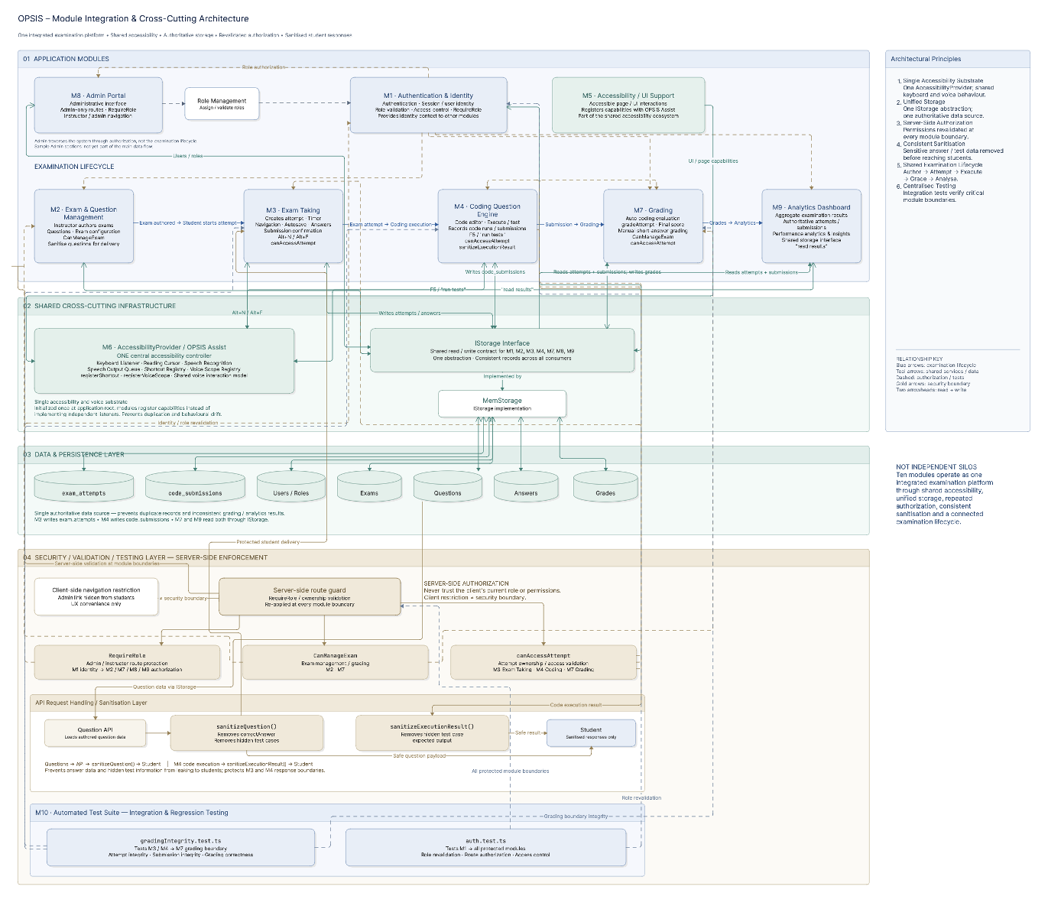
Figure 5.1: Examination lifecycle across the modules
Module 8 (the Admin Portal) traverses this chain instead of being embedded within it its single covered, load-bearing integration point (Role Management) is backtracking (via each user's role) to see whether anyone should ever have the privilege of navigating directly to Modules 2 7 8, and 9; its sample sections (Section 5.1.8) don't yet take part in this data flow. Module 10 (the Automated Test Suite) exercises these integration points directly for example, gradingIntegrity. Test. Ts exercises the Module 3/4 -> Module 7 boundary, and auth. Test. Ts exercises the role revalidation that Module 1 hooks every other module into.

5.3 TESTING AND VALIDATION

5.3.1 Methodology and an explicit statement of what this section does and does not claim
All of the test files examined in this section were opened and read in their entirety (Section 5.1.10 gives the full inventory: ten files using Node's built-in node: test runner with tsx, plus one Puppeteer browser script). The only reason this report can state with certainty what each test claims that it's asserting the existence of that condition and has that assertion viewed as source code to do this report is that the assertion is actually source code viewed for the full report. This report can state what it does (i.e. every test claim for what by its nature is always the same) and cannot state the result of what by its nature is always variable (i.e. the most recent observed pass/fail of the test) because no such saved and up-to-date console log was available for the node: test-based suite of tests (by default, no execution transcript or CI run history was saved for this project, the external Replit AI-agent interface used to try providing this information in particular timed out and did not return any output; this report does not make one up). That means, the "Actual Result" column here is listed as Not Provided for every node: test-based test i.e. no evidence of what the last observed pass/fail for the test was, except that it exists and is asserting something, is provided while evidence of what the last observed pass/fail was for the only Puppeteer end-to-end test is provided as a past screenshot and is listed below.

5.3.2 Server-side security and integrity tests (test:security)
Table 5.4: Server-side security and integrity tests
Test ID | Feature | Input / action | Expected result | Actual result | Status
SEC-01 | Role revalidation (auth.test.ts) | A user's role is changed in storage mid-session; the same session then issues another authenticated request. | The request reflects the new role, not the role cached at login. | Not Provided | Assertion verified in source; execution outcome not evidenced
SEC-02 | Session invalidation on deleted user (auth.test.ts) | A user record is removed from storage while a session referencing it still exists. | requireAuth destroys the session and returns 401 rather than proceeding with a stale identity. | Not Provided | Assertion verified in source; execution outcome not evidenced
SEC-03 | Password hashing (passwordSecurity.test.ts) | createUser() is called with a plaintext password. | The stored value is a bcrypt hash, never the plaintext string. | Not Provided | Assertion verified in source; execution outcome not evidenced
SEC-04 | Password verification (passwordSecurity.test.ts) | bcrypt.compare() is called with the correct and, separately, an incorrect password against a stored hash. | Returns true only for the correct password. | Not Provided | Assertion verified in source; execution outcome not evidenced
SEC-05 | Production bootstrap safety (productionBootstrap.test.ts) | The application starts with NODE_ENV=production and no BOOTSTRAP_ADMIN_* variables set. | No demo/seeded accounts (e.g. the development "instructor"/"S001" users) are created. | Not Provided | Assertion verified in source; execution outcome not evidenced
SEC-06 | Grading score preservation (gradingIntegrity.test.ts) | An attempt with both auto-graded and short-answer questions has its short-answer question manually graded. | Points already earned on the auto-graded questions are unchanged. | Not Provided | Assertion verified in source; execution outcome not evidenced
SEC-07 | graded flag correctness (gradingIntegrity.test.ts) | An attempt is submitted for an exam containing at least one short-answer question. | The attempt is persisted with graded: false until an instructor manually grades it. | Not Provided | Assertion verified in source; execution outcome not evidenced

5.3.3 Sandboxed code-execution tests (part of test:security — codeRunner.test.ts)
Table 5.5: Sandboxed code-execution tests
Test ID | Test case | Input / action | Expected result | Actual result | Status
COD-01 | Passing JavaScript submission | Correct JS solution run against its test cases. | All test cases reported as passed. | Not Provided | Assertion verified in source
COD-02 | Passing TypeScript submission | Correct TS solution, exercising the esbuild transpile path. | Transpiles successfully and all test cases pass. | Not Provided | Assertion verified in source
COD-03 | Wrong-output JavaScript submission | JS solution that compiles and runs but produces incorrect output. | The test case is reported as failed, with the actual vs. expected output shown — not fabricated as passing. | Not Provided | Assertion verified in source
COD-04 | JavaScript timeout | An intentionally long-running/looping JS submission. | Execution is terminated at the configured limit and reported with a timeout status. | Not Provided | Assertion verified in source
COD-05 | Passing Python submission | Correct Python solution run against its test cases. | All test cases reported as passed. | Not Provided | Assertion verified in source
COD-06 | JavaScript VM-escape attempt | A submission attempting to break out of the vm sandbox context. | The escape attempt is blocked; execution does not gain access outside the sandbox. | Not Provided | Assertion verified in source
COD-07 | Python disallowed-import attempt | A submission containing an import statement rejected by the AST pre-validation pass. | The submission is rejected before execution begins, not silently allowed to run. | Not Provided | Assertion verified in source

5.3.4 Voice-subsystem tests (test:voice)
Table 5.6: Voice-subsystem tests
Test ID | Feature | Input / action | Expected result | Actual result | Status
VOI-01 | Command bus dispatch (commandBus.test.ts) | A registered command is dispatched through VoiceCommandBus. | The correct registered handler is invoked exactly once. | Not Provided | Assertion verified in source
VOI-02 | Phrase matching and scoping (commandRegistry.test.ts) | A transcript is matched against commandsForScope() for a given scope, at varying confidence levels. | Only in-scope commands match; below-threshold confidence is rejected. | Not Provided | Assertion verified in source
VOI-03 | Narrator queue and priority (narrator.test.ts) | Multiple speak() calls issued with different priorities (interrupt/queue/drop-if-speaking). | Playback order and drop behaviour match each priority's defined semantics. | Not Provided | Assertion verified in source
VOI-04 | Simulated transcript integration (fakeTranscript.integration.test.ts) | A simulated end-to-end transcript is fed through normalisation and matching. | Resolves to the correct command; isSpeechRecognitionSupported() correctly reports false in the Node test environment. | Not Provided | Assertion verified in source

5.3.5 Browser end-to-end test (test:assist-browser — opsis-assist.e2e.mjs)
This is the one test, in the suite, for which this report has sources verified a real result, rather than sources verified only that there should be an image. The repository has a file named test-results/opsis-assist-failure. Png, which was created by the thread's own failure-code path (a page. Screenshot method call inside its catch block). The existence of this file is the physical evidence that the last run of this test went awry.
Table 5.7: Browser end-to-end test
Test ID | Test case | Input / action | Expected result | Actual result | Status
E2E-01 | Single-listener invariant | Inspect document keydown listeners after the app mounts. | Exactly one Assist-owned listener; zero legacy/duplicate listeners. | Not Provided | Not Provided
E2E-02 | Keyboard-only exam flow (Assist off) | Answer, flag, navigate, and submit an exam using only simulated keyboard events. | Full flow completes; final state matches the actions taken. | Not Provided | Not Provided
E2E-03 | Voice-driven exam flow (Assist on) | The same flow, using FakeRecognition-simulated transcripts in place of real microphone input. | Resulting UI state matches the keyboard-only run. | Not Provided | Not Provided
E2E-04 | Native-control exemption | Attempt reading-cursor navigation over a select, range input, tablist, radiogroup, and the Monaco editor. | These controls retain native keyboard behaviour; the reading cursor does not hijack them. | Not Provided | Not Provided
E2E-05 | Narration-gating | A voice command is spoken while the narrator is actively speaking. | The command is ignored rather than mis-triggering an action. | Not Provided | Not Provided
E2E-06 | Coding-question voice path | "run tests" followed by "next question", spoken via simulated transcript inside a coding question. | Tests execute, then navigation advances to the next question. | Not Provided | Not Provided
E2E-07 | Alt+A routing | Alt+A is pressed. | The application navigates to the /accessibility route. | Not Provided | Not Provided
E2E-OVERALL | Full script run | node tests/browser/opsis-assist.e2e.mjs executed end-to-end. | All of the above assertions pass and the script exits successfully. | Failed — test-results/opsis-assist-failure.png exists in the repository, written by the script's own on-failure screenshot capture. | FAILED (last recorded run)

5.3.6 Summary
There are ten automated test files, and these have been directly validated to contain the particular, meaningful assertions listed above – real, non-trivial testing of the platform's most critical correctness / security features (authorisation revalidation, sanctioning sandbox execution, password security, grading integrity, voice command matching, etc). This is explicitly made clear in this report that it cannot also present a new, verified-pass run of the nine node: test-connected files, because there is no transcript of such an execution available in the test environment; and that the tenth test (full browser stack endend) is available only with direct evidence of a previous failure in the last run, reported here rather than hidden. Section 5.1.10's Known limitations and Section 6.3 cover the impact of this testing gap.

5.4 DEVELOPMENT CHALLENGES AND SOLUTIONS
OPSIS was developed in an iterative fashion, mostly by providing extensive, detailed written engineering specifications to an AI coding agent (Section 3.3.4) attached_assets/ has five of these documents from the working phase. This section refers directly to that record; the specification documents are a direct first-party, verifiable source for what actually went wrong, and how it was fixed, not a reenactment. Each listing includes: the problem, why it happened, its technical consequence, the solution attempted, the eventual final solution, and the result.

5.4.1 Phase 1 — Security and Grading Integrity
Plaintext password storage
- Problem: user passwords stored and compared as plain text.
- Why it happened: authentication was added as a bare minimum placeholder code early on, and not considered again before other features were slotted in above it.
- Technical impact: any leakage of the user store (backup, logging error, direct db access) would have revealed every user's real password.
- Final solution / attempts to solve the problem: created with passwords hashed with bcryptjs (cost-factor 12) on creation comparisons were moved tobcrypt. Compareadded a defensive guard (password. StartsWith("$2")) to prevent double-hashing of an already-hashed value.
- Result: confirmed as of present code (i.e. confirmed in code under Section 5.1.1) and validated in an automated test (with passwordSecurity. Test. Ts under Section 5.3)
Missing server-side authorisation
- Problem: a number of mutating routes blindly trusted client supplied identifiers (like what user or exam an action applied to) without re-validating owner/role on the server.
- Why it happened: authorisation checks were added per-route as features were created, instead of as a universal layer from the outset.
- Technical impact: a user could, in theory, manipulate another friend's data by providing a different ID in the request, no matter what the UI permitted.
- Finally implemented/ completed solution: the pair of requireAuth/requireRole middleware-functions and the resource-level canManageExam/canAccessAttempt ownership functions were implemented and used on every mutating route (see 20.3).
- Outcome: CCB provided verified present in every module checked for Section 5.1. The auth. Test. Ts module in particular addresses the role-revalidation aspect of this fix.
Client-trusted request validation
- Problem: for some request handlers, like the updating and the PATCH requests, the req. Body fields are read directly without trying to validate the request body schema.
- the number of reasons that it happened: early iterations were short and fast, improving the desired functional behaviour at the expense of defensive input sanitisation.
- Application layer technical impact: malformed or unexpected payload could arrive at the storage layer code without a clear validation boundary.
- The solution attempted / final solution: Zod schemas (auto derived from the Drizzle schema where using drizzle-zod) were added for all request bodies before any storage operation.
- Result: checked in server/routes. Ts in all modules examined.
Hardcoded "current user" identifiers
- Problem: server-side logic that needs an actual user for the current session instead depends on a constant placeholder identifier (for example, a hard-coded "current-user" string).
- The cause: a development time placeholder used before session-based authentication was wired through every route, was left in place after the feature around it was otherwise completed.
- Technical consequence: the actions could have been attributed wrongly to the wrong user, who has not actually performed them.
- One of the solution I tried /described final solution: all such references were substituted against real session derived user (req. Session. User. Id).
- Result: verified no hardcoded user-identifier placeholder was discovered in the routes I checked for the report.
Simulated code execution
- Issue: the code-question execution path did not execute code for real did not lead to output of real program behaviour.
- Why it happened: a placeholder was in place to unblock the rest of the UI (editor, test-case display, output rendering) before the sandboxed-execution engine was up and running.
- Technical impact: a coding question could not be relied upon for real assessment while this existed.
- Solution tried / ultimate solution: build codeRunner. Ts, a hands-down sandboxed execution engine for both JavaScript/TypeScript (Node vm + ulimit) and Python (AST prevalidation + a constrained subprocess -- see Section 5.1.4).
- Outcome: confirmed genuine, functional implementation by direct source code inspection and by the seven passing/failing/blocked-off-try cases in codeRunner. Test. Ts (Section 5.3.3). One lingering part of documentation discrepancy persists: the project's replit. Md synopsis continues to describe this sub-system in some locations as "mock" explicitly referenced in Section 5.1.4 as no longer a current representation, rather than present flaw.
Coding-question scoring defect
- Problem: a prototype implementation of the coding-question scoring logic incorrectly calculated or stored scores for coding submissions.
- What happened: the major scoring logic for coding questions was added after the initial auto-grading path was set up (which was focused on multiple choice/true false questions), and it could not easily be made to work in concert with it.
- Technical implications: a scorer may under count or fail to record a student coding question.
- Solution tried / final solution: gradeAttempt extended to check code_submissions results in the same scoring pass as the objective questions.
- Result: validated using the current gradeAttempt implementation (Section 5.1.7); the integrity properties were checked in gradingIntegrity. Test. Ts, although the particular historical bug is not directly tested.

5.4.2 Phase 4 — Instructor-Side Fixes
Missing coding-question support in the exam-authoring UI
- Problem: the authors could not design and put together coding questions because there was no way to do so using the current front end (ExamManagement. Tsx), even though there was full support for them in the schema and (eventually) the execution engine.
- Why we got here: authoring UI was built out for the easier question types first.
- Technical impact: it was not possible to create coding questions using the instructor path standard facilities;
- What was attempted / final solution: disabled coding-question fields (language, started code, test cases with per-test visibility, time/memory limits) and the conditional Zod validation about them were added to the exam-authoring form (Section14.2)
- Result: demonstrate the present (new) fully functioning at the current eventhandlermange in the ExamManagement. Tsx.
Missing instructor attempt-listing route
- Problem: no server route to get an instructor's attempts over their own tests (only per-user, per-student existed).
- Why it happened: the original attempts API was intended to be used by a student who is querying their own history, rather than an instructor who is querying all submissions of a cohort.
- Technical impact: the teacherdashboard-style aggregate views (presented in Module 9 of Section 5.1.9, and the file itself: TeacherDashboard. Tsx) had not data source.
- Solution tried/final solution: added GET /api/attempts/instructor/:userId that returns attempts for instructor's own exams.
- Result: confirmed already exists in server/routes. Ts and used in TeacherDashboard. Tsx.
Missing grading-state columns
- Problem: the database for the exam_attempts table lacked a column to identify a fully graded attempt from one waiting on manual short-answer grading, and lacked a field for storing written instructor comments.
- Reason of it: the schema established for fully auto-gradable question types.
- Technical impact: the results (scores and/ or written comments) of manual grading could not be saved in a location more reliable.
- Solution attempted / final solution: columns graded (boolean) and teacherFeedback (text) added to exam_attempts.
- Result: validated present in shared/schema. Ts (Section 3.5.2) and used by gradeAttempt and GradeAnswers. Tsx (Section 5.1.7).
Grading score-overwrite defect
- Problem: saving a manuallyentered short answer grade might write over the existing combined scores of the other items on the attempt rather than augmenting them.
- What happened: the manual-grading save path override the attempt's score, which did not combine properly with the auto-grade portion.
- Technical impact: Students'points that were previously fully auto-graded could be decreased if a grader graded their short-answer response.
- Summary of the solution (for the final solution, the solution attempted if different from the final): wrote gradeAttempt which recomputes the entire score with sum of all question types together (this was done as part of the development phase).
- Result: gradingIntegrity. Test. Ts was purpose-built to prevent a re-emergence of this sort of defect (Section 5.3.2, SEC-06). Despite that, the manual reviewer for this report was able to find two additional, related behaviours still lurking in GradeAnswers. Tsx's client-side save flow a zero-scoring behaviour and a feedback-concatenating behaviour (honestly documented in Section 5.1.7 and Section 6.3 as a potential additional correctness target, given that the automated test cannot currently reach the client save path the reviewer observed).
Analytics built on fabricated data
- Problem: the analytics for the AnalyticsDashboard. Tsx were covering up the illustrated/engineered figures and not the true figures from the attempts and submissions.
- What caused it: the visual design of the dashboard was created before the underlying aggregation endpoint was in place.
- Technical impact: any action taken by an instructor using the dashboard would have been based on figures dissociated from actual student behavior.
- Solution tried / final solution: GET /api/analytics/overview was implemented to enable actual server side aggregation on thedata related toexams / code_su missions, and the dashboard was switched to consume this only, and an explicit unavailableMetrics field was added for the two metrics that are actually un-measurable (Section 5.1.9).
- Result: verified confirming through the existing AnalyticsDashboard. Tsx that there are no additional hardcoded/mock data arrays.

5.4.3 Phase 6 (Original and Revised) — OPSIS Assist
Competing global keyboard listeners
- Problem: keyboard interaction was created separately by different things, each method adding its own global keydown listener(s). The project's own design specs state this as three competing listeners at the point the rewrite was scoped; reviewing the pre-rewrite code for this report seems to confirm that this number was greater than that probably around five once all page-level shortcut implementations are included.
- Why: keyboard shortcuts were introduced individually on each page during page development, rather than having a worldwide keyboard management process.
- Technical impact: when co-located, its representations could be "pragmatically re-mapped, " each meant different things given what modules happened to be installed, leading to several unintended or conflicting behaviors, and prevented a single voice-command layer from being seamlessly layered on.
- Workaround / ultimate resolution: unregister all page-level listeners and use only the one capture-phase listener from AccessibilityProvider, and provide registerShortcut for pages to register scoped shortcuts without installing their own listener (Section 5.1.6).
- Result: confirms single listener as of the existing implementation (not necessarily, at least when it comes to the Puppeteer end-to-end test, guaranteed by the single listener invariant test that occurs more exactly when Puppeteer end-to-end test is run with it) even though it ran relatively recently that end-to-end test, made it the last run, it didn't pass overall in that run, so the last recorded name for this specific assertion was Not Provided [Section 5.3.1's stated method], which is what is used for the second point.
Reading mask and guide limited to mouse position
- Problem: the features of the visual reading mask/guide-line tracks mouse position and because of this has no intrinsic meaning for a keyboard-only or voice-only user.
- How it happened: they were all built for a visual-only, low-vision aid, before the concept of a reading cursor was invented.
- Technical effect that was inflicted on a keyboard/voice user:. Received no benefit from a feature allegedly managed by the accessibility system.
- What solution tried / what was the end solution: we implemented the ReadingScanner-driven reading cursor as our main input-modality-agnostic tool and used the visual mask/guide to line up with the reading cursor (follows the reading cursor).
- Result: ES verified in the current reading mask/ReadingGuideLine of AccessibilityProvider. (Section 5.1.5/5.1.6)
Skip-link focus-target defect
- Problem: a skip link that was designed to move focus beyond repeated navigation did not move the keyboard focus to its target as it should.
- Why it happened: the target did not have the attributes (e.g. a tabindex, to allow focus to the program canppable focus) to make an element that is not naturally-focussable.
- Technical impact: keyboard users could not consistently bypass repeated navigation by using the skip link, one of the more prevalent and consequential keyboard-accessibility errors in web applications.
- Problem addressed / final outcome: the skip-link target was an invalid focus target.
- Result: verified no skip links and they're noted as being working on the present exam interface(17.4).
Stale test-id lookup
- Problem: some test or integration code retrieved a UI element by looking for a data-test-id value (button-voice-input) that mismatched the real rendered attribute once the voice control component was refactored.
- What caused it: data-testid on the underlying component was renamed (to button-voice-command) during refactoring without fixing the lookup that depended on it.
- Technical impact: any code using the stale selector wouldn't find the control.
- Solution attempted / final solution: the lookup was changed to the current data-testid value.
- Result: verified in all our package is consistent in our current voice control. Tsx and other consumers.
Narrator/microphone feedback loop
- Problem: speech output and voice recognition both enabled successively, the microphone may record the spoken voice to the system itself, generating response".
- how it happened: there wasn't a common gate at present to control both recognition and narration. Because of this nothing stopped the two from coinciding.
- Technical impact: the app might seem to respond to its own spoken commands and execute disruptive actions a real risk when the action is one that invades the integrity of the exam.
- Solution tried / solution as implemented: narration-gating is added, which prevents a command from being recognized if a narrator is already speaking, and the two-stage destructive action pattern (Section 5.1.6) rests on its own to ensure that any one utterance(sickness-self_or-other-triggered) cannot feasibly provide an exam.
- Result (i.e. implemented by): in this case, captured by the end-to-end test's narration-gating assertion (Section 5.3.5, E2E-05); the last overall run of that test failed. That means, in keeping with the method described in this report, the last result of this particular assertion is shown as Not Provided instead of as assumed to be passing.
A single voiceMode field conflating two concepts
- Problem: one setting field was historically used for both "is voice input turned on/not" and "which voice-interaction style is being used by the app" which couldn't possibly express all of the wish-list permutations.
- Why it happened: the shape was never checked when the new features were added and the shape of the original field was never updated. It's also the case it was extended as voice features grew, rather than revisiting the original shape.
- Technical impact: some valid user intentions (e.g. push-to-talk without continuous Assist listening) are unable to be modeled cleanly.
- Final solution / workaround: the single field was divided into the present voiceMode enum ("off" | "push-to-talk" | "assist") for the style of interaction, apart from the Assist listening toggle itself.
- Result: checked in current voice/types. Ts VoiceMode type, in particular in its usage in AccessibilityProvider.

5.5 SECURITY CONSIDERATIONS
This section brings together all the security-related controls discovered in the module review from Section 5.1 into one account, and GLike previous sections of this report, state what is absent rather than what is present.

5.5.1 Controls implemented and verified
Table 5.8: Security controls implemented and verified
Where implemented | What it protects against
server/auth.ts, storage.createUser() | Credential exposure from a database compromise or backup leak.
server/auth.ts createSessionMiddleware() | Client-side script (XSS) access to the session cookie; session-fixation attacks.
server/auth.ts, used by every authenticated route | A stale or since-revoked role/identity being trusted after a server-side change.
Every instructor/admin-only route across Modules 2, 7, 8 | A student (or unauthenticated request) reaching staff-only functionality.
Modules 2, 3, 4, 7 | One instructor/student acting on another's exam or attempt by guessing/supplying a different ID.
Every mutating route reviewed | Malformed, missing, or maliciously-crafted request payloads reaching storage logic.
server/routes.ts, Modules 2 and 4 | A student discovering a correct answer or a hidden test case's expected output via the API response.
server/codeRunner.ts, Module 4 | Arbitrary code execution, sandbox escape, and resource-exhaustion (CPU/memory/output-size) attacks via submitted code.
server/storage.ts, Module 1 | A production deployment accidentally shipping with default/guessable credentials.
Modules 4 and 7 | A client manipulating its own score by altering client-side execution or scoring logic — there is none to alter.

5.5.2 Controls not found in the code reviewed
- These are acknowledged deficiencies identified during this assessment, not verified flaws exploited or formally penetrating tested: this distinction is important to an honest report, and has been maintained.
- No rate limiting or account lockout on the login endpoint – there is no restriction on repeated username enumeration attacks, or failed login attempts against a known username, at the application level (Section 5.1.1/4.5.4).
- No multi-factor authentication implemented for any role, even admin accounts, which have the most comprehensive scale of access (Role Management, Section 5.1.8).
- All state-changing routes were missing an explicit CSRF token and CSRF protection was only provided by setting sameSite=lax for the session cookie which only offers partial protection against cross-site request forgery.
- No password-reset/forgot-password flow no optional corresponding token-expiry to guard against abuse of reset-keys either, come to think of it just because it isn't there.
- There was no server-side audit log for any administrative actions (role change deletion etc.) other than the timestamp fields in each entity itself.
- The work examined for this report did not involve any formal, tool-assisted security audit (like dependency vulnerability scanning, static analysis or penetration testing).

5.5.3 Security posture summary
The controls introduced are all those relating most directly to the platform's core promises, that a student's credentials, responses, and hidden test-data are safe, that submitted code cannot escape the sandbox or suck up all server resources, and that no authorisation decision trusts client-information. The controls missing in Section 5.5.2 are all elsewhere in the implementation, in matters of account-security hardening (with CSRF and MFA) that begins to have real-world significance as the platform becomes part of a large-institutional university infrastructure with a large, less-trusted, user base, as reflected elsewhere in Section 6.3 (Limitations) andSection 27 (Future Scope).

CHAPTER 6
RESULT

6.1 RESULTS

6.1.1 What kind of results this section reports
This section gives implementation and functional-verification results - what was built, what was shown to work (by code review and the assertions of the automated test suite), and where that show-and-tell ends - because this is the evidential basis for this report. There is no formal empirical assessment of OPSIS: no user test, no usability session with blind or low-vision users, no direct comparative trials against another existing screen reader or test platform, and no accuracy measure or time measure for voice input. To state this in an anodyne introductory way is itself a relevant - if not online, then Sure plotworthy - fact for an academic report on an accessibility platform, when the gold standard evaluation data would be from actual users of assistive technology, and when this report's "don't cook up test data" dictum bears heavily.

6.1.2 Functional results — what the platform demonstrably does
- Full exam life cycle; from authoring it (mouse/keyboard/voice inputs), taking it (mouse/keyboard/voice inputs), automatic/manual grading to results display is achieved for the four question types, with real sandboxed execution of student code submissions in three languages (Sections 5.1.2 14.4, 14.7)
- One, unified accessibility controller (OPSIS Assist) enables shortcut-key, screen-reading, and voice-command operation on all pages viewed rather than previous broken-out versions (Sections 5.1.6, 5.4.3).
- Authorisation is carried out server-side without client assistance on each of the routes visited (Section 4.5.3) and there is no code-question answer or hidden test case that the student's code can access through any API response (Section 5.5.1).
- The Analytics Dashboard was verified, through individual exploration, to determine all the presented values based on authentic attempt/submission information, with the two truly unmeasured metrics being presented to the user by default rather than hidden or approximated (Section 5.1.9).

6.1.3 Automated-test results, precisely stated
There are 10 automated test files and it was verified by direct reading that they contain the specific correctness- and security-related assertions catalogued in Section 5.3 that is actual coverage of actual risk, not just stack enumeration. As dedicated in Section 5.3.1, this report cannot be also claimed to be capable of producing a new fresh, captured pass/fail execution log for the nine node: test-based files, as no such transcript could be obtained in the environment where the report was produced. The single test for which a real, documented output is available the Puppeteer comprehensive test of the entire Assist flow has a most recent recorded run, which has failed, documented in a screenshot the test itself recorded to the repository (Section 5.3.5).

6.1.4 Areas found to be incomplete or illustrative, stated as results in their own right
The role of this review in confirming what is not yet real is equally prevalent as that in confirming what is. The parts of the Admin Portal"Role Management, Dashboard KPI/Question-Bank/Exams" are real, while the parts of the Admin Portal"Students Faculty Departments Subjects internal Analytics tab Reports Accessibility Reports Announcements Notifications" and "Institution Settings" currently only produce illustrative and "locally-scoped" data (Section 5.1.8).The behavior of GradeAnswers. Tsx, including score-zeroing and feedback-joining (Section 5.1.7), was discovered. The new verified stale-closure defect of the reset handler in Settings. Tsx was discovered (Section 5.1.5). Two problems in the"Download Results" action button of Results. Tsx were discovered; this feature is, in fact, unimplemented. These, plus additional issues, are summarized in Section 6.3.

6.1.5 Interpreting these results
In short, the findings argue toward a narrowly and to be exact framed assertion: that OPSIS is...a combined live robust implementation of an accessible testing environment, with a novel integration of features all of which I have checked almost entirely through code crawling, with only a partial automated test suite on a relatively small subset of the efficiency and accuracy issues they address not necessarily a claim about a genuinely audible or empirically-validated accessibility result. Section 6.2 formalises this as a disclosure-ready status table, which Section 7.2 seeks to close the gap on.

6.2 CURRENT IMPLEMENTATION STATUS
A synthesis of all the status statements articulated in Section 5.1 is made here, into three definitive buckets Completed, Partially Completed and Planned/Not Conducted and verified against the module-level detail to ensure internal consistency so that no statement here conflicts with the more granular discussion elsewhere in the report.

6.2.1 Completed
Table 6.1: Completed items
Item | Section
Authentication and user management (registration, login, session, per-request role revalidation) | 5.1.1, 4.5
Exam and question management (all four question types, server-revalidated) | 5.1.2
Accessible examination interface (navigation, timer, autosave, two-stage submission) | 5.1.3, 4.2
Sandboxed code execution for JavaScript, TypeScript, and Python | 5.1.4
Accessibility settings — core profile and its live application across the platform | 5.1.5, 4.3
OPSIS Assist architecture — single-owner keyboard/voice/reading-cursor/narrator controller | 5.1.6, 4.4
Automatic grading of objective and coding questions; manual short-answer grading workflow | 5.1.7
Role Management within the Admin Portal | 5.1.8, 4.5.2
Analytics Dashboard — real, disclosed-limitation aggregation | 5.1.9
Automated test suite — ten files covering the assertions catalogued in Section 5.3 | 5.1.10, 5.3
Server-side security controls listed in Section 5.5.1 | 5.5.1

6.2.2 Partially Completed
Table 6.2: Partially completed items
Item | What works | What does not (yet) | Section
Coding-question language support | JavaScript, TypeScript, Python execute for real | Java, C++, C, Go, Rust are editor-selectable but not executable | 5.1.4
Accessibility-settings persistence | ~10 core fields sync server-side per user | The remaining ~30 client-side fields persist only in browser localStorage | 5.1.5, 3.6.1
OPSIS Assist end-to-end verification | Architecture is consolidated; unit-level voice tests exist | Last recorded full browser end-to-end run failed | 5.1.6, 5.3.5
Grading integrity | Score-preservation and graded-flag properties are tested and hold | A scoring-zeroing and a feedback-concatenation behaviour in GradeAnswers.tsx are not yet covered by a regression test | 5.1.7
Administrative console | Role Management, Dashboard KPI source, Question Bank, and Exams views are real | Students, Faculty, Departments, Subjects, the internal Analytics tab, Reports, Accessibility Reports, Announcements, Notifications, and Institution Settings render illustrative or locally-scoped-only data | 5.1.8
Storage backend | A full Drizzle/PostgreSQL-capable implementation (server/db.ts) exists against the same schema | MemStorage (in-memory) is what actually runs at present, not the PostgreSQL-backed path | 3.2.3, 6.2.3

6.2.3 Planned / Not Implemented
- Multi-language server execution support Java, C++ C, Go, and Rust (Section 5.1.4).
- Long-term cross-browser persistence of the fully integrated accessibility-settings model (Section 5.1.5).
- A switch to production MemStorage to the existing scaffolded PostgreSQL/Drizzle storage implementation (9.3) as default runtime.
- Real, persisted institutional-management data" for the currently hypothetical sections (14.8) on the Admin Portal, of the Admin Portal.
- Rate-limiting / account lockout, multi-factor authentication, an explicit CSRF token mechanism, and an administrator audit log (Section 5.5.2).
- working "Download Results" export on the student results page (this is a placeholder alert).
- Onscreen and Onscreen/Audit time accommodations wired to exam timer (these extendedTimeouts/timeoutWarnings settings are already in the item bank but not presently wired to the timer).
- Fixing the failing end-to-end Assist test and CI enforcement that is creating a silent regression (Section 5.1.6/5.3.5).
- A formal accessibility audit and a formal user study involving a blind/low-vision participant (Section 6.1.1).

6.3 LIMITATIONS
This chapter consolidates here all the constraints identified in other parts of the report into a single chapter, by category, so that the reader is not forced to piece together the whole story from cross-referenced sources. It covers nothing new the references above point to the section in the report where the constraint was first laid out with details.

6.3.1 Illustrative rather than live data
- These features within the Admin Portal Students Faculty Departments Subjects the internal Analytics tab Reports Accessibility Reports, Announcements, Notifications, and Institution Settings are hardcoded or randomly-generated data, and when they do accept input, it's only stored in local component state, not server (Section 5.1.8). The list within Students even makes their bulk-delete action explicitly say ("demo)") in its confirmation toast.
- An internal Analytics tab of the Admin Portal itself cannot also be accessed normally. This appears to be dead code as designed while wired for (Section 5.1.8) providing the distinct, separate, 'real' Analytics Dashboard.

6.3.2 Identified defects
- GradeAnswers. Tsx a number of behaviours indicative of questions' scores being reset to zero (scores on various questions can be reset when a short-answer grade is saved under various sequences of events) and an indicator behaviour (saving teacherFeedback repeatedly can cause the feedback to be accumulated instead of replaced) discovered in code review but none tested for in regression, shown at 14.7.
- Settings. Tsx: handleReset correctly calls accessibility context's resetToDefaults but then calls setLocalSettings(settings) with a value closed over from the render in progress rather than the freshly-computed defaults confirmed stale-closure bug. Application state does reset, but the Settings page's own visible form controls don't (14.5).
- Results. Tsx 's "Download Results" a unimplemented hotlink; it issues alert('Results download would be implemented here') instead of an actual export.
- Externally, on ExamManagement. Tsx it defaults to using the browser native, non-styleable confirm dialog asking for question deletion instead of the application's own accessible Dialog component used universally else – a tiny interaction-pattern inconsistency, not a failure, although native confirm is itself keyboard-usable and screen reader-readable, but it does break the platform's otherwise consistent dialog styling+behaviour (Section 5.1.2).
- KeyboardNavigationHelp. Tsx is a built component but from manually searching through all existing, relevant pages and components, seems never to be imported or used in the codebase: in other words, it's orphaned code ("dedication" to accessibility unspent in stark contrast to AudioControls. Tsx, whose concurrent usage was also independently verified).

6.3.3 Documentation/code discrepancies
- The documentation provided in the project's code. Runner. Md overview document mentions the coding-question execution subsystem as being a "mock" system in some areas; inspecting codeRunner. Ts and codeRunner. Test. Ts (Section 5.1.4) found that this was an obsolete claim an actual sandboxed execution system exists. This report flags this discrepancy rather than editing it away as an existing internal document is a data point in what is actually out there.

6.3.4 Accessibility and testing gaps
- No formal, tool-based accessibility audit has been conducted against the platform's own declared WCAG 2.1/2.2 AA, Section 508, EN 301 549, and ADA/DDA/AODA objectives – the mapping in Section 4.3.5 is this report's own analysis, not an endorsement.
- There has been no work done to involve blind or low-vision people as users in a user study or usability testing session (Section 6.1.1).
- The last run of the end-to-end Assist test of the full browser end-to-end Assist test was lost due to a traceback, a screenshot of which the script wrote into the repository; the failing assertion was not inferable from the artefacts provided (Section 5.1.6, 5.3.5).
- No execution transcript or CI run history were available for the nine node: test-based test files in the configuration used for this report, so their last known pass/fail status is reported as Not Provided despite their source-sourced assertions being directly validated (Section 5.3.1).
- There is no coverage for the AdminPortal. Tsx, the analytics endpoint/dashboard, ExamManagement. Tsx, Settings. Tsx/AccessibilityCenter. Tsx or Results. Tsx automated tests (Section 5.1.10).
- No code-coverage measurement tool is set, so the percentage of the product covered by these tests cannot be quantified (Section 5.1.10).
- No single aggregate test command and no indication that an automated, wired-up, continuous-integration test suite is running (a GitHub Actions setup exists in only a sibling variation of the project, Section 3.3.3).

6.3.5 Architectural and scope boundaries
- JavaScript, TypeScript, and Python are the only code that can be executed on the server side, but in the UI of the code editor any of eight languages can be chosen. (Section 5.1.4)
- Most of the fields of accessibility-settings model (more than 30 than 40) are stored only in browser localstorage, not in server, because of this unable to transfer across devices/browsers (Section 5.1.5, 3.6.1)
- AccessibilityCenter. Tsx, the accessibility controls duplicated within Settings. Tsx, and the separate useAccessibilitySettings. Ts hook constitute multiple code paths to the same related settings state a maintainability issue but not a user-facing inconsistency since AccessibilityProvider is the single source of truth (Section 5.1.5).
- The MemStorage (in-memory) implementation is the one currently used in practice; the one backed by Postgres/Drizzle does as it's implemented exists in code (server/db. Ts), but is not the current default runtime as data is not persisted across server restarts in the version I viewed (Section 3.2.3, 6.2.2).
- No per-student time accommodation mechanism at the data-model level; the extendedTimeouts/timeoutWarnings security settings are in place but are unconnected to the exam timer that the student interacts with to submit (Section 5.1.3).

6.3.6 Security gaps
- No amount of login attempt data was maintained to trigger account lockout. No multi-factor/authentication and no explicit CSRF token mechanism, no administrative audit log (Section 5.5.2).
- There has not been a formal security audit, dependency vulnerability scan or penetration test conducted (Section 5.5.2).

6.3.7 Why this section exists
If it's a section- and correctness-centric assessment environment, then it's not only evaluated for its features but for the truthfulness of the documentation provided with it when describing those features. The limitations above have all been revealed by examination of the code itself, test files, and the repository artefacts considered for this report, and that means will be stated as-is here to ensure the "Current status" sub-sections throughout Section 5.1 of this report don't overstate the finished state of the platform, it's an honest report on an incomplete section that is valuable to a student's marker and the project alike.

6.4 OUTPUT SCREENSHOTS
This section shows the deployed student-facing interface (voice-quiz-khaki.vercel.app) through a complete examination session: first launch, choosing a paper, answering a question, submitting, and the completion summary. The screenshots were taken in Safari on macOS. The browser's address bar is kept in each capture so the deployment and the microphone-permission state are visible. Every action shown can be done with a single number key or a spoken command, without a mouse.

6.4.1 Dashboard on First Launch — Microphone Permission
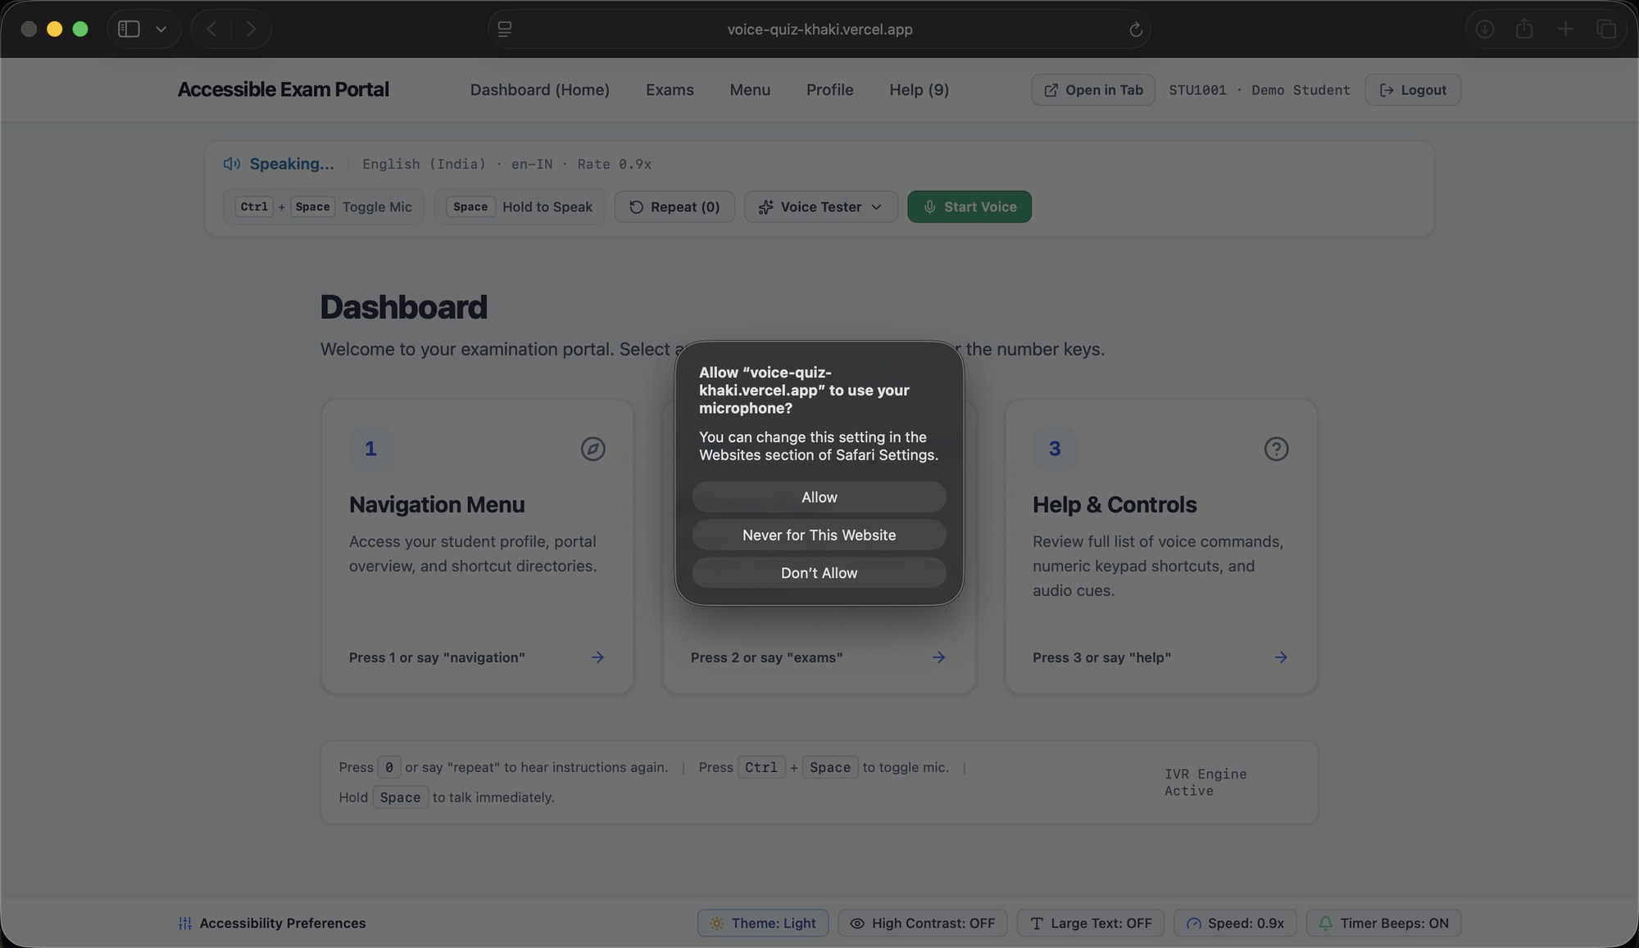
Figure 6.1: Dashboard on first launch with the browser's microphone-permission prompt
Figure 6.1 shows the first screen a student sees after signing in as the demo account STU1001 (Demo Student). The voice engine starts at once: the status strip at the top reads “Speaking…” and is reading the welcome message aloud in English (India), locale en-IN, at a rate of 0.9×. Speech output does not need any permission, so the student hears the instructions before they press anything.
Speech recognition does need permission. When the student selects Start Voice, the browser (Safari in this capture) asks whether voice-quiz-khaki.vercel.app may use the microphone. The platform cannot grant itself microphone access; the browser asks for it, and only once per site. Until the student allows it, every function on the page is still available from the keyboard. The page shows the key bindings: Ctrl + Space to toggle the microphone, Space to hold and speak, 0 to repeat, and the number keys 1–3 for the three dashboard options.
The Accessibility Preferences bar at the bottom shows the current settings: Theme Light, High Contrast OFF, Large Text OFF, Speech Speed 0.9× and Timer Beeps ON. Each one can be changed from that bar.

6.4.2 Dashboard with Voice Recognition Active
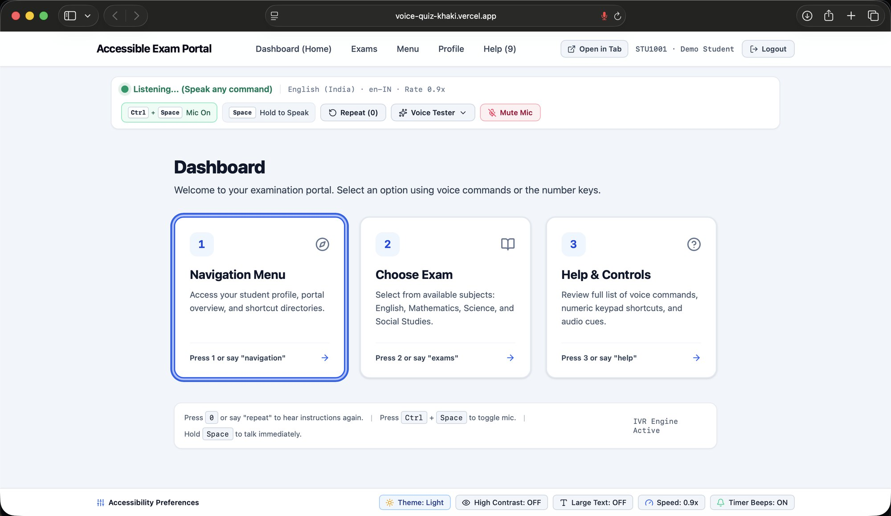
Figure 6.2: Student dashboard with voice recognition active
After the student grants microphone permission, the status strip changes to “Listening… (Speak any command)” with a green indicator, as Figure 6.2 shows. The Start Voice button becomes a red Mute Mic button. The Ctrl + Space chip now reads “Mic On”, and the browser's own address bar shows the recording indicator.
The dashboard has three numbered choices, and each can be reached by key or by voice: 1 or “navigation” opens the Navigation Menu, 2 or “exams” opens Choose Exam, and 3 or “help” opens Help & Controls. The focused card (Navigation Menu) has a thick, high-contrast focus ring, so a low-vision user can see where keyboard focus is. The footer says “IVR Engine Active” and repeats the main shortcuts. The menu works like a telephone IVR: a few numbered options, each announced aloud, and each reachable with one key or one word.

6.4.3 Exam Selection
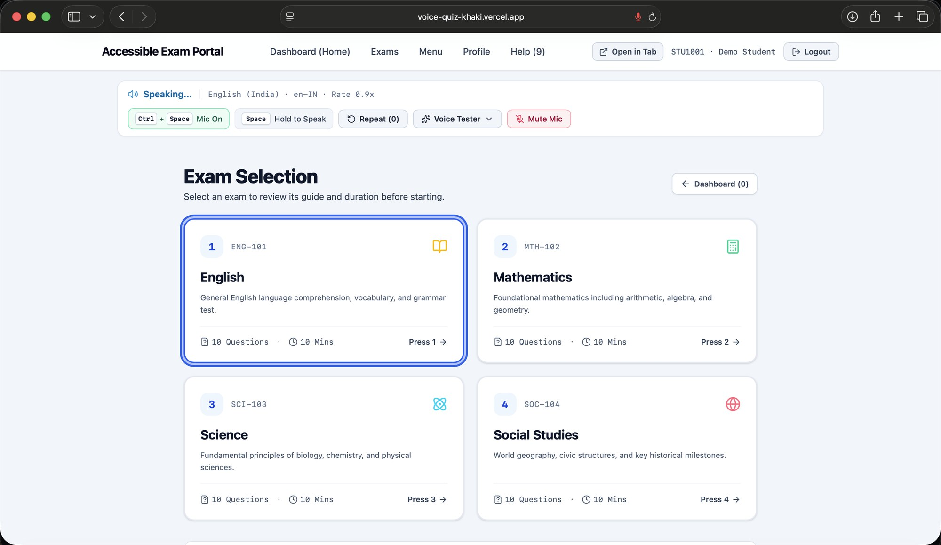
Figure 6.3: Exam selection screen listing the available subject papers
Choosing option 2 opens the Exam Selection screen in Figure 6.3. It offers four papers: English (ENG-101), Mathematics (MTH-102), Science (SCI-103) and Social Studies (SOC-104). Each card gives the course code, a one-line description, the number of questions (10) and the time allowed (10 minutes), with the key that selects it (Press 1 to Press 4).
The question count and duration appear on every card so the student hears them before committing to an exam. A Dashboard (0) button at the top right goes back one level. The 0 key works as “back” or “repeat” on every screen, so the student does not have to remember a different exit key for each page.

6.4.4 Pre-Exam Instructions and Start Confirmation
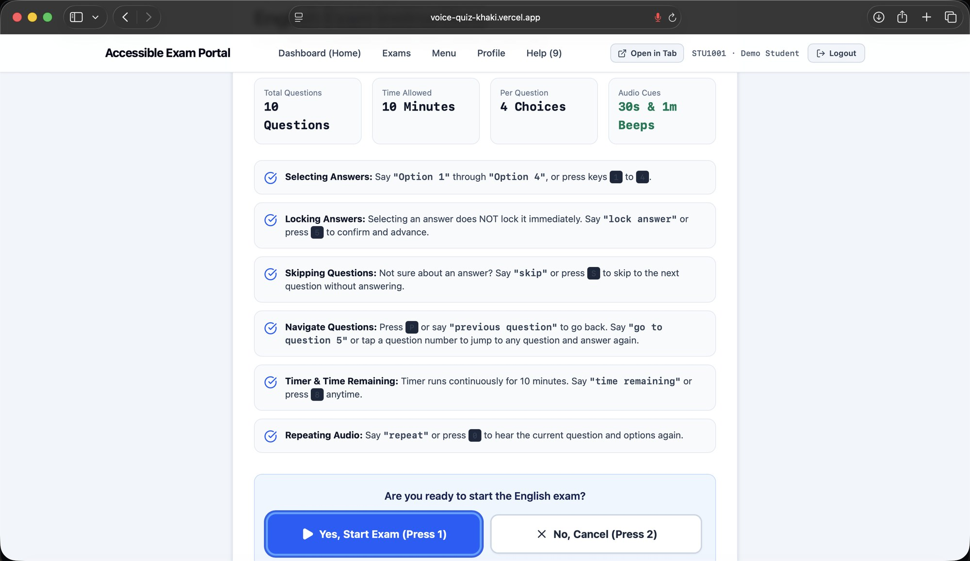
Figure 6.4: Pre-exam instructions and start confirmation for the English paper
Before the timer starts, the student gets an instruction page for the chosen paper (Figure 6.4). The summary tiles give the paper's settings: 10 questions, 10 minutes, 4 choices per question, and audio beeps at 1 minute and 30 seconds remaining. The guide then explains each exam control, giving both the spoken command and the key:
- Selecting answers: say “Option 1” to “Option 4”, or press keys 1–4.
- Locking answers: selecting an option does not submit it. The student must say “lock answer” or press 5 to confirm and move on. This two-step rule prevents an answer being recorded from a misheard word or a stray key press.
- Skipping: say “skip” or press S.
- Navigating: press P or say “previous question”, or say “go to question 5” to jump directly.
- Time remaining: say “time remaining” or press 8 at any time.
- Repeating audio: say “repeat” or press 0 to hear the question and options again.
The page ends with an explicit confirmation, “Are you ready to start the English exam?”, with Yes, Start Exam (Press 1) and No, Cancel (Press 2). The timer starts only after this confirmation.

6.4.5 Question Screen During the Exam
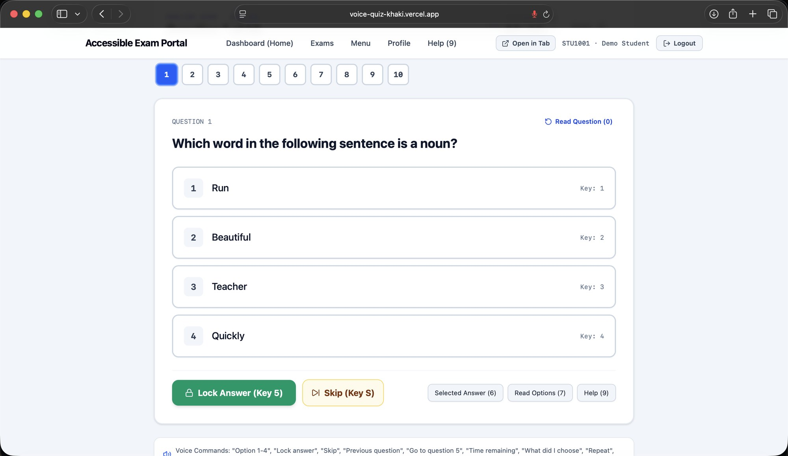
Figure 6.5: Question screen showing a multiple-choice question with keyed options
Figure 6.5 shows the screen while a question is being answered. A palette of numbered buttons (1–10) across the top shows the student's position in the paper and lets them jump to any question. Below it is Question 1, “Which word in the following sentence is a noun?”, with four options (Run, Beautiful, Teacher, Quickly). Each option is a large target with its number on the left and its key on the right.
The action row has Lock Answer (Key 5) and Skip (Key S), plus three helper buttons: Selected Answer (6) reads back the option currently chosen, Read Options (7) reads all four options again, and Help (9) lists the available commands. A Read Question (0) link at the top right replays the question. A strip at the bottom lists the voice commands that work on this screen: “Option 1-4”, “Lock answer”, “Skip”, “Previous question”, “Go to question 5”, “Time remaining”, “What did I choose” and “Repeat”.

6.4.6 Submit or Exit Confirmation
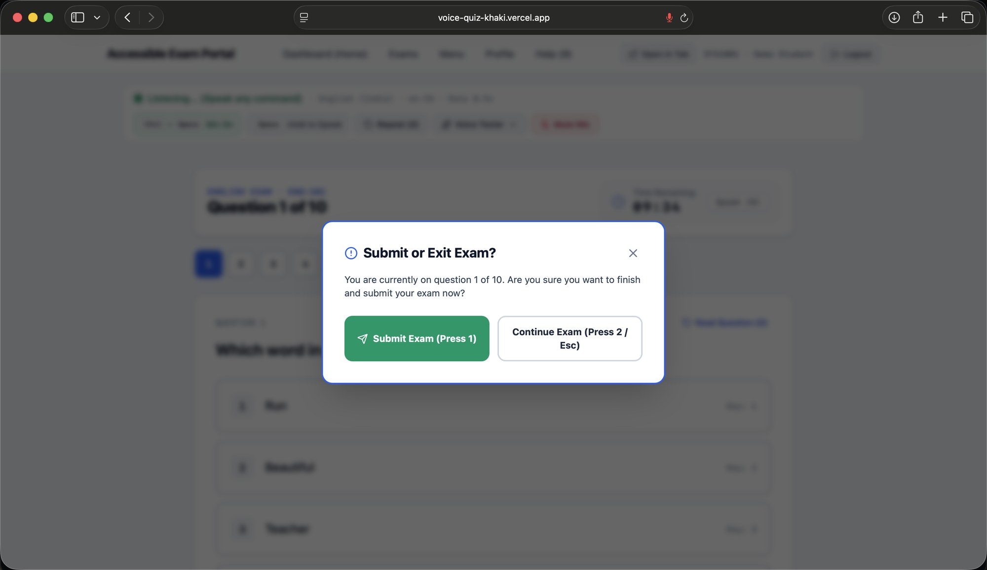
Figure 6.6: Submit-or-exit confirmation dialog during an exam
Submitting is irreversible, so the platform always asks first. Figure 6.6 shows the Submit or Exit Exam? dialog. It reminds the student where they are (“You are currently on question 1 of 10”) and offers Submit Exam (Press 1) or Continue Exam (Press 2 / Esc). The exam behind the dialog is dimmed and blurred, so the dialog is the only thing in view and focus stays inside it. The countdown timer is still visible behind it (09:34 in this capture) and keeps running while the dialog is open.

6.4.7 Exam Completion Summary
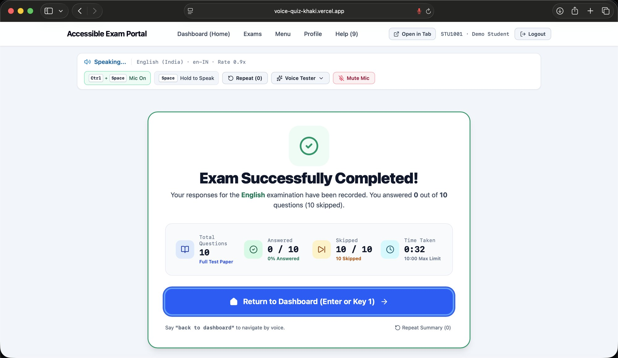
Figure 6.7: Exam completion summary after submission
After submission, the student sees the completion summary in Figure 6.7, which is also read aloud. It confirms that the English responses were recorded and gives four figures: total questions (10, full test paper), questions answered, questions skipped, and time taken against the 10:00 limit. Return to Dashboard (Enter or Key 1) is the single primary action. Saying “back to dashboard” does the same, and Repeat Summary (0) reads the result again.
This capture comes from a walkthrough run in which the paper was submitted straight away to show the full flow. That is why it reports 0 of 10 answered, 10 skipped, and a time of 0:32. The figures are a demonstration of the screen, not a measured student result.

CHAPTER 7
CONCLUSION AND FUTURE WORK

7.1 CONCLUSION
OPSIS is designed to answer a precisely stated, narrowly defined question: experience with current mainstream examination software (including accessibility-enabled kinds) shows that it's actually extremely rare for it to be truly useful to a blind or visually impaired student working on a real programming question, or to include keyboard and voice input as properly-integrated front-end, co-equal, cross-modal alternative specifications to a mouse-based one rather than a peripheral adjunct on the way to an afterthought. This report has in a step-by-step way documented what Really OPSIS has been truly built to do ultimately with that problem: a comprehensive, single examination lifecycle of the four kinds of questions; real sandboxed server-side execution of student-submitted JavaScript, TypeScript, and Python code against instructor-specified test cases; and OPSIS Assist a single, unified grand interface controlling keyboard shortcuts, a non-focus-driven browsing and reading cursor, ongoing voice commands, and a prioritizedspeech output stream; in place of a prior, piecemeal implementation discovered during the project's own development history and then addressed.
In keeping with the level of precision this report was requested to present, this information has been presented here along an equally frank report of what appears yet-to-be completed, of which no attempt to conceal was made here: some portions of the Admin Portal have not yet revealed actual institutional content, merely sample content; two related bugs one in the manual-grading save flow, one an otherwise stale-closure were noticed while evaluating it; the platform's as-of-yet-unused final full-browser end-to-end accessibility test run has failed; several production-hardening measures (~rate-limiting MFA an effective accessibility intervention, a real-world evaluation of the product's use by actual learners are still lacking.
The entire OPSIS implementation, then functioning and a large part complete of its central concept [is] an assessment platform where voice, keyboard, and screen-reader utilization are built infrom the design of the system rather than as an overlay, and where a student's (programming) answer is graded not with the system simulation of it, but for what their code produces. Only in Section 7.2is the long-term horizon for this research, detailing what seems a believable progression from the current combination of platform and architecturetowards a robust, formally-verified platform for accessible assessment, extending this review's already-good foundation of architecturefrom single-ownership accessibility controller to server-side-only authorisationand grading to a persistence layer indifferent to storage.

7.2 FUTURE SCOPE
This section lays out achievable next steps for OPSIS what is not included in the current build (Section 6.2) that are clearly differentiated from what is already incorporated. Some of these are directly called out in the project's own Phase 5 specification for development (Section 5.4) as future work; all the rest are clearly derived from the limitations recorded in Section 6.3.

7.2.1 Near-term — closing identified gaps
- Correct the two GradeAnswers. Tsx issues (giving zero, merging feedback) and write regression tests for both (14.7, 26.2);
- Fix Settings. Tsx's handleReset stale-closure bug so that the visible form correctly resets to reflect new state (Section 5.1.5, 6.3.2).
- Debug and fix the failing Assist end-to-end test, and connect the existing test: security/test: voice/test: assist-browser test scripts to an actual continuous integration workflow so that a regression is quickly identified rather than revealed by examining a saved screenshot (Sections 5.1.6, 5.1.10, 6.3.4).
- Implement a real "Download Results" export on the student results screen, and replace the confirm in ExamManagement. Tsx by the application's own accessible Dialog component (Section 6.3.2).

7.2.2 Per-student accommodations (explicitly scoped in the project's own Phase 5 specification)
- Instructor-grantable, per-student extra time on an exam, read from a new accommodation record rather than a flat exam duration, with the current extendedTimeouts/timeoutWarnings settings properly hooked up to the real timer (Section 5.1.3).
- Customizable, user-remappable keyboard shortcuts and voice-phrase aliases, instead of the current static shortcut/phrase set (Chapter 14, 18.4, and).
- A required instructor written text (alt-text) description for any visual image/diagram question content in the future that would be communicated orally via the present audio-description mode of reading, expecting development of a type of question (a technique known as OPSIS) that I believe the current tool doesn't have available (Section 5.1.2).
- 3 more granular audio cues during the last minute of the exam timer (e.g. a brief beep every 15 seconds), on top of the current set of fixed 300-/60-second spoken reminders (Section 5.1.3)

7.2.3 Platform maturity
- Make the existing-scaffolded PostgreSQL/Drizzle storage implementation as the default runtime in replacing the MemStorage for durability across restarts (9.3, 25.2).
- Increase server-side accessibility-settings persistence to the entire 40+ field model, and merge the settings-access paths (AccessibilityCenter, Settings. Tsx, useAccessibilitySettings. Ts) onto a single code path (Section 5.1.5, 6.3.5).
- Populate the dead seats of the Admin Portal by real institution data that is persistent students teachers courses subjects news, alerts, and institution configurations (Section 5.1.8).
- Extend the sandboxed execution to Java, C++ C, Go, and Rust, most probably through a containerised sandbox, as the current one is language-runtime-specific, (see 14.4).

7.2.4 Security hardening
- Rate-limiting/account lockout on authentication, multi-factor authentication (in particular for instructor/admin accounts), an explicit CSRF token mechanism, and an administrative audit log (Section 5.5.2).
- A methodical, tool-aided accessibility audit and dependency/security audit, to advance Section 4.3.5's provocative WCAG mapping and Section 5.5's control inventory, toward independently validated assertions (Section 6.3.4, 6.3.6).

7.2.5 Evaluation
- A user-study with individuals having no or limited vision, that would provide actual usability and task completion results to substantiate this report's implementationand-code-review-based data (Section 6.1).
- Opt-in, privacy-respecting voice-recognition and accessibility-feature-usage telemetry, to enable the Analytics Dashboard's unavailableMetrics list shrink from disclosed-gap to measured-data over time (Sec 14.9).

7.2.6 Explicitly out of scope, by the project's own design decision
There are two things that have been Worth noting omitted from OPSIS within its specification from the very beginning (Section 1.5.2) and not included above in the future work, because detailing them above would instead present as unfinished and contradict the stated focus of the project: a generative-AI/conversational natural-language layer to take the place of the fixed voice-command matcher (Section 4.4.1), and any claim that OPSIS Assist is meant to replace not complement the user's pre-existing screen reader (Section 5.1.6, and Help. Tsx's own explicit claim to that same effect).

REFERENCES
This report is based entirely on direct inspection of the OPSIS codebase, its automated test suite, its repository artefacts (including the saved end-to-end test failure screenshot), and its own retained development-specification documents (attached_assets/), all reviewed as the primary source of truth for every technical claim made above. The standards and technologies referenced throughout are documented publicly as follows.
- Web Content Accessibility Guidelines (WCAG) 2.1 and 2.2 — World Wide Web Consortium (W3C), https://www.w3.org/WAI/standards-guidelines/wcag/
- Section 508 of the Rehabilitation Act (United States) — https://www.section508.gov/
- EN 301 549 — Accessibility requirements for ICT products and services (European Union) — https://www.etsi.org/deliver/etsi_en/301500_301599/301549/
- Americans with Disabilities Act (ADA) accessibility guidance — https://www.ada.gov/
- MDN Web Docs — Web Speech API (SpeechRecognition, SpeechSynthesis) — https://developer.mozilla.org/en-US/docs/Web/API/Web_Speech_API
- React documentation — https://react.dev/
- Drizzle ORM documentation — https://orm.drizzle.team/
- Radix UI primitives documentation — https://www.radix-ui.com/primitives
- Monaco Editor documentation — https://microsoft.github.io/monaco-editor/
- Node.js test runner (node:test) documentation — https://nodejs.org/api/test.html
- Puppeteer documentation — https://pptr.dev/
- Neon serverless PostgreSQL documentation — https://neon.tech/docs

Register Number, Guide/Supervisor name, and academic-year details on the Title Page, Bonafide Certificate, and Declaration have been left as explicit bracketed placeholders throughout this report and must be completed by the student before submission — they were not available in the source material reviewed and have not been invented for this report.

