Session-1

230701332

2025-01-25

result <- sqrt(64)  
print(result)

## [1] 8

result <- exp(2)  
print(result)

## [1] 7.389056

result <- factorial(8)  
print(result)

## [1] 40320

result <- tanh(1)  
print(result)

## [1] 0.7615942

library(gmp)

##   
## Attaching package: 'gmp'

## The following objects are masked from 'package:base':  
##   
## %*%, apply, crossprod, matrix, tcrossprod

result <- gcd(36,24)  
print(result)

## [1] 12

result <- trunc(7.9)  
print(result)

## [1] 7

result <- log10(1000)  
print(result)

## [1] 3

result <- abs(-1078)  
print(result)

## [1] 1078

result <- ceiling(5.7)  
print(result)

## [1] 6

x <- seq(-10,10,by=0.1)  
y <- x^2-25  
plot(x, y, type = "l", col = "blue", main = "y = x^2-25", xlab = "x", ylab = "y")

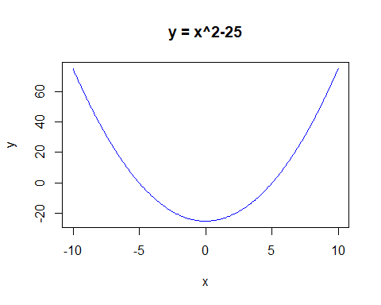

random_numbers <- rnorm(1000)  
hist(random_numbers, main = "Histogram of Random Normal Numbers", xlab = "Value", col = "lightblue")

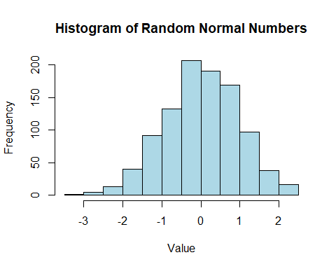

fruits <- c("Apple", "Banana", "Cherry", "Date")  
counts <- c(10, 15, 7, 5)  
barplot(counts, names.arg = fruits, col = "pink", main = "Fruit Counts", xlab = "Fruit", ylab = "Count")

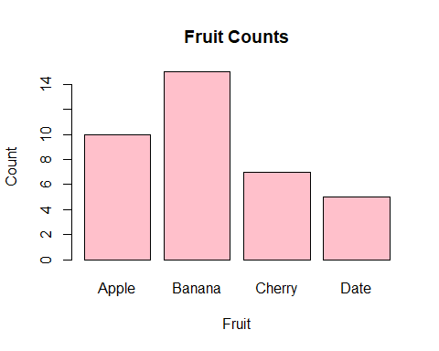

x <- runif(50, 1, 10)  
y <- runif(50, 1, 10)  
plot(x, y, main = "Scatter Plot", xlab = "X values", ylab = "Y values", col = "yellow", pch= 16)

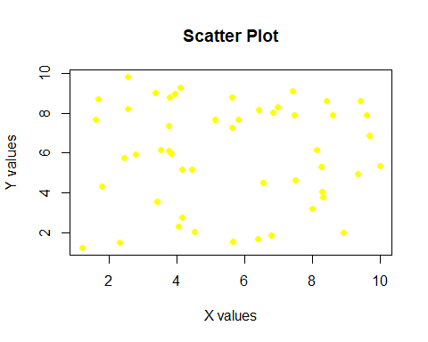

sales <- c(20, 30, 25, 25)  
labels <- c("Q1", "Q2", "Q3", "Q4")  
pie(sales, labels = labels, col = rainbow(4), main = "Sales Distribution")

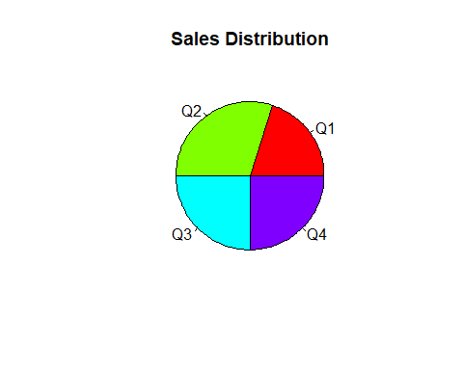

data <- rnorm(100)  
boxplot(data, main = "Boxplot of Random Data", ylab = "Values", col = "lightgreen")

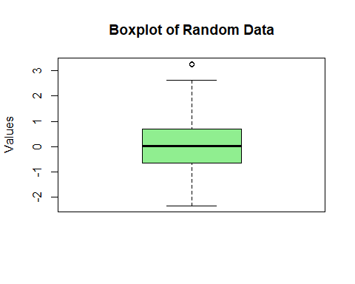

result <- gamma(4)  
print(result)

## [1] 6

result <- tan(pi / 4)  
print(result)

## [1] 1

f <- function(x) x^3  
result <- integrate(f, lower = 0, upper = 4)  
print(result)

## 64 with absolute error < 7.1e-13

f <- function(x) sin(x)  
result <- integrate(f, lower = 0, upper = pi)  
print(result)

## 2 with absolute error < 2.2e-14

library(pracma)

##   
## Attaching package: 'pracma'

## The following objects are masked from 'package:gmp':  
##   
## gcd, isprime

f <- function(x, y) x + y  
result <- dblquad(f, 0, 1, 0, 1)  
print(result)

## [1] 1