Session-3

230701332

2025-02-08

n <- 10  
p <- 0.5  
x <- 0:n  
pdf <- dbinom(x, size = n, prob = p)  
barplot(pdf, names.arg = x, main = "Binomial PDF", xlab = "x", ylab = "Probability")

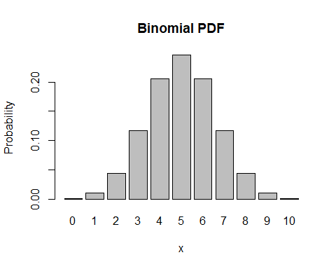

cdf <- pbinom(x, size = n, prob = p)  
plot(x, cdf, type = "s", main = "Binomial CDF", xlab = "x", ylab = "Cumulative Probability")

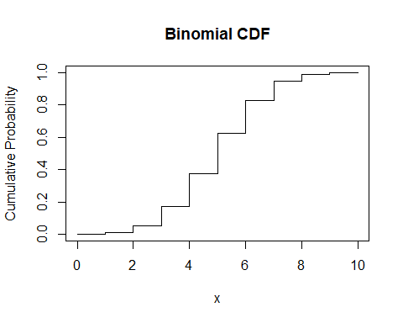

lambda <- 4  
x <- 0:15  
pdf <- dpois(x, lambda)  
barplot(pdf, names.arg = x, main = "Poisson PDF", xlab = "x", ylab = "Probability")

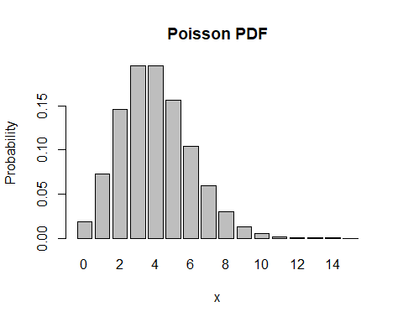

cdf <- ppois(x, lambda)  
plot(x, cdf, type = "s", main = "Poisson CDF", xlab = "x", ylab = "Cumulative Probability")

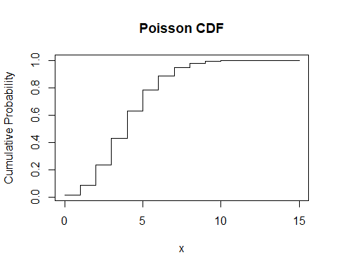

b <- 1  
x <- seq(0, 0.1, by = 0.01)  
pdf <- dunif(x, min = 0, max = 0.1)  
plot(x, pdf, type = "l", main = "Uniform PDF", xlab = "x", ylab = "Density")

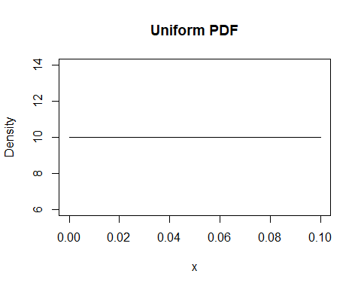

cdf <- punif(x, min = 0, max = 0.1)  
plot(x, cdf, type = "l", main = "Uniform CDF", xlab = "x", ylab = "Cumulative Probability")

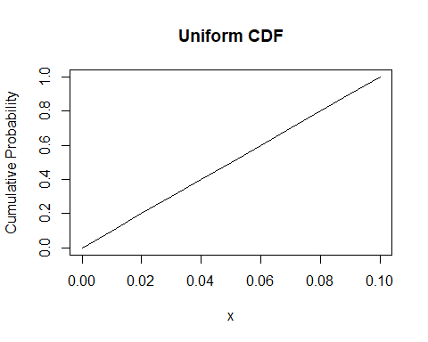

mean <- 0  
sd <- 1  
x <- seq(-4, 4, by = 0.1)  
pdf <- dnorm(x, mean = mean, sd = sd)  
plot(x, pdf, type = "l", main = "Normal PDF", xlab = "x", ylab = "Density")

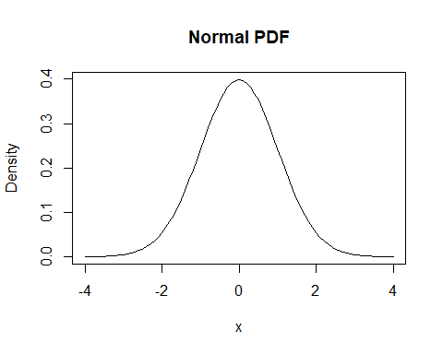

cdf <- pnorm(x, mean = mean, sd = sd)  
plot(x, cdf, type = "l", main = "Normal CDF", xlab = "x", ylab = "Cumulative Probability")

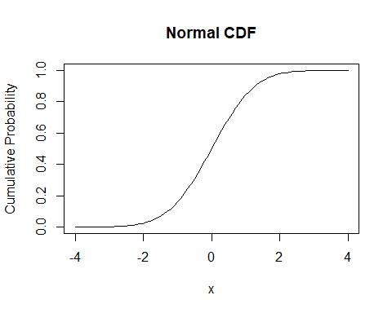

prob <- pnorm(1, mean = 0, sd = 1) - pnorm(-1, mean = 0, sd = 1)  
prob

## [1] 0.6826895

rate <- 1.5  
mean_value <- integrate(function(x) x * dexp(x, rate), lower = 0, upper = Inf)$value  
mean_value

## [1] 0.6666667

n <- 8  
p <- 0.6  
prob <- dbinom(3, size = n, prob = p)  
prob

## [1] 0.123863

lambda <- 2  
prob <- ppois(5, lambda)  
prob

## [1] 0.9834364

set.seed(123)  
data <- runif(1000, min = 5, max = 10)  
hist(data, main = "Histogram of Uniform Distribution", xlab = "Value", ylab = "Frequency", col = "lightblue")

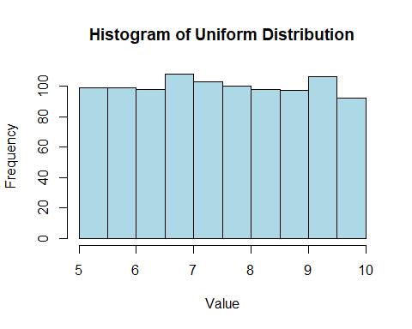

set.seed(123)  
data <- rnorm(1000, mean = 50, sd = 10)  
hist(data, main = "Histogram of Normal Distribution", xlab = "Value", ylab = "Frequency", col = "lightpink", breaks = 30)

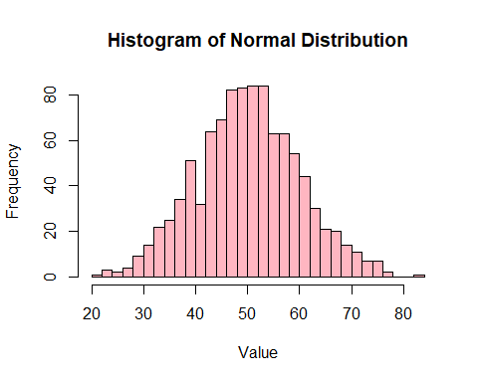

set.seed(123)  
data <- rpois(1000, lambda = 3)  
mean(data)

## [1] 2.967

var(data)

## [1] 2.916828

set.seed(123)  
n <- 10  
p <- 0.5  
data <- rbinom(1000, size = n, prob = p)  
mean(data)

## [1] 4.975

var(data)

## [1] 2.556932