FINGEAR AI: AN EXPLAINABLE FINANCIAL DIGITAL TWIN FOR PERSONALIZED FINANCIAL WELLNESS, FORECASTING AND DECISION SUPPORT

PHASE I REPORT

Submitted by
[STUDENT NAME]
[REGISTER NUMBER]
in partial fulfillment for the award of the degree
of
BACHELOR OF ENGINEERING
IN
COMPUTER SCIENCE AND ENGINEERING
[COLLEGE NAME], [CITY]
ANNA UNIVERSITY : CHENNAI 600 025
SEPTEMBER 2026

FINGEAR AI: AN EXPLAINABLE FINANCIAL DIGITAL TWIN FOR PERSONALIZED FINANCIAL WELLNESS, FORECASTING AND DECISION SUPPORT

A PROJECT REPORT

Submitted by
[STUDENT NAME]
[REGISTER NUMBER]
in partial fulfillment for the award of the degree
of
BACHELOR OF ENGINEERING
IN
COMPUTER SCIENCE AND ENGINEERING
[COLLEGE NAME], [CITY]
ANNA UNIVERSITY : CHENNAI 600 025
SEPTEMBER 2026

BONAFIDE CERTIFICATE
Certified that this project report "FINGEAR AI: AN EXPLAINABLE FINANCIAL DIGITAL TWIN FOR PERSONALIZED FINANCIAL WELLNESS, FORECASTING AND DECISION SUPPORT" is the bonafide work of [STUDENT NAME] ([REGISTER NUMBER]) who carried out the project work under my supervision.
SIGNATURE  HEAD OF THE DEPARTMENT  [Name and Designation]  [Department and College Address] | SIGNATURE  SUPERVISOR  [Name and Academic Designation]  [Department and College Address]

ABSTRACT
FINGEAR AI is an explainable financial intelligence system for personalized financial wellness. The completed Phase I system uses authenticated accounts, a React interface, FastAPI services and a PostgreSQL financial ledger. It supports manual income and expense entry, PDF bill references, sixty-day transaction recovery, income-update choices and category-based analytics. Users are categorized into income tiers between Rs. 15,000 and Rs. 2,00,000 and above. Instead of applying 50:30:20 uniformly, the system assigns practical Needs, Wants and Savings targets for the appropriate tier. These targets, cash flow, emergency reserves, debt burden, saving behaviour and payment discipline produce a transparent 100-point health score. An anomaly detector flags unusual spending and retains a user confirmation or exclusion action. Forecasting starts with a statistical baseline and advances to a per-user ARIMA model as personal history grows. Goal planning, AI Copilot, simulation, the complete Financial Digital Twin and investment advisory are planned for Phase II.

TABLE OF CONTENTS
CHAPTER / SECTION | PAGE
ABSTRACT | iii
LIST OF TABLES | v
LIST OF FIGURES | vi
LIST OF ABBREVIATIONS | vii
CHAPTER 1 INTRODUCTION | 1
CHAPTER 2 LITERATURE REVIEW | 5
CHAPTER 3 SYSTEM ANALYSIS AND REQUIREMENTS | 10
CHAPTER 4 SYSTEM DESIGN | 17
CHAPTER 5 IMPLEMENTATION AND TESTING | 27
CHAPTER 6 RESULTS AND DISCUSSION | 37
CHAPTER 7 CONCLUSION AND FUTURE WORK | 43
APPENDIX 1 HEALTH SCORE FORMULAE | 47
APPENDIX 2 DATA DICTIONARY | 51
REFERENCES | 54

LIST OF TABLES
TABLE NO. | CAPTION
Table 2.1 | Comparison of financial wellness and analytics approaches
Table 3.1 | Functional requirements for Phase I
Table 3.2 | Income-tier allocation targets
Table 4.1 | Financial health score components
Table 4.2 | Transaction category taxonomy
Table 5.1 | Phase I test cases
Table 6.1 | Illustrative score interpretation

LIST OF FIGURES
FIGURE NO. | CAPTION
Figure 1.1 | Phase I scope within the FINGEAR AI roadmap
Figure 4.1 | FINGEAR AI Phase I architecture
Figure 4.2 | Phase I financial intelligence flow
Figure 4.3 | Explainable financial health score
Figure 4.4 | Personalized forecasting lifecycle

LIST OF ABBREVIATIONS
ABBREVIATION | EXPANSION
AI | Artificial Intelligence
API | Application Programming Interface
ARIMA | AutoRegressive Integrated Moving Average
DBMS | Database Management System
EMI | Equated Monthly Instalment
JWT | JSON Web Token
ML | Machine Learning
NWS | Needs Wants Savings
PDF | Portable Document Format
UI | User Interface

CHAPTER 1
INTRODUCTION
1.1 BACKGROUND
Financial wellness depends on a person's ability to meet current commitments, absorb financial shocks, manage borrowing and make progress toward future needs. These outcomes are not visible from income alone. A person with a high income may face unstable cash flow, excessive lifestyle expenditure or inadequate emergency reserves, while a lower-income person may be financially resilient through disciplined spending and saving. A useful personal-finance system must therefore analyze behaviour in context rather than impose a single generic rule.
FINGEAR AI addresses this requirement through an explainable financial intelligence foundation. It captures a financial profile, maintains a transaction ledger and converts transaction behaviour into understandable indicators. The system is designed around the principle that financial technology should make the reasons behind a result visible. Instead of returning an unexplained score, it identifies the actual allocation of needs, wants and savings, shows the appropriate target for the user's income tier, highlights risks and recommends a gradual course correction.
1.2 PROBLEM STATEMENT
Existing expense trackers commonly focus on recording transactions and displaying totals. They do not consistently connect transaction activity with an income-aware financial profile, an emergency-resilience assessment, debt safety, anomaly feedback and individualized forecasts. Generic budgeting advice such as a fixed 50:30:20 allocation can be unrealistic for users with lower income or inadequate for higher-income users who are vulnerable to lifestyle inflation. Further, forecast logic is frequently fragmented across dashboards and modules, producing conflicting estimates.
The problem addressed in Phase I is the creation of a unified, secure and explainable platform that converts personal financial data into a consistent view of present financial health and expected expenditure. The platform must preserve user control, retain data in a structured relational database and provide useful results even when the user's history is initially limited.
1.3 OBJECTIVES
The primary objective is to implement the Phase I intelligence layer of FINGEAR AI. The system provides secure user management, financial profile management with income-tier categorization, transaction and expense tracking, spending anomaly detection, a transparent financial health score and personalized forecasting. Each outcome must be derived from data available to the user, traceable to explicit rules or model outputs and capable of supporting later Phase II Digital Twin features.
Table 1.1 Phase I objectives
NO. | PHASE I OBJECTIVE
1 | Authenticate users and isolate each user's data securely.
2 | Capture income, liabilities, assets, emergency fund and financial preferences.
3 | Maintain a complete transaction ledger with recovery and bill-reference support.
4 | Classify spending into Needs, Wants and Savings/wealth-building categories.
5 | Calculate an income-aware and explainable financial health score.
6 | Detect anomalous transactions and forecast personal spending behaviour.

1.4 SCOPE
The completed scope includes accounts, profiles, category-based transaction management, document attachments, anomaly feedback, health scoring and forecasting. The health score is descriptive and educational; it is not investment, credit or legal advice. The system uses PostgreSQL as the persistent store for users, profiles, financial events, transactions, transaction attachments, anomaly feedback, health results and forecast records.
The Phase II scope deliberately remains outside the present implementation: adaptive goal and budget planning, AI Copilot interaction, what-if decision simulation, completion of the Financial Digital Twin and stock or investment advisory. The Phase I data model and service boundaries are designed so that these modules can consume the same validated ledger in future work.
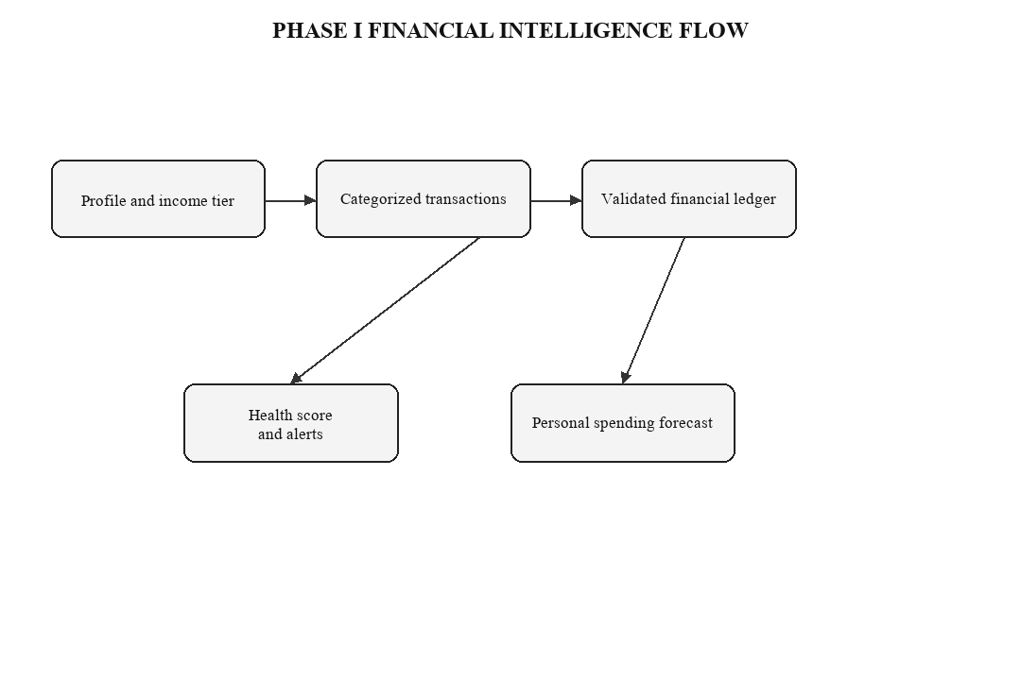
Figure 1.1 Phase I scope within the FINGEAR AI roadmap
1.5 ORGANIZATION OF THE REPORT
Chapter 2 reviews concepts relevant to financial wellness measurement, transaction analytics, anomaly detection and time-series forecasting. Chapter 3 states the requirements and feasibility. Chapter 4 presents the architecture, data design and analytical methods. Chapter 5 explains the implementation and testing strategy. Chapter 6 discusses representative results. Chapter 7 concludes the Phase I work and defines the Phase II roadmap.

CHAPTER 2
LITERATURE REVIEW
2.1 FINANCIAL WELLNESS MEASUREMENT
Financial health is a multidimensional construct. The Financial Health Network organizes it around spending, saving, borrowing and planning/protection. This framing is valuable because it distinguishes the ability to meet current obligations from resilience against shocks and progress toward long-term needs. The Consumer Financial Protection Bureau similarly describes wellbeing in terms of control over day-to-day finances, capacity to absorb a shock, progress toward goals and freedom of choice. These sources support the use of a balanced score rather than a single ratio or net-worth measure.
For a practical personal-finance application, purely subjective surveys are insufficient because the user expects direct feedback from transactions. Conversely, raw transaction data does not capture every contextual factor. FINGEAR AI therefore uses a hybrid approach: objective transaction and profile measures create the primary health score, while confidence indicators and optional future wellbeing inputs can qualify how complete the result is.
2.2 INCOME-AWARE BUDGETING
The 50:30:20 framework is widely understood because it separates expenditure into needs, wants and savings. A rigid application is not equitable across income levels. Essential housing, food and transport can consume a greater portion of a lower-income household's earnings, whereas the same fixed costs may be proportionately lower for a higher-income household. FINGEAR AI operationalizes a tiered target system: 65:15:20 for the survival tier, 50:30:20 for the baseline tier, 45:25:30 for the accumulation tier, 40:20:40 for the reverse-budget tier and 35:15:50 for the wealth-building tier.
Targets are recommendations rather than punitive limits. The application compares current allocation with the appropriate tier and suggests a gradual glide path. For example, it can propose a limited monthly reduction in excess wants and direct the released amount to emergency savings. This prevents a sudden, unrealistic demand for complete behavioural change.
2.3 ANOMALY DETECTION IN PERSONAL FINANCE
Anomaly detection identifies observations that depart materially from expected behaviour. In personal finance, an unusual transaction might result from an error, fraud, a rare necessary purchase or a genuine change in lifestyle. A fully automated system should not silently delete it. FINGEAR AI marks an anomalous transaction, displays its reason or score, and retains a human-in-the-loop action. The user can confirm it as normal, improving the user-specific model, or exclude it from model training while retaining the financial record.
This feedback design is important because financial data is contextual and sparse. It combines machine learning's ability to recognize patterns with user authority over meaning and training eligibility.
2.4 PERSONALIZED TIME-SERIES FORECASTING
Forecasting in finance must recognize the cold-start condition. A newly registered user does not have enough individual data for a dependable personal time-series model. FINGEAR AI therefore uses a rule-based statistical baseline during the initial seven-day collection period. As categorized personal history accumulates, a user-specific ARIMA model is fitted and persisted. The same Forecast Service is used by all Phase I views, avoiding multiple forecast definitions.
The forecast reports a predicted expense trend, anticipated cash-flow pressure and a confidence level. It is intended to inform planning and does not promise a future financial outcome. Model performance is monitored through forecast error against later actual transactions.
Table 2.1 Comparison of financial wellness and analytics approaches
AREA | ESTABLISHED IDEA | FINGEAR AI ADAPTATION
Wellness | Spend, save, borrow, plan/protect dimensions | Five visible score components with explanations
Budgeting | Needs, wants and savings allocation | Income-tier targets and gradual corrections
Anomalies | Deviation from normal transaction pattern | User confirmation or exclusion from learning
Forecasting | Time-series models improve with history | Baseline first, then per-user ARIMA

CHAPTER 3
SYSTEM ANALYSIS AND REQUIREMENTS
3.1 EXISTING SYSTEM LIMITATIONS
A conventional tracker records credits and debits but leaves the user to interpret whether a spending pattern is sustainable. Static budgets can become disconnected from live transactions. Generic health scores may treat all incomes identically, while independent forecast calculations produce inconsistent results between modules. Data stored only in a temporary demonstration layer also prevents trustworthy longitudinal analysis.
The proposed system resolves these limitations through a common relational data source, standardized categorization, a single forecasting service and an explainable score engine. All Phase I analytical outputs are user scoped and derived from a consistent ledger.
3.2 FUNCTIONAL REQUIREMENTS
Table 3.1 Functional requirements for Phase I
ID | REQUIREMENT
FR-01 | Register, authenticate and manage user sessions using secure credentials and JWT access control.
FR-02 | Store a financial profile containing income, expense context, savings, investments, debts and risk inputs.
FR-03 | Assign an income tier and its applicable Needs/Wants/Savings target allocation.
FR-04 | Create, view, edit, delete and restore income and expense transactions.
FR-05 | Accept a PDF bill attachment for a transaction and preserve its metadata.
FR-06 | Apply category and NWS bucket classification to each transaction.
FR-07 | Flag anomalous transactions and support confirm-normal or exclude-learning feedback.
FR-08 | Compute a component-level health score, grade, risk flags and data confidence.
FR-09 | Generate a baseline forecast and transition to a persisted personal ARIMA forecast.

3.3 NON-FUNCTIONAL REQUIREMENTS
Security requires authenticated endpoints, password hashing, token validation, user-level authorization and input validation. Reliability requires database constraints, transactional writes and soft deletion rather than immediate irreversible removal. Usability requires a responsive interface, understandable language, confirmation prompts for destructive actions and visibility of score reasons. Maintainability requires modular APIs, separate services for analytics and reusable schemas. Explainability requires that every health component and anomaly action can be traced to its inputs.
3.4 USER TIER CLASSIFICATION
The tier is assigned from the rolling three-month average net monthly income. This reduces distortion from a one-time bonus or an isolated low-income month. When the profile has insufficient history, the most recently declared net income is used and the result is marked provisional. Tier classification changes the target allocation, not a user's eligibility for system functions.
Table 3.2 Income-tier allocation targets
TIER | NET MONTHLY INCOME | NEEDS | WANTS | SAVINGS
Survival | Rs. 15,000 - Rs. 30,000 | 65% | 15% | 20%
Baseline | Rs. 30,000 - Rs. 50,000 | 50% | 30% | 20%
Accumulation | Rs. 50,000 - Rs. 80,000 | 45% | 25% | 30%
Reverse Budget | Rs. 80,000 - Rs. 1,25,000 | 40% | 20% | 40%
Wealth Building | Rs. 1,25,000 and above | 35% | 15% | 50%

3.5 FEASIBILITY
Technical feasibility is established through a browser-based React interface, FastAPI web services, PostgreSQL persistence and Python analytical libraries. Operational feasibility is supported by familiar transaction-entry patterns and plain-language explanations. Economic feasibility is supported by open-source components for development and a modular deployment model. The project is ethically feasible because it presents educational insights, preserves user control over anomaly learning and avoids representing the output as guaranteed investment advice.

CHAPTER 4
SYSTEM DESIGN
4.1 ARCHITECTURE
FINGEAR AI follows a layered architecture. The React client provides authenticated profile and transaction interfaces. FastAPI exposes feature-oriented REST endpoints and coordinates validation, business rules and analytics. PostgreSQL persists user-scoped entities and audit-relevant events. The classification, health scoring, anomaly and forecasting services are independent components that receive validated ledger data and return structured outputs to the API layer.
This separation ensures that later Phase II modules can reuse the same ledger and profile without reimplementing essential financial calculations. For example, a what-if simulator can obtain its baseline from the common Forecast Service, while a future Digital Twin can consume health history, anomaly signals and financial events.
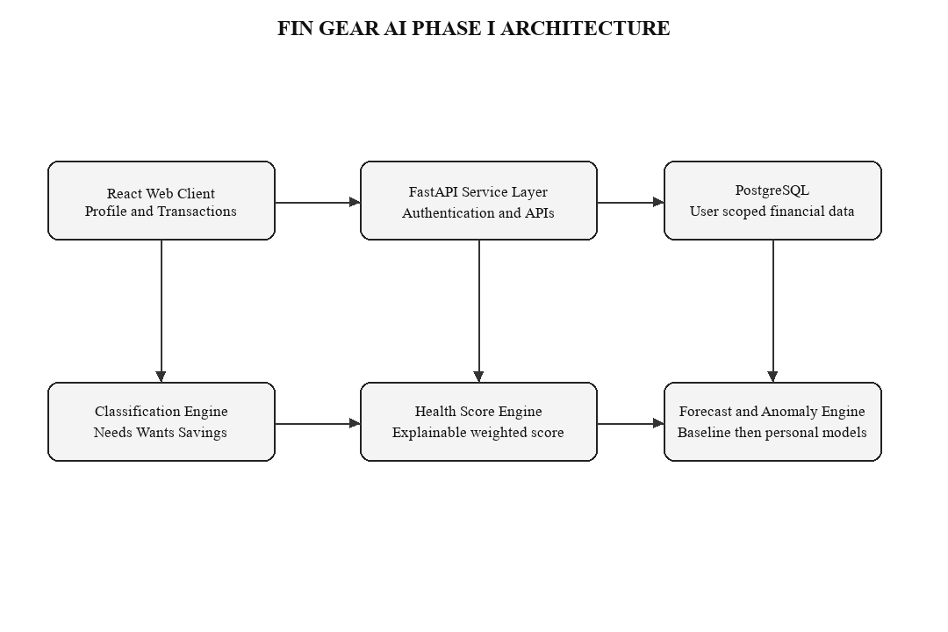
Figure 4.1 FINGEAR AI Phase I architecture
4.2 DATA DESIGN
The PostgreSQL schema is designed around a stable user identity and a complete financial ledger. Major tables include users, financial_profiles, transactions, transaction_attachments, category_mappings, budgets, debts, goals, health_scores, forecast_runs, anomaly_feedback and financial_events. Each record includes a user identifier, creation timestamp and appropriate integrity constraints. Monetary fields use fixed-precision numeric types rather than binary floating-point types.
A transaction holds date, description, category, amount, type, NWS bucket, recurring status, optional income-scope selection and a soft-deletion timestamp. Attachments are stored through controlled metadata and binary-storage references. Soft deletion preserves a recoverable sixty-day window and supports auditability.
4.3 TRANSACTION CLASSIFICATION
Table 4.1 Transaction category taxonomy
BUCKET | REPRESENTATIVE CATEGORIES | DESIGN RULE
Needs | Rent, groceries, utilities, health, education, insurance, transport, mandatory EMI | Essential or contractual spending
Wants | Dining, entertainment, subscriptions, shopping, travel, hobbies | Discretionary lifestyle spending
Savings / wealth building | Emergency transfer, FD, SIP, mutual fund, PPF/NPS, extra principal payment | Future-resilience or wealth allocation
Income | Salary, freelance income, business income, interest, bonus | Incoming cash flow

Mandatory EMI is counted as a need because it is a current obligation. Only extra principal repayment is classified as savings or wealth building. This mutual exclusivity prevents the score from incorrectly rewarding a user simply for carrying a large compulsory loan.
4.4 FINANCIAL HEALTH SCORE DESIGN
The Financial Health Score is an explainable score on a 0 to 100 scale. It uses the rolling three-month average of closed months wherever data is available. The system separates score from data confidence: incomplete records reduce confidence, not the user's health result. Each component returns a bounded subscore, a human-readable reason and an associated recommendation.
Table 4.2 Financial health score components
COMPONENT | WEIGHT | PRIMARY MEASURES
Spending sustainability | 30% | Tier allocation fit and monthly surplus
Emergency resilience | 25% | Liquid fund coverage against risk-adjusted essential outflow
Debt manageability | 20% | EMI-to-income and outstanding debt-to-annual-income
Future readiness | 15% | Saving target achievement, goal feasibility and investment consistency
Payment discipline and protection | 10% | On-time obligations, planning status and coverage details

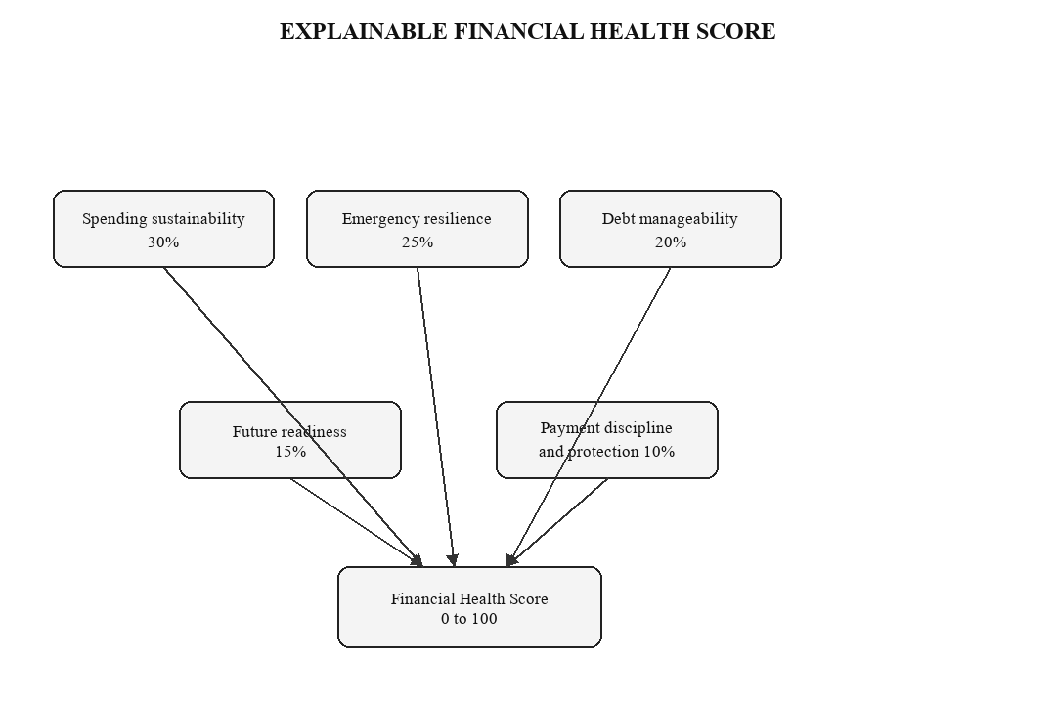
Figure 4.2 Explainable financial health score
4.5 SCORING FORMULATION
Let I be average net monthly income, NE average monthly needs expenditure, WA average monthly wants expenditure, SV average monthly savings and wealth-building contributions, EMI mandatory monthly repayment, OD outstanding debt and EF liquid emergency funds. Let NT, WT and ST represent the target needs, wants and savings ratios for the user's income tier. The allocation scores are NeedsFit = min(100, 100 x NT / (NE/I)), WantsFit = min(100, 100 x WT / (WA/I)) and SavingsFit = min(100, 100 x (SV/I) / ST). AllocationFit weights these values at 25%, 30% and 45% respectively.
Spending Sustainability combines 75% of AllocationFit and 25% of SurplusFit. Emergency Resilience is min(100, 100 x EF / EmergencyTarget), where EmergencyTarget is essential monthly outflow multiplied by three to six risk-adjusted months; the survival tier uses a minimum target of Rs. 25,000. Debt Manageability combines a 70% EMI score and 30% outstanding-debt score. The final score is 0.30 x Spending Sustainability + 0.25 x Emergency Resilience + 0.20 x Debt Manageability + 0.15 x Future Readiness + 0.10 x Payment Discipline and Protection.
Guardrails prevent an attractive average from hiding a serious issue. Negative cash flow caps the score at 59. An EMI ratio at or above 40% caps the score at 49. Emergency coverage below one month and missed obligations in the last ninety days generate high-risk flags. The score is marked provisional until at least thirty days of transaction data exists.
4.6 ANOMALY DETECTION DESIGN
The anomaly service evaluates new transactions against the user's category, amount, time and historical behaviour. During sparse-data periods it uses robust statistical thresholds and rule checks. As more transactions become available, an online learned representation improves its ability to identify deviations. A flagged transaction remains in the ledger. The user can select a positive confirmation action to label it normal or an exclusion action to prevent it from influencing future model training. This design supports explainable human-in-the-loop learning.
4.7 UNIFIED FORECASTING DESIGN
The Forecast Service provides one common source of truth for all Phase I outputs. During the first seven days it estimates expense using categorized transaction averages, declared profile inputs and simple statistical smoothing. Following collection of sufficient individual observations, it fits an ARIMA time-series model separately for each user and persists the model state, forecast horizon, confidence and error metrics. Forecasts are based on a user's own financial activity rather than a global synthetic profile.
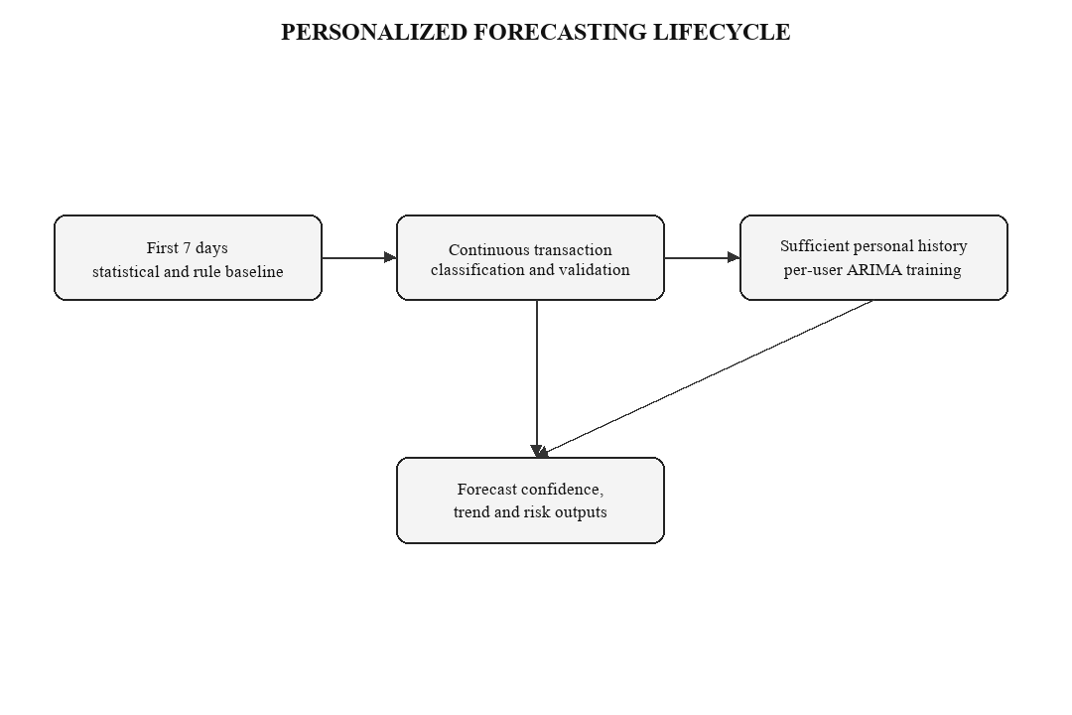
Figure 4.3 Personalized forecasting lifecycle

CHAPTER 5
IMPLEMENTATION AND TESTING
5.1 IMPLEMENTATION STACK
The frontend is implemented using React, Vite, React Router, Recharts and Lucide React. It provides authentication views, profile forms, transaction management, health-score views and forecasting dashboards. The backend is implemented with FastAPI and Pydantic schemas. PostgreSQL provides persistent storage. Authentication uses password hashing and JWT-based authorization. Python services perform financial calculations, anomaly processing and forecast generation.
The services are organized by feature to maintain clear responsibilities. Authentication, profile, transaction, health, forecast and AI endpoints obtain the current user identity from the security layer. Repository operations query and update only the relevant user's records. This design prevents one user's transaction or model feedback from affecting another user's result.
5.2 USER LOGIN AND PROFILE MANAGEMENT
A user can register with name, email and password, authenticate through the login endpoint and receive a protected session token. The profile captures income, occupation, experience level, essential expenses, savings balance, investments, debts, emergency fund and financial goals. On profile save, the categorization service computes the current income tier and target allocation. Income is treated as changeable rather than a fixed onboarding value.
Income transactions can optionally be incorporated into the monthly-income suite. The system asks whether the income should apply only to the present month or to all future months. This preserves the distinction between a temporary bonus and a sustained change in earnings.
5.3 TRANSACTION AND EXPENSE TRACKING
The transaction interface supports income and expense entries with date, description, category, amount and type. The category taxonomy maps entries to their health-score bucket. A PDF bill can be attached as a reference subject to type and size validation. Before a destructive operation, the interface requests confirmation. Deleted transactions move to a recently deleted collection, remain recoverable for sixty days and can be restored by the user.
Transactions are placed immediately below the dashboard in the navigation hierarchy so that the ledger is treated as the operational core of the system rather than an isolated utility. Dashboard totals, health scoring, anomaly signals and forecasts consume the same validated transaction records.
5.4 ANOMALY FEEDBACK FLOW
When a new transaction is saved, the anomaly engine evaluates it and, if necessary, attaches an anomaly flag and score. The transaction row exposes two direct actions. The confirmation action indicates that the user considers the entry normal and permits the transaction to be included in learning. The exclusion action retains the transaction as a financial fact but excludes it from model training. This reduces the chance that irregular events such as an emergency purchase distort the user's baseline behaviour.
5.5 TESTING STRATEGY
Testing combines API validation, service-level calculations, authorization checks and interface-flow verification. Test data includes different income tiers, normal and irregular transactions, changes in income, invalid upload types, recovery-window expiry and insufficient-history forecasts. The test strategy prioritizes financial correctness, prevention of unauthorized access and understandable handling of missing data.
Table 5.1 Phase I test cases
ID | TEST SCENARIO | EXPECTED RESULT
TC-01 | Register and log in a new user | Protected token issued; data isolated to the user.
TC-02 | Enter a valid income transaction and select present month | Ledger records income and updates only current income view.
TC-03 | Delete then restore a transaction within sixty days | Transaction returns to active ledger and analytics refresh.
TC-04 | Upload non-PDF bill attachment | Request rejected with validation message.
TC-05 | Add a highly unusual expense | Transaction retained and visibly flagged for review.
TC-06 | Confirm an anomalous transaction as normal | Feedback persisted and transaction eligible for learning.
TC-07 | Create a low-history profile | Baseline forecast and provisional confidence displayed.
TC-08 | Maintain negative cash flow | Health score capped at needs-attention range with risk message.

5.6 SECURITY AND PRIVACY
Sensitive financial information is protected through authenticated API access, user-scoped database queries and secure credential handling. Input schemas validate amounts, dates, categories and upload content. Monetary values are stored using numeric database types. The application does not represent generated insights as a credit decision or investment guarantee. Users retain control over deletion recovery and anomaly-model feedback.

CHAPTER 6
RESULTS AND DISCUSSION
6.1 HEALTH SCORE INTERPRETATION
The final design provides a score that can be interpreted in components. A user does not receive only a number; they see whether spending sustainability, emergency resilience, debt, future readiness or payment discipline is driving the outcome. For example, a person may have a satisfactory allocation but insufficient liquid reserves. In that case the system does not incorrectly recommend more investment; it prioritizes emergency-fund construction.
Table 6.1 Illustrative score interpretation
SCORE | GRADE | SYSTEM INTERPRETATION
80-100 | Financially Healthy | Spending, resilience, debt and forward progress are broadly stable.
60-79 | Stable, improving | The financial position is generally sound but one or more components need attention.
40-59 | Needs Attention | A material cash-flow, savings, debt or planning weakness requires action.
0-39 | Financially Vulnerable | The user has immediate resilience or affordability concerns.

6.2 ADAPTIVE ALLOCATION EXAMPLE
Consider a user with a net monthly income of Rs. 50,000. The user belongs to the Accumulation tier, whose target is 45% Needs, 25% Wants and 30% Savings. If wants expenditure is Rs. 30,000, the actual wants ratio is 60%, producing an excess of Rs. 17,500 against the tier target. The application does not require an immediate reduction of the entire amount. It can recommend a controlled monthly decrease, for example up to five percent of income (Rs. 2,500), and redirect it to emergency reserves or savings. The health score will improve as observed allocation approaches the target.
This method is fairer than a universal 50:30:20 calculation. A user in the survival tier may require 65% for essential needs and should be evaluated against that realistic context. At higher income levels, the model identifies lifestyle inflation and places stronger emphasis on savings and wealth-building.
6.3 FORECASTING RESULTS
The forecasting design handles both new and established users. In the cold-start period, the baseline forecast provides a cautious projection with an explicit confidence level. Once adequate personal data exists, the per-user ARIMA service captures recurring patterns and recent expense trends. The result is used consistently by the forecast page and can later be consumed by planning, simulation and Digital Twin modules. By avoiding separate formulas in separate interfaces, the system prevents contradictory financial estimates.
6.4 ANOMALY DETECTION RESULTS
The anomaly workflow enhances the transaction manager without treating anomalies as errors by default. A transaction can be anomalous because it is an outlier, not because it is invalid. The explicit confirmation and exclusion choices produce a transparent feedback loop. This is particularly useful when irregular expenses occur, such as medical treatment, travel, one-time repairs or seasonal purchases. The model becomes increasingly personal without hiding the user's control over training data.
6.5 DISCUSSION
Phase I demonstrates that meaningful financial intelligence can be delivered without using a black-box model for every decision. The primary health score is rule-based because financial guidance should be auditable. Machine learning is used where it has a clearer role: recognizing unusual transaction patterns and improving forecasts as user history grows. The combined approach improves trust, permits detailed explanations and remains technically extensible.
The current results depend on transaction completeness and correct categorization. FINGEAR AI addresses this limitation by publishing a separate confidence status and by allowing users to edit records. It does not confuse absence of data with poor financial health. Continued use improves both the reliability of forecast results and the quality of personalization.

CHAPTER 7
CONCLUSION AND FUTURE WORK
7.1 CONCLUSION
FINGEAR AI Phase I establishes an explainable, database-backed foundation for personalized financial wellness. The project integrates secure account management, financial profiles with income-tier categorization, a conventional yet connected transaction manager, anomaly detection, an adaptive financial health score and unified personal forecasting. The system is designed to make its logic visible: budget targets vary by income context, mandatory commitments are not misrepresented as voluntary savings, serious risks trigger guardrails and anomalies require human confirmation or exclusion.
By adopting PostgreSQL persistence and user-scoped services, the Phase I implementation creates reliable longitudinal financial data. The common ledger and Forecast Service prevent individual pages from making isolated or conflicting calculations. The outcome is a practical foundation for a Financial Digital Twin that can evolve responsibly as additional decision-support modules are implemented.
7.2 PHASE II FUTURE WORK
Phase II will add goal and budget planning, AI Copilot assistance, what-if simulation, completion of the Financial Digital Twin and stock/investment advisory and management. Goal and budget planning will consume the health score and forecast to recommend feasible contributions. The AI Copilot will explain system outputs in conversational form while retaining the same source-of-truth services. The simulator will compare potential changes in income, expenditure, investments and debt against the forecast baseline. The completed Digital Twin will connect profile state, transaction behaviour, health history, anomaly feedback and forecast scenarios into a continuous representation of the user's financial position.
Investment capabilities will be introduced with explicit risk profiling, suitability safeguards, explanations and disclaimers. These features will remain decision support rather than a substitute for regulated professional advice. Future evaluation will include usability studies, forecast-error tracking, score-stability analysis and feedback on recommendation clarity.
7.3 LIMITATIONS
The system relies on the completeness and correctness of user-entered data. Initial forecasts are inherently less personalized until adequate history is available. The score is a financial-wellness indicator, not a credit score, tax calculation, insurance recommendation or guarantee of financial outcomes. The scope intentionally excludes direct bank integration and regulated investment execution in Phase I.

APPENDIX 1
FINGEAR AI FINANCIAL HEALTH SCORE FORMULAE
Definitions: I = rolling average net monthly income; NE = monthly needs expenditure; WA = monthly wants expenditure; SV = monthly savings, investments and extra debt repayment; EMI = mandatory debt repayment; OD = outstanding debt; EF = liquid emergency funds. Let NT, WT and ST be the income-tier targets.
NeedsFit = min(100, 100 x NT / (NE/I)). WantsFit = min(100, 100 x WT / (WA/I)). SavingsFit = min(100, 100 x (SV/I) / ST). AllocationFit = 0.25 x NeedsFit + 0.30 x WantsFit + 0.45 x SavingsFit. SurplusFit = min(100, 100 x max(I - NE - WA, 0) / (ST x I)). Spending Sustainability = 0.75 x AllocationFit + 0.25 x SurplusFit.
Emergency Resilience = min(100, 100 x EF / EmergencyTarget). EmergencyTarget equals essential monthly outflow multiplied by the risk-adjusted target of three to six months; the survival tier target is not lower than Rs. 25,000. Debt Manageability combines 70% EMI score and 30% outstanding-debt score. Future Readiness combines saving target achievement, goal feasibility where present and investment consistency. Payment Discipline and Protection combines payment history, planning status and recorded coverage status.
Final Health Score = 0.30 x Spending Sustainability + 0.25 x Emergency Resilience + 0.20 x Debt Manageability + 0.15 x Future Readiness + 0.10 x Payment Discipline and Protection. Negative monthly cash flow caps the score at 59. EMI at or above 40% of income caps the score at 49. Emergency coverage below one month creates a high-resilience-risk flag.

APPENDIX 2
PHASE I DATA DICTIONARY
Table A2.1 Phase I data dictionary
ENTITY | KEY DATA
User | User identifier, name, email, password hash, created timestamp
Financial Profile | Income, tier, assets, debts, emergency fund, profile preferences
Transaction | Date, amount, type, category, NWS bucket, income scope, soft-delete status
Attachment | Transaction reference, file metadata, secure storage reference
Anomaly Feedback | Transaction reference, flag, user decision, training eligibility
Health Score | Component scores, final score, grade, risk flags, confidence, created timestamp
Forecast Run | User model state, horizon, forecast values, confidence and error metrics

REFERENCES
1. Consumer Financial Protection Bureau. (2023). Measuring Financial Well-Being: A Guide to Using the CFPB Financial Well-Being Scale. Washington, DC: CFPB.
2. Financial Health Network. (2026). From Insight to Impact: The Next Phase of Financial Health Measurement. Chicago, IL: Financial Health Network.
3. Hyndman, R. J. and Athanasopoulos, G. (2021). Forecasting: Principles and Practice. 3rd ed. Melbourne: OTexts.
4. Box, G. E. P., Jenkins, G. M., Reinsel, G. C. and Ljung, G. M. (2015). Time Series Analysis: Forecasting and Control. 5th ed. Hoboken: Wiley.
5. Chandola, V., Banerjee, A. and Kumar, V. (2009). Anomaly Detection: A Survey. ACM Computing Surveys, 41(3), pp. 1-58.
6. FastAPI. (2026). FastAPI Documentation. Available at: https://fastapi.tiangolo.com/ (Accessed: 7 September 2026).
7. PostgreSQL Global Development Group. (2026). PostgreSQL 16 Documentation. Available at: https://www.postgresql.org/docs/16/ (Accessed: 7 September 2026).
8. React Team. (2026). React Documentation. Available at: https://react.dev/ (Accessed: 7 September 2026).

