**EXPERIMENT - 02**

**Aim:**

The aim of this experiment is to design a user interface (UI) in Figma for evaluating the effect of chunking on user memory. The UI will involve showing groups of visual elements (icons or text), followed by a recall phase where users will attempt to recall the displayed items. The goal is to assess how different chunk sizes and types (icons vs. text) affect memory retention.

**Procedure:**

1. **Home Screen (Instruction Page)**:
   * Create a frame (1024x768px) to represent the Home Screen.
   * Add instructions to explain the task, including the time limit for viewing the items.
   * Design a "Start" button to transition to the Chunking Phase.
2. **Chunking Phase**:
   * Create a new frame for the Chunking Phase.
   * Display grouped items (either icons or text) in chunks. Optionally, use borders to separate chunks or place them without borders for a different effect.
   * Set the viewing time to 5 seconds using Figma’s prototyping tools to transition to the Recall Phase after a 5-second delay.
3. **Recall Phase**:
   * Create a new frame for the Recall Phase where users will recall the displayed items.
   * Provide options for users to recall the items using either multiple-choice (checkboxes/radio buttons) or text input fields.
   * Add a "Submit Recall" button that will move the user to the Result Screen after submission.
4. **Result Screen**:
   * Create a feedback screen that shows how many items the user recalled correctly (e.g., "You recalled 4/5 items correctly!").
   * Evaluate the impact of chunk size (3 vs. 5 items) and chunk type (icons vs. text) on recall.

**Outputs:**

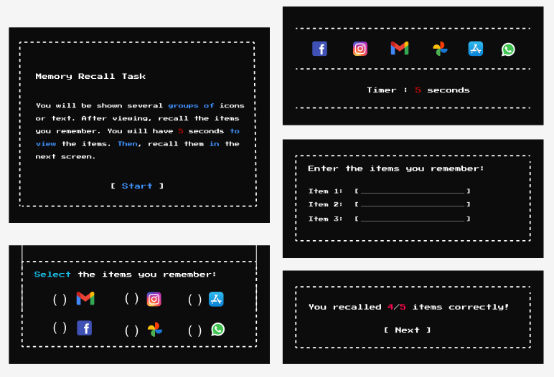

**Result:**

The experiment will allow you to evaluate the effects of chunking on user memory by analyzing recall accuracy across different chunk sizes and types. The feedback screen will display the user's performance, helping assess how varying the number of items per chunk and the format (icons vs. text) influences memory retention.