**EXPERIMENT - 03**

**Aim:**

The aim is to develop and compare Command Line Interface (CLI), Graphical User Interface (GUI), and Voice User Interface (VUI) for the same task, and assess user satisfaction using Python (with Tkinter for GUI and Speech Recognition for VUI) and Terminal.

**Procedure:**

1. **CLI (Command Line Interface)**:

* Implement a task management system in the terminal where users can add, view, and remove tasks by typing commands.
* The program allows users to choose from a menu with options for adding, viewing, and removing tasks.

**Output:**

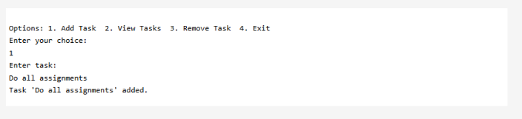

1. **VUI (Voice User Interface)**:

* Use the speech_recognition library for voice input and pyttsx3 for voice output.
* The system listens for voice commands to add, view, or remove tasks, and speaks back the results or errors.

**Output:**

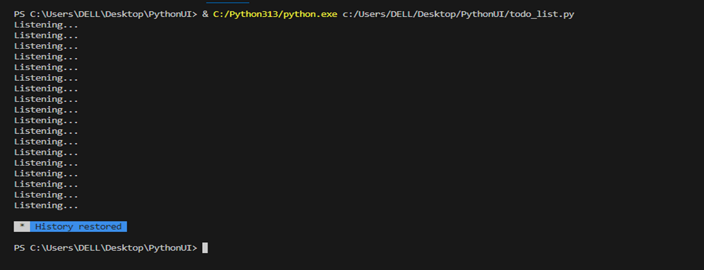

1. **GUI (Graphical User Interface)**:

* Use Tkinter to create a graphical interface with buttons for adding and removing tasks, and a listbox to display tasks.
* Users interact with the GUI by clicking buttons to add or remove tasks.

**Output:**

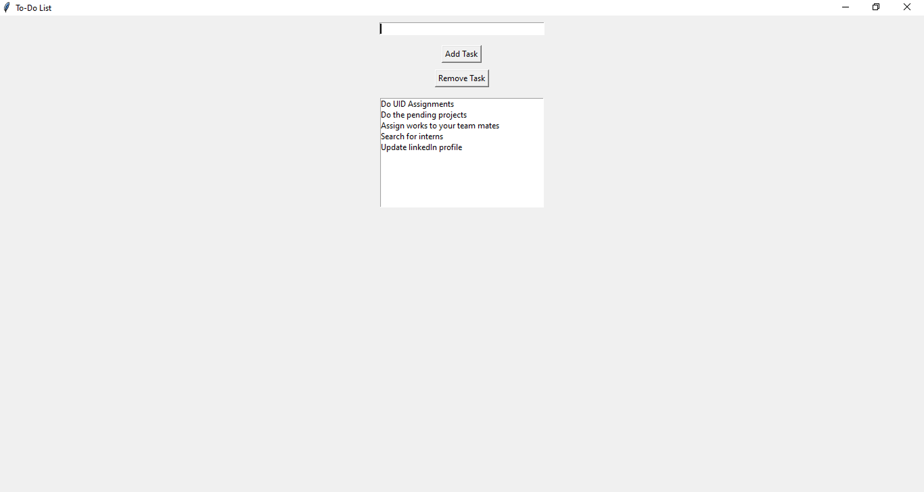

**Result:**

Thus, the CLI, GUI, and VUI allows users to manage tasks through different interaction methods, with user satisfaction varying based on ease of use, speed, and familiarity with the interface is implemented successfully.