|  |  |  |
| --- | --- | --- |
| **Ex.No.: 2** | | **DATA MANIPULATIONS** |
| **Date:** | 5/8/24 |

# Create the following tables with the given structure. EMPLOYEES TABLE

|  |  |  |
| --- | --- | --- |
| **NAME** | **NULL?** | **TYPE** |
| Employee_id | Not null | Number(6) |
| First_Name |  | Varchar(20) |
| Last_Name | Not null | Varchar(25) |
| Email | Not null | Varchar(25) |
| Phone_Number |  | Varchar(20) |
| Hire_date | Not null | Date |
| Job_id | Not null | Varchar(10) |
| Salary |  | Number(8,2) |
| Commission_pct |  | Number(2,2) |
| Manager_id |  | Number(6) |
| Department_id |  | Number(4) |

1. Find out the employee id, names, salaries of all the employees

SELECT Employee_id, First_name, Last_name, Salary FROM EMPLOYEES;

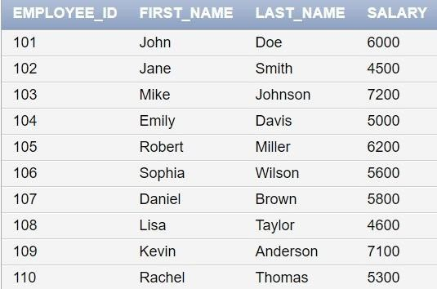

1. List out the employees who works under manager 100

SELECT Employee_id, First_name, Last_name FROM EMPLOYEES WHERE Manager_id = 100;

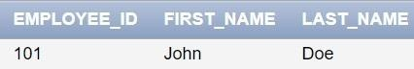

1. 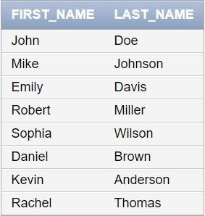Find the names of the employees who have a salary greater than or equal to 4800 SELECT First_name, Last_name FROM EMPLOYEES WHERE Salary >= 4800;
2. List out the employees whose last name is ‗AUSTIN‘

SELECT Employee_id, First_name, Last_name FROM EMPLOYEES WHERE Last_name = 'AUSTIN';

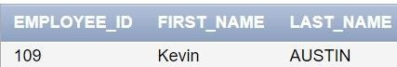

1. Find the names of the employees who works in departments 60,70 and 80

SELECT First_name, Last_name FROM EMPLOYEES WHERE Department_id IN (60, 70, 80);

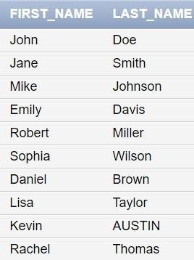

1. Display the unique Manager_Id.

SELECT DISTINCT Manager_id FROM EMPLOYEES;

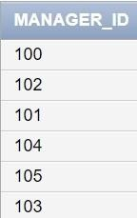

Create an Emp table with the following fields: (EmpNo, EmpName, Job,Basic, DA, HRA,PF, GrossPay, NetPay) (Calculate DA as 30% of Basic and HRA as 40% of Basic)

1. Insert Five Records and calculate GrossPay and NetPay.

INSERT INTO EMP (EmpNo, EmpName, Job, Basic, DA, HRA, PF, GrossPay, NetPay) VALUES (1, 'John Doe', 'Manager', 50000, 0.30 * 50000, -- DA as 30% of Basic

0.40 * 50000, -- HRA as 40% of Basic,0.12 * 50000, -- PF as 12% of Basic

50000 + (0.30 * 50000) + (0.40 * 50000), -- GrossPay (50000 + (0.30 * 50000) + (0.40 *

50000)) - (0.12 * 50000) -- NetPay

);

INSERT INTO EMP (EmpNo, EmpName, Job, Basic, DA, HRA, PF, GrossPay, NetPay) VALUES (2, 'Jane Smith', 'Clerk', 30000, 0.30 * 30000, 0.40 * 30000,

0.12 * 30000,

30000 + (0.30 * 30000) + (0.40 * 30000),

(30000 + (0.30 * 30000) + (0.40 * 30000)) - (0.12 * 30000)

);

INSERT INTO EMP (EmpNo, EmpName, Job, Basic, DA, HRA, PF, GrossPay, NetPay) VALUES (3, 'Mike Johnson', 'Salesman', 40000,

0.30 * 40000,

0.40 * 40000,

0.12 * 40000,

40000 + (0.30 * 40000) + (0.40 * 40000),

(40000 + (0.30 * 40000) + (0.40 * 40000)) - (0.12 * 40000)

);

INSERT INTO EMP (EmpNo, EmpName, Job, Basic, DA, HRA, PF, GrossPay, NetPay) VALUES (4, 'Emily Davis', 'Accountant', 35000,

0.30 * 35000,

0.40 * 35000,

0.12 * 35000,

35000 + (0.30 * 35000) + (0.40 * 35000),

(35000 + (0.30 * 35000) + (0.40 * 35000)) - (0.12 * 35000)

);

INSERT INTO EMP (EmpNo, EmpName, Job, Basic, DA, HRA, PF, GrossPay, NetPay) VALUES (5, 'Robert Miller', 'Clerk', 25000,

0.30 * 25000,

0.40 * 25000,

0.12 * 25000,

25000 + (0.30 * 25000) + (0.40 * 25000),

(25000 + (0.30 * 25000) + (0.40 * 25000)) - (0.12 * 25000)

);

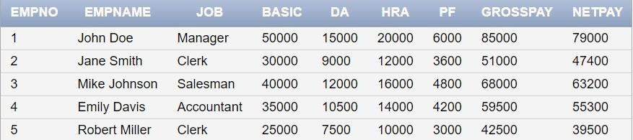

1. Display the employees whose Basic is lowest in each department.

SELECT EmpNo, EmpName, Job, Basic FROM EMP E1 WHERE Basic = ( SELECT MIN(Basic) FROM EMP E2 WHERE E2.Job = E1.Job);

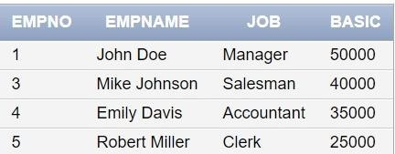

1. 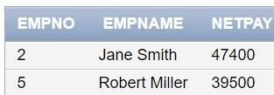If Net Pay is less than 50000, display employee number,name and net pay SELECT EmpNo, EmpName, NetPay FROM EMP WHERE NetPay < 50000;

# DEPARTMENT TABLE

|  |  |  |
| --- | --- | --- |
| **NAME** | **NULL?** | **TYPE** |
| Dept_id | Not null | Number(6) |
| Dept_name | Not null | Varchar(20) |
| Manager_id |  | Number(6) |
| Location_id |  | Number(4) |

**JOB_GRADE TABLE**

|  |  |  |
| --- | --- | --- |
| **NAME** | **NULL?** | **TYPE** |
| Grade_level |  | Varchar(2) |
| Lowest_sal |  | Number |
| Highest_sal |  | Number |

# LOCATION TABLE

|  |  |  |
| --- | --- | --- |
| **NAME** | **NULL?** | **TYPE** |
| Location_id | Not null | Number(4) |
| St_addr |  | Varchar(40) |
| Postal_code |  | Varchar(12) |
| City | Not null | Varchar(30) |
| State_province |  | Varchar(25) |
| Country_id |  | Char(2) |

* 1. Create the DEPT table based on the DEPARTMENT following the table instance chart below. Confirm that the table is created.

|  |  |  |
| --- | --- | --- |
| **Column name** | ID | NAME |
| **Key Type** |  |  |
| **Nulls/Unique** |  |  |
| **FK table** |  |  |
| **FK column** |  |  |
| **Data Type** | Number | Varchar2 |
| **Length** | 7 | 25 |

CREATE TABLE DEPT (Dept_id NUMBER(6) NOT NULL, Dept_name VARCHAR2(20)

NOT NULL,Manager_id NUMBER(6), Location_id NUMBER(4), CONSTRAINT my_dept_id_pk PRIMARY KEY (Dept_id));

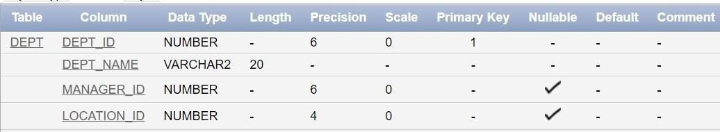

* 1. Create the EMP table based on the following instance chart. Confirm that the table is created.

|  |  |  |  |  |
| --- | --- | --- | --- | --- |
| **Column name** | ID | LAST_NAME | FIRST_NAME | DEPT_ID |
| **Key Type** |  |  |  |  |
| **Nulls/Unique** |  |  |  |  |
| **FK table** |  |  |  |  |
| **FK column** |  |  |  |  |
| **Data Type** | Number | Varchar2 | Varchar2 | Number |
| **Length** | 7 | 25 | 25 | 7 |

CREATE TABLE EMP (EmpNo NUMBER(7) PRIMARY KEY,Last_name VARCHAR2(25)

NOT NULL,First_name VARCHAR2(25),Dept_id NUMBER(7), CONSTRAINT my_emp_dept_id_fk FOREIGN KEY (Dept_id) REFERENCES DEPT(Dept_id));

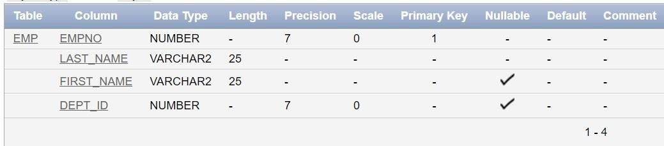

* 1. Modify the EMP table to allow for longer employee last names. Confirm the modification.(Hint: Increase the size to 50)

ALTER TABLE EMP MODIFY (Last_name VARCHAR2(50));

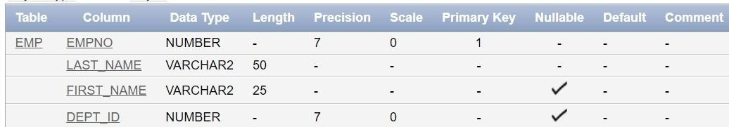

* 1. Create the EMPLOYEES2 table based on the structure of EMPLOYEES table. Include Only the Employee_id, First_name, Last_name, Salary and Dept_id coloumns. Name the columns Id, First_name, Last_name, salary and Dept_id respectively.

CREATE TABLE EMPLOYEES2 (Id NUMBER(6) PRIMARY

KEY,First_name VARCHAR2(20),Last_name VARCHAR2(25), Salary NUMBER(8,2),Dept_id NUMBER(4));

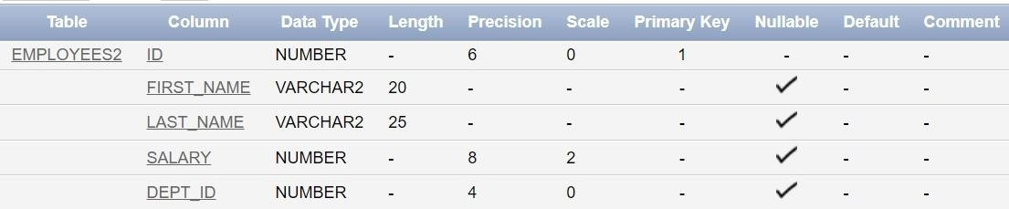

* 1. Drop the EMP Table DROP TABLE EMP;



* 1. Rename the EMPLOYEES2 table as EMP.

ALTER TABLE EMPLOYEES2 RENAME TO EMP;



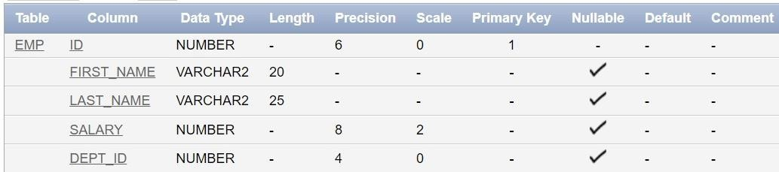

* 1. Add a comment on DEPT and EMP tables. Confirm the modification by describing the table.

COMMENT ON TABLE DEPT IS 'This table contains department information.'; COMMENT ON TABLE EMP IS 'This table contains employee information.';

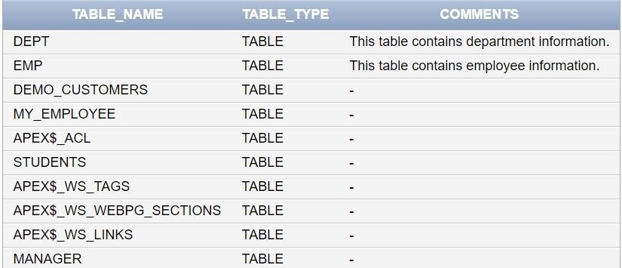

* 1. Drop the First_name column from the EMP table and confirm it.

ALTER TABLE EMP DROP COLUMN First_name;

