# 07 – Tuple/Set

Ex. No. : 7.1 Date: 06/04/24

Register No.: 230701349 Name: S Subramanian

## Binary String

Coders here is a simple task for you, Given string str. Your task is to check whether it is a binary string or not by using python set.

Examples:

Input: str = "01010101010"

Output: Yes

Input: str = "REC101"

Output: No

For example:

|  |  |
| --- | --- |
| Input | Result |
| 01010101010 | Yes |
| 010101 10101 | No |

Program:

a = input() try:

c = int(a) print("Yes") except:

print("No")

Ex. No. : 7.2 Date: 06/04/24

Register No.: 230701349 Name: S Subramanian

## DNA Sequence

The DNA sequence is composed of a series of nucleotides abbreviated as 'A', 'C', 'G', and 'T'.

For example, "ACGAATTCCG" is a DNA sequence.

When studying DNA, it is useful to identify repeated sequences within the DNA.

Given a string s that represents a DNA sequence, return all the 10-letterlong sequences (substrings) that occur more than once in a DNA molecule. You may return the answer in any order.

Example 1:

Input: s = "AAAAACCCCCAAAAACCCCCCAAAAAGGGTTT" Output: ["AAAAACCCCC","CCCCCAAAAA"] Example 2:

Input: s = "AAAAAAAAAAAAA"

Output: ["AAAAAAAAAA"]

For example:

|  |  |
| --- | --- |
| Input | Result |
| AAAAACCCCCAAAAACCCCCCAAAAAGGGTTT | AAAAACCCCC  CCCCCAAAAA |

Program:

def findRepeatedSequences(s):

sequences = {} result = [] for i in range(len(s) - 9):

seq = s[i:i+10] sequences[seq] = sequences.get(seq, 0) + 1 if sequences[seq] == 2: result.append(seq) return result s1 = input() for i in findRepeatedSequences(s1):

print(i)

Ex. No. : 7.3 Date: 06/04/24

Register No.:230701349 Name: S Subramanian

## American keyboard

Given an array of strings words, return the words that can be typed using letters of the alphabet on only one row of American keyboard like the image below.

In the American keyboard:

* the first row consists of the characters "qwertyuiop",
* the second row consists of the characters "asdfghjkl", and ● the third row consists of the characters "zxcvbnm".

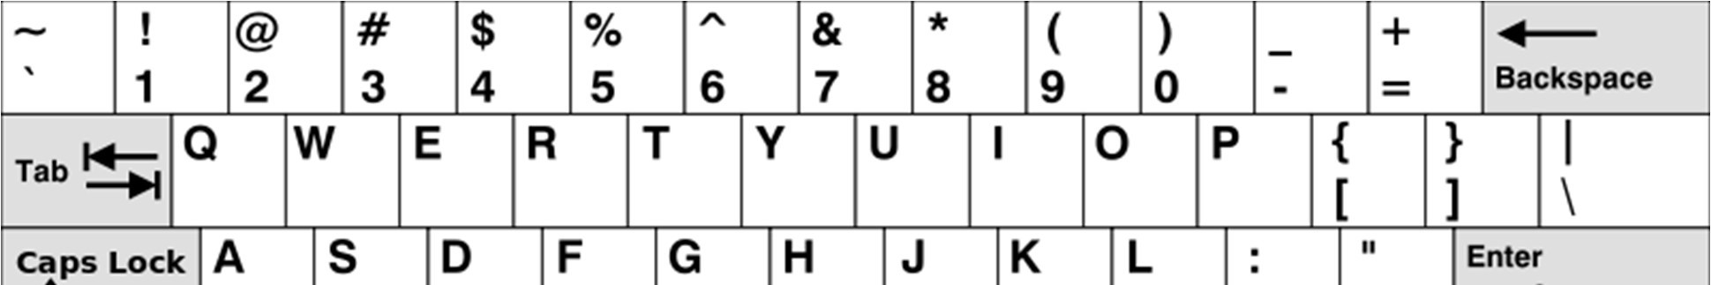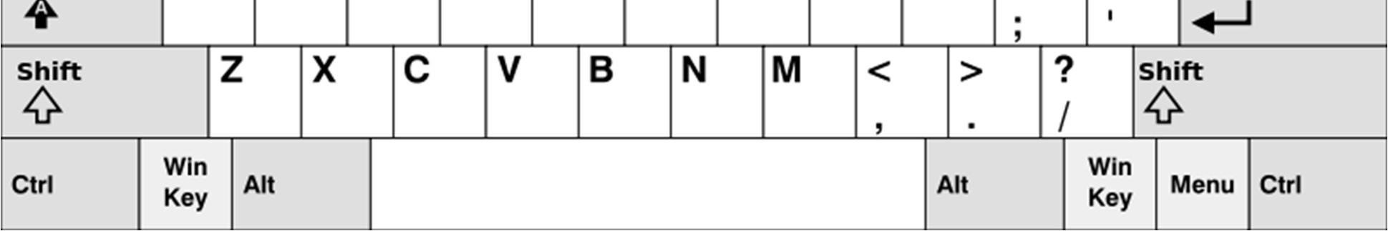

●

* Example 1:
* Input: words = ["Hello","Alaska","Dad","Peace"] ● Output: ["Alaska","Dad"] ● Example 2:
* Input: words = ["omk"] ● Output: []
* Example 3:
* Input: words = ["adsdf","sfd"]
* Output: ["adsdf","sfd"]

●

* For example:

|  |  |
| --- | --- |
| Input | Result |
| 4  Hello  Alaska  Dad  Peace | Alaska Dad |

Program:

def findWords(words): row1 = set('qwertyuiop') row2 = set('asdfghjkl') row3 = set('zxcvbnm')

result = [] for word in words:

w = set(word.lower()) if w.issubset(row1) or w.issubset(row2) or w.issubset(row3):

result.append(word) if len(result) == 0: print("No words") else: for i in result: print(i)

a = int(input()) arr = [input() for i in range(a)] findWords(arr)

Ex. No. : 7.4 Date: 06/04/24

Register No.: 230701349 Name S Subramanian

## Print repeated no

Given an array of integers nums containing n + 1 integers where each integer is in the range [1, n] inclusive.There is only one repeated number in nums, return this repeated number. Solve the problem using set.

Example 1:

Input: nums = [1,3,4,2,2]

Output: 2

Example 2:

Input: nums = [3,1,3,4,2]

Output: 3

For example:

|  |  |
| --- | --- |
| Input | Result |
| 1 3 4 4 2 | 4 |

Program:

n =input().split(" ") n = list(n) for i in range(len(n)):

for j in range(i+1,len(n)):

if n[i] == n[j]: print(n[i]) exit(0)

Ex. No. : 7.5 Date: 06/04/24

Register No.:230701349 Name: S Subramanian

# Check Pair

Given a tuple and a positive integer k, the task is to find the count of distinct pairs in the tuple whose sum is equal to K.

Examples:

Input: t = (5, 6, 5, 7, 7, 8 ), K = 13

Output: 2

Explanation:

Pairs with sum K( = 13) are {(5, 8), (6, 7), (6, 7)}.

Therefore, distinct pairs with sum K( = 13) are { (5, 8), (6, 7) }. Therefore, the required output is 2.

For example:

|  |  |
| --- | --- |
| Input | Result |
| 1,2,1,2,5  3 | 1 |
| 1,2  0 | 0 |

Program:

def count_distinct_pairs(t, K):

distinct_pairs = set() for i in range(len(t)):

for j in range(i + 1, len(t)): if t[i] + t[j] == K: distinct_pairs.add((min(t[i], t[j]), max(t[i], t[j]))) return len(distinct_pairs) t_input = input() t = tuple(map(int, t_input.split(','))) K = int(input()) print(count_distinct_pairs(t, K))