EXPERIMENT – 1
Register No.: 230701350 Name: SUDHARSHAN KRISHNAA L K
--------------------------------------------------------------------------------------------------
A PYTHON PROGRAM TO IMPLEMENT UNIVARIATE REGRESSION, BIVARIATE REGRESSION AND MULTIVARIATE REGRESSION

Aim:
To implement univariate, bivariate, and multivariate linear regression using the Iris dataset and evaluate the performance of the regression models.

Algorithm:
- Import the required libraries and load the Iris dataset.
- Perform univariate, bivariate, and multivariate data visualization.
- Select dependent and independent variables for regression analysis.
- Train univariate, bivariate, and multivariate regression models.
- Predict output values and calculate R-squared scores.
- Display regression plots and print the model results.
Code:

import pandas as pd
import numpy as np
import matplotlib.pyplot as plt
import seaborn as sns

from sklearn.linear_model import LogisticRegression, LinearRegression
from sklearn.model_selection import train_test_split
from sklearn.metrics import r2_score
from sklearn.datasets import load_iris
from mpl_toolkits.mplot3d import Axes3D

#load dataset
iris = load_iris()
data = pd.DataFrame(iris.data, columns = iris.feature_names)
data['target'] = iris.target
data
 | sepal length (cm) | sepal width (cm) | petal length (cm) | petal width (cm) | target
0 | 5.1 | 3.5 | 1.4 | 0.2 | 0
1 | 4.9 | 3.0 | 1.4 | 0.2 | 0
2 | 4.7 | 3.2 | 1.3 | 0.2 | 0
3 | 4.6 | 3.1 | 1.5 | 0.2 | 0
4 | 5.0 | 3.6 | 1.4 | 0.2 | 0
... | ... | ... | ... | ... | ...
145 | 6.7 | 3.0 | 5.2 | 2.3 | 2
146 | 6.3 | 2.5 | 5.0 | 1.9 | 2
147 | 6.5 | 3.0 | 5.2 | 2.0 | 2
148 | 6.2 | 3.4 | 5.4 | 2.3 | 2
149 | 5.9 | 3.0 | 5.1 | 1.8 | 2

#univariate analysis
plt.scatter(data['sepal width (cm)'], np.zeros_like(data['sepal width (cm)']))
plt.xlabel('Sepal Width')
plt.title('Univariate Analysis')
plt.show()
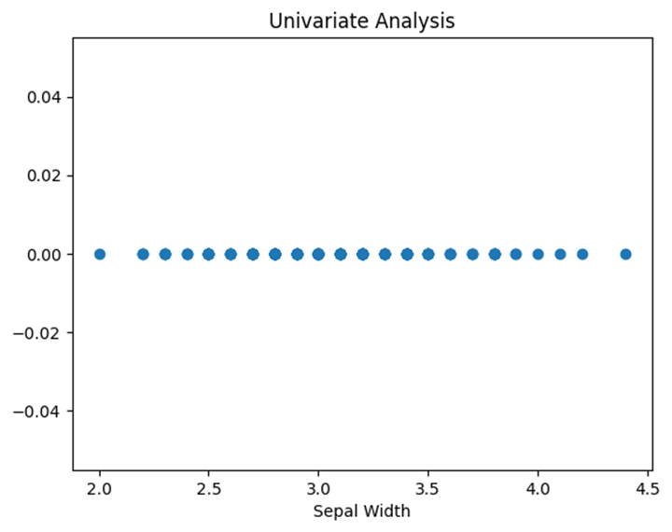
#bivariate analysis
sns.FacetGrid(data, hue='target', height=5).map(plt.scatter,'sepal width (cm)','petal width (cm)').add_legend()
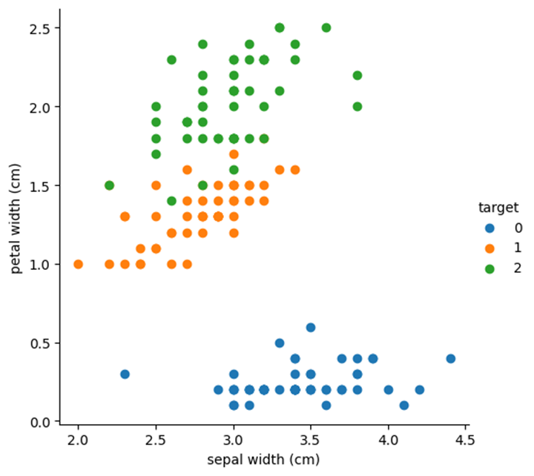

#multivariate analysis
sns.pairplot(data,hue='target',height=3)
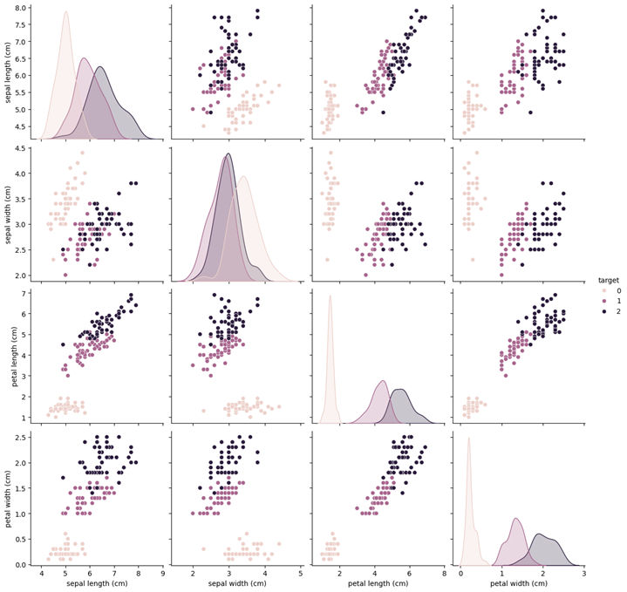

#prepare dependent variable
y = data['sepal length (cm)']

#univariate linear regression
X_uni = data[['petal length (cm)']]
model_uni = LinearRegression()
model_uni.fit(X_uni, y)
y_pred_uni = model_uni.predict(X_uni)
r2_uni = r2_score(y, y_pred_uni)
# Plot Univariate Regression
plt.figure()
plt.scatter(X_uni, y, color='blue', label='Actual Data')
plt.plot(X_uni, y_pred_uni, color='red', label='Regression Line')
plt.xlabel('Petal Length (cm)')
plt.ylabel('Sepal Length (cm)')
plt.title('Univariate Regression')
plt.legend()
plt.show()
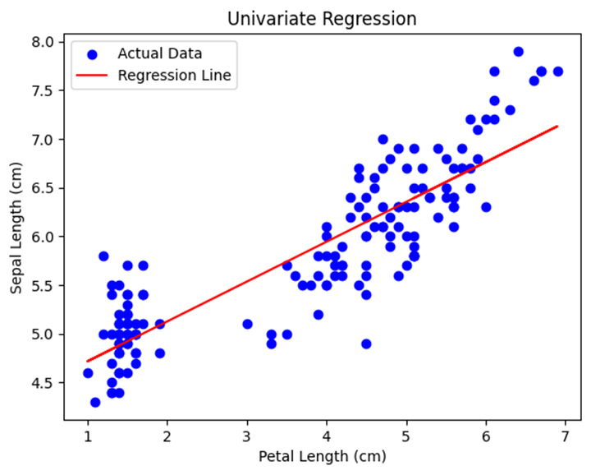

#bivariate linear regression
X_bi = data[['petal length (cm)', 'petal width (cm)']]
model_bi = LinearRegression()
model_bi.fit(X_bi, y)
y_pred_bi = model_bi.predict(X_bi)
r2_bi = r2_score(y, y_pred_bi)
# Plot Bivariate Regression (3D)
fig = plt.figure()
ax = fig.add_subplot(111, projection='3d')
ax.scatter(X_bi.iloc[:, 0], X_bi.iloc[:, 1], y, color='blue')
ax.set_xlabel('Petal Length (cm)')
ax.set_ylabel('Petal Width (cm)')
ax.set_zlabel('Sepal Length (cm)')
ax.set_title('Bivariate Regression')
plt.show()
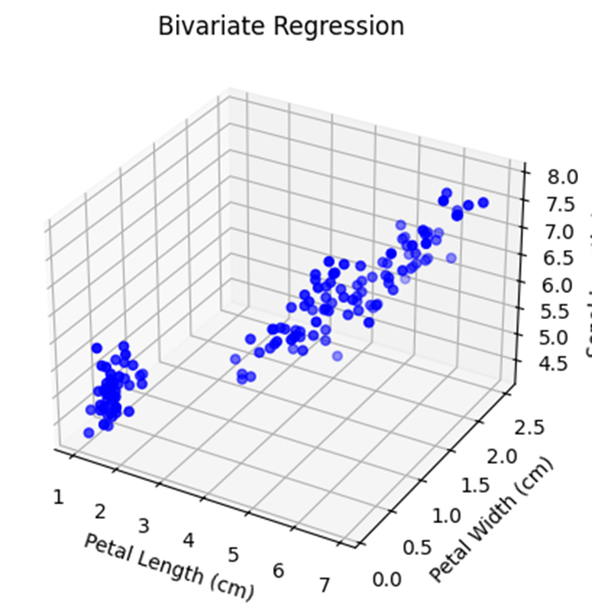

#Multivariate Regression
X_multi = data.drop(columns=['target'])
model_multi = LinearRegression()
model_multi.fit(X_multi, y)
y_pred_multi = model_multi.predict(X_multi)
r2_multi = r2_score(y, y_pred_multi)
# Plot Multivariate Regression (Predicted vs Actual)
plt.figure()
plt.scatter(y, y_pred_multi, color='green')
plt.xlabel('Actual Values')
plt.ylabel('Predicted Values')
plt.title('Multivariate Regression')
plt.show()
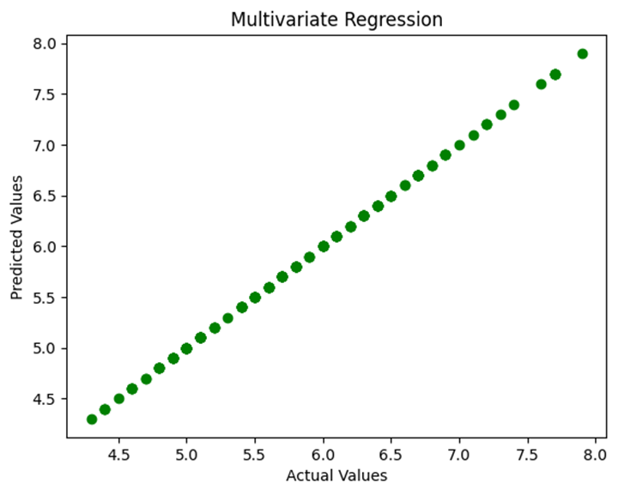

#Results
print("UNIVARIATE REGRESSION")
print("Coefficient:", model_uni.coef_)
print("Intercept:", model_uni.intercept_)
print("R-squared:", r2_uni)
print("\nBIVARIATE REGRESSION")
print("Coefficients:", model_bi.coef_)
print("Intercept:", model_bi.intercept_)
print("R-squared:", r2_bi)
print("\nMULTIVARIATE REGRESSION")
print("Coefficients:", model_multi.coef_)
print("Intercept:", model_multi.intercept_)
print("R-squared:", r2_multi)
UNIVARIATE REGRESSION
Coefficient: [0.40892228]
Intercept: 4.306603415047579
R-squared: 0.759954645772515
BIVARIATE REGRESSION
Coefficients: [ 0.54177715 -0.31955056]
Intercept: 4.190582428651586
R-squared: 0.7662612975425306
MULTIVARIATE REGRESSION
Coefficients: [ 1.00000000e+00 2.22638574e-16 -1.01586076e-16 -2.32824196e-16]
Intercept: -4.440892098500626e-15
R-squared: 1.0

Result:
Thus, univariate, bivariate, and multivariate regression models were successfully implemented using the Iris dataset, and their performances were evaluated using R-squared values.
EXPERIMENT – 2
Register No.: 230701350 Name: SUDHARSHAN KRISHNAA L K
--------------------------------------------------------------------------------------------------
A PYTHON PROGRAM TO DEMONSTRATE SIMPLE LINEAR REGRESSION

Aim:
To implement simple linear regression using the least squares method and plot the best fit line for the given dataset.

Algorithm:
- Import the required libraries and define the input dataset.
- Calculate the mean values of independent and dependent variables.
- Compute the slope of the regression line using the least squares formula.
- Calculate the intercept value of the regression equation.
- Predict the output values using the regression equation.
- Plot the data points and regression line using matplotlib.
Code:
import numpy as np
import matplotlib.pyplot as plt
# Sample data points
x = np.array([1, 2, 3, 4, 5]) # Independent variable
y = np.array([2, 4, 5, 4, 5]) # Dependent variable
# Step 1: Calculate means
x_mean = np.mean(x)
y_mean = np.mean(y)
# Step 2: Calculate slope (m) using least squares formula
numerator = np.sum((x - x_mean) * (y - y_mean))
denominator = np.sum((x - x_mean) ** 2)
m = numerator / denominator
# Step 3: Calculate intercept (c)
c = y_mean - m * x_mean
print(f"Equation of best fit line: y = {m:.2f}x + {c:.2f}")
# Step 4: Predict values
y_pred = m * x + c
# Step 5: Plot data points and regression line
plt.scatter(x, y, color="blue", label="Data points")
plt.plot(x, y_pred, color="red", label="Best fit line")
plt.xlabel("x")
plt.ylabel("y")
plt.legend()
plt.show()
Equation of best fit line: y = 0.60x + 2.20
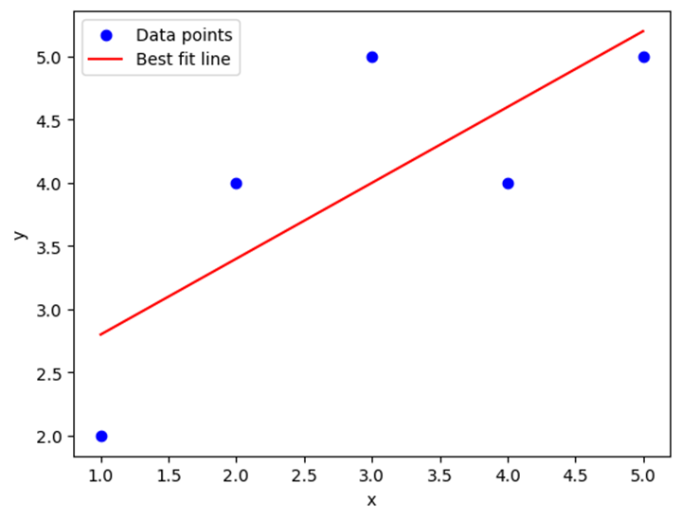

Result:
Thus, the simple linear regression model was successfully implemented, and the best fit line for the given dataset was obtained and visualized graphically.
EXPERIMENT – 3
Register No.: 230701350 Name: SUDHARSHAN KRISHNAA L K
--------------------------------------------------------------------------------------------------
A PYTHON PROGRAM TO IMPLEMENT LOGISTIC REGRESSION

Aim:
To implement logistic regression for predicting whether a student will pass or fail based on the number of hours studied.

Algorithm:
- Import the required libraries and define the dataset.
- Assign input values as independent variables and labels as dependent variables.
- Create and train the logistic regression model using the training data.
- Provide new input data for prediction.
- Predict the class label and probability values using the trained model.
- Display the prediction result and probability of each class.
Code:
import numpy as np
from sklearn.linear_model import LogisticRegression
# Sample dataset: hours studied vs pass/fail (1 = pass, 0 = fail)
# Example data: [hours studied], [result]
X = np.array([[1], [2], [3], [4], [5], [6], [7], [8]]) # hours studied
y = np.array([0, 0, 0, 1, 1, 1, 1, 1]) # pass/fail labels
# Create and train logistic regression model
model = LogisticRegression()
model.fit(X, y)
# Predict for a new student
hours = np.array([[3.5]]) # Example: 3.5 hours of study
prediction = model.predict(hours)
probability = model.predict_proba(hours)
print(f"Hours studied: {hours[0][0]}")
print("Prediction:", "Pass" if prediction[0] == 1 else "Fail")
print(f"Probability of Fail: {probability[0][0]:.2f}, Pass: {probability[0][1]:.2f}")
Hours studied: 3.5
Prediction: Pass
Probability of Fail: 0.49, Pass: 0.51

Result:
Thus, the logistic regression model was successfully implemented to predict whether a student would pass or fail based on study hours.
EXPERIMENT – 4
Register No.: 230701350 Name: SUDHARSHAN KRISHNAA L K
--------------------------------------------------------------------------------------------------
A PYTHON PROGRAM TO IMPLEMENT SINGLE LAYER PERCEPTRON

Aim:
To implement a single layer perceptron for the AND logic gate and determine the final weight values after training.

Algorithm:
- Import the required library and define the training dataset for the AND gate.
- Initialize weights, learning rate, and threshold values.
- Calculate the weighted sum and apply the step activation function.
- Compute the error by comparing actual and predicted outputs.
- Update the weights using the perceptron learning rule when error occurs.
- Repeat the process until the perceptron converges and display final weights.
Code:
import numpy as np
# Training data for AND function
X = np.array([
[0, 0],
[0, 1],
[1, 0],
[1, 1]
])
Y = np.array([0, 0, 0, 1]) # Desired output (AND)
# Initial parameters (given in question)
w1 = 0.3
w2 = -0.2
alpha = 0.2 # Learning rate
theta = 0.4 # Bias (threshold)
# Step activation function
def step_function(x):
if x >= 0:
return 1
else:
return 0
epoch = 0
converged = False
while not converged:
epoch += 1
print(f"\nEpoch {epoch}")
converged = True
for i in range(len(X)):
x1, x2 = X[i]
# Net input
weighted_sum = (x1 * w1 + x2 * w2) - theta
# Predicted output
y_pred = step_function(weighted_sum)
# Error
error = Y[i] - y_pred
print(f"Input: ({x1},{x2}) Weighted Sum: {weighted_sum:.2f} "
f"Y_pred: {y_pred} Error: {error} "
f"W1: {w1:.2f} W2: {w2:.2f}")
# Update weights if error exists
if error != 0:
w1 = w1 + alpha * error * x1
w2 = w2 + alpha * error * x2
converged = False
print("\nTraining completed!")
print(f"Final Weights: W1 = {w1}, W2 = {w2}")
Epoch 1
Input: (0,0) Weighted Sum: -0.40 Y_pred: 0 Error: 0 W1: 0.30 W2: -0.20
Input: (0,1) Weighted Sum: -0.60 Y_pred: 0 Error: 0 W1: 0.30 W2: -0.20
Input: (1,0) Weighted Sum: -0.10 Y_pred: 0 Error: 0 W1: 0.30 W2: -0.20
Input: (1,1) Weighted Sum: -0.30 Y_pred: 0 Error: 1 W1: 0.30 W2: -0.20
Epoch 2
Input: (0,0) Weighted Sum: -0.40 Y_pred: 0 Error: 0 W1: 0.50 W2: 0.00
Input: (0,1) Weighted Sum: -0.40 Y_pred: 0 Error: 0 W1: 0.50 W2: 0.00
Input: (1,0) Weighted Sum: 0.10 Y_pred: 1 Error: -1 W1: 0.50 W2: 0.00
Input: (1,1) Weighted Sum: -0.10 Y_pred: 0 Error: 1 W1: 0.30 W2: 0.00
Epoch 3
Input: (0,0) Weighted Sum: -0.40 Y_pred: 0 Error: 0 W1: 0.50 W2: 0.20
Input: (0,1) Weighted Sum: -0.20 Y_pred: 0 Error: 0 W1: 0.50 W2: 0.20
Input: (1,0) Weighted Sum: 0.10 Y_pred: 1 Error: -1 W1: 0.50 W2: 0.20
Input: (1,1) Weighted Sum: 0.10 Y_pred: 1 Error: 0 W1: 0.30 W2: 0.20
Epoch 4
Input: (0,0) Weighted Sum: -0.40 Y_pred: 0 Error: 0 W1: 0.30 W2: 0.20
Input: (0,1) Weighted Sum: -0.20 Y_pred: 0 Error: 0 W1: 0.30 W2: 0.20
Input: (1,0) Weighted Sum: -0.10 Y_pred: 0 Error: 0 W1: 0.30 W2: 0.20
Input: (1,1) Weighted Sum: 0.10 Y_pred: 1 Error: 0 W1: 0.30 W2: 0.20
Training completed!
Final Weights: W1 = 0.3, W2 = 0.2
Result:
Thus, the single layer perceptron was successfully implemented for the AND logic gate, and the final weight values were obtained after training.
EXPERIMENT – 5
Register No.: 230701350 Name: SUDHARSHAN KRISHNAA L K
--------------------------------------------------------------------------------------------------
A PYTHON PROGRAM TO IMPLEMENT MULTI LAYER PERCEPTRON USING BACKPROPAGATION

Aim:
To implement a Multi Layer Perceptron using the backpropagation algorithm and train the network to reduce prediction error.

Algorithm:
- Initialize the input values, weights, biases, learning rate, and epochs.
- Perform forward propagation to calculate outputs of hidden and output layers.
- Compute the error between actual and predicted outputs.
- Calculate error gradients using the backpropagation algorithm.
- Update weights and biases using the calculated gradients.
- Repeat the process for all epochs and display the final output and error.
Code:
import numpy as np
# Input values
x1, x2, x3, x4 = 1, 1, 0, 1
Y = 1
# Parameters
epochs = 4
alpha = 2.0
# Initial Weights
w15, w25, w35, w45 = 0.5, -0.4, 0.2, 0.3
w16, w26, w36, w46 = 0.4, 0.5, -0.3, 0.6
w57, w67 = -0.6, 0.7
# Bias values
t5, t6, t7 = 0.2, 0.2, -0.4
# Sigmoid Activation Function
def sigmoid(x):
return 1 / (1 + np.exp(-x))
# Training Process
for epoch in range(epochs):
print("\nEpoch", epoch + 1)
# Forward Pass
O5 = sigmoid(x1*w15 + x2*w25 + x3*w35 + x4*w45 + t5)
O6 = sigmoid(x1*w16 + x2*w26 + x3*w36 + x4*w46 + t6)
O7 = sigmoid(O5*w57 + O6*w67 + t7)
# Error Calculation
error = Y - O7
print("Output =", round(O7, 4),
" Error =", round(abs(error), 4))
# Backpropagation
E7 = O7 * (1 - O7) * error
E6 = O6 * (1 - O6) * (E7 * w67)
E5 = O5 * (1 - O5) * (E7 * w57)

# Update Hidden to Output Weights
w57 += alpha * E7 * O5
w67 += alpha * E7 * O6
# Update Input to Hidden Weights
w15 += alpha * E5 * x1
w25 += alpha * E5 * x2
w35 += alpha * E5 * x3
w45 += alpha * E5 * x4
w16 += alpha * E6 * x1
w26 += alpha * E6 * x2
w36 += alpha * E6 * x3
w46 += alpha * E6 * x4
# Update Bias Values
t5 += alpha * E5
t6 += alpha * E6
t7 += alpha * E7
# Final Output
print("\nTraining Completed")
print("Final Output =", round(O7, 4))
print("Final Error =", round(abs(error), 4))

Epoch 1
Output = 0.4513 Error = 0.5487
Epoch 2
Output = 0.6011 Error = 0.3989
Epoch 3
Output = 0.6965 Error = 0.3035
Epoch 4
Output = 0.7524 Error = 0.2476
Training Completed
Final Output = 0.7524
Final Error = 0.2476

Result:
Thus, the Multi Layer Perceptron using backpropagation was successfully implemented, and the network was trained to minimize the prediction error.

EXPERIMENT – 6
Register No.: 230701350 Name: SUDHARSHAN KRISHNAA L K
--------------------------------------------------------------------------------------------------
A PYTHON PROGRAM TO IMPLEMENT FACE RECOGNITION USING SVM

Aim:
To implement face recognition using Support Vector Machine (SVM) by extracting facial features from images.

Algorithm:
- Import the required libraries and load the Haar Cascade face detector.
- Read training images from the dataset folders and convert them to grayscale.
- Detects faces from images and extract HOG feature descriptors.
- Train the SVM classifier using extracted facial features and labels.
- Read the test image and detect the face region for prediction.
- Predict the person's name using the trained SVM model and display the result.
Code:

import cv2, os
import numpy as np
from sklearn import svm
from skimage.feature import hog
# Load face detector
face_cascade = cv2.CascadeClassifier(
cv2.data.haarcascades + 'haarcascade_frontalface_default.xml'
)
data, labels = [], []
# -------- TRAIN --------
for person in os.listdir("C:/Users/USER/FOML/dataset"):
path = os.path.join("C:/Users/USER/FOML/dataset", person)
if not os.path.isdir(path):
continue
for img_name in os.listdir(path):
if not img_name.endswith(('.jpg','.png','.jpeg')):
continue
img = cv2.imread(os.path.join(path, img_name))
gray = cv2.cvtColor(img, cv2.COLOR_BGR2GRAY)
faces = face_cascade.detectMultiScale(gray, 1.3, 5)
for (x,y,w,h) in faces:
face = cv2.resize(gray[y:y+h, x:x+w], (100,100))
features = hog(face)
data.append(features)
labels.append(person)
# Train SVM
model = svm.SVC(kernel='linear')
model.fit(data, labels)
# -------- TEST --------
img = cv2.imread("C:/Users/USER/FOML/test1.jpg")
gray = cv2.cvtColor(img, cv2.COLOR_BGR2GRAY)
faces = face_cascade.detectMultiScale(gray, 1.3, 5)
for (x,y,w,h) in faces:
face = cv2.resize(gray[y:y+h, x:x+w], (100,100))
features = hog(face).reshape(1,-1)
name = model.predict(features)[0]
cv2.rectangle(img,(x,y),(x+w,y+h),(0,255,0),2)
cv2.putText(img,name,(x,y-10),0,0.8,(0,255,0),2)
cv2.imshow("Result", img)
cv2.waitKey(0)
cv2.destroyAllWindows()
Training on: {np.str_('person1'), np.str_('person2')}
Predicted: person2
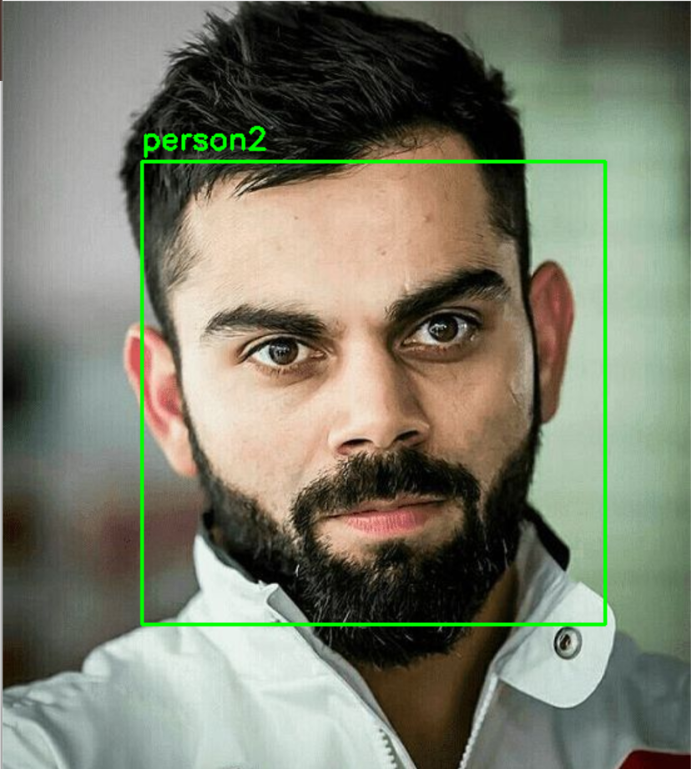

Result:
Thus, face recognition using Support Vector Machine was successfully implemented, and the person in the test image was correctly identified.

EXPERIMENT – 7
Register No.: 230701350 Name: SUDHARSHAN KRISHNAA L K
--------------------------------------------------------------------------------------------------
A PYTHON PROGRAM TO IMPLEMENT DECISION TREE CLASSIFIER

Aim:
To implement a Decision Tree Classifier using the Iris dataset and evaluate the classification accuracy.

Algorithm:
- Import the required libraries and load the Iris dataset.
- Select feature variables and target labels from the dataset.
- Split the dataset into training and testing sets.
- Train the Decision Tree Classifier using the training data.
- Predict the output labels for the test data and calculate accuracy.
- Visualize the Decision Tree structure using a plot.
Code:
import pandas as pd
from sklearn.datasets import load_iris
from sklearn.model_selection import train_test_split
from sklearn.tree import DecisionTreeClassifier, plot_tree
from sklearn.metrics import accuracy_score
import matplotlib.pyplot as plt
# Load dataset
iris = load_iris()
# Convert to DataFrame
X = pd.DataFrame(iris.data, columns=iris.feature_names)
y = iris.target
# Split data
X_train, X_test, y_train, y_test = train_test_split(
X, y, test_size=0.3, random_state=42
)
# Train model
clf = DecisionTreeClassifier(criterion='entropy', max_depth=3, random_state=42)
clf.fit(X_train, y_train)
# Predictions
y_pred = clf.predict(X_test)
# Accuracy
accuracy = accuracy_score(y_test, y_pred)
print(f"Model Accuracy: {accuracy:.2f}")
# Plot Decision Tree
plt.figure(figsize=(12, 8))
plot_tree(
clf,
feature_names=iris.feature_names,
class_names=iris.target_names,
filled=True,
rounded=True
)
plt.title("Decision Tree Visualization")
plt.show()

Model Accuracy: 0.98
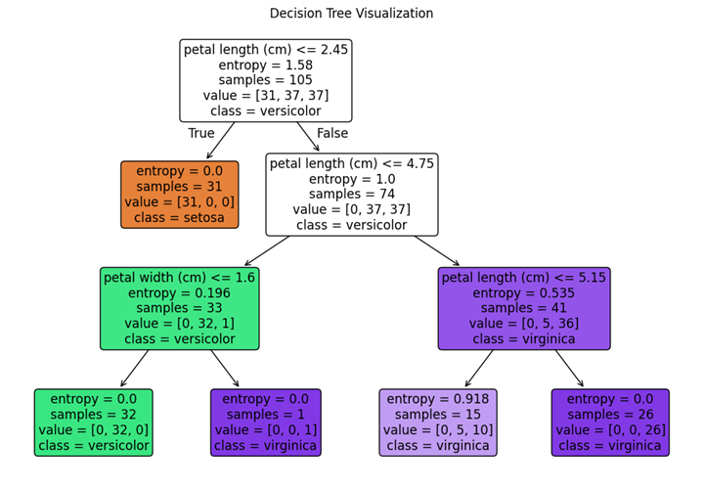

Result:
Thus, the Decision Tree Classifier was successfully implemented using the Iris dataset, and high classification accuracy was achieved.

EXPERIMENT – 8
Register No.: 230701350 Name: SUDHARSHAN KRISHNAA L K
--------------------------------------------------------------------------------------------------
A PYTHON PROGRAM TO IMPLEMENT BOOSTING ALGORITHMS

Aim:
To implement and compare different boosting algorithms such as AdaBoost, Gradient Boosting, and XGBoost using the Iris dataset.

Algorithm:
- Import the required libraries and load the Iris dataset.
- Add noise to the dataset and split it into training and testing sets.
- Train the AdaBoost classifier using the training data.
- Train the Gradient Boosting and XGBoost classifiers.
- Predict the test results and calculate the accuracy of each model.
- Compare the performance of the boosting algorithms using a bar graph.
Code:
import numpy as np
import pandas as pd
import matplotlib.pyplot as plt
from sklearn.datasets import load_iris
from sklearn.model_selection import train_test_split
from sklearn.metrics import accuracy_score
from sklearn.ensemble import AdaBoostClassifier, GradientBoostingClassifier
from xgboost import XGBClassifier
# Load dataset from sklearn
iris = load_iris()
X = iris.data
y = iris.target
# Optional: convert to DataFrame (if needed)
df = pd.DataFrame(X, columns=iris.feature_names)
df['species'] = y
# Add Noise
np.random.seed(42)
X = X + np.random.normal(0, 0.5, X.shape)
# Split data
X_train, X_test, y_train, y_test = train_test_split(X, y, test_size=0.4)
# ---------------- AdaBoost ----------------
ada = AdaBoostClassifier(n_estimators=10)
ada.fit(X_train, y_train)
y_pred_ada = ada.predict(X_test)
acc_ada = accuracy_score(y_test, y_pred_ada)
# ---------------- Gradient Boosting ----------------
gb = GradientBoostingClassifier(n_estimators=30)
gb.fit(X_train, y_train)
y_pred_gb = gb.predict(X_test)
acc_gb = accuracy_score(y_test, y_pred_gb)
# ---------------- XGBoost ----------------
xgb = XGBClassifier(n_estimators=30, max_depth=3, eval_metric='mlogloss')
xgb.fit(X_train, y_train)
y_pred_xgb = xgb.predict(X_test)
acc_xgb = accuracy_score(y_test, y_pred_xgb)
# Results
print("AdaBoost Accuracy:", acc_ada)
print("Gradient Boosting Accuracy:", acc_gb)
print("XGBoost Accuracy:", acc_xgb)
# Plot
models = ['AdaBoost', 'Gradient Boosting', 'XGBoost']
accuracies = [acc_ada, acc_gb, acc_xgb]
plt.bar(models, accuracies)
plt.title("Boosting Comparison")
plt.xlabel("Models")
plt.ylabel("Accuracy")
plt.show()
AdaBoost Accuracy: 0.85
Gradient Boosting Accuracy: 0.8333333333333334
XGBoost Accuracy: 0.8
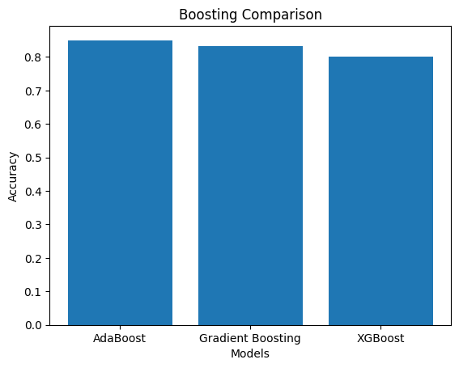

Result:
Thus, the boosting algorithms AdaBoost, Gradient Boosting, and XGBoost were successfully implemented and compared based on their classification accuracy.

EXPERIMENT – 9
Register No.: 230701350 Name: SUDHARSHAN KRISHNAA L K
--------------------------------------------------------------------------------------------------
A PYTHON PROGRAM TO IMPLEMENT KNN AND K-MEANS ALGORITHMS

Aim
To implement K-Nearest Neighbors (KNN) classification and K-Means clustering algorithms using sample datasets.

Algorithm – KNN
- Import the required libraries and define the training dataset.
- Calculate the Euclidean distance between the test point and training points.
- Sort the distances in ascending order.
- Select the nearest k neighbors based on minimum distance.
- Perform majority voting among the selected neighbors.
- Display the predicted class label for the test point.

Algorithm – K-Means
- Import the required libraries and define the input dataset.
- Initialize the centroids for the required number of clusters.
- Calculate the distance between each point and centroids.
- Assign each data point to the nearest centroid.
- Update the centroids by calculating the mean of cluster points.
- Repeat the process until final clusters and centroids are obtained.
Code:
KNN
import math
from collections import Counter
# Function to calculate Euclidean distance
def euclidean_distance(p1, p2):
sum = 0
for i in range(len(p1)):
sum += (p1[i] - p2[i]) ** 2
return math.sqrt(sum)
# KNN function
def knn(train_data, train_labels, test_point, k):
distances = []
# Calculate distance from test point to all training data
for i in range(len(train_data)):
dist = euclidean_distance(train_data[i], test_point)
distances.append((dist, train_labels[i]))
# Sort distances
distances.sort()
# Get k nearest neighbors
neighbors = distances[:k]
# Extract labels of neighbors
labels = [label for (_, label) in neighbors]
# Majority voting
most_common = Counter(labels).most_common(1)
return most_common[0][0]
# Sample dataset
train_data = [
[2, 4],
[4, 6],
[6, 8],
[8, 10]
]
train_labels = ['A', 'A', 'B', 'B']
# Test point
test_point = [5, 7]
# Value of k
k = 3
# Prediction
result = knn(train_data, train_labels, test_point, k)
print("Test Point:", test_point)
print("Predicted Class:", result)
Test Point: [5, 7]
Predicted Class: A
K-MEANS
import math
# Function to calculate Euclidean distance
def distance(p1, p2):
return math.sqrt(sum((p1[i] - p2[i])**2 for i in range(len(p1))))
# Function to calculate mean of points
def mean(points):
n = len(points)
return [sum(p[i] for p in points)/n for i in range(len(points[0]))]
# K-Means function
def kmeans(data, k, iterations=10):
# Step 1: Initialize centroids (first k points)
centroids = data[:k]
for _ in range(iterations):
clusters = [[] for _ in range(k)]
# Step 2: Assign points to nearest centroid
for point in data:
distances = [distance(point, c) for c in centroids]
min_index = distances.index(min(distances))
clusters[min_index].append(point)
# Step 3: Update centroids
for i in range(k):
if clusters[i]: # avoid empty cluster
centroids[i] = mean(clusters[i])
return centroids, clusters
# Sample dataset
data = [
[1, 2],
[2, 3],
[3, 4],
[8, 9],
[9, 10],
[10, 11] ]
k = 2
centroids, clusters = kmeans(data, k)
# Output
print("Final Centroids:", centroids)
print("\nClusters:")
for i, cluster in enumerate(clusters):
print(f"Cluster {i+1}: {cluster}")

Final Centroids: [[2.0, 3.0], [9.0, 10.0]]
Clusters:
Cluster 1: [[1, 2], [2, 3], [3, 4]]
Cluster 2: [[8, 9], [9, 10], [10, 11]]

Result:
Thus, the KNN classification and K-Means clustering algorithms were successfully implemented, and the data points were correctly classified and clustered.
EXPERIMENT – 10
Register No.: 230701350 Name: SUDHARSHAN KRISHNAA L K
--------------------------------------------------------------------------------------------------
A PYTHON PROGRAM TO IMPLEMENT PRINCIPAL COMPONENT ANALYSIS

Aim:
To implement Principal Component Analysis (PCA) for reducing the dimensionality of the given dataset.

Algorithm:
- Import the required library and define the input dataset.
- Calculate the mean of the dataset and center the data.
- Compute the covariance matrix of the centered data.
- Calculate the eigenvalues and eigenvectors of the covariance matrix.
- Sort the eigenvectors based on descending eigenvalues.
- Select the principal component and transform the data into reduced dimensions.
Code:
import numpy as np
# Step 1: Sample dataset (2D → reduce to 1D)
data = np.array([
[2, 4],
[4, 6],
[6, 8],
[8, 10]
])
# Step 2: Compute mean
mean = np.mean(data, axis=0)
# Step 3: Center the data
centered_data = data - mean
# Step 4: Compute covariance matrix
cov_matrix = np.cov(centered_data.T)
# Step 5: Compute eigenvalues and eigenvectors
eigenvalues, eigenvectors = np.linalg.eig(cov_matrix)
# Step 6: Sort eigenvectors by eigenvalues (descending)
sorted_indices = np.argsort(eigenvalues)[::-1]
eigenvectors = eigenvectors[:, sorted_indices]
# Step 7: Select top k eigenvectors (k = 1)
k = 1
principal_components = eigenvectors[:, :k]
# Step 8: Transform data
reduced_data = np.dot(centered_data, principal_components)
# Output
print("Original Data:\n", data)
print("\nReduced Data (1D):\n", reduced_data)
Original Data:
[[ 2 4]
[ 4 6]
[ 6 8]
[ 8 10]]
Reduced Data (1D):
[[-4.24264069]
[-1.41421356]
[ 1.41421356]
[ 4.24264069]]

Result:
Thus, Principal Component Analysis was successfully implemented, and the dimensionality of the dataset was reduced from 2D to 1D.

