**RAJALAKSHMI ENGINEERING COLLEGE**

**RAJALAKSHMI NAGAR, THANDALAM – 602 105**



|  |
| --- |
| **CS23A34**  **USER INTERFACE AND DESIGN LAB** |
| **Laboratory Observation NoteBook** |

# Name : VARSHA H Year/Branch/Section : II/CSE/F Register No. : 230701371 Semester : IV Academic Year: 2024-25

**Ex. No.**  **: 5b**

**Register No. : 230701371**   **Name : VARSHA H**



**Conduct task analysis for an app (e.g., online shopping) and** **document user flows. Create corresponding wireframes**

**using dia**

**AIM:**

The aim is to perform task analysis for an app, such as online shopping, document user flows, and create corresponding wireframes using Dia.

**PROCEDURE:**

**Tool link:** http://dia-installer.de/

1. Install Dia:

○ Download Dia from the official website (http://dia-installer.de/)

○ Install Dia on your computer ○ Open Dia:

○ Launch the Dia application.

2. Create New Diagram:

○ Go to File -> New Diagram.

○ Select Flowchart as the diagram type.

3. Add Shapes:

○ Use the shape tools (rectangles, ellipses, etc.) to create wireframes for each screen.

■ For example:

■ Home Page: Rectangle

■ Product Categories: Rectangle

■ Product Listings: Rectangle

■ Product Details: Rectangle

■ Cart: Rectangle

■ Checkout: Rectangle

■ Order Confirmation: Rectangle

■ Order History: Rectangle

4. Connect Shapes:

○ Use the line tool to connect shapes, representing the user flows.

■ For example:

■ Home Page -> Product Categories

■ Product Categories -> Product Listings

■ Product Listings -> Product Details

■ Product Details -> Cart

■ Cart -> Checkout

■ Checkout -> Order Confirmation

■ Order Confirmation -> Order History

5. Label Shapes:

○ Double-click on each shape to add labels.

■ For example:

■ Label the rectangle as “Home Page”, "Categories”, "Product

Listings”, “Product Details”, “Cart”, “Checkout”, “Order

Confirmation”, “Order History”.

6. Save the Diagram:

○ Go to File -> Save As.

○ Save the diagram with a meaningful name, such as “Online Shopping App

User Flows”.

**OUTPUT:**

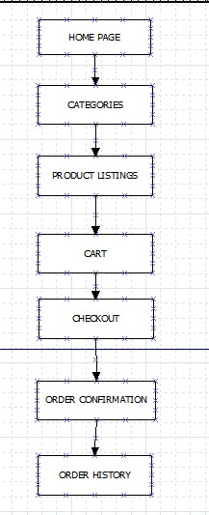

**RESULT:**

Task analysis for an online shopping app has been conducted to document user flows and corresponding wireframes using dia has been successfully created.