**RAJALAKSHMI ENGINEERING COLLEGE**

**RAJALAKSHMI NAGAR, THANDALAM – 602 105**



|  |
| --- |
| **CS23A34**  **USER INTERFACE AND DESIGN LAB** |
| **Laboratory Observation Notebook** |

**Name :**VARSHA H

**Year/Branch/Section :** II/CSE/F

**Register No. :** 230701371

**Semester :** IV

**Academic Year:** 2024-25

**Ex. No.: 3**

**Register No.: 230701371**  **Name: VARSHA H**



**Develop and compare CLI, GUI, and Voice User Interfaces** **(VUI) for the same task and assess user satisfaction using**

**Python (Tkinter for GUI, Speech Recognition for VUI),**

**Terminal**

**Aim:**

The aim is to develop and compare Command Line Interface (CLI), Graphical User Interface (GUI), and Voice User Interface (VUI) for the same task, and assess user satisfaction using Python (with Tkinter for GUI and Speech Recognition for VUI) and

Terminal.

**Procedure:**

**i) CLI (Command Line Interface)** CLI implementation where users can add, view, and remove tasks using the terminal.



def add_task(task):

tasks.append(task) print(f"Task '{task}' added.") def view_tasks(): if tasks:

print("Your tasks:") for idx, task in enumerate(tasks, 1): print(f"{idx}. {task}") else:

print("No tasks to show.")

def remove_task(task_number):

if 0 < task_number <= len(tasks):

removed_task = tasks.pop(task_number - 1) print(f"Task '{removed_task}' removed.")

else: print("Invalid task number.") def main(): while True:

print("\nOptions: 1.Add Task 2.View Tasks 3.Remove Task 4.Exit") choice = input("Enter your choice: ") if choice == '1.': task = input("Enter task: ") add_task(task) elif choice == '2.':

view_tasks() elif choice == '3': task_number = int(input("Enter task number to remove: "))

remove_task(task_number) elif choice == '4':

print("Exiting...")

break else:

print("Invalid choice. Please try again.")

if **__name__**== "__**main__**":

main()

**Output:**

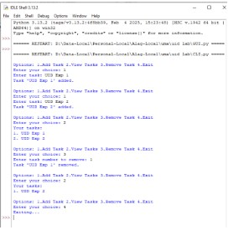

# GUI (Graphical User Interface)

Tkinter to create a simple GUI for our To-Do List application.

tk

from tkinter import messagebox

tasks = [] def add_task(): task = task_entry.get() if task:

tasks.append(task)

task_entry.delete(0, tk.END)

update_task_list()

else: messagebox.showwarning("Warning", "Task cannot be empty") def update_task_list(): task_list.delete(0, tk.END) for task in tasks:

task_list.insert(tk.END, task) def remove_task():

selected_task_index = task_list.curselection() if selected_task_index: task_list.delete(selected_task_index) tasks.pop(selected_task_index[0]) app = tk.Tk()

app.title("To-Do List")

task_entry = tk.Entry(app, width=40) task_entry.pack(pady=10)

add_button = tk.Button(app, text="Add Task", command=add_task) add_button.pack(pady=5)

remove_button = tk.Button(app, text="Remove Task", command=remove_task) remove_button.pack(pady=5)

task_list = tk.Listbox(app, width=40, height=10) task_list.pack(pady=10) app.mainloop()

**Output**:

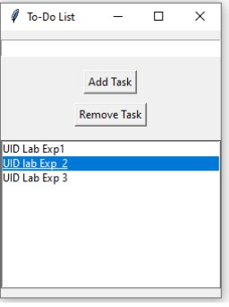

# VUI (Voice User Interface)

speech_recognition library for voice input and the pyttsx3 library for text-to-speech output. Make sure you have these libraries installed (pip install SpeechRecognition pyttsx3).



import pyttsx3

tasks = [] recognizer = sr.Recognizer() engine = pyttsx3.init()

def add_task(task):

tasks.append(task) engine.say(f"Task {task} added") engine.runAndWait()

def view_tasks(): if tasks: engine.say("Your tasks are") for task in tasks:

engine.say(task) else:

engine.say("No tasks to show") engine.runAndWait() def remove_task(task_number):

if 0 < task_number <= len(tasks):

removed_task = tasks.pop(task_number - 1) engine.say(f"Task {removed_task} removed") else:

engine.say("Invalid task number") engine.runAndWait() def recognize_speech(): with sr.Microphone() as source: print("Listening...") audio = recognizer.listen(source) try:

command = recognizer.recognize_google(audio)

return command except sr.UnknownValueError: engine.say("Sorry, I did not understand that")

engine.runAndWait()

return None def main(): while True:

engine.say("Options: add task, view tasks, remove task, or exit") engine.runAndWait() command = recognize_speech() if not command:

continue if "add task" in command: engine.say("What is the task?") engine.runAndWait()

task = recognize_speech() if task:

add_task(task) elif "view tasks" in command: view_tasks() elif "remove task" in command: engine.say("Which task number to remove?") engine.runAndWait() task_number = recognize_speech() if task_number:

remove_task(int(task_number)) elif "exit" in command: engine.say("Exiting...")

engine.runAndWait()

break else:

engine.say("Invalid option. Please try again.") engine.runAndWait() if _**name__** == "__**main__**": main ()

**Output:**

The program initializes the speech recognizer and text-to-speech engine. It then enters a loop where it announces the available options ("add task, view tasks, remove task, or exit").

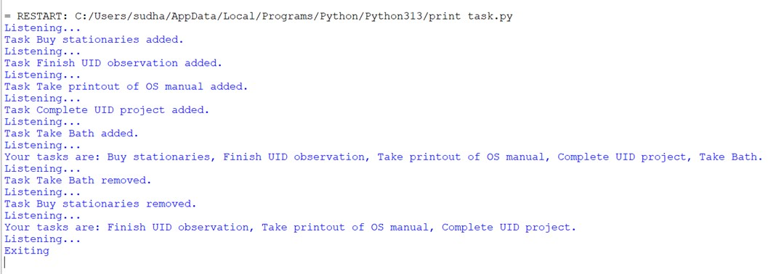

**Result:**

CLI, GUI, and Voice User Interfaces (VUI) have been developed and compared for the given task and the user satisfaction has been assessed using Python (Tkinter for GUI, Speech Recognition for VUI).