**Experiment 1: Evaluating Good vs. Bad UI Design in Figma**

**Aim:**

To analyse the impact of good and bad UI design principles on user experience by creating two versions of a mobile login screen in Figma.

**Procedure:**

1. **Set Up the Experiment:**
   * Open Figma and create a new project.
   * Design two mobile login screens: one following good UI/UX principles and the other with bad design choices.
2. **Designing the Good UI Version:**
   * Use a clean and consistent layout with proper spacing.
   * Apply a clear visual hierarchy with readable font sizes.
   * Use a high-contrast color scheme for accessibility.
   * Add clear input fields with labels and placeholders.
   * Provide a properly styled login button with a distinct color.
   * Implement feedback mechanisms like error messages.
   * Ensure mobile responsiveness and touch-friendly elements.
3. **Designing the Bad UI Version:**
   * Use inconsistent fonts and poor color contrast.
   * Place elements in a cluttered and misaligned manner.
   * Remove labels from input fields, relying only on placeholder text.
   * Use small buttons that are difficult to tap on mobile.
   * Provide no error handling or feedback mechanisms.
   * Ignore accessibility considerations like color blindness support.
4. **User Testing:**
   * Recruit 5-10 participants to interact with both designs.
   * Ask them to complete a simple login task in both versions.
   * Record their time taken, errors made, and overall satisfaction.
5. **Analyze Results:**
   * Measure the usability of both designs using metrics like:
     + Time taken to complete login.
     + Number of errors (e.g., missed input fields).
     + User ratings on a scale of 1-10 for ease of use.

**Output**

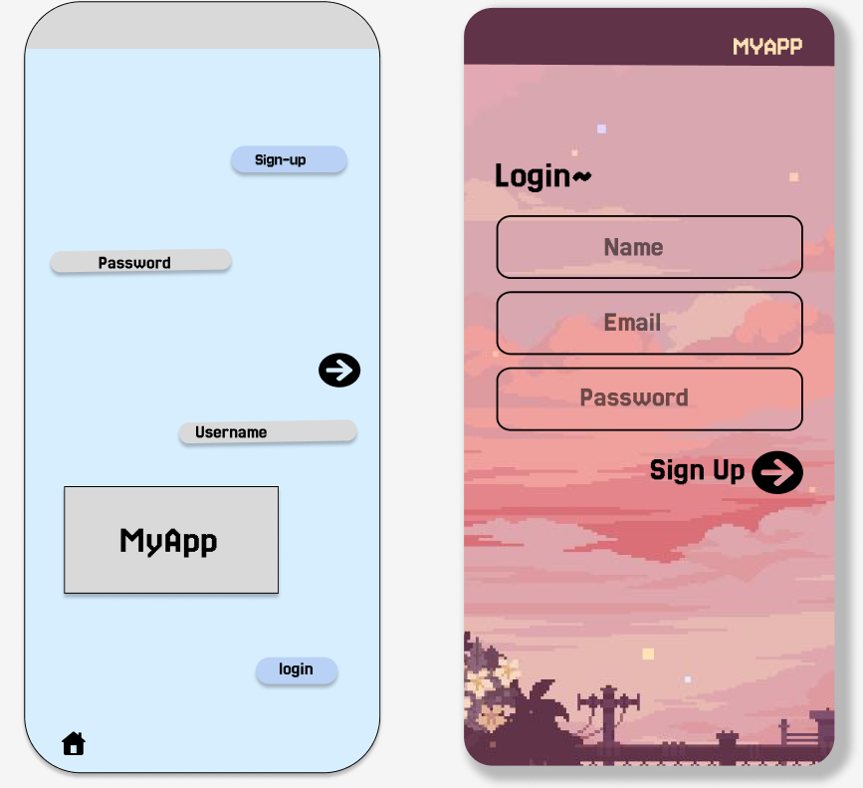

**Results:**

* **Good UI Design:** Users completed the login process faster, made fewer errors, and reported a smoother experience.
* **Bad UI Design:** Users struggled with navigation, took longer to complete tasks, and expressed frustration over unclear elements.

**Link**

[**https://www.figma.com/design/WsiPazyLBkndw4QhypVrdl/baddesign_gooddesign?node-id=0-1&t=YkrjEiD2gvPATsrb-1**](https://www.figma.com/design/WsiPazyLBkndw4QhypVrdl/baddesign_gooddesign?node-id=0-1&t=YkrjEiD2gvPATsrb-1)