**Experiment No. 2: Evaluating the Effect of Chunking on User Memory in UI Design**

**Aim:**

To examine how chunking (grouping visual elements such as icons or text) affects users’ ability to recall information in a UI environment designed in Figma.

**Procedure:**

**Step 1: Setting Up the UI in Figma**

1. **Create a Home Screen (Instruction Page)**
   * Open Figma and create a **new frame** (1024x768px for desktop view).
   * Add a **heading**: "Memory Recall Task."
   * Provide **instructions** explaining that users will view grouped icons/text and recall them later.
   * Create a **Start button** using a rectangle and link it to the next screen using Figma’s **Prototype feature**.
2. **Chunking Phase (Display Chunked Items)**
   * Create a **new frame** to show the items users will memorize.
   * Design two versions:
     + **Chunked Design:** Group icons or text into 3-5 item clusters using boxes.
     + **Unchunked Design:** Display items randomly without clear separation.
   * Set up a **5-second delay** to automatically transition to the next screen.
3. **Recall Phase (User Memory Test)**
   * Create a **new frame** for recall.
   * Design two options for user input:
     + **Multiple-choice selection:** Users select from a set of options.
     + **Text input fields:** Users type the items they remember.
   * Add a **Submit button** to move to the results screen.
4. **Result Screen (Feedback and Analysis)**
   * Show feedback like: “You recalled 4/5 items correctly!”
   * Record user performance based on the number of correct answers.
   * Compare results for chunked vs. unchunked groups and icons vs. text-based chunks.

**Output**

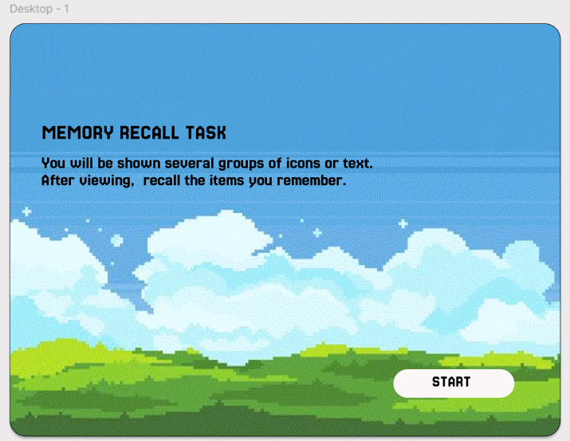

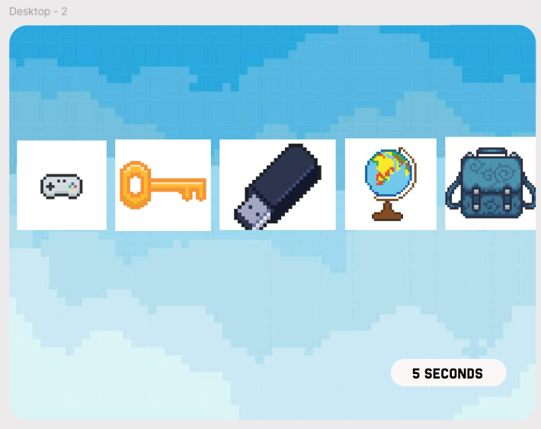

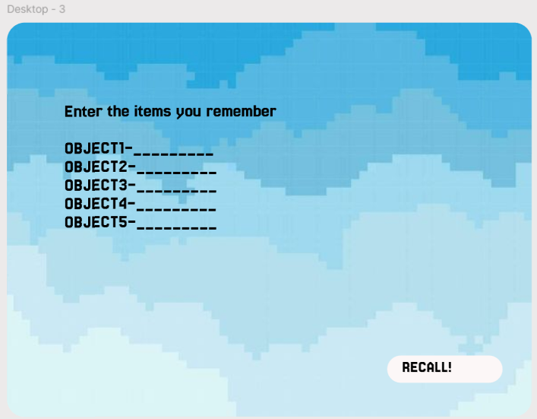

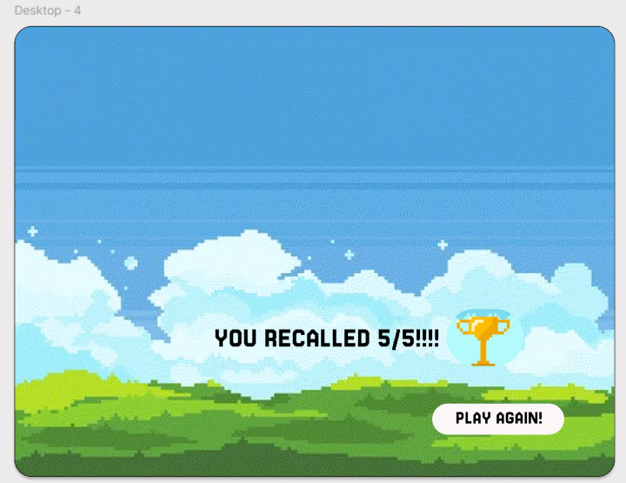

**Results:**

Users recalled chunked items better than unstructured ones, with icons being more memorable than text. The optimal chunk size was 3-5 items, as recall dropped beyond this. Multiple-choice input was easier, but text input led to better memory retention.

**Link**

[**https://www.figma.com/design/rV9LXcUBvMP6SlcDTK38e9/Excerise2?node-id=0-1&t=kegOrF0sQMpqBRzs-1**](https://www.figma.com/design/rV9LXcUBvMP6SlcDTK38e9/Excerise2?node-id=0-1&t=kegOrF0sQMpqBRzs-1)