**10 - Searching & Sorting**

**Ex. No. : 10.1 Date: 01.06.24**

**Register No.: 230701388**   **Name YASIR ALI N**

# Bubble Sort

Bubble Sort is the simplest sorting algorithm that works by repeatedly swapping the adjacent elements if they are in wrong order. You read an list of numbers. You need to arrange the elements in ascending order and print the result. The sorting should be done using bubble sort.

Input Format: The first line reads the number of elements in the array. The second line reads the array elements one by one.

Output Format: The output should be a sorted list.

**For example**:

|  |  |
| --- | --- |
| Input | Result |
| 6  3 4 8 7 1 2 | 1 2 3 4 7 8 |
| 5 4 5 2 3 1 | 1 2 3 4 5 |

**Program:**

n=int(input())

k=[int(x) for x in input().split()] k.sort() for i in k:

print(i,end=' ')

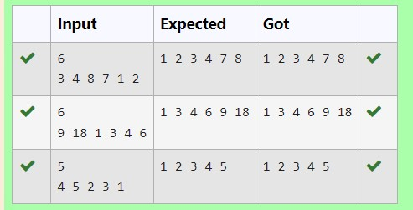

**Ex. No. : 10.2 Date: 01.06.24**

**Register No.: 230701388** **Name YASIR ALI N**

# Peak Element

Given an [list,](http://118.185.187.137/moodle/mod/resource/view.php?id=1068) find peak element in it. A peak element is an element that is greater than its neighbors.

An element a[i] is a peak element if

A[i-1] <= A[i] >=a[i+1] for middle elements. [0<i<n-1]

A[i-1] <= A[i] for last element [i=n-1]

A[i]>=A[i+1] for first element [i=0]

**Input Format**

The first line contains a single integer n , the length of A . The second line contains n space-separated integers,A[i].

**Output Format**

**Print** peak numbers separated by space.

**Sample Input**

5

8 9 10 2 6

**Sample Output**

10 6

**For example:**

|  |  |
| --- | --- |
| **Input** | **Result** |
| 4  12 3 6 8 | 12 8 |

**Program:**

a=int(input()) lst1=[str(x) for x in input().split(" ")] lst2=[] lst=[]

g=0

for i in lst1: if i.isdigit(): g=int(i) lst.append(g) for i in range(0,a): if(i==0): if(lst[i]>=lst[i+1]): lst2.append(lst[i]) elif(i>0 and i<a-2): if(lst[i]>=lst[i-1] and lst[i]>=lst[i+1]):

lst2.append(lst[i]) elif(i==a-1): if(lst[i]>=lst[i-1]): lst2.append(lst[i]) for i in lst2:

print(i,end=" ")

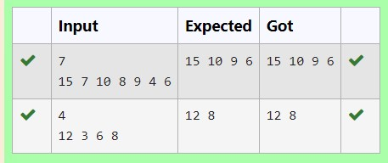

**Ex. No. : 10.3 Date: 01.06.24**

**Register No.: 230701388** **Name: YASIR ALI N**

# Merge Sort

Write a Python program to sort a list of elements using the merge sort algorithm.

**For example:**

|  |  |
| --- | --- |
| **Input** | **Result** |
| 5  6 5 4 3 8 | 3 4 5 6 8 |

**Program:**

def merge_sort(arr): if len(arr) > 1:

mid = len(arr) // 2 left_half = arr[:mid] right_half = arr[mid:] merge_sort(left_half) merge_sort(right_half) i = j = k = 0 while i < len(left_half) and j < len(right_half): if left_half[i] < right_half[j]:

arr[k] = left_half[i] i += 1

else:

arr[k] = right_half[j] j += 1 k += 1 while i < len(left_half): arr[k] = left_half[i] i += 1 k += 1 while j < len(right_half): arr[k] = right_half[j] j += 1 k += 1

def main(): n = int(input()) arr = list(map(int, input().split())) merge_sort(arr) for num in arr: print(num, end=" ") if __name__ == "__main__":

main()

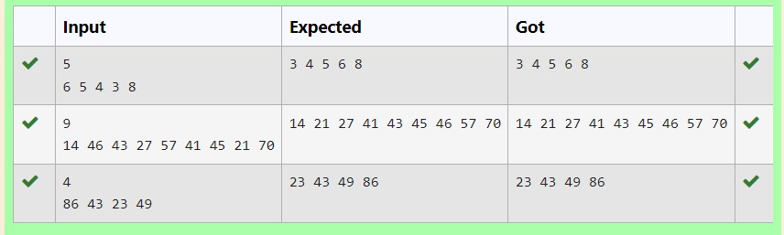

**Ex. No. : 10.4 Date: 01.06.24**

**Register No.: 230701388** **Name: YASIR ALI N**

# Sum of Two numbers

An list contains N numbers and you want to determine whether two of the numbers sum to a given number K. For example, if the input is 8, 4, 1, 6 and K is 10, the answer is yes (4 and 6). A number may be used twice.

**Input Format**

The first line contains a single integer n , the length of list The second line contains n space-separated integers, list[i].

The third line contains integer k.

**Output Format**

Print Yes or No.

**Sample Input**

7

0 1 2 4 6 5 3

1

**Sample Output**

Yes

**For example:**

|  |  |
| --- | --- |
| **Input** | **Result** |
| 5  8 9 12 15 3  11 | Yes |
| 6  2 9 21 32 43 43 1  4 | No |

**Program:**

n=int(input()) a=[int(x) for x in input().split()] k=int(input()) flag=0 if len(a)!=n: print("No") flag=1 for i in a: for j in a:

if i+j==k and flag==0: flag=1 print("Yes") break if flag==0: print("No")

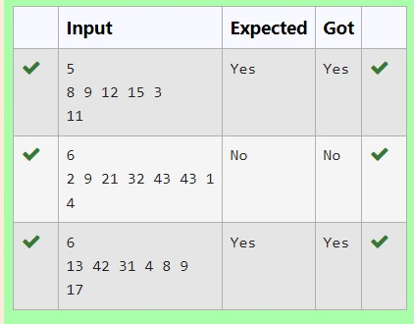

**Ex. No. : 10.5 Date: 01.06.24**

**Register No.: 230701388** **Name: YASIR ALI N**

## Frequency of Elements

To find the frequency of numbers in a list and display in sorted order.

**Constraints:**  1<=n, arr[i]<=100 **Input:**

1 68 79 4 90 68 1 4 5

**output:**

1 2

1. 2
2. 1

68 2

79 1

90 1

**For example:**

|  |  |
| --- | --- |
| **Input** | **Result** |
| 4 3 5 3 4 5 | 1. 2 2. 2 3. 2 |
|  |  |

**Program:**

lst5=[int(x) for x in input().split(" ")] lst=sorted(list(set(lst5))) c=0 for i in lst: c=0 for j in lst5: if(i==j): c=c+1 print("%d %d"%(i,c))

