Experiment -1 Good design and bad design

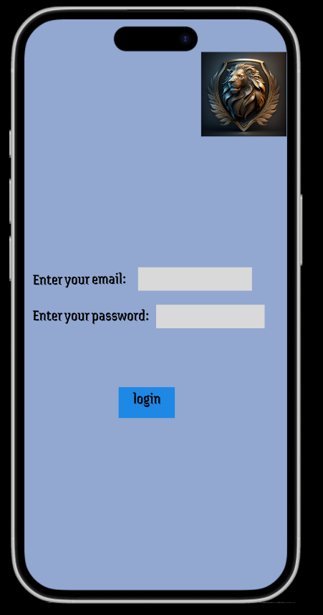

Good design:

The above user interface is said to be a good design as the design of the page is very familiar and easy to understand.

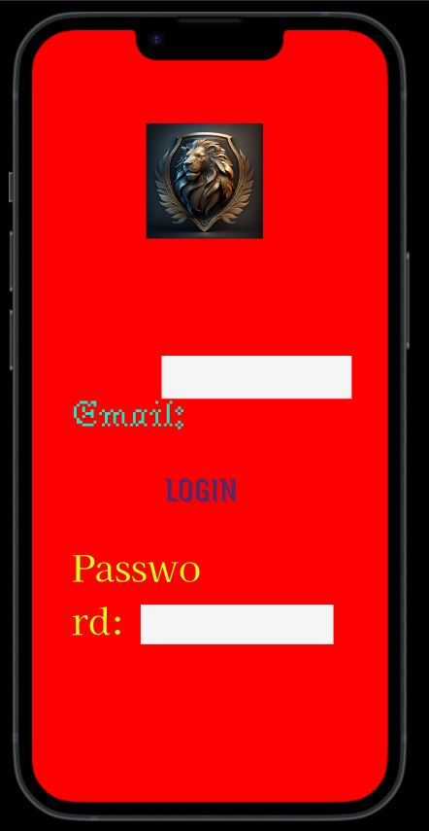

Bad design:

The above user interface is a bad design as there is no consistency, it is not familiar. Login button is not present in familiar position. Different fonts and colours have been used – no consistency.