Ex. No.: 4 Name:Praveenraj.M
Date: 14.02.2025 RegNo:230701396
a)EMPLOYEE AVERAGE PAY
Aim:
To find out the average pay of all employees whose salary is more than 6000 and no. of days worked is more than 4.
Algorithm:
1. Create a flat file emp.dat for employees with their name, salary per day and number of days worked and save it.
2. Create an awk script emp.awk
3. For each employee record do
a. If Salary is greater than 6000 and number of days worked is more than 4, then print name and salary earned
b. Compute total pay of employee
4. Print the total number of employees satisfying the criteria and their average pay

Program Code:
BEGIN{print "EMPLOYEES DETAILS"}
{
more than 4
if($2>6000 && $3>4)
{
print $1,"\t\t", $2*$3
pay=pay+ $2*$3
count=count+1
}
}
END{
{
print "no of employees are=",count
print "total pay=",pay
print "average pay=",pay/count
}
}
Sample Input:
THARUN 8000 5
YOKESH 6000 5
PRAVEEN 5000 6
VISHWA 7000 7
TRILOK 6500 6
Sample Output:
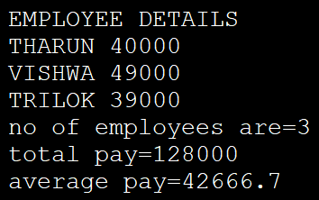

Result:
The above program has executed successfully.

b)RESULTS OF EXAMINATION
Aim:
To print the pass/fail status of a student in a class.
Algorithm:
1. Read the data from file
2. Get a data from each column
3. Compare the all subject marks column
a. If marks less than 45 then print Fail
b. else print Pass
Program Code:
BEGIN{
print "NAME", "\t","SUB-1","\t","SUB-2","\t","SUB- 3","\t","SUB-4","\t","SUB 5","\t","SUB-6","\t","STATUS"
{
if ( $2 < 45 || $3 < 45 || $4 < 45 || $5 < 45 || $6 < 45
|| $7 < 45)
{
print $1,"\t",$2,"\t",$3,"\t",$4,"\t",$5,"\t",
$6,"\t", $7,"\t","FAIL"
}
else
{

print $1,"\t",$2,"\t",$3,"\t",$4,"\t",$5,"\t",
$6,"\t",$7,"\t","PASS"
}
}

END {
Sample Input:
THARUN 55 40 60 71 85 92
PRAVEEN 60 75 85 90 82 95
HARI 70 80 90 20 60 40
VENKY 80 85 85 60 75 85
Sample Output:
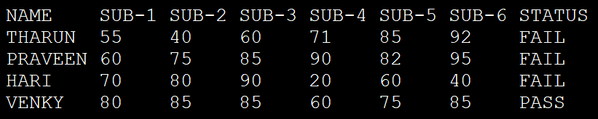
Result:
The above program has executed successfully.

