Ex. No.: 5 Name:Praveenraj.M
Date: 15.2.25 RegNo:230701396
System Calls Programming
Aim:
To experiment system calls using fork(), execlp() and pid() functions.
Algorithm:
1.Start
- Include the required header files (stdio.h and stdlib.h).
2. Variable Declaration
- Declare an integer variable pid to hold the process ID.
3. Create a Process
- Call the fork() function to create a new process. Store the return value in the pid variable
- If fork() returns: -1: Forking failed (child process not created).
0: Process is the child process. Positive integer: Process is the parent process.
4. Print Statement Executed Twice
- Print the statement: scss Copy code THIS LINE EXECUTED TWICE (This line is executed by both parent and child processes after fork()).
5. Check for Process Creation Failure
- If pid == -1: Print: Copy code CHILD PROCESS NOT CREATED Exit the program using exit(0).
6. Child Process Execution
- If pid == 0 (child process): Print: Process ID of the child process using getpid(). Parent process ID of the child process using getppid().
7. Parent Process Execution
- If pid > 0 (parent process): Print: Process ID of the parent process using getpid(). Parent's parent process ID using getppid().
8. Final Print Statement
- Print the statement: Copy code IT CAN BE EXECUTED TWICE (This line is executed by both parent and child processes).
9. End

Program:
#include<stdio.h>
#include<stdlib.h>
int main( )
{
int pid;
pid=fork( );
printf("\n THIS LINE EXECUTED TWICE");
if(pid==-1)
{
printf("\n CHILD PROCESS NOT CREATED\n");
exit(0);
}
if(pid==0)
{
printf("\n I AM CHILD PROCESS AND MY ID IS %d \n",getpid( ));
printf("\n THE CHILD PARENT PROCESS ID IS:%d \n",getppid( ));
}
else
{
printf("\n I AM PARENT PROCESS AND MY ID IS:%d\n",getpid( ));
printf("\n THE PARENTS PARENT PROCESS ID IS:%d\n",getppid( ));
}
printf("\n IT CAN BE EXECUTED TWICE");
printf("\n");
}
OUTPUT:
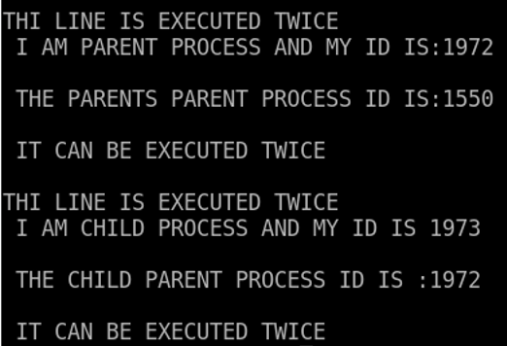

Result:
Thus the script for system call using fork excelp(),pid() is executed successfully.

