EX.NO:7 NAME:M.Praveenraj
DATE:28-03-2025 REG.NO:230701396
IPC USING SHARED MEMORY
Aim:
To write a C program to do Inter Process Communication (IPC) using shared memory between sender process and receiver process.
Algorithm:
sender
1. Set the size of the shared memory segment
2. Allocate the shared memory segment using shmget
3. Attach the shared memory segment using shmat
4. Write a string to the shared memory segment using sprintf
5. Set delay using sleep
6. Detach shared memory segment using shmdt
receiver
1. Set the size of the shared memory segment
2. Allocate the shared memory segment using shmget
3. Attach the shared memory segment using shmat
4. Print the shared memory contents sent by the sender process.
5. Detach shared memory segment using shmdt

Program Code:
sender.c
#include <stdio.h>
#include <stdlib.h>
#include <sys/ipc.h>
#include <sys/shm.h>
#include <unistd.h>
#include <string.h>
#define SHM_SIZE 1024
int main() {
key_t key = ftok("shmfile", 65);
int shmid = shmget(key, SHM_SIZE, 0666 | IPC_CREAT);
if (shmid == -1) {
perror("shmget failed");
exit(1);
}
char *shmaddr = (char*) shmat(shmid, NULL, 0);
if (shmaddr == (char*) -1) {
perror("shmat failed");
exit(1);
}
sprintf(shmaddr, "Hello from sender process!");
printf("Sender: Data written to shared memory: %s\n", shmaddr);
sleep(10);
shmdt(shmaddr);
return 0;
}
receiver.c
#include <stdio.h>
#include <stdlib.h>
#include <sys/ipc.h>
#include <sys/shm.h>
#include <unistd.h>
#define SHM_SIZE 1024
int main() {
key_t key = ftok("shmfile", 65);
int shmid = shmget(key, SHM_SIZE, 0666);
if (shmid == -1) {
perror("shmget failed");
exit(1);
}
char *shmaddr = (char*) shmat(shmid, NULL, 0);
if (shmaddr == (char*) -1) {
perror("shmat failed");
exit(1);
}
printf("Receiver: Data read from shared memory: %s\n", shmaddr);
shmdt(shmaddr);
shmctl(shmid, IPC_RMID, NULL);
return 0;
}

OUTPUT:
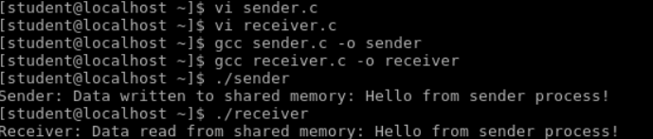
RESULT:
Hence , the process for Inter Process Communication (IPC) using shared memory between sender process and receiver process has been successfully executed.

