Ex. No.: 10a) Name:Praveenraj
Date: 9.4.2025 Regno:230701396
BEST FIT

Aim:
To implement Best Fit memory allocation technique using Python.
Algorithm:
- Input memory blocks and processes with sizes
- Initialize all memory blocks as free.
- Start by picking each process and find the minimum block size that can be assigned to current process
- If found then assign it to the current process.
- If not found then leave that process and keep checking the further processes.
Program Code:
def best_fit(blocks, processes):
n = len(blocks)
m = len(processes)
allocation = [-1] * m
for i in range(m):
best_idx = -1
for j in range(n):
if blocks[j] >= processes[i]:
if best_idx == -1 or blocks[j] < blocks[best_idx]:
best_idx = j
if best_idx != -1:
allocation[i] = best_idx
blocks[best_idx] -= processes[i]
print("Process No. Process Size Block No.")
for i in range(m):
if allocation[i] != -1:
print(i + 1, processes[i], allocation[i] + 1)
else:
print(i + 1, processes[i], "Not Allocated")
b = int(input("Enter the number of memory blocks : "))
p = int(input("Enter the number of processes :"))
blocks = [int(input(f"Enter size of block {i+1}: ")) for i in range(b)]
processes = [int(input(f"Enter size of process {i+1}: ")) for i in range(p)]
best_fit(blocks, processes)

Output:

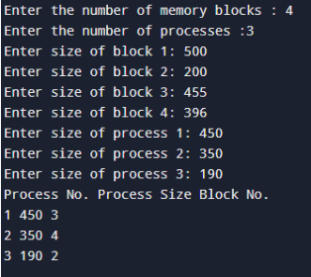

Result:
Thus the program for bestfit memory allocation has been executed successfully.

Ex. No.: 10b)

FIRST FIT
Aim:
To write a C program for implementation memory allocation methods for fixed partition
using first fit.
Algorithm:

1. Define the max as 25.
2: Declare the variable frag[max],b[max],f[max],i,j,nb,nf,temp, highest=0, bf[max],ff[max]. 3:
Get the number of blocks,files,size of the blocks using for loop.
4: In for loop check bf[j]!=1, if so temp=b[j]-f[i]
5: Check highest
Program Code:
#include <stdio.h>
void firstFit(int blockSize[], int blockCount, int processSize[], int processCount) {
int allocation[processCount];
for (int i = 0; i < processCount; i++) {
allocation[i] = -1;
for (int j = 0; j < blockCount; j++) {
if (blockSize[j] >= processSize[i]) {
allocation[i] = j + 1;
blockSize[j] -= processSize[i];
break;
}
}
}
printf("\nProcess No. Process Size Block No.\n");
for (int i = 0; i < processCount; i++) {
if (allocation[i] != -1)
printf("%d %d %d\n", i + 1, processSize[i], allocation[i]);
else
printf("%d %d Not Allocated\n", i + 1, processSize[i]);
}
}
int main() {
int blockCount, processCount;
printf("Enter the number of memory blocks: ");
scanf("%d", &blockCount);
int blockSize[blockCount];
printf("Enter the sizes of %d memory blocks: ", blockCount);
for (int i = 0; i < blockCount; i++) {
scanf("%d", &blockSize[i]);
}
printf("Enter the number of processes: ");
scanf("%d", &processCount);
int processSize[processCount];
printf("Enter the sizes of %d processes: ", processCount);
for (int i = 0; i < processCount; i++) {
scanf("%d", &processSize[i]);
}
firstFit(blockSize, blockCount, processSize, processCount);
return 0;
}

Output:

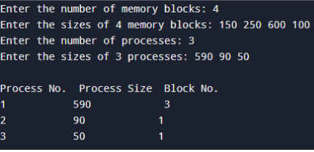

Result:
Thus the program for first fit memory allocation technique has been executed successfully.

