Ex. No.: 11a) Name:Praveenraj.M
Date:12.4.2025 Regno:230701396

FIFO PAGE REPLACEMENT
Aim:
To find out the number of page faults that occur using First-in First-out (FIFO) page replacement technique.
Algorithm:
- Declare the size with respect to page length
- Check the need of replacement from the page to memory
- Check the need of replacement from old page to new page in memory
- Form a queue to hold all pages
- Insert the page require memory into the queue
- Check for bad replacement and page fault
- Get the number of processes to be inserted
- Display the values
Program Code:
#include <stdio.h>
int main() {
int n, i, j, page, frame_size, page_faults = 0;
int ref_str[100], memory[10], index = 0, found;
printf("Enter the size of reference string: ");
scanf("%d", &n);
for (i = 0; i < n; i++) {
printf("Enter [ %d] : ", i + 1);
scanf("%d", &ref_str[i]);
}
printf("Enter page frame size : ");
scanf("%d", &frame_size);
for (i = 0; i < frame_size; i++) {
memory[i] = -1;
}
printf("\n");
for (i = 0; i < n; i++) {
page = ref_str[i];
found = 0;
for (j = 0; j < frame_size; j++) {
if (memory[j] == page) {
found = 1;
break;
}
}
if (!found) {
memory[index] = page;
index = (index + 1) % frame_size;
page_faults++;
printf("%d -> ", page);
for (j = 0; j < frame_size; j++) {
if (memory[j] == -1)
printf("- ");
else
printf("%d ", memory[j]);
}
printf("\n");
} else {
printf("%d -> No Page Fault\n", page);
}
}
printf("\nTotal page faults: %d.\n", page_faults);
return 0;
}

Output:
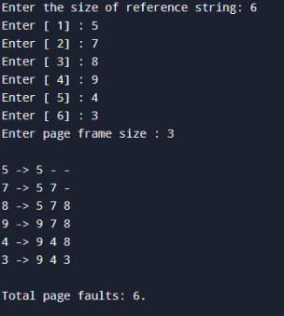
Result:
Thus the program for FIFO page replacement technique has been executed successfully.

Ex. No.: 11b)
Date:18.4.2025
LRU
Aim:
To write a c program to implement LRU page replacement algorithm.
Algorithm:
1: Start the process
2: Declare the size
3: Get the number of pages to be inserted
4: Get the value
5: Declare counter and stack
6: Select the least recently used page by counter value 7: Stack them according the selection.
8: Display the values
9: Stop the process
Program Code:
#include <stdio.h>
int main() {
int frames, pages, i, j, k, page_faults = 0, least, count = 0;
int ref_str[100], memory[10], time[10];
printf("Enter number of frames: ");
scanf("%d", &frames);
printf("Enter number of pages: ");
scanf("%d", &pages);
printf("Enter reference string: ");
for(i = 0; i < pages; i++) {
scanf("%d", &ref_str[i]);
}
for(i = 0; i < frames; i++) {
memory[i] = -1;
time[i] = 0;
}
printf("\n");
for(i = 0; i < pages; i++) {
int flag1 = 0, flag2 = 0;
for(j = 0; j < frames; j++) {
if(memory[j] == ref_str[i]) {
count++;
time[j] = count;
flag1 = flag2 = 1;
break;
}
}
if(flag1 == 0) {
for(j = 0; j < frames; j++) {
if(memory[j] == -1) {
count++;
page_faults++;
memory[j] = ref_str[i];
time[j] = count;
flag2 = 1;
break;
}
}
}
if(flag2 == 0) {
int min = time[0];
least = 0;
for(j = 1; j < frames; j++) {
if(time[j] < min) {
min = time[j];
least = j;
}
}
count++;
page_faults++;
memory[least] = ref_str[i];
time[least] = count;
}
for(j = 0; j < frames; j++) {
if(memory[j] == -1)
printf("- ");
else
printf("%d ", memory[j]);
}
printf("\n");
}
printf("Total Page Faults = %d\n", page_faults);
return 0;
}

Output:
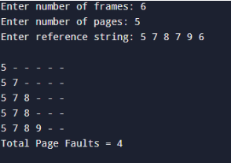

Result:
Thus the program for LRU page replacement technique has been executed successfully.

Ex. No.: 11c)
Date:18.4.2025

Optimal
Aim:
To write a c program to implement Optimal page replacement algorithm.

ALGORITHM:

- Start the process

- Declare the size

- Get the number of pages to be inserted

- Get the value

- Declare counter and stack

- Select the least frequently used page by counter value

- Stack them according the selection.

- Display the values

- Stop the process

PROGRAM:

#include <stdio.h>
int main() {
int frames, pages, i, j, k, page_faults = 0, ref_str[100];
int memory[10], future[10], flag1, flag2, pos;
printf("Enter number of frames: ");
scanf("%d", &frames);
printf("Enter number of pages: ");
scanf("%d", &pages);
printf("Enter reference string: ");
for(i = 0; i < pages; i++) {
scanf("%d", &ref_str[i]);
}
for(i = 0; i < frames; i++) {
memory[i] = -1;
}
printf("\n");
for(i = 0; i < pages; i++) {
flag1 = flag2 = 0;
for(j = 0; j < frames; j++) {
if(memory[j] == ref_str[i]) {
flag1 = flag2 = 1;
break;
}
}
if(flag1 == 0) {
for(j = 0; j < frames; j++) {
if(memory[j] == -1) {
memory[j] = ref_str[i];
page_faults++;
flag2 = 1;
break;
}
}
}
if(flag2 == 0) {
for(j = 0; j < frames; j++) {
future[j] = -1;
for(k = i + 1; k < pages; k++) {
if(memory[j] == ref_str[k]) {
future[j] = k;
break;
}
}
}
int max = -1;
for(j = 0; j < frames; j++) {
if(future[j] == -1) {
pos = j;
break;
}
if(future[j] > max) {
max = future[j];
pos = j;
}
}
memory[pos] = ref_str[i];
page_faults++;
}
for(j = 0; j < frames; j++) {
if(memory[j] == -1)
printf("- ");
else
printf("%d ", memory[j]);
}
printf("\n");
}
printf("Total Page Faults = %d\n", page_faults);
return 0;
}

Output:
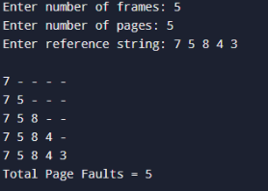

Result:
Thus the program for optimal page replacement technique has been executed successfully.

