Ex. no: 2a) Name:M.Praveenraj
Date: 1.02.25 Regno:230701396
a)Shell Script
Aim:
To write a Shellscript to to display basic calculator.

Program:
echo “ Enter the first number : “
read a
echo “ Enter the second number : “
read b
c=`expr $a + $b`
d=`expr $a - $b`
e=`expr $a * $b`
f=`expr $a / $b`
g=`expr $a % $b`
echo "Sum is = $c”
echo "Difference is = $d"
echo “ Product is = $e"
echo "Division $f “
echo "Reminder after Division $g"

Output:
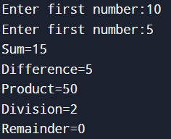

Result:
The above program is executed successfully

b) Shell Script
Aim: To write a Shellscript to test given year is leap or not using conditional statement

Program:

echo "Enter a Year: “
read a
m=`expr $a % 4`
if [ $m -eq 0 ]
then
echo " Leap Year "
else
echo “ Not a Leap Year"
fi
Output:
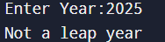

Result:
The above program is executed successfully

