EX.NO:6(a) NAME:M.Praveenraj
DATE:22-02-2025 REG.NO:230701396
First Come First Serve
Aim:
To implement First-come First- serve (FCFS) scheduling technique
Algorithm:
1. Get the number of processes from the user.
2. Read the process name and burst time.
3. Calculate the total process time.
4. Calculate the total waiting time and total turnaround time for each process
5. Display the process name & burst time for each process.
6. Display the total waiting time, average waiting time, turnaround time
Program Code:
n=int(input("Enter number of processes : "))
processes=list(range(1,n+1))
burst_time=[]
for i in range(n):
burst_time.append(int(input(f"Enter burst time for process {i+1} : ")))
waiting_time=[0]*n
turnaround_time=[0]*n
arrival_time=[0]*n
completion_time=[0]*n
completion_time[0]=turnaround_time[0]=burst_time[0]
for i in range(1,n):
completion_time[i]=completion_time[i-1]+burst_time[i]
for i in range(1,n):
turnaround_time[i]=completion_time[i]-arrival_time[i]
for i in range(1,n):
waiting_time[i]=turnaround_time[i]-burst_time[i]
print("Process\tBurst time\tArrival time\tCompletion time\tWaiting time\tTurnaround time")
total_wt=total_tat=0
for i in range(n):
total_wt+=waiting_time[i]
total_tat+=turnaround_time[i]
print(f"{processes[i]}\t\t{burst_time[i]}\t\t{arrival_time[i]}\t\t{completion_time[i]}\t\t{waiting_time[i]}\t\t{turnaround_time[i]}")
print(f"Average Waiting Time = {total_wt/n : .2f}")
print(f"Average Turnaround Time = {total_tat/n : .2f}")

OUTPUT:
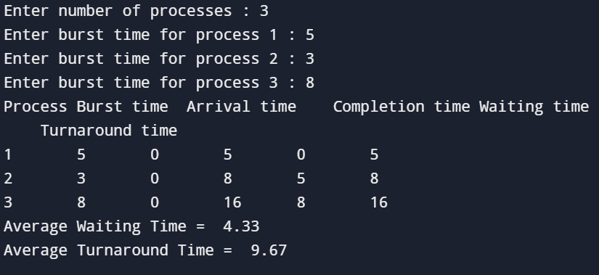

RESULT:
The FCFS CPU scheduling algorithm has been studies and successfully executed.

EX.NO:6(b)
DATE:22-02-2025
SHORTEST JOB FIRST
Aim:
To implement the Shortest Job First (SJF) scheduling technique Algorithm:
1. Declare the structure and its elements.
2. Get number of processes as input from the user.
3. Read the process name, arrival time and burst time
4. Initialize waiting time, turnaround time & flag of read processes to zero.
5. Sort based on burst time of all processes in ascending order
6. Calculate the waiting time and turnaround time for each process.
7. Calculate the average waiting time and average turnaround time.
8. Display the results.
Program Code:
n = int(input("Enter number of processes: "))
processes = {}
for i in range(n):
burst_time = int(input(f"Enter burst time for process {i + 1}: "))
processes[i + 1] = {'burst_time': burst_time, 'arrival_time': 0, 'completion_time': 0, 'waiting_time': 0, 'turnaround_time': 0}
sorted_processes = {k: v for k, v in sorted(processes.items(), key=lambda x: x[1]['burst_time'])}
previous_completion_time = 0
for process, times in sorted_processes.items():
times['completion_time'] = previous_completion_time + times['burst_time']
times['turnaround_time'] = times['completion_time'] - times['arrival_time']
times['waiting_time'] = times['turnaround_time'] - times['burst_time']
previous_completion_time = times['completion_time']
print("Process\tBurst time\tArrival time\tCompletion time\tWaiting time\tTurnaround time")
total_wt = total_tat = 0
for process, times in sorted_processes.items():
total_wt += times['waiting_time']
total_tat += times['turnaround_time']
print(f"{process}\t\t{times['burst_time']}\t\t{times['arrival_time']}\t\t{times['completion_time']}\t\t{times['waiting_time']}\t\t{times['turnaround_time']}")
print(f"Average Waiting Time = {total_wt / n:.2f}")
print(f"Average Turnaround Time = {total_tat / n:.2f}"
Output:
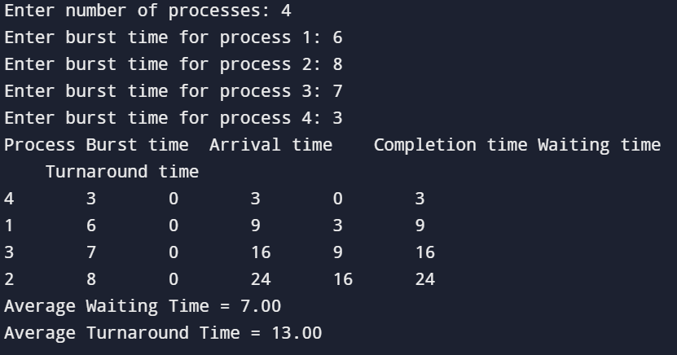
Result:
The SJF CPU scheduling algorithm has been studied and successfully executed.
EX.NO:6(c)
DATE:28-02-2025
PRIORITY SCHEDULING
Aim:
To implement priority scheduling technique
Algorithm:
1. Get the number of processes from the user.
2. Read the process name, burst time and priority of process.
3. Sort based on burst time of all processes in ascending order based priority
4. Calculate the total waiting time and total turnaround time for each process
5. Display the process name & burst time for each process.
6. Display the total waiting time, average waiting time, turnaround time
Program Code:
import array
num = int(input("Enter number of processes: "))
pro= array.array('i', range(1, num + 1))
bt = array.array('i', map(int, input("Enter burst times: ").split()))
pri = array.array('i', map(int, input("Enter priorities: ").split()))
n= sorted(range(num), key=lambda i: pri[i])
bt = array.array('i', [bt[i] for i in n])
pro = array.array('i', [pro[i] for i in n])
pri = array.array('i', [pri[i] for i in n])
at = array.array('i', [0] * num)
wt = array.array('i', [0] * num)
ct = array.array('i', [0] * num)
tat = array.array('i', [0] * num)
ct[0] = bt[0]
for i in range(1, num):
ct[i] = ct[i - 1] + bt[i]
for i in range(num):
tat[i] = ct[i] - at[i]
for i in range(num):
wt[i] = tat[i] - bt[i]
avg_wt = sum(wt) / num
avg_tat = sum(tat) / num
print("\nProcess\tBurst time\tPriority\tCompletion time\tWaiting time\tTurnaround time")
for i in range(num):
print(f"{pro[i]}\t{bt[i]}\t\t{pri[i]}\t\t{ct[i]}\t\t{wt[i]}\t\t{tat[i]}")
print(f"\nAverage Waiting Time: {avg_wt:.2f}")
print(f"Average Turnaround Time: {avg_tat:.2f}")
OUTPUT:
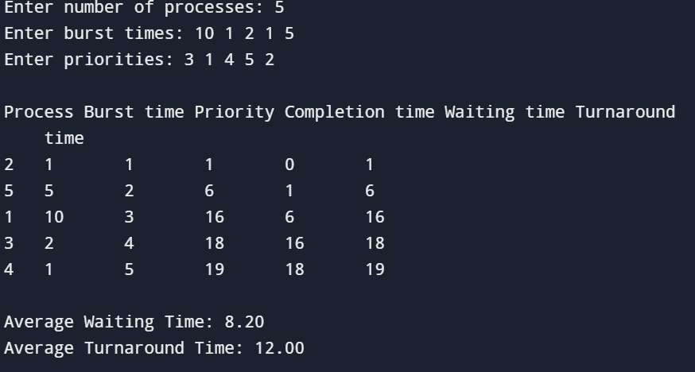
RESULT:
The Priority scheduling algorithm has been studied and successfully executed.

EX.NO:6(d)
DATE:28.02.2025
ROUND ROBIN SCHEDULING
Aim:
To implement the Round Robin (RR) scheduling technique
Algorithm:
1. Declare the structure and its elements.
2. Get number of processes and Time quantum as input from the user.
3. Read the process name, arrival time and burst time
4. Create an array rem_bt[] to keep track of remaining burst time of processes which is initially copy of bt[] (burst times array)
5. Create another array wt[] to store waiting times of processes. Initialize this array as 0.
6. Initialize time : t = 0
7. Keep traversing the all processes while all processes are not done. Do following for i'th process if it is not done yet. a- If rem_bt[i] > quantum (i) t = t + quantum (ii) bt_rem[i] -= quantum; b- Else // Last cycle for this process (i) t = t + bt_rem[i]; (ii) wt[i] = t - bt[i] (iii) bt_rem[i] = 0; // This process is over
8. Calculate the waiting time and turnaround time for each process.
9. Calculate the average waiting time and average turnaround time.
10. Display the results.
Program Code:
n=int(input("Enter the nuber of processes : "))
process=[]
for i in range(0,n):
process.append(i+1)
bt=[]
for i in range(0,n):
burst_time=int(input(f"Enter burst time of process {i+1} : "))
bt.append(burst_time)
tq=int(input("Enter time quantum : "))
wt=[0]*n
tat=[0]*n
rem_bt=bt.copy()
time=0
while(1):
complete=True
for i in range(n):
if rem_bt[i]>0:
complete=False
if rem_bt[i]>tq:
time+=tq
rem_bt[i]-=tq
else:
time+=rem_bt[i]
wt[i]=time-bt[i]
rem_bt[i]=0
if complete:
break
for i in range(0,n):
tat[i]=bt[i]+wt[i]
total_wt=0
total_tat=0
for i in range(0,n):
total_wt=total_wt+wt[i]
total_tat=total_tat+tat[i]
print("Processes Burst Time Waiting Time Turnaround Time")
for i in range(0,n):
print(i+1,"\t\t",bt[i],"\t\t",wt[i],"\t\t",tat[i])
print("Average Turnaround Time = ",(total_tat/n))
print("Average Waiting Time = ",(total_wt/n))
OUTPUT:
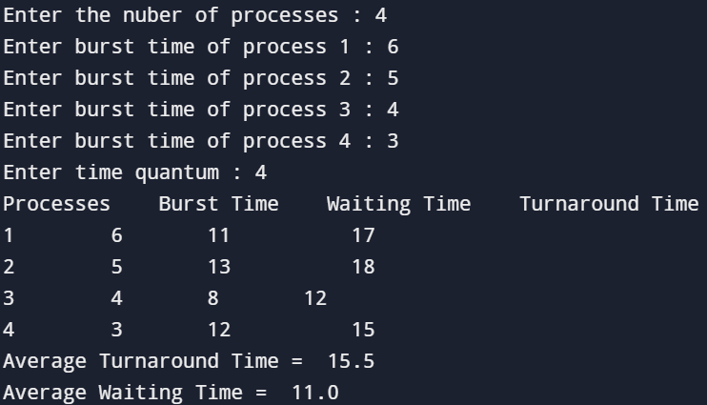
RESULT:
The Round Robin CPU scheduling algorithm has been studied and executed successfully.

