Ex. No.: 8 NAME:M.Praveenraj
DATE:28-03-2025 REG.NO:230701396
PRODUCER CONSUMER USING SEMAPHORES
Aim: To write a program to implement solution to producer consumer problem using semaphores.
Algorithm:
- Initialize semaphore empty, full and mutex.
- Create two threads- producer thread and consumer thread.
- Wait for target thread termination.
- Call sem_wait on empty semaphore followed by mutex semaphore before entry into critical section.
- Produce/Consume the item in critical section.
- Call sem_post on mutex semaphore followed by full semaphore 7. before exiting critical section.
- Allow the other thread to enter its critical section.
- Terminate after looping ten times in producer and consumer Threads each.
Program Code:
#include <stdio.h>
#include <semaphore.h>
#include <stdlib.h>

#define SIZE 3

int buffer[SIZE];
int in = 0, out = 0;
int count = 0;

sem_t empty, full, mutex;

void produce() {
if (sem_trywait(&empty) == 0) {
sem_wait(&mutex);

int item = in + 1;
buffer[in] = item;
printf("Producer produces the item %d\n", item);
in = (in + 1) % SIZE;
count++;

sem_post(&mutex);
sem_post(&full);
} else {
printf("Buffer is full!!\n");
}
}

void consume() {
if (sem_trywait(&full) == 0) {
sem_wait(&mutex);

int item = buffer[out];
printf("Consumer consumes item\n%d\n", item);
out = (out + 1) % SIZE;
count--;

sem_post(&mutex);
sem_post(&empty);
} else {
printf("Buffer is empty!!\n");
}
}

int main() {
int choice;

sem_init(&empty, 0, SIZE);
sem_init(&full, 0, 0);
sem_init(&mutex, 0, 1);

while (1) {
printf("1. Producer\n2. Consumer\n3. Exit\nEnter your choice:");
scanf("%d", &choice);

switch (choice) {
case 1:
produce();
break;
case 2:
consume();
break;
case 3:
printf("Exiting...\n");
sem_destroy(&empty);
sem_destroy(&full);
sem_destroy(&mutex);
exit(0);
default:
printf("Invalid choice!\n");
}
}

return 0;
}

Output:

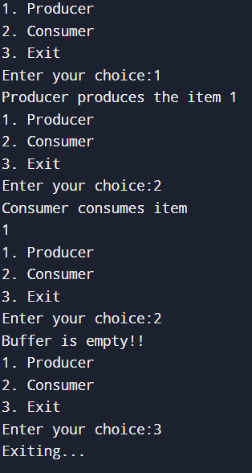

Result:
Thus the program for producer consumer problem has been executed successfully

