Ex No: 1a) Name:M.Praveenraj
Date: Regno:230701396

INSTALLATION AND CONFIGURATION OF LINUX Aim: To install and configure Linux operating system in a Virtual Machine

Aim:
To install and configure Linux operating system in a Virtual Machine.

Installation/Configuration Steps:
1. Install the required packages for virtualization dnf install xen virt-manager qemu libvirt
2. Configure xend to start up on boot systemctl enable virt-manager.service
3. Reboot the machine Reboot
4. Create Virtual machine by first running virt-manager virt-manager &
5. Click on File and then click to connect to localhost
6. In the base menu, right click on the localhost(QEMU) to create a new VM
7. Select Linux ISO image
8. Choose puppy-linux.iso then kernel version
9. Select CPU and RAM limits
10.Create default disk image to 8 GB
11.Click finish for creating the new VM with PuppyLinux

Output:

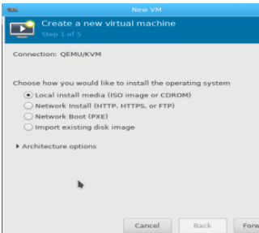

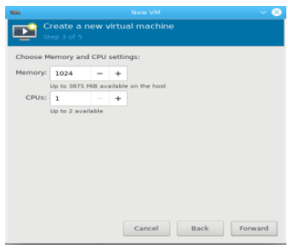
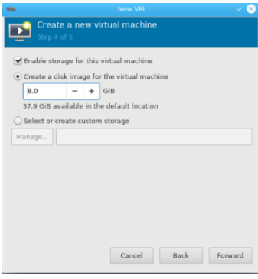

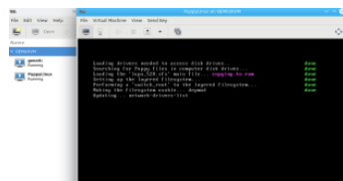

RESULT:
The installation of linux has been studied successfully.

