EX.NO:6(a) NAME:M.Praveenraj
DATE:22-02-2025 REG.NO:230701396
First Come First Serve
Aim:
To implement First-come First- serve (FCFS) scheduling technique
Algorithm:
1. Get the number of processes from the user.
2. Read the process name and burst time.
3. Calculate the total process time.
4. Calculate the total waiting time and total turnaround time for each process
5. Display the process name & burst time for each process.
6. Display the total waiting time, average waiting time, turnaround time
Program Code:
n=int(input("Enter number of processes : "))
processes=list(range(1,n+1))
burst_time=[]
for i in range(n):
burst_time.append(int(input(f"Enter burst time for process {i+1} : ")))
waiting_time=[0]*n
turnaround_time=[0]*n
arrival_time=[0]*n
completion_time=[0]*n
completion_time[0]=turnaround_time[0]=burst_time[0]
for i in range(1,n):
completion_time[i]=completion_time[i-1]+burst_time[i]
for i in range(1,n):
turnaround_time[i]=completion_time[i]-arrival_time[i]
for i in range(1,n):
waiting_time[i]=turnaround_time[i]-burst_time[i]
print("Process\tBurst time\tArrival time\tCompletion time\tWaiting time\tTurnaround time")
total_wt=total_tat=0
for i in range(n):
total_wt+=waiting_time[i]
total_tat+=turnaround_time[i]
print(f"{processes[i]}\t\t{burst_time[i]}\t\t{arrival_time[i]}\t\t{completion_time[i]}\t\t{waiting_time[i]}\t\t{turnaround_time[i]}")
print(f"Average Waiting Time = {total_wt/n : .2f}")
print(f"Average Turnaround Time = {total_tat/n : .2f}")

OUTPUT:
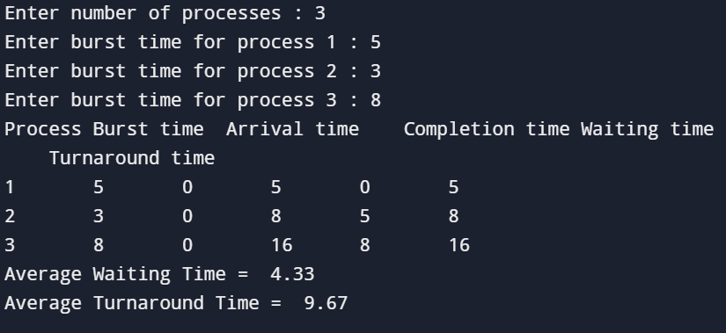

RESULT:
The FCFS CPU scheduling algorithm has been studies and successfully executed.

