EX.NO:6(b) NAME:M.Praveenraj
DATE:22-02-2025 REG.NO:230701396
SHORTEST JOB FIRST
Aim:
To implement the Shortest Job First (SJF) scheduling technique Algorithm:
1. Declare the structure and its elements.
2. Get number of processes as input from the user.
3. Read the process name, arrival time and burst time
4. Initialize waiting time, turnaround time & flag of read processes to zero.
5. Sort based on burst time of all processes in ascending order
6. Calculate the waiting time and turnaround time for each process.
7. Calculate the average waiting time and average turnaround time.
8. Display the results.
Program Code:
n = int(input("Enter number of processes: "))
processes = {}
for i in range(n):
burst_time = int(input(f"Enter burst time for process {i + 1}: "))
processes[i + 1] = {'burst_time': burst_time, 'arrival_time': 0, 'completion_time': 0, 'waiting_time': 0, 'turnaround_time': 0}
sorted_processes = {k: v for k, v in sorted(processes.items(), key=lambda x: x[1]['burst_time'])}
previous_completion_time = 0
for process, times in sorted_processes.items():
times['completion_time'] = previous_completion_time + times['burst_time']
times['turnaround_time'] = times['completion_time'] - times['arrival_time']
times['waiting_time'] = times['turnaround_time'] - times['burst_time']
previous_completion_time = times['completion_time']
print("Process\tBurst time\tArrival time\tCompletion time\tWaiting time\tTurnaround time")
total_wt = total_tat = 0
for process, times in sorted_processes.items():
total_wt += times['waiting_time']
total_tat += times['turnaround_time']
print(f"{process}\t\t{times['burst_time']}\t\t{times['arrival_time']}\t\t{times['completion_time']}\t\t{times['waiting_time']}\t\t{times['turnaround_time']}")
print(f"Average Waiting Time = {total_wt / n:.2f}")
print(f"Average Turnaround Time = {total_tat / n:.2f}"
Output:
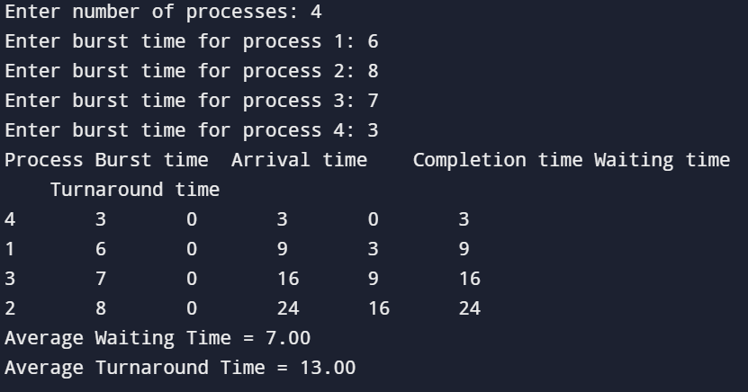
Result:
The SJF CPU scheduling algorithm has been studied and successfully executed.

