EX.NO:6(c) NAME:M.Praveenraj
DATE:28-02-2025 REG.NO:230701396
PRIORITY SCHEDULING
Aim:
To implement priority scheduling technique
Algorithm:
1. Get the number of processes from the user.
2. Read the process name, burst time and priority of process.
3. Sort based on burst time of all processes in ascending order based priority
4. Calculate the total waiting time and total turnaround time for each process
5. Display the process name & burst time for each process.
6. Display the total waiting time, average waiting time, turnaround time
Program Code:
import array
num = int(input("Enter number of processes: "))
pro= array.array('i', range(1, num + 1))
bt = array.array('i', map(int, input("Enter burst times: ").split()))
pri = array.array('i', map(int, input("Enter priorities: ").split()))
n= sorted(range(num), key=lambda i: pri[i])
bt = array.array('i', [bt[i] for i in n])
pro = array.array('i', [pro[i] for i in n])
pri = array.array('i', [pri[i] for i in n])
at = array.array('i', [0] * num)
wt = array.array('i', [0] * num)
ct = array.array('i', [0] * num)
tat = array.array('i', [0] * num)
ct[0] = bt[0]
for i in range(1, num):
ct[i] = ct[i - 1] + bt[i]
for i in range(num):
tat[i] = ct[i] - at[i]
for i in range(num):
wt[i] = tat[i] - bt[i]
avg_wt = sum(wt) / num
avg_tat = sum(tat) / num
print("\nProcess\tBurst time\tPriority\tCompletion time\tWaiting time\tTurnaround time")
for i in range(num):
print(f"{pro[i]}\t{bt[i]}\t\t{pri[i]}\t\t{ct[i]}\t\t{wt[i]}\t\t{tat[i]}")
print(f"\nAverage Waiting Time: {avg_wt:.2f}")
print(f"Average Turnaround Time: {avg_tat:.2f}")
OUTPUT:
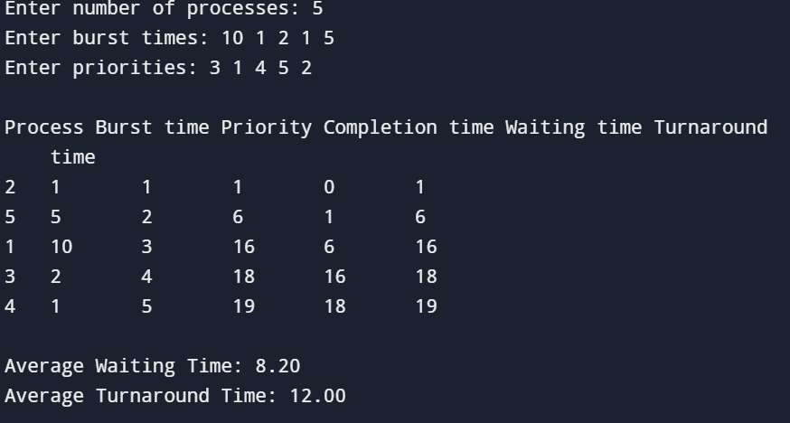
RESULT:
The Priority scheduling algorithm has been studied and successfully executed.

