EX.NO:6(d) NAME:M.Praveenraj
DATE:28.02.2025 REG.NO:230701396
ROUND ROBIN SCHEDULING
Aim:
To implement the Round Robin (RR) scheduling technique
Algorithm:
1. Declare the structure and its elements.
2. Get number of processes and Time quantum as input from the user.
3. Read the process name, arrival time and burst time
4. Create an array rem_bt[] to keep track of remaining burst time of processes which is initially copy of bt[] (burst times array)
5. Create another array wt[] to store waiting times of processes. Initialize this array as 0.
6. Initialize time : t = 0
7. Keep traversing the all processes while all processes are not done. Do following for i'th process if it is not done yet. a- If rem_bt[i] > quantum (i) t = t + quantum (ii) bt_rem[i] -= quantum; b- Else // Last cycle for this process (i) t = t + bt_rem[i]; (ii) wt[i] = t - bt[i] (iii) bt_rem[i] = 0; // This process is over
8. Calculate the waiting time and turnaround time for each process.
9. Calculate the average waiting time and average turnaround time.
10. Display the results.
Program Code:
n=int(input("Enter the nuber of processes : "))
process=[]
for i in range(0,n):
process.append(i+1)
bt=[]
for i in range(0,n):
burst_time=int(input(f"Enter burst time of process {i+1} : "))
bt.append(burst_time)
tq=int(input("Enter time quantum : "))
wt=[0]*n
tat=[0]*n
rem_bt=bt.copy()
time=0
while(1):
complete=True
for i in range(n):
if rem_bt[i]>0:
complete=False
if rem_bt[i]>tq:
time+=tq
rem_bt[i]-=tq
else:
time+=rem_bt[i]
wt[i]=time-bt[i]
rem_bt[i]=0
if complete:
break
for i in range(0,n):
tat[i]=bt[i]+wt[i]
total_wt=0
total_tat=0
for i in range(0,n):
total_wt=total_wt+wt[i]
total_tat=total_tat+tat[i]
print("Processes Burst Time Waiting Time Turnaround Time")
for i in range(0,n):
print(i+1,"\t\t",bt[i],"\t\t",wt[i],"\t\t",tat[i])
print("Average Turnaround Time = ",(total_tat/n))
print("Average Waiting Time = ",(total_wt/n))
OUTPUT:
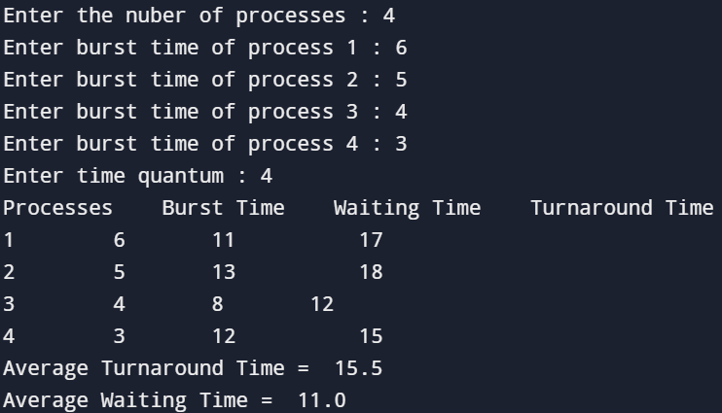
RESULT:
The Round Robin CPU scheduling algorithm has been studied and executed successfully.

