Department of Computer Technology
Vision of the Department
To be a well-known centre for pursuing computer education through innovative pedagogy, value-based education and industry collaboration.
Mission of the Department
To establish learning ambience for ushering in computer engineering professionals in core and multidisciplinary area by developing Problem- solving skills through emerging technologies.

Session 2025-2026
Mission: Means to achieve Vision
Vision: Dream of where you want.

Program Educational Objectives of the program (PEO): (broad statements that describe the professional and career accomplishments)
PEO1 | Preparation | P: Preparation | Pep-CL abbreviation pronounce as Pep-si- lL easy to recall
PEO2 | Core Competence | E: Environment  (Learning Environment)
PEO3 | Breadth | P: Professionalism
PEO4 | Professionalism | C: Core Competence
PEO5 | Learning Environment | L: Breadth (Learning in diverse areas)
Program Outcomes (PO): (statements that describe what a student should be able to do and know by the end of a program)

Keywords of POs:
Engineering knowledge, Problem analysis, Design/development of solutions, Conduct Investigations of Complex Problems, Engineering Tool Usage, The Engineer and The World, Ethics, Individual and Collaborative Team work, Communication, Project Management and Finance, Life-Long Learning
PSO Keywords: Cutting edge technologies, Research
“I am an engineer, and I know how to apply engineering knowledge to investigate, analyse and design solutions to complex problems using tools for entire world following all ethics in a collaborative way with proper management skills throughout my life.” to contribute to the development of cutting-edge technologies and Research.

Integrity: I will adhere to the Laboratory Code of Conduct and ethics in its entirety.

Name and Signature of Student and Date
(Signature and Date in Handwritten)

Department of Computer Technology
Vision of the Department
To be a well-known centre for pursuing computer education through innovative pedagogy, value-based education and industry collaboration.
Mission of the Department
To establish learning ambience for ushering in computer engineering professionals in core and multidisciplinary area by developing Problem- solving skills through emerging technologies.

Session | 2025-26 (Even) |  | Course Name | PE-III: Lab -Reinforcement Learning
Semester | 6th |  | Course Code | 23ADS1644
Roll No | 13 |  | Name of Student | Prerna Utane
Practical Number |  | 06
Course Outcome |  | CO1: Apply fundamental reinforcement learning concepts to model and solve decision-making problems.  CO2: Implement basic reinforcement learning algorithms to train agents in a given  environment.  CO3: Analyze agent behavior
Aim |  | To implement the Q-Learning algorithm to enable an agent to learn optimal actions through trial and error.
Problem Definition |  | To implement the Q-Learning algorithm in a GridWorld environment, enabling an agent to learn optimal actions through trial and error. The objective is to maximize cumulative rewards by navigating from a start state to a goal state while avoiding obstacles (holes), using reinforcement learning techniques  without prior knowledge of the environment.
Theory (100  words) |  | Q-Learning is a model-free reinforcement learning algorithm that enables an agent to learn optimal actions by interacting with an environment. It uses a Q- table to store state-action values, which represent the expected cumulative reward of taking an action in a given state. The agent updates these values using the Bellman equation, balancing immediate rewards and future rewards through a discount factor. An ε-greedy strategy is used to balance exploration and exploitation, where the agent explores randomly with probability ε and exploits the best-known action otherwise. Over time, ε decays, reducing exploration.  Through repeated episodes, the Q-values converge, allowing the agent to learn  the optimal policy for reaching the goal while avoiding penalties.

Department of Computer Technology
Vision of the Department
To be a well-known centre for pursuing computer education through innovative pedagogy, value-based education and industry collaboration.
Mission of the Department
To establish learning ambience for ushering in computer engineering professionals in core and multidisciplinary area by developing Problem- solving skills through emerging technologies.

Procedure and Execution | Algorithm:
(100 Words) | - Initialize:  - Environment (GridWorld)  - Q-table with zeros  - Learning rate (α), discount factor (γ), exploration rate (ε)  - For each episode:  - Reset environment to start state  - Convert state to index  - While episode not finished:  - Choose action:  - Random action with probability ε (exploration)  - Best action from Q-table (exploitation)  - Perform action → get new state, reward, done  - Update Q-value using:
 | Q(s,a) = Q(s,a) + α[ r + γ max Q(s′,a′)−Q(s,a)]
- Update current state
- Decay ε using exponential decay formula
- Store total reward per episode
- After all episodes:
  - Plot rolling average reward
  - Display final Q-table
 | Code:
import numpy as np import pandas as pd import io
import matplotlib.pyplot as plt
 | print("Generated 'grid_config.csv' file with GridWorld configuration.")
class GridWorld:
def init (self, size=4, start=(0, 0), goal=(3, 3), holes=None): self.size = size
self.start = start self.goal = goal

Department of Computer Technology
Vision of the Department
To be a well-known centre for pursuing computer education through innovative pedagogy, value-based education and industry collaboration.
Mission of the Department
To establish learning ambience for ushering in computer engineering professionals in core and multidisciplinary area by developing Problem- solving skills through emerging technologies.
self.holes = holes if holes is not None else [] self.state = self.start
def from_csv_config(csv_file_path): df_config = pd.read_csv(csv_file_path)

size = 4
start = (0, 0)
goal = (3, 3) holes = []

for index, row in df_config.iterrows(): setting = row['setting']

if setting == 'size':
size = int(row['value1']) elif setting == 'start':
start = (int(row['value1']), int(row['value2'])) elif setting == 'goal':
goal = (int(row['value1']), int(row['value2'])) elif setting == 'hole':
holes.append((int(row['value1']), int(row['value2'])))
return GridWorld(size=size, start=start, goal=goal, holes=holes) def reset(self):
self.state = self.start return self.state

def step(self, action): row, col = self.state

if action == 0:
row = max(0, row - 1) elif action == 1:
row = min(self.size - 1, row + 1) elif action == 2:
col = max(0, col - 1) elif action == 3:
col = min(self.size - 1, col + 1)

self.state = (row, col)

Department of Computer Technology
Vision of the Department
To be a well-known centre for pursuing computer education through innovative pedagogy, value-based education and industry collaboration.
Mission of the Department
To establish learning ambience for ushering in computer engineering professionals in core and multidisciplinary area by developing Problem- solving skills through emerging technologies.
reward = -0.1 done = False

if self.state == self.goal: reward = 100
done = True
elif self.state in self.holes: reward = -100
done = True
return self.state, reward, done def render(self):
grid = np.full((self.size, self.size), '.')
for r, c in self.holes: grid[r, c] = 'H' grid[self.goal] = 'G' grid[self.state] = 'A'
for row in grid: print(' '.join(row))
print('---\n')

def state_to_index(state_tuple, size):
return state_tuple[0] * size + state_tuple[1]

env = GridWorld.from_csv_config('grid_config.csv') env.render()

num_states = env.size * env.size num_actions = 4
q_table = np.zeros((num_states, num_actions))

learning_rate = 0.8
discount_factor = 0.95
epsilon = 1.0
max_epsilon = 1.0
min_epsilon = 0.01
decay_rate = 0.005

num_episodes = 1000
print(f"Q-table shape: {q_table.shape}")

Department of Computer Technology
Vision of the Department
To be a well-known centre for pursuing computer education through innovative pedagogy, value-based education and industry collaboration.
Mission of the Department
To establish learning ambience for ushering in computer engineering professionals in core and multidisciplinary area by developing Problem- solving skills through emerging technologies.

rewards_per_episode = []

for episode in range(num_episodes): state_tuple = env.reset()
state = state_to_index(state_tuple, env.size) done = False
current_episode_reward = 0

while not done:
if np.random.uniform(0, 1) < epsilon: action = np.random.randint(num_actions)
else:
action = np.argmax(q_table[state, :])

new_state_tuple, reward, done = env.step(action) new_state = state_to_index(new_state_tuple, env.size)

q_table[state, action] = q_table[state, action] + learning_rate * (
reward + discount_factor * np.max(q_table[new_state, :]) -q_table[state, action])

state = new_state current_episode_reward += reward

epsilon = min_epsilon + (max_epsilon - min_epsilon) * np.exp(-decay_rate * episode)
rewards_per_episode.append(current_episode_reward)

if episode % 100 == 0:
print(f"Episode {episode}: Total Reward = {current_episode_reward:.2f}, Epsilon = {epsilon:.2f}")

print("\nTraining complete!") print("Final Q-table:\n", q_table)

plt.figure(figsize=(12, 6)) plt.plot(pd.Series(rewards_per_episode).rolling(window=50).mean()) plt.xlabel('Episode')
plt.ylabel('Total Reward (Rolling Average)')
plt.title('Q-Learning Training Progress: Total Reward per Episode (Rolling Average)')

Department of Computer Technology
Vision of the Department
To be a well-known centre for pursuing computer education through innovative pedagogy, value-based education and industry collaboration.
Mission of the Department
To establish learning ambience for ushering in computer engineering professionals in core and multidisciplinary area by developing Problem- solving skills through emerging technologies.

plt.grid(True) plt.show()
Output:
1. Grid and Q-values

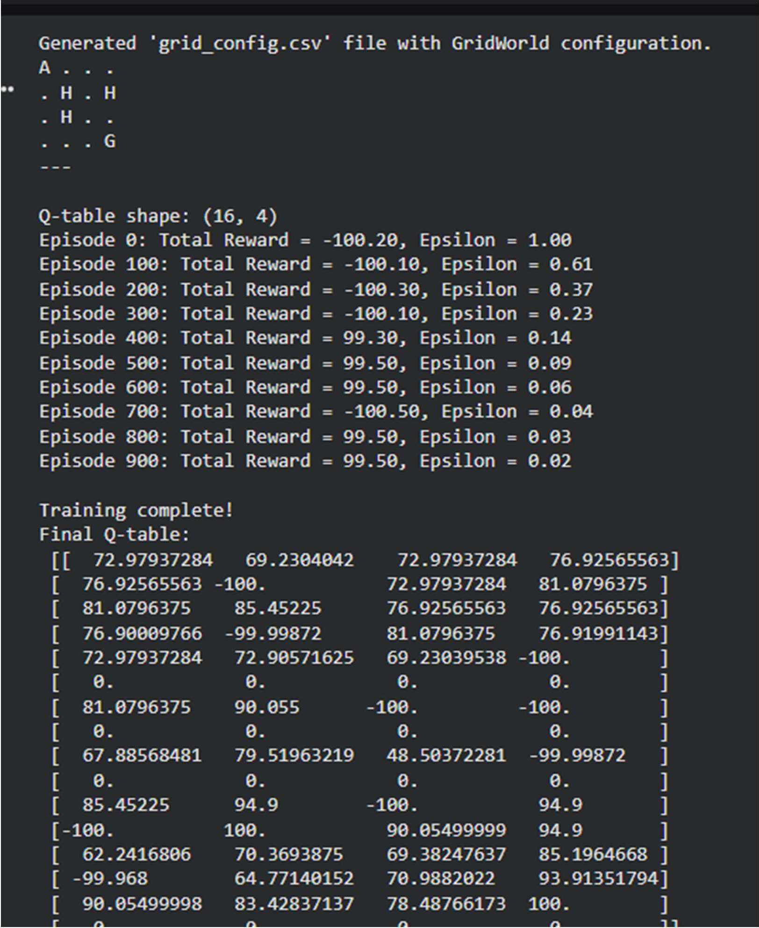

Department of Computer Technology
Vision of the Department
To be a well-known centre for pursuing computer education through innovative pedagogy, value-based education and industry collaboration.
Mission of the Department
To establish learning ambience for ushering in computer engineering professionals in core and multidisciplinary area by developing Problem- solving skills through emerging technologies.

2. Q-learning Graph

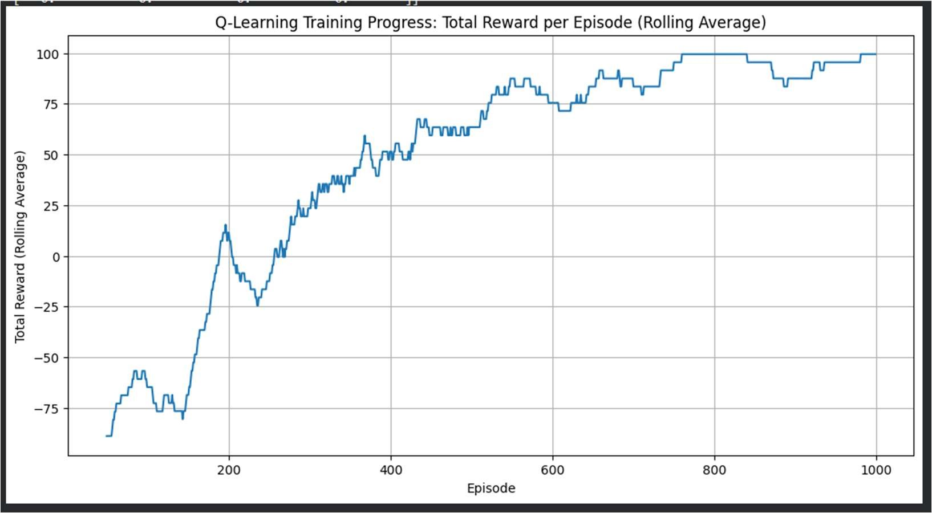

Output Analysis | - Reward Trend (Graph):  Initially, rewards are low due to random exploration. Over time, the rolling average reward increases, showing learning progress.  - Effect of Epsilon Decay:  High ε at the start promotes exploration. As ε decreases, the agent increasingly exploits learned optimal actions.  - Q-Table Values:  Final Q-values reflect the expected rewards of optimal paths, with higher values near the goal state.  - Agent Behavior: The agent learns to:  - Move efficiently toward the goal (+100 reward)  - Avoid holes (-100 penalty)
- Stability:
The graph smoothens over episodes, indicating convergence toward an optimal policy.

Department of Computer Technology
Vision of the Department
To be a well-known centre for pursuing computer education through innovative pedagogy, value-based education and industry collaboration.
Mission of the Department
To establish learning ambience for ushering in computer engineering professionals in core and multidisciplinary area by developing Problem- solving skills through emerging technologies.

Link of student Github profile where lab assignment has  been uploaded | https://github.com/23071121-pixel/RL_Practicals/edit/main/Practical-6_13
Conclusion | The Q-Learning algorithm successfully enables the agent to learn optimal navigation strategies in the GridWorld environment through trial and error. By balancing exploration and exploitation using ε-greedy policy and updating Q- values iteratively, the agent improves its performance over time. The increasing reward trend and stable Q-values confirm convergence toward an optimal policy. This demonstrates the effectiveness of Q-Learning in solving decision-making  problems in unknown environments.
Plag Report (Similarity index < 12%) | 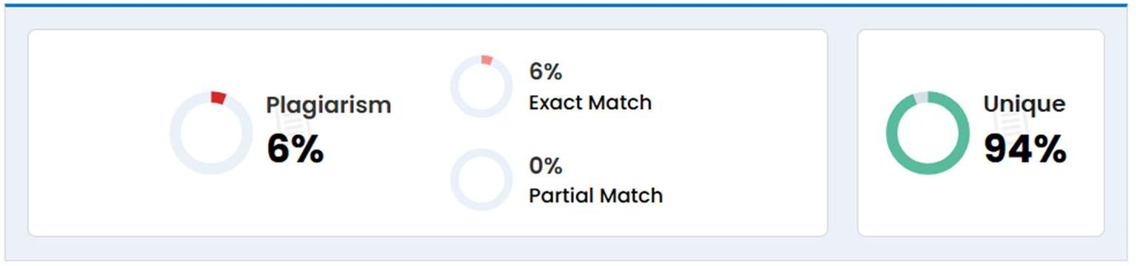
Date | 28/03/2026

