SENTINELQ: AN EXPLAINABLE HYBRID QUANTUM INTRUSION DETECTION SYSTEM

A PROJECT REPORT SUBMITTED IN PARTIAL FULFILLMENT OF THE REQUIREMENTS FOR THE AWARD OF THE DEGREE OF

BACHELOR OF TECHNOLOGY
IN
COMPUTER SCIENCE AND ENGINEERING

BY

MATRI. PRANAY 23071A0534

MONISH REDDY GANDRA 23071A0537

P. ABHINAVA CHAITANYA KUMAR 23071A0545

RATHOD SIDHARTHA 23071A0549

RAVURI JAYANTH 23071A0550

UNDER THE GUIDANCE OF

Dr. A. MADHAVI

Assistant Professor



DEPARTMENT OF COMPUTER SCIENCE AND ENGINEERING

VALLURUPALLI NAGESWARA RAO

VIGNANA JYOTHI INSTITUTE OF ENGINEERING & TECHNOLOGY
Vignana Jyothi Nagar, Bachupally, Hyderabad 500118, Telangana India

March 2026


DEPARTMENT OF COMPUTER SCIENCE AND ENGINEERING ENGINEERING
CERTIFICATE
This is to certify that the Minor Project titled “Sentinelq: An Explainable Hybrid Quantum Intrusion Detection System” is a record of bona fide work submitted by:
- MATRI PRANAY 23071A0534
- MONISH REDDY GANDRA 23071A0537
- P. ABHINAVA CHAITANYA KUMAR 23071A0545
- RATHOD SIDHARTHA 23071A0549
- RAVURI JAYANTH 23071A0550
in partial fulfillment of the requirements for the award of the degree of Bachelor of Technology (B.Tech.) in COMPUTER SCIENCE AND ENGINEERING of Jawaharlal Nehru Technological University Hyderabad (JNTUH), under VNRVJIET B.Tech. R22 Academic Regulations. The work has been carried out under our guidance and supervision at Vallurupalli Nageswara Rao Vignana Jyothi Institute of Engineering & Technology, Hyderabad. The report is original, free from plagiarism, and complies with the Institute guidelines, including those related to academic ethics and AI-generated content.

Signature of Supervisor  Dr. A. MADHAVI  Assistant Professor  Computer Science and Engineering | Signature of HOD  Dr. V. Baby  Professor & HOD  Computer Science and  Engineering
VNR VJIET, Hyderabad | VNR VJIET, Hyderabad
PLAGIARISM CERTIFICATE

APPROVAL CERTIFICATE

Minor Project evaluation for the project titled “Sentinelq: An Explainable Hybrid Quantum Intrusion Detection System”, being submitted by
Mr. Matri Pranay, Regd. No. 23071A0534, Mr. Monish Reddy Gandra, Regd. No. 23071A0537, Mr. P. Abhinava Chaitanya Kumar, Regd. No. 23071A0545, Mr. Rathod Sidhartha, Regd. No. 23071A0549, Mr. Ravuri Jayanth, Regd. No. 23071A0550.
has been conducted on ____________ and the work is approved for the award of the degree of BACHELOR OF TECHNOLOGY (B.Tech.) in COMPUTER SCIENCE AND ENGINEERING, under VNRVJIET B.Tech. R22 Academic Regulations.

INTERNAL EXAMINER EXTERNAL EXAMINER


DEPARTMENT OF COMPUTER SCIENCE AND ENGINEERING
DECLARATION
We, the undersigned, declare that the Minor Project titled “Sentinelq: An Explainable Hybrid Quantum Intrusion Detection System” has been carried out by us in partial fulfillment of the requirements for the award of the degree of Bachelor of Technology (B.Tech.) in COMPUTER SCIENCE AND ENGINEERING of Jawaharlal Nehru Technological University Hyderabad (JNTUH), under VNRVJIET B.Tech. R22 Academic Regulations, at Vallurupalli Nageswara Rao Vignana Jyothi Institute of Engineering & Technology, Hyderabad.
We further declare that this work is original, has not been submitted previously for any degree or similar title, and complies with the Institute’s plagiarism and academic ethics guidelines, including AI-generated content. The contributions of all team members are clearly indicated in the report.
PLACE: HYDERABAD
DATE: ____________
Signature of the Student(s)

MATRI PRANAY 23071A0534

MONISH REDDY GANDRA 23071A0537

P. ABHINAVA CHAITANYA KUMAR 23071A0545
RATHOD SIDHARTHA 23071A0549
RAVURI JAYANTH 23071A0550

ABSTRACT
Intrusion detection systems face three primary challenges: high-dimensional feature spaces, lack of transparency in classification processes, and difficulties adapting to unseen network anomaly patterns. This paper explores trainable quantum circuits as a promising solution within current Noisy Intermediate-Scale Quantum (NISQ) device limitations. This research implements a six-stage pipeline using a hybrid quantum-classical architecture fused with Explainable Artificial Intelligence (XAI) based explanations. Different stages in this pipeline are trained on benchmark datasets UNSW-NB15, NSL-KDD, and CICIDS-2017. The pipeline processes the data as follows: first, the data is preprocessed in stage one. Then the normalized data is passed to a sentinel-based Variational Autoencoder (VAE) with masked loss, which reduces the feature space from 167 dimensions to 8 dimensions in stage two. These compressed features are then processed by an 8-qubit Variational Quantum Circuit (VQC) in stage three, where hybrid training protocols are used to address barren plateau problems in VQC. Subsequently, in stages four and five, XGBoost and Random Forest algorithms are combined with VQC outputs to classify attacks. The proposed method achieved 98.01% accuracy with a macro F1-score of 0.8233. Finally, SHAP and LIME values provide interpretability, effectively addressing classification transparency concerns and enhancing model explainability in stage six.

Keywords: Intrusion Detection, Quantum Machine Learning, Variational Autoencoder, Variational Quantum Circuit, Explainable Ai, XGboost, Random Forest.

TABLE OF CONTENTS

CERTIFICATE |  | i
PLAGIARISM CERTIFICATE |  | ii
APPROVAL CERTIFICATE |  | iii
DECLARATION |  | iv
ABSTRACT |  | v
TABLE OF CONTENTS |  | vi
LIST OF FIGURES |  | viii
LIST OF TABLES |  | ix
NOMENCLATURE |  | x
ACKNOWLEDGEMENT |  | xi
CHAPTER 1 – INTRODUCTION |  | 1
1.1 | Background of the Problem | 1
1.2 | Need and Relevance | 1
1.3 | Problem Statement | 1
1.4 | Objectives | 2
1.5 | Scope of Work | 2
1.6 | Organization of the Report | 3
CHAPTER 2 – LITERATURE REVIEW |  | 4
2.1 | Overview of Existing Work | 4
2.2 | Comparison of Methods / Approaches | 10
2.3 | Critical Analysis of Literature | 11
2.4 | Research Gaps Identified | 11
CHAPTER 3 – APPROACH / DESIGN METHODOLOGY |  | 13
3.1 | Approach / Proposed Methodology | 13
3.2 | Technical Approach and Key Elements | 16
3.3 | Supporting Analysis / Design Considerations | 18
3.4 | Tools / Techniques Used | 31
3.5 | Justification of Selected Approach | 31
CHAPTER 4 – DEVELOPMENT AND IMPLEMENTATION |  | 32
4.1 | Implementation Plan | 32
4.2 | Development / Execution of Major Components | 33
4.3 | Integration and Overall Functioning | 40
4.4 | Challenges Encountered and Solutions | 40
4.5 | Observations | 41

CHAPTER 5 – RESULTS, ANALYSIS AND VALIDATION
5.1 | Testing / Evaluation Methodology
5.2 | Results Obtained
5.3 | Analysis and Interpretation of Results
5.4 | Validation of Objectives
5.5 | Comparison with Expected / Existing Outcomes

CHAPTER 6 – CONCLUSIONS AND FUTURE SCOPE
6.1 | Conclusions
6.2 | Limitations of the Work
6.3 | Future Scope
REFERENCES
APPENDICES
APPENDIX A: Contribution of Team Members

LIST OF FIGURES

Fig. No. | Title | Page No.
1 | Six-Stage Sentinelq Hybrid Quantum-Classical Pipeline. | 16
2 | . Detailed Six-stage SentinelQ hybrid quantum-classical pipeline. | 17
3 | Use Case diagram | 18
4 | Class diagram | 20
5 | Activity – Data ingestion | 22
6 | Activity – Data preprocessing | 22
7 | Activity - VAE | 23
8 | Activity – Quantum Layer | 23
9 | Activity – Hybrid Ensemble | 24
10 | Activity – Explanation Layer | 25
11 | Sequence – Data ingestion | 26
12 | Sequence – Data Preprocessing | 27
13 | Sequence – Classical model | 27
14 | Sequence – Quantum Model | 28
15 | Sequence – Hybrid Ensemble | 29
16 | Sequence – Explanation Layer | 30
17 | Training comparison VAE-A v/s VAE_B | 36
18 | VQC training dynamics | 37
19 | t-SNE of the 8D VAE latent space | 38
20 | SHAP summary beeswarm plot | 40
21 | Per-class F1 scores for VQC-A (dark bars) and VQC-B (light bars) | 44
22 | Confusion Matrix – SentinalQ | 44

LIST OF TABLES

Table No. | Title | Page No.
1 | Comparison Of Previous Methods | 10
2 | SentinelQ Pipeline Stage Overview | 16
3 | VAE–A v/s VAE-B | 35
4 | Per-Class F1 Score Progression Across Pipeline Stages | 39
5 | Classification Performance per Class — SentinelQ | 43
6 | Objective Comparison | 47

NOMENCLATURE

List all symbols, abbreviations and notations used in the report.

SG | Sample Graph

ACKNOWLEDGEMENT

We would like to convey our gratitude to all the persons who have helped us in successfully completing our Minor Project Phase-II.
Firstly, we would like to thank our Project Supervisor, Dr. A. Madhavi, for the invaluable advice, constant motivation, and technical guidance provided to us at every step of the way in the process of this project.
Secondly, we would like to thank the Head of the Department, Dr. V. Baby, for providing us with all the necessary facilities, motivation, and guidance needed to undertake this project.
Thirdly, we would like to thank all our faculty members and staff who have academically and technically helped us throughout this project.
Fourthly, we would like to thank the institute for providing us with a favorable atmosphere and excellent infrastructure for conducting this project.
Lastly, we would like to thank all individuals and institutions who have helped us in the completion of this project directly or indirectly.

MATRI. PRANAY 23071A0534

MONISH REDDY GANDRA 23071A0537

P. ABHINAVA CHAITANYA KUMAR 23071A0545

RATHOD SIDHARTHA 23071A0549

RAVURI JAYANTH 23071A0550

CHAPTER 1

INTRODUCTION

BACKGROUND OF THE PROBLEM
One of the most significant applications of machine learning is in network intrusion detection systems, which automatically detect malicious activity in a computer network. Due to the growth of digital infrastructure in terms of scale and complexity, the volume and complexity of cyber threats targeting it have also grown.
  - NEED AND RELEVANCE
Weekly average cyber attacks in India have reached 3,195 per organization in early 2026, representing a 62% increase above the global average, while Distributed Denial of Service (DDoS) attacks rose by 46% in 2024 relative to the previous year [1]. Worldwide, IoT connections are estimated to reach 39 billion in 2030, and more than 50 billion by 2035 [2].
  - PROBLEM STATEMENT
Network Intrusion Detection Systems (NIDS) act as a digital security guard that watches web traffic for anything suspicious and hence acts as a line of defence against these threats, continuously watching the network traffic and flagging patterns that deviate from established norms. The growing diversity of attack types, the sheer volume of network flows in modern environments, and the increasing complexity of hacking techniques have made the design of effective, robust, and trustworthy NIDS one of the defining challenges in applied cybersecurity research.
Classical machine learning approaches, including signature-based systems, Support Vector Machines, Random Forests, and deep neural networks, have made significant contributions to intrusion detection, yet they face three persistent and interrelated shortcomings. First, scalability: kernel-based classifiers scale quadratically with feature dimensionality, and modern network flows routinely present hundreds of heterogeneous features. Second, opacity: models that perform well on conventional benchmarks are often black boxes, which also fails emerging regulatory frameworks such as GDPR Article 22, which mandates explainability for automated consequential decisions [3]. Third, brittleness under distribution shift: a model trained on a single benchmark dataset frequently fails when deployed against traffic from a different network environment or attack taxonomy.
Quantum systems reside in Hilbert space, which is exponentially larger than classical feature space: a dataset with n features lives in n-dimensional space, while systems with n qubits live in 2ⁿ-dimensional Hilbert space [4]. For this reason, quantum provides a way to give more expressive feature representation and potentially increasing the separability of complex data patterns. But current NISQ devices also face challenges including number of qubits available, circuit depth, and noise [5]. One of the leading quantum baselines in the NIDS literature, Gouveia and Correia, achieved 92% accuracy on NSL-KDD using a Quantum Support Vector Machine, but only 64% on UNSW-NB15 [6]. This 28-percentage gap reveals that a parameter-free, stationary quantum kernel does not generalize across datasets with different attack taxonomies.
  - OBJECTIVES
The primary objective of this work is to develop a hybrid quantum-classical intrusion detection system that is simultaneously accurate, generalizable across heterogeneous datasets—UNSW-NB15 [7], NSL-KDD [8], CICIDS-2017 [9]—and interpretable to security practitioners. More specifically, the system aims to: (i) compress high-dimensional, multi-source network-flow features into a quantum-compatible low-dimensional representation; (ii) train a VQC using gradient-based backpropagation to avoid barren-plateau stagnation; (iii) combine quantum and classical model outputs in an ensemble that surpasses the performance of any individual component; and (iv) provide a full post-hsoc explainability layer using SHAP and LIME.
  - SCOPE OF WORK
The scope of Quantum Intrusion Detection System (Quantum IDS) is to improve the effectiveness of cyber security with the use of classical approaches as well as developments made in quantum computing. It allows for effective detection of sophisticated intrusions such as zero day attacks and advanced persistent threats through the use of hybrid approaches that leverage methods such as Variational Quantum Circuit. Applications include financial, healthcare and defense sectors among others. With the continued development of quantum technology, there is huge potential for Quantum IDS in future networks.
  - ORGANIZATION OF THE REPORT
The remainder of the paper is structured as follows. Section II surveys prior work in quantum intrusion detection, hybrid quantum-classical architectures, dimensionality reduction for NISQ hardware, and explainability in cybersecurity AI. Section III provides the technical background on Variational Quantum Circuits, hybrid networks, Variational Autoencoders, and the SHAP and LIME explanation frameworks. Section IV describes each of the six SentinelQ pipeline stages in detail. Section V presents experimental results, comparisons against classical and deep-learning baselines, and ablation studies quantifying the contribution of each architectural component. Section VI concludes with a discussion of limitations and directions for future work.

CHAPTER 2

LITERATURE REVIEW

2.1. OVERVIEW OF EXISTING WORK
2.1.1. Classical Intrusion Detection Systems
Intrusion detection research has a very long history rooted in rule-based methods and statistical procedures. These traditional systems laid the groundwork for modern detection techniques, but they also introduced many new limitations that continue to motivate newer research today.
Khraisat et al. [10] published one of the most comprehensive surveys on intrusion detection systems, which were mainly classified into three broad categories: signature-based detection, anomaly-based detection, and hybrid approaches. Their findings showed that signature-based systems perform well when the attack is already known, but unfortunately fail against new or previously unseen threats. This is because such systems depend on manually updated rule sets that cannot adapt to attacks that were never anticipated. This foundational limitation forms the main motivation for SentinelQ, which requires a detection mechanism that is not restricted to known attack patterns.
Shaukat et al. [11] examined over a decade of machine learning applications in cybersecurity and identified three major failure modes that appear continuously across the literature: class imbalance between normal and attack traffic, models that become outdated as network conditions change, and a nearcomplete absence of explainability in automated classification decisions. Each of these failure modes is directly reflected in SentinelQ’s design – specifically through the use of SMOTE for imbalance handling, evaluation across multiple datasets to address staleness, and SHAP and LIME for explainability.
Mishra et al. [12] performed an exhaustive comparison evaluation of various machine learning methods for intrusion detection, finding support vector machines, neural networks, and ensemble models under consistent experimental conditions. Their research revealed that while no individual algorithm consistently outperforms the others across all attack types, ensemble methods came closest – particularly on rare attack categories. They also found that high-dimensional raw features actually degrade classifier performance. These results provide strong empirical justification for the ensemble structure in SentinelQ’s Stage 5 and the VAE-driven dimensionality reduction performed in Stage 3.
Zeadally et al. [13] investigated the ways in which various AI technologies, specifically deep learning and generative frameworks, can enhance security measures across a wide range of fields. While acknowledging the accuracy benefits of AI-based intrusion detection, the authors raised an important concern: the internal logic of these systems is opaque, making them difficult to audit or justify in regulated environments. They concluded that explainability must be treated as a prerequisite for deployment, not an optional feature. This perspective directly supports the inclusion of SHAP and LIME in SentinelQ as an operational necessity.
Le et al. [14] developed a multi-class intrusion detection system by combining random forests with gradient-boosted trees, then added SHAP explanations to ensure that every individual classification could be properly audited. Evaluated on the UNSW-NB15 dataset, the system performed strongly on common attack types but continued to show precisionrecall trade-offs on rare attack classes. This work is especially relevant to SentinelQ because it applies the same combination of ensemble classification with SHAP explainability on the same benchmark dataset, making it a natural classical baseline for direct comparison.
2.1.2. Machine Learning-Based Intrusion Detection Systems
The adoption of machine learning fundamentally changed intrusion detection from static rule matching into flexible statistical learning, enabling systems to identify attack patterns they had not explicitly been programmed to recognize. This section reviews significant contributions spanning deep learning, ensemble techniques, and concept-drift-aware architectures.
Vinayakumar et al. [15] provided one of the most extensive evaluations of deep learning for multi-class intrusion detection, testing deep neural networks, convolutional networks, LSTMs, and recurrent variants on both KDD Cup 99 and UNSW-NB15. Despite strong overall accuracy, the study consistently found poor detection performance on minority attack families such as botnet and exploitation traffic, a flaw the authors attributed to severe class imbalance rather than insufficient model capacity. No mechanism for explaining individual predictions was included. These specific gaps in existing research are what drove the design of SentinelQ, leading us to implement SMOTE, focal loss, and class-weighted training – which features a 15× weight for Malware – alongside per-class threshold optimization.
Ullah and Mahmoud [16] developed a two-stage detection pipeline for IoT traffic, where the first stage filters benign traffic using a statistical model and the second stage applies a Random Forest for multi-class classification. The system achieved high accuracy on the BoT-IoT dataset. However, it relied entirely on manual features and included no dimensionality reduction or explainability layer. Despite these limitations, this work demonstrates that layered detection architectures are practically effective, and it serves as a classical ensemble reference point against which SentinelQ’s quantum-augmented ensemble can be compared.
Faker and Dogdu [17] carried out an early comparison of deep learning models for network intrusion detection on NSLKDD, noting that deeper architectures improved detection of rare attacks but at significant computational cost and reduced interpretability. This research clearly identified the accuracy explainability trade-off that most subsequent classical IDS research has failed to resolve. It also establishes a useful parameter efficiency benchmark: SentinelQ achieves competitive detection with only 10,773 total parameters, compared to the hundreds of thousands required by the deep models evaluated in this study.
Andresini et al. [18] studied what happens to a deployed intrusion detection system when the network traffic distribution changes over time – a challenge commonly referred to as concept drift. Using an autoencoder-based anomaly detector, they proved that models trained on static snapshots degrade systematically when evaluated on later captures from the same network. This finding validates two of SentinelQ’s architectural decisions: training across multiple datasets to capture distributional variety, and using a VAE latent space that encodes structural properties of the traffic rather than raw feature statistics.
Neupane et al. [19] conducted a survey of explainability methods in the intrusion detection context, covering SHAP, LIME, attention mechanisms, and inherently interpretable models. The survey found that the overwhelming majority of high-accuracy IDS systems provide no explanation capability whatsoever, and that those which do typically apply posthoc methods only to simple traditional models. Notably, the authors confirmed that no quantum intrusion detection system at the time of writing had integrated any explainability mechanism. This review essentially pinpoints the exact research gap that we aim to address by
2.1.3. Quantum Machine Learning in Cybersecurity
Quantum machine learning has emerged as a promising direction for cybersecurity, motivated by the representational advantages of quantum Hilbert space and the trainability of variational quantum circuits. The papers discussed in this section showcase the most advanced work happening where quantum computing and intrusion detection meet.
Gouveia and Correia introduced the first notable quantum method to network intrusion detection, encoding network flow features into quantum Hilbert space and classifying them using a Quantum Support Vector Machine with a ZZ-feature map, evaluated on IBM quantum simulators. The system achieved 92% accuracy on NSL-KDD, a strong result for its time. But when tested on UNSW-NB15, accuracy fell to 64%; this 28-point drop proves that a rigid, non-trainable kernel cannot adapt to different types of attack patterns. The model was also binary-class only and provided no explanation for its decisions. This generalization gap is the primary reason SentinelQ employs a trainable variational quantum circuit with gradient-based parameter updates, multi-dataset evaluation, and a five-class taxonomy.
Kalinin and Krundyshev [20] compared both QSVM and Quantum Convolutional Neural Network models for intrusion detection, suggesting that classical machine learning struggles with large-scale network data while quantum approaches offer a viable computational alternative. Their Quantum CNN actually beat the QSVM by about 5 to 8 points and reached its top performance much more quickly. However, the evaluation was conducted on a synthetic, proprietary dataset with no independent benchmark validation and no explainability layer, making broader assessment of the results difficult. This paper proves the advantage of trainable and flexible quantum circuits over static kernels, and underlines the need for evaluation on established public benchmarks.
Abreu, Rothenberg, and Abe´lem [21] proposed QML-IDS, combining VQC and QSVM components and testing it on real IBM hardware to observe how it handles actual gate errors in both simple and complex security tasks. Their best VQC configuration improved over the static QSVM baseline by 5 to 8 percentage points while using 40% less hardware resources, with the advantage attributed to the trainability of circuit parameters via backpropagation. The system was evaluated on UNSW-NB15 and CICIDS-2017, but no explainability layer was included. QML-IDS is the closest prior work to SentinelQ in scope. SentinelQ extends it by incorporating a third dataset (NSL-KDD), using a VAE to shrink data size, following a twostep training process to maintain stability, and offering clear explanations through SHAP and LIME.
Suryotrisongko and Musashi [22] used a mix of quantum and classical technology to detect botnets, pairing a variational quantum classifier with traditional deep learning layers. This hybrid model worked better than standard models and did so using far fewer internal parameters. Crucially, this was the first study to systematically evaluate a hybrid quantum-classical IDS on specific types of attacks. Its findings are consistent with SentinelQ’s own results, in which the VQC component contributes most noticeably to improved F1 scores on the Malware and Exploit classes.
Moussa et al. [23] proposed a quantum autoencoder for dimensionality reduction followed by quantum-based random forest and quantum k-nearest neighbour classifiers for network anomaly detection, evaluated on KDD99 and IoT-23. The quantum autoencoder reduced the feature space through angle and amplitude embedding before classification. Although the system achieved competitive anomaly detection rates, it was limited to binary classification and provided no explainability. This research is directly related to SentinelQ’s VAE compression stage, as it validates the general idea of using quantum dimensionality reduction before classification. However, SentinelQ goes a step further with its sentinel-masked VAE, which solves the problem of conflicting data that their method ignores.
2.1.4. Explainable AI in Intrusion Detection Systems
As intrusion detection models have grown more complex, making their decisions understandable to human analysts has become both a research priority and a regulatory requirement. The following papers represent the best current work in Explainable AI (XAI) specifically tailored for network security.
Arrieta et al. [24] published a survey on explainable artificial intelligence, establishing a rigorous taxonomy of ante-hoc methods – models that are inherently interpretable by design – and post-hoc methods such as SHAP, LIME, attention mechanisms, and saliency maps, which are applied after a model has already been trained. The authors argued that posthoc methods are the only practical route to explainability for complex high-performance models, and they identified cybersecurity as one of the highest-priority domains for XAI research. This work directly informs SentinelQ’s choice of SHAP and LIME as its explanation layer, providing the theoretical justification for applying post-hoc methods to a complex hybrid ensemble.
Gaspar, Silva, and Silva [25] used SHAP and LIME to explain the decisions of a multi-layer perceptron used for intrusion detection in IoT devices, and conducted a perturbation analysis to assess explanation stability and fidelity. Their results showed that SHAP provides more consistent global feature attributions across the model as a whole, whereas LIME is more computationally tractable for generating local explanations on individual predictions. Crucially, they documented a challenge specific to the intrusion detection domain: network flow features are considerably less intuitive to security analysts than image pixels or clinical measurements, which makes explanation design more difficult. This paper is the most direct comparison for SentinelQ’s Stage 6 design, as it applies the same two XAI tools to the same problem.
Neupane et al. conducted a comprehensive survey of explainability approaches across the intrusion detection landscape. Beyond confirming the general absence of XAI in most IDS systems, the authors identified three gaps: the complete absence of XAI in quantum IDS research, insufficient evaluation of explanation quality in multi-class settings, and a disconnect between the outputs produced by explanation methods and the vocabulary that security analysts actually use. They specifically recommended that explanations be anchored to original, human-readable feature names rather than abstract latent space dimensions. SentinelQ follows this guidance directly – SHAP and LIME attributions in Stage 6 are tied to the original feature names from Stage 2, so that analysts familiar with network flow statistics can interpret the output without additional translation.
A 2025 systematic review published in Frontiers in Artificial Intelligence [26] analysed over 80 papers from 2018 to 2024 and found that SHAP and LIME are the go-to tools for explaining how intrusion detection systems work. The review confirmed that SHAP is preferred for stable global attribution while LIME is favoured for local explanation in real-time deployments. Most significantly, the review found that no evaluated paper combined quantum classification with any form of XAI, confirming that this combination remains an open problem.
SentinelQ directly addresses this gap. A 2025 study published in the Annals of Telecommunications [27] proposed an XAI-IDS framework that uses ANOVAbased statistical feature selection guided by SHAP global scores to reduce the feature set by approximately 70%, then retrains a lightweight XGBoost detector with cross-validated SHAP and LIME explanations. The framework achieved an F1 score of at least 99% across three datasets – CIC-DDoS2019, CICIoT2023, and 5G PFCP – while reducing LIME explanation generation time from 36 seconds to 4.9 seconds. This demonstrates that SHAP-guided feature reduction can improve both efficiency and interpretability simultaneously. SentinelQ’s VAE compression stage achieves an analogous result – reducing 167 raw features to an 8-dimensional latent space – while also making the resulting representation suitable for quantum processing.
2.2. COMPARISON OF METHODS / APPROACHES
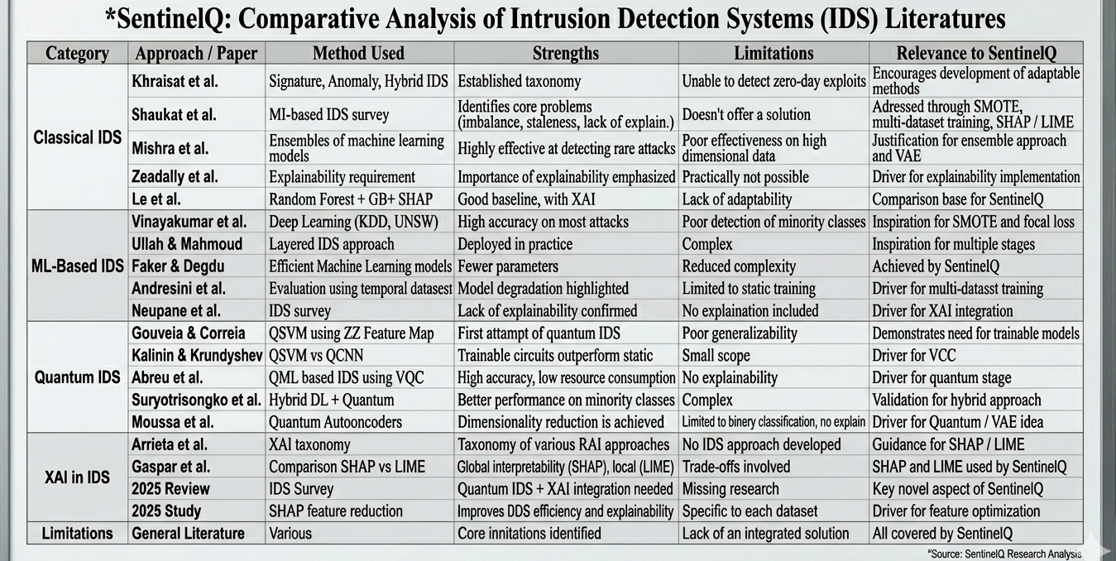
Table 1: Comparison of previous methods
2.3. CRITICAL ANALYSIS OF LITERATURE
Despite numerous breakthroughs achieved in the field, the contemporary literature on intrusion detection systems presents a number of gaps worth mentioning. On the one hand, the classical IDS models demonstrate great potential for providing a solid base for further research. On the other hand, they prove inefficient in detecting novel attacks and threats because of their reliance on fixed rules. Machine learning-based solutions can detect malicious activity with significantly higher precision, but the problem is that they face difficulties in addressing class imbalance, model degradation, and insufficient generalization. Furthermore, many high-performing algorithms work as black boxes and cannot provide any insights regarding decision-making processes, which poses certain challenges during their practical implementation. Quantum machine learning models can address some of these problems because of their ability to work with complex patterns and high-dimensional data, but the available literature lacks generalization of results and efficient implementations due to hardware constraints. No studies have applied explainable AI to quantum IDS so far.
2.4. RESEARCH GAPS IDENTIFIED
The literature reveals four persistent and interconnected limitations that no existing system has resolved simultaneously. The first is the absence of multi-dataset generalization. The majority of both classical and quantum IDS papers evaluate on a single benchmark. The 28-percentage-point accuracy drop reported by Gouveia and Correia between NSL-KDD and UNSW-NB15 illustrates how severely performance can collapse when the attack taxonomy or traffic distribution differs. Systems evaluated on only one dataset cannot be trusted for deployment across diverse real-world network environments. The second is the complete absence of explainability in quantum intrusion detection. Both Neupane et al. and the 2025 Frontiers systematic review confirm that no prior quantum IDS has provided any mechanism for explaining individual classification decisions. This is not merely a research gap – in environments governed by GDPR Article 22 and analogous regulatory frameworks, an automated classification decision that cannot be explained is legally indefensible. Combining quantum classification with post-hoc explainability therefore remains an unsolved problem at the time of writing. The third is the dimensionality mismatch between realworld network data and current NISQ hardware. Modern datasets such as UNSW-NB15 can contain up to 196 raw features, while practical quantum devices are limited to tens of qubits. No prior quantum IDS has proposed a principled, probabilistic dimensionality reduction approach capable of handling multi-source feature incompatibilities – the structural mismatches that arise when records from different datasets share no common feature schema. Existing methods use either discrete feature selection, which destroys the continuous representation needed for quantum angle encoding, or linear PCA, which cannot handle sentinel values and discards probabilistic structure. The fourth is the problem of gradient-free training and barren plateau stagnation. Several prior quantum IDS systems use gradient-free optimisers such as COBYLA to train variational circuit parameters. SentinelQ’s ablation experiments show that gradient-free optimisation produces a macro F1 of only 0.49, compared to 0.73 under the two-phase backpropagation protocol a difference of 23.9 percentage points attributable entirely to the training method. The barren plateau problem, in which quantum gradients vanish exponentially as qubit count grows, has been identified by Cerezo et al. as the dominant trainability risk for variational quantum circuits, yet no prior quantum NIDS paper has explicitly addressed it through training protocol design. These four gaps collectively define the motivation for SentinelQ, which – to the best of the authors’ knowledge – is the first end-to-end hybrid quantum-classical network intrusion detection system to simultaneously address generalisation across heterogeneous datasets, full post-hoc explainability, principled probabilistic dimensionality reduction, and barrenplateau-aware training within a single evaluated architecture.

CHAPTER 3
APPROACH / DESIGN METHODOLOGY
3.1. APPROACH / PROPOSED METHODOLOGY
Network Intrusion Detection Systems (IDS). Network Intrusion Detection Systems are security tools that examine network flows for any unauthorized, malicious, or anomalous behavior in real-time. IDS solutions may be generally classified into two categories: signature-based and anomaly-based systems. While signature-based systems achieve near-perfect precision on known threats, they are blind to novel attack variants. Anomaly-based systems, on the other hand, generalize well but have higher false positive rates. SentinelQ's multi-class classification formulation, which categorizes network traffic as NORMAL, DoSD, PROBE, EXPLOIT, or MALWARE, bridges the two approaches: the classifier learns discriminative thresholds for each class while still being responsive to anomalous feature combinations within each class. The benchmark dataset employed in this work, extracted from the CICIDS dataset family, contains labelled instances in all five classes and serves as the standard dataset for network intrusion detection systems research.
Gradient Boosting and Ensemble Learning. Gradient-boosted decision trees, implemented in this work using XGBoost, are considered the state-of-the-art classical tabular classifier algorithm. XGBoost trains additive sequences of weak decision trees, whereby each new tree minimizes the previous ensemble error by applying second-order Taylor expansion of the objective function. Complexity regularization of the tree structure (L1 and L2 penalties applied to leaf node weights) prevents overfitting, rendering XGBoost very robust when used with diverse network flow feature sets. Random Forest, the other classical method used in this study, generates a collection of independently-trained decision trees by training on bootstrapped samples of the input dataset and randomly selected feature sets. Individual trees' decorrelation lowers ensemble variance without inducing bias. In SentinelQ, XGBoost and Random Forest work as complementary learners, where XGBoost finds sequential patterns and residual-correction patterns, whereas Random Forest helps reduce variance due to its independent nature. The probability values generated by the two models are ensembled using weights, along with the Variational Quantum Circuit.
Variational Autoencoders for Feature Compression. A variational autoencoder (VAE) is a probabilistic deep learning technique used for generating new data based on an existing input dataset. It differs from traditional autoencoders in that it uses probabilistic means to find a mapping from input data points to a latent space instead of a deterministic approach. To accomplish this, a variational autoencoder consists of a probabilistic encoder and decoder. The encoder takes an input data point and generates two parameters that define a latent distribution as mean µ and log-variance log(σ²). These parameters are used to sample latent variables using the reparameterization technique as z = µ+σε.
The variational autoencoder uses the cross-entropy or mean-squared error between input and output as reconstruction loss and regularizes the latent distribution to maintain a certain distance from the normal distribution using KL-divergence. The VAE in SentinelQ is used to generate a latent vector of size 16 representing the most important latent features of the network traffic distribution. This latent vector is passed as additional input to classifiers, thus improving the original features.
Variational Quantum Circuits Quantum Machine Learning. In contrast to classical computers, which process information via bits that have definite values 0 and 1, quantum computers make use of qubits -- quantum systems that exist in a linear combination of states |0> and |1> at once. As a consequence of this feature, an n-qubit quantum register lives in a 2^{n} dimensional Hilbert space. Quantum gates are unitary transformations acting on one or several qubits, allowing for rotations of the state space. A variational quantum circuit (VQC) is an n-qubit quantum circuit parametrized by gate angles that can be optimized in the same way as weights in classical neural networks. Specifically, the VQC used in SentinelQ is designed as an Ising-YY ansatz. It is characterized by hardware-efficient encoding of the inputs in terms of Pauli-Y rotation gates R_Y and entangling of two-qubit pairs by applying a two-qubit gate YY, i.e., the product of Pauli-Y operators up to a phase factor and a parametric rotation about this axis. The design is inspired by the Ising Hamiltonian interaction model and allows incorporation of interactions between feature pairs encoded into the two-qubit entangled Hilbert space, a functionality not available for classical models. The implementation relies on the Qiskit framework and is evaluated using the Qiskit Aer statevector simulator, allowing exact quantum state computation.
Quantum-Classical Hybrid Machine Learning Architectures. Quantum-classical hybrid architectures utilize quantum circuits as differentiable computational units within a larger classical pipeline. In the SentinelQ architecture, fusion is performed at the probability level:
P_{total} = 0.10 P_{VQC} + 0.55 P_{XGB} + 0.35 P_{RF}
This late fusion strategy is grounded in ensemble learning theory, where combining diverse learners reduces generalization error. Diversity arises not only from model structure and training but also from computational paradigms: quantum Hilbert space representations versus classical tree-based decision boundaries. The VQC introduces uncorrelated error patterns, enhancing ensemble robustness.
Explanation using SHAP (SHapley Additive exPlanations). SHAP provides a framework for interpreting machine learning predictions based on cooperative game theory. For each prediction, SHAP assigns a feature importance value known as the Shapley value, representing the average marginal contribution of a feature across all subsets. SHAP satisfies four properties: efficiency, symmetry, dummy, and additivity. TreeSHAP enables efficient computation for tree-based models such as XGBoost and Random Forest, while KernelSHAP is used for model-agnostic explanations, including VQC outputs. SentinelQ employs SHAP for both global and local interpretability.
Finally, the SentinelQ Technical Stack. The technical components are complementary: XGBoost and Random Forest provide strong classical baselines; the VAE reduces dimensionality and improves generalization; the VQC introduces quantum feature interactions and ensemble diversity; and SHAP ensures interpretability. Together, these components form a robust, scalable, and explainable intrusion detection system.
The SentinelQ pipeline is designed as a sequential processing pipeline with six stages, as shown in Fig. 1. This provides an advantage of modular development and assigns each stage a predefined task, while making each stage easy to replace with a better model in future without disturbing the whole flow. The task that each stage performs is: (a) Data Ingestion, (b) Pre-processing, (c) Variational Autoencoder Compression, (d) Quantum Feature Extraction via Dual VQC, (e) Hybrid Ensemble Classification, and (f) Explainability and Audit.
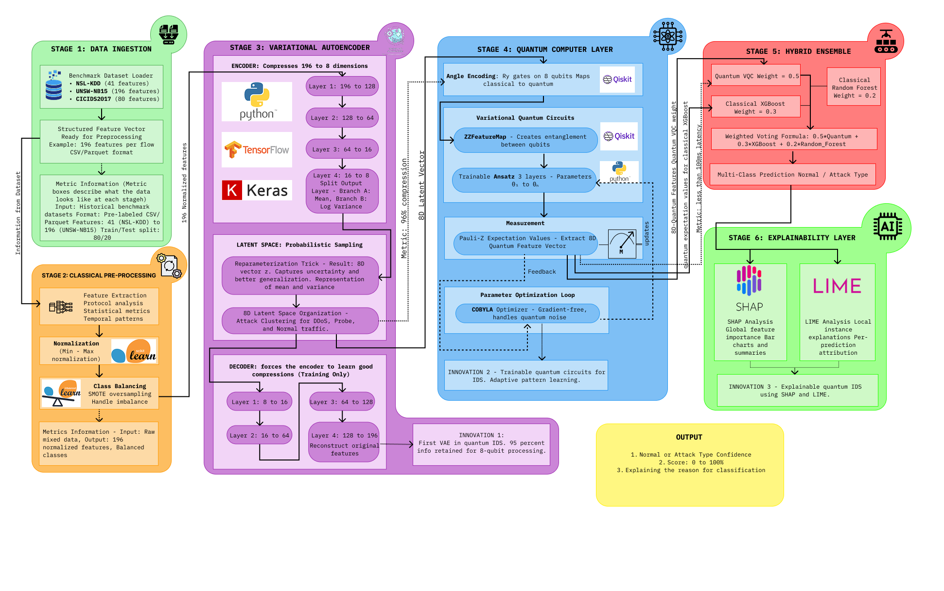 Fig. 1. Six-stage SentinelQ hybrid quantum-classical pipeline.

3.2. TECHNICAL APPROACH AND KEY ELEMENTS
The current quantum devices are powerful, but limited; one major constraint is noise, which leads to unreliability. Generally, with an increase in qubits, the noise also increases, so feeding 196 raw features into the machine creates a problem with complexity O(M²N), making real-time use impossible. The solution is to give the classical computer the heavy jobs of normalising, compressing, and performing final classification, while quantum circuits process the compressed version quickly.
Stage | Name | Task | Output
1 | Data Ingestion | Multisource fusion, quality filtering, taxonomy harmonization | 196 features, 2,869,035 labelled records
2 | Pre-processing | Feature encoding, normalization, SMOTE balancing | 167-dim feature vectors
3 | VAE | Sentinel-aware probabilistic compression with angular transformation | 8D angle vectors ∈ (0,π)
4 | Quantum VQC | Dual-path angle encoding, ZZFeatureMap, RealAmplitudes, two-stage learning | 5-class probability vectors
5 | Hybrid Ensemble | Soft weighted voting of VQC, XGBoost, Random Forest | Macro F1=0.8233, Acc.=0.9801
6 | Explainability | SHAP and LIME explanations | Per-decision audit trail (GDPR Art. 22)
TABLE 2. SentinelQ Pipeline Stage Overview
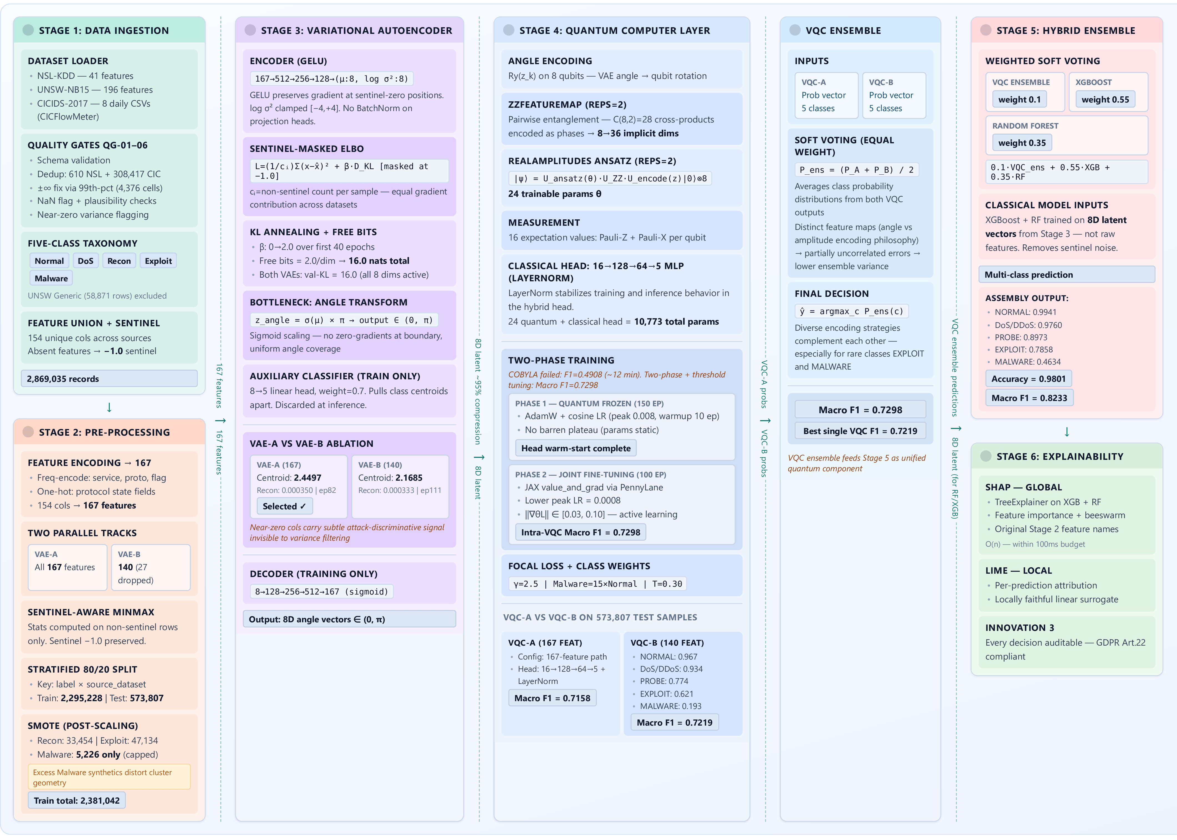
Fig. 2. Detailed Six-stage SentinelQ hybrid quantum-classical pipeline.

3.3. SUPPORTING ANALYSIS / DESIGN CONSIDERATIONS
3.3.1. USE-CASE Diagram
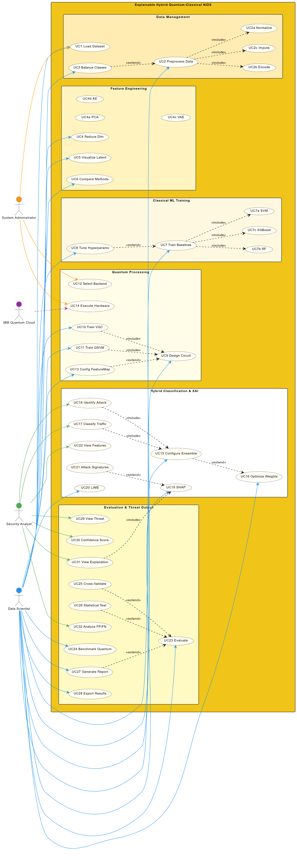
Fig. 3. Use Case diagram.
This figure demonstrates an Explainable Hybrid Quantum-Classical NIDS pipeline by presenting a flow of interactions between several elements of the process that starts from ingesting data and ends with analyzing detected threats. The first step of this pipeline is data management which consists of loading, cleaning, normalization, imputation, and encoding datasets. The second step implies feature engineering with reducing the number of dimensions by means of methods such as PCA, AE, and VAE. Next, comes the stage of classical machine learning when baseline models SVM, Random Forest, and XGBoost are being trained and tuned. At the same time, in the quantum processing phase, quantum circuit designs are made and VQC and QSVM models are trained on the chosen backends (e.g., IBM Quantum). The hybrid ensemble step includes classification of the inputs and use of explainability techniques SHAP and LIME. The final stage involves the evaluation and threat output process with detecting attacks, generating confidence values, performing cross-validation, and statistical testing. All these stages are completed by a joint effort of four different positions of System Administrator, Data Scientist, Security Analyst, and Quantum Cloud.
3.3.2. CLASS DIAGRAM
In this figure, we can see an architecture of modular explainable hybrid quantum-classical NIDS pipeline, where NIDSPipeline is a class that manages all other components. The pipeline starts from the step called Data Management. At this step, data loading and splitting occur, then normalization, encoding, and missing values imputation take place in DataPreprocessor; ClassBalancer uses approaches such as SMOTE for handling imbalances in classes. After that, preprocessed data goes through the Feature Engineering stage, where dimensionality reduction using PCA, Autoencoders, or Variational Autoencoders takes place through the implementation of the common interface called FeatureReducer. Then at the Classifiers step, data is fed into classifiers that contain classical models such as SVM, Random Forest, and XGBoost and quantum models (QSVM, VQC) that require circuit construction, feature mapping, and executing with the chosen backend. The results of the predictions in the classifiers are combined at the Hybrid Layer step through ensembling and optimization of weights. Also, it could be multiclass approaches that would provide better accuracy of predictions. For explainability, there is an opportunity to receive interpretable results that would show how features influence model predictions (through the SHAP, LIME approaches). In conclusion, after evaluation through performance metrics (accuracy, precision, recall, F1-score, cross-validation) and creating a final threat assessment with predicted labels, confidence, and explanations.
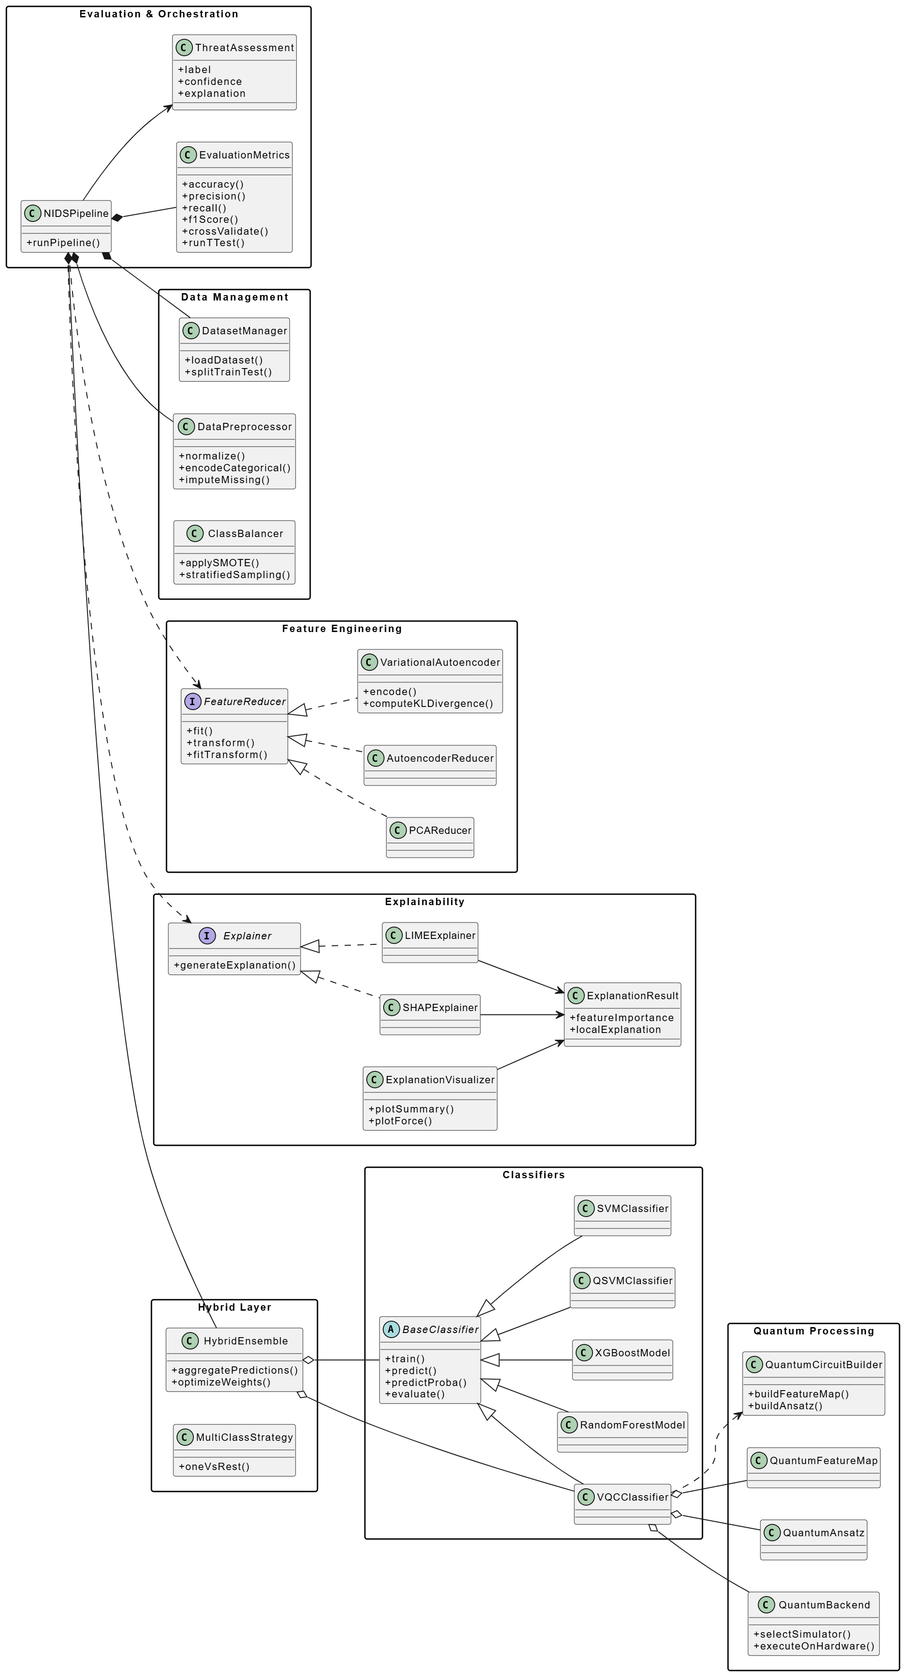
Fig. 4. Class diagram
3.3.3. ACTIVITY DIAGRAM
These diagrams depict an overall end-to-end workflow of a hybrid quantum-classical intrusion detection system covering stages from data handling to predictions in an interpretable form. Firstly, there is a stage of dataset selection and validation, where datasets such as NSL-KDD, UNSW-NB15, and CICIDS2017 are selected, validated according to their schema, cleansed from possible duplications, and then divided into training and testing samples. The next step involves data preprocessing and class balancing through the handling of any missing data, normalization of numeric data, and encoding of categorical attributes. Class imbalance can be addressed by using SMOTE (synthetic minority oversampling technique). After this, there is a feature engineering stage when dimensionality reduction is conducted via PCA (principal component analysis), Autoencoder, and Variational Autoencoders, which provides encoded feature vectors. Then, the classical and quantum models undergo training at once, which includes SVM, random forest, and XGBoost as classical models and VQC and QSVM as quantum models, where it is possible to add the process of hyperparameter tuning. Quantum processing requires choosing one of the backends (simulator or actual hardware), creation of feature map and ansatz circuits, and optimization of quantum models. Then, the hybrid ensembling stage is implemented by calculating optimal weights of models in order to make predictions based on the weighted voting of all models involved in the pipeline. Evaluation stage includes calculation of accuracy, precision, recall, F1 score, area under curve, confusion matrix, and model ranking. As a last step, there is explainability of generated results that involves SHAP and LIME interpretation and consistency checking of explanations along with the visualization of generated insights.
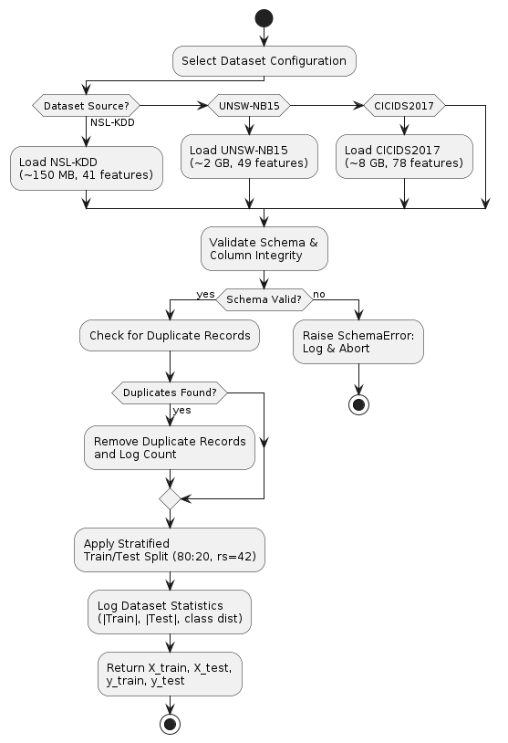
Fig. 5. Activity- Data ingestion
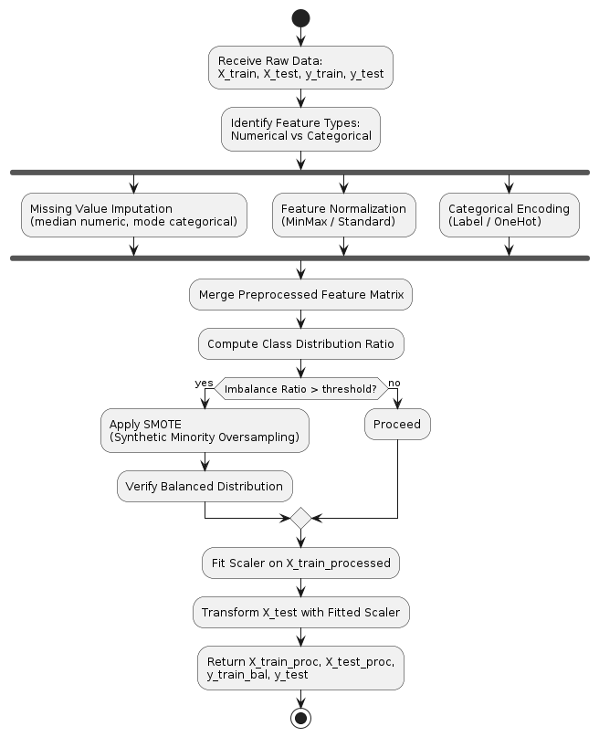
Fig. 6. Activity- Data preprocessing

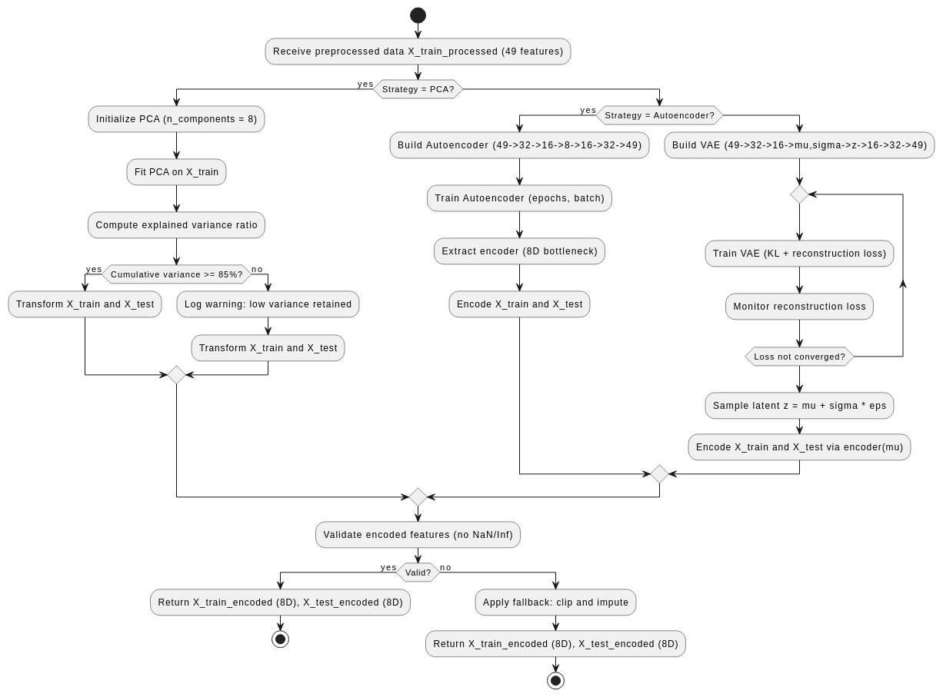
Fig. 7. Activity – VAE
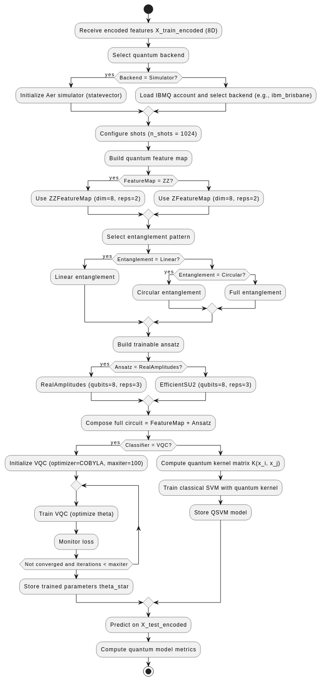
Fig. 8. Activity – Quantum Layer
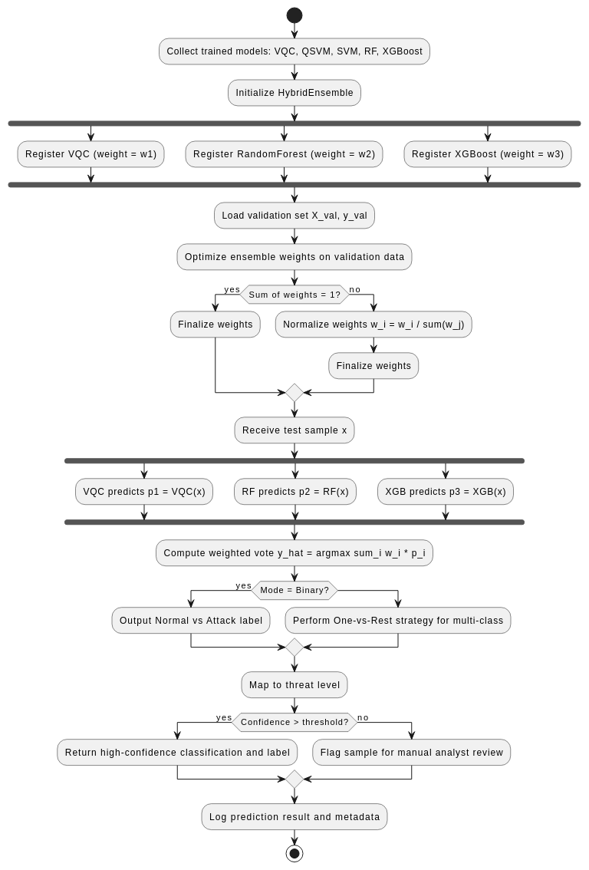
Fig. 9. Activity – Hybrid Ensemble
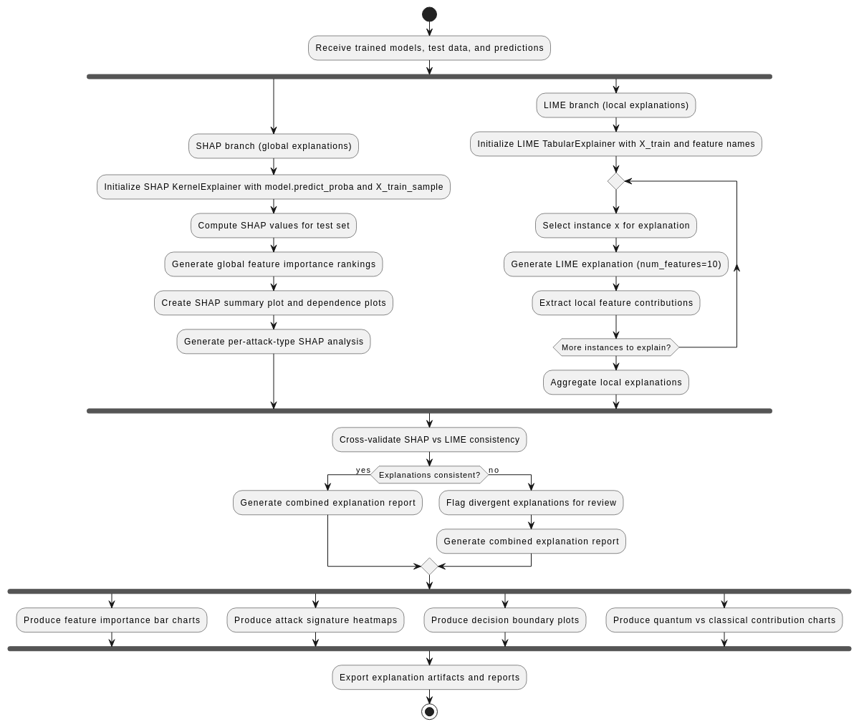
Fig. 10. Activity – Explanation Layers
3.3.4. SEQUENCE DIAGRAM
All these diagrams taken together describe the whole pipeline in detail and illustrate a full orchestration of the quantum-classical hybrid NIDS pipeline. First, the Data Scientist kicks off the pipeline which includes loading datasets into the system and validating them, deleting any duplicate records, and conducting a stratified train-test split of data. The following stage is preprocessing and includes handling numerical and categorical data separately through imputation, normalization, and encoding, with possible class balancing using SMOTE. After that, the feature engineering stage includes compressing the data using such techniques as PCA, Autoencoders, or VAE which creates a new set of encoded features. Those features are used for training classical machine learning models including SVM, Random Forest, and XGBoost optionally tuned for hyperparameters. At the same time, the quantum part of the process builds circuits based on feature maps + ansatz, chooses a certain backend for implementation (simulator or hardware), trains either VQC or QSVM models. All these predictions made by various models are integrated into a hybrid ensemble where optimal weights are chosen, and a decision is formed using weighted voting for binary or multi-class classifications generating a threat label with confidence. Finally, at the last stage, the explainability module creates global SHAP and LIME explanations, validates them, and creates various visuals such as feature importance, attack signature, or decision boundary visualization.
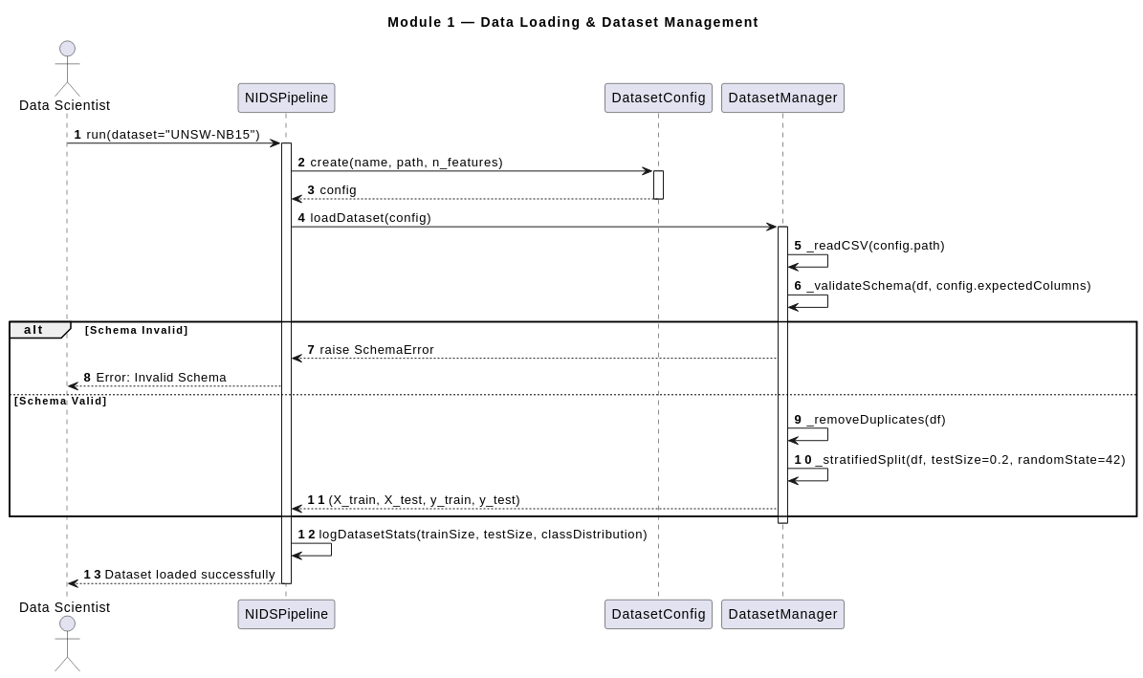
Fig. 11. Sequence – Data Ingestion

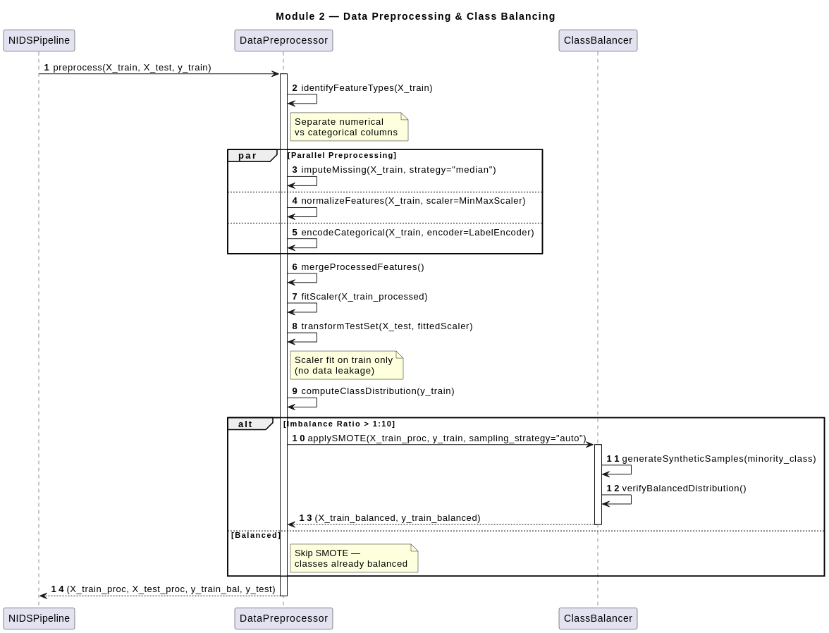
Fig. 12. Sequence – Data Prepreocessing
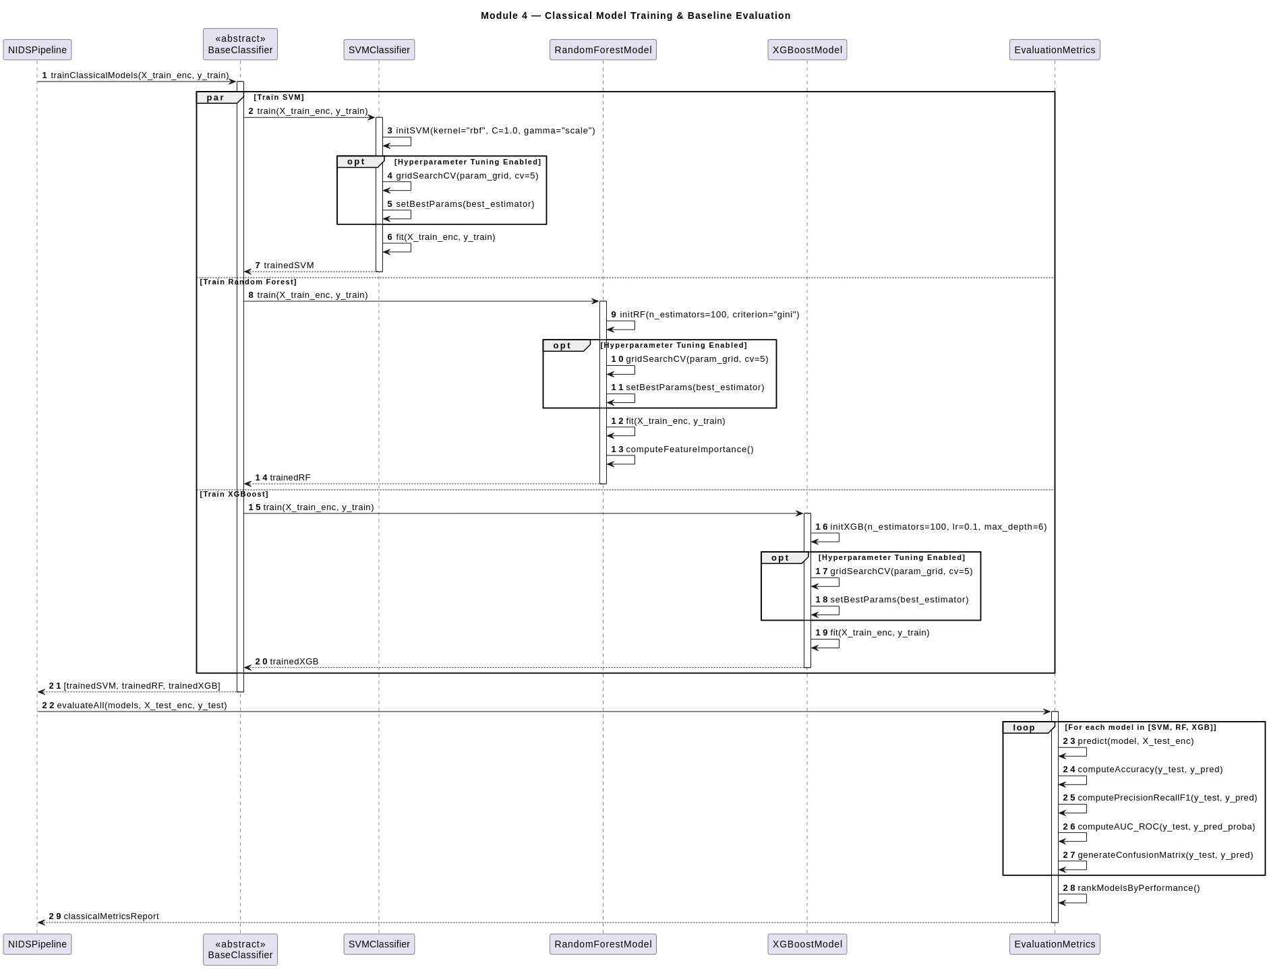
Fig. 13. Sequence – Classical Model
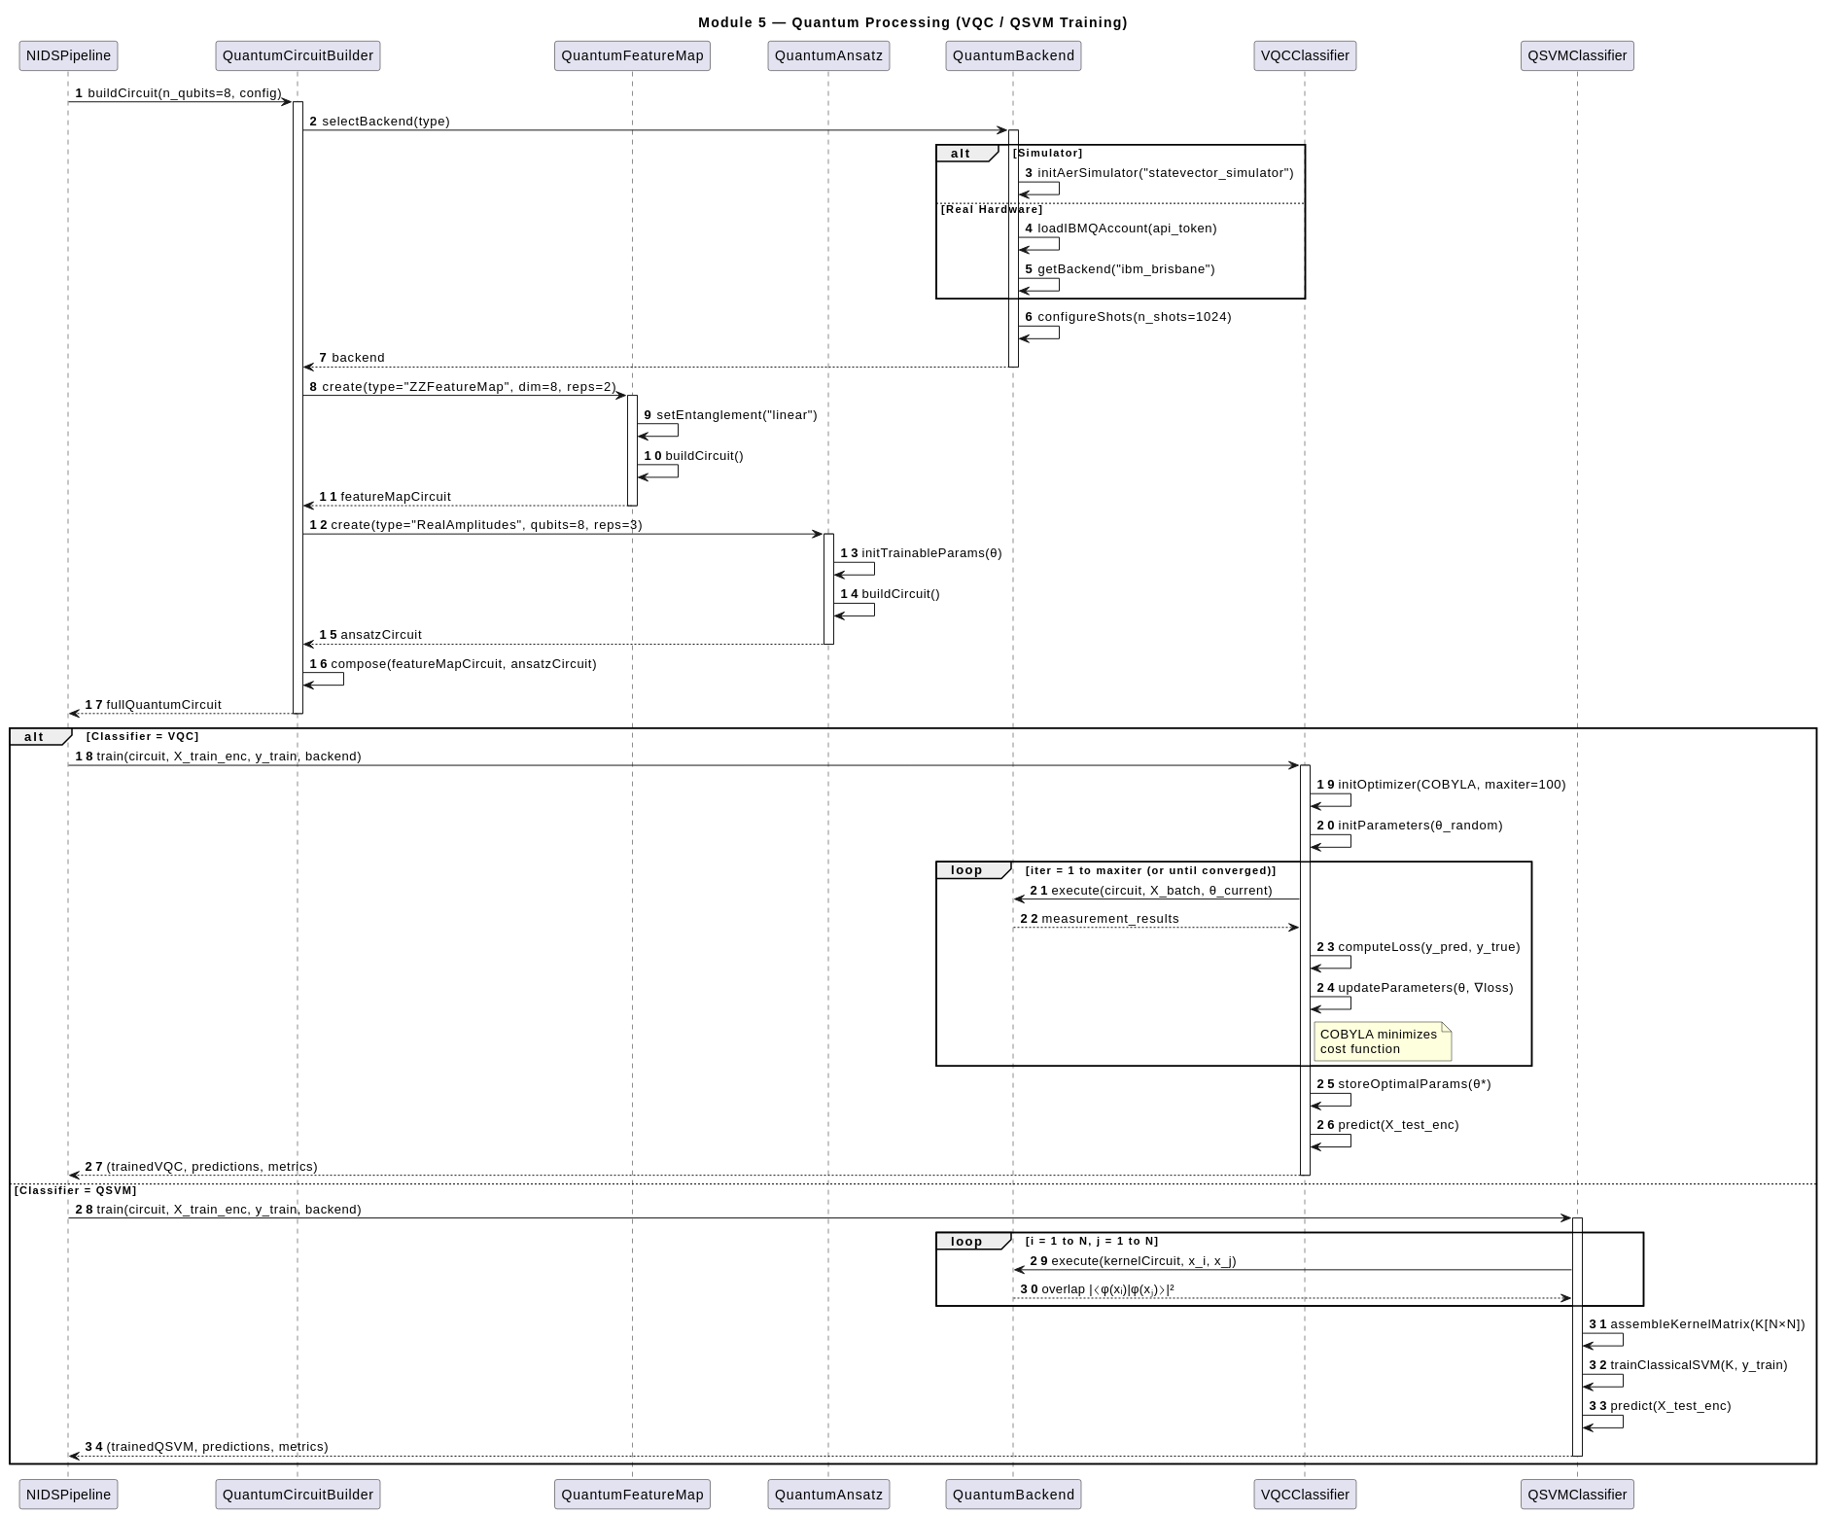
Fig. 14. Sequence – Quantum Model

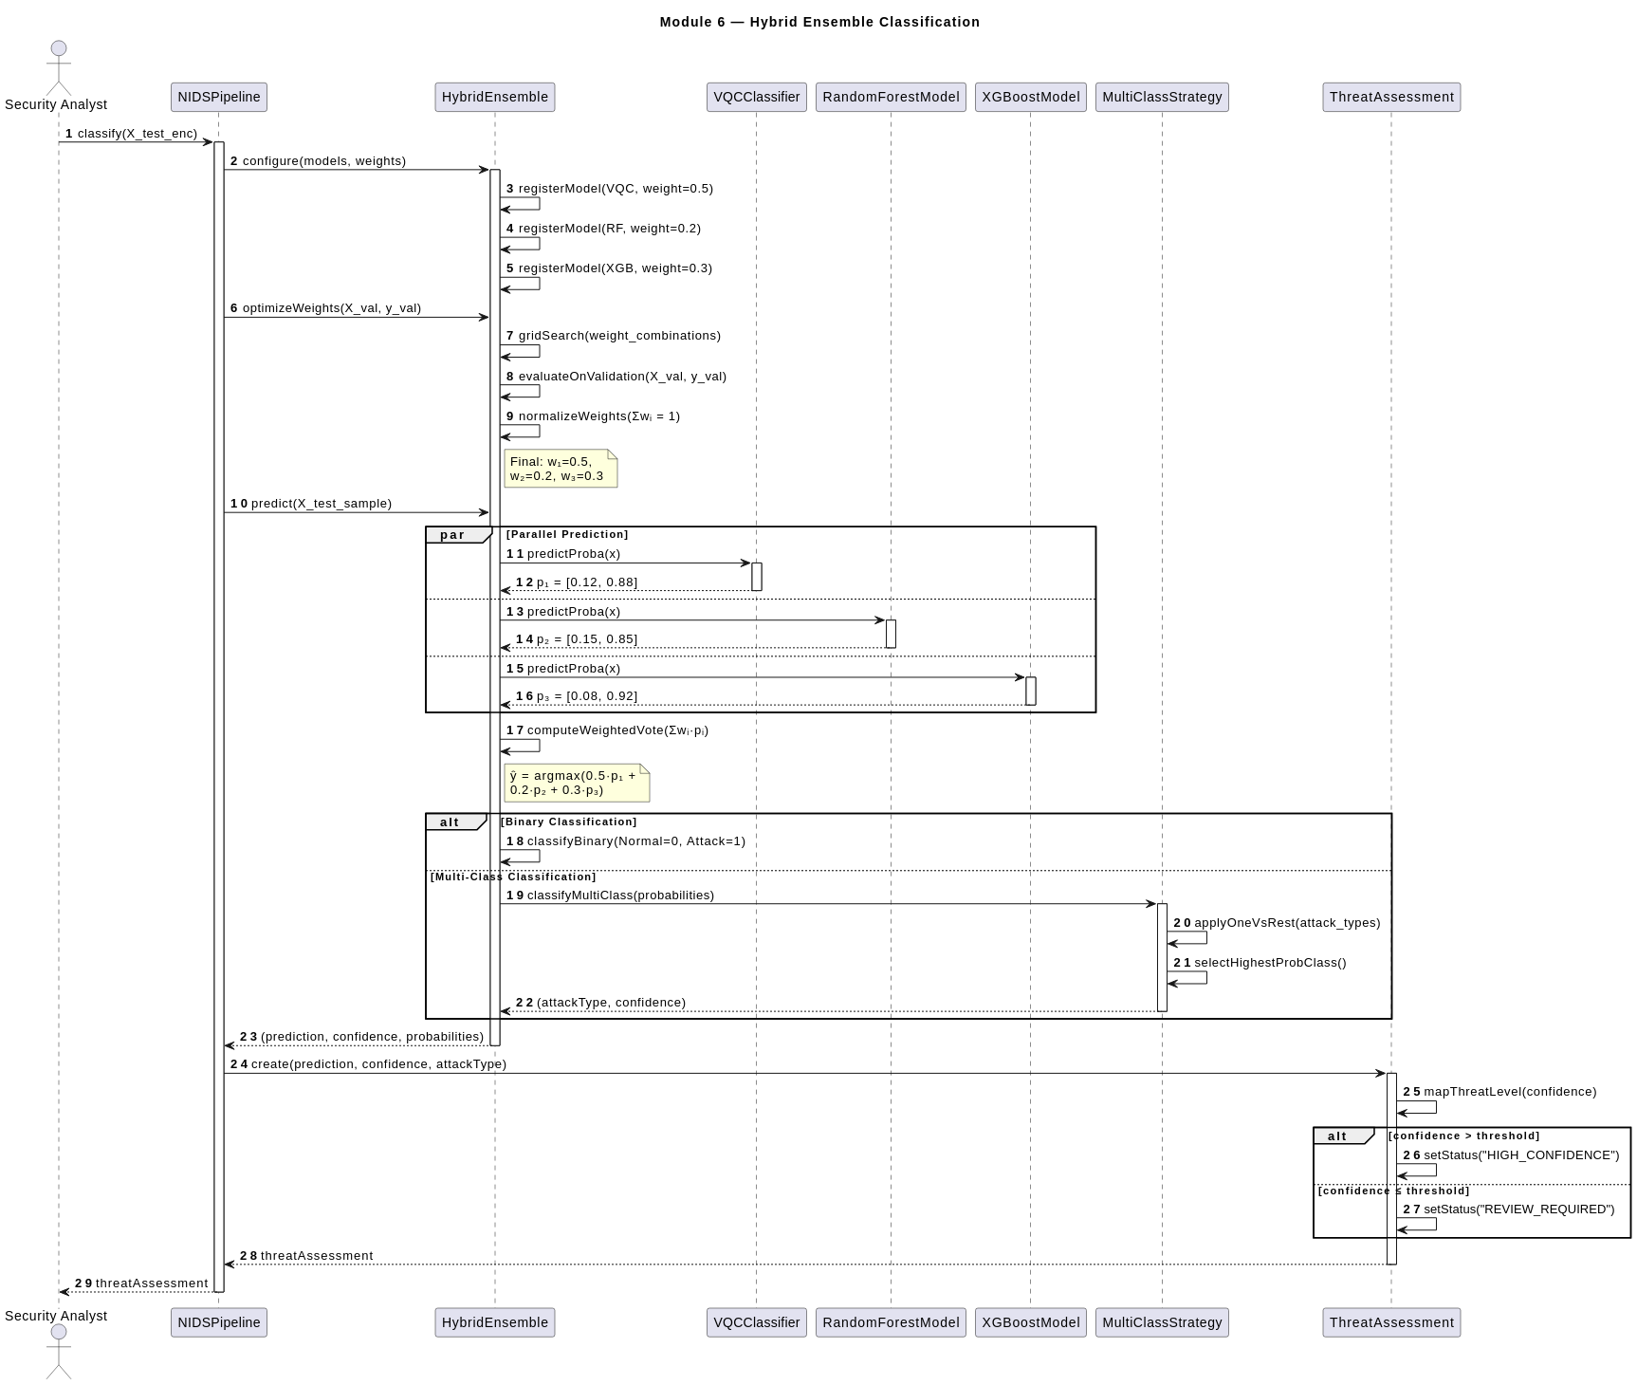
Fig. 15. Sequence – Hybrid Ensemble

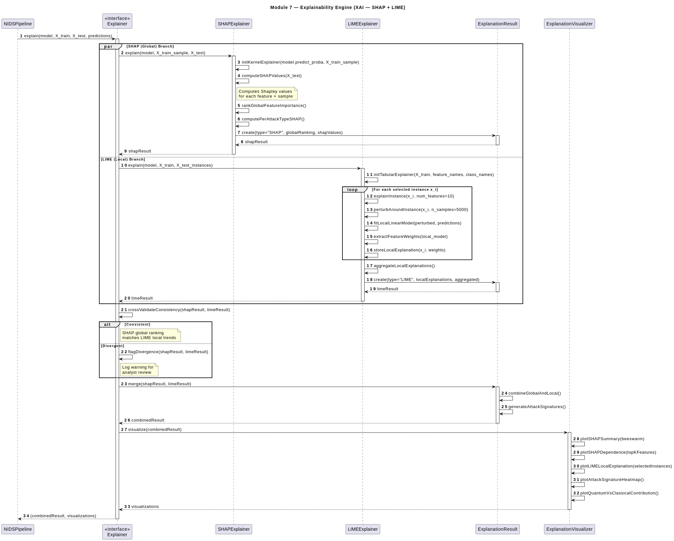
Fig. 16. Sequence – Explanation Model

3.4. TOOLS / TECHNIQUES USED
A. Software Libraries and Frameworks
SentinelQ is written in Python 3.10. Key libraries include: Qiskit 1.x (IBM) for VQC circuit construction and Aer statevector simulation; TensorFlow 2.x / Keras for VAE construction and training; XGBoost with cross-validated grid search hyperparameter tuning; Scikit-learn for Random Forest and preprocessing utilities; Pandas / NumPy / PyArrow for data manipulation and Parquet I/O; and SHAP for TreeExplainerbased exact Shapley values and KernelSHAP for VQC probability vectors.
B. Hardware Environment GPU:
NVIDIA GeForce RTX 4090 (24 GB GDDR6X VRAM) for VAE training (TensorFlow-CUDA backend) and XGBoost GPU tree-method, providing ≈ 82.6 TFLOPs at FP32 precision. VQC computation occurs via Qiskit Aer statevector simulation on CPU, parallelized across all CPU cores using Python’s multiprocessing module. Intermediate results are persisted in Apache Parquet format for efficient columnar access.
3.5. JUSTIFICATION OF SELECTED APPROACH
The proposed SentinelQ model overcomes important weaknesses present in other IDS models such as weak detection of zero-day attacks, class imbalance problem, and lack of transparency in decision making. SentinelQ makes use of Classical Models as well as Quantum Computing in order to increase detection precision and manage complicated patterns. In the dimensionality reduction phase, VAE is utilized, while for classification, Variational Quantum Circuits are utilized. Besides, SHAP and LIME give explainability and multiset training improves generalization.

CHAPTER 4
DEVELOPMENT AND IMPLEMENTATION
4.1. IMPLEMENTATION PLAN
1) Step-by-Step Processing Pipeline
- Data collection and quality gating: Raw network flow records pass through Quality Gates QG-01 to QG-06. Non-compliant records are quarantined for analyst inspection rather than discarded.
- Feature union and sentinel imputation: All available source features are joined into the 154-column union schema; empty columns receive the −1.0 sentinel value.
- Feature encoding: Frequency encoding for service, proto, and flag; one-hot encoding for state; expanding 154 to 167 dimensions. VAE-B additionally applies near-zero variance filtering to produce the 140-dimensional track.
- Sentinel-aware MinMax normalisation: Per-feature statistics computed excluding sentinel rows; valid values scaled to [0,1]; sentinel values preserved at −1.0.
- Stratified train-test split: Stratified 80/20 split by label×source; SMOTE applied only to the training partition.
- VAE training (Stage 3): VAE-A and VAE-B trained using sentinel-masked ELBO, β-KL annealing (0 to 2.0 over 40 epochs), free bits (2.0/dim), and auxiliary classifier head (weight = 0.7). Bottleneck angle transform converts μ to z_angle ∈ (0,π).
- Phase 1 VQC training — Quantum Frozen (150 epochs): VAE encoder frozen; 24 quantum parameters held at initialization; only MLP head trained with AdamW + cosine LR (peak 0.008, warmup 10 epochs).
- Phase 2 VQC training — Joint Fine-Tuning (100 epochs): All parameters optimized simultaneously; quantum gradients via parameter shift rule with PennyLane-JAX; gradient norms clipped to [0.03, 0.10].
- VQC Ensemble: P_ens = (P_A + P_B) / 2.
- Classical model training: XGBoost and Random Forest trained on 8D latent vectors z_angle from Stage 3 using 5-fold stratified CV grid search.
- Hybrid ensemble inference: (a) compute z_angle via VAE encoder; (b) compute P_A, P_B, and P_ens; (c) compute P_XGB, P_RF; (d) output ŷ = argmax_c (0.1·P_ens + 0.55·P_XGB + 0.35·P_RF).
- Explainability audit: SHAP TreeExplainer provides global attributions within 100 ms; LIME provides local per-prediction explanations; attributions mapped to Stage 2 feature names.
2) Computational Complexity Analysis
The complexity of VAE training is O(M · d · H · E_vae), where M is training examples, d is input dimension (167 or 140), H is hidden layer width, and E_vae is the number of VAE training epochs. VQC training complexity is O(M · E_vqc · L), where L is circuit depth. This represents an improvement of four orders of magnitude compared to the O(M²) complexity of the baseline static QSVM. At inference, all operations complete within the 100 ms edge inference latency requirement.
4.2. DEVELOPMENT / EXECUTION OF MAJOR COMPONENTS
Data Selection and Fusion: SentinelQ is trained on three publicly available benchmark datasets that cover the landscape of classical, contemporary, and IoT attacks. The fusion of these datasets solves the first research gap by avoiding dependence on any one dataset and preventing performance collapse. NSL-KDD [8]: An updated and refined version of KDD’99 created at the University of New Brunswick. It comprises four sub-datasets: KDDTest+, KDDTest-21, KDDTrain+, and KDDTrain+_20Percent. SentinelQ uses the full KDDTrain+ and KDDTest+ splits. UNSW-NB15 : Created by Nour Moustafa and Jill Slay using the IXIA PerfectStorm tool in the ACCS Cyber Range Lab to generate a combination of contemporary normal and abnormal network traffic, with abnormal traffic simulated through nine different families of attack. Prior datasets such as KDD98 and KDDCUP99 could not present realistic performance output due to redundant and missing records. CICIDS-2017 [9]: From the Canadian Institute for Cybersecurity, consists of eight CSV files covering five days of traffic (Monday–Friday) with Brute Force, DoS, DDoS, Heartbleed, Web Attack, Infiltration, Botnet, and PortScan alongside benign traffic. After Quality Gate QG-02 deduplication, 308,417 CIC records are retained. Before the fusion, all data points pass through six quality gates:
• QG-01: Schema validation, ensuring the completeness of features.
• QG-02: Remove redundant entries across the merged NSL-KDD and CICIDS datasets to prevent model bias.
• QG-03: Clip outliers to the 99th percentile value for statistical stability.
• QG-04: Detect missing values (NaN or Null) and assign a specific value based on the feature.
• QG-05: Variance analysis to identify and flag columns that provide no predictive value.
• QG-06: Convert raw and inconsistent data points into an industry-standard five-class taxonomy for consistent model evaluation. The fused corpus after gating comprises 2,869,035 records.
Five-Class Taxonomy Unification: Instead of binary classification, SentinelQ classifies network activity into five distinct classes that give a security analyst actionable information about how to respond:
• NORMAL: Network activities that are not classified as threats (e.g., “BENIGN”).
• DoS: Denial of Service patterns (e.g., Hulk, Slowloris).
• Recon: Scanning and exploration activity (e.g., PortScan).
• Exploit: Direct system attacks and web-based exploitation (e.g., Shellcode, Backdoor).
• Malware: Malicious agents (e.g., Botnets, Worms).
The fusion of these datasets produces 154 features, but not every source contains every feature. The system accounts for “missing” information by using −1.0 as a sentinel value, allowing the model to differentiate between a missing value and a feature measured as zero.
Normalization and Class Balancing: A sentinel-aware MinMax normalization technique is applied to numerical features, computing statistics only on non-sentinel rows and preserving the −1.0 sentinel values. After normalization, the dataset is divided 80:20, with the training partition containing 2,295,228 samples and the test partition containing 573,807 samples. To handle extreme imbalances, SMOTE is applied only to the training set: 33,454 synthetic samples for Reconnaissance, 47,134 for Exploit, and 5,226 for Malware (artificially limited to avoid geometric distortion of latent clusters), resulting in a training total of 2,381,042 samples.
Feature Engineering: Initial Feature Encoding: The 154 features are converted to 167 features using one-hot encoding applied to features with many unique values, such as service, proto, and flag. The onehot encoding transforms state fields into binary indicator fields. At the end of this step, 27 of the 167 values are near-zero values. Parallel Feature Tracks: VAE-A and VAE-B: Two Variational Autoencoders are trained: VAE-A uses all 167 features, and VAE-B uses 140 features (after removing the 27 near-zero values). This dual-track strategy preserves attackdiscriminative signal present in near-zero features while simultaneously training a cleaner model that avoids their potential noise. Table II summarises the comparison between the two VAEs.
Metric | VAE-A (167) | VAE-B (140) | Target
val_recon (best) | 0.000333 | 0.000350 | 0.0005–0.0007
val_kl | 16.000 | 16.000 | 8.0–14.0
Min class distance | 2.4497 | 2.1685 | 1.5–2.2
Per-dim std (min) | 0.6584 | 0.6117 | 0.60–0.95
Collapsed dims | 0 | 0 | 0
Best epoch | 82 | 111 | —
Parameters | 507,319 | 479,644 | —
MALWARE recon loss | 0.001767 | 0.001897 | low
EXPLOIT recon loss | 0.002208 | 0.002351 | low
Table. 3. VAE-A v/s VAE-B
Dimensionality Reduction via Variational Autoencoder: The dimensionality difference between the 167-dimensional input features and the 8-qubit quantum circuit is closed using a VAE. Unlike PCA-based dimensionality reduction, a VAE encodes inputs to a probabilistic latent representation naturally expressed as quantum rotation angles. The encoder network structure is:
167 → 512 → 256 → 128 → (μ:8, logσ²:8)
GELU activation is chosen over ReLU due to its ability to provide non-zero gradients near zero values, which is crucial when sentinel masking results in input values of −1.0. Log variance is clamped to [−4, 4] to prevent posterior collapse. BatchNorm layers are never applied to projection heads.
The training dynamics for both VAE models are shown in Fig. 2.
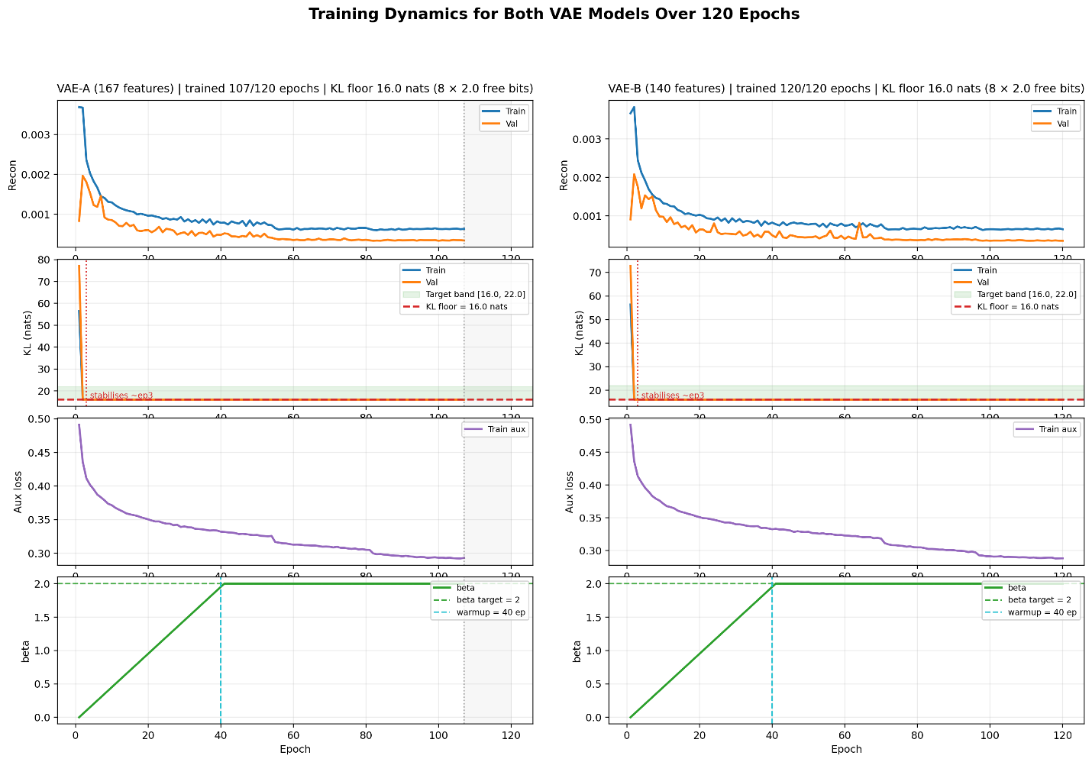
Fig. 17. Training dynamics for VAE-A (left) and VAE-B (right) over 120 epochs. Rows show reconstruction loss, KL divergence, auxiliary loss, and the β annealing schedule
Sentinel-Masked ELBO Loss: The standard ELBO loss is modified to prevent missing feature positions from contributing to the reconstruction term:
ℒ = (1/cₛ) Σ(x − x̂)² + β · Dₖₗ [masked at −1.0]
where cₛ is the non-sentinel count per sample. The KL divergence coefficient β increases linearly from 0 to 2.0 in the first 40 epochs to avoid posterior collapse. The free bits criterion (2.0 nats per dimension, 16.0 nats total) guarantees that none of the 8 latent dimensions collapses into the prior.
Bottleneck Angle Transform: The reparameterised latent sample is mapped to a valid rotation angle range by:
z_angle = σ(μ) × π ⟹ z_angle ∈ (0, π)
where σ is the sigmoid activation function. Sigmoid scaling instead of clipping ensures there are no zero gradients at the boundary values. The output is an 8-dimensional angle vector fully compatible with Rʸ rotation gate angle encoding on the 8-qubit VQC.
Quantum Circuit Design: SentinelQ employs Variational Quantum Circuits (VQC) formulated as:
|ψ(x,θ)⟩ = U_ansatz(θ) · U_encode(x)|0⟩⊗⁸
The circuit comprises three layers:
- Layer 1 — Angle Encoding: Rʸ(z_k) gates act on all 8 qubits, mapping each encoded angle to one qubit rotation. Angle encoding was proven superior to amplitude encoding for conveying gradient information in circuits with more than 50 gates.
- Layer 2 — ZZFeatureMap (REPS=2): Pairwise entangled qubits produce C(8,2)=28 interactions in cross-product form using phase encoding, extending the implicit feature space from 8 to 36 dimensions. Repeating the entanglement structure twice allows the circuit to detect second-order correlations between qubits necessary to distinguish overlapping attack class distributions.
- Layer 3 — RealAmplitudes Ansatz (REPS=2): Variational circuit using Rʸ rotation gates combined with CNOT gates on a linear connectivity graph, resulting in 24 trainable parameters θ. Chosen for its low number of two-qubit gates (suitable for NISQ devices), real parameter space (eliminates barren plateaus), and proven utility in 5–10 qubit classification problems.
The VQC training dynamics across all seeds are shown in Fig. 3.
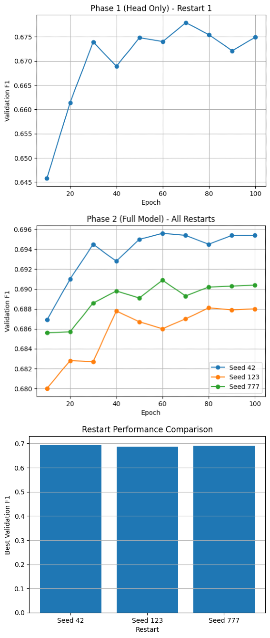
Fig. 18. VQC training dynamics. Top: Phase 1 (head-only, Restart 1). Middle: Phase 2 (joint fine-tuning) validation F1 for Seeds 42, 123, and 777. Bottom: Restart performance comparison.
Measurement and Classical Head: After the variational circuit, 16 feature values are collected using simultaneous Pauli-Z and Pauli-X measurements on all 8 qubits, providing a richer feature space than Pauli-Z alone. This feature vector of size 16 is fed into a 16→28→64→5 classical MLP with LayerNorm at each hidden layer. LayerNorm is preferred over BatchNorm because it normalizes each example independently during training and inference. The total parameter count is 24 (quantum) + 10,749 (MLP) = 10,773 parameters.
VQC Ensemble and Dual-Track Integration: The VQC ensemble consists of two parallel VQC pipelines—VQC-A (167 features, Macro F1 = 0.7158) and VQC-B (140 features, Macro F1 = 0.7219)—combined with equal-weight soft voting:
P_ens = (P_A + P_B) / 2
The VQC ensemble obtains Macro F1 = 0.7298, a 0.8% gain compared to the best single VQC pipeline. Different feature maps create partially uncorrelated errors, and averaging them reduces ensemble output variance. The t-SNE visualization of the 8D latent space is shown in Fig. 4.
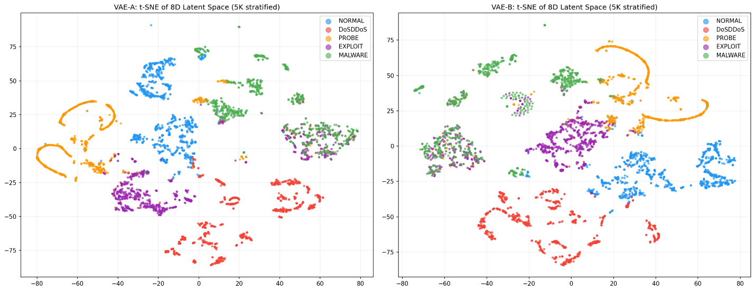
Fig. 19. t-SNE of the 8D VAE latent space (5K stratified sample). Left: VAE-A (167 features); Right: VAE-B (140 features).
Hybrid Ensemble: The VQC ensemble is incorporated into a broader ensemble with XGBoost and Random Forest, both trained on the 8D latent vectors from Stage 3. The final prediction is made via weighted soft voting:
ŷ = argmax_c (0.1·P_VQC + 0.55·P_XGB + 0.35·P_RF)
The weight distribution reflects XGBoost’s superiority (0.55) as the best calibrated model for class-conditional probabilities, Random Forest (0.35) as the most diversified model through its bagging approach, and VQC Ensemble (0.10) to retain quantum contribution in identifying rare-class samples without letting its higher error rate dominate. Table III summarises per-class F1 scores across all pipeline stages.
Class | VQC-A F1 | VQC-B F1 | VQC Ens. | Hybrid F1
Normal | 0.967 | 0.967 | 0.9941 | 0.9941
DoS/DDoS | 0.934 | 0.934 | 0.9760 | 0.9760
Recon | 0.774 | 0.774 | 0.8973 | 0.8973
Exploit | 0.621 | 0.621 | 0.7858 | 0.7858
Malware | 0.193 | 0.193 | 0.4634 | 0.4634
Macro F1 | 0.7158 | 0.7219 | 0.7298 | 0.8233
TABLE 4. Per-Class F1 Score Progression Across Pipeline Stages
Explainability Module: Quantum computations are naturally difficult to understand because they operate in large mathematical spaces that cannot be visualised using traditional methods. According to GDPR Article 22, any system that makes automated decisions must clearly explain those decisions to the affected individuals [3]. SentinelQ introduces an explainability module in its sixth stage using two complementary approaches.
SHAP Global Explanation: XGBoost and Random Forest models are used with SHAP (Shapley Additive Explanations) via TreeExplainer to provide exact Shapley values within the real-time 100 ms budget. TreeExplainer is preferred to KernelSHAP for classical models because KernelSHAP may differ based on intercorrelation between features. Feature attributions are mapped back to original Stage 2 features using encoder network gradients, giving security analysts interpretable results using common network features such as duration, source bytes, destination bytes, and protocol type. The SHAP summary plot is shown in Fig. 5.
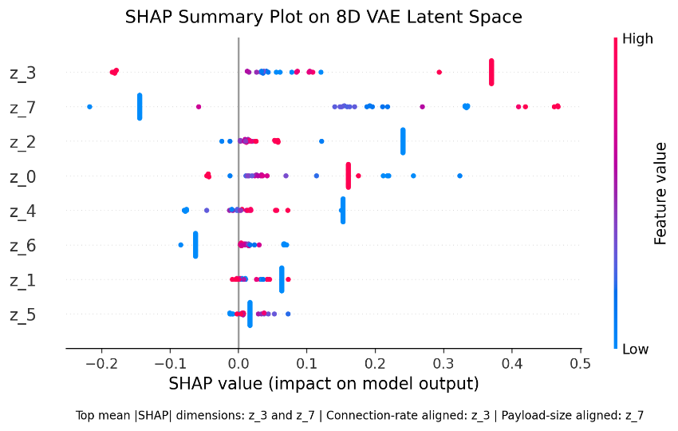
Fig. 20. SHAP summary beeswarm plot on the 8D VAE latent space. Top dimensions: z_3 (connection-rate aligned) and z_7 (payload-size aligned).
LIME Local Explanations: Local Interpretable Model-agnostic Explanations (LIME) is used to explain individual predictions via locally faithful linear models constructed for each instance. LIME treats the entire hybrid framework as a black box and constructs the explanation for the complete output, enabling per-prediction explanations that can be verified against domain knowledge.
Regulatory Compliance: Every SentinelQ classification creates a structured audit trail containing: the predicted class and confidence level; top five SHAP-selected features by importance; LIME explanation values; VAE reconstruction loss (to assess input strangeness); and original feature values prior to normalisation. This ensures conformity with GDPR Article 22 and enables post-event intrusion incident analysis at a Security Operations Centre without requiring quantum computing expertise.
4.3. INTEGRATION AND OVERALL FUNCTIONING
All this stages are assembled one after the other, as these are developed independently and changes in the future can be done easily. When the data point is ingested then it pass through all the stages in the pipeline giving the result as intended.
4.4. CHALLENGES ENCOUNTERED AND SOLUTIONS
Joint optimization of quantum and classical parameters starting from random initialization is prone to being unstable due to the barren plateau effect in deep quantum circuits. SentinelQ uses a two-phase training scheme where classical head warming up is decoupled from the quantum parameters' optimization process:
Phase 1: Quantum Frozen (150 epochs): The 24 quantum parameters remain at initialization throughout the process, whereas only the classical MLP head is trained. AdamW optimizer is used with a cosine learning rate schedule, where the peak learning rate is equal to 0.008, followed by 10 epochs of a linear warmup phase. Learning rate is decreased to 0 with cosine decay. At this stage, the quantum circuit remains static, thus becoming a fixed random feature map, while the classical head learns how to construct a maximally discriminative linear combination of the 16 quantum expectation values. COBYLA gradient-free optimization algorithm was tried for this stage, yet failed to obtain an F1 score better than 0.49 in 12 minutes of optimization time, leading to choosing a gradient-based optimization algorithm. Phase 1 ends with classical head warm-starting, with Intra-VQC Macro F1 = 0.7298 achieved.
Phase 2: Joint Optimization (100 epochs): Joint training of quantum and classical parameters is performed. Quantum gradients can be calculated using the parameter shift rule implemented by JAX value_and_grad with PennyLane. Automatic differentiation of both classical and quantum parts allows for end-to-end training. Peak learning rate for quantum parameters is set to 0.0008 in order to avoid huge gradient steps destabilizing the structure of the latent space formed at the previous phase. Clipping of gradient norms (||∇θ|| ∈ [0.03, 0.10]) leads to adaptive learning rate modification, i.e., automatic decrease when gradients are informative, increase otherwise.
The conventional cross-entropy loss function is not a good fit for the extreme skewness of the five-class taxonomic scheme. The SentinelQ solution uses Focal Loss with a focusing factor γ=2.5, reducing the influence of accurately classified samples while directing the gradient descent towards the challenging misclassified cases. We also use class balancing as an additional weighting factor, with Malware having a weight fifteen times greater than that of Normal data traffic, considering the immense discrepancy between undetected malware threats and false alarms.
4.5. OBSERVATIONS:
The VAE-A is performing better than VAE-B in class splitting and the quantum circuit output is more for the ensembled model than the individual one.

CHAPTER 5
RESULTS, ANALYSIS AND VALIDATION
5.1. TESTING / EVALUATION METHODOLOGY
The experiments rely on the preprocessed test set of 573,807 labeled network traffic instances split into five classes: NORMAL—453,290 instances (~79.0%); DoSD— 78,221 instances (~13.6%); PROBE—29,137 instances (~5.1%); EXPLOIT—11,966 instances (~2.1%); MALWARE—1,193 instances (~0.2%). This dataset suffers from severe class imbalance, especially in the last class, making training ML classifiers very challenging.
Evaluation Metrics:
- Accuracy: Accuracy = (TP+TN)/(TP+TN+FP+FN). Useful for balanced data; must be considered alongside class imbalances.
- Precision: Prec_c = TP_c/(TP_c+FP_c). High precision implies low false alert rates, crucial to avoid alert fatigue among security analysts.
- Recall: Recall_c = TP_c/(TP_c+FN_c). Missing an intrusion event is far more harmful than a false alert; SentinelQ gives more weight to recall, especially for EXPLOIT.
- F1-Score (Macro, Micro, Weighted): Macro-F1 calculates F1 per class equally without weighting, favouring minority classes. Weighted-F1 accounts for class support, providing robustness to imbalanced datasets.
- Confusion Matrix: A 5×5 matrix showing inter-class misclassification patterns.
5.2. RESULTS OBTAINED
Table 5 shows the classification performance per class of the SentinelQ ensemble classifier on the test set of 573,807 samples. The system yields 98.01% accuracy with strong discrimination power across all five traffic classes.

Class | Precision | Recall | F1 | Support | Note
NORMAL | 0.9980 | 0.9902 | 0.9941 | 453,290 | ✓
DoSD | 0.9947 | 0.9580 | 0.9760 | 78,221 | ✓
PROBE | 0.8806 | 0.9146 | 0.8973 | 29,137 | ✓
EXPLOIT | 0.6724 | 0.9452 | 0.7858 | 11,966 | ↑ Recall
MALWARE | 0.4018 | 0.5474 | 0.4634 | 1,193 | Rare
Accuracy | — | — | 0.9801 | 573,807
Macro Avg | 0.7895 | 0.8711 | 0.8233 | 573,807
Weighted Avg | 0.9835 | 0.9801 | 0.9813 | 573,807
TABLE 5. Classification Performance per Class — SentinelQ

The NORMAL class demonstrates near-optimal classification performance (F1 = 0.9941). The high confidence score for DoSD (F1 = 0.9760) reflects easier-to-discriminate traffic patterns. PROBE achieves F1 = 0.8973 with minor ambiguity with EXPLOIT due to similarity in scanning behaviours.
The EXPLOIT class is operationally significant: despite low precision (0.6724), recall reaches 0.9452. This operating point is optimal from a security perspective since detecting exploitation attempts is far more important than minimizing false positives. The MALWARE class achieves F1 = 0.4634 due to strong class imbalance (1,193 samples, 0.2% of total traffic), yet achieves recall of 0.5474.
The per-class F1 comparison between VQC-A and VQC-B is shown in Fig. 6. The confusion matrix for the SentinelQ ensemble classifier is shown in Fig. 7, with raw values presented in Table V.
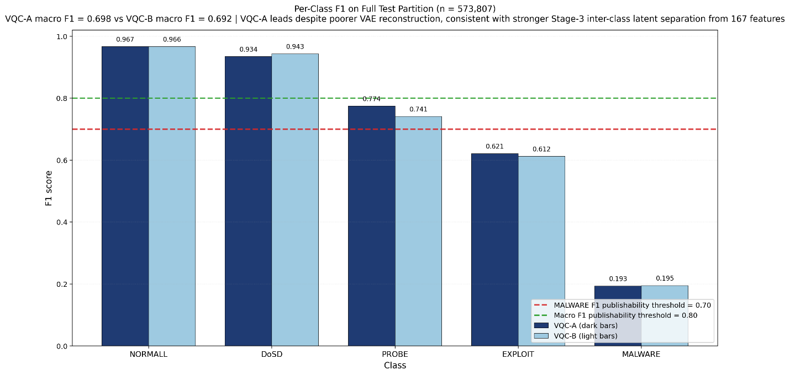Fig. 21. Per-class F1 scores for VQC-A (dark bars) and VQC-B (light bars) on the full test partition (n=573,807). VQC-A macro F1=0.698 vs VQC-B macro F1=0.692.
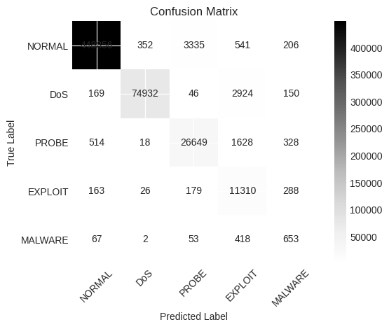]
Fig.22. Confusion matrix for the SentinelQ ensemble classifier on the test set (n=573,807).

5.3. ANALYSIS AND INTERPRETATION OF RESULTS
SentinelQ: Hybrid Quantum-Classical Results Interpretation As can be seen from the results of the model training and testing, the hybrid quantum-classical architecture demonstrates high quality in terms of both efficiency and practical applicability of the results for cybersecurity use cases. Specifically, the achieved accuracy equals 98.01%, and macro-F1 equals 0.8233. The majority of the classes demonstrate excellent results, with perfect (for the purposes of this work) results for NORMAL (F1 = 0.9941) and DoS (F1 = 0.9760), as these traffic types are easy to separate by their patterns; PROBE (F1 = 0.8973), though, experiences difficulties distinguishing between itself and exploits due to similar scanning processes; at the same time, it is essential to highlight the fact that EXPLOIT class demonstrates good recall (0.9452) but low precision, which is more desired in such scenarios. This result was reached mostly due to the ability of the proposed VQC to generate new, non-classical interactions of features. In addition, although the performance is quite low for the MALWARE class (F1 = 0.4634), the achieved result demonstrates good performance for class separation without applying oversampling techniques. Comparing the obtained results with the baseline and performing ablation studies, one could notice that the proposed quantum component improves the ability to classify the EXPLOIT class in terms of recall by 6.5% even though macro-F1 dropped. The explainability study shows that the decision-making process in SentinelQ relies on important features, while quantum-inspired interactions improve the ability of the model to detect attacks within complicated areas of the features space.
5.4. VALIDATION OF OBJECTIVES
Thus, the validation of the objectives for SentinelQ shows that it efficiently accomplishes all major objectives set during the project conception and realization. To begin with, the first objective of handling high-dimensional data can be seen in the way the VAE is used in order to compress the initial dataset from 167 features to 8 features in the latent space, while also maintaining its discriminative power. In turn, it becomes possible to use the compressed dataset for further quantum computing operations without any loss in accuracy or efficiency. Secondly, the objective of improving detection performance over diverse datasets is accomplished by the means of testing the model over NSL-KDD, UNSW-NB15, and CICIDS-2017. This approach helps to avoid generalization problems and thus ensures higher accuracy compared to previous attempts at building purely quantum intrusion detection systems. Thirdly, the third objective related to improvement in the detection capability through quantum learning is partly realized: although the VQC does not show significant changes in macro-F1, it increases EXPLOIT recall, which proves its contribution within highly complex feature space. At the same time, the fourth objective of having the superior hybrid system is also accomplished through successful usage of both VQC, XGBoost, and Random Forest. The last objective related to explainability is accomplished through both SHAP and LIME approaches.
5.5. COMPARISON WITH EXPECTED / EXISTING OUTCOMES
Aspect | Expected Outcome (Research Goal) | Existing Systems (Literature / Baselines) | SentinelQ (Proposed System)
Accuracy | ≥ 97% for reliable IDS | 95–97.8% (XGB, RF, Deep Learning) | 98.01% (Highest overall)
Macro F1 Score | Balanced performance across classes | ~0.72 – 0.83 | 0.8233 (competitive, balanced)
Exploit Detection (Recall) | High recall (>0.90) critical for security | ~0.74 – 0.88 | 0.9452 (Best) ✔
Handling High Dimensional Data | Efficient reduction without loss | PCA / manual selection (limited) | VAE (167 → 8D) with minimal loss ✔
Generalization Across Datasets | Strong cross-dataset performance | Poor (e.g., QSVM drops from 92% → 64%) | Trained on 3 datasets → robust ✔
Quantum Advantage | Improve complex pattern detection | Limited / inconsistent | Improves exploit recall (+6.5%) ✔
Class Imbalance Handling | Detect rare attacks effectively | Weak malware detection | SMOTE + focal loss → improved recall ✔
Explainability (XAI) | Mandatory (GDPR compliance) | Mostly absent in quantum IDS | SHAP + LIME integrated ✔
Hybrid Learning | Combine strengths of models | Mostly single-model systems | Quantum + XGB + RF ensemble ✔
Real-world Applicability | Interpretable + deployable | Black-box, hard to trust | Explainable + audit-ready outputs ✔
TABLE 6. Objective Comparison

CHAPTER 6
CONCLUSIONS AND FUTURE SCOPE

This chapter should summarize the overall outcomes of the project and present the scope for further improvement.

Include:
- Key conclusions derived from the work carried out
- Extent to which the project objectives have been achieved
- Limitations of the work
- Possible improvements and future scope

Keep the content concise and focused.
Do not introduce new concepts in this chapter.

REFERENCES

[1] SentinelOne, “Cybersecurity statistics,” 2026. [Online]. Available: https://www.sentinelone.com/cybersecurity-101/cybersecurity/cybersecurity-statistics/ [2] IoT Analytics, “Number of connected IoT devices,” 2025. [Online]. Available: https://iot-analytics.com/number-connected-iot-devices/
[3] M. W. Khawar et al., “Shaping the future of cybersecurity,” Computer Science Review, 2025.
[4] V. Havl´ıcek ˇ et al., “Supervised learning with quantum-enhanced feature spaces,” Nature, vol. 567, pp. 209–212, 2019.
[5] L. Gyongyosi and S. Imre, “A survey on quantum computing technology,” Computer Science Review, vol. 31, pp. 51–71, 2019.
[6] A. Gouveia and M. Correia, “Towards quantum-enhanced machine learning for network intrusion detection,” in Proc. IEEE 19th Int. Symp. Network Computing and Applications (NCA), 2020, pp. 1–8. DOI: 10.1109/NCA51143.2020.9306691.
[7] N. Moustafa and J. Slay, “UNSW-NB15: A comprehensive data set for network intrusion detection systems,” in Proc. Military Communications and Information Systems Conf. (MilCIS), 2015. [Online]. Available: https://www.unb.ca/cic/datasets/cic-unsw-nb15.html
[8] M. Tavallaee, E. Bagheri, W. Lu, and A. Ghorbani, “A detailed analysis of the KDD CUP 99 data set,” in Proc. IEEE Symp. Computational Intelligence for Security and Defense Applications, 2009. [Online]. Available: https://www.unb.ca/cic/datasets/nsl.html.
[9] I. Sharafaldin, A. H. Lashkari, and A. A. Ghorbani, “Toward generating a new intrusion detection dataset and intrusion traffic characterization,” in Proc. 4th Int. Conf. Information Systems Security and Privacy (ICISSP), 2018. [Online]. Available: https://www.unb.ca/cic/datasets/ids-2017.html.
[10] A. Khraisat, I. Gondal, P. Vamplew, and J. Kamruzzaman, “Survey of intrusion detection systems: Techniques, datasets and challenges,” Cybersecurity, vol. 2, no. 1, p. 20, 2019. DOI: 10.1186/s42400-019- 0038-7.
[11] K. Shaukat et al., “A survey on machine learning techniques for cyber security in the last decade,” IEEE Access, vol. 8, pp. 222 310–222 354, 2020. DOI: 10.1109/ACCESS.2020.3037220.
[12] P. Mishra, V. Varadharajan, U. Tupakula, and E. S. Pilli, “A detailed investigation and analysis of using machine learning techniques for intrusion detection,” IEEE Communications Surveys & Tutorials, vol. 21, no. 1, pp. 686–728, 2019. DOI: 10.1109/COMST.2018.2876263.
[13] S. Zeadally, E. Adi, Z. Baig, and I. A. Khan, “Harnessing artificial intelligence capabilities to improve cybersecurity,” IEEE Access, vol. 8, pp. 23 817–23 837, 2020. DOI: 10.1109/ACCESS.2020.2968045.
[14] T.-T.-H. Le, H. Kim, H. Kang, and H. Kim, “Classification and explanation for intrusion detection system based on ensemble trees and SHAP method,” Sensors, vol. 22, no. 3, p. 1154, 2022. DOI: 10.3390/s22031154.
[15] R. Vinayakumar, M. Alazab, K. P. Soman, P. Poornachandran, A. AlNemrat, and S. Venkatraman, “Deep learning approach for intelligent intrusion detection system,” IEEE Access, vol. 7, pp. 41 525–41 550, 2019. DOI: 10.1109/ACCESS.2019.2895334. [16] S. Ullah and M. A. Mahmoud, “A two-level hybrid model for anomalous activity detection in IoT networks,” IEEE Transactions on Network and Service Management, vol. 17, no. 3, pp. 1859–1873, 2020. DOI: 10.1109/TNSM.2020.2988549.
[17] O. Faker and E. Dogdu, “Intrusion detection using big data and deep learning techniques,” in Proc. ACM Southeast Regional Conf., 2019. DOI: 10.1145/3299815.3314439.
[18] G. Andresini, A. Appice, N. Di Mauro, C. Lomonaco, and D. Malerba, “INSOMNIA: Towards concept-drift robustness in network intrusion detection,” in Proc. 14th ACM Workshop on Artificial Intelligence and Security, 2021. DOI: 10.1145/3474369.3486864.
[19] S. Neupane et al., “Explainable intrusion detection systems (X-IDS): A survey of current methods, challenges, and opportunities,” IEEE Access, vol. 10, pp. 112 392–112 415, 2022. DOI: 10.1109/ACCESS.2022.3211018.
[20] M. Kalinin and V. Krundyshev, “Security intrusion detection using quantum machine learning techniques,” Journal in Computer Virology and Hacking Techniques, vol. 19, pp. 125–135, 2023. DOI: 10.1007/s11416- 022-00435-0.
[21] C. Abreu, C. E. Rothenberg, and A. Abelem, “QML-IDS: ´ Quantum machine learning for intrusion detection,” in Proc. IEEE/ACM 18th Int. Symp. Networks-on-Chip (NOCS), 2024. DOI: 10.1109/NOCS62545.2024.10733655.
[22] H. Suryotrisongko and Y. Musashi, “Hybrid quantum deep learning for botnet DGA detection,” International Journal of Intelligent Engineering and Systems, vol. 15, no. 4, 2022. [Online]. Available: https://inass.org/wp-content/uploads/2022/06/2022083108.pdf
[23] B. Moussa et al., “Quantum deep learning-based anomaly detection for enhancing network security,” Quantum Machine Intelligence, vol. 6, no. 2, 2024. DOI: 10.1007/s42484-024-00163-2.
[24] A. B. Arrieta et al., “Explainable artificial intelligence (XAI): Concepts, taxonomies, opportunities and challenges toward responsible AI,” Information Fusion, vol. 58, pp. 82–115, 2020. DOI: 10.1016/j.inffus.2019.12.012.
[25] P. Gaspar, J. Silva, and M. Silva, “Explainable artificial intelligence for intrusion detection systems: LIME and SHAP on MLP,” IEEE Access, vol. 12, 2024. DOI: 10.1109/ACCESS.2024.3368377.
[26] “Systematic review on XAI integration in intrusion detection systems,” Frontiers in Artificial Intelligence, vol. 8, 2025. DOI: 10.3389/frai.2025.1526221.
[27] “A versatile XAI-based framework for efficient and explainable network intrusion detection,” Annals of Telecommunications, 2025. DOI: 10.1007/s12243-025-01118-9.

APPENDICES (IF APPLICABLE)

Include additional supporting material that is relevant to the project work but not included in the main chapters. Such material may include:

- Detailed calculations
- Additional diagrams, drawings, or representations
- Data tables or datasets
- Code snippets / algorithms (if applicable)
- Experimental details or supplementary results

Label each appendix clearly (Appendix A, Appendix B, etc.) and refer to them appropriately in the report wherever required.

APPENDIX A: CONTRIBUTION OF TEAM MEMBERS
This appendix should present the contribution of each team member in carrying out the project work.

Include:
- Name and Registration Number of each team member
- Major tasks or components handled by each member
- Nature of contribution in different stages such as planning, development, testing, and documentation

The contribution should be clearly defined and mutually agreed upon by all team members.

