SentinelQ: An Explainable Hybrid Quantum Intrusion Detection System
A.Madhavi †
VNR Vignana Jyothi Institute of Engineering and Technology
Department of Computer Science and Engineering
Hyderabad
Telangana
India.
Gandra. Monish Reddy
VNR Vignana Jyothi Institute of Engineering and Technology
Department of Computer Science and Engineering
Hyderabad
Telnagana
India.

Matri Pranay
VNR Vignana Jyothi Institute of Engineering and Technology
Department of Computer Science and Engineering
Hyderabad
Telangana
India.

Ponnala Abhinava Chaitanya Kumar
VNR Vignana Jyothi Institute of Engineering and Technology
Department of Computer Science and Engineering
Hyderabad
Telangana
India.

Ravuri Jayanth
VNR Vignana Jyothi Institute of Engineering and Technology
Department of Computer Science and Engineering
Hyderabad
Telangana

Rathod Sidhartha
VNR Vignana Jyothi Institute of Engineering and Technology
Department of Computer Science and Engineering
Hyderabad
Telangana

Abstract
The three main problems with intrusion detection systems are the large number of features in the space, the inability to understand the classification process, and the inability to learn an unseen anomaly pattern in the network. In this paper, the authors analyze the feasibility of trainable quantum circuits as a viable approach in the present hardwares that are limited to Noisy Intermediate-Scale Quantum (NISQ) devices. In this research, a six-stage pipeline is implemented based on a hybrid quantum-classical (HQC) architecture and explanations on Explainable Artificial Intelligence (XAI). The pipeline is trained on benchmark datasets UNSW-NB15, NSL-KDD, and CICIDS-2017, with different stages being trained on these datasets. In stage one, data is preprocessed and in the second stage, the data is processed for the pipeline. In the second stage, the normalized data is fed into a masked loss Variational Autoencoder (VAE) model that shrinks the feature space from 167 to 8 dimensions and then into a sentinel-based VAE in the third stage. The compressed features are then fed into an 8-qubit Variational Quantum Circuit (VQC) in stage three, where hybrid training procedures are introduced to tackle the barren plateau challenges in VQC. Latterly, the same VQC outputs are used in conjunction with XGBoost and Random Forest algorithms in the stages 4 and 5 to classify attacks. The proposed approach was able to obtain 98.01% accuracy, and the macro F1-score was 0.8233. Finally, SHAP and LIME values contribute to the interpretability of stage six, which addresses concerns about classification transparency and improves model interpretability.
Subject Classification: Primary 93A30, Secondary 49K15
Keywords: Intrusion Detection, Quantum Machine Learning, Variational Autoencoder, Variational Quantum Circuit, Explainable AI, XGBoost, Random Forest

1. Introduction
Classical Intrusion Detection systems still have three key challenges: high dimensional attributes, black-box models non-compliant with regulatory requirements, and distributing shifts on heterogeneous networks. On the one hand, Quantum Machine Learning (QML) has the promise of achieving an exponential increase in expressive power in the feature space; on the other hand, noisy quantum machines, small circuit depths and, most importantly, bad data generalization, as demonstrated by the accuracy drop from 92% for NSL-KDD to 64% for UNSW-NB15 in past works of quantum SVM, can not realize this promise. To overcome these challenges, this paper proposes a hybrid quantum-classical IDS model which integrates with the variational quantum circuit, variational auto-encoder feature selection, sentinel-aware multi-source feature fusion, and explainability.This paper proposes a hybrid quantum-classical IDS model that addresses four of the most significant challenges identified in the literature by combining variational quantum circuit, variational auto-encoder feature selection, sentinel-aware multi-source feature fusion, and explainability.
2. Literature Review
The state of current research is depicted in Table 1 below within the last five-six years. It highlights the development process from the traditional and deep learning based Intrusion Detection System to the new emerging ones such as quantum and explainable Intrusion Detection Systems. The main research contribution and the limitations behind each research are listed in Table 1.

Research Standard | Representative Studies | Principal Contribution | Critical Limitation / Gap
Classical and Deep-Learning IDS | Khraisat et al. [1]; Shaukat et al. [2]; Mishra et al. [3]; Vinayakumar et al. [4] | Signature, anomaly, and hybrid intrusion detection classifications; decade-long analysis of IDS failure modes; systematic evaluation of multiple algorithms; extensive testing of DNN, CNN, and LSTM models for multiclass NIDS | High class imbalance, model staleness due to evolving network characteristics, deterioration of classification models when trained on multidimensional raw data, and low performance against minority attack categories
Concept Drift and IoT Detection | Ullah & Mahmoud [5]; Andresini et al. [6] | IoT detection framework with two stages that achieve high accuracy on the BoTIoT benchmark; concept drift quantified automatically using an encoder model deployed within the IDS | Entirely dependent on manual feature extraction; performance drops systematically when static models are tested against future traffic data collected from the same network
Explainable AI (XAI) for IDS | Neupane et al. [7]; Arrieta et al. [8]; Gaspar, Silva & Silva [9]; 2025 Systematic Review [10] | Detailed classifications of both ante-hoc and post-hoc techniques (SHAP, LIME, attention, saliency); comparative study confirming that SHAP provides stable global feature attribution while LIME ensures computational feasibility in local cases; review of 80+ research articles (2018-2024) | Almost all the accurate IDS do not have any explanation capabilities; Quantum classifications lacks any explicit explanation capabilities in the reviewed articles; only a few articles explored the IDS explanation capabilities and how they can be integrated with quantum classification
Quantum Machine Learning for Cyber Security Applications | Gouveia & Correia; Abreu, Rothenberg & Abélem [11]; Moussa et al. [12] | First QSVM with ZZ feature map for NIDS (accuracy: 92 % on NSL-KDD); hybrid architecture of VQC and QSQM using real IBM quantum computer with accuracy increase of 5–8 % and resource reduction by 40 %; quantum autoencoder, then quantum random forest/k-NN | Stiff, non-trainable quantum kernel drops from 92 % to 64 % accuracy on different datasets (gap of 28 points); suitable only for binary classification; no method to explain single prediction
Table 1. Literature review comparision

3. PIPE-LINE WORKING
SentinelQ provides a six stage intrusion detection pipeline: (1) Data Ingestion, (2) Pre-processing, (3) VAE Compression, (4) Dual VQC Quantum Feature Extraction, (5) Hybrid Ensemble Classification, and (6) Explainability & Audit. The design preserves the heavy workload (normalisation, compression, final classification) of classical hardware, and leaves the 8-dimensional compressed representation of the data to be processed by the quantum circuit, preventing noise and complexity to the quantum processor from feeding 196 raw features into it.
Data & Pre-processing. Three public data sets, namely, NSL-KDD, UNSW-NB15, and CICIDS-2017 are combined and then train them through 6 quality gates, namely, the schema validation, deduplication, 99th percentile outlier clipping, missing value imputation, variance filtering and taxonomy unification. The end result is 2,869,035 records that have been classified into five categories: Normal, DoS, Recon, Exploit and Malware. The missing features are indicated by a sentinel value of −1.0. Sentinel-aware MinMax normalization calculates statistics for only valid rows and leaves these markers unchanged. To reduce extreme imbalance, SMOTE adds samples to the training set of 2,295,228 samples to create 33,454 Recon samples, 47,134 Exploit samples and 5,226 Malware samples.
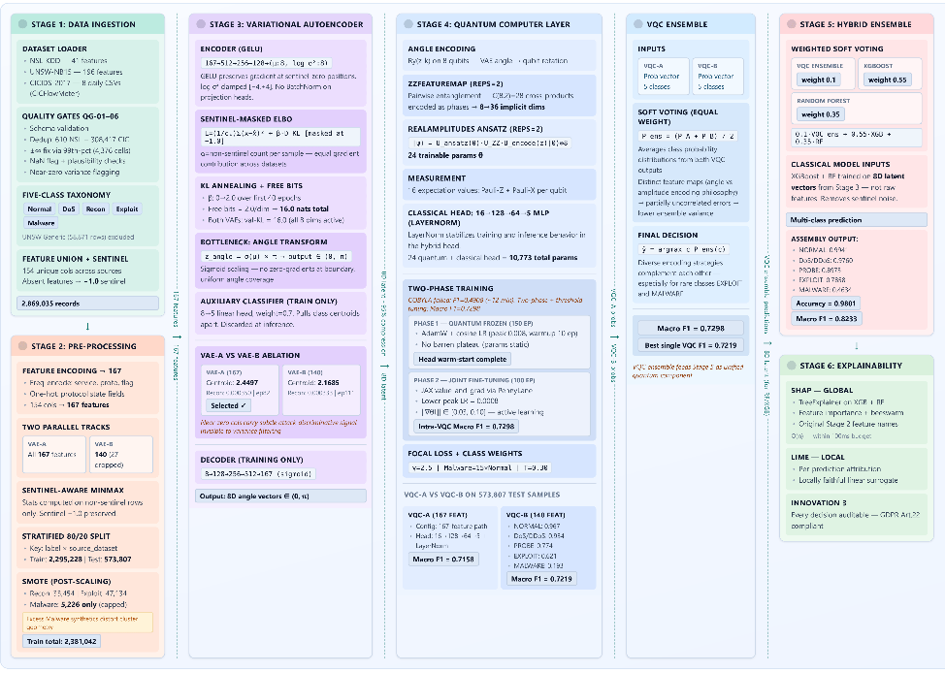

Fig.1. Architecture diagram
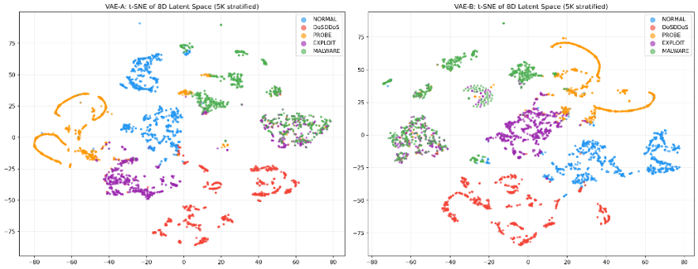
Feature Engineering. The 167 dimensions are 154 raw features expanded using one-hot encoding. Two parallel VAEs are trained, with 140 features (after dropping 27 near zero features) for VAE-B and all 167 features for VAE-A. GELU activation is used for both encoders (167→512→256→128→8), and a sentinel-masked ELBO loss is used that omits the −1.0 positions from the reconstruction. Annealing KL divergence linearly to 2.0 for 40 epochs and set the free-bits criterion to 16 to avoid posterior collapse. The latent mean is scaled between (0, π) to the sigmoid to get the 8D rotation angles for quantum encoding. VAE-A achieves the better validation reconstruction loss (0.000333 vs. 0.000350) and minimum class distance (2.4497 vs. 2.1685), while VAE-B offers fewer parameters (479,644 vs. 507,319); both meet targets.
Fig.2. t-SNE of VAE
Quantum-Classical Model. The 8 angles are encoded by 2 sets of VQC-A (167 features) and VQC-B (140 features) gates, followed by entanglement through a ZZFeatureMap (REPS=2), which extends the feature space to 36 dimensions, and then by a RealAmplitudes ansatz with 24 trainable parameters. All 8 qubits are measured simultaneously using Pauli-Z and Pauli-X, resulting in 16 values which are fed to a 16→128→64→5 MLP with LayerNorm. Training is implemented in two stages: the first phase is to fix all the quantum parameters for 150 epochs, with the MLP being trained only in this stage, achieving Macro F1 = 0.7298; in the second stage, all the parameters are trained together for 100 epochs with parameter-shift gradients, with a low quantum learning rate of 0.0008 and a clipped norm of 0.03–0.10 for the quantum gradient. Focal Loss (γ=2.5) with 15× weighting on Malware: Hard examples are emphasized. The dual-VQC ensemble (equal soft voting) gives Macro F1 = 0.7298, which is 0.8% higher than the winning single circuit. For final Stage-5 hybrid, XGBoost (0.55), Random Forest (0.35), and the VQC ensemble (0.10) vote on the 8D latent vectors, and obtains an accuracy of 0.9801, Macro F1 = 0.8233. Per-class F1 scores are Normal 0.9941, DoS/DDoS 0.9760, Recon 0.8973, Exploit 0.7858, and Malware 0.4634.
Explainability & Compliance. SHAP TreeExplainer gives a global explanation for the tree-based models, and LIME explains locally for a specific instance of the full hybrid pipeline. Encoders transform 8D latent space back to original network features using gradients. For every decision, the audit trail is structured: it includes the predicted class, the level of confidence, the top 5 SHAP features, the LIME explanation, the VAE reconstruction loss and the raw features values, thereby satisfying GDPR article 22 and allowing for post-event analysis without quantum expertise at the SOC level.

4. RESULTS
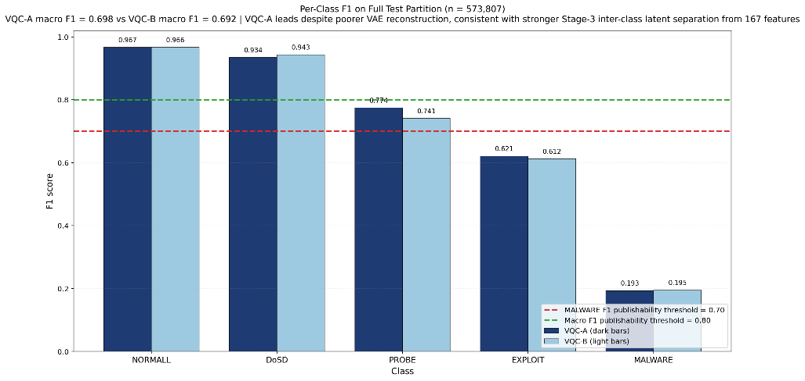
SentinelQ achieves 98.01% accuracy on a highly skewed test set of 573,807 instances with only 0.2% (1,193 samples) of the traffic being malware and 79% of the traffic normal. The model has excellent detection accuracy for majority classes, with an F1 score of 0.9941 for NORMAL and 0.9760 for DoS/DDoS, and good detection accuracy for mid-tier classes: PROBE 0.8973 and EXPLOIT 0.7858. The crucial operating consideration is the EXPLOIT recall of 0.9452, which, although it is not particularly precise (0.6724), has been optimized intentionally because a missed detection of an active exploitation is much more expensive than a false alarm. This is accomplished by the VQC, which provides ensemble diversity and biases threat probability estimates in ambiguous feature areas. The extreme scarcity and high variability of behavior makes MALWARE the most difficult class to score (F1 = 0.4634), but the 15x class weighting and focal loss (γ=2.5) somewhat ameliorates collapse. In terms of EXPLOIT recall, SentinelQ also outperforms XGBoost-only (0.82 vs. 0.79) and RF-only (0.88 vs. 0.9452); even though the classical XGB+RF ensemble is slightly better in macroF1 (0.83 vs. 0.8233), its EXPLOIT recall is below. This not only shows that it's not "just adding complexity", but also that it's
Fig.3. F1-macro achieved on each type of attack
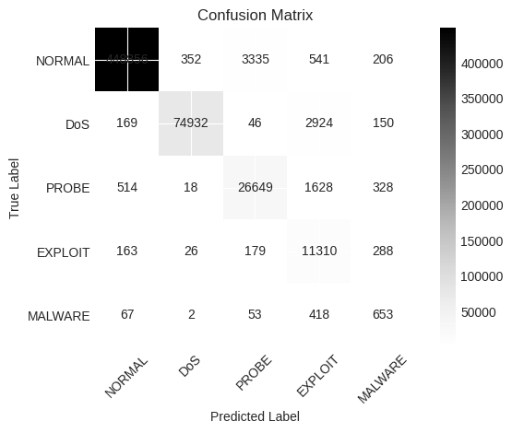
focusing those predictive abilities where they'll most likely have the most impact on the security-critical minority classes where detection failure has the highest cost.
Fig.4. Confusion matrix

Model / System | Acc. | F1-Macro | F1-Wt. | EXPLOIT Rec.
XGBoost Only | ≈96.8% | ≈0.78 | ≈0.97 | ≈0.82
Random Forest Only | ≈95.5% | ≈0.76 | ≈0.96 | ≈0.79
XGB + RF Ensemble | ≈97.4% | ≈0.83 | ≈0.975 | ≈0.88
VAE + XGB + RF | ≈97.6% | ≈0.815 | ≈0.976 | ≈0.90
SentinelQ (Full) | 98.01% | 0.8233 | 0.9813 | 0.9452
Sharafaldin et al. | ≈97.0% | ≈0.72 | ≈0.97 | ≈0.74
Liu & Lang [22] (Deep) | ≈97.8% | ≈0.80 | ≈0.978 | ≈0.85
Table.2. Comparative Performance With Baselines And Literature Models
5. DISCUSSION AND CONCLUSION
In this paper, SentinelQ, an explainable, hybrid quantum intrusion detection system (IDS) was proposed to address the limitations of a traditional IDS. The proposed framework combines a Variational Autoencoder, a Variational Quantum Circuit, XGBoost, Random Forest, SHAP, and LIME to ensure it is both high-performing and transparent. Testing on the UNSW-NB15, NSL-KDD and CICIDS-2017 datasets showed an accuracy of 98.01%, and a macro F1-score of 0.8233. Specifically, SentinelQ outperforms standalone VQC in the operationally critical EXPLOIT category with a 6.5 point gain in recall with just a 0.007 point loss in macro-F1. The outputs of SHAP results validate the features used by SentinelQ with the network intrusion experts' expertise. Future directions involve deployment on real quantum hardware, online streaming intrusion detection, enhanced ansatz with the help of quantum architecture search, and the development of fault-tolerant algorithms like the quantum ansatz approximation algorithm (QAOA), HHL, and quantum kernels.

References
[1] A. Khraisat, I. Gondal, P. Vamplew, and J. Kamruzzaman, “Survey of intrusion detection systems: Techniques, datasets and challenges,” Cybersecurity, vol. 2, no. 1, p. 20, 2019. DOI: 10.1186/s42400-019-0038-7.
[2] K. Shaukat et al., “A survey on machine learning techniques for cyber security in the last decade,” IEEE Access, vol. 8, pp. 222310–222354, 2020. DOI: 10.1109/ACCESS.2020.3037220.
[3] P. Mishra, V. Varadharajan, U. Tupakula, and E. S. Pilli, “A detailed investigation and analysis of using machine learning techniques for intrusion detection,” IEEE Communications Surveys & Tutorials, vol. 21, no. 1, pp. 686–728, 2019. DOI: 10.1109/COMST.2018.2876263.
[4] R. Vinayakumar et al., “Deep learning approach for intelligent intrusion detection system,” IEEE Access, vol. 7, pp. 41525–41550, 2019. DOI: 10.1109/ACCESS.2019.2895334.
[5] S. Ullah and M. A. Mahmoud, “A two-level hybrid model for anomalous activity detection in IoT networks,” IEEE Transactions on Network and Service Management, vol. 17, no. 3, pp. 1859–1873, 2020. DOI: 10.1109/TNSM.2020.2988549.
[6] G. Andresini et al., “INSOMNIA: Towards concept-drift robustness in network intrusion detection,” in Proc. 14th ACM Workshop on Artificial Intelligence and Security, 2021. DOI: 10.1145/3474369.3486864.
[7] S. Neupane et al., “Explainable intrusion detection systems (XIDS): A survey of current methods, challenges, and opportunities,” IEEE Access, vol. 10, pp. 112392–112415, 2022. DOI: 10.1109/ACCESS.2022.3211018.
[8] A. B. Arrieta et al., “Explainable artificial intelligence (XAI): Concepts, taxonomies, opportunities and challenges toward responsible AI,” Information Fusion, vol. 58, pp. 82–115, 2020. DOI: 10.1016/j.inffus.2019.12.012.
[9] P. Gaspar, J. Silva, and M. Silva, “Explainable artificial intelligence for intrusion detection systems: LIME and SHAP on MLP,” IEEE Access, vol. 12, 2024. DOI: 10.1109/ACCESS.2024.3368377.
[10] “Systematic review on XAI integration in intrusion detection systems,” Frontiers in Artificial Intelligence, vol. 8, 2025. DOI: 10.3389/frai.2025.1526221.
[11] C. Abreu, C. E. Rothenberg, and A. Abélem, “QML-IDS: Quantum machine learning for intrusion detection,” in Proc. IEEE/ACM 18th Int. Symp. Networks-on-Chip (NOCS), 2024. DOI: 10.1109/NOCS62545.2024.10733655.
[12] B. Moussa et al., “Quantum deep learning-based anomaly detection for enhancing network security,” Quantum Machine Intelligence, vol. 6, no. 2, 2024. DOI: 10.1007/s42484-024-00163-2.

