MINOR PROJECT
QUANTUM-ENHANCED NETWORK INTRUSION DETECTION VIA HYBRID VARIATIONAL LEARNING

- PROBLEM STATEMENT:
Develop a novel hybrid quantum-classical intrusion detection system (IDS) that leverages quantum machine learning algorithms (VQE/QAOA and parameterized quantum circuits) on NISQ devices for advanced feature extraction and pattern recognition in high-dimensional network traffic data, combined with classical machine learning for real-time threat detection and explainable AI (XAI) techniques for transparent decision-making.
Explanation: Build an IDS where a quantum circuit helps discover hidden patterns in complicated network traffic, a normal ML model uses those patterns to quickly detect attacks, and SHAP/LIME explains the reason for each alert to humans.
Network traffic data has many columns (features), and attacks can look like complicated combinations of those features.
The quantum part uses parameterized quantum circuits (quantum circuits with tunable knobs/parameters) to convert the raw data into new features that may highlight hidden patterns.
After the quantum circuit creates features, a classical ML model (like a neural network, random forest, etc.) makes the final decision in real time: “attack” or “normal”, or even “attack type”.
Terminology:
- VQE and QAOA are examples of hybrid quantum-classical algorithms designed to work on today’s quantum computers.
- NISQ means Noisy Intermediate-Scale Quantum: today’s quantum computers have only tens to hundreds of qubits and they are error-prone (“noisy”), so we must keep circuits small and shallow.
- Explainable AI methods like SHAP/LIME(XAI) help show which input features pushed the decision towards “attack” and which pushed it away, so the alert becomes understandable and trustworthy.

- WHY THIS SYSTEM REQUIRED:
Modern intrusion detection systems face three critical limitations:
- Poor Generalization to Unseen Attacks (Zero-Day Detection):
Classical machine learning models achieve 98-99% accuracy on known attack patterns but drop to 74-78% accuracy on unseen/zero-day attacks from different network environments. This generalization gap represents a major security vulnerability.
- High-Dimensional Feature Space Complexity:
Contemporary network traffic datasets contain 42-79 correlated features (NSL-KDD: 42 features; CICIDS2017: 79 features). Classical feature extraction struggles to capture complex, non-linear relationships in such high-dimensional data without exponential computational cost.
- Lack of Explainability in Security Operations:
Traditional deep learning-based IDS models operate as "black boxes," making it difficult for security analysts to understand why specific network traffic was flagged as malicious. This limits adoption and auditability in enterprise environments.

- HOW QUANTUM COMPUTING EXTRACT FEAURES:
The Approach: Instead of hand-crafting features or using classical neural networks to extract features, we use a quantum feature map a parameterized quantum circuit that transforms raw network data into quantum features.

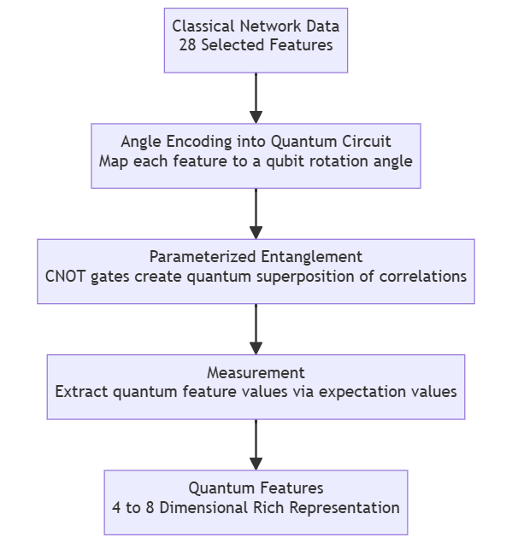
  - Quantum superposition allows the circuit to simultaneously explore many possible feature combinations.
  - Entanglement captures non-linear dependencies between network features (e.g., "if packet size is large AND protocol is TCP AND port is 443, then likely HTTPS").
  - The result is a feature representation that classical ML models cannot easily capture without exponential overhead.
  - Research Evidence: Recent hybrid quantum-classical IDS implementations show:
    - Equivalent or better accuracy on standard test data (98-99%)
    - 4-28% improvement on zero-day attacks (unseen attack types) compared to purely classical baselines.
    - More stable and robust decision boundaries.

- OBJECTIVES:
Objective 1 — Build a strong classical IDS baseline
- Train and evaluate classical ML/DL models (e.g., RandomForest/XGBoost/MLP/CNN) for intrusion detection.
- Record standard metrics: Accuracy, Precision, Recall, F1, confusion matrix.
- This baseline is necessary so you can later prove whether the hybrid quantum approach helps.
This is aligned with how IDS work is typically benchmarked on NSL-KDD and CICIDS2017.​
Objective 2 — Prepare network traffic data for quantum + classical learning
- Implement preprocessing: missing values, encoding categorical features, scaling/normalization.​
- Reduce feature dimension to match feasible qubit counts (e.g., PCA / feature selection → ~8–16 features), since quantum models usually have limited input size and Qiskit tutorials explicitly discuss reducing features when datasets have more features than qubits.​
Objective 3 — Implement the quantum ML component (feature extraction / representation learning)
- Build a small parameterized quantum circuit model (VQC / variational circuits) that learns a representation from the preprocessed traffic features.​
- Train it on a simulator first (Qiskit Aer), because Qiskit’s own tutorial demonstrates training VQC on a simulator and highlights choices like using gradient-free optimizers (e.g., COBYLA).​
Objective 4 — Build the hybrid quantum–classical IDS
- Combine (concatenate) the quantum features (measurement outputs / expectation values) with classical features (or a small CNN/MLP embedding), then train a classical classifier for the final decision.
- The deliverable here is an end-to-end pipeline: input network flow → quantum feature map → classical decision.​
Objective 5 — Evaluate “unseen attack reliability” (zero-day style test)
- Beyond normal train/test splits, do a withheld attack-type test: train on some attacks, test on different attacks.
- This is how you support your main claim: improved reliability/generalization, not just accuracy.​
Objective 6 — Add explainability (XAI) for analyst-friendly outputs
- Use SHAP/LIME on the final classical decision layer to show which features contributed most to an “attack” decision.
- Produce 5–10 example explanations as part of final deliverables.​

- DATASETS TO USE
Primary : NSL-KDD
- NSL-KDD is designed to be a cleaner benchmark than KDD’99 and has a “reasonable” train/test set size for full experiments.​
- Easiest for fast iteration; great for your 4-month timeline.​
- TECH STACK
Quantum Stack:
- Qiskit + Qiskit Aer (simulator) for quantum circuits and execution.​
- Qiskit Machine Learning for models like Variational Quantum Classifier (VQC) and hybrid training patterns.​
- Optimizer: COBYLA (commonly used in Qiskit ML tutorial for VQC training).​
Classical ML stack
- Python
- scikit-learn (baselines, preprocessing, metrics)
- TensorFlow/Keras or PyTorch (CNN/MLP + hybrid fusion layer)
Explainability stack
- SHAP (global + local explanations)​
- LIME (local explanations)​
Dev tools
- Jupyter / VS Code/ Google Colab
- Git + GitHub (version control, reproducibility)

