Q-LogiOpt
Quantum Approximate Optimization for Intelligent Logistics Route and Delivery Optimization
FINAL-YEAR MAJOR PROJECT DOCUMENTATION
Prepared by
A. Nikhil Sai Ram Reddy
B.Tech – Computer Science & Engineering
KL University, Hyderabad
Technology Domain: Quantum Artificial Intelligence
Implementation: Python + Qiskit + Qiskit Aer + Streamlit
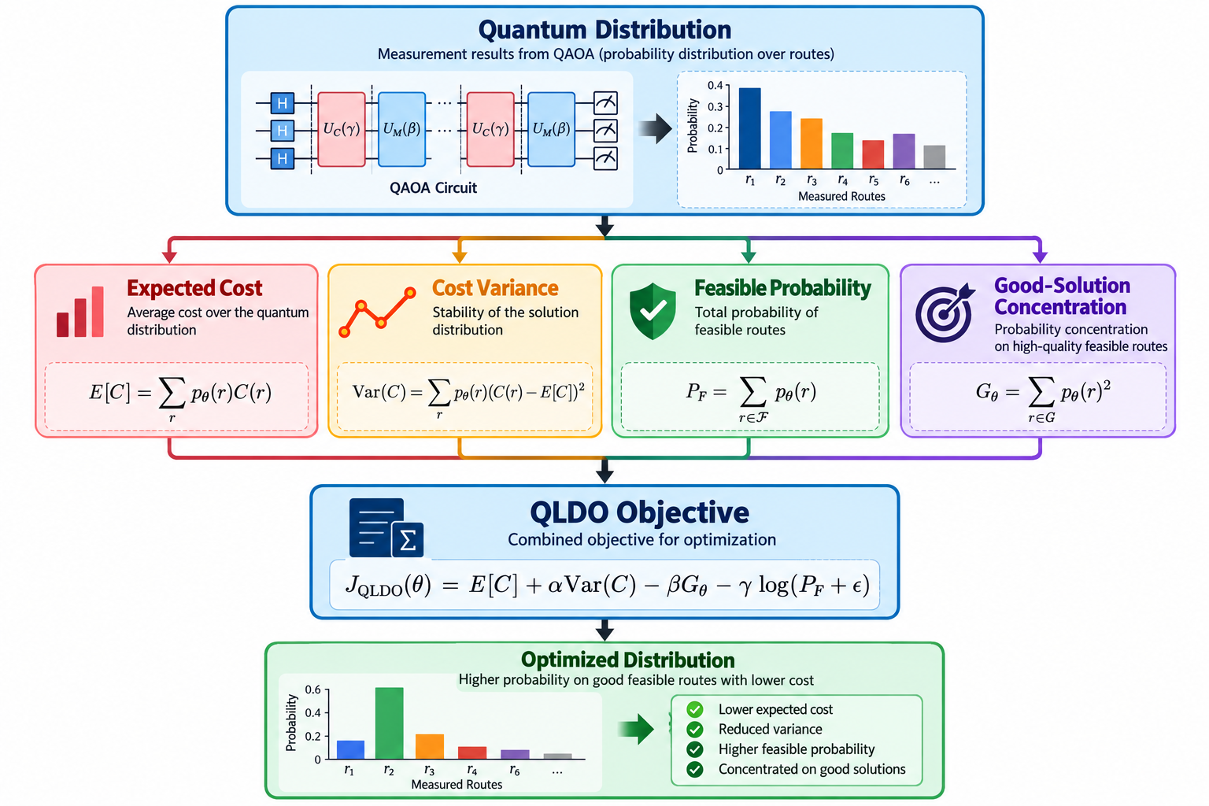
Figure: Quantum Distribution → QLDO Objective → Optimized Distribution
Project Type: Pure Software / Quantum Simulation

Document Control
Item | Details
Project Title | Q-LogiOpt: Quantum Approximate Optimization for Intelligent Logistics Route and Delivery Optimization
Project Category | Final-Year Major Project
Application Domain | Logistics, Route Optimization, Quantum AI
Programming Language | Python
Frontend / Dashboard | Streamlit
Quantum Framework | Qiskit, Qiskit Aer, Qiskit Optimization
Optimization Model | Anchored-Depot QUBO / Ising Hamiltonian / QAOA
Classical Baselines | Nearest Neighbor, 2-opt, Simulated Annealing, Exact Brute Force for small instances
Research Objective | Investigate a distribution-aware QLDO objective for QAOA-based logistics routing

Abstract
Q-LogiOpt is a pure-software hybrid quantum-classical optimization platform for intelligent logistics route planning. The project models a constrained routing problem as a Quadratic Unconstrained Binary Optimization (QUBO) problem, maps the QUBO to an Ising cost Hamiltonian, and applies the Quantum Approximate Optimization Algorithm (QAOA) using Qiskit Aer simulation. The system also evaluates classical routing heuristics including Nearest Neighbor, 2-opt, and Simulated Annealing.
A central research component is the proposed Quantum Logistics Distribution Objective (QLDO). Instead of considering only expected route cost, QLDO evaluates expected cost, cost variance, feasible-route probability, and concentration on good feasible solutions. A Streamlit dashboard exposes dataset processing, route configuration, QUBO inspection, QAOA execution, route decoding, experiments, and performance visualization.
The project is an experimental research framework rather than a claim of practical quantum advantage. Quantum simulation becomes expensive as the number of qubits grows, and performance claims should be supported by controlled experiments against classical baselines.

Keywords
Quantum Artificial Intelligence, QAOA, QUBO, Ising Hamiltonian, Logistics Optimization, TSP, Quantum Simulation, Streamlit, Hybrid Quantum-Classical Optimization, QLDO

1. Introduction

1.1 Background
Last-mile logistics is a combinatorial optimization domain in which a delivery operator must determine an efficient sequence for visiting customers from a depot. Route decisions affect travel distance, cost, time, and operational efficiency. The Traveling Salesperson Problem (TSP) provides a useful mathematical abstraction for a single vehicle visiting a set of locations and returning to the depot.

1.2 Motivation
- Investigate quantum optimization for a practical logistics problem.
- Build an end-to-end QUBO-to-QAOA pipeline without physical quantum hardware.
- Compare quantum optimization with classical heuristics.
- Study the full QAOA probability distribution rather than only expected cost.
- Provide a reproducible Streamlit research platform.

1.3 Problem Statement
Given a depot and delivery customers with geographic coordinates, demands, and priorities, determine a feasible visiting sequence that minimizes the defined logistics cost. The problem is transformed into binary optimization, executed with QAOA simulation, decoded into candidate routes, and evaluated with common metrics plus QLDO.

1.4 Scope
- Pure software implementation.
- Local Qiskit Aer simulation.
- Anchored-depot TSP-style formulation.
- Classical baseline comparison.
- QLDO objective and parameter experiments.
- Optional simulated NISQ noise experiments.
- Interactive Streamlit dashboard.

2. Objectives and Requirements

2.1 Primary Objectives
- Load and validate logistics datasets or generate synthetic instances.
- Calculate pairwise distance/cost matrices.
- Formulate an anchored-depot QUBO.
- Map the QUBO to an Ising Hamiltonian.
- Construct parameterized QAOA circuits.
- Optimize QAOA parameters using classical optimizers.
- Sample and decode quantum measurement bitstrings.
- Measure feasibility, route cost, probability concentration, and related metrics.
- Implement and evaluate QLDO.
- Compare Standard QAOA, QLDO-QAOA, and classical baselines.
- Expose the workflow through Streamlit.

2.2 Functional Requirements
ID | Requirement
FR-01 | CSV dataset upload and validation
FR-02 | Synthetic logistics instance generation
FR-03 | Distance matrix calculation
FR-04 | Classical route optimization
FR-05 | Anchored QUBO generation
FR-06 | QUBO-to-Ising conversion
FR-07 | QAOA circuit construction and simulation
FR-08 | Route decoding and feasibility checking
FR-09 | QLDO objective evaluation
FR-10 | Benchmarking, parameter sweeps, and noise experiments
FR-11 | Interactive route, distribution, and performance visualization

2.3 Non-Functional Requirements
- Reproducibility through controlled seeds and configurable parameters.
- Modular Python architecture.
- Separation of data, optimization, quantum, QLDO, experiments, and visualization.
- Transparent reporting of infeasible quantum samples and limitations.
- Usable academic demonstration interface.

3. System Architecture
The system follows a hybrid pipeline. The Streamlit interface is the entry point. Data are processed into a distance/cost matrix, after which the problem is evaluated using classical and quantum branches. The quantum branch converts the routing model to QUBO, then Ising, then QAOA. Outputs are decoded and compared through common metrics.
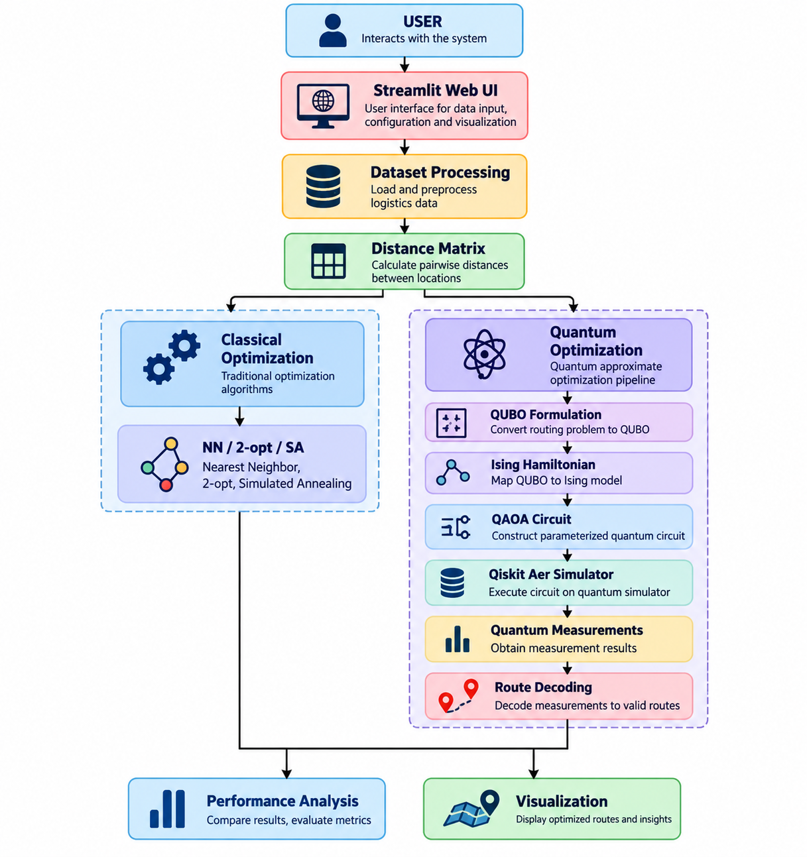
Figure 3.1: Q-LogiOpt high-level system architecture
Component | Responsibility
Streamlit UI | User interaction, configuration, visualization, experiment controls
Data Processing | CSV loading, validation, synthetic generation, distance calculation
Classical Optimization | Nearest Neighbor, 2-opt, Simulated Annealing, exact small-instance solving
QUBO Builder | Binary decision variables, routing objective, and penalties
Hamiltonian Mapper | QUBO to Ising representation
QAOA Engine | Parameterized circuit and hybrid optimization
Route Decoder | Bitstring parsing, feasibility checking, minimum-conflict repair
QLDO Module | Distribution metrics and QLDO objective
Experiments | Benchmarks, parameter sweeps, scaling, noise
Visualization | Maps, charts, circuit metrics, comparisons

4. Dataset and Data Processing

4.1 Input Schema
Column | Description | Example
Location | Depot/customer identifier | C1
Latitude | Geographic latitude | 17.4000
Longitude | Geographic longitude | 78.4800
Demand | Delivery demand value | 5
Priority | Delivery priority | 3

4.2 Sample Dataset
Location | Latitude | Longitude | Demand | Priority
DEPOT | 17.385 | 78.4867 | 0 | 0
C1 | 17.400 | 78.4800 | 5 | 3
C2 | 17.410 | 78.5000 | 8 | 2
C3 | 17.370 | 78.5100 | 4 | 5
C4 | 17.360 | 78.4700 | 7 | 1
C5 | 17.430 | 78.4500 | 6 | 4
C6 | 17.350 | 78.5300 | 3 | 2
C7 | 17.440 | 78.4900 | 5 | 5

4.3 Distance Matrix
The distance module calculates pairwise distances between depot and customer locations. Geographic coordinates can be processed using a Haversine calculation, while Euclidean calculations are suitable for synthetic or normalized instances. The resulting matrix becomes the base routing cost.

5. Mathematical Formulation

5.1 Routing Decision Variables
Let xᵤ,ₛ ∈ {0,1} indicate whether customer u is assigned to route position s. A value of 1 means customer u occupies position s.

5.2 Anchored Depot Reduction
The depot is fixed at the start of the tour. This removes redundant depot variables and reduces the binary variable count from n² to (n−1)².
n | Standard n² | Anchored (n−1)²
4 | 16 | 9
5 | 25 | 16
6 | 36 | 25
7 | 49 | 36
8 | 64 | 49

5.3 Customer Visitation Constraint
H_node = λ Σ_u (1 − Σ_s x_(u,s))²

This penalty encourages every customer to appear exactly once.

5.4 Step Occupancy Constraint
H_time = λ Σ_s (1 − Σ_u x_(u,s))²

This penalty encourages every route position to contain exactly one customer.

5.5 Routing Cost
H_cost = Σ_u C_(0,u+1)x_(u,0)
+ Σ_s Σ_(u≠v) C_(u+1,v+1)x_(u,s)x_(v,s+1)
+ Σ_u C_(u+1,0)x_(u,m−1)

The full QUBO combines routing cost with constraint penalties so that low-energy solutions favor valid permutations.

6. QUBO to Ising and QAOA

6.1 QUBO
E(x) = xᵀ Q x + c

6.2 QUBO-to-Ising Mapping
x_k = (I − Z_k) / 2

After substitution and collection of constant, linear, and quadratic Pauli-Z terms:
H_C = Σ_k h_k Z_k + Σ_(j<k) J_jk Z_j Z_k + offset

6.3 QAOA
QAOA alternates a cost unitary and a mixer unitary for p layers. A classical optimizer updates variational parameters based on the measured objective.
U_C(γ) = exp(−i γ H_C)
U_M(β) = exp(−i β H_M)
U(γ,β) = U_M(β) U_C(γ)

7. Proposed QLDO Objective

7.1 Motivation
Standard expectation-based QAOA evaluation often focuses on E[C]. QLDO evaluates multiple properties of the quantum measurement distribution simultaneously.
Figure 7.1: Quantum distribution metrics feeding the QLDO objective

7.2 QLDO Definition
J_QLDO(θ) = E[C] + α Var(C) − β G_θ − γ log(P_F + ε)

7.3 Components
Term | Definition | Interpretation
E[C] | Σ_r p_θ(r) C(r) | Expected route cost
Var(C) | Σ_r p_θ(r)(C(r)−E[C])² | Cost dispersion / stability
P_F | Σ_(r∈F) p_θ(r) | Probability mass on feasible routes
G_θ | Σ_(r∈G) p_θ(r)² | Concentration on good feasible routes
α, β, γ | Hyperparameters | Relative importance of QLDO terms
ε | Small positive constant | Prevents log(0)

7.4 Interpretation
- Lower expected cost is preferred.
- Lower cost variance can indicate a more stable distribution.
- Higher feasible probability means more mass on valid routes.
- Higher good-solution concentration means probability is concentrated on selected good feasible routes.
QLDO is a proposed research objective in this project. Its effectiveness must be established experimentally and should not be presented as a proven quantum advantage.

8. Route Decoding and Feasibility

8.1 Measurement Bitstrings
QAOA produces measurement bitstrings. Because the QUBO is unconstrained at the quantum-state level, some bitstrings may violate permutation constraints. The decoder evaluates each sampled state.

8.2 Strict Permutation Filtering
The strict decoder accepts states corresponding directly to a valid one-to-one customer-to-position assignment.

8.3 Minimum-Conflict Repair
For infeasible samples, the implementation supports a minimum-conflict Hungarian-style repair projector to obtain a valid assignment when possible.

8.4 Constraint Satisfaction Rate
CSR = feasible measured samples / total measured samples

9. Classical Optimization Baselines

9.1 Nearest Neighbor
Starts at the depot and repeatedly selects the nearest unvisited customer.

9.2 2-opt
Improves a route by removing two edges and reconnecting segments when the replacement is shorter.

9.3 Simulated Annealing
Uses stochastic exploration and can temporarily accept worse solutions to escape local minima.

9.4 Exact Solver
For small instances, brute-force enumeration can provide a reference optimum, but factorial growth limits scalability.

10. Experimental Methodology

10.1 Head-to-Head Experiment
- Use identical instances, seeds, shots, and QAOA depths.
- Run Standard QAOA using expected cost.
- Run QLDO-QAOA using the distribution-aware objective.
- Compare route cost, feasibility, distribution metrics, and runtime.

10.2 QAOA Depth Scaling
Evaluate p ∈ {1, 2, 3} and inspect changes in objective behavior and route quality.

10.3 Problem-Size Scaling
Increase the number of locations while recording qubit count, circuit depth, runtime, and solution metrics.

10.4 QLDO Hyperparameter Sweep
- Sweep α for variance regularization.
- Sweep β for good-route concentration.
- Sweep γ for feasible-probability barrier.
- Evaluate sensitivity to ε.

10.5 Noise Experiment
Simulate depolarizing and readout-error models to study degradation under noisy quantum execution assumptions.

11. Streamlit Application
The application is organized into research-oriented pages:
Page | Purpose
Dashboard | Executive overview and KPIs
Dataset | Upload data and synthetic generation
Route Configuration | Configure route and objective parameters
Classical | Inspect classical baselines
QUBO Matrix | QUBO heatmap and Ising information
QAOA Optimization | Run Standard QAOA and QLDO-QAOA
Quantum Circuit | Circuit structure and gate analysis
Experiments | Automated benchmark and experiment tabs
Performance | Tripartite comparison and analytical graphs
About Research | Literature context and research limitations

11.1 Demonstration Workflow
- Launch Streamlit.
- Load sample_routes.csv.
- Inspect customer locations and distance matrix.
- Run classical baselines.
- Configure QAOA depth, shots, and optimizer.
- Generate and inspect QUBO.
- Execute the simulator.
- Inspect measurement probabilities.
- Decode feasible routes.
- Run QLDO-QAOA.
- Compare all approaches.
- Export or capture charts.

12. Project Directory Structure
Q LogiOpt/
├── app.py
├── requirements.txt
├── README.md
├── data/
│ └── sample_routes.csv
├── config/
│ └── settings.py
├── classical/
│ ├── nearest_neighbor.py
│ ├── two_opt.py
│ ├── simulated_annealing.py
│ └── exact_solver.py
├── quantum/
│ ├── qubo.py
│ ├── hamiltonian.py
│ ├── circuit.py
│ ├── simulator.py
│ ├── qaoa_optimizer.py
│ └── qaoa_qldo.py
├── optimization/
│ ├── objective.py
│ ├── constraints.py
│ └── route_decoder.py
├── qldo/
│ ├── probability.py
│ ├── feasibility.py
│ ├── concentration.py
│ ├── objective.py
│ └── metrics.py
├── visualization/
│ ├── maps.py
│ ├── charts.py
│ └── circuit_visualizer.py
├── experiments/
│ ├── qldo_benchmark.py
│ ├── parameter_sweep.py
│ ├── noise_experiment.py
│ └── benchmark_runner.py
├── pages/
│ ├── 1_Dashboard.py
│ ├── 2_Dataset.py
│ ├── 3_Route_Configuration.py
│ ├── 4_Classical.py
│ ├── 5_QUBO_Matrix.py
│ ├── 6_QAOA_Optimization.py
│ ├── 7_Quantum_Circuit.py
│ ├── 8_Experiments.py
│ ├── 9_Performance.py
│ └── 10_About_Research.py
└── tests/

13. Installation and Execution

13.1 Environment
Recommended: Python 3.11+ in a dedicated virtual environment.
python -m venv venv
venv\Scripts\activate
python -m pip install -r requirements.txt

13.2 Run the Application
streamlit run app.py

The Streamlit application is normally available at http://localhost:8501.

13.3 Run Tests
python -m pytest tests/ -v

The supplied repository README reports 26 tests passed. A fresh execution should be performed after installing the declared dependencies; if Qiskit is unavailable, quantum test modules cannot be collected.

14. Testing and Verification
Test File | Coverage
test_classical.py | Classical route solver behavior
test_data_processing.py | Distance and data loading
test_qubo.py | QUBO construction and energy consistency
test_quantum.py | Circuit, Aer, and decoder behavior
test_qldo.py | Probability moments, feasibility, concentration, objective
test_experiments.py | Experiment runner behavior

14.1 Verification Principles
- Validate QUBO energy against direct objective evaluation on small states.
- Verify valid permutations decode to valid routes.
- Check feasibility penalties for violated constraints.
- Check QLDO components against the measured distribution.
- Use deterministic seeds where appropriate.

15. Results Reporting Template
Do not insert fabricated numerical results. Populate the following table after running the application in a configured environment.
Metric | NN | 2-opt | SA | Standard QAOA | QLDO-QAOA
Best route cost | — | — | — | — | —
Mean sampled cost | — | — | — | — | —
Feasibility / CSR | — | — | — | — | —
Runtime | — | — | — | — | —
Qubits | N/A | N/A | N/A | — | —
Circuit depth | N/A | N/A | N/A | — | —

15.1 Recommended Figures
- Optimized route map.
- QUBO heatmap.
- QAOA circuit.
- Measurement probability distribution.
- QLDO metric decomposition.
- Cost convergence curve.
- Classical vs quantum route-cost comparison.
- CSR vs problem size.
- QAOA depth vs objective.
- Ideal vs noisy simulation.

16. Limitations
- Quantum simulation has exponential growth in state-space requirements.
- QAOA includes classical parameter-optimization overhead.
- Small instances may favor classical heuristics.
- The project does not establish practical quantum advantage.
- Real logistics may require capacity, multiple vehicles, time windows, traffic, and dynamic demand.
- QLDO requires empirical validation across diverse benchmark instances.
An N-qubit statevector requires 2^N complex amplitudes, making large local simulations increasingly expensive.

17. Future Scope
- Run suitable circuits on real quantum hardware.
- Extend from TSP-style routing to Vehicle Routing Problem (VRP).
- Add vehicle capacity and time windows.
- Investigate multi-depot routing.
- Integrate traffic and travel-time estimates.
- Explore hybrid decomposition for larger instances.
- Study alternative mixers and warm-start QAOA.
- Perform broader repeated-trial statistical benchmarking.
- Evaluate QLDO on additional combinatorial optimization problems.

18. Research Contribution
The principal contribution is an experimental framework combining an anchored-depot QUBO with a distribution-aware QLDO objective for QAOA-based logistics routing. The work is best framed as a research hypothesis and evaluation framework rather than as a proven quantum advantage.

18.1 Research Question
Can a distribution-aware objective improve useful characteristics of QAOA output—such as feasibility, cost stability, or concentration on good routes—relative to an expectation-based objective under controlled logistics-routing experiments?

18.2 Testable Hypotheses
- H1: QLDO-QAOA can alter probability mass toward feasible routes under suitable parameters.
- H2: Variance regularization can change route-cost dispersion.
- H3: Good-solution concentration can increase for selected small instances.
- H4: Noise can reduce feasibility and concentration.

19. Viva / Presentation Explanation
Logistics problem
↓
TSP-style model
↓
Anchored-depot QUBO
↓
Ising Hamiltonian
↓
QAOA circuit
↓
Qiskit Aer simulation
↓
Quantum measurement distribution
↓
Route decoding + feasibility
↓
QLDO evaluation
↓
Classical comparison

19.1 Common Viva Questions
Why QUBO?
QUBO provides a binary quadratic representation that maps naturally to an Ising Hamiltonian.
Why QAOA?
QAOA is a hybrid quantum-classical method designed for approximate combinatorial optimization.
Why anchor the depot?
It removes redundant variables and reduces qubits from n² to (n−1)².
Why Qiskit Aer?
It allows local simulation without physical quantum hardware.
Why compare classical algorithms?
Baselines are necessary to evaluate whether the quantum method changes quality, feasibility, or runtime.
What is QLDO?
A proposed distribution-aware objective combining expected cost, variance, feasible probability, and good-solution concentration.
Does this prove quantum advantage?
No. It is an experimental framework and does not establish quantum advantage without controlled evidence.

20. Conclusion
Q-LogiOpt demonstrates an end-to-end workflow for applying hybrid quantum-classical optimization to logistics route planning. It connects data processing, mathematical optimization, QUBO construction, Ising modeling, QAOA simulation, route decoding, distribution analysis, and interactive visualization.
The QLDO objective provides a structured way to investigate more than expected route cost by incorporating distributional properties of quantum outputs. Its value should be established experimentally using controlled comparisons and transparent reporting of limitations.

Appendix A — Technology Stack
Technology | Role
Python 3.11+ | Core implementation
Qiskit 2.x | Quantum circuit and operator framework
Qiskit Aer | Quantum simulation
Qiskit Optimization | Optimization support
Streamlit | Interactive dashboard
NumPy / SciPy | Numerical computation
Pandas | Dataset handling
Plotly / Matplotlib | Visualization
NetworkX | Graph operations
Pytest | Automated testing

Appendix B — Screenshot Checklist
- Dashboard
- Dataset upload
- Distance matrix
- Classical output
- QUBO heatmap
- Ising Hamiltonian
- QAOA circuit
- QAOA convergence
- Quantum distribution
- QLDO metrics
- Optimized route map
- Performance comparison
- Parameter sweep
- Noise experiment

Appendix C — Evidence Note
This documentation was prepared from the supplied Q-LogiOpt project repository, including its README, source-module structure, sample dataset, experimental capabilities, and QLDO formulation. Numerical benchmark results should be inserted only after running the project with the required dependencies and recording the generated outputs.

