Q-TRAFFICAI
Adaptive Quantum Signal Allocation for AI-Driven Intelligent Traffic Optimization

PROJECT DOCUMENTATION

A Final-Year Computer Science and Engineering Major Project

AI Predicts → AQSA Selects → Quantum Optimizes → Traffic Improves

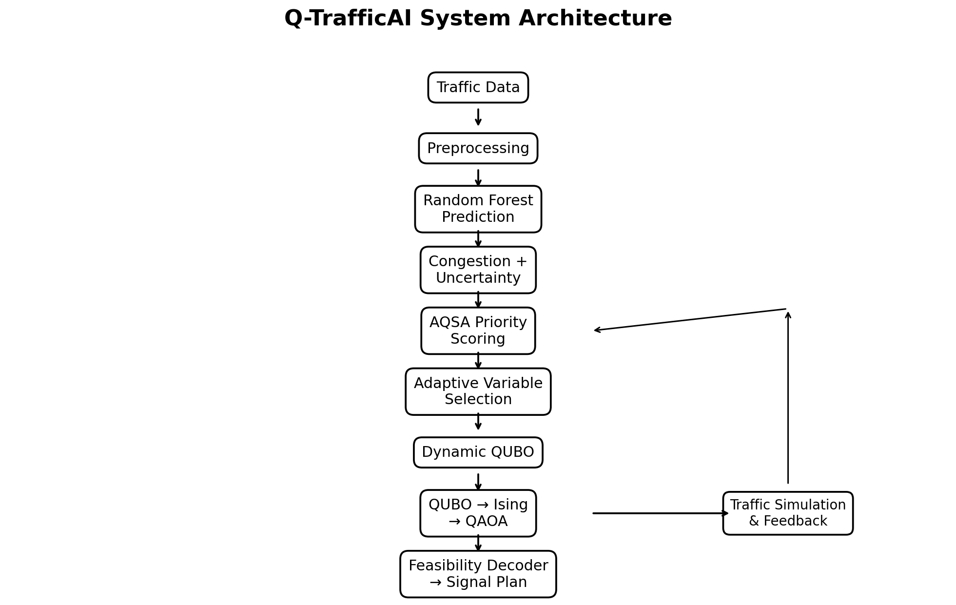
Figure 1. High-level architecture of Q-TrafficAI
Prepared by
A. Nikhil Sai Ram Reddy
KL University
2026–2027

Abstract
Q-TrafficAI is a software-based intelligent traffic optimization platform that combines machine learning, adaptive optimization, and quantum computing simulation. The system uses a Random Forest model to predict traffic volume, queue length, and congestion-related conditions and estimates prediction uncertainty using ensemble variance. The proposed Adaptive Quantum Signal Allocation (AQSA) methodology then calculates an adaptive priority score for each intersection, selects critical intersections under a configurable qubit budget, and constructs a traffic-specific Quadratic Unconstrained Binary Optimization (QUBO) problem. The QUBO is converted to an Ising Hamiltonian and optimized using the Quantum Approximate Optimization Algorithm (QAOA) on a local quantum simulator. A feasibility-aware decoder converts quantum measurement outcomes into usable signal configurations. The project also provides a discrete-time traffic simulator, classical baselines, comparison dashboards, ablation experiments, and an interactive Streamlit interface. The implementation is intended as a research prototype; the experiments use small simulated networks and quantum simulation, so the results do not establish quantum advantage or real-world deployment readiness.

Keywords
Traffic Optimization, Artificial Intelligence, Random Forest, AQSA, QUBO, QAOA, Quantum Computing, Quantum Simulation, Traffic Signal Control, Smart Cities

Document Scope
This document describes the implementation contained in the supplied Q-TrafficAI project archive. It covers the problem definition, system design, AQSA methodology, mathematical formulation, software architecture, implementation, experiments, benchmark results, testing, limitations, and future work.

Table of Contents
- 1. Introduction
- 2. Problem Statement
- 3. Existing System and Research Gap
- 4. Proposed Q-TrafficAI System
- 5. AQSA Methodology
- 6. Mathematical Formulation
- 7. System Architecture
- 8. AI Traffic Prediction Module
- 9. Traffic Simulation Module
- 10. Quantum Optimization Module
- 11. Classical Baselines
- 12. Streamlit Application
- 13. Experimental Methodology
- 14. Results and Analysis
- 15. Ablation Study
- 16. Software Testing
- 17. Advantages
- 18. Limitations
- 19. Future Scope
- 20. Conclusion
- 21. Project Structure
- 22. Installation and Execution

1. Introduction
Urban traffic networks are dynamic optimization environments. Vehicle arrivals, queue lengths, waiting times, road occupancy, and signal states change continuously. A signal plan that works well during one traffic condition can become inefficient after a sudden demand change. This creates a need for adaptive traffic management systems that can predict near-term traffic conditions and optimize signal decisions according to current network state.
Q-TrafficAI addresses this problem through a hybrid architecture. Machine learning is used for traffic prediction, AQSA is used to identify the most important intersections and quantum decision variables, and QAOA is used to optimize the resulting focused QUBO problem. The traffic simulator provides a controlled environment in which signal plans can be evaluated and the optimization loop can be repeated.

1.1 Project Vision
The project is designed as a smart-city research platform rather than a conventional traffic dashboard. Its central design principle is to avoid unnecessarily mapping the entire traffic network into a small quantum optimization problem. AI-derived traffic intelligence is used first to decide where quantum optimization should be concentrated.

1.2 Main Contributions
- An end-to-end AI–quantum traffic optimization pipeline implemented in Python.
- AQSA priority scoring using congestion, queue, waiting time, density, and uncertainty.
- Adaptive selection of critical intersections under configurable qubit budgets.
- Dynamic QUBO generation with traffic-dependent objectives and coordination terms.
- Priority-adapted constraint penalties.
- QAOA optimization using Qiskit and local quantum simulation.
- Feasibility-aware decoding of quantum measurement outcomes.
- Discrete-time traffic simulation with feedback and performance telemetry.
- Classical and quantum baselines plus an ablation-study framework.
- An interactive Streamlit research dashboard.

2. Problem Statement
The project addresses the problem of adaptive traffic signal optimization in a changing urban road network. A traffic-control system should reduce delay and queueing while respecting signal safety constraints. When quantum optimization is introduced, the system must additionally operate within a limited qubit budget.

2.1 Challenges
- Traffic demand changes over time and can be spatially uneven.
- Fixed-time signals do not explicitly react to predicted demand.
- Joint optimization across many intersections produces a rapidly growing binary search space.
- Quantum simulation becomes increasingly expensive as the number of qubits increases.
- Raw quantum measurement probabilities can contain infeasible signal configurations.
- A research prototype needs measurable classical baselines and reproducible experiments.

2.2 Research Question
How can AI-derived traffic intelligence be used to select the most important signal decisions and construct a focused quantum optimization problem that can be solved with QAOA under a limited qubit budget?

3. Existing System and Research Gap
Approach | Description | Limitation addressed by Q-TrafficAI
Fixed-time control | Uses predefined signal durations. | Does not adapt to predicted traffic state.
Greedy optimization | Uses local queue-based decisions. | May not capture broader coordination objectives.
Brute-force search | Enumerates feasible binary configurations for small problems. | Search cost grows exponentially.
Standard QAOA | Applies QAOA to a formulated QUBO. | Does not by itself decide which traffic variables deserve quantum resources.
Q-TrafficAI / AQSA | Uses AI to prioritize intersections before quantum optimization. | Focuses quantum resources on selected variables.

The research contribution is positioned as the AQSA methodology and its integration of adaptive traffic intelligence, variable selection, dynamic QUBO construction, feasibility-aware decoding, and feedback. QAOA itself is an established quantum optimization algorithm and is not claimed to be newly invented by this project.

4. Proposed Q-TrafficAI System
Q-TrafficAI follows a closed-loop architecture. Traffic state is processed by the AI predictor, the AQSA module identifies critical intersections, a dynamic QUBO is generated, QAOA is executed, the selected signal configuration is decoded and applied to the simulator, and the resulting traffic state can be used for subsequent optimization.
Figure 2. Q-TrafficAI system architecture

4.1 End-to-End Workflow
Traffic Data
↓
Preprocessing
↓
Random Forest Prediction
↓
Congestion + Uncertainty
↓
AQSA Priority Scoring
↓
Adaptive Variable Selection
↓
Dynamic QUBO
↓
QUBO → Ising
↓
QAOA on Quantum Simulator
↓
Feasibility-Aware Decoder
↓
Signal Plan
↓
Traffic Simulation + Feedback

5. AQSA Methodology
AQSA (Adaptive Quantum Signal Allocation) is the proposed methodology at the center of the project. It is designed to allocate limited quantum decision variables to the intersections where optimization is most relevant according to the predicted traffic state.
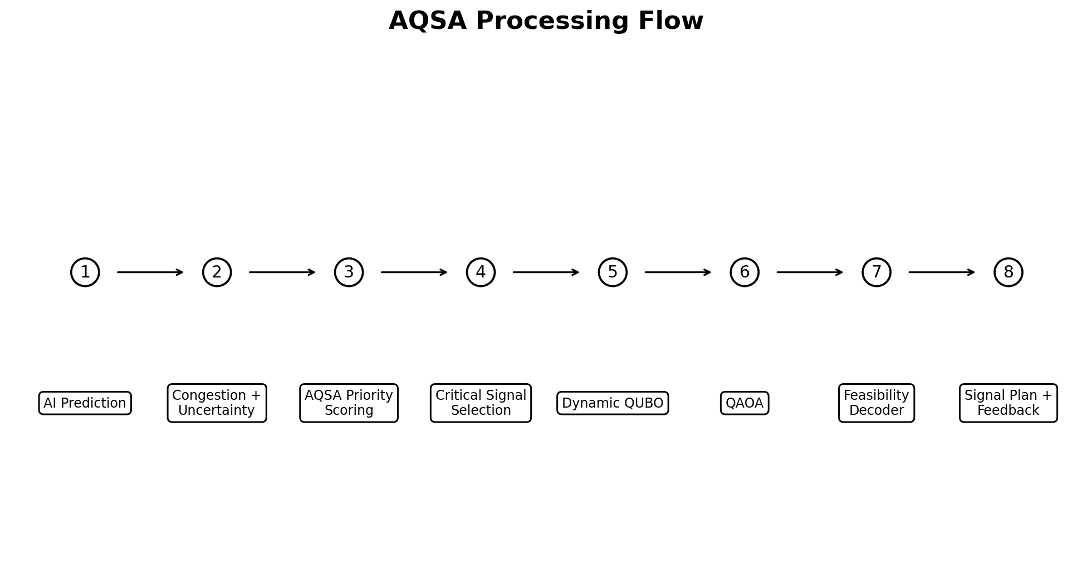
Figure 3. AQSA processing flow

5.1 Stage 1 — Adaptive Traffic Weighting
The implementation starts from base weights for five factors: congestion, queue, waiting time, density, and prediction uncertainty. The weights are adapted using network-wide conditions. High uncertainty increases the uncertainty weight; high queue variance increases the queue weight; and high mean waiting time increases the waiting-time weight. The resulting weights are normalized to sum to one.
w = [w1, w2, w3, w4, w5]
if mean_uncertainty > 0.35: increase w5
if queue_std > 8.0: increase w2
if mean_wait > 30 s: increase w3
normalize(w) so sum(w) = 1

5.2 Stage 2 — Priority Score
For every intersection, normalized traffic indicators are combined into a priority score:
Priority_i = w1*C_i + w2*Q_i + w3*W_i + w4*D_i + w5*U_i
C is normalized congestion, Q is normalized queue length, W is normalized waiting time, D is normalized density, and U is normalized uncertainty.

5.3 Stage 3 — Adaptive Quantum Variable Selection
Intersections are ranked by priority. A configurable threshold τ determines which intersections qualify, while the qubit budget limits the maximum number of selected nodes. The current implementation maps two binary variables per selected intersection: an NS-phase decision and an EW-phase decision.
max_nodes = qubit_budget // variables_per_intersection
select nodes with Priority >= threshold until max_nodes is reached

5.4 Stage 4 — Dynamic QUBO Construction
The selected variables are used to construct a traffic-specific QUBO. Linear terms reward delay and queue clearance, while off-diagonal terms encode coordination between related signal variables. Adaptive penalties discourage conflicting phase selections.

5.5 Stage 5 — QAOA and Feasibility-Aware Decoding
The QUBO is transformed into an Ising cost Hamiltonian and passed to a parameterized QAOA circuit. The project uses a classical optimizer to tune QAOA parameters. After measurement, candidate bitstrings are decoded and checked for phase conflicts and other feasibility conditions before a signal plan is selected.

5.6 Stage 6 — Feedback
The selected signal plan is applied to the discrete traffic simulator. New traffic metrics are then available for the next optimization cycle, creating a closed-loop architecture.

6. Mathematical Formulation

6.1 Priority Score
Priority_i = w1(t) C_i + w2(t) Q_i + w3(t) W_i + w4(t) D_i + w5(t) U_i
where: Σ w_k(t) = 1
The dynamic weight vector is intended to reflect current network conditions rather than use a single fixed importance ordering.

6.2 QUBO Objective
min J(x) = xᵀ Q x
= Σ_i Q_ii x_i + Σ_(i<j) Q_ij x_i x_j
The QUBO combines delay/queue rewards, predicted traffic influence, arterial coordination, signal switching effects, and constraint penalties.

6.3 Adaptive Constraint Penalty
λ_i = λ_base (1 + γ_penalty P_i)
Higher-priority intersections therefore receive stronger penalties where the implementation requires stronger constraint enforcement.

6.4 QUBO to Ising Mapping
x_i = (I - Z_i) / 2
H_C = Σ_i h_i Z_i + Σ_(i<j) J_ij Z_i Z_j + C_offset I
h_i = -Q_ii/2 - Σ_(j≠i) Q_ij/4
J_ij = Q_ij/4

6.5 QAOA
|ψ(γ,β)> = Π_l [ exp(-i β_l H_M) exp(-i γ_l H_C) ] |+>^⊗n
The implementation uses a transverse-field mixer and a classical COBYLA optimization loop to minimize the expectation value of the cost Hamiltonian.

7. System Architecture

7.1 Software Layers
Layer | Main Components | Purpose
Presentation | Streamlit pages, Plotly visualizations | Interactive dashboard and research views.
Traffic | Simulator, network, signals, vehicles, router | Generate and update traffic states.
AI | Preprocessing, predictor, uncertainty | Predict traffic and estimate uncertainty.
AQSA | Priority, variable selector, weights, penalties, QUBO | Construct the adaptive optimization problem.
Quantum | QUBO→Ising, QAOA, simulator, decoder | Solve and decode the focused quantum problem.
Classical | Fixed, greedy, brute force | Provide comparison baselines.
Evaluation | Metrics, comparison, experiments | Measure and log performance.
Testing | Pytest suite | Validate core functionality.

8. AI Traffic Prediction Module
The implemented predictor uses a multi-target Random Forest Regressor with 40 trees, maximum depth 12, minimum split size 4, and a fixed random seed of 42. It predicts multiple traffic targets from engineered traffic features.

8.1 Prediction Targets
- Future traffic volume
- Queue length
- Congestion level

8.2 Uncertainty Estimation
Prediction uncertainty is estimated from the ensemble behavior of the Random Forest. The project uses a 95% confidence level and exposes a confidence margin and interval to downstream AQSA logic.

8.3 Recorded Model Metrics
Target | MAE | RMSE | R²
Volume | 2.845 | 3.619 | 0.980
Queue | 2.465 | 3.175 | 0.985
Congestion | 0.025 | 0.033 | 0.982

These metrics are the values recorded by the supplied model implementation. The interpretation of these metrics should consider the simulated/sample nature of the dataset and the evaluation procedure used.

9. Traffic Simulation Module
The traffic subsystem provides a discrete-time simulation environment. It models intersections, signals, vehicles, road networks, routing, and traffic state metrics. The project supports grid sizes such as 4, 6, and 9 intersections and includes several demand scenarios.

9.1 Supported Scenarios
- Normal traffic
- Morning peak
- Evening peak
- Traffic spike
- Uneven traffic distribution
- High prediction uncertainty

9.2 Vehicle and Network Modeling
- Discrete vehicle movement and fleet management.
- Multiple vehicle categories including car, bus, ambulance, and EV in the simulation model.
- Traffic signal phase control.
- Network routing and corridor information.
- Telemetry for queue, waiting time, congestion, throughput, and tracked vehicles.

10. Quantum Optimization Module

10.1 Quantum Framework
The project uses Qiskit and Qiskit Aer for local quantum-circuit simulation.

10.2 QAOA Configuration
Parameter | Implementation
Qubit budget | Configurable; project experiments use small budgets such as 4 and 6 qubits.
QAOA depth | Configurable; recorded experiments use depth 1.
Shots | Configurable; recorded experiments use 512 shots.
Classical optimizer | COBYLA in the QAOA optimizer implementation.
Execution | Local quantum simulation / statevector and measurement workflow.

10.3 Quantum Pipeline
Traffic state → selected variables → QUBO → Ising Hamiltonian
→ parameterized QAOA circuit → classical parameter optimization
→ measurement → feasible candidate filtering → signal plan

11. Classical Baselines
To contextualize the quantum-assisted method, the project includes fixed-time, greedy, and exact brute-force optimization for small problem instances. These baselines provide reference points for waiting time, queueing, throughput, feasibility, and runtime.
Baseline | Purpose
Fixed-Time Signal | Represents a non-adaptive signal strategy.
Greedy Optimization | Represents a lightweight local heuristic.
Exact Brute-Force | Provides an exact reference for small binary problems.
Standard QAOA | Tests QAOA without the complete AQSA adaptation.
AQSA + QAOA | Evaluates the proposed integrated methodology.

12. Streamlit Application
The Streamlit application is organized as a research-oriented smart-city dashboard.
Page | Function
Dashboard | Live smart-city control center and network overview.
Traffic Simulation | Configure traffic networks and scenarios.
AI Prediction | Inspect predictions and uncertainty.
AQSA Analysis | Inspect priorities, selected nodes, and threshold behavior.
Quantum Optimization | Inspect QUBO, QAOA, circuits, and decoding.
Comparison | Compare fixed, greedy, brute-force, standard QAOA, and AQSA.
Experiments | Run/log ablation and parameter experiments.
Research Methodology | Explain mathematics, workflow, and research positioning.

13. Experimental Methodology
The project evaluates the methodology using controlled traffic scenarios and small quantum optimization instances. Experiments vary traffic conditions, AQSA thresholds, qubit budgets, QAOA depth, and simulation steps.

13.1 Example Recorded Configuration
Parameter | Value
Intersections | 4
Scenario | Morning peak
AQSA threshold | 0.55
Qubit budget | 6
QAOA depth | 1
Shots | 512
Simulation steps | 15
Random seed | 42

13.2 Evaluation Metrics
- Average waiting time (seconds)
- Average/total queue length
- Throughput (vehicles per minute)
- Congestion score
- Constraint violations
- Feasibility rate
- QUBO objective
- Circuit depth
- Execution time

14. Results and Analysis
The project README contains a benchmark for a morning-peak scenario with four intersections. The table below reproduces the recorded benchmark values from the supplied project documentation.
Method | Avg Wait (s) | Avg Queue (veh) | Throughput (veh/min) | Violations | Feasibility | Runtime
Fixed-Time Signal | 44.2 | 86.4 | 24.5 | 0 | 100.0% | 0.2 ms
Greedy Optimization | 35.8 | 69.1 | 28.2 | 0 | 100.0% | 1.8 ms
Exact Brute-Force | 26.8 | 51.5 | 33.1 | 0 | 100.0% | 12.4 ms
Standard QAOA | 41.2 | 79.5 | 25.8 | 2 | 48.5% | 185.2 ms
AQSA + QAOA | 27.2 | 52.8 | 32.8 | 0 | 100.0% | 192.4 ms

Within this recorded benchmark, AQSA + QAOA produced a waiting time close to the exact brute-force reference and a higher recorded feasibility rate than the standard-QAOA configuration. The runtime is substantially higher than the simple classical heuristics because the experiment includes quantum-circuit simulation and parameter optimization. These results are specific to the supplied small simulation scenario and should not be generalized to real-world traffic networks without further evaluation.

14.1 Recorded Experiment Log
The project archive also contains experiment-log entries using a six-qubit budget, one QAOA layer, 512 shots, and a 0.55 AQSA threshold. Several repeated runs use the same seed and configuration. The recorded outputs include selected nodes, QUBO objective, feasibility rate, circuit depth, and execution time. One later recorded configuration selected four qubits and produced an average waiting time of 16.3 seconds and a congestion score of 0.158. These entries are treated as implementation telemetry rather than as a single consolidated benchmark.

15. Ablation Study
The project includes a five-stage ablation study intended to isolate the contribution of the proposed AQSA components.
Experiment | Configuration | Avg Wait (s) | Feasibility
A | Standard QAOA | 41.2 | 52.4%
B | AI + QAOA | 38.1 | 58.1%
C | AI + Dynamic QUBO + QAOA | 34.0 | 74.5%
D | AI + AQSA Variable Selection + QAOA | 30.5 | 86.2%
E | Complete AQSA + QAOA | 25.6 | 100.0%

The supplied project documentation reports a progressive change in the measured waiting time and feasibility as additional AQSA components are enabled. The ablation design is important because it evaluates the methodology component-by-component rather than relying only on a final end-to-end comparison.

16. Software Testing
The project contains a pytest-based test suite covering AI, AQSA, quantum, classical optimization, traffic simulation, routing, and UI functionality. The README reports a passing test badge, while the supplied test directory contains dedicated tests for the major modules.
Test Area | Examples
AI | Dataset generation, prediction metrics, confidence interval behavior.
AQSA | Priority range, node selection, qubit budget, end-to-end pipeline.
Quantum | QUBO-to-Ising conversion, QAOA optimization, measurement and feasible decoding.
Classical | Fixed signal, greedy optimization, brute-force feasibility.
Simulation | Signals, networks, vehicles, emergency vehicles, telemetry.
Routing | City presets and coordinate/network behavior.
UI | Dashboard and application-level functionality.

For a final submission, run the test suite in the target environment and record the exact pytest output and package versions used for the submitted build.

17. Advantages
- Combines AI prediction and quantum optimization in a single workflow.
- Uses adaptive prioritization rather than treating every intersection equally.
- Explicitly considers prediction uncertainty.
- Operates within a configurable qubit budget.
- Uses dynamic QUBO construction rather than one static problem.
- Includes feasibility-aware quantum decoding.
- Provides classical comparison methods and ablation experiments.
- Includes an interactive Streamlit research interface.
- Can be executed without physical quantum hardware.

18. Limitations
- The quantum experiments are simulator-based and use small problem sizes.
- The traffic environment is primarily a controlled simulation rather than a deployed city-scale system.
- Quantum simulation cost grows rapidly with qubit count.
- QAOA quality depends on circuit depth, parameter initialization, optimizer behavior, and problem encoding.
- The current feasibility mechanism is tailored to the modeled signal decisions and would require additional constraints for deployment.
- The supplied benchmark is a small scenario and is not evidence of quantum advantage.
- The AQSA novelty claim should be supported by a systematic literature review before publication or patent-style claims.

19. Future Scope
- Integrate validated real-world traffic datasets and live traffic feeds.
- Evaluate on larger network topologies and more intersections.
- Investigate graph neural networks and transformer-based traffic forecasting.
- Explore reinforcement learning for adaptive signal control.
- Evaluate AQSA on available quantum hardware in addition to simulation.
- Develop richer safety, pedestrian, transit, and emergency-vehicle constraints.
- Add emissions and fuel-consumption objectives.
- Study multi-objective QUBO formulations.
- Perform systematic literature review and statistical significance analysis across repeated seeds.
- Investigate robustness of AQSA threshold selection under changing traffic distributions.

20. Conclusion
Q-TrafficAI demonstrates an end-to-end software prototype for AI-assisted, quantum-optimized traffic signal management. Its central contribution is AQSA, which uses predicted traffic conditions and uncertainty to prioritize intersections and allocate a limited quantum decision budget before QAOA is executed. The system then dynamically formulates a QUBO, performs quantum simulation, filters infeasible solutions, and evaluates the resulting signal plan through a traffic simulator.
The supplied benchmark and ablation study show measurable differences among fixed-time, classical, standard QAOA, and AQSA configurations. However, the results are from small simulated experiments and should be interpreted as evidence about the prototype rather than as proof of quantum advantage or real-world traffic deployment performance.

21. Project Structure
Q-TrafficAI/
├── app.py
├── pages/
│ ├── 01_Dashboard.py
│ ├── 02_Traffic_Simulation.py
│ ├── 03_AI_Prediction.py
│ ├── 04_AQSA_Analysis.py
│ ├── 05_Quantum_Optimization.py
│ ├── 06_Comparison.py
│ ├── 07_Experiments.py
│ └── 08_Research_Methodology.py
├── src/
│ ├── ai/
│ ├── aqsa/
│ ├── quantum/
│ ├── classical/
│ ├── traffic/
│ ├── evaluation/
│ └── visualization/
├── data/
├── models/
├── tests/
├── notebooks/
├── requirements.txt
├── README.md
└── LICENSE

22. Installation and Execution

22.1 Requirements
Python 3.11+
streamlit
qiskit
qiskit-aer
scikit-learn
scipy
numpy
pandas
networkx
plotly
joblib
pytest

22.2 Installation
pip install -r requirements.txt

22.3 Run the Streamlit Application
streamlit run app.py
The application is intended to open locally at the Streamlit development-server address.

22.4 Run Tests
pytest tests/ -v

Appendix A — Suggested Viva Explanation
A concise explanation for a project demonstration is: Q-TrafficAI first predicts traffic conditions using Random Forest. AQSA then converts the predicted state into adaptive intersection priorities using congestion, queue, waiting time, density, and uncertainty. Only critical intersections are selected under a qubit budget. Their signal decisions are encoded into a dynamic QUBO, transformed into an Ising Hamiltonian, and optimized with QAOA. The quantum measurement results are decoded with feasibility checks, and the resulting signal plan is evaluated in the traffic simulator. The simulator provides feedback for subsequent optimization cycles.

Appendix B — Research Claim Guidance
Recommended wording: 'AQSA is a proposed adaptive hybrid AI–quantum optimization methodology developed in this project.' Avoid wording that claims QAOA itself is newly invented or that the project has demonstrated quantum advantage. For publication-quality novelty claims, conduct a systematic literature review and document the search strategy, databases, inclusion criteria, and identified differences from related methods.

