Mental Health Trends from Social Media Analytics
A Project Based Learning Report Submitted in partial fulfilment of the requirements for the award of the degree

of

Bachelor of Technology
Department of CSE
DATA ANALYTICS AND VISUALISATION - 23CS2227F

Submitted by
Roll.no: 2310030061
Roll.no: 2310030038
Roll.no: 2310030330
Roll.no:2310030254
Roll.no:2310030317

Under the guidance of
Dr. Shadab Siddiqui


Department of Computer Science Engineering
Koneru Lakshmaiah Education Foundation, Aziz Nagar
Aziz Nagar – 500075
FEB - 2025.

Abstract

Mental health has become one of the most critical global challenges in recent years, particularly among youth. With the widespread use of digital platforms, social media has evolved into both a risk factor and a valuable data source for understanding mental well-being. This project explores how Social Media Analytics (SMA) can be leveraged to detect, analyze, and interpret mental health trends through user-generated content across platforms such as Twitter (X), Instagram, and Reddit.
By employing techniques like sentiment analysis, topic modeling, hashtag tracking, and engagement analysis, the study examines how emotions, discussions, and community behaviors reflect collective mental states. The findings highlight significant trends, including pandemic-driven anxiety, exam stress among students, and increasing workplace burnout. Additionally, the research emphasizes the positive role of online peer-support communities and the gradual reduction of mental health stigma through social media advocacy.
This study demonstrates that Social Media Analytics can serve as an early-warning system for emerging mental health crises, helping policymakers, educators, and mental health professionals design data-driven interventions. However, challenges such as privacy, data ethics, and interpretational accuracy must be addressed to ensure responsible and effective application.
Keywords: Social Media Analytics, Sentiment Analysis, Mental Health Trends, Topic Modeling, Data Visualization, Depression, Anxiety, Online Behavior

Table of Contents

- Abstract ................................................................................................................... i
- Introduction ............................................................................................................. 1
- Literature Review ................................................................................................... 3
- The Role of Social Media Analytics in Mental Health .......................................... 6
- Key Analytics Approaches ..................................................................................... 8
  - 5.1 Sentiment Analysis
  - 5.2 Topic Modeling
  - 5.3 Hashtag Tracking
  - 5.4 Engagement Analysis
  - 5.5 Image and Emoji Analysis
- Identified Trends in Mental Health Discussions ................................................. 13
- Opportunities and Challenges ............................................................................... 17
- Conclusion ............................................................................................................. 19
- References .............................................................................................................. 21

Introduction
Mental health issues are rapidly increasing worldwide, with young people being particularly vulnerable. In today’s digital age, social media plays a dual role—it often acts as a trigger that worsens mental health problems while also serving as a support system where individuals seek comfort and share experiences. Since social media platforms function like digital diaries, millions of users openly express their emotions such as stress, depression, anxiety, or even happiness. They also share opinions and personal experiences related to mental health challenges, making these platforms a rich source of real-time information.
Unfortunately, the lack of structured analysis of this vast data means that valuable opportunities to identify early warning signs are often missed. Social Media Analytics (SMA) can help bridge this gap. Through advanced techniques such as sentiment analysis, it becomes possible to detect shifts in mood or emotional well-being across large groups of users. Pattern recognition allows researchers to study discussions, trends, and recurring themes that highlight mental health concerns. More importantly, SMA can enable the early detection of harmful behavior, such as self-harm signals, allowing timely interventions.
Effectively leveraging social media analytics could provide mental health professionals, policymakers, and communities with actionable insights to detect, address, and even prevent mental health crises.

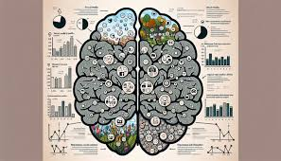
- Figure.1
Literature Review

Using Social Media Analytics to Detect and Address Mental Health Trends

Mental health is becoming one of the most pressing issues of our time, with growing concern across all age groups, especially among youth. As lifestyles become more digitalized, social media has emerged as both a challenge and an opportunity in the mental health landscape. On the one hand, platforms like Instagram, Twitter (X), TikTok, and Reddit can amplify stress, anxiety, and negative self-comparisons. On the other hand, they also serve as safe spaces where individuals openly express their feelings, seek help, and connect with communities experiencing similar challenges. This dual role makes social media a powerful source of real-time data on mental health trends.

By 2025, there are over 4.8 billion active social media users worldwide, which means that platforms reflect an enormous amount of real-time emotional states. Each like, comment, post, hashtag, or emoji shared online contains signals of individual and collective mental well-being. Communities frequently form around hashtags such as #Depression, #Anxiety, and #MentalHealthAwareness, allowing people to share their struggles, coping strategies, and supportive messages. For researchers, health professionals, and policymakers, analyzing this vast pool of information through Social Media Analytics (SMA) can unlock new insights into mental health conditions at global, regional, and demographic levels.

The Role of Social Media Analytics in Mental Health

Social Media Analytics involves the use of computational and statistical techniques to analyze online conversations, behaviors, and interactions. Unlike traditional surveys or clinical studies, SMA draws from large-scale, real-time, and organic data generated by millions of users. This allows for a more accurate and dynamic understanding of public mental health.

One of the key benefits is that SMA can identify patterns across geographical, age, and gender groups. For instance, young adults may express stress related to academic performance, while corporate employees may post about workplace burnout. Gender-based differences can also be detected, with women more likely to share experiences of anxiety or body image struggles, while men may discuss stress in professional or financial contexts.

Key Analytics Approaches

Several analytic approaches are used to extract meaningful insights from social media data:

1. Sentiment Analysis
This method detects the tone of a post, categorizing it as positive, negative, or neutral. For example, positive sentiments may be found in motivational content about recovery, while negative sentiments may indicate rising levels of stress or depression. Sentiment analysis allows researchers to measure the overall “emotional climate” of online spaces.

2. Topic Modeling
Topic modeling helps identify trending mental health themes. For example, during exam seasons, there may be a surge in discussions about “exam stress” or “study pressure.” Similarly, in professional communities, terms like “workplace burnout” and “toxic work culture” might dominate conversations. By clustering similar words and phrases, topic modeling can reveal emerging concerns that might otherwise go unnoticed.

3. Hashtag Tracking
Hashtags are powerful markers of online communities and movements. By monitoring tags such as #mentalhealth, #stress, #wellbeing, #selfcare, and #therapy, analysts can map the spread of mental health discussions and measure engagement levels. Tracking the rise or decline of hashtags can also indicate shifting public attitudes and priorities.
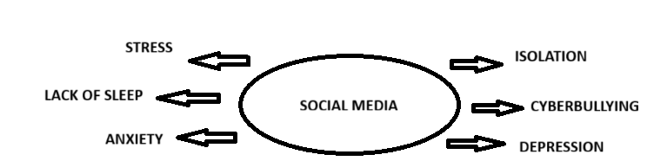
- Figure.2

4. Engagement Analysis
Beyond content, it is important to study how people interact with mental health posts. Engagement analysis looks at likes, shares, and comments to evaluate which types of content resonate the most. For example, a personal story of recovery shared by an influencer might generate thousands of supportive comments, showing the demand for relatable narratives.

5. Image and Emoji Analysis
Social media is increasingly visual. People often share emotional states through images, memes, and emojis. A sad emoji 😔 or broken heart 💔 can signal distress, while pictures with dark filters might reflect depressive moods. Advanced image recognition tools can detect recurring patterns, such as frequent posting of self-harm imagery, enabling timely interventions.

Identified Trends in Mental Health Discussions

The application of these analytics techniques has already highlighted important mental health trends worldwide:

- Pandemic-Driven Anxiety: During the COVID-19 pandemic, social media saw a dramatic increase in anxiety-related discussions. Hashtags like #pandemicstress and #lockdownanxiety trended globally, reflecting collective emotional distress. Students expressed worries about online learning, while employees voiced concerns about job insecurity.

- Exam Season Stress: Every year, a noticeable spike in anxiety-related posts appears during exam periods. Keywords such as “exam stress,” “study pressure,” and “failure fear” dominate conversations among younger users. This allows educators and policymakers to plan targeted interventions, such as stress-management workshops.

- Workplace Burnout: Among corporate circles, hashtags like #burnout and #mentalhealthatwork have been on the rise. Employees often discuss long working hours, toxic office environments, and lack of work-life balance. Such data helps organizations recognize the urgent need for wellness programs and flexible work arrangements.

- Peer-Support Communities: Platforms such as Reddit, Instagram, and Twitter (X) have seen the growth of peer-support groups where users share coping strategies and encourage one another. These communities provide emotional relief and reduce feelings of isolation for people struggling with depression and anxiety.

- Stigma Reduction: In recent years, mental health influencers and celebrities have started openly discussing therapy, medication, and self-care practices. Their openness has sparked widespread conversations, contributing to the reduction of stigma around seeking professional help. This trend highlights how online advocacy can influence real-world attitudes.

Opportunities and Challenges

The insights gained from Social Media Analytics hold immense promise for improving mental health support systems. Governments and health organizations can use this data for early detection of crises, resource allocation, and awareness campaigns. For example, identifying a sudden spike in self-harm discussions in a specific region could trigger targeted outreach programs.

However, several challenges must be addressed. Privacy concerns remain a major issue since analyzing personal posts can raise ethical questions. There is also the risk of misinterpretation—sarcasm, cultural differences, or coded language may lead to inaccurate analysis. Moreover, not everyone shares their mental health experiences online, meaning SMA captures only part of the picture.

Conclusion

Social media has become a mirror of society’s mental health struggles and triumphs. With billions of active users, platforms provide real-time insights into emotions, stressors, and coping mechanisms. Through advanced analytics techniques like sentiment analysis, topic modeling, hashtag tracking, engagement analysis, and image/emoji recognition, researchers can detect patterns and trends that reflect the collective mental well-being of populations. Identified trends—ranging from pandemic-driven anxiety to the rise of burnout discussions—demonstrate the power of social media as both a trigger and a support system.

If applied responsibly, Social Media Analytics can transform mental health monitoring and intervention strategies. By combining technology, ethics, and empathy, society can harness social media not just as a diary of distress, but as a tool for prevention, awareness, and healing.

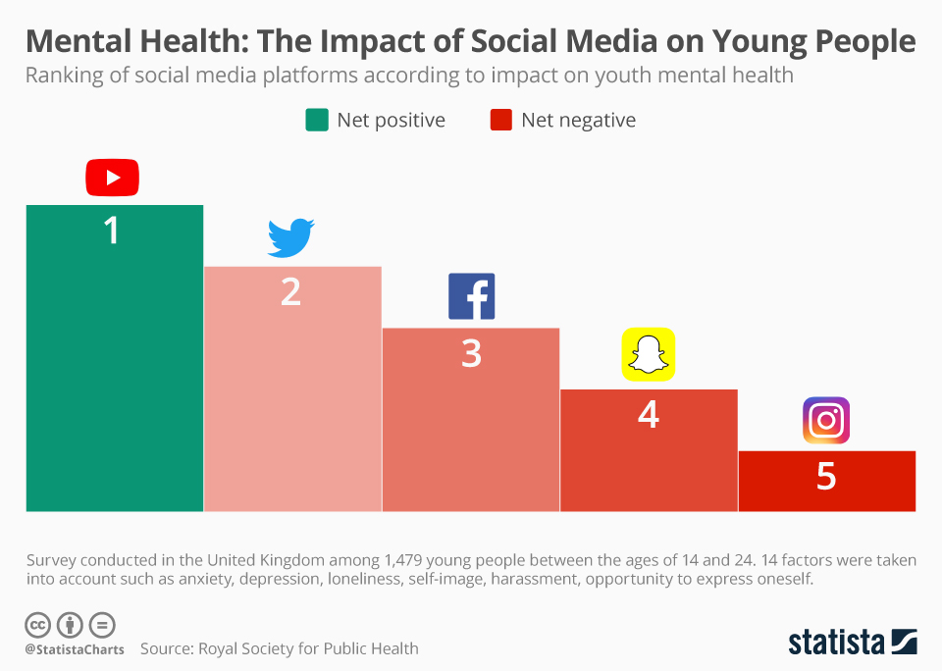
- Figure.3

References
JOURNALS/CONFERENCES
1. Fassi, L., et al. (2025). Social media use in adolescents with and without mental health conditions. Nature Human Behaviour.
https://www.nature.com/articles/s41562-025-02134-4 Nature
2.Nagata, J. M., et al. (2025). Social Media Use and Depressive Symptoms During Early Adolescence. JAMA Network Open.
https://jamanetwork.com/journals/jamanetworkopen/fullarticle/2834349 JAMA Network
3. Shannon, H., et al. (2022). Problematic Social Media Use in Adolescents and Young Adults: A Meta-analysis. JMIR Mental Health.
https://mental.jmir.org/2022/4/e33450 Mental Health Journal
4.Ulvi, O., et al. (2022). Social Media Use and Mental Health: A Global Analysis. MDPI.
https://www.mdpi.com/2673-3986/3/1/2 MDPI
5. Ahmed, O., et al. (2024). Social Media Use, Mental Health and Sleep: A Systematic Review. Journal of Affective Disorders.
https://www.sciencedirect.com/science/article/pii/S0165032724014265 ScienceDirect

