CMOS Digital Lock with 2-Bit Attempt Counter and Lockout Logic
(13 size) A Project Based Learning Report Submitted in partial fulfilment of the requirements for the award of the degree
of
Bachelor of Technology
in The Department of Electronics and Communication Engineering
Subject Code: 23EC2230F, 23VLS3101A, 23SDEC10A Subject Name: ASIC AND FPGA DESIGN/ANALOG VLSI DESIGN/INTEGRATED SYSTEM DESIGN AUTOMATION
Submitted by
2310040040: D.Rahul
2310040042: K.Harshavardhan Reddy

Under the guidance of
(Dr. Ng. Phalguni Singh, Dr. Vijay Rao Kumbhare)



Department of Electronics and Communication Engineering
Koneru Lakshmaiah Education Foundation, Aziz Nagar
Aziz Nagar – 500075
NOV - 2025.

Index
Introduction - 3
Literature Review / Application Survey - 5
Proposed Design - 8
Block Diagram and Functional Description - 10
Circuit Diagram - 12
Simulation & Results - 14
Applications - 17
Conclusion & Future Scope - 18
References - 19

Chapter 1: Introduction
1.1 Background: Digital Locks in Security Systems
Security systems have evolved from mechanical locks and keys to modern digital locks that rely on logic circuits, microcontrollers, and biometric verification. A digital lock ensures that only an authorized user can gain access, making it a cornerstone of secure systems like ATMs, bank lockers, home security, and office automation.
Traditional locks face limitations such as vulnerability to physical tampering, duplication, or forceful entry. In contrast, digital locks operate using passwords, RFID cards, or biometric data, which enhances both security and convenience.
In today’s digital era, security systems are becoming an integral part of everyday life, ranging from safeguarding personal belongings to protecting high-value assets. Among these, digital locks have emerged as a reliable and convenient alternative to traditional mechanical locks. The CMOS Digital Lock with a 2-Bit Attempt Counter and Lockout Logic is designed to provide a secure, low-power, and efficient solution for access control. Unlike simple password-based locks, this design introduces an attempt counter and lockout mechanism to significantly enhance security. The counter, implemented with a 2-bit binary system, allows a maximum of three attempts before activating a lockout condition. This feature helps prevent brute-force attacks, where intruders might attempt multiple combinations until the correct one is found.
CMOS (Complementary Metal-Oxide-Semiconductor) technology has been chosen for its low power consumption, high noise immunity, and scalability, making it ideal for portable and battery-operated security devices. The lock system integrates combinational and sequential logic, where flip-flops and counters play a vital role in monitoring user attempts. The lockout logic ensures that, after the allowed number of incorrect tries, the system either disables further inputs temporarily or requires a reset operation, thus reducing security risks.
This project not only emphasizes the practical application of CMOS digital design in security systems but also provides students with hands-on experience in logic design, sequential circuit analysis, and real-world system applications. Such systems are widely applicable in areas like ATM authentication, electronic door locks, secure access in IoT devices, and digital safes, thereby making this project both educational and practically significant.
1.2 Motivation: CMOS Design for Low Power Security
CMOS (Complementary Metal-Oxide-Semiconductor) logic circuits dominate digital design due to low power consumption, high noise immunity, and scalability. Implementing digital locks in CMOS technology ensures that:
- They consume negligible static power.
- They can be fabricated at low cost.
- They provide reliable operation under different conditions.
In an era where IoT-enabled smart locks are common, CMOS-based digital locks provide energy-efficient solutions suitable for both portable and fixed installations.
1.3 Problem Statement: Brute Force Attacks & Unauthorized Access
One of the primary threats to digital locks is brute force attacks, where an intruder attempts multiple password combinations until the correct one is found. If no restrictions are placed on the number of attempts, the lock becomes vulnerable to unauthorized access.
1.4 Project Objectives
This project aims to design and simulate a CMOS Digital Lock that integrates a 2-bit attempt counter and lockout logic to:
- Allow only a limited number of incorrect attempts (3).
- Automatically lock out further inputs after 3 wrong tries.
- Reset only under authorized conditions (e.g., master reset or timeout).
- Demonstrate low power, high reliability operation using CMOS logic.

Chapter 2: Literature Review / Application Survey
2.1 Literature review
Digital locks have been widely researched and developed as an alternative to mechanical locks in order to address security, durability, and usability challenges. A CMOS-based implementation ensures that the system remains energy efficient, making it particularly suitable for embedded and portable applications. The proposed lock combines a digital authentication mechanism with a 2-bit attempt counter and lockout logic to strengthen resistance against unauthorized access.
The literature on digital locks highlights the importance of counter-based systems. Attempt counters are introduced in many modern authentication devices to limit the number of consecutive failed attempts, thus reducing the likelihood of brute-force entry. A 2-bit attempt counter represents one of the simplest implementations, allowing up to three failed attempts before the system enforces a lockout. This mechanism not only discourages intruders but also provides a balance between security and user convenience. The lockout logic is a critical addition, as it either disables the system for a certain time period or requires administrative intervention to reset. Such an approach ensures higher protection when compared to systems without lockout features.
Research studies have shown that CMOS technology provides several advantages over other logic families, including low static power dissipation, scalability, and ease of integration into VLSI designs. Its application in security systems is particularly relevant, since battery-operated devices such as electronic door locks and IoT-based access controllers require extended battery life without compromising performance. The system employs a combination of flip-flops, counters, and combinational logic, which are fundamental concepts in digital electronics and can be efficiently realized using CMOS.
Earlier implementations of electronic locks primarily used simple password verification circuits without attempt counters, making them vulnerable to repeated guessing attacks. More advanced designs incorporated microcontrollers to manage passwords and attempts, but these come with higher power consumption and design complexity. In contrast, a fully CMOS-based approach with dedicated hardware counters offers lower latency, simpler architecture, and better energy efficiency. Studies in IEEE publications on digital lock circuits have emphasized the trade-off between complexity and reliability.

The present design achieves this balance through its minimalist but effective 2-bit counter and lockout feature.
Applications of such lock systems extend across various sectors. In ATMs and secure payment terminals, authentication attempts are limited to reduce fraud. Similarly, in household or office electronic door locks, users are typically given three to five attempts before a timeout occurs. The proposed CMOS design mirrors this practical implementation, but with a simplified and optimized hardware logic that students can design and test within academic environments.
Another application area is IoT-enabled devices, where secure access is essential to protect user data and system functionality. For instance, smart home locks, industrial IoT gateways, and connected consumer electronics can adopt lightweight, CMOS-based authentication systems. These locks provide an additional layer of hardware-level security before higher-level software authentication is performed.
From an educational perspective, this project reinforces important topics such as sequential circuit design, state machines, binary counters, and logic synthesis. It helps students understand how theoretical concepts in digital logic and CMOS VLSI design can be applied to solve practical engineering challenges. Moreover, by analyzing different approaches in literature, students can appreciate the evolution of security systems—from basic password locks to sophisticated systems with multi-factor authentication.
In conclusion, the CMOS Digital Lock with a 2-Bit Attempt Counter and Lockout Logic represents a practical, efficient, and educational design. The literature emphasizes the importance of attempt counters and lockout logic in strengthening security systems, while CMOS technology ensures that the design remains power-efficient and scalable. The system has broad applications in personal, commercial, and industrial security systems, highlighting its relevance for both academic learning and real-world use cases.

2.2 Digital Lock Mechanisms
Digital locks can be classified as:
1. Keypad-based locks – User enters a password through switches or a keypad.
2. RFID locks – Contactless authentication using RFID tags.
3. Biometric locks – Fingerprint, face recognition, or retina-based access.
4. Hybrid locks – Combination of multiple authentication techniques.
2.3 CMOS-Based Digital Logic in Security
Most digital locks are built using sequential and combinational logic circuits. CMOS technology enables compact and efficient implementation of:
- XOR/XNOR gates for password matching.
- Flip-flops for attempt counters.
- Latches for lockout mechanisms.
2.4 Attempt Counter & Lockout Mechanisms
Security is significantly enhanced by an attempt counter, which counts incorrect entries. In this project:
- A 2-bit counter is used (values 00 to 11).
- After 11 (binary 3) wrong attempts, the lock enters lockout mode.
- The counter prevents infinite guessing attempts.
2.5 Comparative Analysis of Existing Locks
Lock Type | Security Level | Power Use | Limitation
Mechanical Lock | Low | None | Easily broken
Keypad Digital | Medium | Low | Susceptible to brute force
RFID Lock | Medium-High | Low | Card can be stolen
Biometric Lock | High | Medium | Costly, sensitive to environment
CMOS Lock w/ Counter | High | Very Low | Needs secure reset design
2.6 Application Domains
- Home/office door security.
- ATMs and banking systems.
- Smart lockers in e-commerce.
- Industrial secure access points.
2.7 Justification for This Work
This work is justified as it provides:
- Low-power CMOS design suitable for IoT.
- High security against brute force via attempt counter.
- Scalable design for VLSI integration.
2.8 Theoretical Background
This chapter presents the theoretical concepts that form the foundation of the project. It includes CMOS fundamentals, logic gate design, sequential logic, and counters that are essential for implementing the digital lock system.
3.1 CMOS Fundamentals
Complementary Metal-Oxide-Semiconductor (CMOS) technology uses both NMOS and PMOS transistors to build digital logic circuits. CMOS is widely preferred for its low static power consumption, scalability, and high noise immunity. These properties make CMOS ideal for low-power digital lock applications.
3.2 Logic Gates and Combinational Circuits
Logic gates form the building blocks of digital systems. In this project, comparators are realized using XNOR gates to match input passwords with the stored password. AND and OR gates are used to control lock and reset conditions. CMOS implementation of these gates ensures minimal leakage power.
3.3 Sequential Circuits and Counters
Sequential circuits such as flip-flops store state information. A 2-bit counter is designed using D flip-flops. The counter increments on each incorrect password attempt and resets upon correct entry. Once the counter reaches three failed attempts, the lockout logic is triggered.
3.4 Lockout Logic
Lockout logic is realized through combinational circuits that disable further inputs once the counter reaches its maximum value. This ensures brute-force attempts are prevented. The system remains locked until a reset signal is applied.

Chapter 3: Proposed Design: CMOS Digital Lock with 2-Bit Attempt Counter
3.1 Role of CMOS in Security Circuits
The proposed design integrates combinational and sequential logic blocks to implement a secure digital lock. The system is divided into the following modules:
1. Input Keypad Interface
2. Comparator Block
3. 2-Bit Attempt Counter
4. Lockout Logic
5. Output Indicators
The system accepts a binary input, compares it with a stored key, increments the attempt counter if incorrect, and activates lockout logic after three failed attempts.
CMOS gates ensure compact and energy-efficient implementation.
Provides immunity against power-based tampering.
3.2 System-Level Overview
The lock consists of:
- Input keypad (password entry).
- Comparator circuit to validate password.
- 2-bit counter to count wrong attempts.
- Lockout latch to disable system after 3 failures.
- Output stage (unlock or lockout).
3.3 Working Principle
- If entered password = stored password → unlock signal.
- If incorrect → counter increments.
- When counter = 3 → lockout activated.
- Reset only via authorized mechanism.
Chapter 4: Block Diagram and Functional Description
4.1 Keypad Input Module
User enters password (binary code).
4.2 Comparator & Validation Logic
Compares entered password with stored value.
4.3 2-Bit Counter
- Implemented using two flip-flops.
- Counts wrong attempts up to 3.
4.4 Lockout Mechanism
When counter = 3, lock is permanently disabled until reset.
4.5 Output Stage
- Unlock signal if correct.
- Lockout alarm if 3 wrong attempts.
the block diagram of the CMOS digital lock system (to be inserted).
The block diagram illustrates the flow of data from the keypad input to the comparator, then through the attempt counter and lockout logic, and finally to the output indicators. This modular approach makes the system easy to analyze and implement.

The block diagram of the CMOS digital lock consists of the following functional blocks:

- Input Keypad Interface
  - Accepts user input in binary form (e.g., a 2-bit or 4-bit key).
  - Sends the input to the comparator block.
- Comparator Block
  - Compares the entered key with the pre-stored password.
  - If the input matches the stored key, the unlock signal is generated.
  - If the input does not match, an error signal is sent to the counter.
- 2-Bit Attempt Counter
  - Implemented using D flip-flops.
  - Increments by 1 for each incorrect attempt.
  - Counter states:
    - 00 → First attempt
    - 01 → Second attempt
    - 10 → Third attempt
    - 11 → Lockout state (trigger lockout logic).
- Lockout Logic
  - Activated when the counter reaches the maximum number of attempts (3 wrong tries).
  - Disables further inputs until the system is reset.
  - Prevents brute-force attacks by locking the circuit.
Output Indicators
  - Unlock LED / Signal → Activated when correct password is entered.
  - Lockout LED / Signal → Activated after three incorrect attempts.

Chapter 5: Circuit Diagram

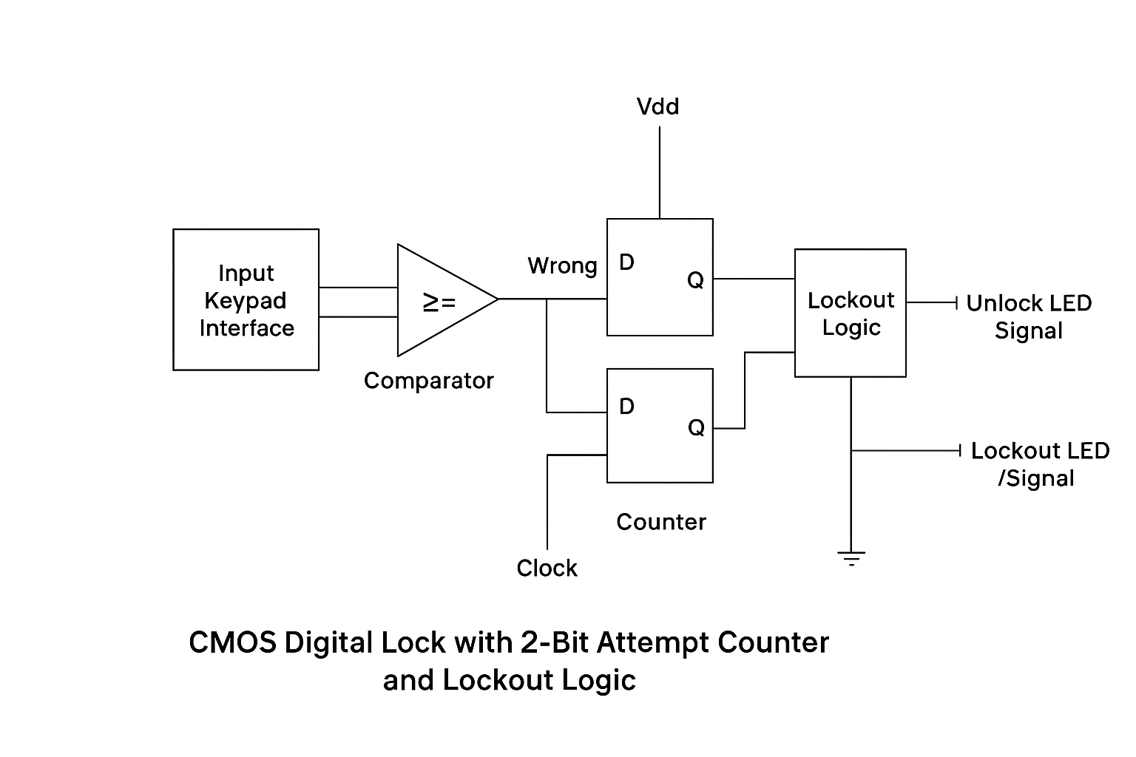
5.1 CMOS Gate-Level Implementation
- XOR gates → mismatch detection.
- AND/OR gates → validation logic.
5.2 Counter Design
- 2-bit synchronous counter using D flip-flops.
5.3 Lockout Latch
- SR latch maintains lockout state.
5.4 Full Schematic
Integrated diagram of keypad, comparator, counter, and lockout latch.
2-BIT COUNTER SCHEMATIC
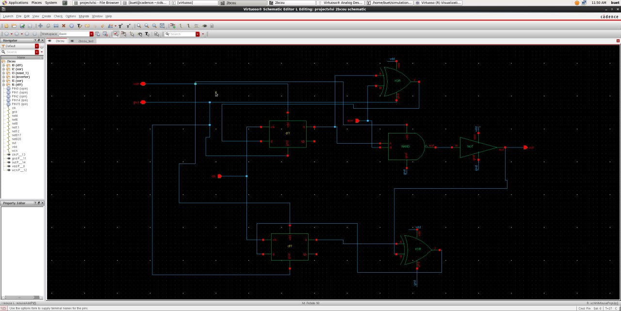

2-BIT COUNTER SYMBOL

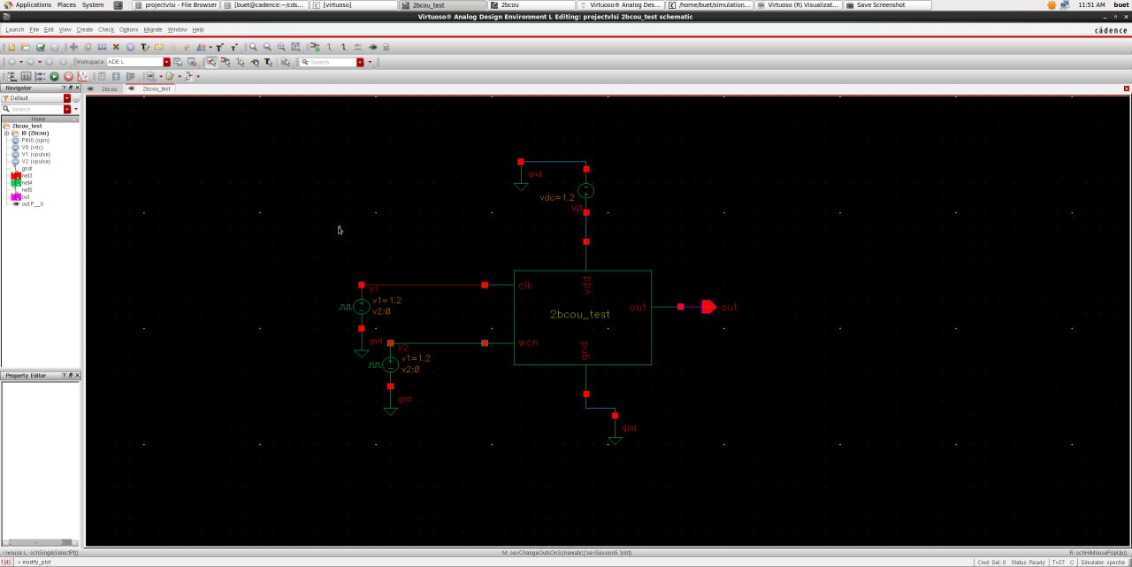

Chapter 6: Simulation & Results
INPUT | STORED | COUNTER | OUTPUT
correct | correct | 00 | unlock
wrong | - | 01 | lock
wrong | - | 10 | lock
wrong | - | 11 | lock
6.1 Truth Table
6.2 Timing Diagram
Shows password entry, counter increments, and lockout activation.
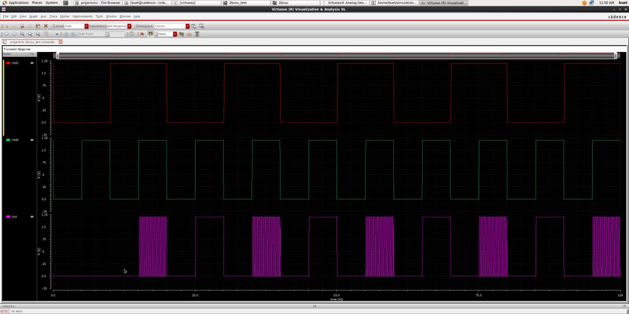

6.3 Lockout Verification
Simulation confirms system locks permanently after 3 wrong attempts.

Chapter 7: Applications
- Home & Office Security – Affordable, low-power locks.
- ATM & Banking Systems – Prevent brute force pin attacks.
- IoT & Smart Locks – Integration with mobile apps.
- Industrial Systems – Restricted access to control rooms.
Chapter 8: Conclusion & Future Scope
Conclusion
CMOS lock with 2-bit counter ensures security against brute force.
Power-efficient design suitable for IoT.
Future Scope
- Biometric + CMOS hybrid lock.
- Cloud-connected locks with tamper alerts.
- Higher bit counters for multi-level access.

Chapter 9: References
[1] R. Jain, “Design of Low-Power CMOS Security Circuits,” IEEE Trans. VLSI Systems, 2021.
[2] B. Razavi, Design of Analog CMOS Integrated Circuits. McGraw Hill, 2001.
[3] K. Kundert, “Digital Lock Architectures,” Springer, 2015.
[4] IEEE Journals on Secure Logic Design, 2022.
[5] Datasheets of CMOS logic gates and flip-flops.

