Low-Power 4-Bit ALU using Adiabatic Logic with FINFET Technology
(13 size) A Project Based Learning Report Submitted in partial fulfilment of the requirements for the award of the degree

of

Bachelor of Technology
in The Department of ECE
ASIC AND FPGA (23EC2237F), ANALOG VLSI (23VLS3101A), INTEGRATED SYSTEM DESIGN AUTOMATION (23SDEC10A)

Submitted by
2310040049: D. Navya
2310040064: M. Gayathri
2310040072: G. Akshaya

Under the guidance of
Dr. Ngangbam Phalguni Singh and Dr. Vijay Rao Kumbhare



Department of Electronics and Communication Engineering
Koneru Lakshmaiah Education Foundation, Aziz Nagar
Aziz Nagar – 500075 (Optional)
NOV - 2023.
Abstract

In today’s era of rapidly advancing semiconductor technology, the continuous scaling down of devices has enabled the creation of smaller, faster, and more efficient integrated circuits. However, this miniaturization also introduces new challenges, particularly in terms of power consumption and leakage current. As device dimensions shrink, leakage power has become a dominant component of total power consumption, which significantly reduces the energy recovery efficiency in adiabatic logic circuits. Managing this leakage while maintaining high performance and energy efficiency is one of the most critical issues in modern VLSI design.
To address this problem, this paper presents the design and implementation of a low-power 4-bit Arithmetic Logic Unit (ALU) using adiabatic logic based on FinFET technology. The FinFET (Fin Field Effect Transistor) structure provides excellent electrostatic control over the channel and minimizes short-channel effects, allowing circuits to operate at lower supply voltages without compromising reliability. The proposed 4-bit ALU performs a total of seven fundamental operations, including three arithmetic operations—addition, subtraction, and comparison—and four logical operations—AND, OR, XOR, and NOT. These functions are essential for performing basic computing tasks in processors and digital systems.
The design employs Efficient Charge Recovery Logic (ECRL), a well-known adiabatic logic technique that enables partial recovery of energy during switching transitions. Unlike conventional CMOS logic, which dissipates energy during each charge and discharge cycle, ECRL circuits recycle a portion of the energy, leading to substantial power savings. When combined with FinFET technology, this approach results in even lower dynamic and static power dissipation, making it highly suitable for low-power VLSI applications.
FinFET-based circuits also provide other advantages such as reduced leakage current, higher drive current, and better scalability compared to planar CMOS technology. The improved control of the gate over the channel helps to minimize off-state leakage, allowing the circuit to function effectively at lower operating voltages. This makes the proposed ALU design not only power-efficient but also faster and more reliable.
Simulation and performance analysis were carried out to evaluate the effectiveness of the FinFET-based adiabatic ALU. The results demonstrate that the proposed design achieves a significant reduction in total power consumption compared to traditional CMOS implementations, without any major compromise in operating speed or output accuracy. The experimental outcomes confirm that using adiabatic logic in combination with FinFET devices enhances energy recovery efficiency and provides better power–performance trade-offs.
CIRCUIT DIAGRAMS:

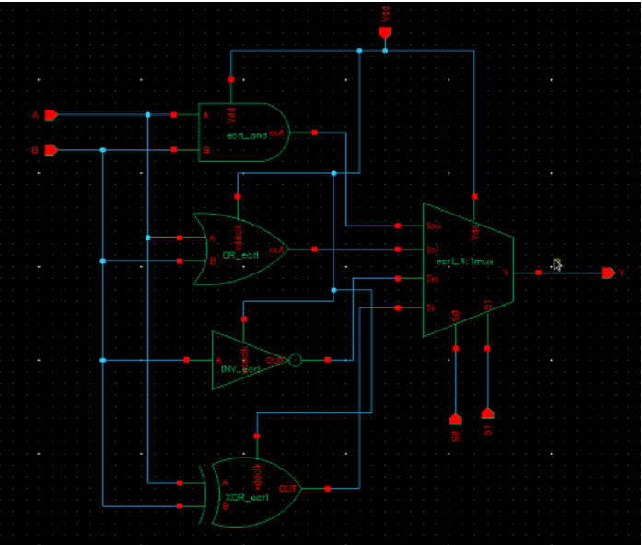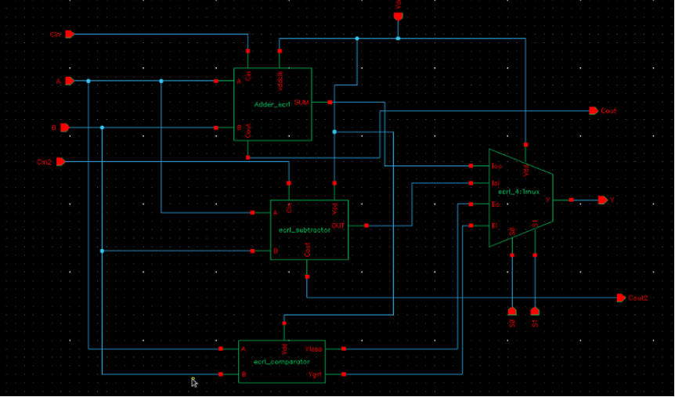
Fig 1.1 Design of Logical Block Fig 1.2 Design of Arithmetic block
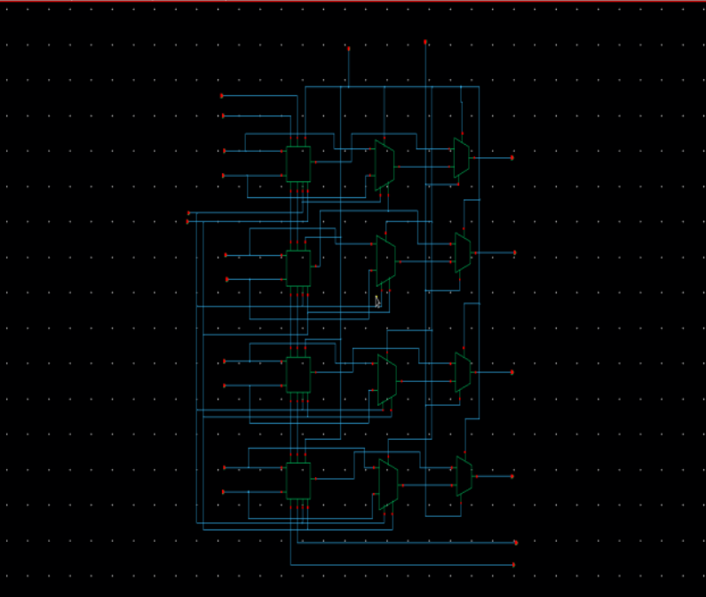
Fig 1.3 Design of complete 4 Bit ALU Block

List of Tables

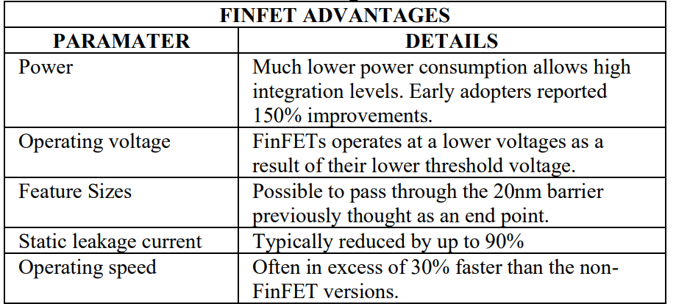
Tabel 2.1 : Advantages of finfet

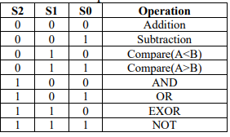
Tabel 2.2: Operation of ALU

Low-Power 4-Bit ALU using Adiabatic Logic with FINFET Technology

Introduction
The evolution of integrated circuit (IC) technology has transformed modern electronics, with MOS transistors playing a crucial role in improving device performance and density. However, as MOS devices continue to be scaled down to achieve higher integration, traditional bulk CMOS technologies face severe challenges, including increased leakage currents, short-channel effects, and higher power consumption. To overcome these limitations, multi-gate transistors such as Fin Field-Effect Transistors (FinFETs) have emerged as a promising alternative for low-power and high-performance VLSI design.
FinFETs utilize a double-gate or wrap-around structure that provides better electrostatic control over the channel, effectively reducing subthreshold leakage, drain-induced barrier lowering, and other short-channel effects. The technology allows threshold voltage adjustment through back-gate biasing, enabling reduced static and dynamic power consumption compared to conventional MOSFETs. FinFETs also offer faster switching speed, higher drive current, and improved energy efficiency, making them highly suitable for modern digital circuits.
In this work, a 4-bit Arithmetic Logic Unit (ALU) is designed using FinFET-based adiabatic logic to further minimize power consumption. The proposed design combines Efficient Charge Recovery Logic (ECRL) with FinFET technology to enhance performance and reduce energy loss. The paper presents the design methodology, simulation results, and performance analysis of the FinFET-based 4-bit ALU, demonstrating its advantages over conventional CMOS implementations.

- Literature Survey

Several researchers have explored FinFET and adiabatic logic technologies to address the limitations of traditional CMOS circuits in terms of power and performance. Nirmal et al. [1] discussed the evolution of double-gate transistors (FinFETs) as replacements for bulk CMOS due to their ability to reduce leakage and power consumption through independent gate control. Utkarsh Tripathi et al. [2] designed and compared adder circuits using MOSFET and FinFET technologies, finding that FinFETs offered better power efficiency and reduced delay. Tawfik et al. [3] proposed independently biased double-gate FinFET flip-flops that reduced power and area significantly while maintaining speed and stability.
A. Datta et al. [4] developed low-power logic designs using independent-gate FinFETs and demonstrated notable area and power savings. Mayank Shrivastava et al. [5] introduced a novel bottom spacer FinFET structure for SoC applications with improved short-channel control and reduced self-heating. Shivani Chopra et al. [6] emphasized that as CMOS technology approaches physical limits, FinFET and nanostructure devices are essential for continued scaling.
To further reduce dynamic power, several researchers explored adiabatic logic techniques. Preeti Bhati et al. [7] demonstrated that PFAL-based adiabatic circuits consume less power than conventional CMOS designs. Jitendra Kanungo et al. [8] analyzed efficient power-clock generators to improve energy recovery in adiabatic systems. P. Kalyani et al. [9] showed that subthreshold adiabatic logic can save over 90% power compared to static CMOS. Akash Agrawal et al. [10] compared adiabatic logic families and proposed the DCDB-PFAL approach, achieving superior performance and ultra-low power dissipation.
Overall, prior research confirms that combining FinFET technology with adiabatic logic provides a powerful approach for achieving low-power, high-performance VLSI circuit designs.

METHODOLOGY

The design and validation of a low-power 4-bit ALU using FinFET-based adiabatic logic involves six main stages: problem definition, adiabatic logic design, FinFET modeling, ALU design, simulation, and validation.
- Problem Definition:
Traditional CMOS ALUs suffer from high dynamic and leakage power, especially in deep sub-micron technologies. The objective is to design a 4-bit ALU performing addition, subtraction, comparison, AND, OR, XOR, and NOT operations, with reduced power dissipation and improved energy recovery.
- Adiabatic Logic Design:
Efficient Charge Recovery Logic (ECRL) is used due to its simplicity, complementary outputs, and energy recovery with sinusoidal power-clock. Adiabatic inverters are designed with power gating to minimize leakage, forming the basis for gates and arithmetic units.
- FinFET Device Modeling:
FinFETs are chosen for their superior electrostatic control, reduced leakage, and low-voltage operation. Predictive Technology Models (PTM) for n- and p-FinFETs at 16–22 nm nodes are used, with parameters like threshold voltage, fin width, height, and gate length optimized for low power.
- ALU Design:
- Arithmetic Unit: Adiabatic full adders handle addition/subtraction; comparators use XOR-based magnitude comparison.
- Logic Unit: Adiabatic AND, OR, XOR, NOT gates with optimized FinFETs.
- Integration: Arithmetic and logic blocks are combined, with adiabatic MUX for operation selection.
- Simulation Environment:
Cadence Virtuoso and Synopsys HSPICE are used with sinusoidal power-clock and Vdd 0.6–1V. Metrics include power, delay, energy recovery efficiency, and area utilization.
- Validation and Comparison:
The ALU is benchmarked against conventional CMOS and MOSFET-based adiabatic ALUs for power, delay, leakage, and power-delay product (PDP). Expected outcomes include reduced power, improved energy recovery, lower leakage, and enhanced performance at reduced voltages.

EXPERIMENTS

Design and Implementation of a 4-bit ALU using Adiabatic Logic on FinFET Technology focuses on reducing power consumption during digital computations by recovering energy instead of dissipating it as heat. A 4-bit ALU performing basic operations such as ADD, SUB, AND, OR, and XOR is first implemented using conventional CMOS logic with FinFET devices. Then, the same ALU is redesigned using an adiabatic logic style (such as PFAL), where a time-varying power-clock supply allows charge to be partially reused during transitions. Both designs are simulated using FinFET device models in SPICE, and parameters such as energy per operation, propagation delay, and power-delay product (PDP) are measured. Results typically show that the adiabatic logic ALU consumes significantly less dynamic power at lower operating frequencies, making it suitable for low-power applications.

RESULTS

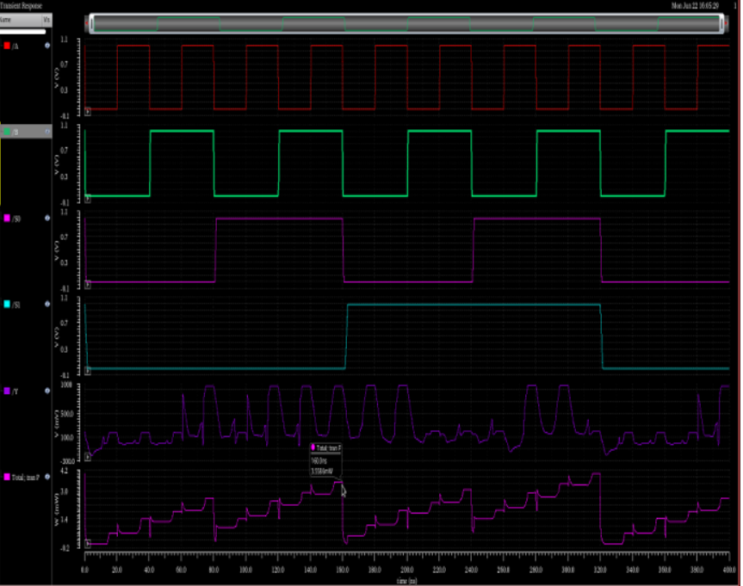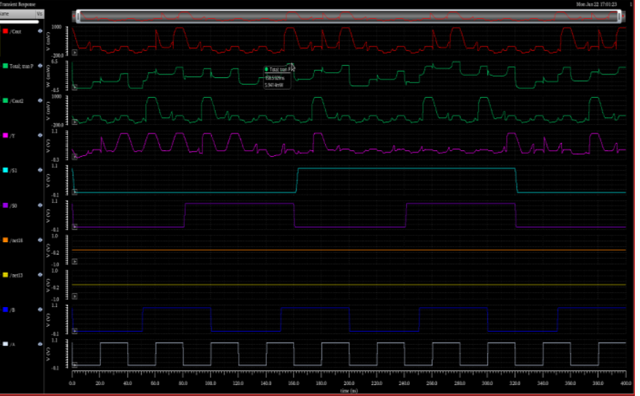
Fig 5.1 Simulation results of Logical Block Fig 5.2 Simulation results of Arithmetic block

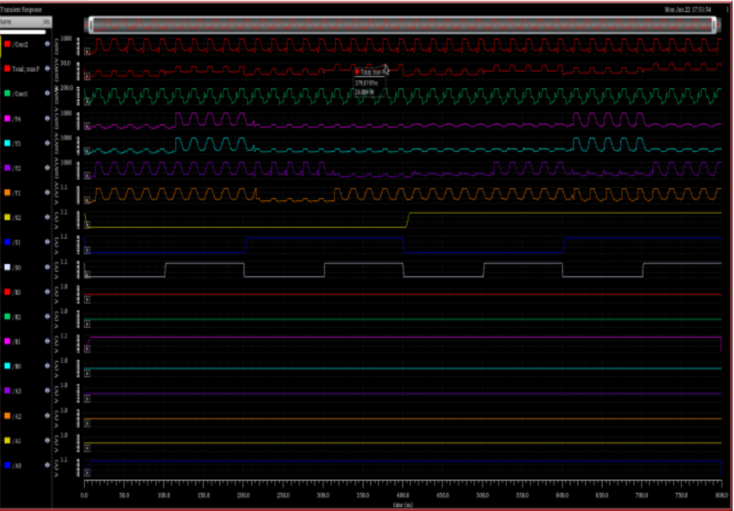

Fig 5.3 Simulation Results of 4 Bit ALU Block

CONCLUSION and FUTURE WORK
In this work, a 4-bit Arithmetic Logic Unit (ALU) was designed and implemented using Adiabatic Logic techniques based on FinFET technology to achieve low-power operation. The performance of the proposed adiabatic ALU was compared with a conventional FinFET CMOS-based ALU. Simulation results show that the adiabatic logic design significantly reduces dynamic power consumption by recovering and reusing part of the energy during signal transitions. This makes the circuit more suitable for low-power and battery-operated systems. However, the design exhibits slightly increased circuit complexity and may suffer performance limitations at very high operating frequencies.
Future work can focus on optimizing the adiabatic power-clock generator to further improve energy recovery efficiency. Additionally, extending the ALU width beyond 4 bits and integrating more arithmetic and logical operations can help evaluate the scalability of the design. Implementing the system on emerging multi-fin FinFET nodes or exploring other adiabatic logic families can also lead to further improvements in power efficiency and performance.

References

[1] Nirmal , Vijay Kumar and Sam Jabaraj,” NAND Gate Using FinFET for NanoScale Technology”, International Journal of Engineering Science and Technology, VoI2(5), 13 15- 1358,20 10
[2] Utkarsh Tripathi,Ms.Tamanna Ashraf Siddiqu,”Optimization Of A Fulladder Based On FinFET Technology”,International Journal of Advanced Research in Computer and Communication Engineering,Vol. 7, Issue 6, June 2018
[3] S.A.Tawfik and V.Kursun.,“Low-power and compact sequential circuits with independentgate FinFETs.”, IEEE Transaction Computer Aided Design. Volume 26. no 55. pp 60-70. January 2008.
[4] A.Datta, A.Goel , R.T.Cakichi , H.Mahmoodi, D.Lakshmanan, and K.Roy.,” Modeling and circuit synthesis for independently controlled double gate FinFET devices. “,IEEE Transaction Computer Aided Design. Volume 26. no 11. pp 1957-1966. Nov 2007.
[5] Mayank Shrivastava, M.S.Baghni, D.K.Sharma, V.R.Rao .”A novel bottom spacer FinFET structure for improved shortchannel, power delay, and thermal performance”,.IEEE Trans. On Electron Devices.vol. 57.no.6. pp 1287-1294 June 2010
[6] Shivani Chopra and Subha Subramaniam, “A Review on Challenges for MOSFET Scaling”, IJISET - International Journal of Innovative Science,Engineering & Technology, Vol. 2 Issue 4, April 2015,ISSN 2348 – 7968.
[7] Preeti Bhati, Navaid Z. Rizvi,”Adiabatic Logic: An Alternative Approach To Low Power Application Circuits “, International Conference on Electrical, Electronics, and Optimization Techniques (ICEEOT) – 2016
[8] Jitendra Kanungo, S. Dasgupta,”Performance analysis of a complete adiabatic logic system driven by the proposed power clock generator”, IOPscience, Vol. 35, No. 9, September 2014
[9] P.Kalyani ,P.Satish Kumar, P.Chandrasekhar, Energy Efficient Logic Gates Using Subthreshold Adiabatic Logic, IEEE conf International Conference on Electronics and Communication Systems.2015
[10] Akash Agrawal ,Tarun Kumar Gupta , “A Novel Efficient Adiabatic Logic Design for Ultra Low Power”, International Conference on Soft Computing Techniques and Implementations- (ICSCTI), Oct 8-10, 2016.

