CS2 Smart Replay Platform
Software Requirements Specification

Team: software_clan
Course: Modern Software Engineering
Document Version: V1.1
Date: October 2026

Document Revision History
Version | Date | Author | Revision Summary
V0.1 | 2026-10 | All members | Confirmed the topic direction and functional framework; produced the first draft
V1.0 | 2026-10 | software_clan | Completed requirements analysis; submitted for review
V1.1 | 2026-10 | software_clan | Added UML domain class model (5.6) and interface prototypes (Chapter 7); renumbered subsequent chapters; corrected the reference URL

Contents
1 Introduction
1.1 Purpose
1.2 Background
1.3 Scope
1.4 Terms and Definitions
1.5 References
2 Project Overview
2.1 Project Positioning
2.2 Team Vision and Goals
2.3 Users and Typical Scenarios
2.4 Stakeholders
3 NABCD Competitive Requirements Analysis
3.1 Need
3.2 Approach
3.3 Benefits
3.4 Competitors
3.5 Delivery
3.6 Elevator Pitch
4 User Requirements Analysis
4.1 Personas
4.2 User Pain Points
4.3 User Research Plan
5 Functional Requirements
5.1 Overview
5.2 Intelligent Demo Review
5.3 Campus Squad Formation
5.4 Web Aim Training
5.5 Account and Personal Center
5.6 Domain Model and UML Class Diagram
6 Typical Use Cases
UC1 Upload a Replay and Obtain a Review Report
UC2 Post and Join a Squad
UC3 Do Aim Training
7 Interface Prototype
7.1 Review Report
7.2 Squad Lobby
7.3 Aim Training
7.4 Personal Center
8 Non-Functional Requirements
9 Functional Priority and Boundary Conditions
9.1 Four Quadrants
9.2 KANO Classification
9.3 Boundary Conditions
9.4 Side Effects and Dependencies
10 Technical Solution Overview
10.1 System Architecture
10.2 Data Sources
10.3 Key Technologies
10.4 Design Principles
11 Acceptance Criteria and Delivery
11.1 Acceptance Criteria
11.2 Post-Launch Data Collection Plan
11.3 Milestones
12 Compliance and Engineering Ethics
Appendix A Glossary
Appendix B Data Metrics

1 Introduction

1.1 Purpose
This document is the Software Requirements Specification (SRS) for the CS2 Smart Replay Platform project. It aims to describe, completely and accurately, the functions, user interactions, performance and quality requirements, boundary conditions, and compliance constraints that the software must implement, serving as a common basis for the team's development, testing, and acceptance. It also acts as an attachment to the project team blog and as supporting material for the topic presentation. This document is written mainly from a functional-specification perspective, treating the software as a black box and describing its external functions and user interactions; Chapter 10 provides an overview of the technical solution from a technical-specification perspective.

1.2 Background
Counter-Strike 2 (CS2) is a first-person-shooter esports title developed by Valve, with a large number of players among university students in China. Its competitive gameplay depends heavily on data: economy management, map control, grenade coordination, and duel win rates directly affect the outcome. Professional teams generally employ dedicated data analysts, while ordinary student players lack such tools. After a match, they can only scrub through the demo manually, which takes more than an hour and rarely reveals deeper problems; forming a squad and analyzing opponents rely mainly on word of mouth through social apps. At the same time, CS2 has a mature open-data ecosystem: Valve provides Game State Integration (GSI) and static data, the community offers the mature open-source demo parsing engine awpy, and the third-party competitive platform FACEIT provides official data APIs, making it realistic for a student team to build this platform within one semester.

1.3 Scope
This document covers the functional and non-functional requirements of four modules: intelligent Demo review, campus squad formation, a web-based aim-training mini-game, and the account and personal center, together with architecture, acceptance, and compliance requirements.
This document does not include: development of the game itself; any hardware peripherals; large-model (LLM) features; any feature that affects match fairness; or support for games other than CS2 (such as MOBAs), which is only a possible long-term direction and is out of scope for this phase.

1.4 Terms and Definitions
The main terms used in this document include Demo/GOTV replay, tick, Rating, ADR, KAST, ECO round, GSI, FACEIT, heat map, and Aim Trainer; full definitions are given in Appendix A.

1.5 References
(1) Zou Xin, The Method of Construction: Modern Software Engineering (3rd ed.), Chapter 8 Requirements Analysis and Chapter 10 Typical Users and Scenarios;
(2) The awpy open-source project and official documentation: https://github.com/pnxenopoulos/awpy ; https://awpy.readthedocs.io ;
(3) The CS Demo Manager open-source project (functional and interaction reference): https://github.com/akiver/cs-demo-manager ;
(4) Valve Game State Integration (GSI) official documentation;
(5) Course assignment page: https://bbs.csdn.net/topics/620549144 .

2 Project Overview

2.1 Project Positioning
The project is named CS2 Smart Replay Platform. It is positioned as a web-based data-analysis platform for CS2 players, centered on intelligent post-match review, supported by a campus squad-formation feature and a web-based aim-training mini-game. The platform does not develop games or intervene in matches; it provides analysis services solely on the basis of officially open data and post-match replays.

2.2 Team Vision and Goals
Most team members play CS2 and have often run into the situation of wanting to improve but being unable to pinpoint the problem, while manual review is too time-consuming, so we plan to use software-engineering methods to solve this problem for ourselves and for players around us. We expect to complete requirements analysis, development, testing, and release within one semester, going through Alpha and Beta versions, and to put core features such as automatic review after Demo upload and campus squad formation into real use. The criteria for project success are that the platform has real registered users and parsed matches, and that users can reproduce the complete analysis flow on the spot.

2.3 Users and Typical Scenarios
(1) Post-match review: after a match, a player uploads the replay and receives a structured review report within a few minutes to identify weaknesses;
(2) Queueing as a group: a player finds teammates with complementary roles and similar ranks in the squad lobby and forms a squad;
(3) Aim practice in spare time: while waiting for a match or between classes, a player uses the web aim mini-game to train positioning, reaction, and tracking;
(4) Esports club training: the university esports club uses the platform for member data management and match review.

2.4 Stakeholders
Role | Description | Core Needs
Core users (student players) | CS2 players at our university | Fast review, identifying weaknesses, forming squads
University esports club | The club that organizes training and intra-school competitions | Member data management, match review
Casual mini-game users | Users who may not play CS but are willing to play the web aim mini-game | Casual challenge, reaction training
Platform operators (our team) | The platform development and operation team | A usable product, data compliance, user growth
Data providers | Providers of the Valve interfaces | Developers following their interface policies

3 NABCD Competitive Requirements Analysis

3.1 N: Need
The core needs are low-cost, high-quality post-match review and efficient campus squad formation; players also need aim training that can be done in fragments of spare time. Specific pain points are detailed in Section 4.2.

3.2 A: Approach
(1) Build our own parsing and analysis pipeline on top of the open-source awpy engine, generating a review report within minutes after a replay is uploaded;
(2) Provide in-depth review dimensions such as heat maps, economy, grenade effects, and weakness diagnosis, forming a diagnose-train-review-again loop;
(3) For the vertical campus scenario, provide squad-formation features based on our university identity;
(4) Embed a pure web, offline-playable aim-training mini-game in the front end, with no additional server cost;
(5) The team itself consists of target players, familiar with the user scenarios and the Python data stack.

3.3 B: Benefits
(1) Review time is shortened from more than an hour to a few minutes;
(2) Key data is quantified automatically, weaknesses are clear, and training is targeted;
(3) Forming a squad changes from asking in group chats to one-click matching in the squad lobby;
(4) Aim training is available as soon as the web page is opened, with no installation and free of charge;
(5) User migration cost is low: the platform is web-based and the core features require no installation.

3.4 C: Competitors
Competitor | Form | Strengths | Weaknesses
Leetify | Pure software review platform | Fairly comprehensive analysis dimensions | Paid subscription, no campus squad formation, inconvenient access and payment in China
GGPredict, etc. | Review and training platforms | Combine review and training | Paid subscription, no campus squad formation
Aim Lab | Aim-training software | Rich training modes, detailed data analysis | Requires download and installation, no CS2 match review, no campus squad formation
Built-in FACEIT statistics | Platform built-in statistics | Free, complete match data | Shallow statistics, FACEIT matches only
5e, Perfect World, and similar assistants | PC match assistants | Free, adapted to Chinese servers | Cluttered features, many ads, limited review depth, no squad formation

Our differentiated positioning is free + in-depth review + campus squad formation + web-based aim training playable on the spot; this combination currently has no direct competitor.

3.5 D: Delivery
(1) Cold start: pilot with classes, dormitories, and the university esports club, with seed users invited by team members;
(2) Traffic: the web aim mini-game has zero barriers and can be played even without playing CS, bringing visits through social sharing and then guiding users to learn about the review feature;
(3) Spread: automatically generate shareable review report cards and post review content in CS-related communities;
(4) Cooperation: work with the university esports club to provide data services for its training and intra-school competitions;
(5) Launch: the front end uses static hosting and the back end is deployed on a cloud server.

3.6 Elevator Pitch
We built the CS2 Smart Replay Platform because student players find post-match review difficult and improve slowly; they need affordable, reliable match analysis, but existing products are either paid, shallow in analysis dimensions, or do not support campus squad formation. We build an automatic review pipeline on a mature open-source parsing engine, able to generate within minutes a report containing heat maps, economy, grenades, and weakness diagnosis, and we provide campus squad matching and aim training playable as soon as the web page is opened, benefits that far exceed existing free tools. Meanwhile, using classes, dormitories, the esports club, and a shareable mini-game as our promotion paths, we can quickly get players at our university using the product and spreading it further.

4 User Requirements Analysis

4.1 Personas
Persona | Characteristics | Core Needs
Competitive student player | Has a fixed rank, pursues rank-up, plays frequently | In-depth data review, weakness identification, targeted training
Casual social player | Enjoys playing with friends, values the squad process | Quickly forming a suitable squad, relaxed fun
Esports club lead | Organizes training and matches, manages multiple members | Member data management, team match review
Spare-time aim practicer | Fragmented time, seeks quick training and feedback | Aim training playable on the spot, score records

4.2 User Pain Points
(1) High review cost: watching one match demo manually takes more than an hour, and ordinary players lack an analysis framework and struggle to locate problems;
(2) Incomplete data: the in-game results screen provides only a small amount of data such as kills and deaths, while dimensions such as economy, grenades, map control, and duel win rates are missing;
(3) Inconvenient access to match information: checking teammates' economy and status requires frequent Tab presses, interrupting play;
(4) Low squad-formation efficiency: forming a squad relies on word of mouth in QQ and WeChat groups, with role conflicts and rank mismatches;
(5) Cumbersome replay management: replays must be downloaded manually in game, only recent matches are kept, and downloaded files are archives that must be extracted manually;
(6) Training lacks targeting: players do not know where their shortcomings lie, and aim practice is disconnected from real matches.

4.3 User Research Plan
(1) User survey questionnaire: distributed to classes, dormitories, and the esports club, collecting ranks, review habits, pain-point ranking, and feature expectations;
(2) In-depth interviews: interviewing a number of players of different ranks and esports club leads;
(3) Card sorting: asking users to categorize the proposed features and rank their priorities;
(4) Rapid prototyping: collecting feedback with page prototypes to verify the information organization of the review report.
Questionnaires are distributed broadly to classes, dormitories, and the esports club, and players of different ranks and esports club leads are selected for interviews, with the goal of collecting sufficient and effective feedback.

5 Functional Requirements

5.1 Overview
ID | Module | Functions | Priority | Version
FR-1 | Demo review | Replay upload, asynchronous parsing, overview, heat map, economy, combat data, grenades, weakness diagnosis | High | Alpha/Beta
FR-2 | Squad formation | Player profile, squad lobby, apply to join, smart recommendation, mutual rating | Medium | Beta
FR-3 | Aim training | Gridshot, Reaction, Spidershot, Microshot, Tracking, score records | Medium | Alpha/Beta
FR-4 | Account center | Registration and login, personal center, privacy settings | High | Alpha

5.2 Intelligent Demo Review
FR-1-1 Replay Upload [Priority: High]
The user selects and uploads an extracted .dem file on the web page, and the front end shows the upload progress and result; the system validates the file format and gives a clear prompt for non-CS2 replays or corrupted files. Input: a .dem file; output: upload status.
FR-1-2 Asynchronous Parsing Queue [Priority: High]
The server places parsing tasks in a queue and executes them in order, avoiding long blocking by large files; the front end can poll or receive queued / parsing / completed / failed status.
FR-1-3 Match Overview [Priority: High]
Displays the map, score, duration, both lineups, and a per-round win/loss timeline, presenting the overall trend of the match.
FR-1-4 Radar Heat Map [Priority: High]
Renders engagement points, death points, and movement trajectories on the map radar, with filtering by round and by player.
FR-1-5 Economy Analysis [Priority: Medium]
Plots both teams' per-round money curves, automatically marks ECO, force-buy, and full-buy rounds, and comments on key economy rounds.
FR-1-6 Combat Data [Priority: High]
Automatically calculates Rating, ADR, KAST, K/D, opening-kill count, clutch win rate, and duel win rate.
FR-1-7 Grenade Analysis [Priority: Medium]
Records flash-blind targets and duration, grenade damage, and areas blocked by smoke.
FR-1-8 Weakness Diagnosis and Training Advice [Priority: Medium]
Summarizes problems and gives targeted training advice, recommending corresponding training modes, map positions, or grenade practice.

5.3 Campus Squad Formation
FR-2-1 Player Profile [Priority: Medium]
Displays rank or FACEIT level, preferred roles, map pool, frequently used weapons, and online status.
FR-2-2 Squad Lobby [Priority: Medium]
Players can post a squad (missing roles, start time) and browse the list of existing squads.
FR-2-3 Apply and Join [Priority: Medium]
Other players can apply to join a squad with one click, and the poster approves it to complete the squad.
FR-2-4 Smart Recommendation [Priority: Low]
Recommends teammates and squads based on complementary roles, similar ranks, and map-pool overlap.
FR-2-5 Mutual Rating [Priority: Low]
After a match, members rate each other, accumulating a credit record.

5.4 Web Aim Training
FR-3-1 Gridshot [Priority: High]
Multiple targets appear on a grid and must be hit one by one quickly within a time limit, training positioning and hand speed.
FR-3-2 Reaction Test [Priority: High]
After a target appears or the screen changes color, click as quickly as possible; reaction time in milliseconds is measured and recorded.
FR-3-3 Spidershot [Priority: Medium]
A target appears at a random position on screen, and the next appears randomly after a hit, training large flicks.
FR-3-4 Microshot [Priority: Medium]
Very small targets appear, training fine aiming and micro-adjustment.
FR-3-5 Tracking [Priority: Low]
The target keeps moving and the crosshair must stay on it; the proportion of time on target is recorded, training tracking.
FR-3-6 Score Records [Priority: Medium]
Records hit rate, hits per minute, average reaction time, and best scores; when not logged in, scores are stored locally in the browser and can optionally be synced after login.

5.5 Account and Personal Center
FR-4-1 Registration and Login [Priority: High]
Supports account registration, login, and logout, with passwords stored encrypted.
FR-4-2 Personal Center [Priority: Medium]
Displays personal match history, review report entries, and aim-training score curves.
FR-4-3 Privacy Settings [Priority: High]
Review reports are private by default, and users can choose whether to share them.

5.6 Domain Model and UML Class Diagram
The domain model of the platform is described with UML class diagrams. The main entities include users and player profiles, replays, matches, rounds, per-player match statistics, review reports and their heat-map, economy, and grenade analyses, squads and squad applications, and aim-training sessions. To keep the diagrams readable, the model is split into two package views. Figure 5-1 shows the demo-review domain: a Replay is parsed into a Match, which contains Rounds and PlayerMatchStats and is associated with a ReviewReport; the report aggregates the HeatMap, EconomyAnalysis, and GrenadeAnalysis. Figure 5-2 shows the account, squad, and training domain: a User owns a PlayerProfile and plays AimTrainingSessions; a PlayerProfile posts Squads, and each Squad receives SquadApplications from applicants.
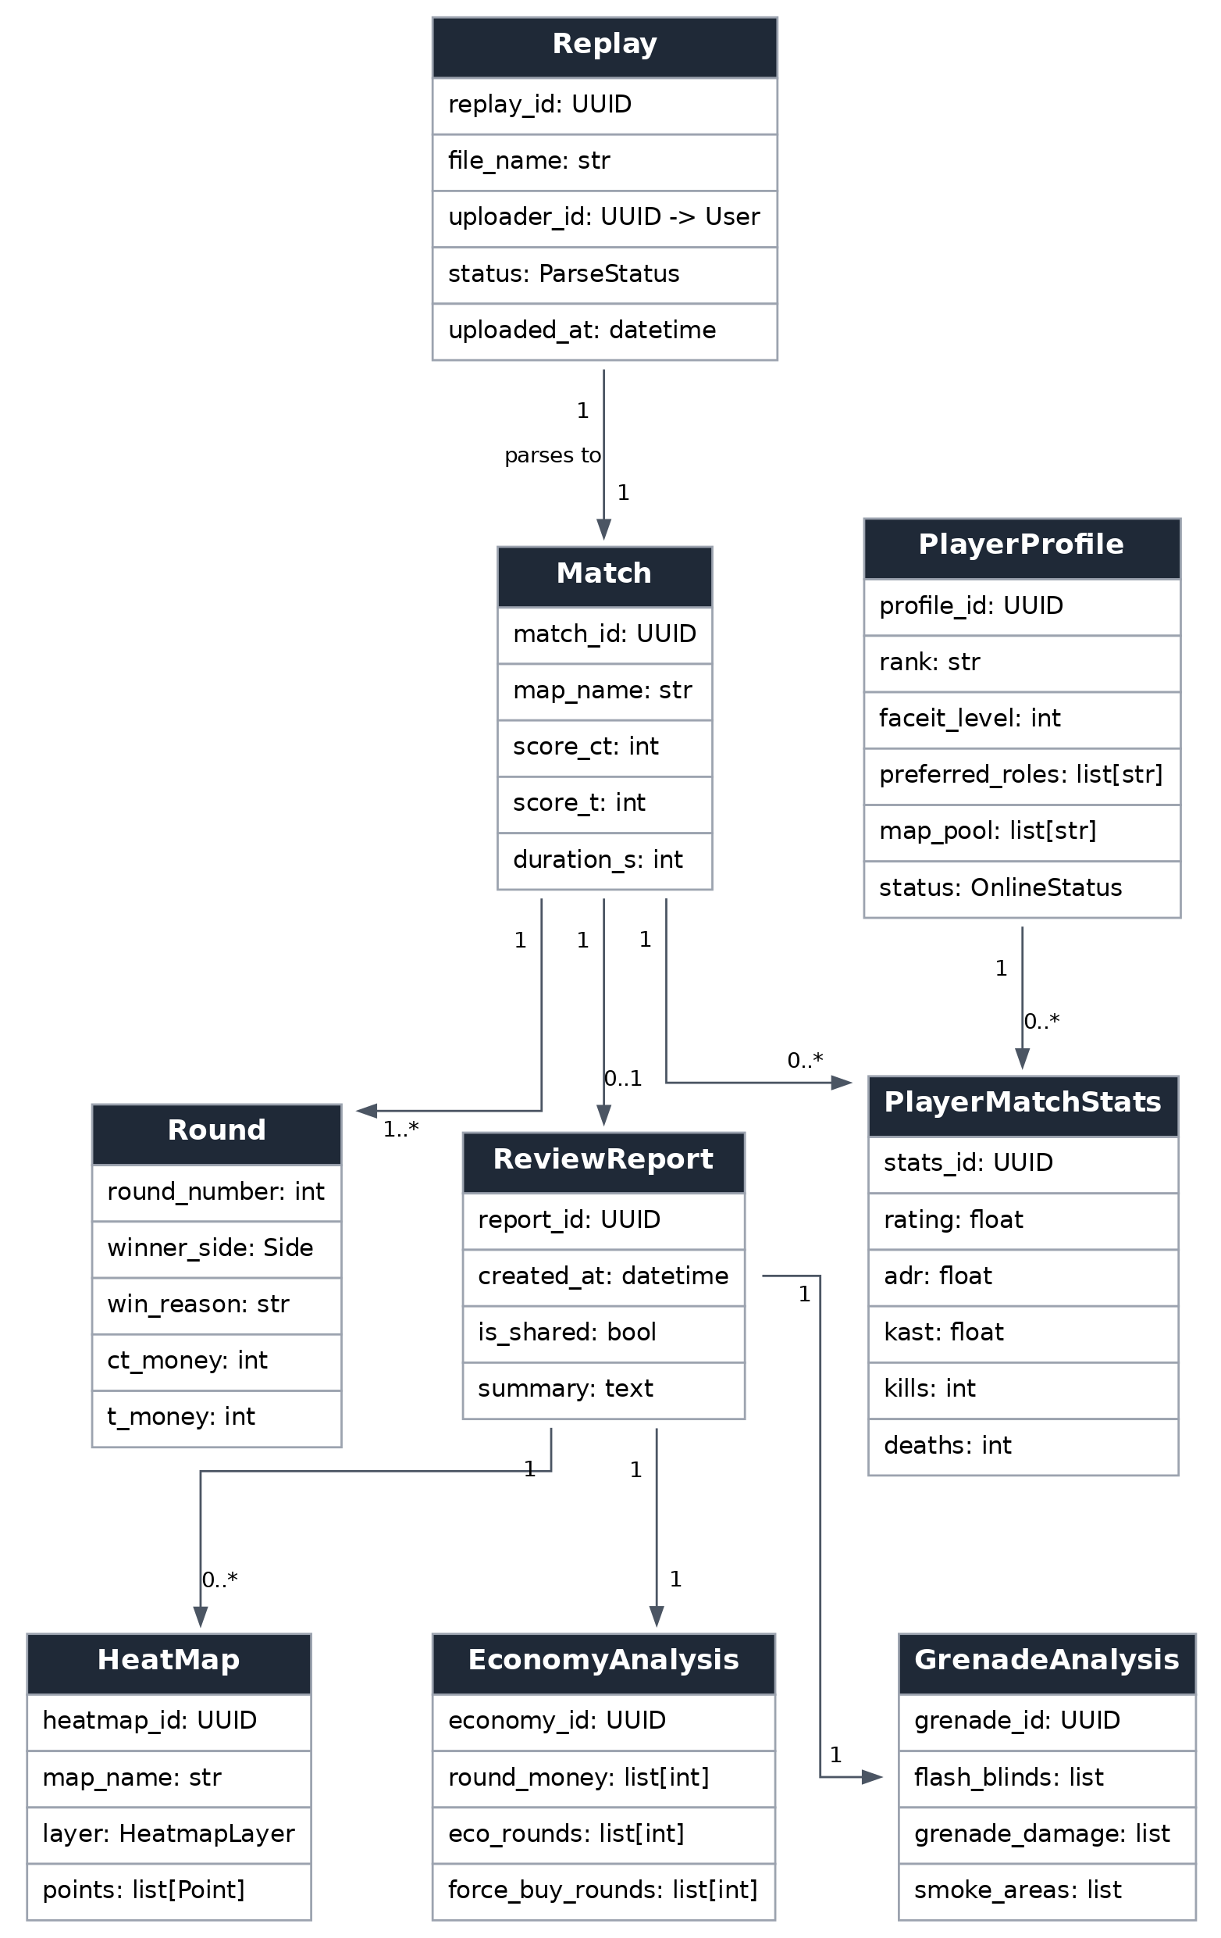
Figure 5-1 UML class diagram - demo-review domain
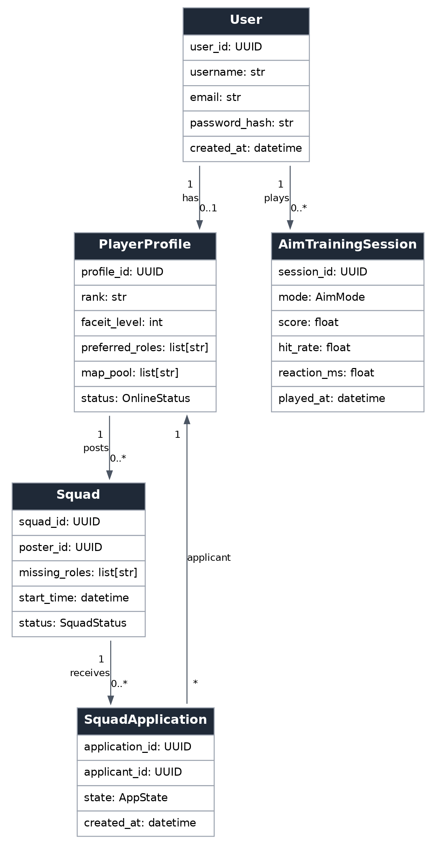
Figure 5-2 UML class diagram - account, squad, and training domain

6 Typical Use Cases

UC1 Upload a Replay and Obtain a Review Report
Actor: a logged-in student player
Precondition: the user has an extracted .dem replay file of one match
Main success scenario:
1. The user enters the review page, clicks Upload Replay, and selects a .dem file
2. The system validates the file format and shows the upload progress
3. After upload, the system places the parsing task in a queue and the page shows Parsing
4. awpy finishes parsing and the system generates a review report
5. The page displays the match overview, heat map, combat data, etc.; the user views and can choose to share
Extensions:
2a. Wrong format or corrupted file: the system shows an error and allows reselecting a file
4a. Parsing failure: the system shows the failure reason, does not generate an incorrect report, and allows re-uploading
Postcondition: the system generates and saves that match's review report, which the user can view at any time in the personal center

UC2 Post and Join a Squad
Actor: student players (poster / applicant)
Precondition: the user is logged in and has filled in a player profile
Main success scenario:
1. The poster enters the squad lobby, fills in missing roles and start time, and posts the squad
2. The applicant browses squads in the lobby, selects a suitable squad, and clicks Apply to Join
3. The poster receives the application and approves it
4. The system adds the applicant to the squad, completing squad formation
Extensions:
3a. The poster rejects the application: the system notifies the applicant, who can continue applying to other squads
Postcondition: the squad is formed successfully and member information is displayed in it

UC3 Do Aim Training
Actor: any user (may be logged out)
Precondition: the user uses a desktop browser that supports Pointer Lock
Main success scenario:
1. The user enters the aim-training page and selects a training mode (e.g., Gridshot)
2. The user clicks start; the browser locks the mouse and displays a custom crosshair
3. The user hits targets as quickly and accurately as possible within the time limit
4. The system records hit rate, hit count, and reaction time
5. The system shows this session score; logged-in users can save it to their personal curve, while logged-out scores are stored locally
Extensions:
2a. The browser does not support mouse lock: the system prompts the user to switch browsers or use a simplified mode
Postcondition: the system records this session score and updates the best record

7 Interface Prototype
This chapter presents low-fidelity interface prototypes of the four core pages, illustrating the information architecture and the main interaction flow. The prototypes use a clean layout: a top navigation bar, page-specific navigation or filters, and content panels. Figures 7-1 to 7-4 correspond to the review report, squad lobby, aim training, and personal center.

7.1 Review Report
The review report page (Figure 7-1) uses a left navigation to switch between the match overview, radar heat map, economy analysis, combat data, grenade analysis, and weakness diagnosis. The main area shows the match header, a per-round timeline, Rating/ADR/KAST metrics, heat-map and economy panels, and a weakness-diagnosis panel with training advice.
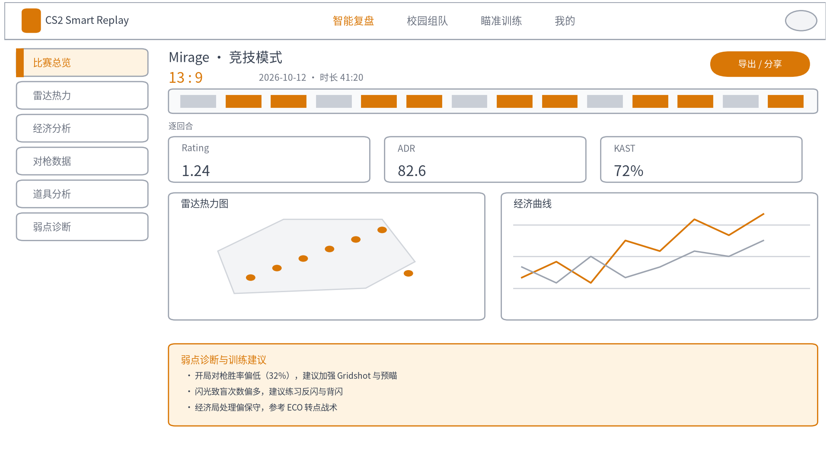
Figure 7-1 Interface prototype - review report

7.2 Squad Lobby
The squad lobby (Figure 7-2) provides a post-a-squad button and a filter panel (role, rank, map pool). The main area lists squad cards, each showing the missing roles, rank, maps, start time, current members, and an apply button.
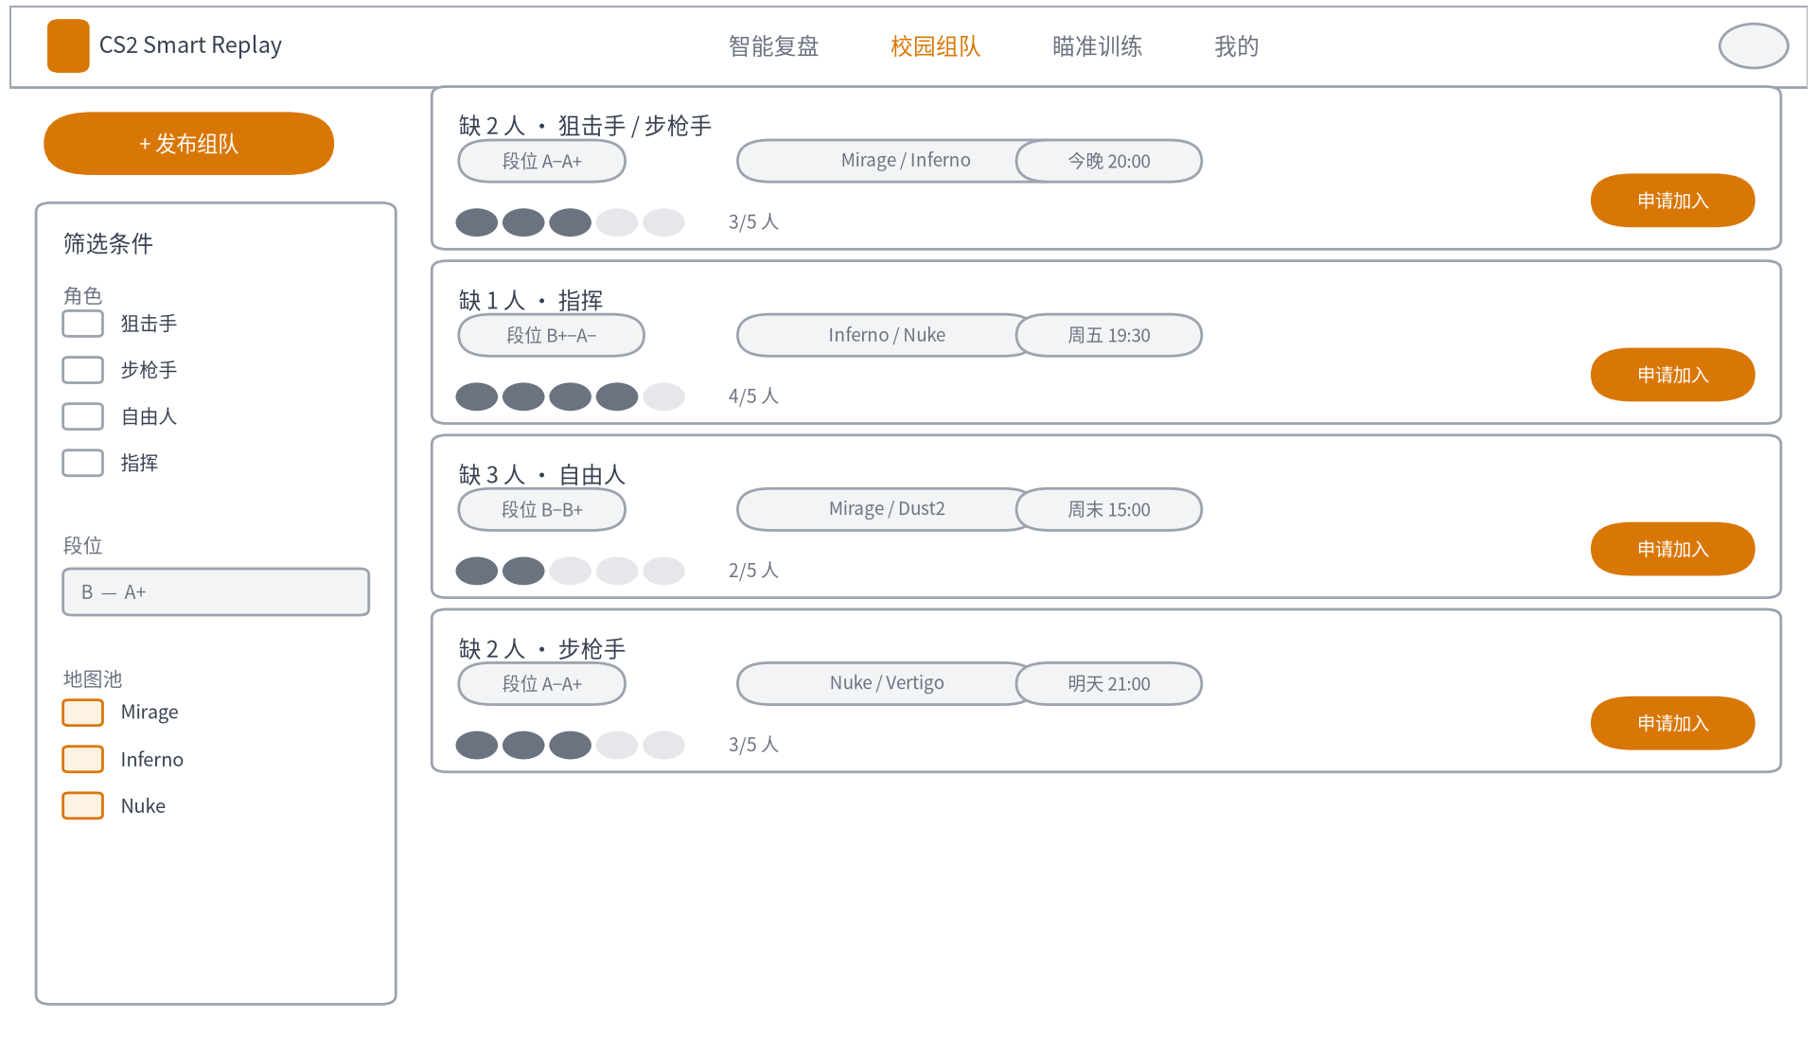
Figure 7-2 Interface prototype - squad lobby

7.3 Aim Training
The aim-training page (Figure 7-3) shows a mode-selection bar (Gridshot, Reaction, Spidershot, Microshot, Tracking) and a full-screen game canvas with score, remaining time, and hit-rate HUD, a custom crosshair, and targets.
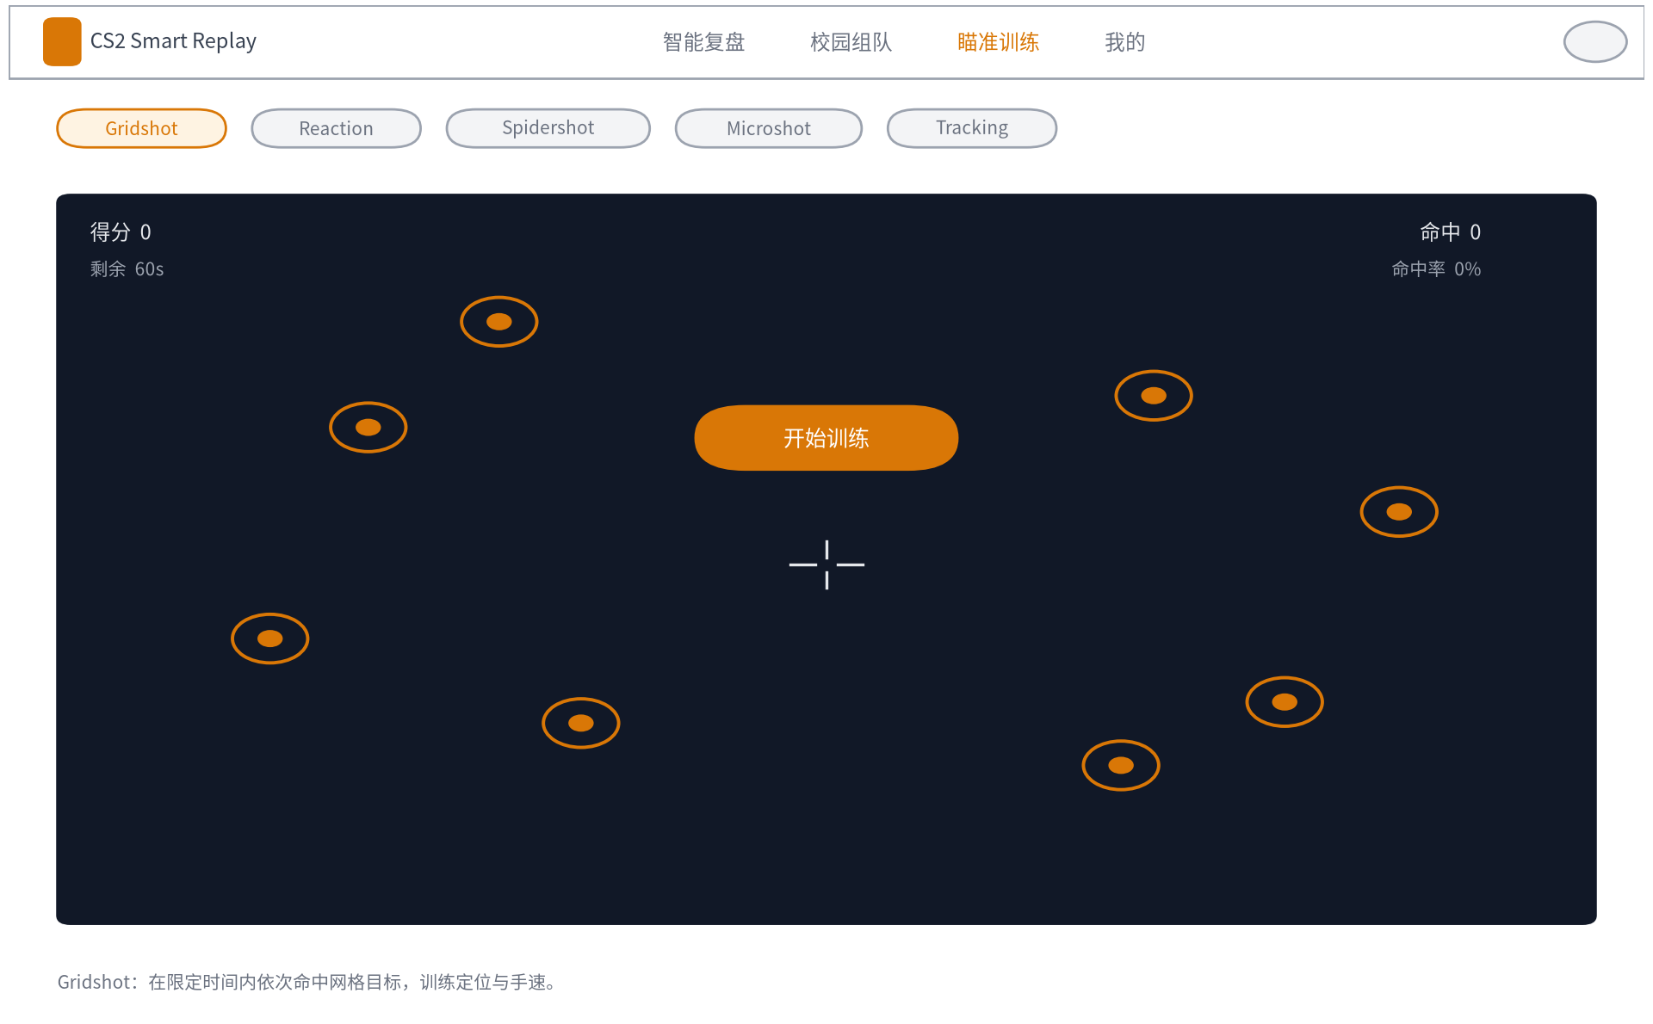
Figure 7-3 Interface prototype - aim training

7.4 Personal Center
The personal center (Figure 7-4) shows the player profile card (rank, roles, total matches, and an edit button), tabs for match history, review reports, and aim scores, and a panel of aim-score trends.
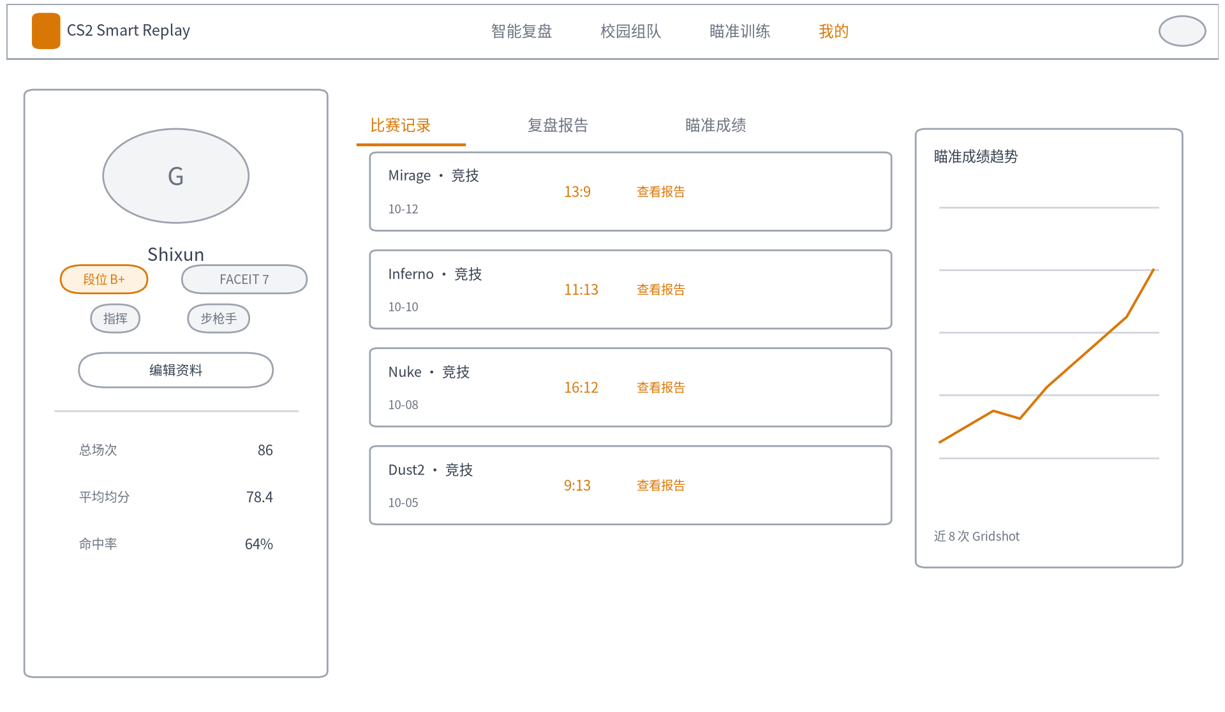
Figure 7-4 Interface prototype - personal center

8 Non-Functional Requirements
ID | Category | Requirement Description | Reference Target
NFR-1 | Performance | Parsing one match replay and generating the report should complete within a few minutes; the first page should load quickly | Per-match parsing target within 2-3 minutes; first screen within 3 seconds
NFR-2 | Concurrency | When multiple users parse simultaneously, queue scheduling prevents server crashes | Rate-limited queuing according to server configuration
NFR-3 | Compatibility | Supports mainstream desktop browsers from the past two years and common resolutions | Chrome / Edge / Firefox; resolution 1280 or above
NFR-4 | Security | Encrypted transmission across the site, encrypted password storage, no reading or writing of game memory | HTTPS; password hashing
NFR-5 | Reliability | Upload or parsing failures give clear prompts without losing user data | Retryable failures, queryable status
NFR-6 | Scalability | Modules are decoupled, and data sources and analysis capabilities are pluggable | Layered architecture, interface contracts
NFR-7 | Data governance | Original replays are cleaned periodically and user data collection is minimized | Delete the .dem periodically after parsing

9 Functional Priority and Boundary Conditions

9.1 The Four Quadrants
 | Peripheral Functions | Killer Functions
Necessary needs | Quadrant II: registration and login, replay upload, basic match data; adopt a counteract strategy, quick and sufficient | Quadrant I: the automatic review report (heat map, economy, grenades, weakness diagnosis); adopt a differentiation strategy with focused investment
Auxiliary needs | Quadrant III: personal settings, message notifications; adopt a maintain strategy at low cost | Quadrant IV: the aim-training mini-game, report sharing cards; adopt maintain or small-scale experiments

9.2 KANO Feature Classification
Feature Type | Corresponding Features | Satisfaction Pattern
Basic type | Accurate parsing, error-free reports, data matching reality, stable upload | Failure guarantees bad reviews; fulfillment is only acceptable
Expected type | Review dimensions, report speed, personal data statistics, squad matching | The better it is done, the higher the satisfaction
Excitement type | Weakness diagnosis and training advice, round animation, shareable report cards | Significantly raises satisfaction once present

9.3 Boundary Conditions
(1) File boundary: supports only CS2 (Source 2) .dem replays, about 50-150 MB per match; out-of-range files prompt the user;
(2) User scale: initially for players at our university, with user scale aimed at covering active CS2 players on campus, without pursuing large-scale promotion;
(3) Version boundary: game updates may affect parsing, requiring adaptation to awpy versions and attention to its updates;
(4) Environment boundary: the front end requires JavaScript enabled, and Pointer Lock must be triggered by a user gesture.

9.4 Side Effects and Dependencies
(1) Replay parsing consumes server CPU and memory and may affect other tasks, requiring queue-based rate limiting;
(2) Large-file uploads consume bandwidth and may be slow at peak times;
(3) When not logged in, aim-training scores are stored only locally in the browser, and clearing the cache causes score loss.

10 Technical Solution Overview

10.1 System Architecture
The system uses a lightweight architecture of a static, self-contained front end plus a thin back end. The front end is a static site that can be hosted independently, carrying pure front-end features such as aim training and the display pages for review and squads; the back end is responsible only for replay parsing and squad/account services that must be done server-side.
Layer | Technology Choice | Main Responsibilities
Front-end presentation layer | Vue3 or React, ECharts, Canvas | Page display, heat-map rendering, the aim-training mini-game
Business service layer | Python FastAPI | Interface services, task scheduling, accounts and squads
Analysis and computation layer | awpy, pandas / Polars, asynchronous task queue | Replay parsing, metric calculation, report generation
Data storage layer | Relational database, file storage | Structured data and temporary replay storage

10.2 Data Sources
Data | Source | Description
Post-match replay (.dem) | Downloaded and extracted by the user under in-game Watch / Your Matches | Contains full per-frame data; the core input
Real-time game state | GSI (official from Valve, optional) | Used to enhance features; not required
Third-party match data | FACEIT Data API (optional, free to apply) | ELO, matches, and statistics
Map resources | awpy data repository (downloaded and cached on first use) | Radar maps, collision meshes, coordinate transformation

10.3 Key Technologies
(1) Replay parsing and event extraction based on awpy, without rebuilding the underlying parsing capability;
(2) Transformation from in-game map coordinates to radar image coordinates and heat-map rendering;
(3) Large-file upload and asynchronous parsing queues with progress feedback;
(4) Implementation of statistics such as Rating, ADR, and KAST;
(5) Front-end aim training: Canvas, requestAnimationFrame, Pointer Lock, and Pointer Events.

10.4 Design Principles
The technical solution follows the principles described in the technical specification of The Method of Construction: abstraction, cohesion and coupling / modularity, information hiding and encapsulation, separation of interface and implementation, unified error handling, flexibility to cope with change, and scalability for growing data volume.

11 Acceptance Criteria and Delivery

11.1 Acceptance Criteria
(1) Review feature: report data matches the actual game (spot-checked), report sections are complete and viewable, and the complete flow can be reproduced on the spot;
(2) Squad feature: the complete flow of posting, applying for, and joining a squad can be completed;
(3) Aim training: each mode is playable and scoring and score records are accurate;
(4) Overall quality: passes format and functional testing with no blocking defects.

11.2 Post-Launch Data Collection Plan
After launch, the platform plans to collect the following data related to the project goals, with instrumentation completed in advance during implementation: number of registered users, number of parsed matches, review report generation success rate, average parsing time, aim-training participation count and average scores, and clicks and retention for each feature.

11.3 Milestones
Time | Milestone or Task
Before 23:59, October 11, 2026 | Second assignment deadline: publish the topic blog, submit this SRS, and fill in the Tencent team-formation form
Week 5 (Oct 12 - Oct 18) | Requirements research, set up the development environment, product prototype and technical spikes
Weeks 6-7 (Oct 19 - Oct 25) | Parsing pipeline, core algorithms, aim-training prototype
Week 8 (Oct 26 - Nov 1) | Alpha version: core web review features and basic training available
Weeks 9-12 (Nov 2 - Nov 29) | Squad features, weakness diagnosis, esports club trials and iteration
Week 13 (Nov 30 - Dec 6) | Beta version released, all features live
Week 14 (Dec 7 - Dec 13) | Feedback fixes, prepare for the defense
Week 15 (Dec 14 - Dec 20) | Final report: user count, match count, and live demo

12 Compliance and Engineering Ethics
(1) Use only officially open interfaces and post-match replays from Valve, FACEIT, etc.; do not inject into the game process, read or write game memory, or intercept or modify network data;
(2) Do not develop or provide any feature that undermines match fairness, and do not display information invisible in game such as enemy positions;
(3) Respect the interface policies of data providers, including rate limits, data attribution, and usage agreements;
(4) Minimize user data collection; review reports are private by default and sharing is chosen actively by the user;
(5) The platform is positioned as a data-analysis and learning tool and does not redistribute copyrighted game content; the open-source works used (awpy and CS Demo Manager, both under the MIT license) are credited.

Appendix A Glossary
Term | Definition
Demo / GOTV replay | A .rep / .dem replay file recorded by the game server, containing complete match data
tick | The smallest time unit of the server and replay; CS2 is usually 64 ticks per second
Rating | An overall performance score combining kills, survival, multi-kills, clutches, and other factors
ADR | Average Damage per Round
KAST | The proportion of rounds with at least one of Kill, Assist, Survival, or Trade
ECO round | A round focused on saving money due to insufficient economy, contrasted with force-buy and full-buy rounds
GSI | Game State Integration, the official Valve game-state push mechanism
FACEIT | A third-party competitive platform providing levels (ELO) and data interfaces
Aim Trainer | An aim-training tool / mini-game for positioning, reaction, and tracking

Appendix B Data Metrics
Metric | Meaning | Definition
Rating | Overall performance score | Weighted from kills, deaths, multi-kills, clutches, etc.
ADR | Average damage per round | Total damage divided by the number of rounds
KAST | Effective-contribution round proportion | The proportion of rounds with one of kill, assist, survival, or trade
Opening kills | First kill of each round | Counts the number of opening-kill achievements
Clutch win rate | Win rate when outnumbered | The proportion of rounds won while at a numerical disadvantage
Hit rate | Aim-training hit proportion | Hits divided by valid shots
Reaction time | Time from stimulus to click | In milliseconds; smaller is better

