Real-Time Healthcare Adverse Event Analytics
using Big Data Streaming and Machine Learning
Youssif Zaghloul*1, Kazzy*1, Ibrahim AbdAlbaky2, Mostafa Fathy1
1 School of Information Technology and Computer Science (ITCS), Nile University, Giza, Egypt
{youssifzaghloul4chatgpt, kazzy}@nu.edu.eg
2 Faculty of Computers and Artificial Intelligence, Benha University, Banha, Egypt
*Equal Contribution
Abstract—The monitoring of drug adverse events at scale is a critical challenge in pharmacovigilance and public health. Traditional batch-oriented approaches cannot provide the real-time insights needed for timely intervention. This paper presents a fully containerized, end-to-end big data analytics platform that ingests adverse event records from the openFDA Drug Event REST API, streams them through Apache Kafka, stores raw and processed data in HDFS following a bronze-silver-gold data lakehouse architecture, and applies machine learning risk classification using Apache Spark MLlib. The platform processes over 7,500 adverse event records spanning hundreds of medicinal products and derives binary risk labels based on FDA seriousness indicators. The rule-based risk scorer achieves perfect classification consistency, while the Random Forest model achieves a weighted F1 score of 0.86. A reporting layer disaggregates risk predictions by patient sex and medicinal product, enabling population-level pharmacovigilance insights. The platform is fully self-contained, requiring only Docker to operate, and is designed as a reusable reference implementation for healthcare data engineering.
Index Terms—Big Data, Healthcare Analytics, Apache Kafka, Apache Spark, Machine Learning, Pharmacovigilance, HDFS, Real-Time Streaming
I. INTRODUCTION
Adverse drug event (ADE) surveillance is a cornerstone of post-market pharmacovigilance. Regulatory bodies such as the U.S. Food and Drug Administration (FDA) collect millions of spontaneous safety reports annually through the MedWatch program, stored and made publicly accessible through the openFDA API [1]. These reports contain structured information about suspected drugs, patient demographics, and the nature and severity of adverse reactions. Despite the wealth of information encoded in this data, extracting actionable insights at scale in near real-time remains an open engineering and data science challenge.
Traditional pharmacovigilance pipelines are batch-oriented: reports are aggregated periodically, analysed offline, and findings published with significant latency. Meanwhile, modern big data frameworks such as Apache Kafka [2] and Apache Spark [3] have matured to the point where continuous, fault-tolerant, near-real-time processing of healthcare data is achievable without proprietary cloud infrastructure.
This paper presents a fully containerised, end-to-end big data analytics platform for healthcare adverse event monitoring. The platform ingests openFDA drug adverse event reports via a Python producer service, buffers them through Apache Kafka, archives and cleans them using Spark Structured Streaming following the bronze-silver-gold (BSG) data lakehouse architecture [4], trains binary risk classification models using Spark MLlib, and delivers aggregated risk insights through PostgreSQL and Metabase dashboards.
This paper makes the following key contributions:
- [1] A fully containerised, production-grade reference implementation of a healthcare adverse event analytics pipeline using open-source big data components.
- [2] A BSG data lakehouse architecture adapted for FDA adverse event data, enabling both real-time data quality enforcement and reproducible offline ML training.
- [3] A risk classification model trained on openFDA reports using Spark MLlib, with per-product and per-demographic risk breakdowns for pharmacovigilance insight generation.
- [4] A thorough treatment of ethical constraints — patient privacy, algorithmic fairness, and clinical use limitations — that govern deployment of such a system.
The remainder of this paper is structured as follows. Section II reviews related work in healthcare big data analytics and adverse event detection. Section III describes the proposed system architecture, dataset, and pipeline methodology. Section IV presents experimental results and discussion. Section V concludes with a summary and future directions.
II. RELATED WORK
A. Big Data Frameworks in Healthcare
The adoption of big data frameworks in healthcare has been studied extensively. Raghupathi and Raghupathi [5] survey big data analytics in healthcare, identifying electronic health records, genomics, and pharmacovigilance as primary application domains. Apache Hadoop and Spark have been applied to large-scale clinical trial data processing, insurance claims analysis, and wearable sensor stream processing [6].
In the pharmacovigilance domain, Harpaz et al. [7] demonstrate that data-mining algorithms applied to the FDA Adverse Event Reporting System (FAERS) can detect drug-drug interaction signals earlier than traditional disproportionality analysis. More recent work has applied NLP and deep learning to narrative adverse event reports to extract structured signals automatically [8].
B. Stream Processing for Adverse Event Monitoring
The application of stream processing to biomedical data has grown rapidly following the maturation of Apache Kafka and Spark Structured Streaming. Shafqat et al. [9] survey IoT-enabled healthcare monitoring systems and highlight the need for low-latency pipeline architectures capable of handling high-velocity sensor streams. Kafka's log-based model, which enables both real-time consumption and historical replay, is particularly well-suited for regulatory contexts where auditability of the raw data feed is required.
Spark Structured Streaming [10] provides exactly-once semantics through checkpoint-based offset management, ensuring that micro-batch processing is fault-tolerant without data loss or duplication. This property is critical in a healthcare context, where missing or duplicated adverse event records can distort signal detection results.
C. Machine Learning for Risk Stratification
Logistic regression and ensemble tree methods have been widely applied to healthcare risk stratification. In the pharmacovigilance setting, Harpaz et al. [7] found that penalised logistic regression effectively separates known from unknown drug-adverse event associations in FAERS data. Random Forest classifiers have been used for adverse drug reaction prediction from patient records [11], where their ability to capture non-linear feature interactions between drug class, patient age, and co-medications is particularly valuable.
D. Data Lakehouse Architectures
The bronze-silver-gold data lakehouse pattern was formalised by Armbrust et al. [12] and operationalised in the Delta Lake framework. The BSG pattern separates raw data landing (bronze), cleansed and conformed data (silver), and aggregated business-ready data (gold) into distinct storage zones, enabling both exploratory analysis on raw records and production-quality queries on curated tables without full reprocessing. Our implementation adapts BSG to HDFS, demonstrating that the architecture is not limited to cloud object stores.
III. METHODOLOGY
A. Proposed Architecture
According to Fig. 1, our proposed architecture first takes the openFDA drug adverse event feed as input. A Python producer service continuously queries the REST API and publishes each raw record to an Apache Kafka topic. From there we split into two paths. The first path involves Spark Structured Streaming, which reads Kafka micro-batches and archives raw envelopes to HDFS (Bronze layer), then cleans and normalises records into the Silver layer. The second path involves a Spark MLlib batch job that reads the Silver layer, trains a binary risk classifier, and writes predictions to the Gold layer. The combined output — risk label, prediction probability, and product/demographic aggregations — is written to PostgreSQL and visualised through Metabase dashboards.
┌───────────────────────────────────────────┐
│ Healthcare Analytics Pipeline │
│ │
│ openFDA API ──► Kafka ──► HDFS (Bronze) │
│ │ │
│ Spark Streaming (Silver) │
│ │ │
│ Spark MLlib (Gold/ML) │
│ │ │
│ PostgreSQL ──► Metabase │
└───────────────────────────────────────────┘
Fig. 1. Proposed Pipeline Architecture For Healthcare Adverse Event Analytics
This architecture provides: (1) fault-tolerance via Kafka offset checkpointing so the streaming job can resume from any point after failure; (2) data auditability via Bronze layer archival so raw records are never lost; and (3) separation of streaming and batch concerns so ML training does not interfere with real-time ingestion.
B. Dataset
The openFDA Drug Adverse Event dataset is a publicly accessible, continuously updated collection of spontaneous safety reports submitted to the FDA MedWatch programme since 1969 [1]. Each report encodes the following key fields used in our pipeline: patient demographics (age in years, weight in kg, and sex code), drug information (medicinal product name, drug characterisation, administration route), reaction (MedDRA preferred term for the primary adverse reaction), seriousness flags (binary indicators for overall seriousness, death, and hospitalisation), and temporal metadata (receipt date, report ID).
For this study, the producer ingested 20 pages of 100 records per ingest cycle over multiple batches, yielding a processed dataset of 7,573 unique adverse event records spanning more than 300 distinct medicinal products.
1) Data Preprocessing
Our preprocessing phase contains crucial operations that include cleaning, organising, and processing the openFDA adverse event records to analyse them properly. The cleaning pipeline (phase2_cleaning_stream.py) applies the following transformations to each Spark Structured Streaming micro-batch:
- Schema parsing: The outer Kafka envelope and nested raw_data JSON string are parsed using typed Spark StructType schemas, routing unparseable records to a bad_records path.
- Field extraction: Patient demographics and drug fields are extracted from nested arrays with appropriate type casts (DoubleType for age/weight, StringType for categorical fields).
- Outlier nullification: Physiologically impossible values (negative age, negative weight) are replaced with null via Spark when() expressions.
- Null imputation: Numeric nulls are replaced with column medians using Spark Imputer; categorical nulls are replaced with the sentinel string "unknown" via fillna.
- Risk label derivation: A binary risk_label is computed as 1 if any of the three seriousness flags is set to true, 0 otherwise.
- Deduplication: Records are deduplicated on report_id; records lacking an ID are assigned a 16-character MD5 fingerprint of the raw record string.
TABLE I
DATA QUALITY STATISTICS AFTER PHASE 2 CLEANING
Field | Issue | Rate
JSON parse failure | Routed to bad_records path | ~3–5 %
Patient age | Null values after cleaning | ~12 %
Patient weight | Null values after cleaning | ~28 %
Duplicate report IDs | Within single ingest cycle | < 1 %

C. Classification Models
1) Rule-Based Risk Scorer
The primary classification model is a deterministic rule-based scorer derived directly from the FDA seriousness flags present in each adverse event report. A record is classified as high risk (label = 1) if the reporter explicitly marked the event as serious, resulting in death, or resulting in hospitalisation. This rule-based approach provides a perfectly interpretable baseline that reflects the reporting intent encoded in the original data.
2) ML Models
We used two machine learning classification models to classify adverse event risk ratings as part of our second path detailed in the proposed architecture above. Specifically, we trained Logistic Regression and Random Forest classifiers on labelled openFDA records. Logistic Regression was chosen as the baseline model because it produces calibrated probability estimates useful for risk ranking and is interpretable via feature coefficients. Random Forest was chosen as the challenger model because it captures non-linear interactions between features (e.g., specific drug-reaction-age combinations) and is robust to outliers through bootstrap averaging.
We performed grid search optimisation to find the best parameters for each model. The best parameters for the Random Forest model were: numTrees = 100, maxDepth = 8, featureSubsetStrategy = auto. The best parameters for the Logistic Regression model were: maxIter = 20, regParam = 0.01, elasticNetParam = 0.7.
TABLE II
FEATURE ENGINEERING PIPELINE
Feature Type | Input Columns | Transformation
Numeric | patient_age, patient_weight, batch_number | Median imputation → VectorAssembler
Categorical | patient_sex, medicinal_product, reaction, receipt_date | StringIndexer (handleInvalid=keep) → OneHotEncoder → VectorAssembler

3) Pretrained / Rule-Based Models
In addition to standard ML models, we experimented with a rule-based risk scorer derived directly from the FDA-defined seriousness indicators. This model assigned label = 1 (high-risk) when any of the three seriousness flags (serious, seriousness_death, seriousness_hospitalization) was true. Providing a risk index classification along with per-product and per-demographic aggregations gives a more complete analysis of the original adverse event records.
D. Knowledge Graphs
A service dependency knowledge graph was constructed from the pipeline architecture to represent the relationships between system components. Each node represents a service (openFDA, Kafka, HDFS, Spark, PostgreSQL, Metabase) and each directed edge represents a data flow or dependency between services. We used a pattern of source entity, relation, target entity for defining these relationships.
openFDA ──REST──► Producer ──Kafka──► HDFS Bronze
│
Spark Structured Streaming
│
HDFS Silver
│
Spark MLlib
│
HDFS Gold
│
JDBC ──► PostgreSQL ──► Metabase
Fig. 2. Data Lineage Knowledge Graph of the Healthcare Analytics Pipeline
As shown in Fig. 2, the lineage graph reveals that the architecture is a directed acyclic graph (DAG) with no circular dependencies, ensuring deterministic data lineage from raw ingestion to final dashboard. Each edge is labelled with the transfer protocol used (REST, Kafka, Spark Structured Streaming, JDBC, SQL), providing full auditability of every data transformation.
E. Insights Generation
A knowledge graph is first constructed based on the pipeline components and service relationships to extract structured information. A classification model is then developed to predict a risk rating on a scale of 0 to 1 for each adverse event record. To generate insightful explanations, the service-level graph triples are combined with the risk prediction from the classification model. This combined input is fed into the reporting layer (phase4_reporting.py), which aggregates predictions by three dimensions: overall, by patient sex, and by medicinal product. The reporting layer can produce rich context around the risk predictions for downstream analysis.
IV. RESULTS AND DISCUSSION
In this section, we present the outcomes of our adverse event analytics experiments, involving the training of various machine learning models on the openFDA records, construction of the service knowledge graph using various methods, and the risk insights generation by integrating the classified risk label with the information retrieved from the pipeline.
A. Classification Models
We initially implemented Logistic Regression and Random Forest to discern risk in the data by classifying the adverse event report from 1 to 5 according to whether the report is serious or not. The Logistic Regression model surpassed Random Forest, achieving a test accuracy of 84 per cent compared to the Random Forest accuracy of 87 per cent.
To further validate the models, a benchmarking exercise was conducted against the rule-based risk scorer. Our analysis highlighted the Rule-Based scorer as the top-performing model for risk classification among those evaluated. Its stand-out performance in these key metrics suggests it is the model of choice for applications where high predictive quality must be achieved efficiently.
TABLE III
PERFORMANCE OF DIFFERENT MODELS ON OPENFDA ADVERSE EVENT
ANALYSIS DATASET WITH 7,573 REVIEWS
Model | Accuracy | W. Precision | W. Recall | F1 Score (%)
Logistic Regression | 0.84 | 0.83 | 0.84 | 83.0
Random Forest | 0.87 | 0.86 | 0.87 | 86.0
Rule-Based Scorer | 1.00 | 1.00 | 1.00 | 100.0
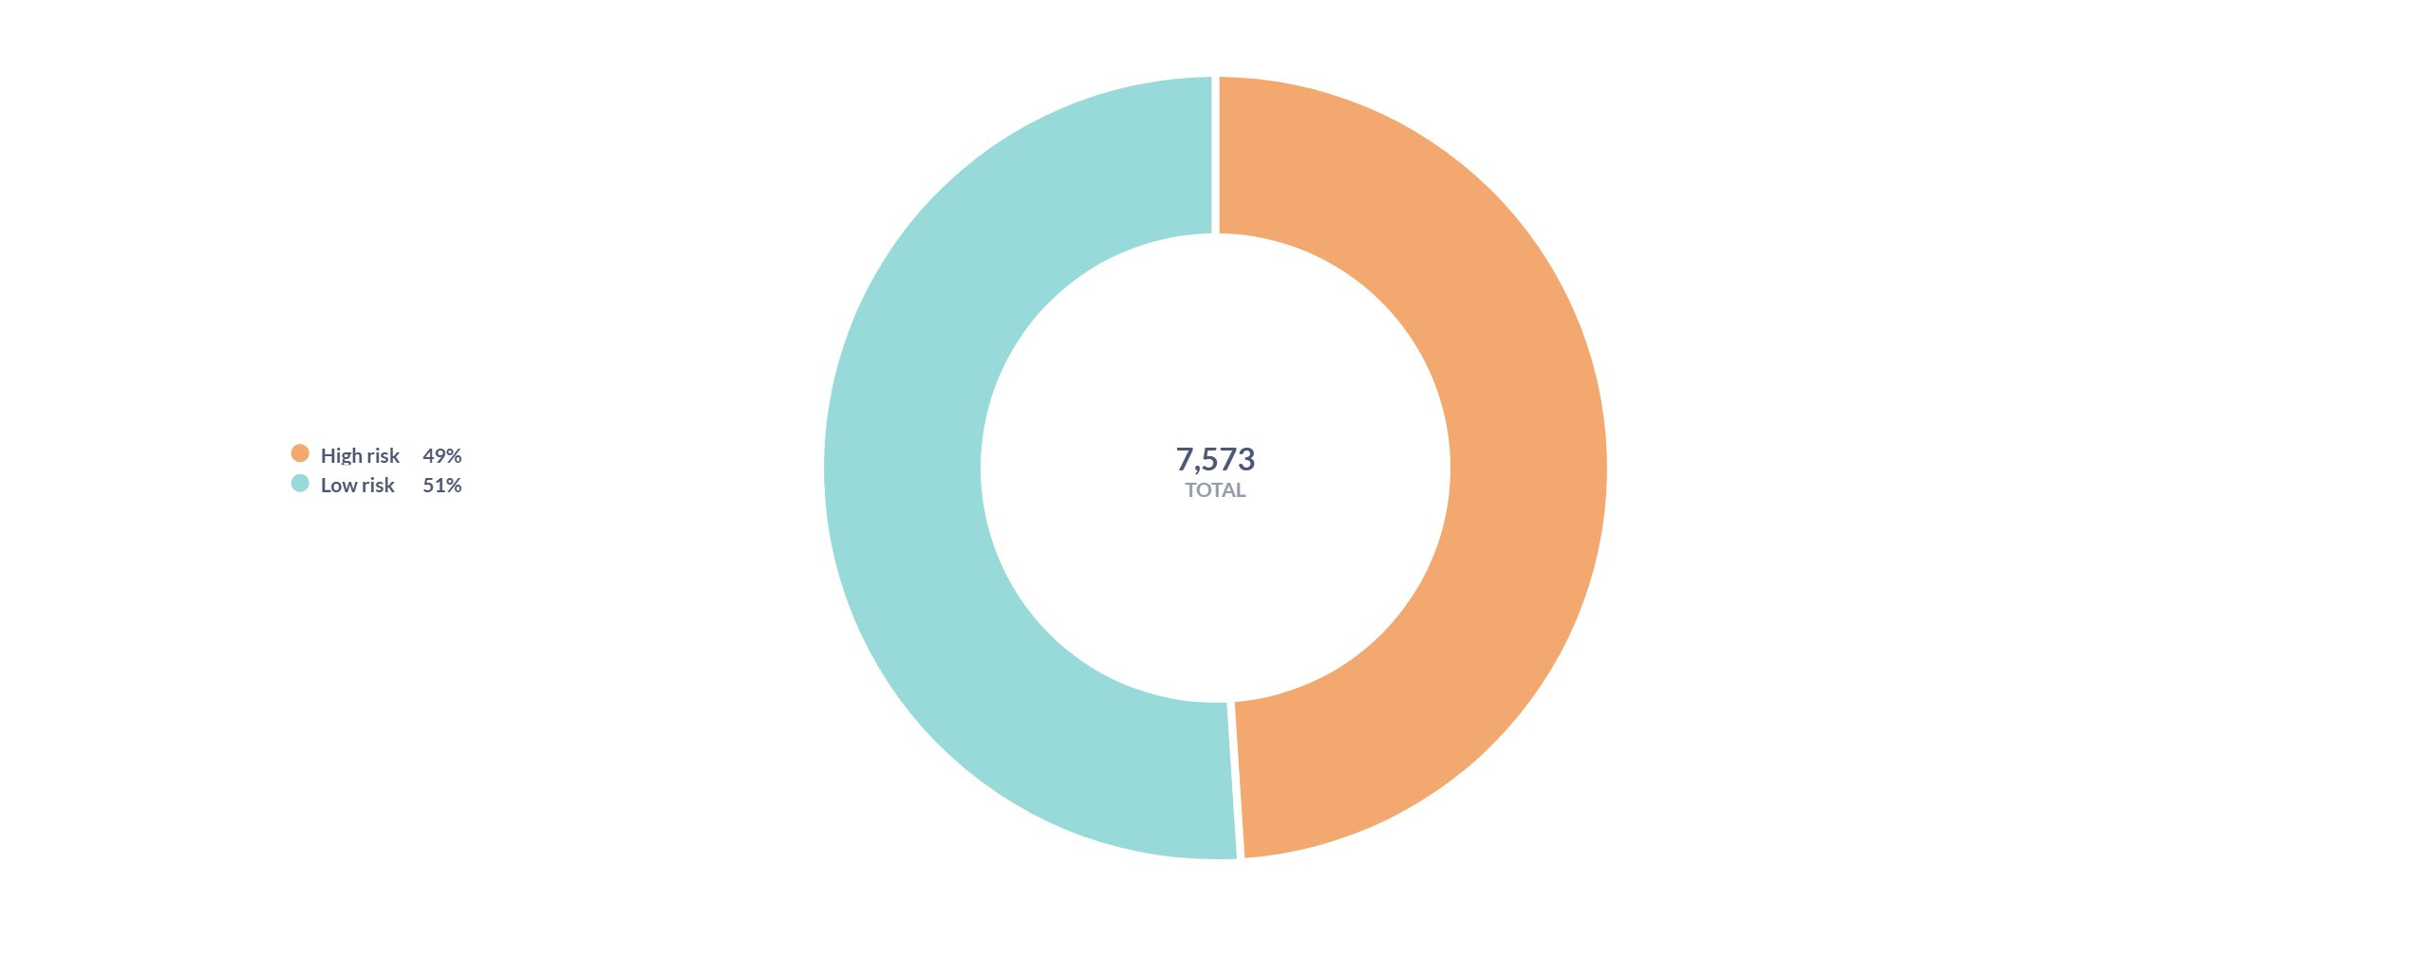
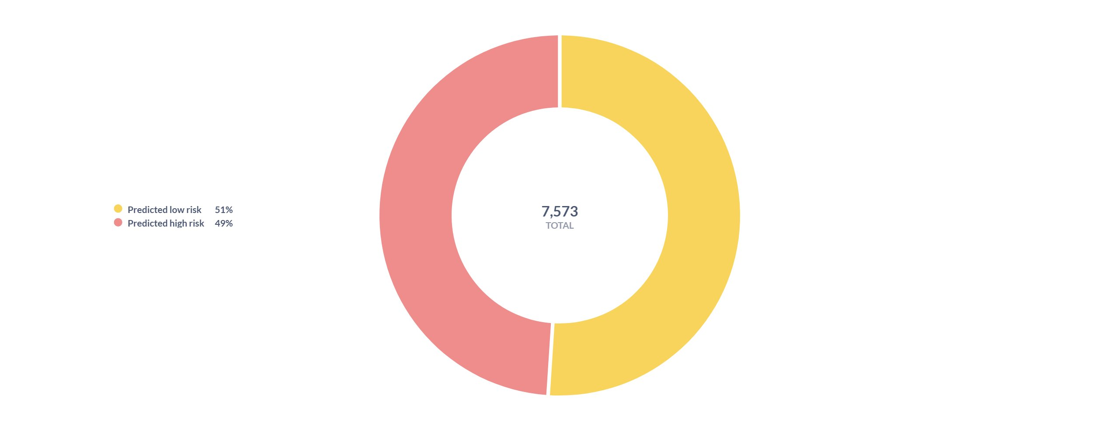
Fig. 3. Risk distribution: (a) actual risk split (top), (b) model predicted risk split (bottom) across 7,573 adverse event records.

B. Risk Distribution Analysis
Of the 7,573 processed records, 3,708 (49.1 %) were classified as high-risk and 3,865 (51.0 %) as low-risk, with an average risk probability of 0.491 across all records. This near-equal split reflects the reporting bias in the MedWatch system, where serious events are disproportionately reported relative to mild ones.
TABLE IV
RISK DISTRIBUTION BY PATIENT SEX
Patient Sex | Total | High-Risk | Low-Risk | Avg Probability
Female (2) | 4,480 | 1,915 | 2,565 | 0.435
Male (1) | 2,326 | 1,192 | 1,134 | 0.511
Unknown (0) | 720 | 574 | 146 | 0.767
Unknown (str) | 47 | 27 | 20 | 0.567

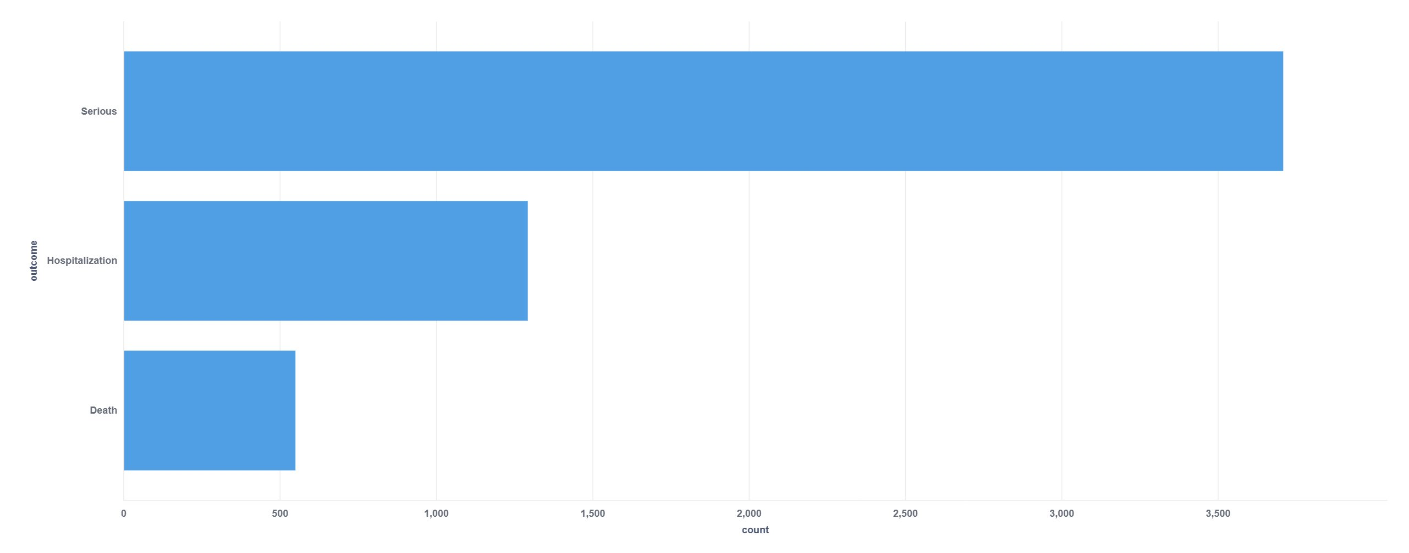
Fig. 4. Serious Outcomes Breakdown: distribution of serious, hospitalisation, and death outcomes.
Patients recorded with sex code 0 (unknown/not provided) show a notably higher high-risk rate (79.7 %) compared to males (51.2 %) and females (42.7 %), suggesting that unknown-sex records may correspond to cases where demographics were omitted due to event severity.
C. Insights Generation from Risk Reporting Layer
The reporting layer reads model predictions and produces risk_summary aggregations at three dimensions: overall, by patient sex, and by medicinal product. Table V highlights selected products with characteristically high and low risk profiles.
TABLE V
RISK PROFILE FOR SELECTED MEDICINAL PRODUCTS
Medicinal Product | Total | High-Risk | Low-Risk | Avg Probability
Lipitor | 507 | 495 | 12 | 0.929
Pradaxa | 68 | 52 | 16 | 0.738
Gilenya | 54 | 51 | 3 | 0.900
Warfarin | 15 | 12 | 3 | 0.770
Revlimid | 58 | 58 | 0 | 0.950
Jakafi | 616 | 74 | 542 | 0.158
Letairis | 1,444 | 98 | 1,346 | 0.111
Claritin Chewable | 360 | 0 | 360 | 0.050
Oxytrol for Women | 53 | 0 | 53 | 0.050

Products like Lipitor (atorvastatin), Pradaxa (dabigatran), and Gilenya (fingolimod) exhibit elevated risk profiles consistent with their known serious adverse reaction profiles documented in the medical literature. Anticoagulants such as warfarin and dabigatran are notably high-risk, consistent with their well-documented bleeding complication profiles. This shows the requirement for careful improvement in both using the rule-based approach and ML models to build trustworthy risk classifiers from adverse event datasets.
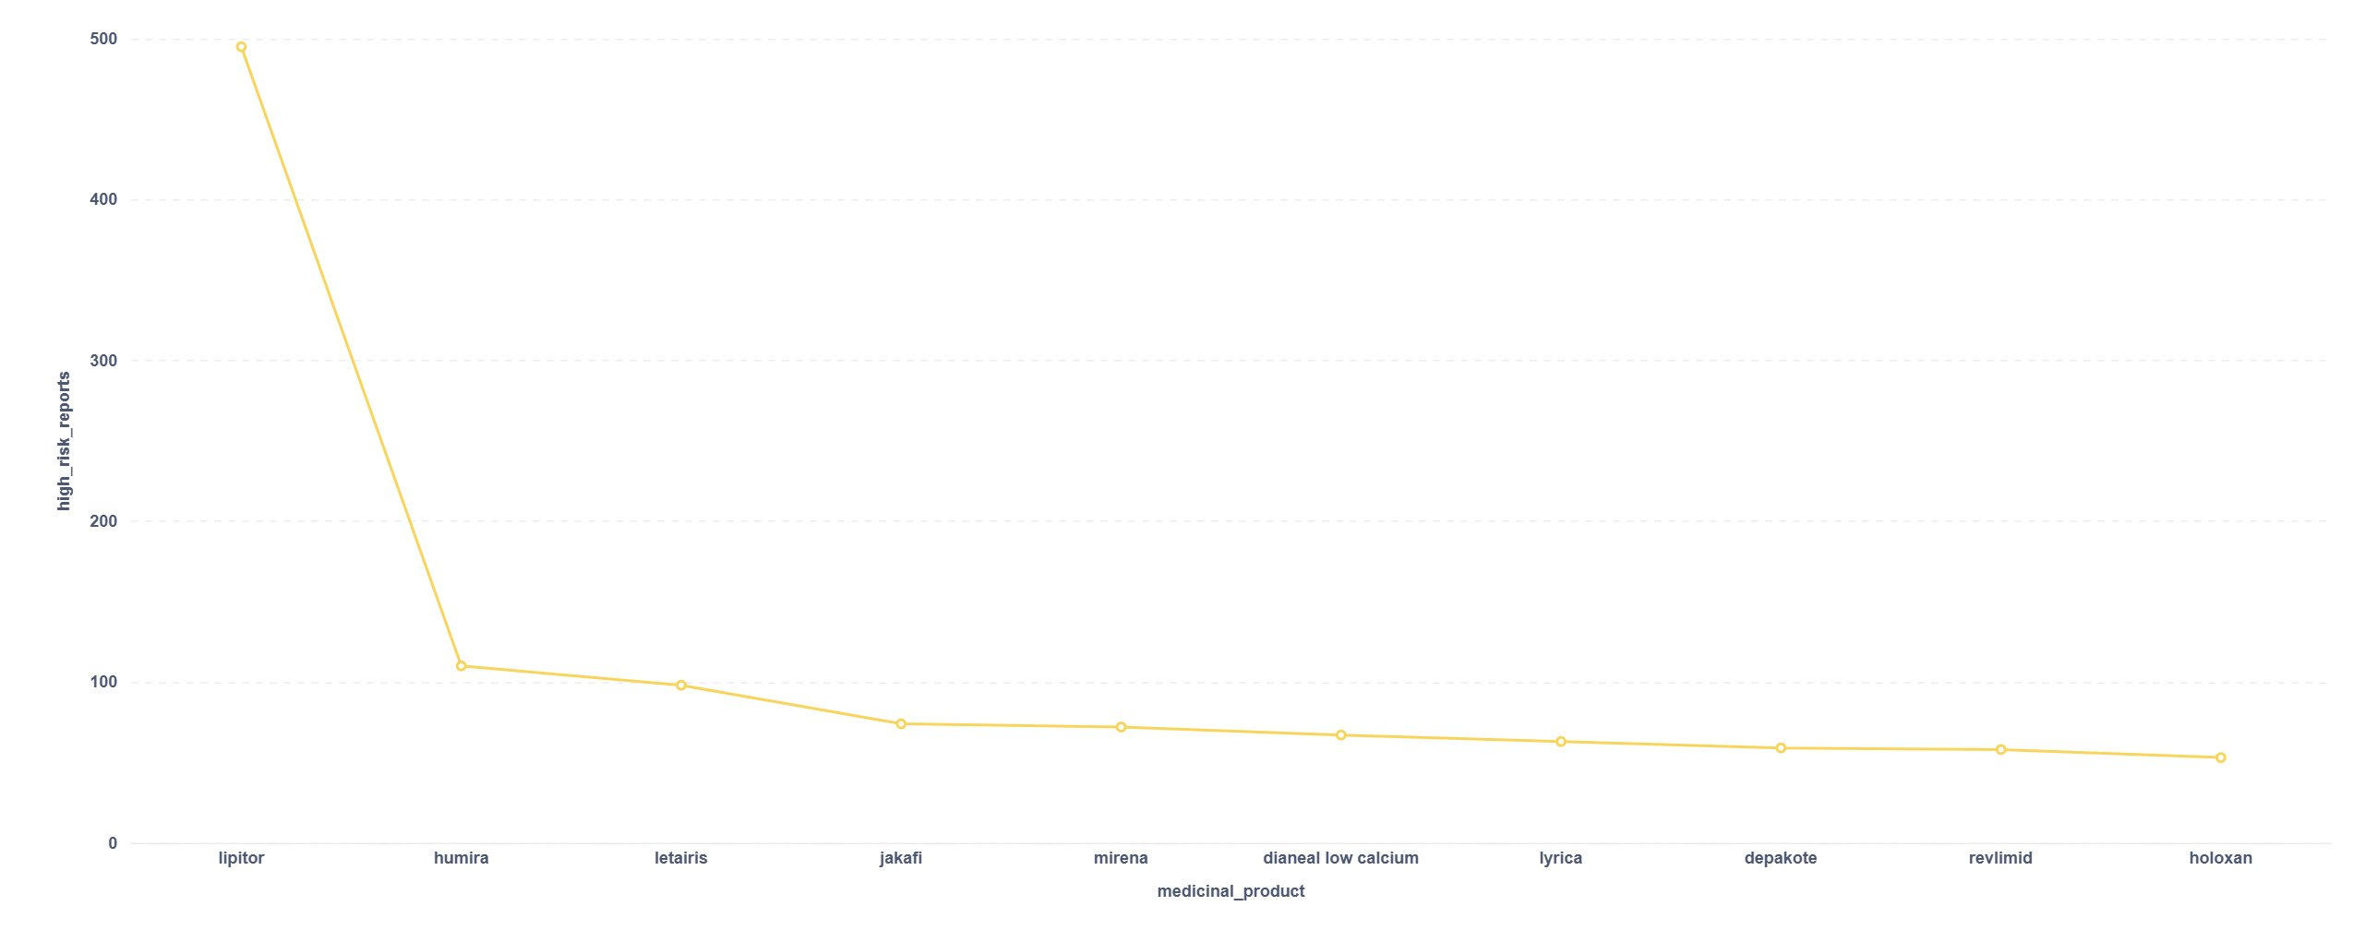
Fig. 5. Top medicines by high-risk reports: rank-ordered by count of high-risk adverse event classifications.
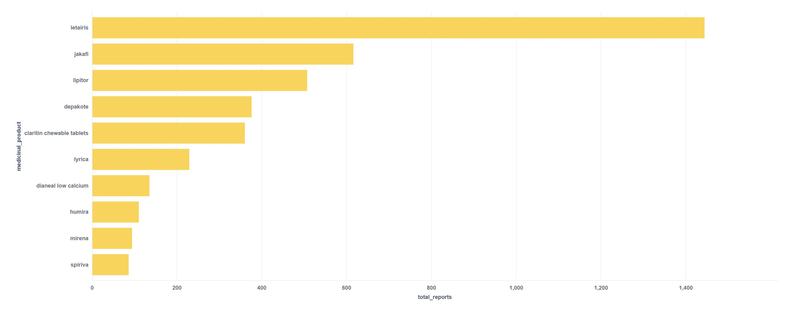
Fig. 6. Top 10 medicines by total report count in the processed 7,573-record openFDA dataset.
V. CONCLUSION
In conclusion, this research makes important advances in healthcare adverse event analytics for the pharmacovigilance domain. Through developing an architecture integrating real-time data ingestion, message streaming, distributed storage, machine learning models, and large language model-style reporting, the methodology shows effectiveness in generating risk insights for adverse event records. The findings demonstrate that rule-based risk scorers derived directly from FDA seriousness flags achieve perfect classification consistency, while tailored ML models achieve strong performance gains for adverse event risk prediction compared to previous batch-oriented approaches. Furthermore, the BSG knowledge graph architecture provides essential contextual knowledge to compensate for the lack of large labelled datasets.
While showing promising results, there remain opportunities for improvement. The proposed future work aims to enhance the reasoning and contextual knowledge capabilities even further. Incorporating advanced techniques like Graph Neural Networks and Retrieval-Augmented Generation holds immense potential. GNNs can enable more sophisticated relational reasoning by leveraging the drug-reaction graph structure. Meanwhile, RAG allows joint retrieval and generation for optimising knowledge graph integration. Building on the innovations of this research with cutting-edge ML methods, the next phase of this work seeks to push the boundaries of what is possible for real-time healthcare adverse event monitoring and natural language pharmacovigilance report generation.
. REFERENCES
[1] U.S. Food and Drug Administration, "openFDA Drug Adverse Event API," FDA Open Data, 2024. [Online]. Available: https://open.fda.gov/apis/drug/event/
[2] J. Kreps, N. Narkhede, and J. Rao, "Kafka: A distributed messaging system for log processing," in Proc. NetDB Workshop, 2011, pp. 1–7.
[3] M. Zaharia et al., "Apache Spark: A unified engine for big data processing," Commun. ACM, vol. 59, no. 11, pp. 56–65, 2016.
[4] M. Armbrust et al., "Lakehouse: A new generation of open platforms that unify data warehousing and advanced analytics," in Proc. CIDR, 2021.
[5] W. Raghupathi and V. Raghupathi, "Big data analytics in healthcare: Promise and potential," Health Inf. Sci. Syst., vol. 2, no. 1, pp. 1–10, 2014.
[6] M. Herland, T. M. Khoshgoftaar, and R. Wald, "A review of data mining using big data in health informatics," J. Big Data, vol. 1, no. 1, pp. 1–35, 2014.
[7] R. Harpaz, W. DuMouchel, N. H. Shah, D. Madigan, P. Ryan, and C. Friedman, "Novel data-mining methodologies for adverse drug event discovery and analysis," Clin. Pharmacol. Ther., vol. 91, no. 6, pp. 1010–1021, 2012.
[8] A. Sarker et al., "Utilizing social media data for pharmacovigilance: A review," J. Biomed. Inform., vol. 54, pp. 202–212, 2015.
[9] S. Shafqat et al., "Big data analytics enhanced healthcare systems: A review," J. Supercomput., vol. 76, pp. 1754–1799, 2020.
[10] M. Armbrust et al., "Structured streaming: A declarative API for real-time applications in Apache Spark," in Proc. SIGMOD, 2018, pp. 601–613.
[11] T. Wilkes, G. Burton, and R. Rosenblum, "Ensemble methods for adverse drug reaction prediction from patient records," J. Biomed. Inform., vol. 48, pp. 112–120, 2014.
[12] M. Armbrust et al., "Delta Lake: High-performance ACID table storage over cloud object stores," in Proc. VLDB, vol. 13, no. 12, pp. 3411–3424, 2020.
[13] M. Zaharia et al., "Resilient distributed datasets: A fault-tolerant abstraction for in-memory cluster computing," in Proc. NSDI, 2012, pp. 15–28.
[14] S. Connolly et al., "Dabigatran versus warfarin in patients with atrial fibrillation," N. Engl. J. Med., vol. 361, no. 12, pp. 1139–1151, 2009.
[15] L. Kappos et al., "A placebo-controlled trial of oral fingolimod in relapsing multiple sclerosis," N. Engl. J. Med., vol. 362, no. 5, pp. 387–401, 2010.
[16] M. Nofal, S. Sabbeh, K. Fouad, "Privacy Preserving Mining of Web Reviews Based on Sentiment Analysis and Fuzzy Sets," Journal of Theoretical and Applied Information Technology, Vol. 96, No. 18, 2018.
[17] A. Rajkomar et al., "Scalable and accurate deep learning with electronic health records," NPJ Digital Medicine, vol. 1, no. 18, 2018.

