**Project Name**

**Diabetes Prediction using Machine Learning Web Application**

Abstract

The goal of this research is to develop a machine learning system that employs logistic regression to predict diabetes. Diabetes is a chronic illness that must be identified and treated early to avoid serious health issues. This system allows users to enter medical parameters such as glucose levels, blood pressure, BMI, and insulin levels through a user-friendly web interface. After submission, a machine learning model is used to process the input data and determine the likelihood that the individual has diabetes.

The Flask framework was used in the development of the web application, guaranteeing a user-friendly, lightweight interface. After evaluating the data, a pre-trained Logistic Regression model predicts if diabetes was detected or not. This project aims to offer a quick, accessible tool that empowers healthcare providers and individuals to monitor diabetes risk proactively.

Introduction

Diabetes is a significant global health issue affecting millions of individuals. Because of either inadequate insulin production or resistance to the effects of insulin, the body is unable to properly control blood glucose levels in this chronic illness. Diabetes can cause serious complications like heart disease, kidney failure, and visual issues if it is not identified and treated in a timely manner. Early detection and preventive measures are essential to improve health outcomes and reduce risks.

The goal of this research is to use machine learning to develop a web-based diabetes prediction system. The method uses logistic regression to determine a person's risk of developing diabetes based on medical data inputs like blood pressure, insulin levels, and glucose levels, and body mass index (BMI). The **Pima Indian Diabetes Dataset** serves as the foundation for building the predictive model, which ensures the accuracy and reliability of predictions.

This application was developed using "Flask," a lightweight web framework based on Python that makes it simple to integrate machine learning models into an interactive online interface. This user-friendly interface enables individuals and healthcare providers to enter patient data and instantly receive predictions on diabetes risk. The prediction output, either “**Diabetes Detected**” or “**No Diabetes Detected**”, offers users actionable insights.

The primary objective of this project is to demonstrate how **machine learning algorithms** can be integrated with **web technologies** to build predictive healthcare tools. The system provides a quick and accessible way for people to monitor their diabetes risk, encouraging early diagnosis and lifestyle interventions.

This report covers the project’s design, algorithm implementation, and evaluation. It also emphasizes the importance of these predictive systems in the medical field, emphasizing how they can help with proactive chronic condition treatment and early detection.

Architecture

Architectural Diagram

User Interface layer

Web application layer

Input form

Form Submission

Data processing

Machine Learning layer

Logistic Regression model

Prediction function

Data storage layer

**User Interface (Frontend):**

HTML form with Bootstrap for styling collects user inputs (e.g., glucose, BMI, age).

**Flask Web Server:**

Handles requests and routes:

/: Displays the form.

/predict: Processes inputs and returns results.

**Form Data Processing:**

Extracts user input via POST request and converts it to numerical format.

**Pre-trained Model (Logistic Regression):**

The Pima Diabetes dataset was used to train the model, which makes predictions on the detection of diabetes.

**Prediction Execution:**

Converts inputs to a Data Frame and passes them to the model for prediction.

**Result Handling:**

Displays Diabetes Detected or No Diabetes Detected on the webpage using Jinja templates.

**Backend Data:**

Uses a CSV dataset for training. After cleaning, the data is divided into testing (20%) and training (80%) sets.

**Development Tools:**

VS Code and Python development tools (Flask, Pandas, Scikit-learn).

**User Feedback Loop:**

Users can re-submit the form to test new input values based on lifestyle changes.

Proposed Algorithm

**Proposed Algorithm: Logistic Regression**

Based on medical input features, your diabetes prediction project uses the **Logistic Regression** technique to determine if a person has diabetes or not. A thorough explanation of the algorithm's operation in this situation is provided below:

**1. Problem Type**

**Classification** **Type**: Binary (Output: Diabetes or No Diabetes)   
**Objective**: Ascertain whether the individual has diabetes (Outcome = 1) or not (Outcome = 0).

**2. Dataset Used**

**Pima Indian Diabetes Dataset:**

includes patient medical records with attributes such as:

- Pregnancies

- Glucose level

- Blood pressure

- Skin thickness

- Insulin level

- BMI

- Diabetes Pedigree Function

- Age

Whether the individual develops diabetes (1) or not (0) is the outcome (target).

**3. Steps in the Algorithm**

**1. Data Preprocessing:**

- Convert non-numeric data to NaN and remove incomplete rows.

-Divide the dataset into target (y) and features (x).

-To train and validate the model, divide the data into training (80%) and testing (20%) sets.

**2. Model Initialization:**

-Make use of the categorization process known as logistic regression.   
 - For binary outcomes, such as the identification of diabetes (0 or 1), logistic regression works well.

**3. Model Training:**

Utilizing the training dataset, train the model with:

\[

y = \sigma(w_1x_1 + w_2x_2 + \ldots + w_nx_n + b)

\]

- Here, \( \sigma \) is the sigmoid function that maps any real value to a range between 0 and 1.

**4. Sigmoid Function:**

- Logistic regression applies the sigmoid function to the weighted sum of inputs:

\[

\sigma(z) = \frac{1}{1 + e^{-z}}

\]

A probability number between 0 and 1 is the end result. The prediction is 1 (Diabetes Detected) if the chance is more than 0.5, and 0 (No Diabetes Detected) otherwise.

**5. Prediction:**

- During prediction, the model uses the following decision rule:

- Predict 1 (Diabetes Detected) if the chance is greater than 2.5.   
 -Predict 0 (no diabetes detected) if the probability is less than 0.5.

**6. Model Evaluation:**

-Utilizing the testing dataset, assess the trained model by computing measures such as accuracy.

**Advantages of Logistic Regression**

- Simple and easy to implement.

- Effective for binary classification problems.

- Outputs probabilities, which can help in making informed decisions (e.g., lifestyle changes).

**Why Logistic Regression for Diabetes Prediction?**

-Binary outcomes, such as diabetes or no diabetes, are frequently included in medical data.

- Logistic regression is a fast and interpretable algorithm, ideal for clinical predictions.

Result

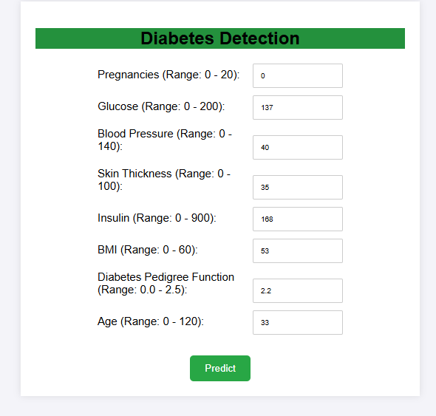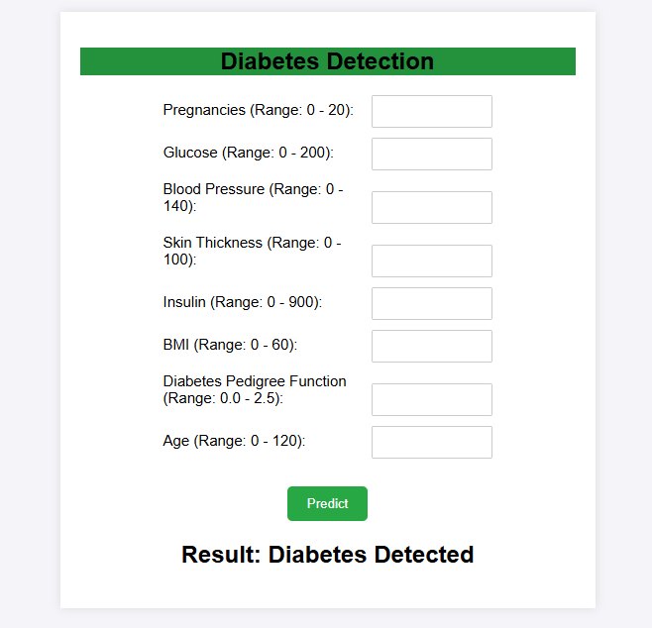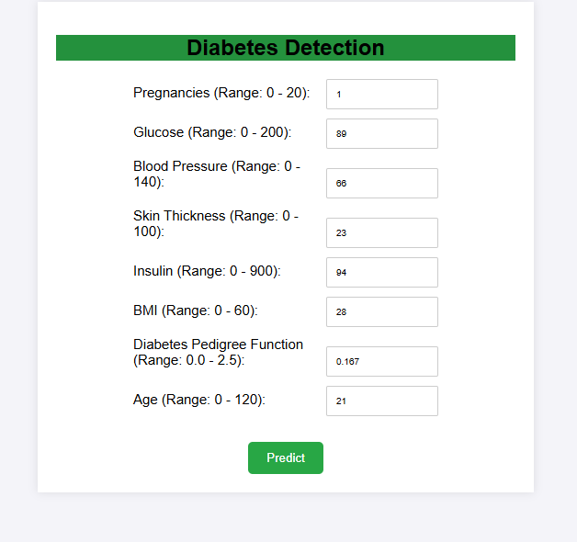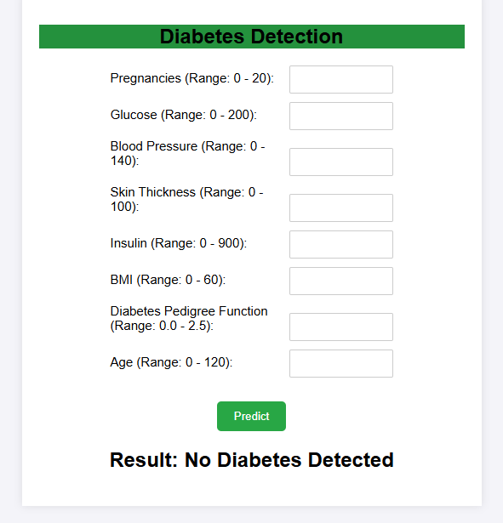

Future Scope

**Data Collection Improvements:**

Integrate with wearable devices for real-time monitoring.

Create a mobile application for intuitive data entry.

**Advanced Algorithms:**

Explore and compare different machine learning models.

Optimize model performance through hyperparameter tuning.

**Feature Engineering:**

Include additional health indicators (diet, exercise).

Employ feature selection strategies to find important predictors.

**Data Visualization:**

Create interactive dashboards for trend analysis.

Generate comprehensive patient reports.

**Model Deployment:**

Create an API to facilitate simple application integration.

Host the model on cloud platforms for better scalability.

**Healthcare Integration:**

Collaborate with healthcare providers for validation.

Implement automated alerts for healthcare professionals.

**Conclusion**

The diabetes detection project represents a significant step forward in leveraging machine learning to address a critical health issue. By utilizing advanced algorithms and comprehensive datasets, the project aims to provide accurate predictions of diabetes risk, empowering users to make informed decisions about their health. The integration of user-friendly interfaces, real-time data collection, and personalized recommendations enhances its practicality and effectiveness.

As the project evolves, the potential for improvement and expansion is vast. Future developments can lead to a more robust healthcare tool, enabling continuous monitoring, early intervention, and better management of diabetes. Collaborating with healthcare professionals and focusing on ethical considerations will ensure that the system not only meets clinical standards but also addresses the diverse needs of users.

In summary, this project not only highlights the capabilities of machine learning in healthcare but also paves the way for innovative solutions that can significantly impact public health outcomes. The ongoing commitment to enhancing this tool promises a brighter future for diabetes management and prevention.