Software Requirements Specification
For
College Management Organization
Version 1.0 approved

Table of Contents
Table of Contents ii
Revision History Error! Bookmark not defined.
1. Introduction 1
1.1 Purpose 1
1.2 Document Conventions 1
1.3 Intended Audience and Reading Suggestions 1
1.4 Project Scope 1
1.5 References 1
2. Overall Description 2

2.1 Student/Parent Perspective

2.2 Operating Environment
2.5 Design and Implementation Constraints 3
3. System Features 3
3.1 System Feature 1: Use Cases to Student/Parent 3
3.2 System Feature 2: Use Cases for Staff Member
3.3 System Feature 3: Use Cases to Login page.
3.4 System Feature 4: Use Cases to Modify Attendance Report
3.5 System Feature 5: Use cases to Modify Marks Sheet
4. External Interface Requirements 5
4.1 User Interfaces 5
4.2 Hardware Interfaces 5
4.3 Software Interfaces 6
4.4 Communications Interfaces 6
5. Other Nonfunctional Requirements 5
5.1 Safety Requirements 6
5.2 Security Requirements 6
5.3 Software Quality Attributes 6
6. Other Requirements 6
7. Activity Diagram: Admin Working Module
7.1 Activity Diagram: User Module
7.2 Activity Diagram:Staff Module
8 ER diagram
9 Dfd diagram

Introduction

Purpose
This specification defines the software requirement for College Management Organization. It also defines project scope include user interface style guides, contracts, standards, system requirements specifications, use case documents, or a vision and scope document.

Document Conventions
Documentation is in simple Arial text, where as key points are highlighted with bold text/italics Links are provided for headings such as introduction, Overall description directly form contents for easier navigation.

Intended Audience and Reading Suggestions
This document is for developers, project manager’s staff, users, testers, and documentation writers.

Project Scope
- The users will be able to know about student’s academic perfomence.
- It will be easy for the management to announce tests and result.

Reference
- www.karnanisoft.co.in
- The reference used for this SRS is Software Engineering A Practitioners approach by Roger pressman

Overall Description

Student/Parent Perspective

Use Case For College Management Organization Website:

Student/Parent Perspective:
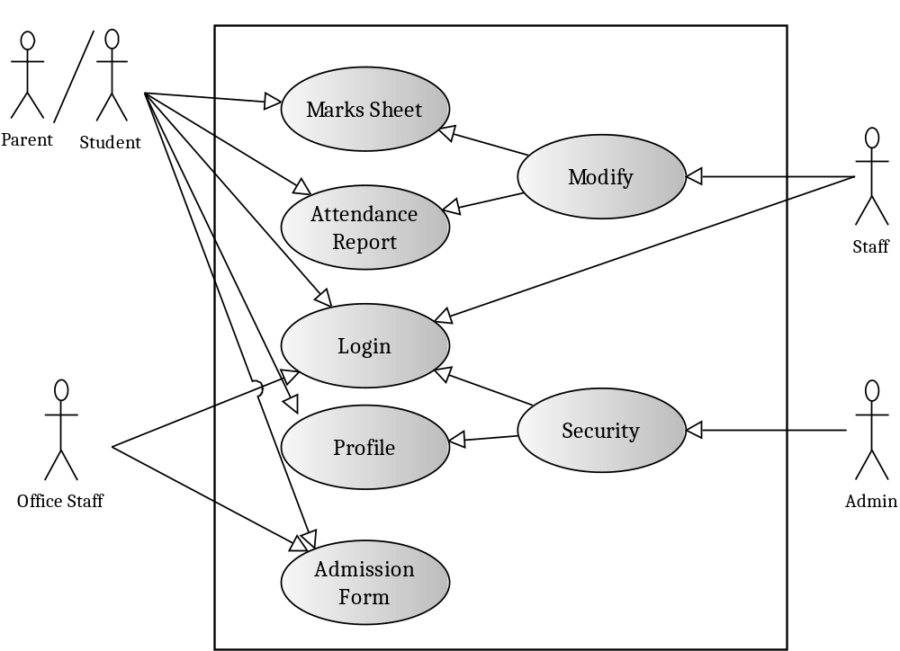

Here the students can view his/her marks sheet and attendance report online by logging in to the website, even their parents can login into the website and know the performance of their children’s easily. And he can even fill the admission form and send to the office address, which will be later handled by office staff. It takes just a few seconds of time to login into the website and perform tasks. The marks sheet and attendance report is managed by Lecturers of respective subjects. The admin is responsible for handling the security of the website.

Operating Environment
- This website is accessible on Internet explorer (6 or above ver) Mozila Firefox or any other windows based web browsers
- Preferred operating system will be Windows XP, Windows NT Windows Vista, Windows7

Design and Implementation Constraints
- It Needs minimum 512MB RAM & Pentium 4 CPU for better functioning
- It needs broadband connectivity for accessing this software.
- Php is the used software for designing of this software with HTML & CSS
- MySQL server is used For Databases
- This software is a web application. So customer should log in to internet & use web browsers to start application.

System Features

Use cases to Start College Management Organization:

This web application can be accessed at remote locations. This system can be used with PC and appropriate browser software to log on to our web site.

System Feature 1: Use Cases to Student/Parent
Student/Parent:

Here Student have to login into the website. Once he is logged in he can view his marks sheet and attendance report. He can also fill his admission form and mail it to office administration through this website.

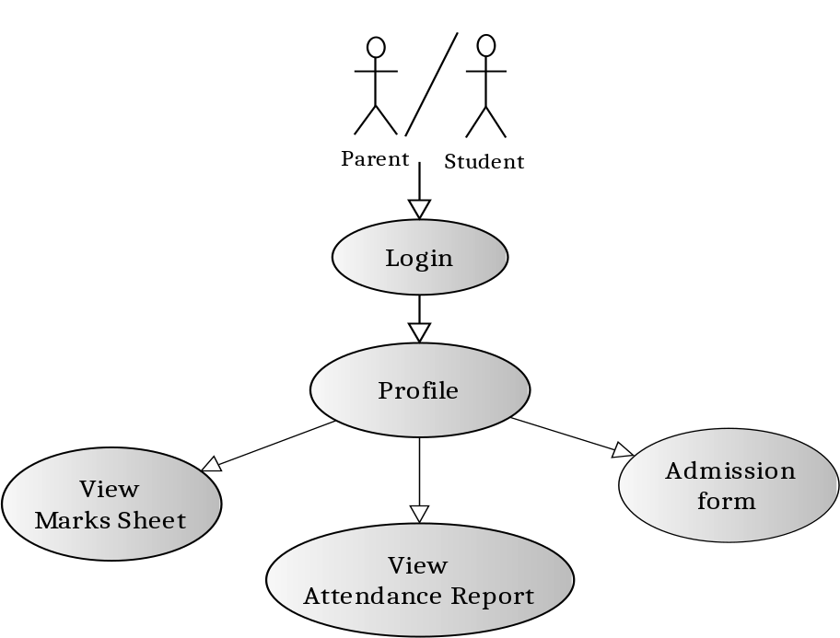

Functional Requirements (Text)
Goals in Context: To get logged in to the website and view the performance.
Login to Student’s account of College Management Organization
Preconditions:

System Feature 2: Use Cases for Staff Member

Staff :

Here Staff Member have to login into the website by giving valid information. He/she will be able to modify Marks sheet/Attendance report related to their subject. After modification, the modified list can be sent to the particular student’s account.

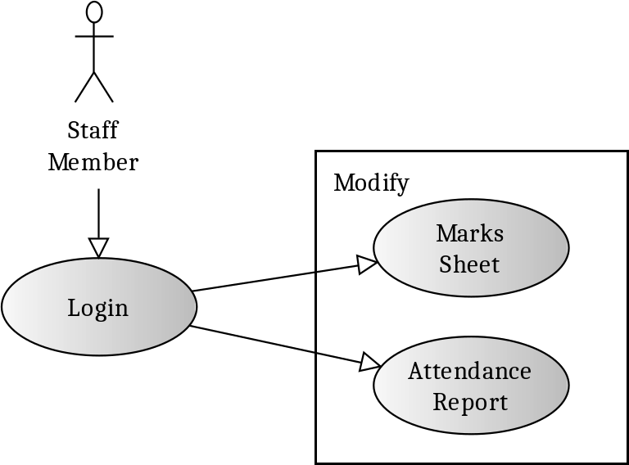

Functional Requirements (Text)
Goals in Context: To modify Student Report.
Preconditions: Login to Staff accout of College Management Organization.

System Feature 3: Use Cases to Login page.
Actors Administrator/User:
- Administrator can login using password provided with Administrator role & manage products.
- User can login using password provided with user role and proceed to user details form. This also allows new user creation to add new entry of user.

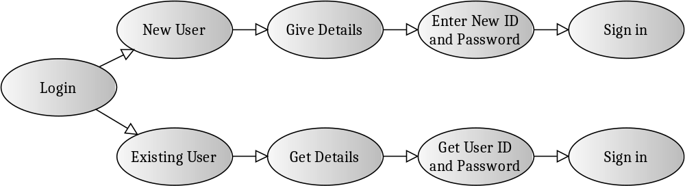

Description and Priority
    - Priority is High
Functional Requirements (Text)
Goals in Context: To add User and login to College Management Organization.
Preconditions:
- Direct login as User form Home page.
- Admin should have separate home page page to login..

Triggers :
- Add new User
- Login as user or get forgotten password

Scenarios:
- Log on to College Management Organization (home page)
- Click Login link (To login to the website), and enter user name & password.
Exceptions:
- Id or password may not match, then raise error message
- Wrong details may be entered, write validations

System Feature 4: Use Cases to Modify Attendance Report

Attendance Report:

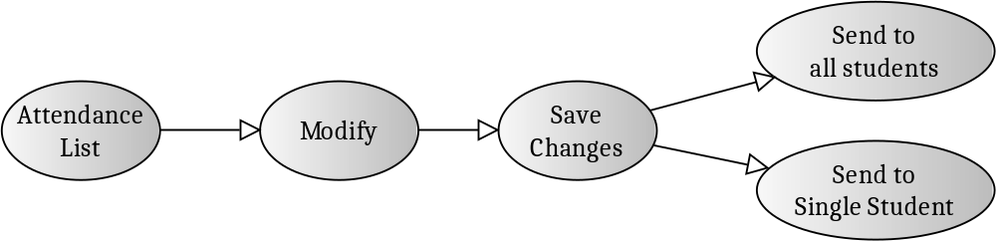

Description and Priority
    - Priority is High
Functional Requirements (Text)
Goals in Context: To Modify the attendance report by the staff
Preconditions:
View Attendance Report

Triggers :
- Edit Required to modify and finalize the Report.
- Submit button to send the contents to students.

Use cases to Modify Marks Sheet
Marks Sheet:
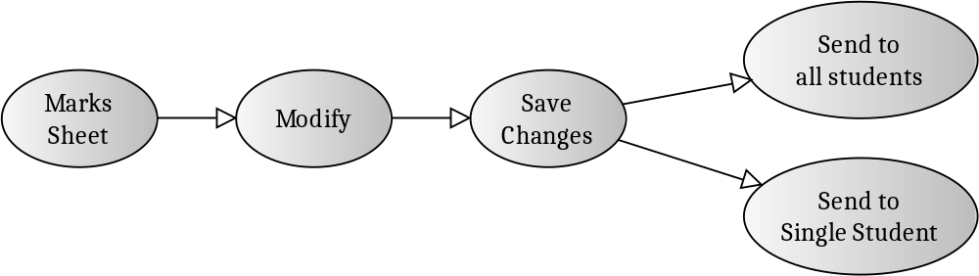

Description and Priority
    - Priority is High
Goals in Context: To modify the Marks Report by the staff
Preconditions:
- Login as staff

Triggers :
1. Edit Required to modify and finalize the Report.
- Submit button to send the contents to students.
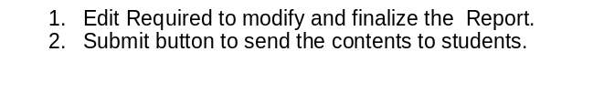
Scenarios:
- Login as Staff
- Click Modify link
- Enter Marks list and click send.

External Interface Requirements

User Interfaces
- User control constructed using php will appear on Every page Containing WebShop name, logo & links to different pages.
- For user interface HTML tags and peace maker is used for page designing.
- Home page will be provided with links to Home, Shop, Shopping cart & Login.
- Login dialog box contains textboxes to enter user name & password. Password character is either * or #.
- Inter face forms for adding Products/Publisher/categories/Shipping should contain textboxes for each fields and links to add /update or delete records
- New user creation is provided, width the User login form.

Hardware Interfaces
- This software needs PC with minimum P4 Processor, 512 Mb RAM
- As it is a web page system needs inter net connection with modem (Rec: Broad band connection)
- During designing phase system needs above configuration along with IIS installed.
- Needs printer for taking print of bill.
- Uses HTTP for accessing web pages.

Software Interfaces
- Software name is College Management Organization Ver1.
- This software uses google chrome to start package
- MySQL server is used as database.
- Works on Win XP / Win NT/Win2000/Vista/Win 07 operating system.
- During development phase System should be installed with Visual Studio 2005, MySQL Server 2005 express Edition, IIS should be installed in System, & google chrome or any other browser.
- As this is online package the data related to Products is shared by users,
- The Product & user details can be managed by Storekeeper.

Communications Interfaces
- User or admin needs windows web browsers such as Internet explorer, IIS,
- Protocol: TCP/IP
- Email facility for confirmations.
- Communication Standard HTTP

Other Non-functional Requirements

Safety Requirements
- System should not allow damage to databases, backup facility should be provided
- Hosting should have good firewall protection & virus protection.
- User interfaces are easier for accessing.

Security Requirements
- User information are managed to keep track of users
- User logins and administrator logins are provided separately for users and admins.

Software Quality Attributes
- This software is reliable to users.
- User control used is for reusable feature.
- Easily accessed using browsers
- As dynamic pages are used students record can be entered and modified from remote places.
- New pages and databases which provides flexibility to software
- This software can be easily modified by changing design.

Other Requirements
- This requires usage of MySQL queries & to manage databases.
- Need to purchase a space from hosting company for website
- ftp is required to uplink pages

Activity Diagram: Admin Working Module

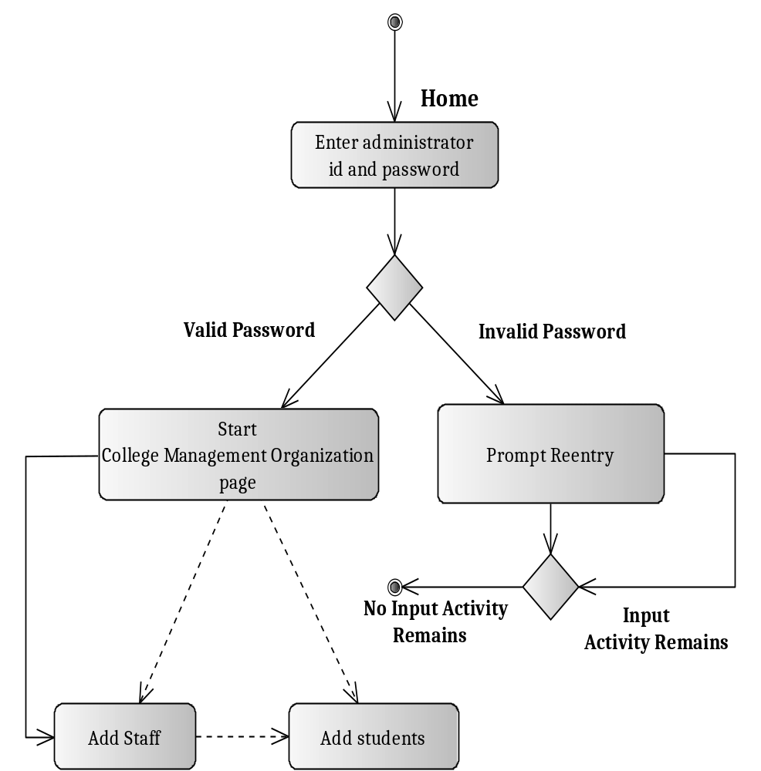

Activity Diagram: User Module

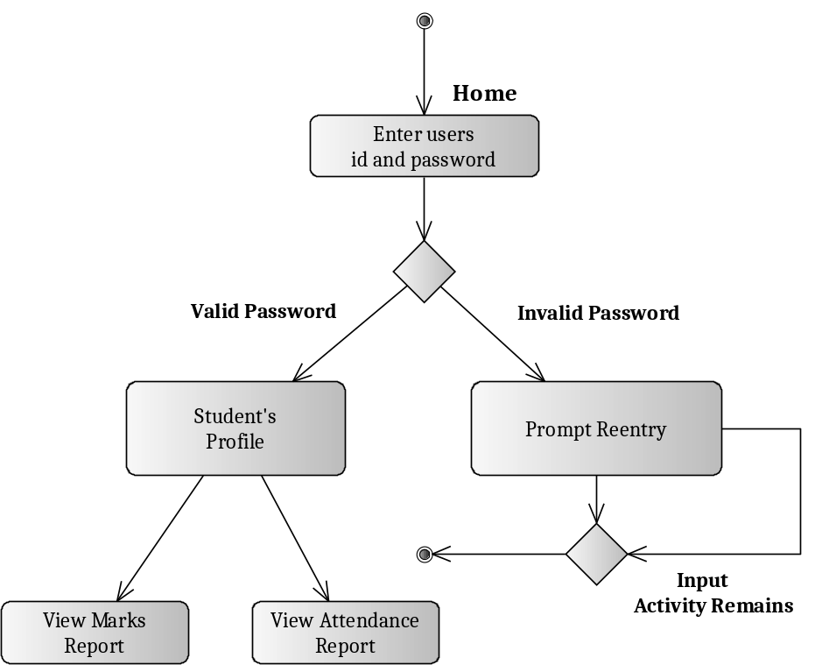

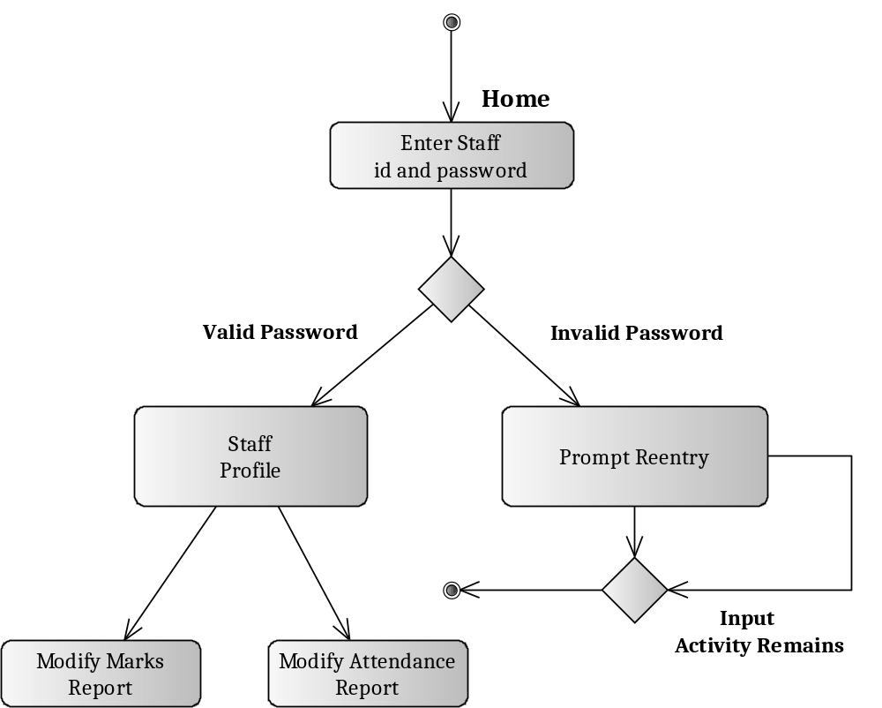
Activity Diagram: Staff Module

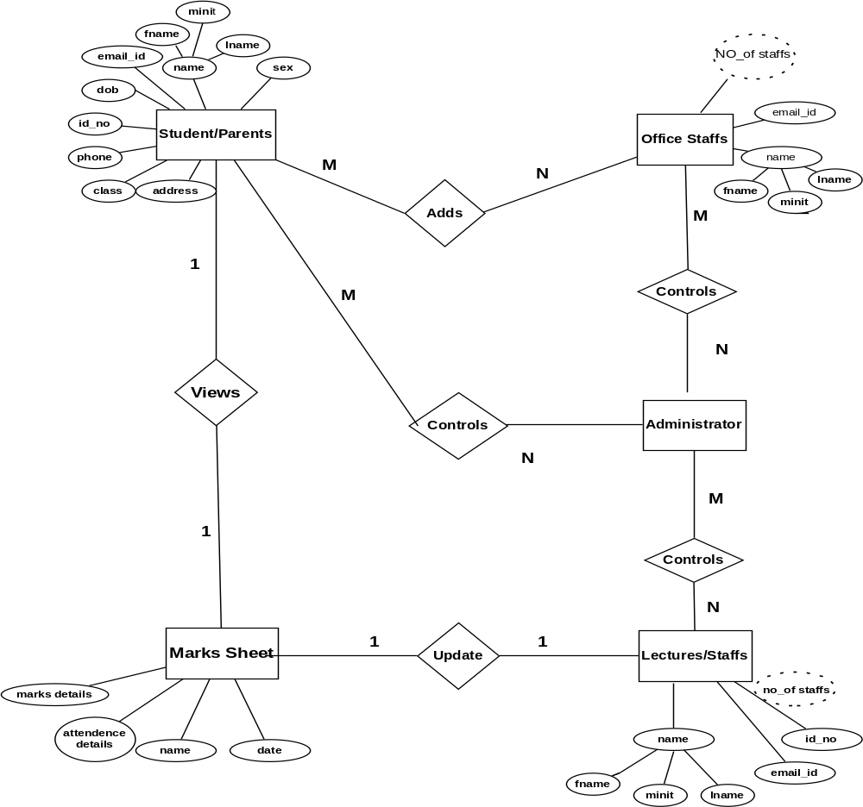
ER Diagram:

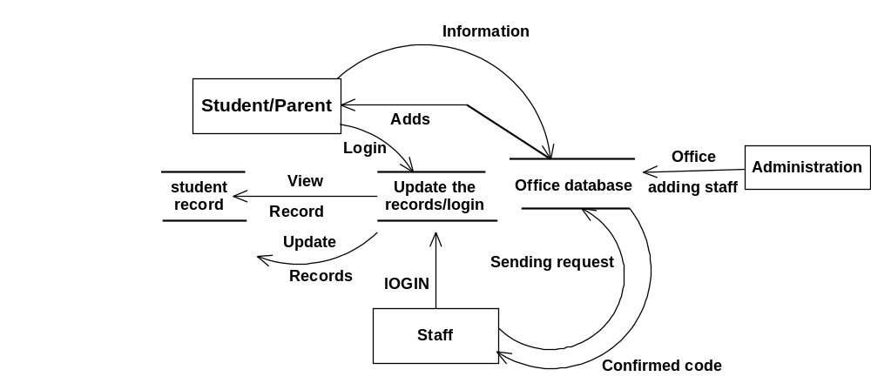
Dfd Diagram:
Level 0:

