PROJECT REPORT: MILESTONE 1
Project Title: Telecom Customer Churn Prediction Using Machine Learning
Course: Machine Learning (Section: C)
Submission Date: June 30, 2026

Group Members
Name | Roll Number | Role
Muneeb Akram | 231400103 | Project Manager
Ifraim Ijaz | 231400107 | Data Engineer
Abdullah Saif | 231400116 | Modelling Lead
Zuhra Noreen | 231400090 | Evaluation & Reporting Lead

1. Introduction & Project Objectives
Customer churn means customers stop using a telecom company's services and move to another company. This causes loss of customers and money.
The main goal of this project is to use machine learning to predict which customers are likely to leave the company.

Milestone 1 Objectives
- Check the dataset for problems.
- Clean the data.
- Handle missing values.
- Create 6 EDA graphs.
- Prepare the data using encoding and scaling.
- Train three machine learning models:
  - Logistic Regression
  - Decision Tree
  - Random Forest
- Compare their performance.

2. Dataset Description & Data Dictionary
We used the IBM Telco Customer Churn Dataset.
- Total Rows: 7043
- Total Columns: 21
After removing the customerID column, 20 columns were used.

Data Dictionary
Feature | Type | Description
gender | Categorical | Male or Female
SeniorCitizen | Numeric | 1 = Senior Citizen, 0 = Not Senior
tenure | Numeric | Number of months with the company
PhoneService | Categorical | Phone service available or not
MultipleLines | Categorical | Multiple phone lines or not
InternetService | Categorical | DSL, Fiber Optic or No Internet
Contract | Categorical | Month-to-month, One year, Two year
MonthlyCharges | Numeric | Monthly bill amount
TotalCharges | Numeric | Total bill amount
Churn | Target | Yes or No

3. Data Quality Issues & Preprocessing

Problems Found
- The customerID column was removed because it is only an ID.
- The TotalCharges column had 11 empty values.
- These empty values were changed to NaN.
- The column was converted into numeric format.
- Missing values were filled using the median.
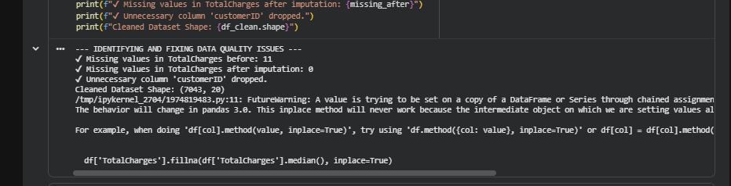

Preprocessing Steps
- Converted text data into numbers using LabelEncoder.
- Scaled numeric columns using StandardScaler.
- Split the data:
  - 80% Training
  - 20% Testing

4. Exploratory Data Analysis (EDA)
Plot 1: Customer Churn Distribution
Most customers did not leave the company.
Around 73% stayed and 27% left.
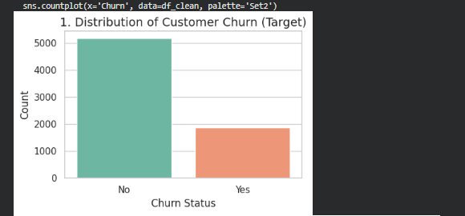
Plot 2: Tenure Distribution
Customers with very low tenure are more likely to leave.
Customers who stay for many months usually do not churn.
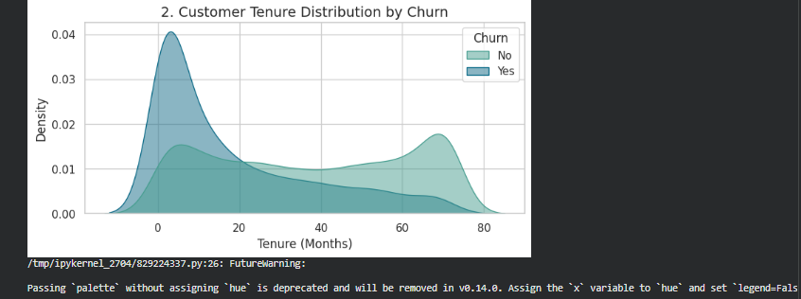
Plot 3: Monthly Charges vs Churn
Customers with higher monthly charges are more likely to leave.
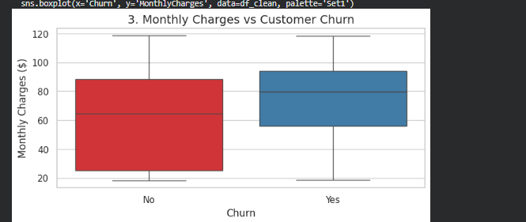
Plot 4: Churn by Contract Type
Customers with Month-to-month contracts leave more often.
Customers with One-year and Two-year contracts usually stay.
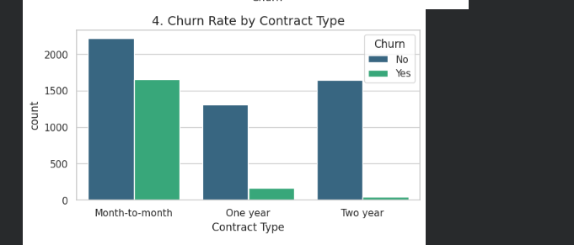
Plot 5: Churn by Internet Service
Customers using Fiber Optic internet have a higher churn rate.
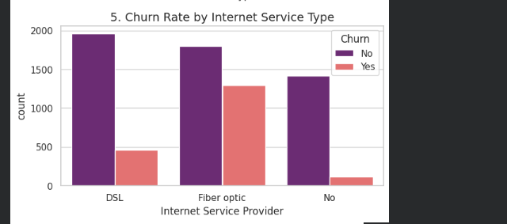
Plot 6: Correlation Heatmap
Tenure has a negative relationship with churn.
This means customers who stay longer are less likely to leave.

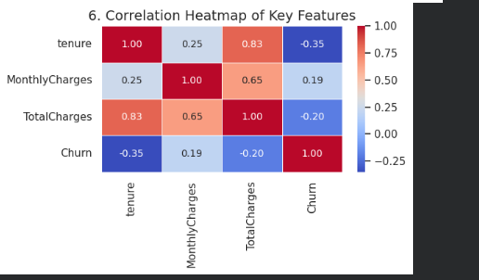

5. Model Training & Evaluation
Three machine learning models were trained.

Performance Table
Model | Accuracy | Precision (Class 1) | Recall (Class 1) | F1-Score (Class 1)
Logistic Regression (Baseline) | 79.91% | 0.64 | 0.55 | 0.59
Decision Tree | 78.50% | 0.60 | 0.55 | 0.58
Random Forest | 79.84% | 0.69 | 0.43 | 0.43

Results
Logistic Regression (Baseline)
- Accuracy: 79.91%
- Demonstrated balanced performance across all evaluation metrics.
- Served as a strong baseline model for comparison.
Decision Tree
- Accuracy: 78.50%
- Used max_depth = 5 to reduce overfitting.
- Achieved slightly lower performance than the other models.
Random Forest
- Accuracy: 79.84%
- Achieved performance comparable to Logistic Regression.
- Demonstrated strong weighted precision (0.79), recall (0.80), and F1-score (0.79).
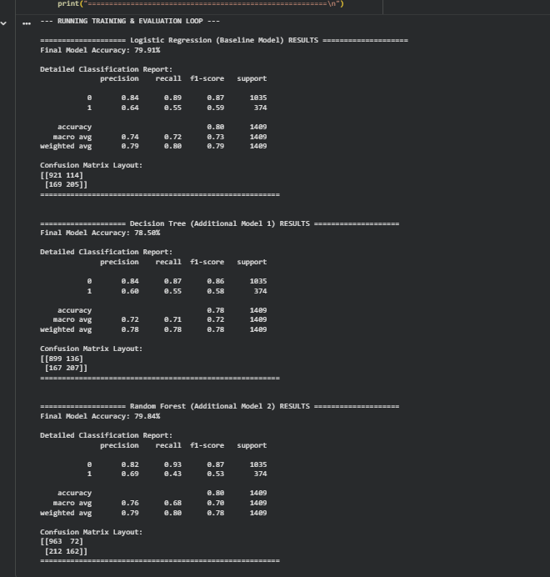

6. Ethical Considerations

Privacy
The customerID column was removed to protect customer privacy.

Fairness
The model focuses on customer behavior and service details.
It should not make unfair decisions based on personal information like gender.

Conclusion
In this milestone, we cleaned the dataset, handled missing values, created six EDA graphs, prepared the data, and trained three machine learning models. Logistic Regression and Random Forest gave the best results, with Random Forest achieving the highest accuracy. These models can help telecom companies identify customers who are likely to churn so they can take steps to retain them.

