Assignment 1
Names: Zuhra Noreen, Ifraim Ijaz
Roll numbers: 231400090, 231400107
Submitted to: Mam Amina
Course: Software Project Management Lab

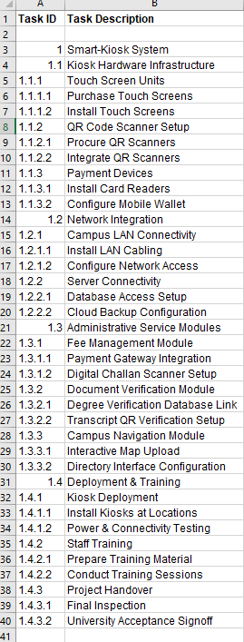
Firstly, I added The Task Ids and Task descriptions
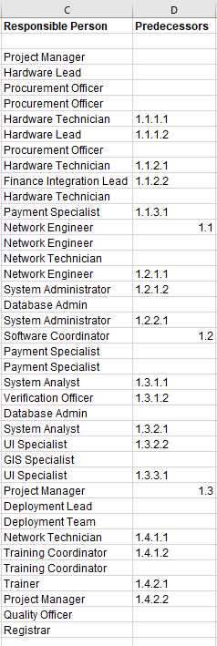
Then I added the persons responsible for that specific task according to their roles. Then I defined the predecessors for tasks.

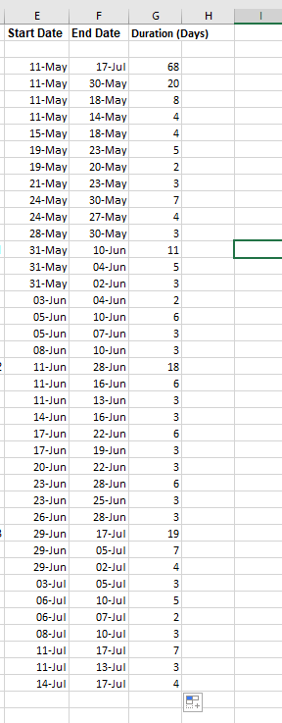
After that the next step was to write the start date and end dates. This was done manually. But the next column Duration was done by a formula that is Start Date- end date +1 and dragged in the whole column.
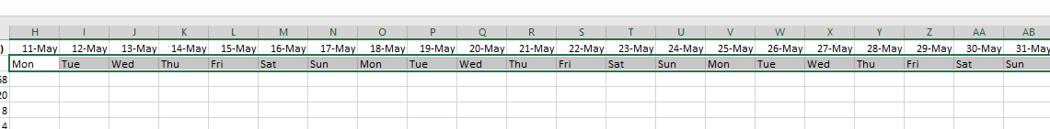
Then I wrote the dates till 17 July i.e. the ending date of project.
I wrote the first date by formula =Start date. In the next column I added +1 and dragged in the whole columns
For Days I used the formula =LEFT(TEXT(H1,"dddd"),3)

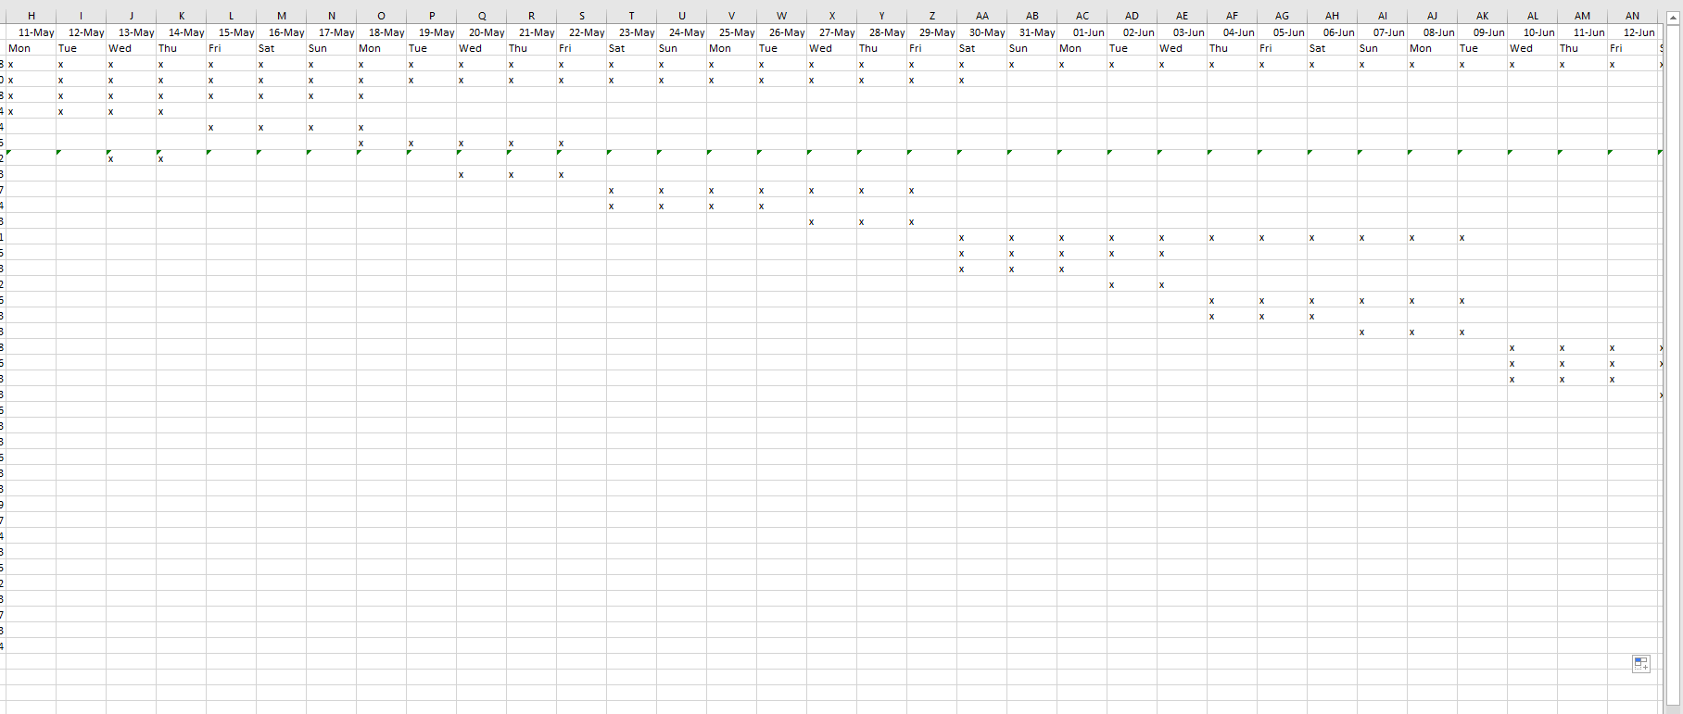
For the Gannt chart I used the formula =IF($B3="","",IF(AND($E3<=H$1,$F3>=H$1),"x",""))
And dragged in respective columns
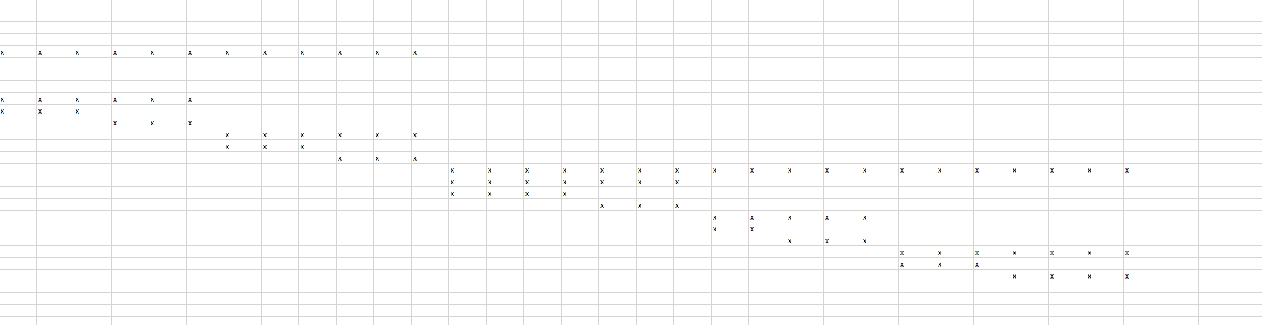

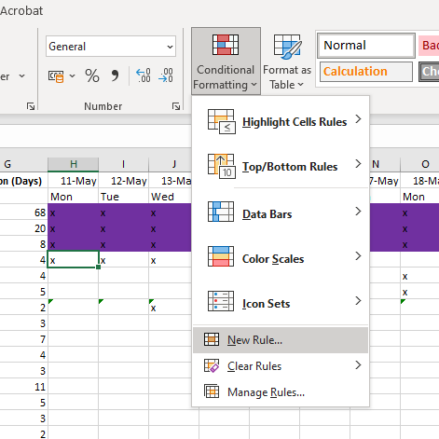
After that I select conditional formatting , new rule
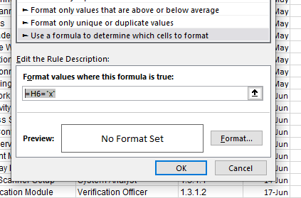
Then select last option , write formula and select format
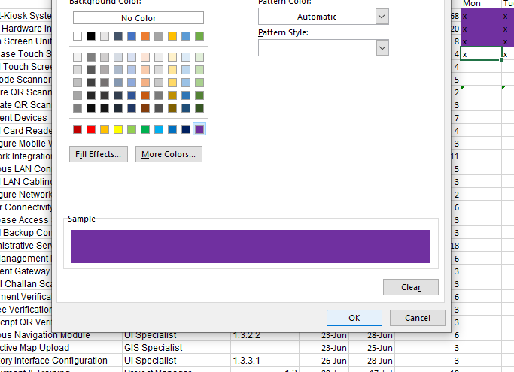
Select a clr and oppress ok

After applying all formulas the final output
