Name: Hadia Nasir Roll number: 231400100

Question 1.a) WBS and Gantt Chart
- Project Structure: Created a 3-level Work Breakdown Structure (WBS) for the SmartClinic System with all tasks set to Auto Schedule.
- Timeline Constraint: Configured to start on 01 September 2026 and finish on 29 October 2026, meeting the October 31 deadline.
- Logic Links: Added parallel execution between UI/UX Design and System Analysis. Linked their milestones using a Finish-to-Finish (FF) dependency (13FF, 16FF).
- Lag Buffer: Added a 1-day lag (+1d) on the Production Environment Setup task to run right after Testing finishes.
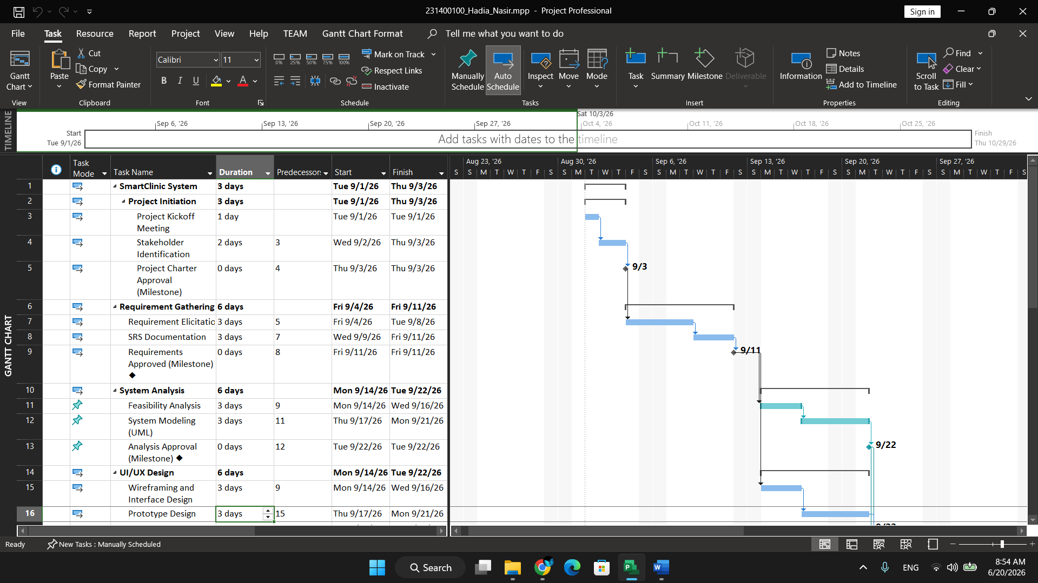

Question 1.b) Resource Registry and Overallocations
- Resource Sheet: Entered all work resources with specific daily standard rates.
- Capacity Constraints: Configured 200% Max Units for the Backend Developer, 75% availability for the QA Engineer, and 50% availability for the Security Analyst.
- Custom & Cost Resources: Added two custom resources (Cloud Solutions Architect and Medical Compliance Officer) and one Cost Resource (Server Hosting Fee set to $500).
- Overallocations: Intentionally assigned the Business Analyst, Frontend Developer, and Database Administrator to overlapping tasks, causing red conflict warnings.
- Resolution: Resolved the Business Analyst conflict automatically using Resource Leveling. Resolved the other two manually by replacing resources and tweaking predecessors.

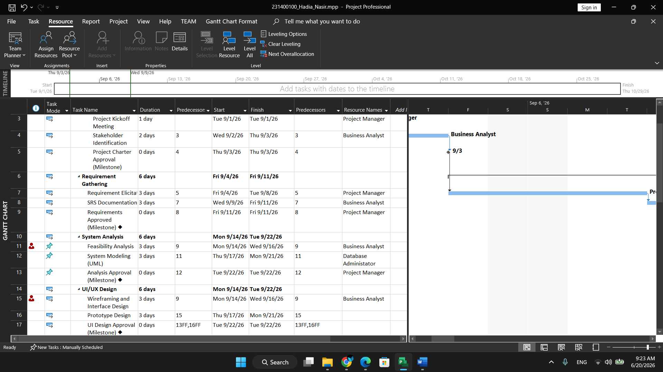
Resources Over Allocated

Resources Graph

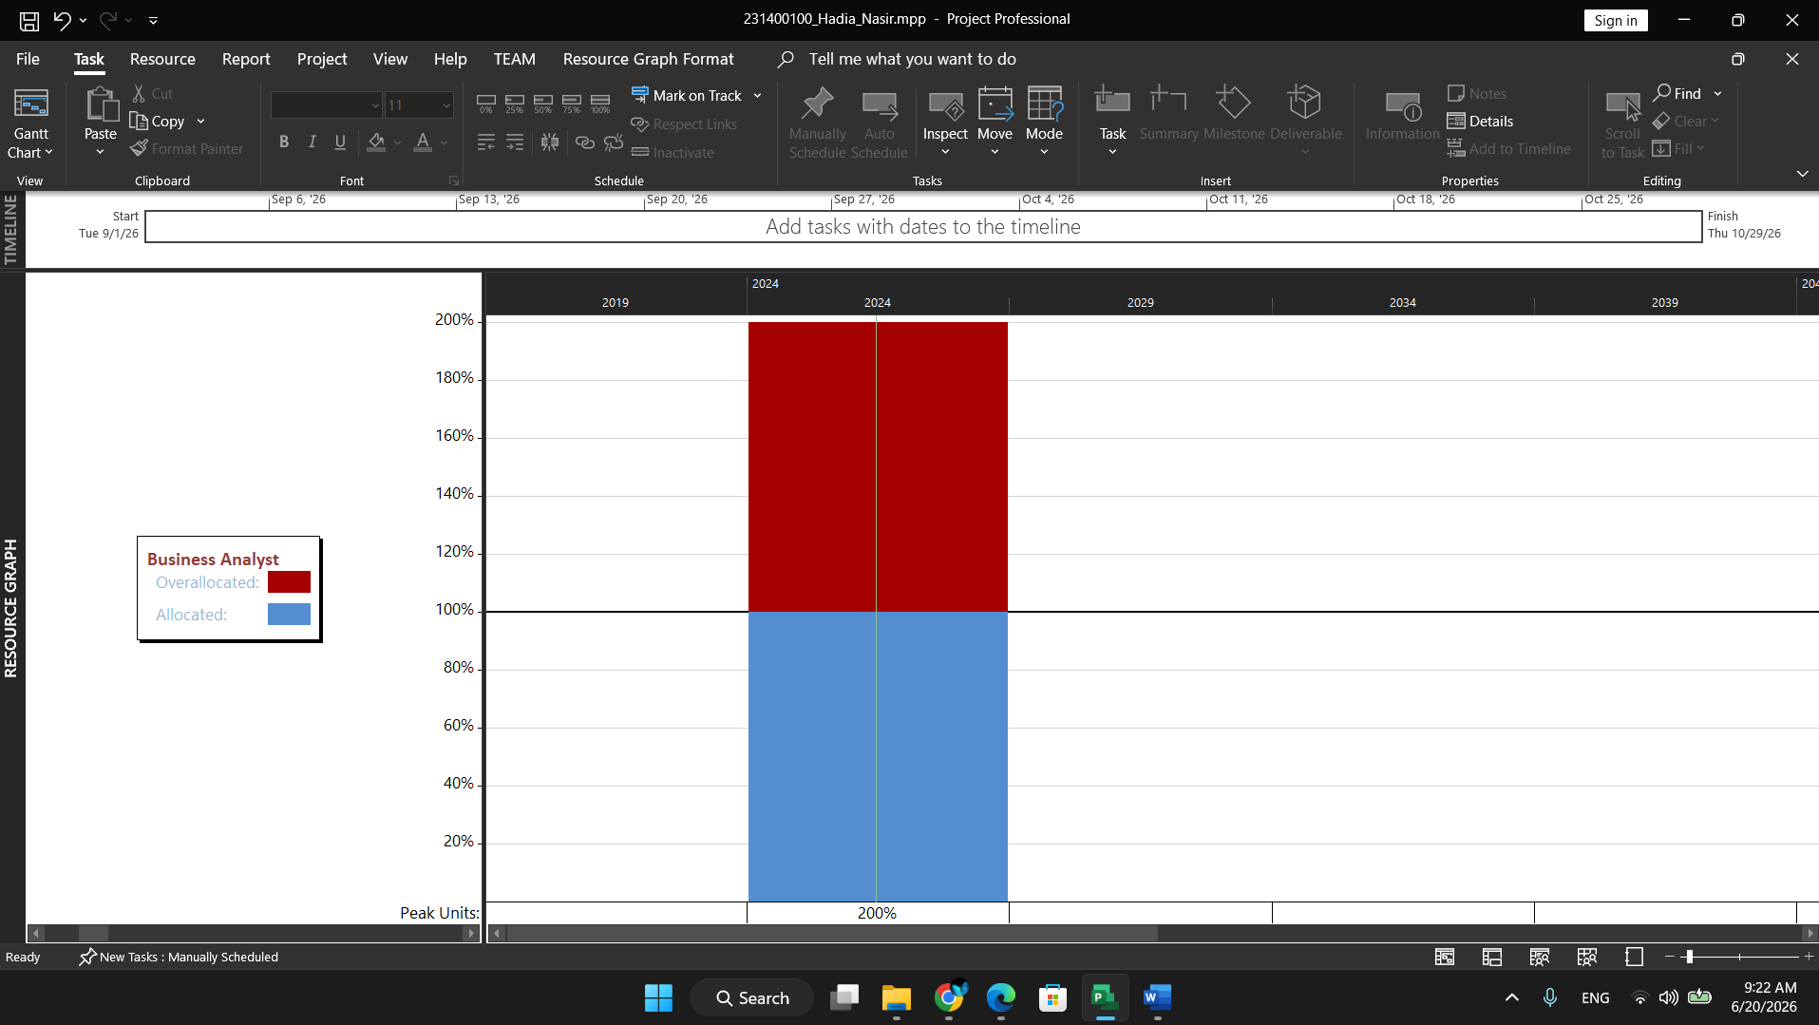

Resources Sheet:
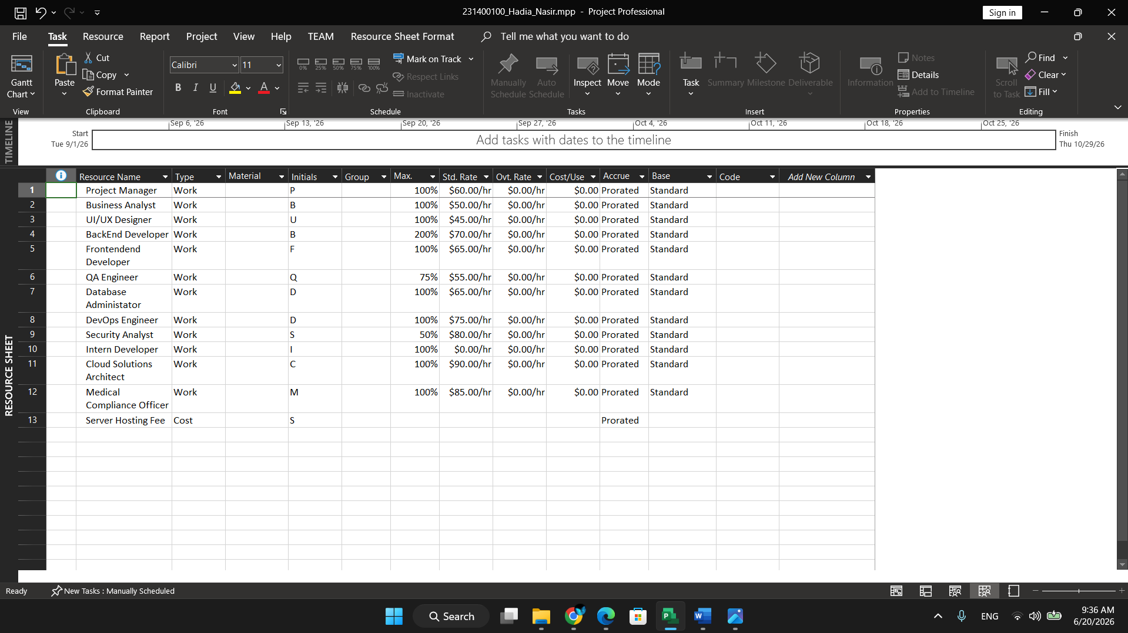

Question 1.c) Baseline and Tracking
- Baseline Saved: Saved the final project baseline plan before applying any task progress updates to lock in scheduled dates.
- Status Date: Configured the official project reporting Status Date to 15 October 2026 in Project Information.
- Progress Tracking: Marked Project Kickoff Meeting and Stakeholder Identification as 100% complete, and Requirement Elicitation as 50% complete.
- Variance Columns: Added Start Variance, Finish Variance, and Duration Variance columns to track delays and project health.

Settings the Base Line:

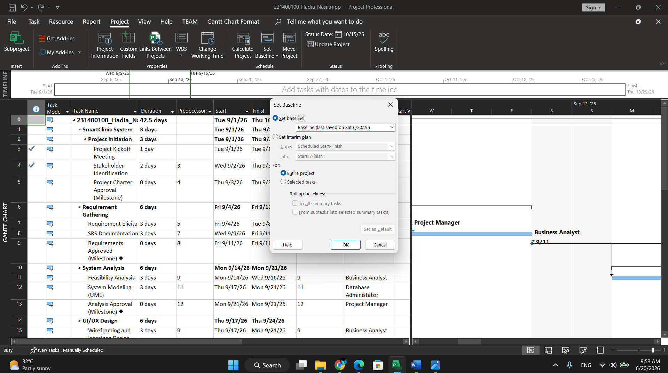

Statues date None

