Software Project Management

Name | Roll Number
Ifraim Ijaz | 231400107
Muhammad Rehan Abid | 231400109
Kashaf Shafiq | 231400112
Tasneem Fatima | 231400115

Section: C

Stage: 3

Resource Sheet:
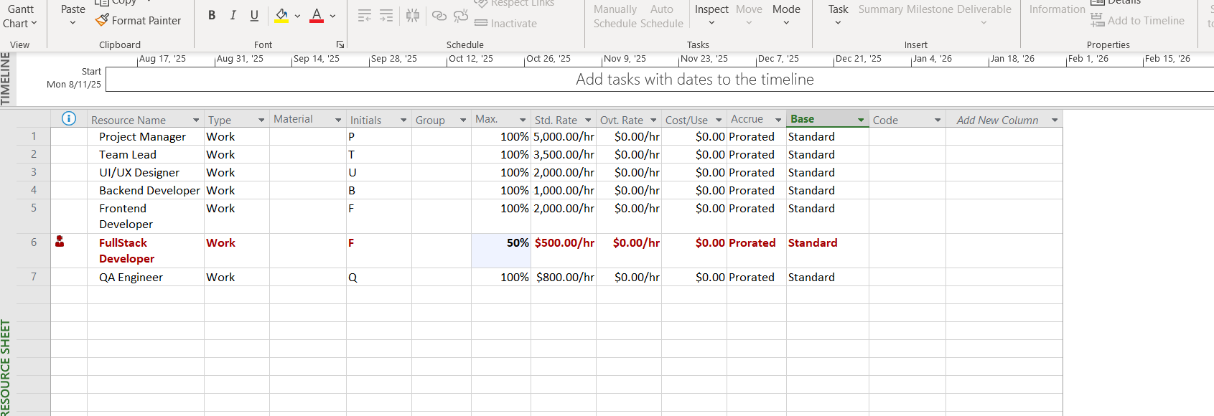
After resolving:
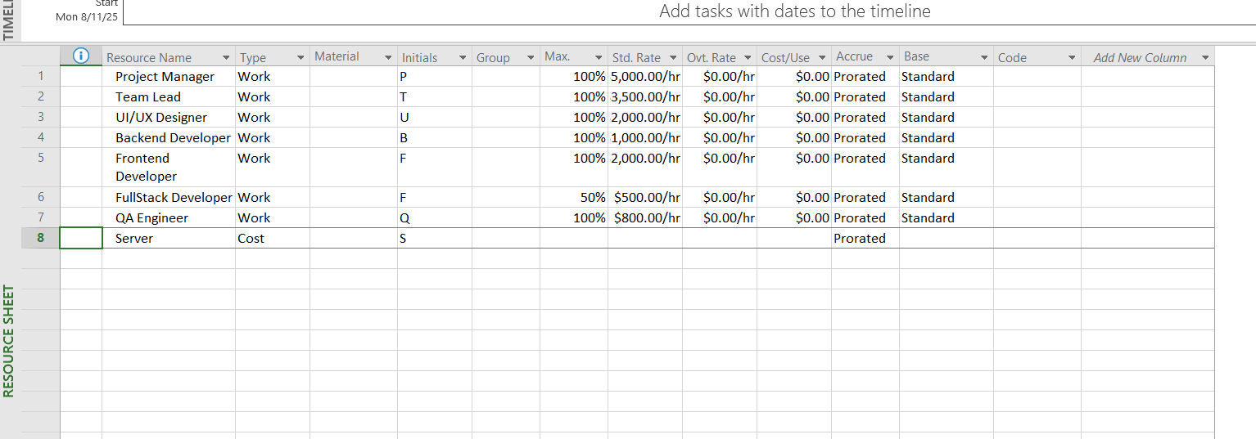

Resource Assigned:

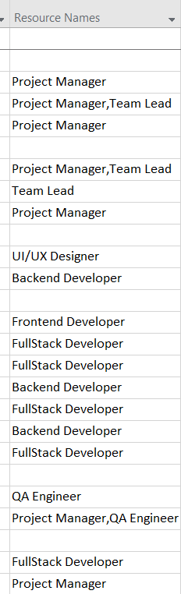
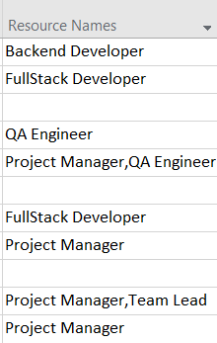
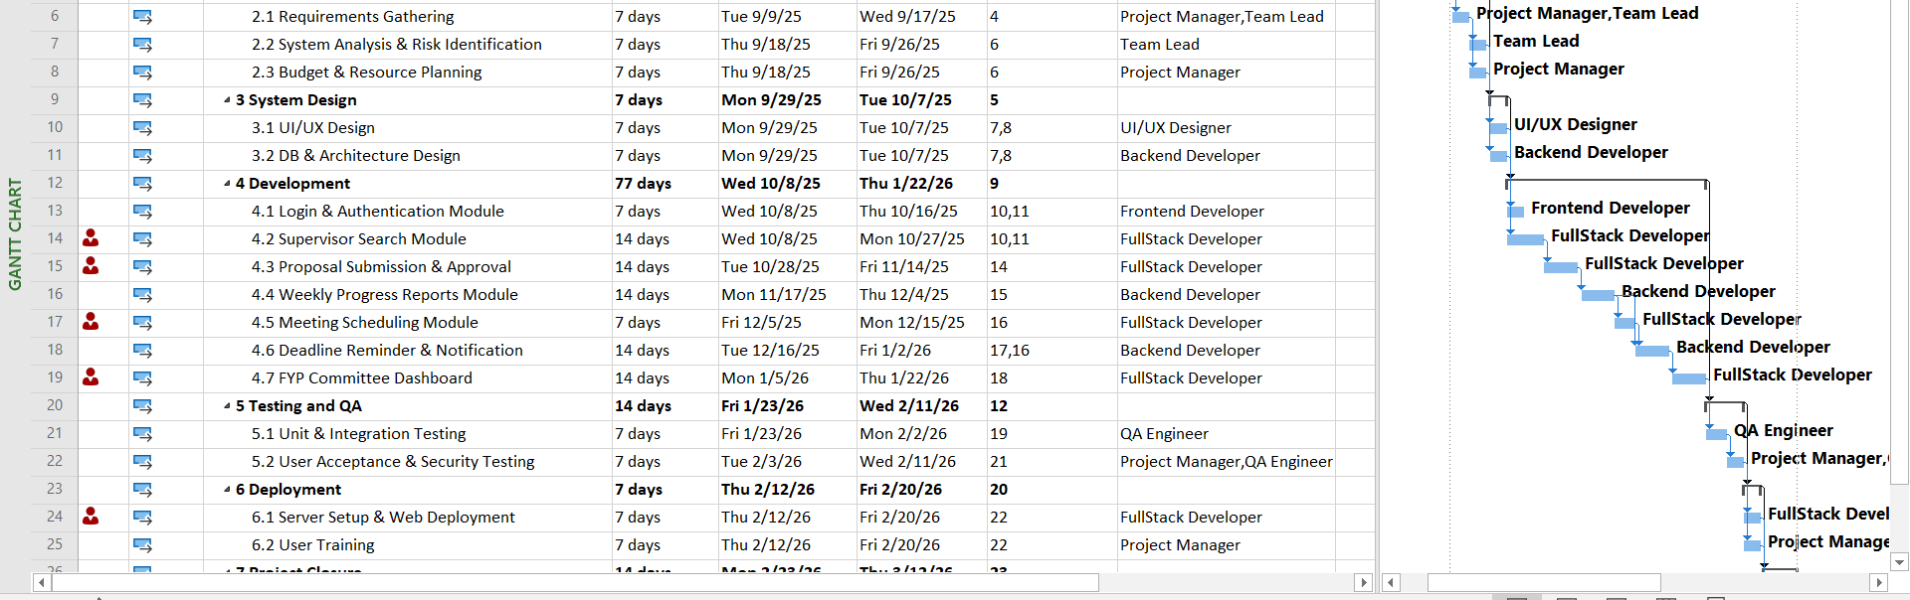After Resolving :

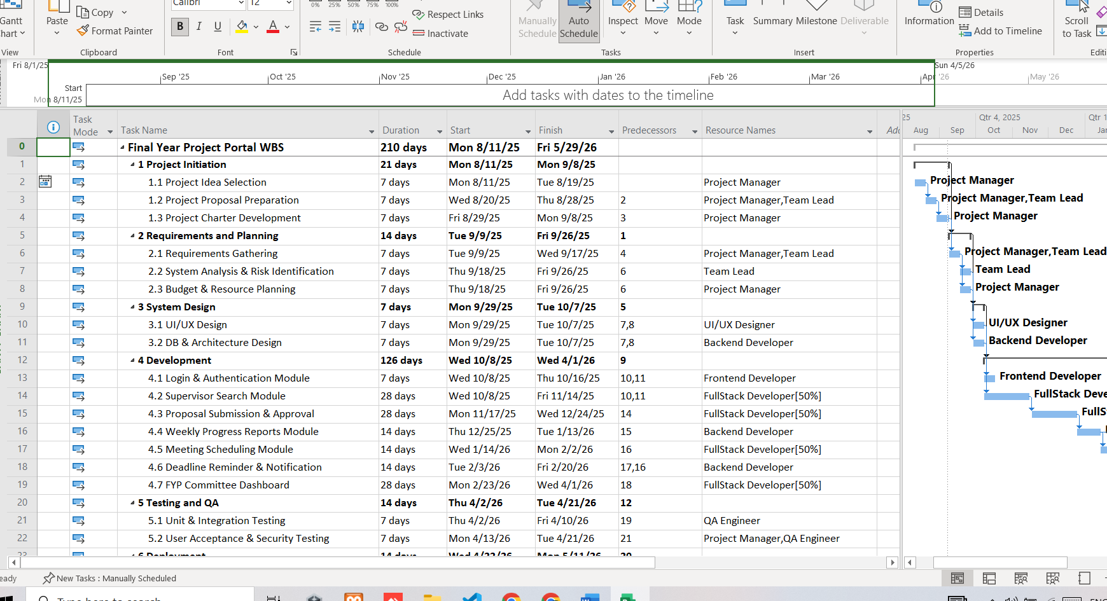
Resource Usage:

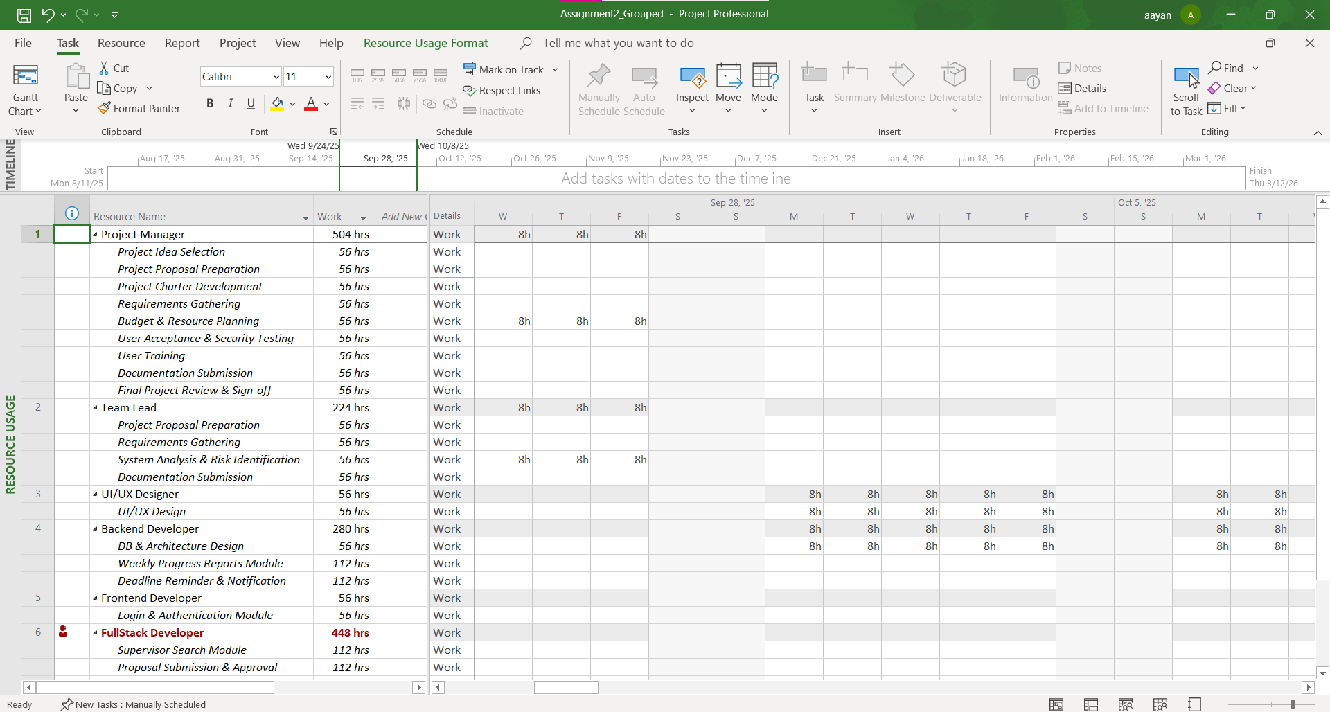

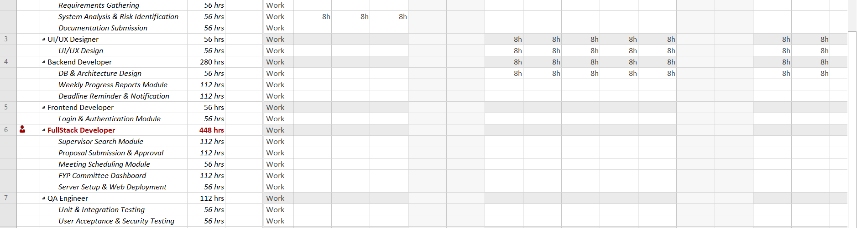

After resolve:
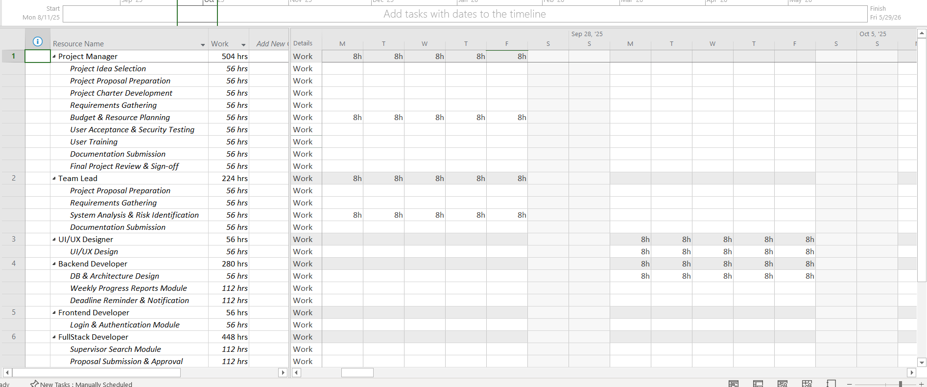

Overallocation Identified: FullStack Developer was overallocated — Max Units reduced to 50%, but task assignments (Supervisor Search Module, Proposal Submission & Approval, Meeting Scheduling Module, FYP Committee Dashboard, Server Setup & Web Deployment) remained at 100% Units, exceeding capacity.
Resolution: Assignment Units on all FullStack Developer tasks were reduced from 100% to 50% to match resource capacity, resolving the overallocation (verified via Resource Usage/Resource Graph view).

