

Course: Software Project Management
Project Name: Final Year Project Portal
Members:
Tasneem Fatima-231400115
Kashaf Shafiq-231400112
Rehan Abid-231400109
Ifraim Ijaz-231400107
Submitted To: Amina Shehbaz

Table of Contents
Project Budget Sheet Preparation Using Excel: 2
Objective: 2
Task Cost Estimation: 2
Explanation: 2
Formulas: 2
Resource Cost Estimation: 3
Explanation: 3
Formulas: 3
Total Budget: 3
Explanations: 3
Formulas: 3
Visualizations: 4

Project Budget Sheet Preparation Using Excel:

Objective:
The purpose of this stage was to prepare a Project Budget Sheet using Microsoft Excel based on the project schedule and resource information obtained from the Microsoft Project file. The budget sheet helps estimate project expenses and monitor cost distribution across different tasks and resources.

Task Cost Estimation:
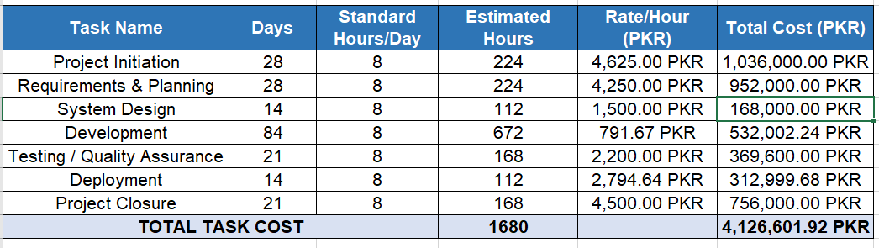

Explanation:
The project was divided into individual tasks and activities. For each task, estimated working hours and hourly rates were entered and used with the help of formulas.

Formulas:
- For Estimated hours, we multiplied the Days column with Standard Hours per day.
Estimated Hours=Days*Standard Hours
- For Total cost we multiplied the estimated hours column values with the rate per hour.
Total cost= Estimated Hours * Rate/Hour
- For the total cost we added all the values of Total Cost
=SUM(F4:F11)

Resource Cost Estimation:
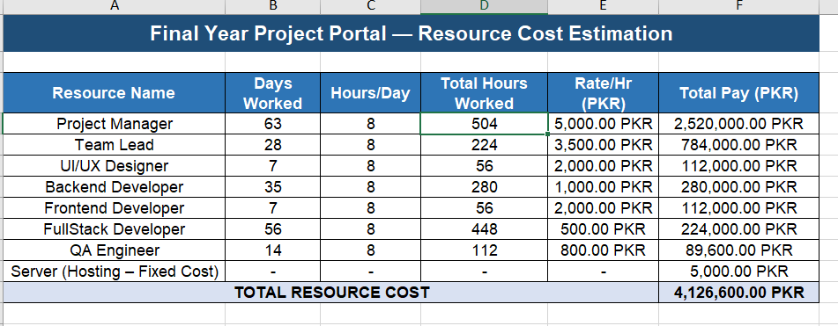

Explanation:
A separate section was created to calculate the cost of project resources and team members.

Formulas:
- Total Hours worked= Days worked*Hours
- Total Pay= Total Hours worked*Rate
- Total resource cost= SUM(F5:F11)

Total Budget:
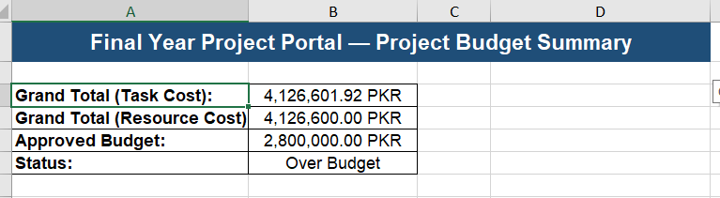

Explanations:
A validation was implemented to compare the calculated budget with the approved project budget limit. This helped identify whether the project remained within the allocated budget or exceeded the available financial resources.

Formulas:
  - Total Budget=Total Task Cost+ Total Resource Cost
  - Status =IF(Total Budget >2800000,"OVER BUDGET - Review Required","WITHIN BUDGET - Approved")

Visualizations:
