Experiment 1

Setting Up Python Environment and Libraries – Jupyter Notebook

Aim
To configure Python and Jupyter Notebook, verify the installation of essential libraries such as NumPy, Pandas, and Matplotlib, and load the Churn Modelling dataset for basic data inspection and visualization.

Algorithm
- Install and open Jupyter Notebook.
- Import the required libraries: NumPy, Pandas, and Matplotlib.
- Verify the installation by checking the library versions.
- Load the Churn_Modelling.csv dataset using the read_csv() function.
- Display the first few records to ensure the dataset is loaded correctly.
- Examine the dataset using info(), shape, and describe() functions.
- Perform basic NumPy operations to verify numerical computations.
- Generate a simple visualization using Matplotlib.
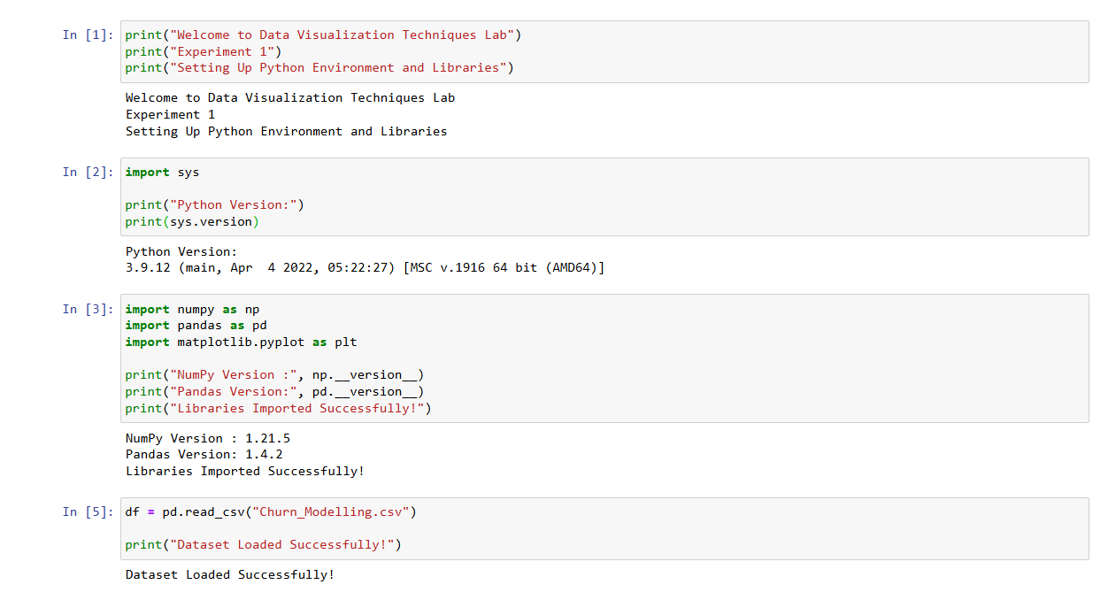
- Verify the successful execution of the Python environment and libraries.
- Import the required libraries: NumPy, Pandas, and Matplotlib.
- Load the Churn_Modelling.csv dataset

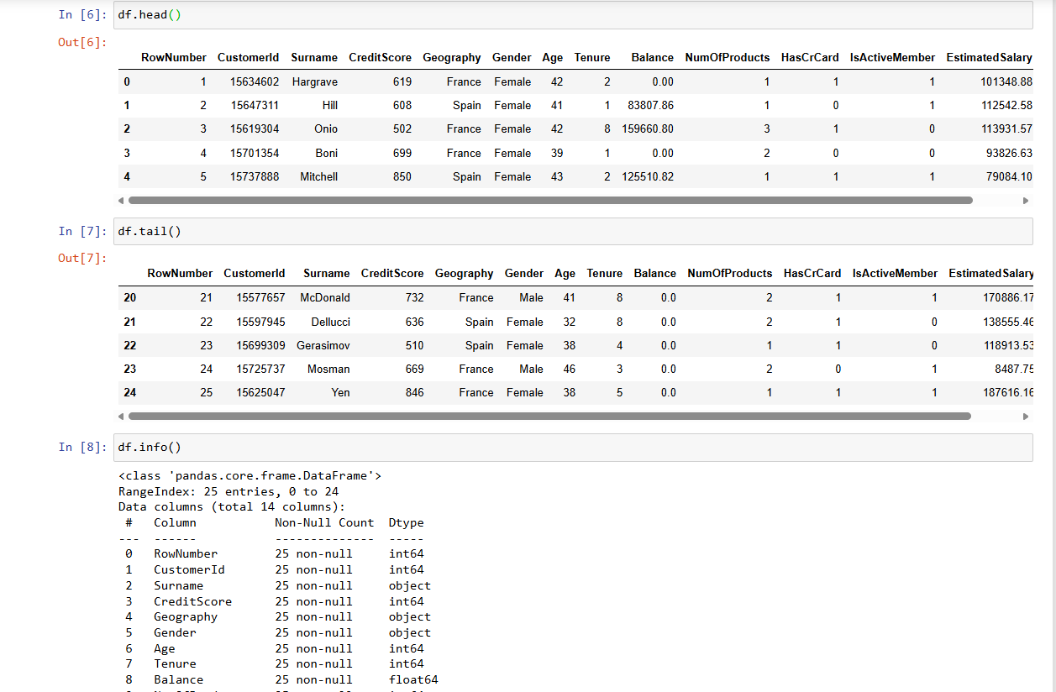

- Displays the last five records of the dataset.
- Examines the dataset structure, data types, and missing values.
- Displays the number of rows and columns in the dataset.
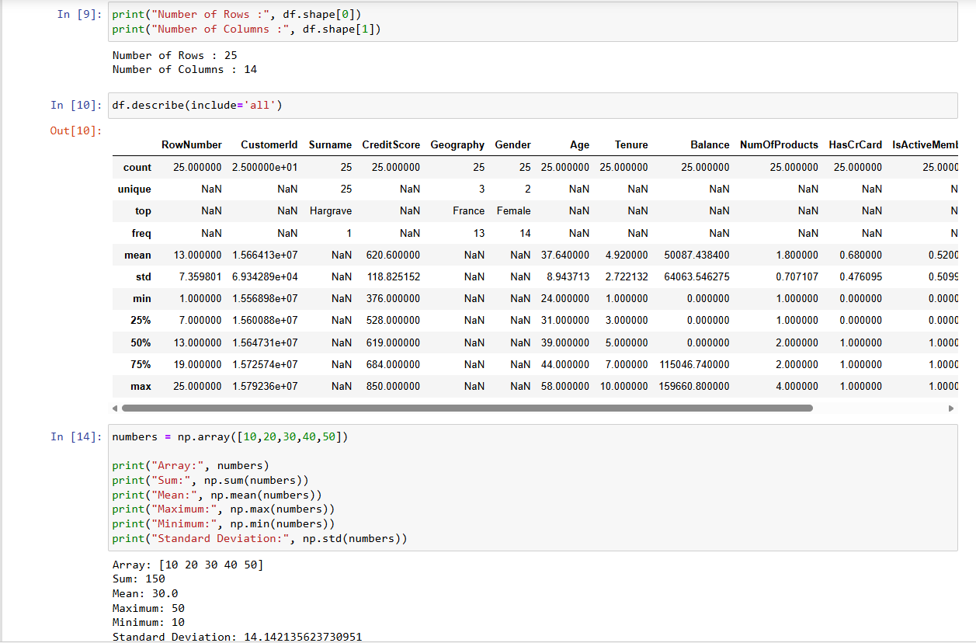

- Lists all the column names in the dataset.
- Generates the statistical summary of the dataset.
- Performs basic NumPy operations on a sample array.

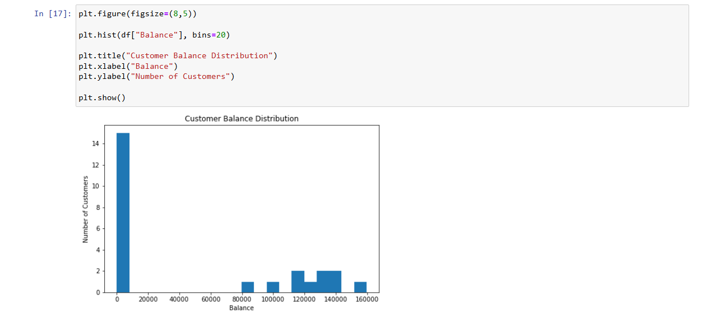
- Checks for missing values in each column of the dataset.
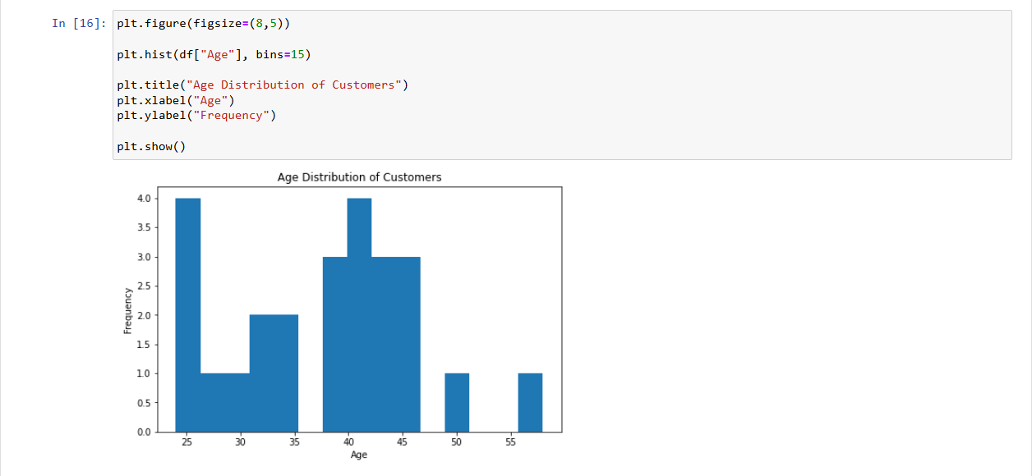
- Creates a histogram to visualize the distribution of customer ages.
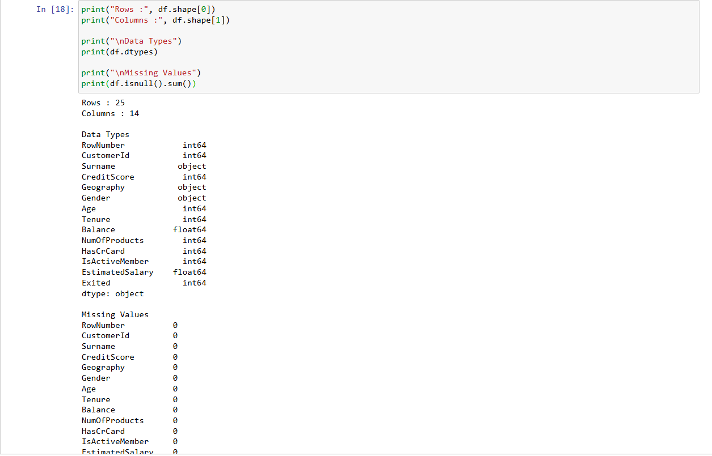
- Creates a histogram to visualize the distribution of customer account balances.

Experiment 2: Exploratory Data Analysis (EDA) – Data Import and Export
Aim:
To import the Churn Modelling dataset, perform basic exploratory data analysis using Pandas, and export the processed data into different file formats.
Procedure
• Import the required libraries such as Pandas and SQLite3.
• Load the Churn_Modelling.csv dataset using read_csv().
• Display the first and last five records of the dataset.
• Examine the dataset using info(), shape, and dtypes.
• Generate the statistical summary using describe().
• Identify missing values using isnull().sum().
• Check for duplicate records using duplicated().
• Export the dataset to Excel and import it again for verification.
• Store the dataset in an SQLite database.

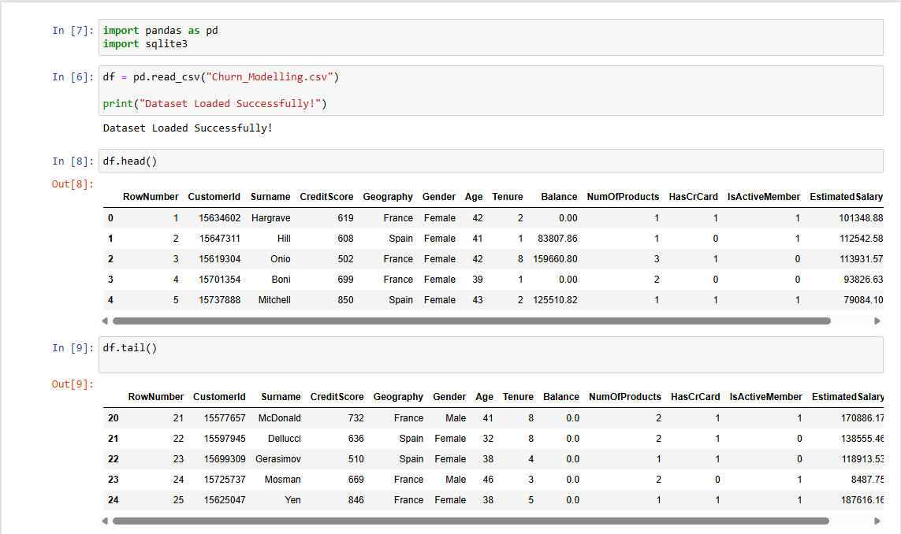
- Imports the required libraries for data analysis and SQLite database operations.
- Loads the Churn_Modelling.csv dataset into a Pandas DataFrame.
- Displays the first five records of the dataset.
- Displays the last five records of the dataset.

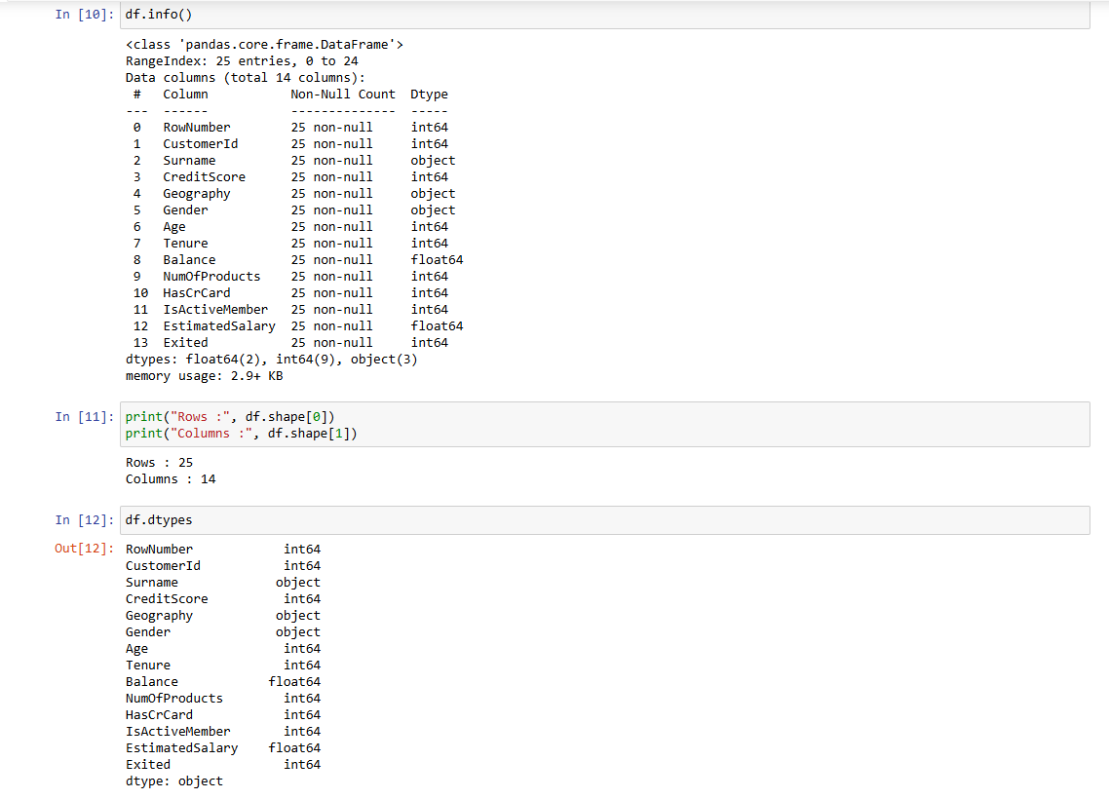
- Displays the dataset structure, data types, and non-null values.
- Displays the total number of rows and columns in the dataset.
- Displays the data type of each column in the dataset.
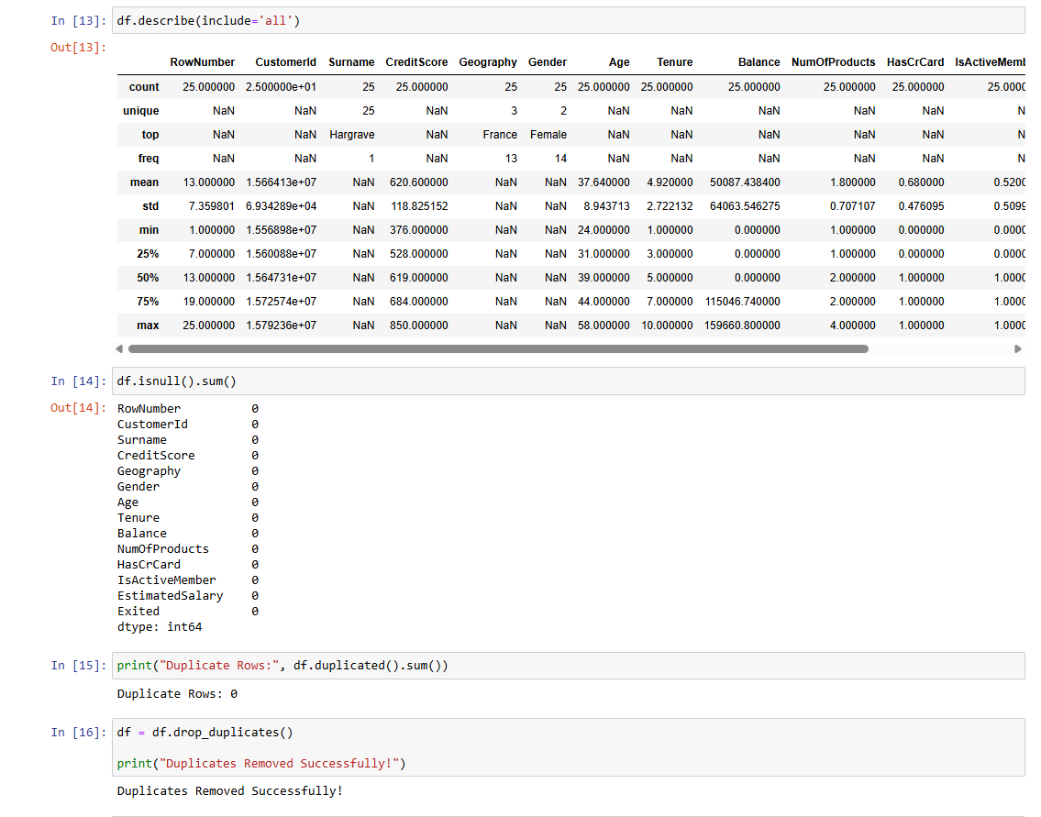
- Generates the statistical summary of the dataset.
- Identifies the missing values in each column.
- Checks the dataset for duplicate records.
- Removes duplicate records from the dataset.
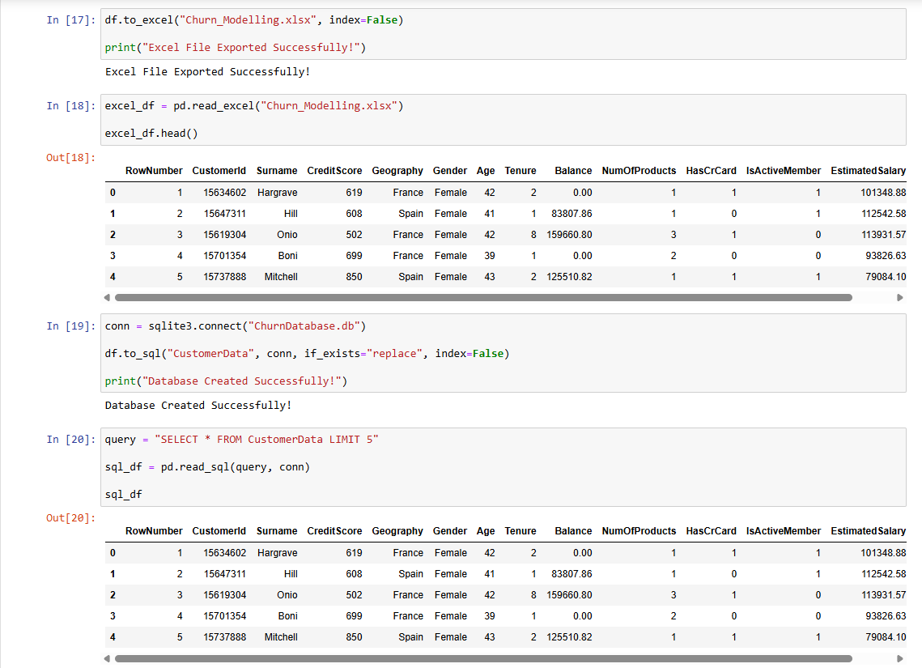

- Exports the dataset to an Excel file.
- Imports the exported Excel file to verify the data.
- Creates an SQLite database and stores the dataset as a table.
- Retrieves and displays records from the SQLite database.
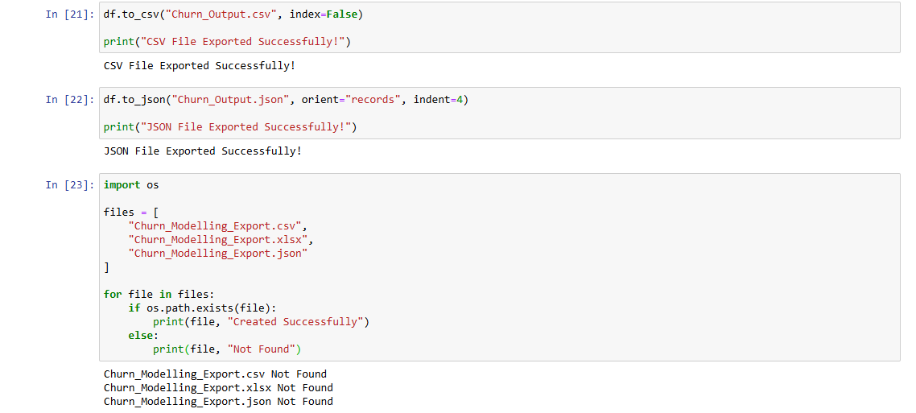

- Exports the dataset to a CSV file.
- Exports the dataset to an Excel file.
- Exports the dataset to a JSON file.
- Verifies that the exported CSV, Excel, and JSON files were created successfully.

