AIM:
To create and analyze various data visualizations such as Line Charts, Bar Charts, Pie Charts, Histograms, Scatter Plots, and Box Plots using Matplotlib for effective data interpretation.
ALGORITHM:
- Import Matplotlib library.
- Create or load the required dataset.
- Select the required data and visualization type.
- Apply the appropriate visualization function such as plot(), bar(), pie(), or boxplot().
- Add a suitable title, axis labels, legends, and percentage labels if required.
- Customize the chart if necessary.
- Display the visualization using show().

PROGRAM:
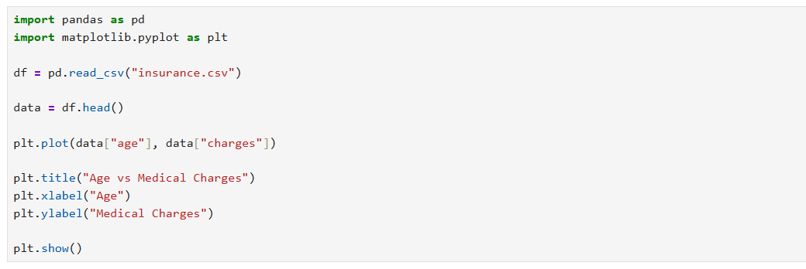
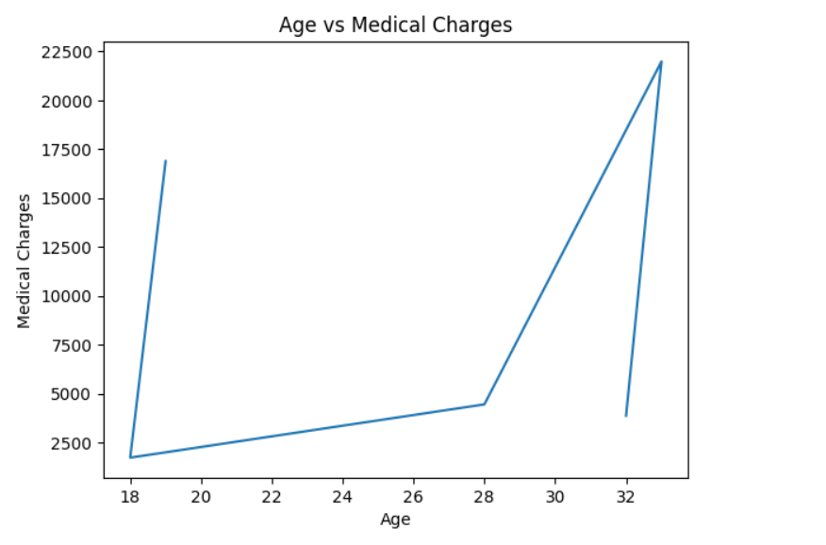
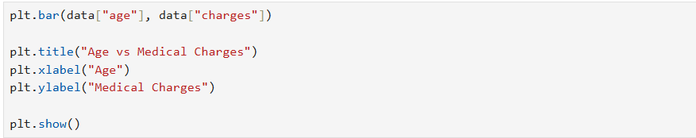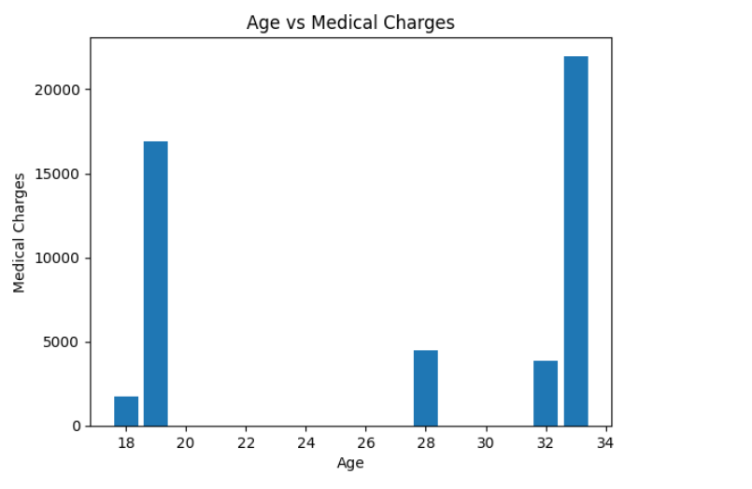
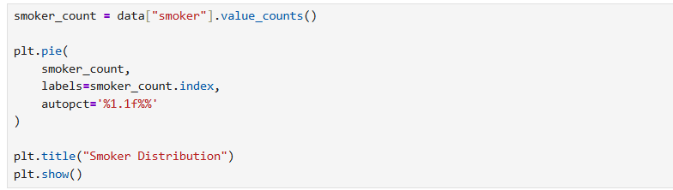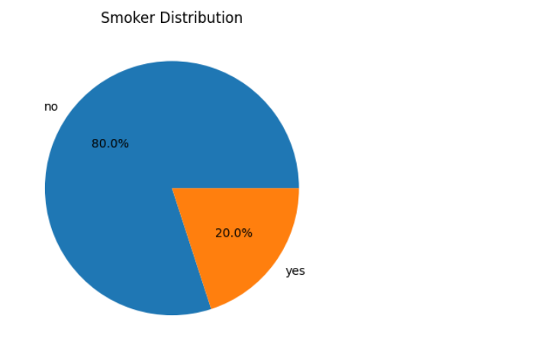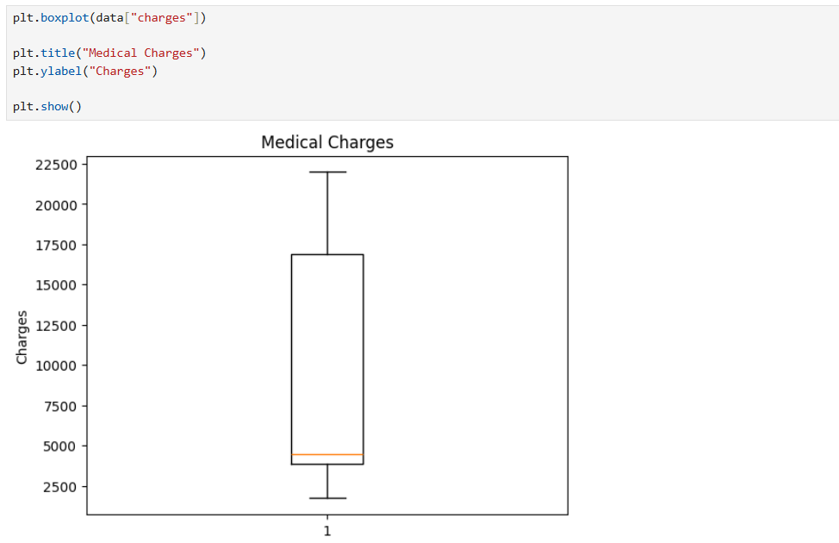
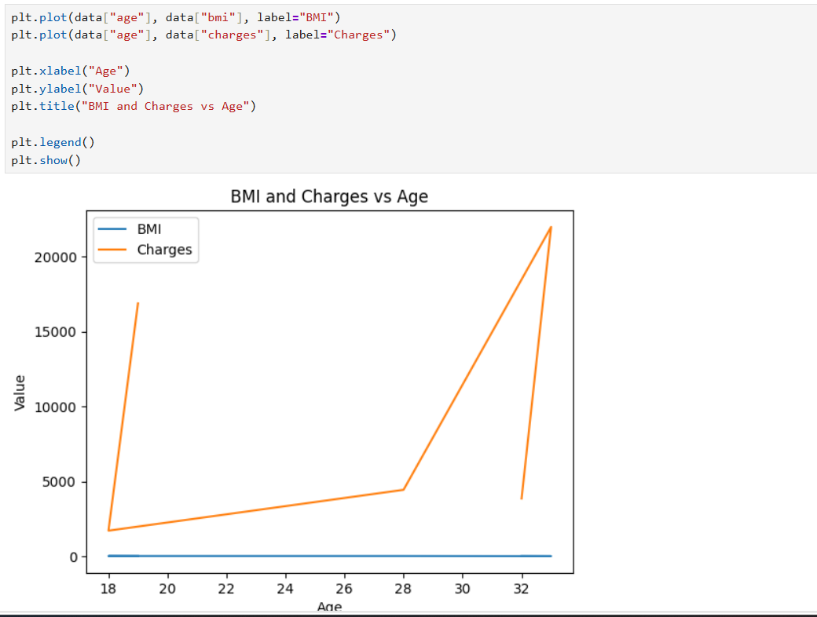

RESULT:
Thus, various visualization techniques such as Line Charts, Bar Charts, Pie Charts, Histograms, Scatter Plots, and Box Plots were successfully created using Matplotlib. The graphical representations helped in understanding trends, distributions, comparisons, and relationships within the dataset.

